Daniel James (2218766)
2218766@student.uwtsd.ac.uk
University of Wales Trinity Saint David
MSc Cybersecurity and Digital Forensics
Enterprise Network Security
ACCA7032

Table of Contents
1.0 Security Infrastructure Deployment 2
2.0 Firewall Policy Design and Enforcement 4
2.1 Firewall Rule Design 5
2.2 Firewall Policy Enforcement 5
3.0 Additional Security Features Implementation 7
3.1 Intrusion Prevention System 7
3.2 Anti-Malware and Anti-Bot Protection 8
3.3 Application Control 9

1.0 Security Infrastructure Deployment
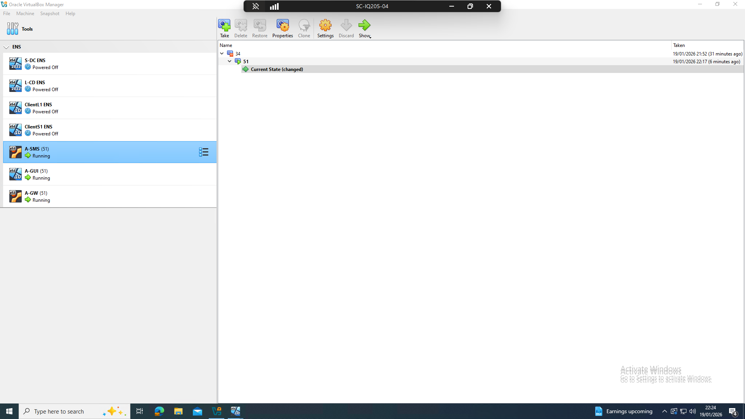
Figure 1: Virtual machine overview showing the deployed Check Point GW (A-GW), SMS (A-SMS), and management workstation (A-GUI), running as part of the secured enterprise network.

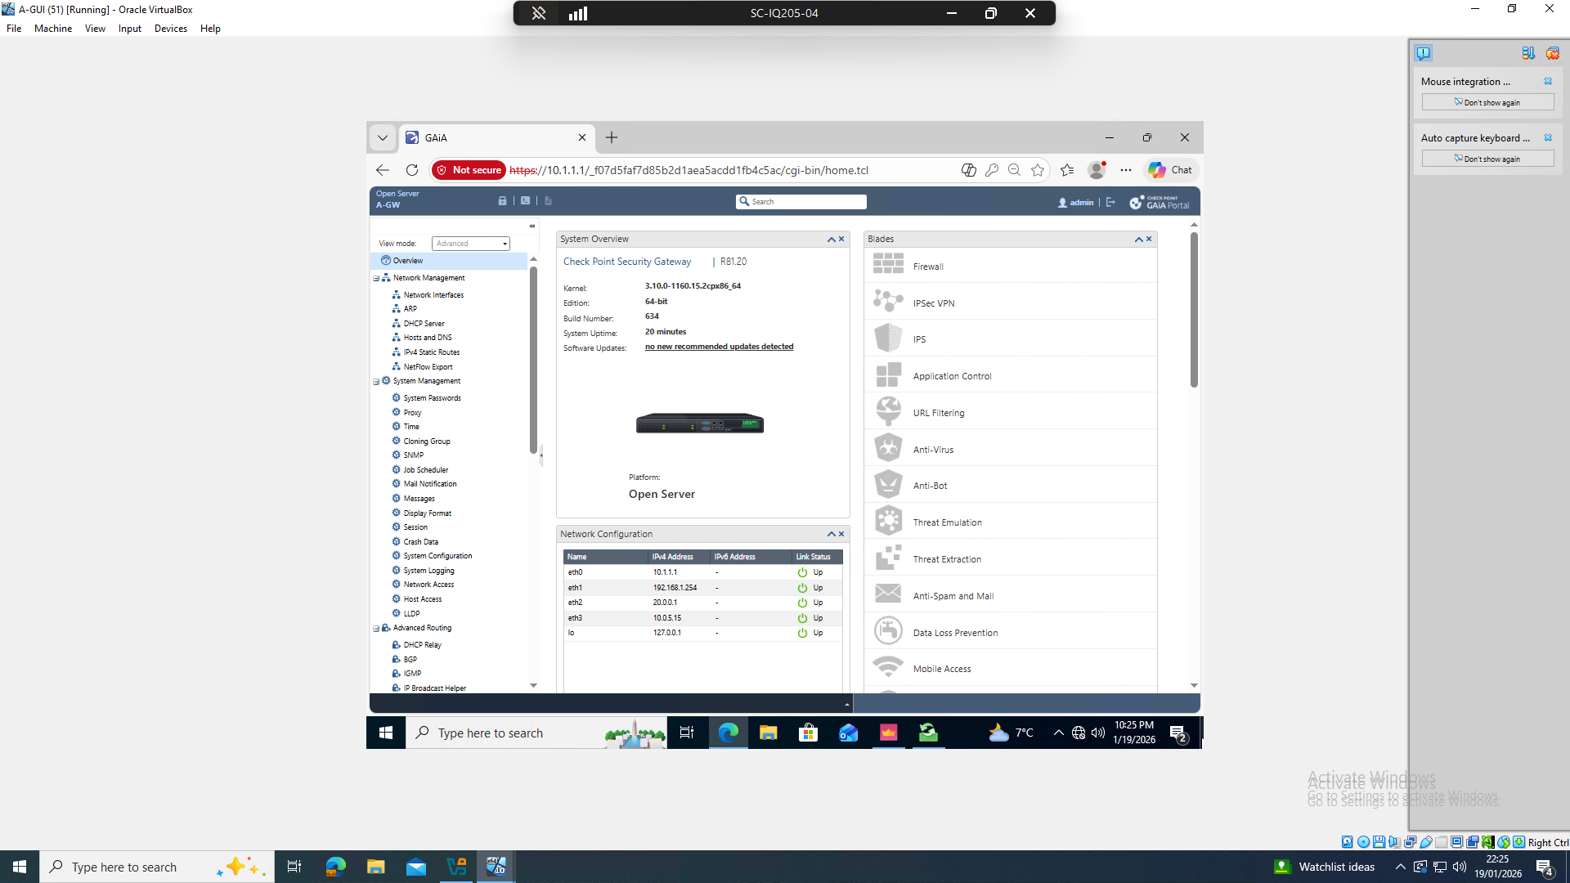
Figure 2: GAIA system overview for the Security Gateway (A-GW), confirming successful installation, assigned hostname, software version, and network interface configuration.
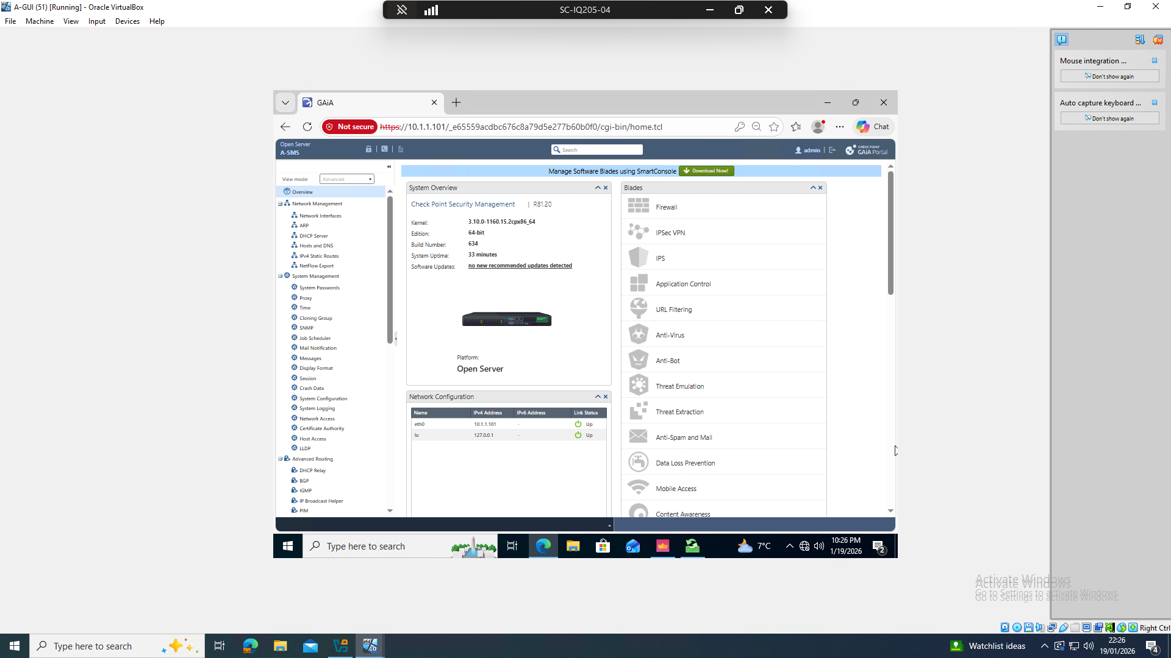
Figure 3: GAIA system overview for the SMS (A-SMS), confirming management role, hostname, software version, and IP configuration.
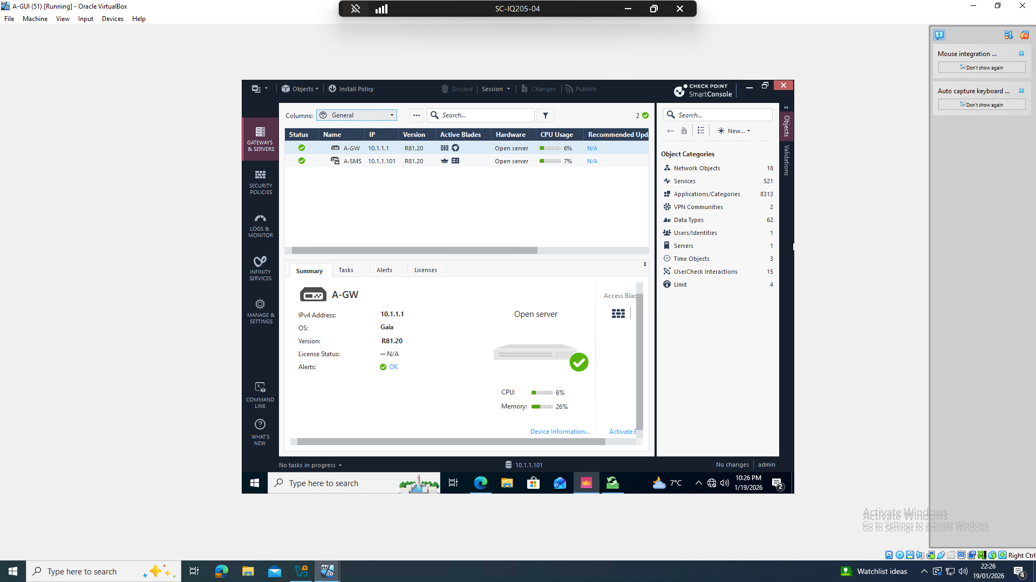
Figure 4: Smart Console view showing successful connectivity between the SMS and GW, with secure internal communication established and the gateway reporting a communicating status.

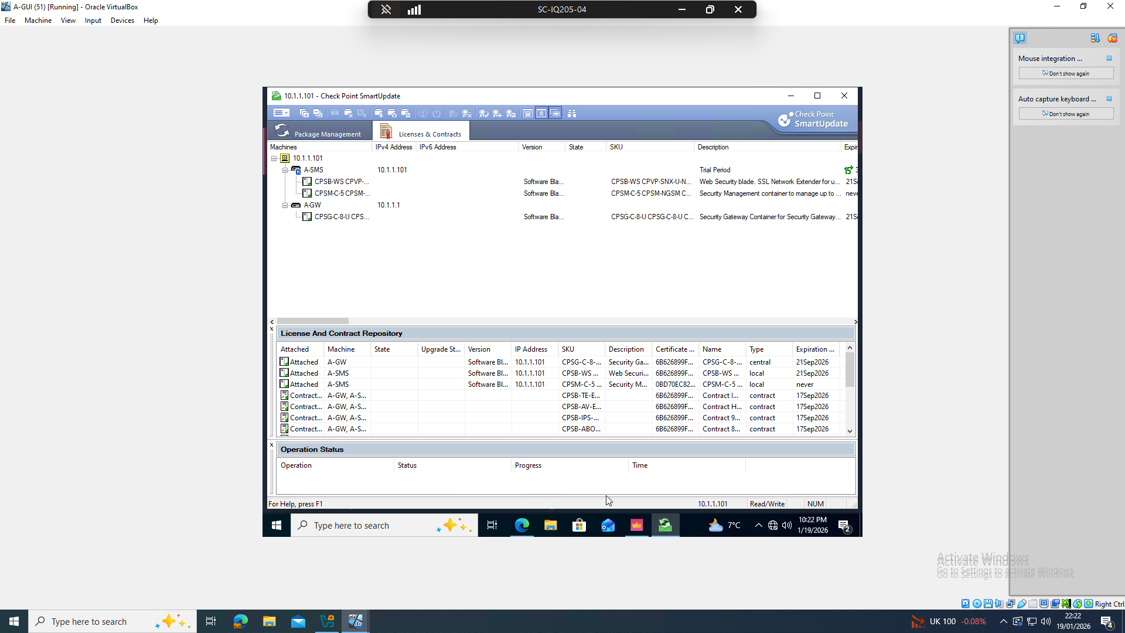
Figure 5: SmartUpdate licensing view confirming that licenses have been successfully applied to both the GW and SMS, including active blades and license expiration details.
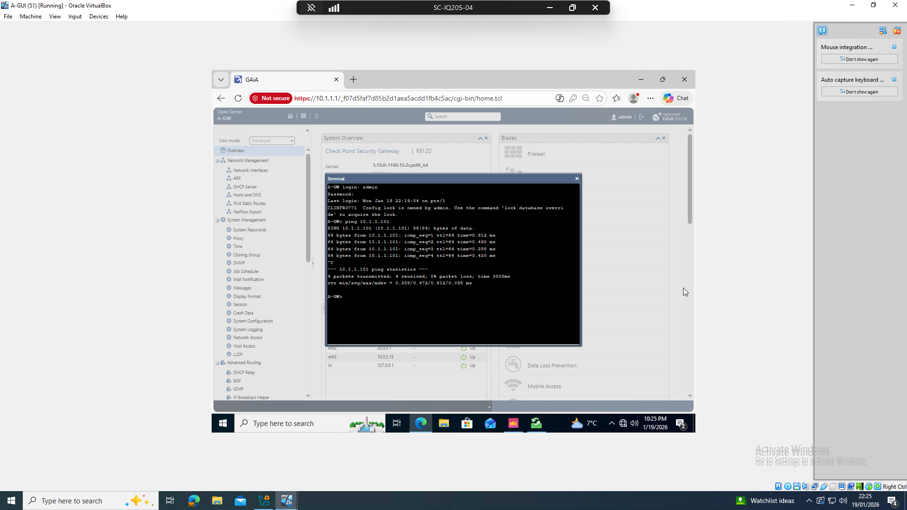
Figure 6: Connectivity verification demonstrating successful network connectivity between the GW and SMS

2.0 Firewall Policy Design and Enforcement
The firewall policy was designed using a default-deny and least-privilege approach. Only explicitly required services will be permitted, blocking and logging all other traffic. Management traffic is restricted to trusted hosts, and legacy or insecure protocols are denied reducing the attack surface of the enterprise network.

2.1 Firewall Rule Design
Administrative access to the security gateway is restricted to the management zone, ensuring that security management functions are isolated from user networks. Communication between the Swansea and London networks are limited to essential directory and authentication services, reducing the risk of unauthorised lateral movement between sites. Outbound access from internal networks to external networks is restricted to standard web services, supporting legitimate business use while preventing exposure through unnecessary or insecure protocols.
All unsolicited inbound traffic from external networks is denied, and a final cleanup rule enforces a default-deny posture across the environment. Rule ordering prioritises management and critical internal services to ensure predictable enforcement and to prevent accidental disruption of essential enterprise functions.
Rule | Source | Destination | Services | Action
1 | Management Zone | A-GW | HTTPS, SSH | Allow
2 | Swansea | London | DNS, LDAP, Kerberos, DHCP | Allow
3 | London | Swansea | DNS, LDAP, Kerberos, DHCP | Allow
4 | Internal (Swansea and London) | External | HTTP, HTTPS | Allow
5 | Any | Any | Any | Drop

2.2 Firewall Policy Enforcement
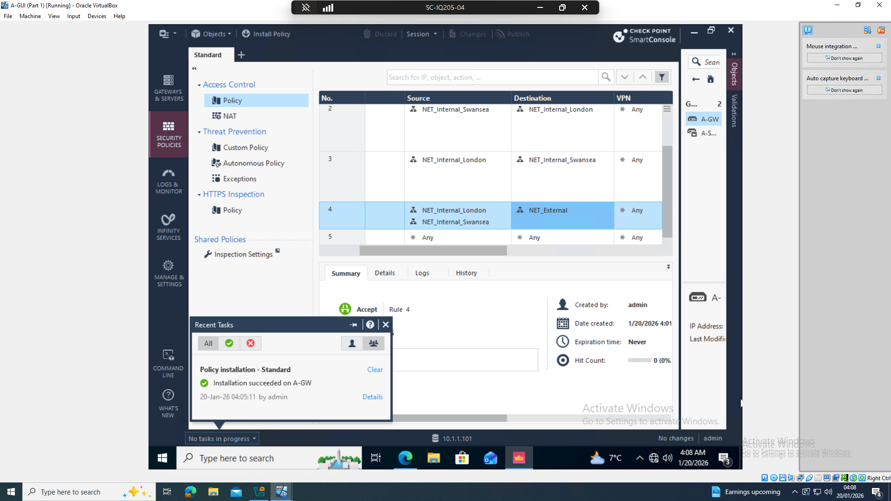
Figure 7: Successful firewall policy installation on A-GW
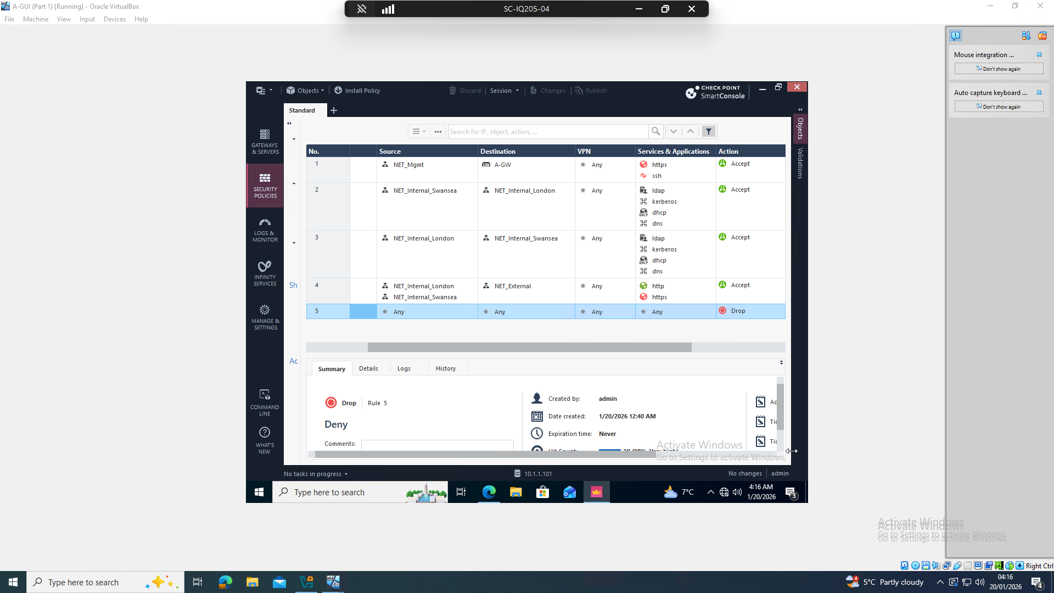
Figure 8: Firewall rule base enforcing least-privilege access control.

3.0 Additional Security Features Implementation

3.1 Intrusion Prevention System
The IPS blade was enabled in A-GW as shown in Figure 9, being centrally managed by the Smart Console. IPS protection was applied using the default protection profile, which provides balanced detection and prevention of known attacks while minimising performance impact, this is shown in Figure 10.
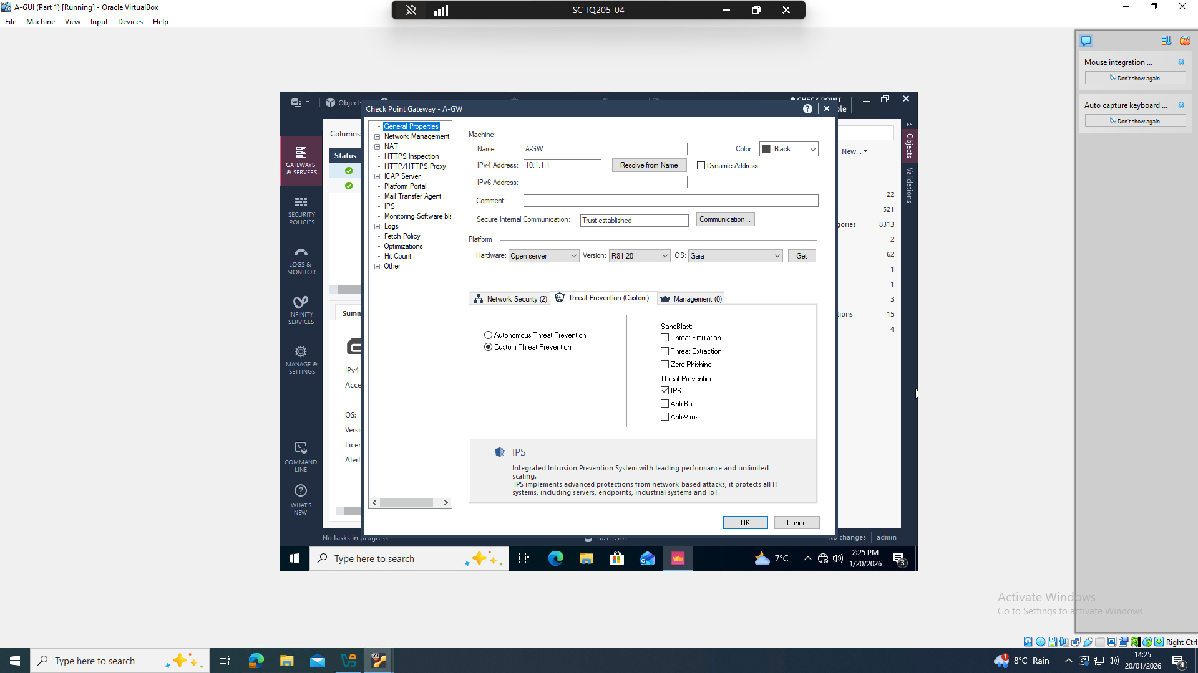
Figure 9: IPS blade enabled on the gateway.

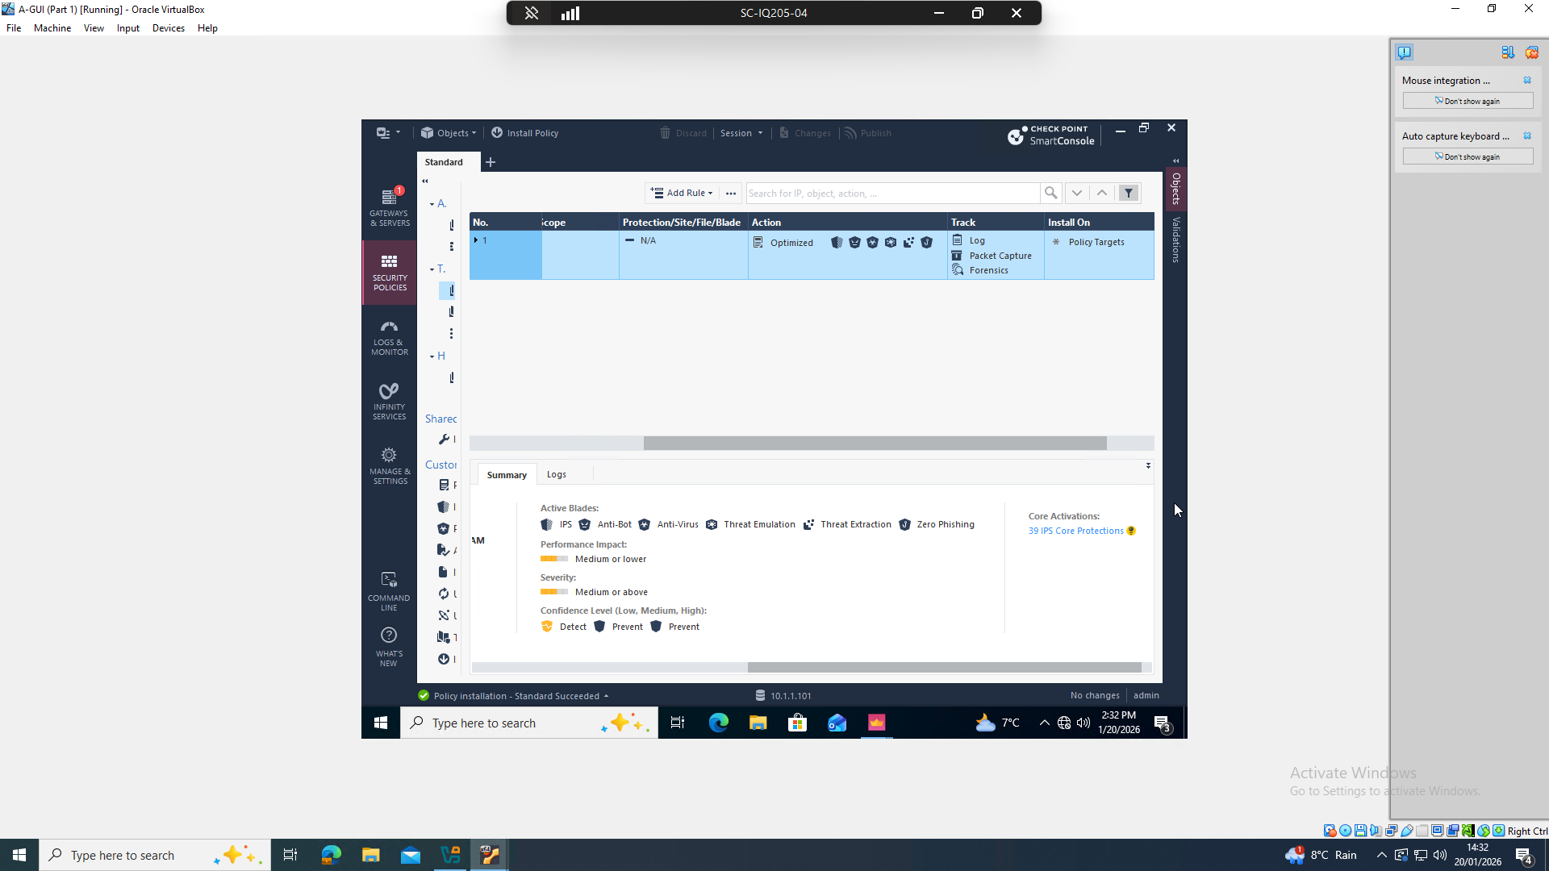
Figure 10: Threat prevention policy showing IPS enabled using the default protection policy.

3.2 Anti-Malware and Anti-Bot Protection
Anti-Malware and Anti-Bot protection was enabled on the Gateway as a part of the Threat Prevention framework to provide gateway-level inspection of malicious payloads and botnet communication. The Anti-Virus and Anti-Bot blades were activated on the gateway and centrally managed through the Smart Console as shown in Figure 11.
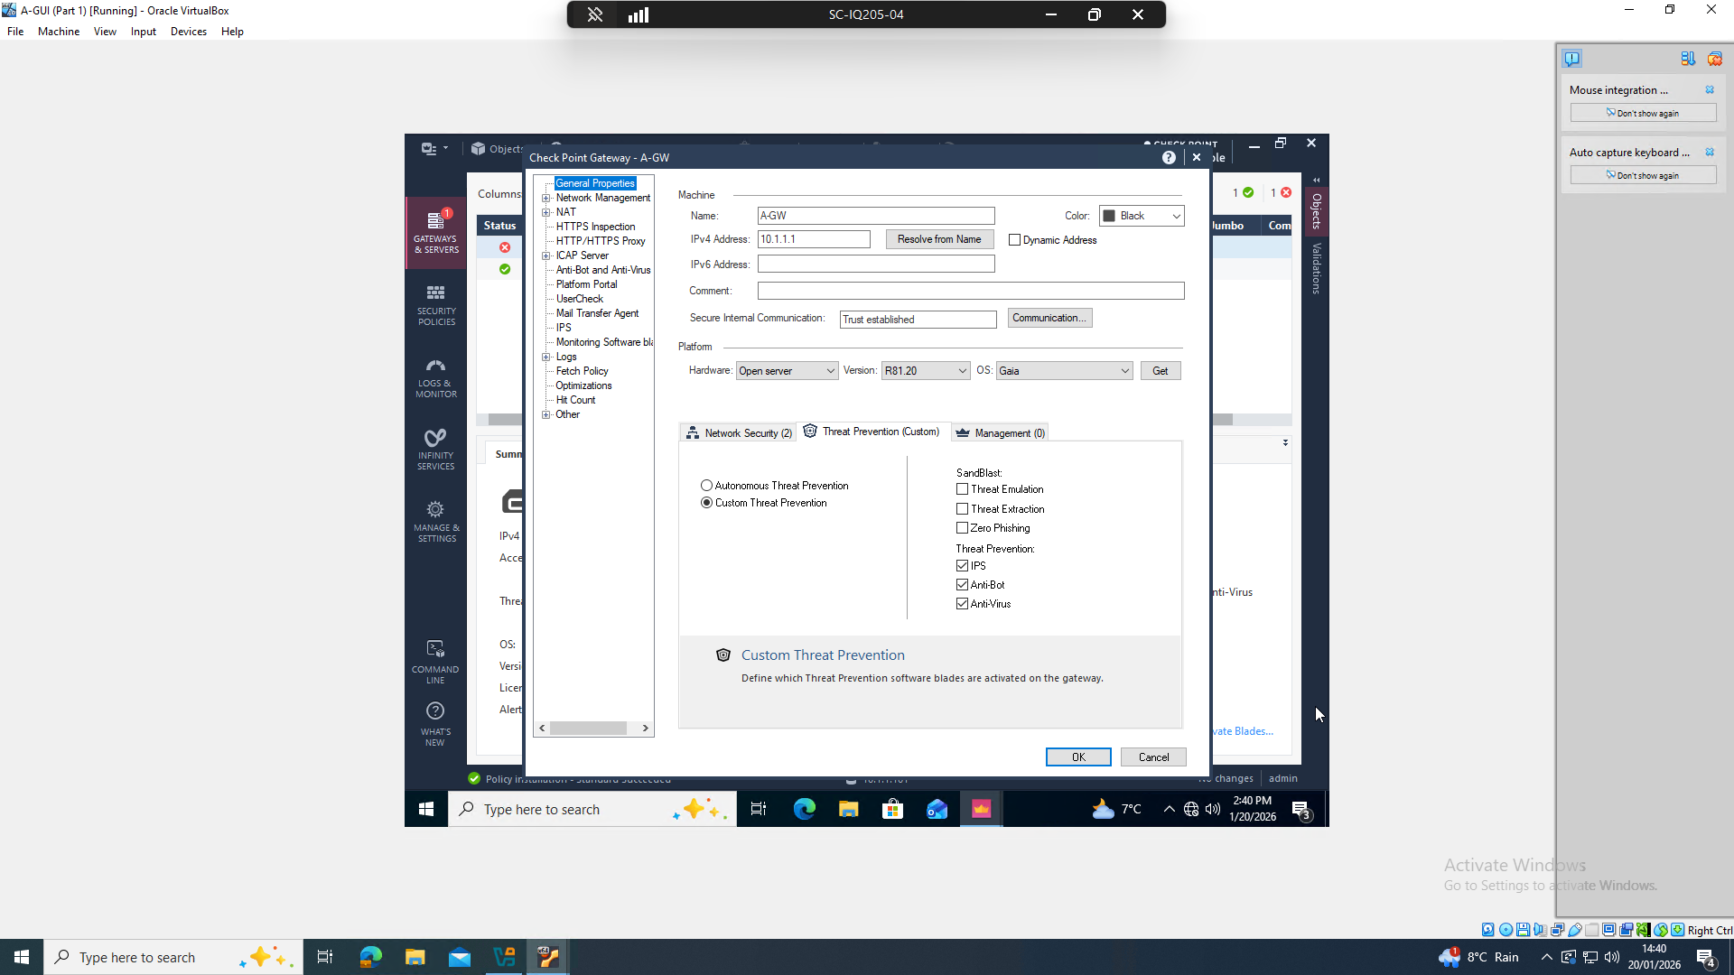
Figure 11: Anti-Virus and Anti-Bot blades are enabled on the gateway
As shown in Figure 12, a default protection profile was applied within the Threat Protection policy to provide balanced malware and bot detection while minimising performance impact and false positives.
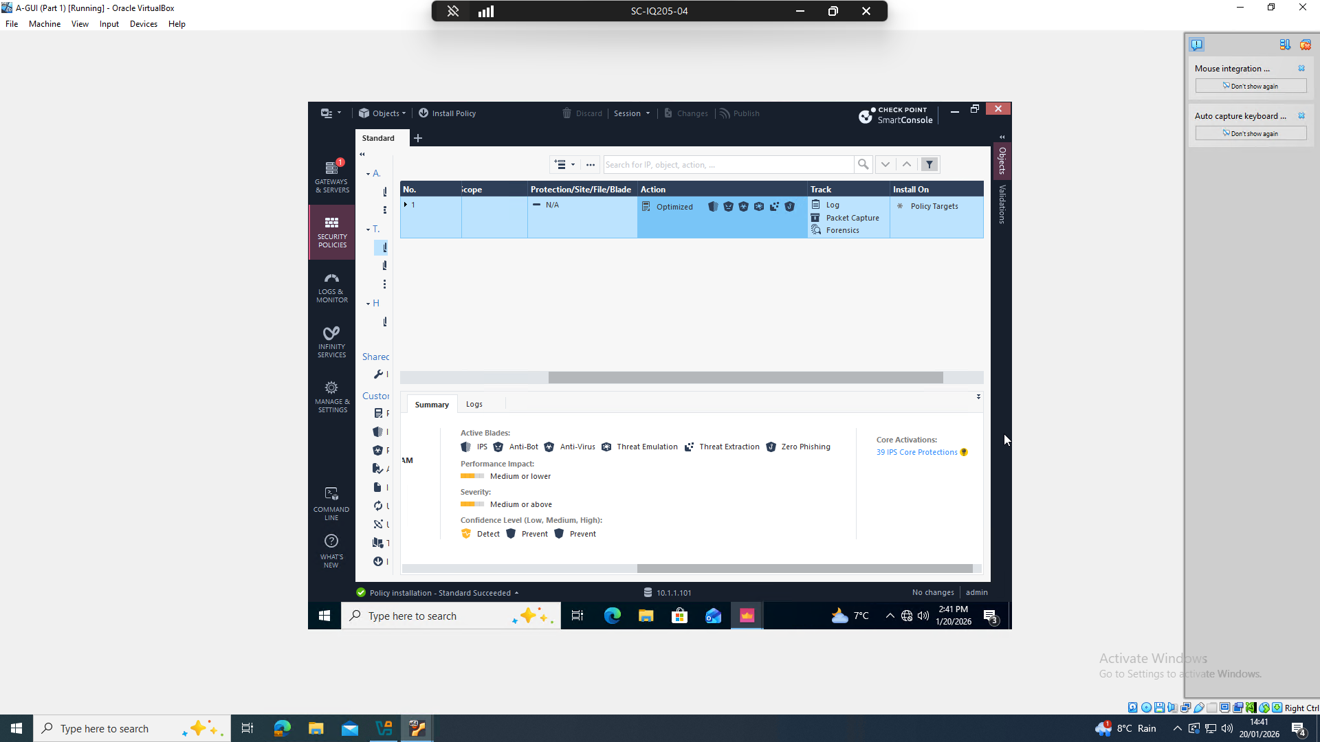
Figure 12: Threat prevention policy is active and applied, including bot and malware protection

3.3 Application Control
Application control was enabled on the gateway to support application traffic identification as a part of the security architecture. The blade was activated, as shown in Figure 13, ensuring that the gateway can identify applications independently of the traditional port and protocol inspections. Due to the isolated nature of the virtualised lab and the absence of an Internet connection to the Checkpoint services, application-level policy enforcement could not be demonstrated. However, the successful activation of the control blade confirms that the gateway is configured to support this inspection and could be extended in future to enforce granular application policies.
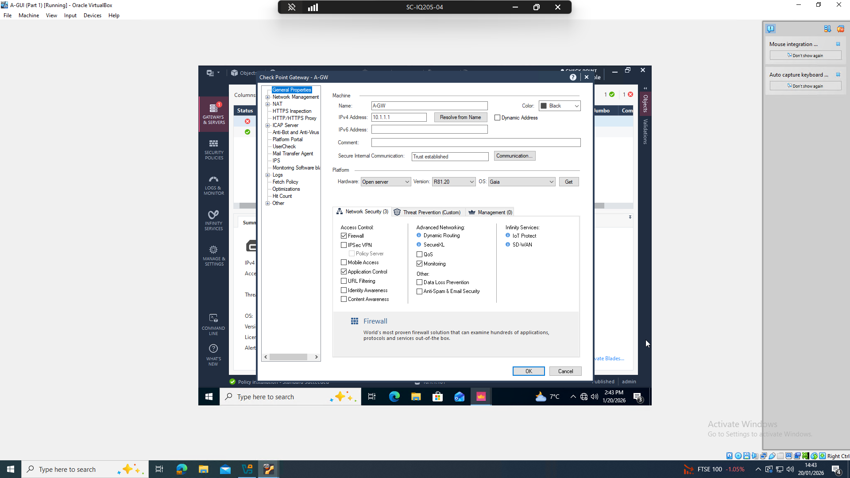
Figure 13: Application control blade enabled on the gateway

