UNIVERSITY OF WALES TRINITY SAINT DAVID

BSc (Hons) Health and Social Care
BMHP5015 Changemakers: Building Your Personal Brand for Sustainable Employment
Developing My Professional Identity and Employability Skills for a Healthcare Assistant Role within the NHS

Student Name: MOAWIA EDRIS ADAM HARON
Student ID: 2336780
Lecturer’s name : Brian

Submission Date:7th August

Table of Contents
1. Introduction 5
2. Job Description and Person Specification of Healthcare Assistant Role 5
3. Analysis of Personal Employability Skills Required for Healthcare Assistant Role 6
3.1 Communication Skills 6
3.2 Teamwork and Collaboration 7
3.3 Compassion, Empathy and Person-Centred Care 7
3.4 Resilience and Working Under Pressure 7
3.5 Digital Literacy and Organisation 7
3.6 Theoretical Frameworks 8
4. Evaluation of My Own Skills, Experience and Development Needs 8
4.1 Self-Assessment Approach 8
4.2 Evidence from Previous Experience 9
4.3 Gibbs Reflective Cycle Application 10
5. Building My Personal Brand and Professional Identity 11
5.1 Personal Values 11
5.2 Unique Selling Point (USP) 12
5.3 Professional Presence 12
6. Action Plan and Timeline for Career Development 13
6.1 Short-Term Goals (0–12 Months) 13
6.2 Medium-Term Goals (1–3 Years) 13
6.3 Long-Term Goals (3–5 Years) 14
7. Conclusion 16
8. References 17
9. Appendices 18
Appendix 1: NHS Healthcare Assistant vacancy screenshot 18
Appendix 2: Person specification screenshot 21
Appendix 3: Skills audit 22
Appendix 4: SWOT Analysis 23
Appendix 5: CV 24

List of Figures
Figure 1: Official logo of The National Health Service 5
Figure 2: Employability Skills Framework 6
Figure 3: NHS Values and 6Cs of Care 8
Figure 4: Personal Skills SWOT Analysis 9
Figure 5: Gibbs Reflective Cycle 11
Figure 6: Personal Brand Model 12
Figure 7: Schedule Table 15
Figure 8: Gantt chart 15
Figure 9: Network Diagram 16
Figure 10: NHS Healthcare Assistant vacancy 20
Figure 11: Person specification 21

List of Tables
Table 1: Career Development Action Plan 14
Table 2: Personal Skills Audit for Healthcare Assistant Career Development 22
Table 3: SWOT Analysis: Healthcare Assistant Career Development 23

1. Introduction
The Health and Social Care sector offers vital support to people who need care, help and protection, and as such, is a profession which calls for members who are skilled, caring and committed. My ambition is to become a Healthcare Assistant (HCA) employed by the National Health Service (NHS) following completion of my BSc (Hons) Health and Social Care degree (Navarro et al., 2024). This career pathway resonates with my passion for helping patients and vulnerable people who want to enhance my professional expertise, skills and dedication to the person cared for.
The report concentrates on the role of the Healthcare Assistant in the NHS and investigates employability skills needed for successful practice in the role. It will examine the skills required in a job, investigate what skills and experiences I have acquired from similar jobs I have undertaken in the past and talk about what my personal brand/personal identity is, and an action plan for further development of my skills.

Figure 1: Official logo of The National Health Service
Source: (NHS, 2025)

2. Job Description and Person Specification of Healthcare Assistant Role
This report is about the work of a Healthcare Assistant (HCA) in the National Health Service (NHS), based on an advertisement for a post on NHS Jobs (Appendix 1). This position would be focused on assisting RNs and health-related workers to provide safe, effective, and person-centred care. Indirect duties involved in supporting patients while maintaining their dignity and ensuring their wellbeing, respecting safeguarding protocols/action plans and confidentiality. Health and Social Care Knowledge, Relevant Training, Compassion, Reliability, Respect, and a commitment to Continuous Professional Development are outlined in the Person Specification.

3. Analysis of Personal Employability Skills Required for Healthcare Assistant Role
Healthcare Assistants must have a fusion of interpersonal, practical and professional attributes to deliver safe, effective and person-centred care in an NHS setting (Carroll et al., 2024). The position requires patient care, interaction with healthcare workers, and addressing various care requirements. Compassion, communication, teamwork and professional responsibility are core areas explored in healthcare practice and are emphasised in the Skills for Care Core Skills Framework, NHS Values and the 6Cs.
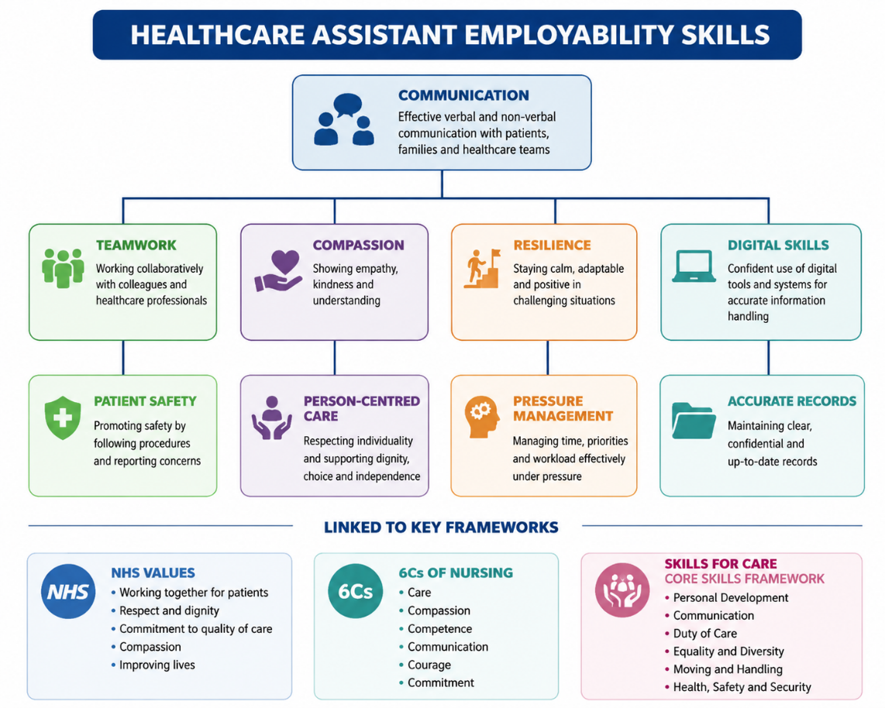
Figure 2: Employability Skills Framework
Source: Self-made

3.1 Communication Skills
A key component in the role of working with patients, families and health care professionals is the skill of communicating. Effective communication ensures accurate information exchange, patient safety and trusting relationships. Healthcare Assistants will need to exhibit: Listening skills, empathy and tailoring service to the individual's needs. This reflects the values of the NHS and the 6Cs of Nursing: caring and compassion. My administration experience built my communication skills, and my English and Arabic skills enable me to have diverse interactions with patients.

3.2 Teamwork and Collaboration
Healthcare Assistants provide support to nurses, doctors and other professionals in multi-disciplinary teams. There must be teamwork in order to share information and ensure patients are able to receive the right information to support them with their care activities (Bates et al., 2025). H.C.W's should exhibit reliability, co-operativeness and willingness to assist colleagues.
Through my previous work as a production operative and Amazon Warehouse Worker, I have developed teamwork skills by having to collaborate with others, obey instructions and accomplish jobs while being in a busy setting. These experiences have helped me to become more able to contribute to the team's goals and to be responsible in team settings.

3.3 Compassion, Empathy and Person-Centred Care
The qualities of compassion and empathy are important as Healthcare Assistants regularly work with some of the most helpless of people who might need support in physical, emotional or social ways. Respecting the dignity, independence, choices and circumstances of patients calls for a perspective on person-centred care. These values follow the principles of Health and Social Care; respect and fairness/thoughtfulness towards others are at the core of working within this care service.

3.4 Resilience and Working Under Pressure
Significant situations, heavy workloads and emotional requirements may occur in a healthcare setting. So, a resilient Healthcare Assistant who has a degree of patience and is professional under pressure is required. My production and warehouse career has allowed me to gain experience in an environment that requires a high level of adaptability, time management and confidence to handle challenging projects with speed.

3.5 Digital Literacy and Organisation
Skills in digital literacy and organising information are also needed as Healthcare Assistants are required to be part of documentation, record keeping, and maintaining confidentiality (Bhandari, Das and Kumar, 2025). There are transferable skills that have been formed during my administration experience, such as management of information accurately and Microsoft Office applications, which can be transferred to management in healthcare systems.

3.6 Theoretical Frameworks
The Kolb Learning Cycle illustrates that skills can advance through concrete learning experiences, the reflective Review and Rehearse, and the Learning Experience itself. Likewise, mention the Employability Skills Framework, which emphasises transferable skills and NHS Values and the 6Cs which relate to the behaviours of good healthcare providers. The use of these frameworks shows that competence in the field of Healthcare Assistant is developed through learning, working and C.P.D.
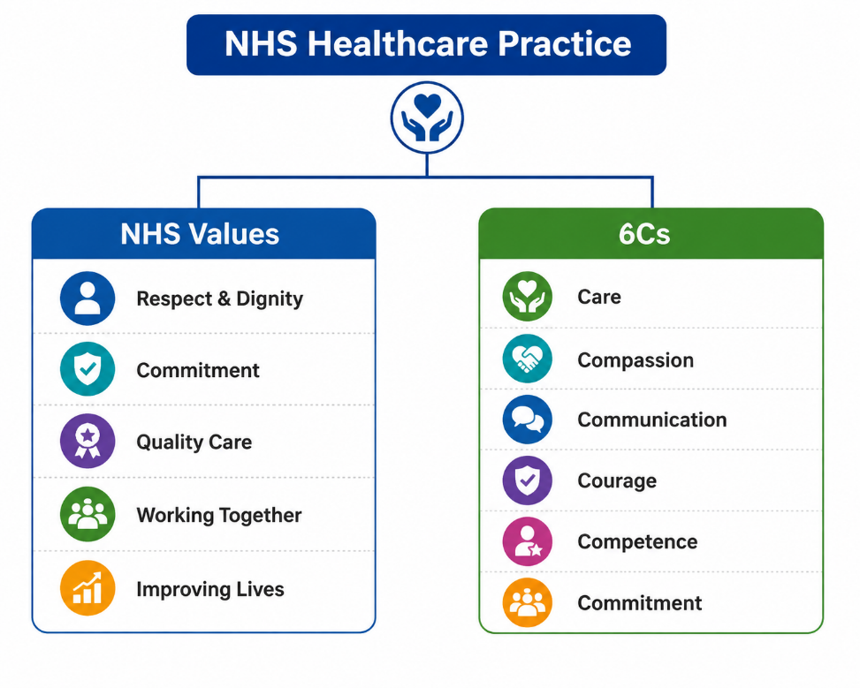
Figure 3: NHS Values and 6Cs of Care
Source: Self-made

4. Evaluation of My Own Skills, Experience and Development Needs

4.1 Self-Assessment Approach
To assess my suitability for the role of Healthcare Assistant, I have also conducted a SWOT analysis for the role, identifying and articulating skills and strengths I have, as well as stating what I lack in order to be better. My strengths are: great communicator, team guy, leader, administration skills, and thinking on my feet. I have gained this from previous career experiences as I have met many different people, had to take on responsibilities and work as a team with others.
But some things could be improved about this. I do not have direct experience in a clinical care setting, although I have some transferable skills to the healthcare field (Mujtaba and Meyer, 2022). I know that I must expand my healthcare-specific knowledge, which covers the safeguarding procedures, practices used in the care of the patient and healthcare-related professional qualifications. These gaps will enable me to feel more confident and prepared to work as a Healthcare Assistant.
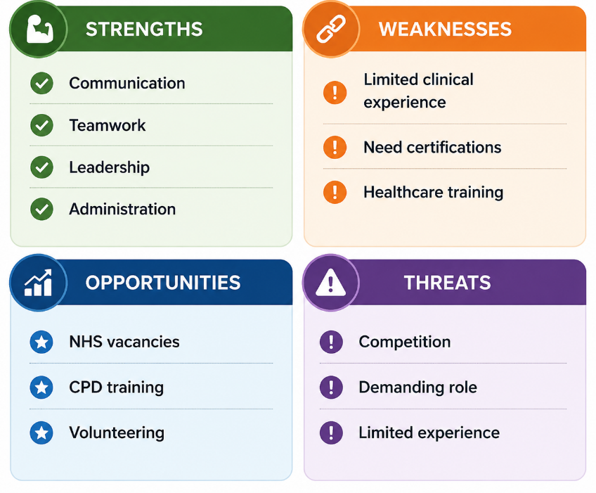
Figure 4: Personal Skills SWOT Analysis
Source: Self-made

4.2 Evidence from Previous Experience
I have amassed a set of transferable skills for my future job in the health sector from past work experiences. As an Administrator, I have improved communication skills and organisational skills related to the management of information, support for visitors, the response to enquiries and the keeping of accurate records. These are covered as relevant to health care environments where documentation, confidentiality and effective communication are fundamental requirements.
Leadership skills, teamwork and problem-solving skills developed from my work in retail and business. Supporting employees and responding to customer issues, handling daily tasks and operations helped me to become a better decision-maker and more at peace in challenging situations. These skills are useful in a healthcare setting where Healthcare Assistants have to collaborate with other personnel and deal with the patient's requirements.
Furthermore, I gained more resilience, awareness of safety, and pressure-working abilities through my work experience as a Production Operative and Amazon Picker-Packer. During their work in quicker time frames, they had to follow procedures, meet quality standards and finish the work in an effective way (Williams et al., 2022). The skills can be used in the health care profession arena to ensure that there is consistency in working safely and supporting children and young people.

4.3 Gibbs Reflective Cycle Application
Drawing on Gibbs' Reflective Cycle, I summarised my experience of working in a fast-paced working team before. It has been a learning experience where I had to do work in a specified time but had to work with other people as well. At the beginning, this pressure was challenging me, but I gained the confidence to tackle tasks and behave professionally.
This experience was good as it helped me work collaboratively with others, communicate with them and be resilient (Brown, 2022). But I knew that there were other skills that were required for healthcare, such as knowledge of clinical aspects and experience with caring for patients. Reflection helped me to see that I have a lot of abilities already and I need to build on them in order to make my job dream come true.
I will undertake appropriate training within the healthcare sector, build up practical skills via volunteering and employment opportunities and continue to build my professional skills to become a competent Healthcare Assistant as an action plan.
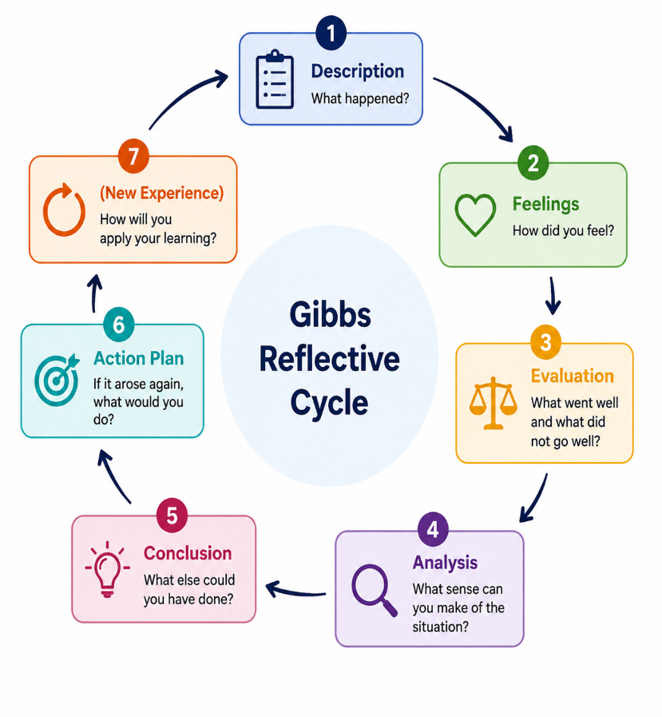
Figure 5: Gibbs Reflective Cycle
Source: Self-made

5. Building My Personal Brand and Professional Identity

5.1 Personal Values
Establishing a good personal brand is important to create a professional career identity in the Health and Social Care field. Compassion, respect, reliability, equality and continuous learning are my professional values and are very similar to NHS values and the principles of person-centred care. Respect allows me to treat patients with dignity and fair treatment; Compassion will enable me to understand people with varying needs and help my patients with their needs. Reliability is crucial because you have to expect your healthcare professional to be reliable so that you can muster trust in him/her to give safe and consistent support. Moreover, the commitment to equality means I can make care welcoming to people from diverse backgrounds, and ongoing training enables my ongoing professional learning and practice improvement.
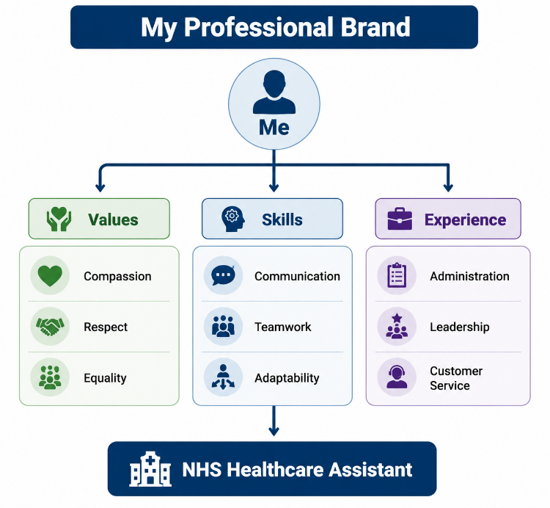
Figure 6: Personal Brand Model
Source: Self-made

5.2 Unique Selling Point (USP)
I am the only person who has done a Health and Social Care course, coupled with a wide range of experiences. I have acquired communication skills, adaptability and problem-solving skills through my previous administrative roles, service roles, teamworking and leadership positions. These transferable skills enable me to interact with the patient population in a healthcare setting with a wider lens and build positive working relationships with other people and multidisciplinary staff.

5.3 Professional Presence
I will build a robust CV to demonstrate my professional identity, work experience in the Health and Social Care sector, transferable skills and any training, plus a commitment to the development of Health and Social Care. A LinkedIn profile will be used to project a professional image through identifying activities, achievements, skills and goals as related to the healthcare field.
I will also do career networking in order to join groups on LinkedIn for healthcare professionals, attend healthcare career events and interact with professional organisations. The following activities will give me experience in the industry, opportunities for jobs and networking with healthcare professionals (Pianda et al., 2024). An online profile and an engaged professional practice will enhance my personal brand and NHS employability.

6. Action Plan and Timeline for Career Development
To succeed as a Healthcare Assistant, involvement in ongoing training, experience, and enhancement of healthcare skills is necessary. A SMART Action Plan will ensure that I can define long-term career goals, track my progress and work towards my goals to reach my future career aspirations in the Health and Social Care sector.

6.1 Short-Term Goals (0–12 Months)
My short-term aim is to finish my studies for the BSc (Hons) Health and Social Care degree successfully, to develop my understanding and theory of healthcare working. Upon completion of school, I will seek a Healthcare Assistant career within the NHS to further acquire essential skills and transfer my current skills and knowledge to a work setting.
I will undertake the necessary training to enhance my preparation for this post, such as safeguarding training, infection control and first aid training. These qualifications will advance my knowledge of patient safety, professional scope of practice and providing effective care. I will also continue to develop the skills of communication and leadership in both the classroom and at work.

6.2 Medium-Term Goals (1–3 Years)
Moving forward in my career, I wish to gain experience in the NHS and improve my clinical skills. As a Healthcare Assistant, I will learn to enhance my knowledge of patient care, team working and healthcare procedures. I will proactively provide feedback and seek feedback from colleagues and superiors for further enhancement areas.
I will attend Continuing Professional Development (CPD) courses to extend my knowledge and continue professional development (Friedman, 2023). Furthermore, I want to build my leadership skills through taking ownership of my place in a healthcare unit and enable to support colleagues and patients better.

6.3 Long-Term Goals (3–5 Years)
Long-term plans for Career progression: Further training in Health and Social Care to continue to move up within the sector to higher levels of responsibility. I want to keep building up my skills and knowledge to work at a higher level in healthcare and be able to make a greater impact on patients and people's development within the workplace.
Table 1: Career Development Action Plan
Timeframe | Goal | Action | Resource
During degree | Gain healthcare knowledge | Complete BSc Health and Social Care degree | University
0–6 months after graduation | Gain employment | Apply for Healthcare Assistant roles | NHS Jobs and recruitment platforms
6–12 months | Improve professional skills | Complete safeguarding, infection control and first aid training | Training providers
1–3 years | Develop career experience | Gain NHS experience and improve clinical skills | NHS workplace and mentors
5 years | Career progression | Undertake further qualifications and progress towards advanced roles | Further study and CPD opportunities
This action plan will offer a realistic plan for progressing towards my career goal and help ensure that I can continually learn and grow and sustain employment in Health and Social Care.
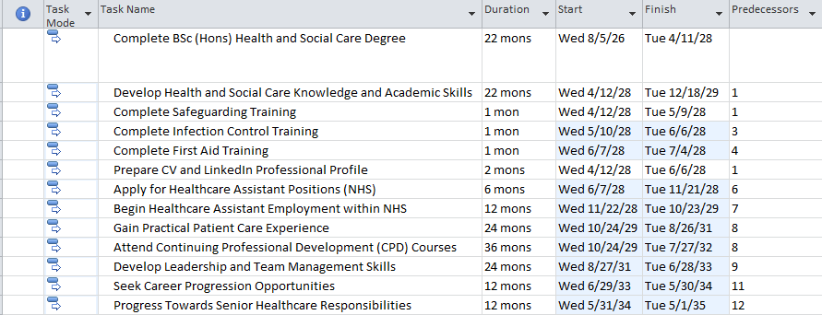
Figure 7: Schedule Table
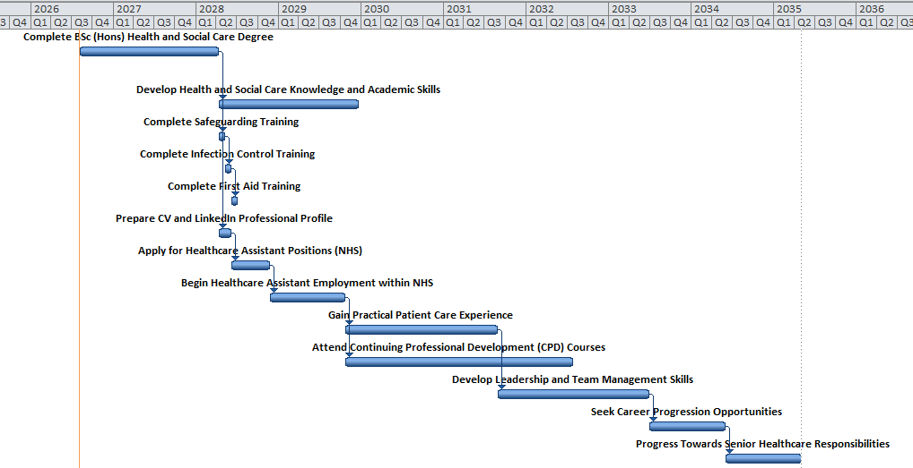
Figure 8: Gantt chart
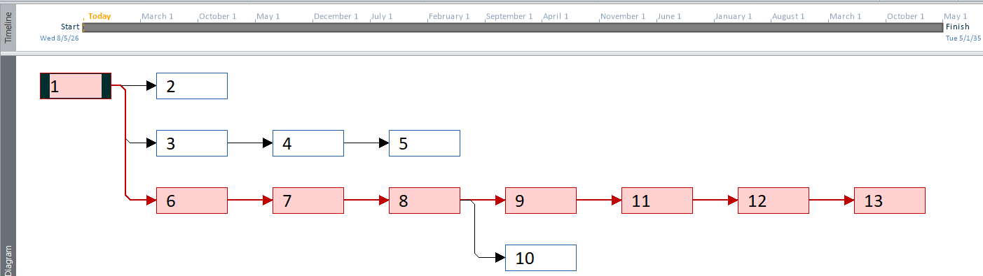
Figure 9: Network Diagram

7. Conclusion
This report has looked at my goal in employment to become a Healthcare Assistant in the NHS and the employability skills that are needed to help my goal come true. Communication skills, team working ability, organisation, and leadership are all aspects of my previous work, and the ability to work under pressure clearly shows that I am suitable for this grade 4, as these are all transferable skills that I have acquired. Yet I am aware that work must be done on some of these areas, including clinical knowledge, expertise in health-related work, and health-related qualifications.
Reflecting on my skills and experiences has led me to recognise the need to continually develop skills and knowledge in HSC. My action plan outlines a clear course of action to meet these development needs: completion of my degree, NHS work experience and relevant training to support me for further development. This will align with my objective of having a career in healthcare that is sustainable and successful.

8. References
Bates, S.M., Lin, J., Allen, L.N., Wright, M. and Kidd, M. (2025). Can multidisciplinary teams improve the quality of primary care? A scoping review. eClinicalMedicine, 88, p.103497. doi:10.1016/j.eclinm.2025.103497.
Bhandari, Y., Das, A. and Kumar, P. (2025). Digital literacy of the Indian health workforce: A core requirement for healthcare delivery in the 21st century. Journal of Surgical Specialties and Rural Practice, 6(1), pp.9–12. doi:10.4103/jssrp.jssrp_6_25.
Brown, N. (2022). Teaching reflective practice in teams: In-person and virtual activities. 2022 IEEE Global Engineering Education Conference (EDUCON), pp.419–422. doi:10.1109/educon52537.2022.9766457.
Carroll, R.E., Vries, K. De, Goodman, C. and Brown, J. (2024). Health care assistant and registered nurse dyads, working together and apart – a qualitative study. BMC Nursing, 23(1). doi:10.1186/s12912-024-02619-z.
Friedman, A.L. (2023). Continuing professional development as lifelong learning and education. International Journal of Lifelong Education, 42(6), pp.1–15.
Mujtaba, B.G. and Meyer, C. (2022). Checklist for professional communication: A path to a healthy personality, reflective mindfulness, and self-development management. Health Economics and Management Review, 3(3), pp.99–108. doi:10.21272/hem.2022.3-010.
Navarro, C.D., Armstrong, R., Charnetski, M., Freeman, K.J., Koh, S., Reedy, G., Smitten, J., Pier Luigi Ingrassia, Francisco Maio Matos and Issenberg, B. (2024). Global consensus statement on simulation-based practice in healthcare. Advances in simulation, 9(1). doi:10.1186/s41077-024-00288-1.
NHS (2025). NHS. [online] NHS. nhs. Available at: https://www.nhs.uk/ [Accessed 5 Aug. 2026].
NHS Job advert (2026). Job advert. [online] Jobs.nhs.uk. Available at: https://www.jobs.nhs.uk/candidate/jobadvert/K0005-26-0087?keyword=Healthcare%20Assistant&language=en [Accessed 5 Aug. 2026].
Pianda, D., Hilmiana, H., Widianto, S. and Sartika, D. (2024). The impact of internship experience on the employability of vocational students: A bibliometric and systematic review. Cogent Business & Management, 11(1). doi:10.1080/23311975.2024.2386465.
Williams, D., Fredendall, L.D., Hair, G., Kilton, J., Mueller, C., Gray, J.D., Graver, C. and Kim, J. (2022). Quality improvement: Implementing nurse standard work in emergency department fast-track area to reduce patient length of stay. Journal of Emergency Nursing, 48(6). doi:10.1016/j.jen.2022.07.009.

9. Appendices

Appendix 1: NHS Healthcare Assistant vacancy screenshot
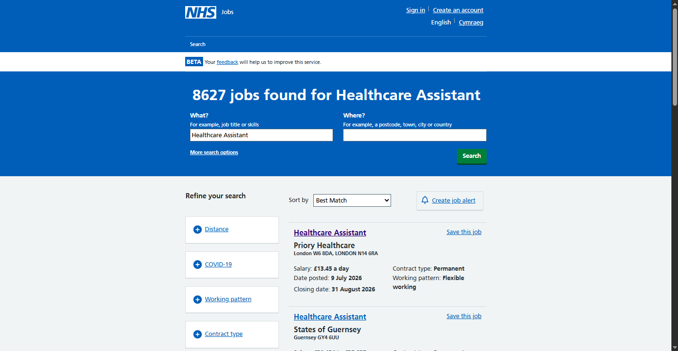
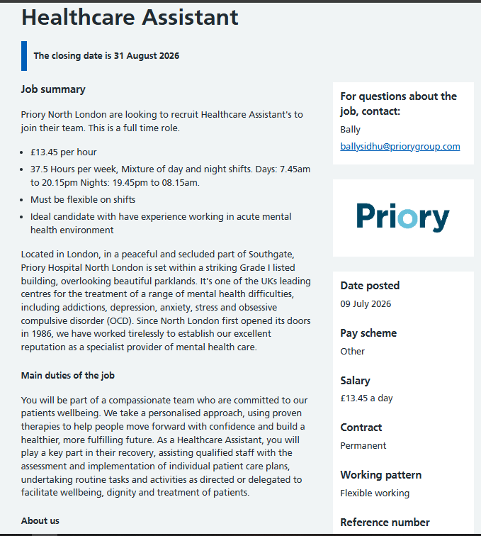
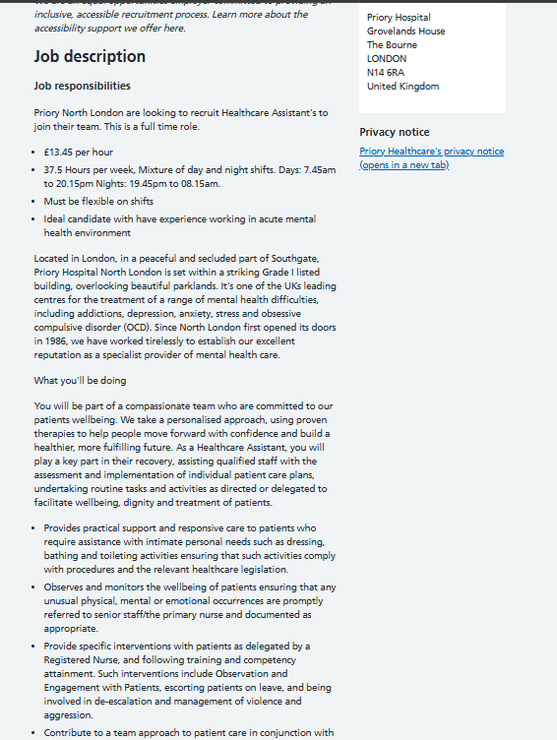
Figure 10: NHS Healthcare Assistant vacancy

Appendix 2: Person specification screenshot
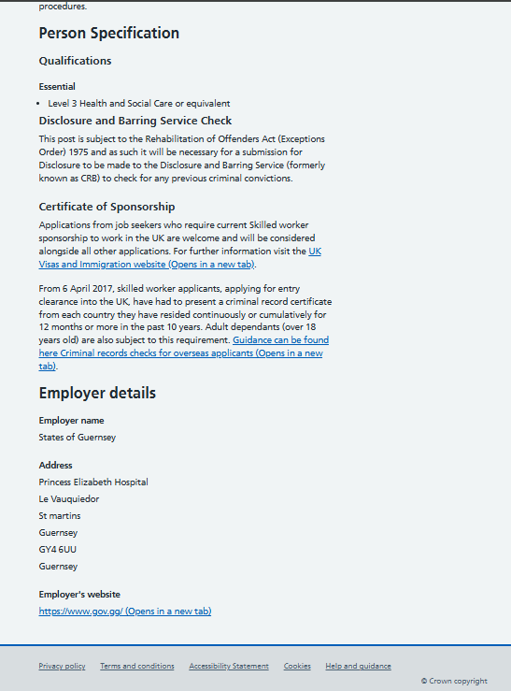
Figure 11: Person specification
Source: (NHS Job advert, 2026)

Appendix 3: Skills audit

Table 2: Personal Skills Audit for Healthcare Assistant Career Development
Skill Area | Current Level | Evidence from Experience | Development Need
Communication skills | Strong | Developed through administration work, customer interaction and communicating with colleagues and visitors. Ability to communicate in English and Arabic supports interaction with diverse individuals. | Continue improving healthcare-specific communication, including communicating with patients and healthcare professionals.
Teamwork and collaboration | Strong | Experience working within teams as a Production Operative and Amazon Picker-Packer, requiring cooperation and shared responsibility. | Develop further understanding of multidisciplinary healthcare teamwork.
Leadership skills | Developing | Shopkeeper/business experience involved managing staff, organising activities and solving problems. | Improve leadership skills within a healthcare environment through mentoring and workplace experience.
Organisation and administration | Strong | Administrator role developed record management, organisation and handling information accurately. | Learned healthcare documentation systems and electronic patient record processes.
Resilience and working under pressure | Strong | Fast-paced production and warehouse roles required meeting deadlines, following procedures and maintaining performance under pressure. | Develop emotional resilience for challenging healthcare situations involving patients and families.
Healthcare knowledge | Developing | Currently studying BSc (Hons) Health and Social Care, developing theoretical understanding of care principles. | Gain practical healthcare experience and complete relevant healthcare training.
Safeguarding and clinical skills | Limited | Limited direct experience in clinical healthcare settings. | Complete safeguarding, infection control, first aid and other relevant CPD training.
Digital skills | Good | Administration experience developed confidence using Microsoft Office and managing information. | Develop familiarity with healthcare-specific digital systems.

Appendix 4: SWOT Analysis
Table 3: SWOT Analysis: Healthcare Assistant Career Development
Strengths | Weaknesses
Strong communication skills developed through administration and customer-facing roles.  Ability to work effectively within teams.  Previous leadership experience from managing business operations.  Resilience and ability to work under pressure.  BSc Health and Social Care education provides relevant theoretical knowledge. | Limited direct healthcare workplace experience.  Need further development of clinical skills.  Require additional healthcare certifications such as safeguarding and first aid.  Limited experience using healthcare-specific systems.
Opportunities | Threats
NHS Healthcare Assistant vacancies provide opportunities to enter the healthcare sector.  CPD courses can improve professional skills and employability.  Volunteering and placements can provide practical experience.  Professional networking can increase career opportunities. | Competition for NHS healthcare roles.  Healthcare work can involve emotional and physical demands.  Lack of practical experience may reduce competitiveness compared with experienced applicants.

Appendix 5: CV
Aspiring Healthcare Assistant | BSc (Hons) Health and Social Care Student
Professional Profile
Apprenticeship, various administrative, customer service, team and business working experience with a dedicated, caring and cultivating BSc (Hons) Health and Social Care learner. Developed and applied communication, organisation, problem solving skills with customers, employees and operations areas. Proven experience of taking on responsibility, keeping information accurate, assisting others and being effective when under pressure.
Shows a desire to progress to a role in the NHS as a Healthcare Assistant and wants to transfer skills to this role that involves Communication, Team Working and Professionalism alongside gaining more knowledge of healthcare, patient-centred, and practical skills.
Key Skills
- Communication Skills
  - Effective verbal and written communication developed through administration and customer-facing roles.
  - Able to communicate with individuals from diverse backgrounds.
  - Fluent communication skills in English and Arabic.
- Teamwork and Collaboration
  - Experienced working within teams to achieve shared goals.
  - Able to support colleagues, follow procedures and contribute positively to workplace environments.
- Compassion and Person-Centred Approach
  - Strong interest in supporting individuals and contributing towards positive experiences.
  - Understands the importance of respect, dignity and equality when working with people.
- Organisation and Record Management
  - Experienced in managing information, maintaining records and completing administrative tasks accurately.
  - Good attention to detail and ability to prioritise responsibilities.
- Resilience and Working Under Pressure
  - Experienced in fast-paced environments requiring efficiency, flexibility and reliability.
  - Able to remain focused and professional during demanding situations.
- Digital Skills
  - Microsoft Office skills including Word, Excel and general information management.
  - Ability to learn new digital systems and workplace technologies.
Education
BSc (Hons) Health and Social Care
Relevant areas:
- Health and Social Care practice
- Professional values and ethics
- Supporting vulnerable individuals
- Communication in care settings
- Health and wellbeing
Professional Experience
Administrator
Key Responsibilities and Achievements:
- Managed communication with visitors, customers and colleagues in a professional manner.
- Responded to enquiries and provided appropriate information and support.
- Maintained accurate records and organised administrative information.
- Developed strong organisational and communication skills relevant to healthcare environments.
- Maintained confidentiality when handling sensitive information.
Transferable Healthcare Skills:
✔ Communication
✔ Confidentiality
✔ Organisation
✔ Professional behaviour
Shopkeeper / Business Owner
Key Responsibilities and Achievements:
- Managed daily business operations and customer relationships.
- Supported recruitment, training and coordination of staff.
- Developed leadership and problem-solving abilities.
- Managed customer concerns professionally and effectively.
- Maintained responsibility for decision-making and operational tasks.
Transferable Healthcare Skills:
✔ Leadership
✔ Teamwork
✔ Problem-solving
✔ Responsibility
Production Operative
Key Responsibilities and Achievements:
- Worked effectively within a fast-paced production environment.
- Followed health and safety procedures and workplace guidelines.
- Maintained quality standards while completing tasks efficiently.
- Collaborated with colleagues to achieve operational targets.
Transferable Healthcare Skills:
✔ Safety awareness
✔ Teamwork
✔ Reliability
✔ Resilience
Amazon Picker/Packer
Key Responsibilities and Achievements:
- Worked efficiently within a high-pressure environment.
- Followed operational procedures and maintained accuracy.
- Managed time effectively to complete tasks within deadlines.
- Demonstrated reliability and adaptability.
Transferable Healthcare Skills:
- Working under pressure
- Attention to detail
- Following procedures
Training and Professional Development
Currently developing knowledge and skills through:
- BSc (Hons) Health and Social Care studies.
- Understanding of healthcare values and professional practice.
- Commitment to completing future healthcare training, including:
  - Safeguarding training.
  - Infection prevention and control.
  - First aid training.
  - Care Certificate.
  - Career Objective
To find employment in the NHS as a Healthcare Assistant where to use communication, teamwork and organisation skills; and to gain practical skills in healthcare. I would like to pursue CPD and develop my clinical skills and further my career in the Health and Social Care field.
References
Available upon request.

