
Business Report – Comparison of Shangri-La Hotels and Premier Inn Hotels.

Module title: Financial Management for the Hotel Industry
Module code: BMIH5007
Lecturer name: Tristan Hawkins
Student name: Anamaria Alma Vida
Student ID: 2244885


I acknowledge the use of ChatGPT (www.chatgpt.com) on 9 October 2024 and 18 October 2024 to check my work and I used the prompt:
- Please can you check the text bellow of any grammatical mistakes?
I confirm that I have not presented any AI generated text as my own work. I confirm I have copies of my drafts, notes, and other resources I used before, and after the use of AI tools which I may be asked to provide in evidence.
Table of Contents

Introduction 2
Comparison of Shangri-La Hotels and Premier Inn Hotels 3
Sources of Revenue 3
Market Positioning 6
Growth Potential 7
Financial Commitment to Corporate Social Responsibility (CSR) 8
Conclusion 9
Recommendations 9
References 11

Introduction
In this report, two well-known hotels will be compared: Shangri-La Hotels and Premier Inn Hotels, which will comprise revenue sources, market position, customers’ class, and their growth strategy. Shangri-La and Premier Inn operate in the distinct niches of the hotel market, the first one targets the luxury segment, while the second is an economy-tier brand. It reveals the revenue patterns of each hotel, their financial development aspects, brand image, and CSR profiles. Further, it defines the possible market niches and threats affiliated with development for both brands and ought to give the directions for the competitive advantage for the brands based on the global hospitality industry.

Comparison of Shangri-La Hotels and Premier Inn Hotels

Sources of Revenue
Shangri-La Hotels: The major source of revenue for Shangri-La Hotels is room bookings, which account for approximately 50% of its total revenue (Shangri-La Group, 2023). The hotel offers a wide range of luxury accommodation options, from standard rooms to high-end suites (Lindmark, 2017). In addition to room rentals, consumer services, including restaurants, cafes, bars, and catering for special occasions, significantly contribute 20-25% to the group's revenue (Guilding, 2014). Shangri-La also generates income from ancillary services such as spas, fitness centres, and retail outlets, which collectively account for 5-10% of revenue, enhancing guests' overall experience (He, 2024). Another important revenue stream comes from hosting events and conferences, including weddings, business meetings, and exhibitions, which bring in an additional 5-10% of revenue, especially during festive seasons (Shangri-La Group, 2023).
Premier Inn Hotels: Most of the Premier Inn Hotels' revenue, approximately 70-75%, comes from accommodation services, with the brand offering low-priced hotel rooms primarily in the UK, Germany, and the Middle East (Premier Inn, 2023). The hotel's budget-friendly pricing appeals to both leisure and business travellers. Additional revenue is generated through ancillary services, which contribute 25-30% of total income. These services include catering, with cafes and restaurants providing breakfast, dinner, snacks, and drinks, as well as other revenue streams such as parking fees and paid Wi-Fi (Yadav, Han, and Kim, 2016).

Revenue Trends
Shangri-La Hotels: Shangri-La Hotel Public Company Limited operates in Thailand, with properties in Bangkok and Chiang Mai, offering a range of services including rooms and suites, restaurants, bars, lounges, and spas. The hotel experienced significant revenue fluctuations from 2019 to 2023. Revenue fell sharply from 2.55 billion in 2019, a decrease of 6.9%, to 663.3 million in 2020, a drop of 74.0%. The downward trend continued in 2021, reaching a five-year low of 355.9 million, a 46.3% decline, largely due to travel restrictions during the COVID-19 pandemic (He, 2024).
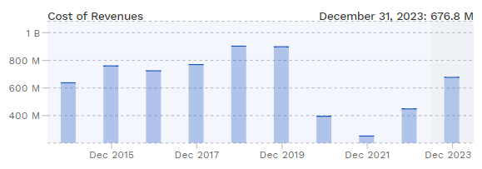
Figure 1: Revenue trend of Shangri-La Hotel
However, the company saw a strong recovery in 2022 with a revenue increase to 1.201 billion, up 237.5%, and further growth in 2023, reaching 2.186 billion, an 82.0% rise. This recovery was driven by the lifting of travel bans in its key markets, mainland China and Hong Kong, leading to a reported attributable net profit of $184.1 million in 2023, after three consecutive years of losses (Chernev, 2019).
Premier Inn Hotels: Premier Inn operates over 77,000 hotel rooms across more than 500 locations in Great Britain, with plans to increase its room count by at least 25% by mid-2029. The revenue trends for Premier Inn from 2015 to 2023 show a generally stable pattern, with a notable surge from 2021 to 2023. Revenue rose significantly from approximately 1,200 million GBP in 2021 to 2,600 million GBP in 2023, representing an average growth rate of 116.7% (Kollewe, 2021). This growth was accompanied by a 36% increase in pre-tax profit, amounting to over $700 million (£561 million), and a 10% improvement compared to the previous year (Aaker and Moorman, 2023).
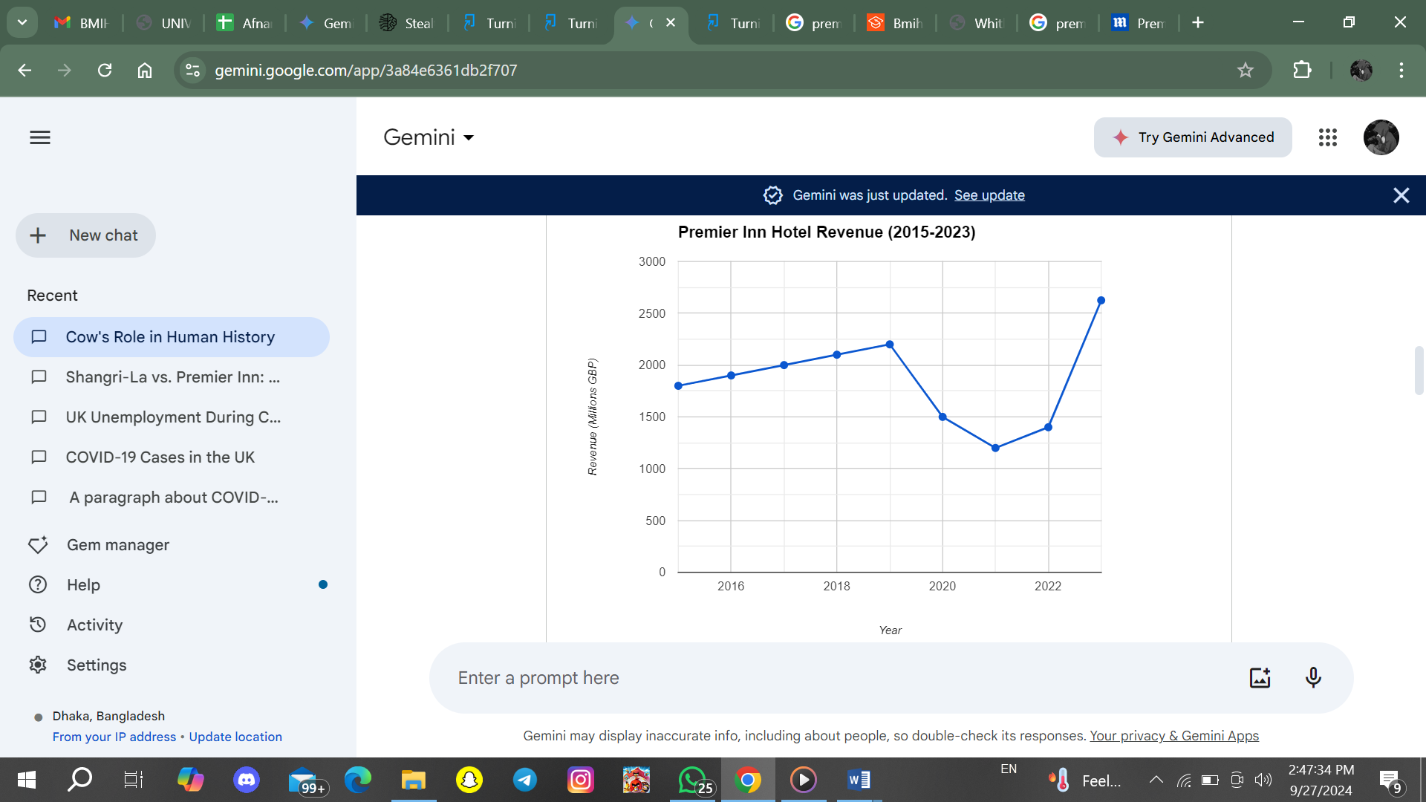
Figure 2: Revenue trend of Premier Inn Hotels (Whitbread, 2023).

Comparative Analysis: Shangri-La's revenue sources are more diversified than Premier Inn’s, with a greater emphasis on luxury amenities and experiences. Conversely, Premier Inn's revenue generation is concentrated on budget accommodations and cost-efficient operations, making it resilient to economic downturns. The differences in their target markets (luxury vs. budget) significantly influence their revenue structure and growth drivers.
Factors Driving Revenue Growth or Decline
Shangri-La Hotels: Shangri-La Hotels' revenue is driven by factors such as economic growth, travel trends, and competition. The hotel’s performance is closely tied to economic conditions in key markets, particularly Asia, where strong growth boosts demand for luxury accommodations (Norazhar, 2021; Singh, 2024). Before the COVID-19 pandemic, Shangri-La saw steady revenue increases due to rising international and business travel, along with the expanding premium hospitality market in the Asia-Pacific (Annis and Schine, 2015). Luxury travel trends among affluent and older travellers also contributed positively (Belton, 2017). However, the pandemic caused a significant revenue to decline due to travel restrictions and reduced consumer confidence, while competition from other luxury brands remains a challenge.
Premier Inn Hotels: Their revenue is shaped by economic conditions, budget travel trends, competition, and technological advancements. Economic fluctuations can impact revenue, as travellers reduce bookings during downturns. However, the rising demand for budget-friendly travel has driven growth, with more people seeking affordable options for leisure and business stays (Lindmark, 2017). While Premier Inn benefits from a strong market for low-cost accommodations, it faces competition from other budget chains offering similar pricing (Seal, 2019). The company uses dynamic pricing strategies to optimize revenue and leverages technology in booking services to enhance customer engagement and convenience (Yadav, Han, and Kim, 2016).
Comparative Analysis: Shangri-La’s growth is oriented towards capturing affluent markets and luxury tourism, while Premier Inn's strategy centres on geographical expansion and technological innovations. Economic conditions and regulatory barriers pose challenges for both brands, but Premier Inn’s cost-effective model offers resilience in uncertain markets, whereas Shangri-La’s luxury positioning makes it more susceptible to economic downturns.

Market Positioning
Shangri-La Hotel: Shangri-La positions itself as a leading luxury hospitality brand, known for premium-quality accommodations and services that cater to affluent travellers seeking exclusivity and comfort (Kotler and Keller, 2021). Emphasizing its Asian roots, the brand offers a distinctive hospitality experience characterized by warmth, personalized service, and cultural elements (Walker, 2021). Its hotels are strategically located in prime global cities and popular leisure destinations, attracting high-end clientele.
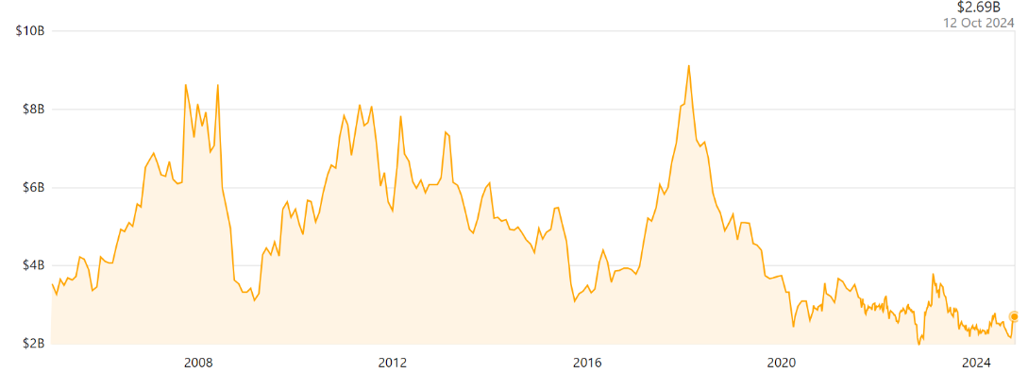
Figure 3: Market share of Shangri-La- Hotel (Shangri-La Asia Limited, 2024)
The target market includes wealthy tourists, middle-aged business travellers, and executives, with a clientele from Asia-Pacific, Europe, and North America, as well as families and event attendees seeking luxury (Adler, 2013). Shangri-La's brand is associated with class and excellence, known for opulent accommodations and high service quality. As of October 2024, its market capitalization is $2.9 billion, reflecting its strong positioning within the luxury hospitality sector.
Premier Inn Hotels: Premier Inn dominates the budget hotel segment in the UK, holding 7-8% of the overall hotel market and over 25-30% of the branded budget segment, making it the leading budget hotel chain (Neville, 2021). The brand targets cost-sensitive travellers, including young people, families, and business travellers, with a focus on domestic leisure and business guests. Its clientele consists largely of families, couples, single travellers, and small to medium-sized enterprises that choose Premier Inn for business trips due to its strategic locations and affordable rates (Yadav, Han, and Kim, 2016).

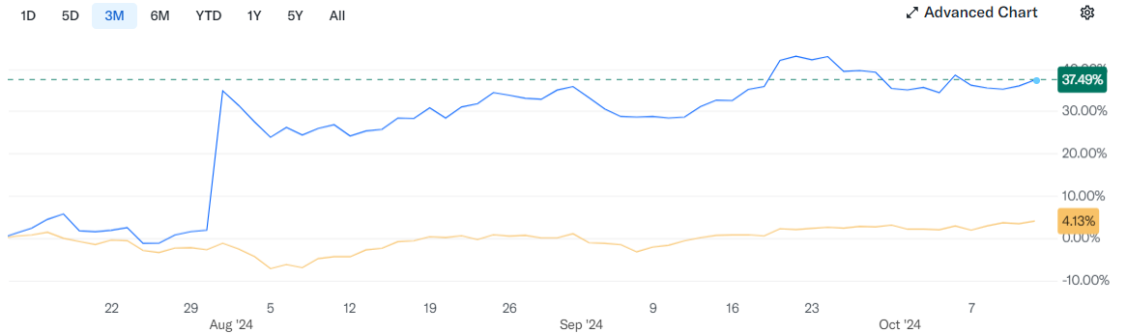
Figure 4: Market share of Premier Inn Hotel
Premier Inn is perceived as a reliable and affordable brand, known for providing quality services at reasonable prices. The brand's market positioning emphasizes affordability, convenience, and consistency, with standardized services that ensure good value and comfortable stays for budget-conscious visitors (Kotler and Keller, 2021; Iacobucci, 2021).
Comparative Analysis: While Shangri-La commands a strong presence in the luxury segment, Premier Inn dominates the budget market. Shangri-La’s focus on high-quality services and luxury amenities contrasts with Premier Inn's strategy of offering standardized, affordable accommodations. Both brands maintain strong market positions within their respective niches, with Shangri-La leveraging its brand prestige and Premier Inn capitalizing on cost-effective operations.

Growth Potential
Shangri-La Hotel: Shangri-La Hotels has strong growth potential through strategic expansion in high-demand markets across Asia-Pacific, Europe, and the Americas, with a focus on emerging regions like China, Southeast Asia, India, and Africa, where luxury tourism is increasing (Singh, 2016; Martinka, 2018). The company pursues diversification via mixed-use developments, integrating hotels with real estate components such as apartments and retail spaces to broaden revenue streams (Johnson, 2021). Additionally, the wellness tourism sector presents opportunities to attract health-conscious guests through enhanced spa and wellness services. However, growth is challenged by potential economic downturns, political instability, and the high costs associated with maintaining a luxury image, requiring effective risk management and cost control (McNair-Connolly and Merchant, 2020).
Premier Inn Hotels: Premier Inn's growth potential is driven by its cost-effective operations, adaptability, and strategic expansion plans. The brand's low-cost model focuses on providing affordable and standardized accommodations for both leisure and business travellers, helping it capture a large share of the budget hotel market (Perrone, 2015). Growth efforts include domestic and international expansion, particularly in the UK and Germany, where the budget hotel market offers significant opportunities (Neville, 2021). The company is also embracing technology, such as mobile app upgrades and self-service check-ins, to enhance customer experience and attract tech-savvy users (Johnson, 2021). However, Premier Inn faces growth challenges, including intense competition from budget hotels and Airbnb, as well as rising operational costs and branding difficulties in international markets like Germany (Lindmark, 2017).
Comparative Analysis: Shangri-La’s growth is oriented towards capturing affluent markets and luxury tourism, while Premier Inn's strategy centres on geographical expansion and technological innovations. Economic conditions and regulatory barriers pose challenges for both brands, but Premier Inn’s cost-effective model offers resilience in uncertain markets, whereas Shangri-La’s luxury positioning makes it more susceptible to economic downturns.

Financial Commitment to Corporate Social Responsibility (CSR)
Shangri-La Hotel: demonstrates a strong commitment to Corporate Social Responsibility (CSR) through Environmental, Social, and Governance (ESG) initiatives. The company invests in sustainable practices, community development, and environmental protection, with significant financial resources allocated toward achieving Sustainable Development Goals (SDGs) (Lancaster and Massingham, 2017). Key efforts include energy conservation, waste minimization, and ethical supply chain management. Shangri-La also supports community projects that address local social and economic needs, promoting social upliftment (Hiller, 2015). Additionally, employee welfare is a priority, with programs focused on health, wellness, training, and improved living standards (Shangri-La Group, 2023).
Premier Inn Hotels: while having a smaller financial capacity than Shangri-La, is committed to Corporate Social Responsibility (CSR), focusing on environmental sustainability and community engagement. The brand's "Force for Good" initiative, led by parent company Whitbread Group, promotes responsible business practices by reducing carbon footprints, enhancing energy efficiency, and supporting local charities (Premier Inn, 2023). Key measures include energy-saving practices, waste management, and sourcing from ethical supply chains to minimize environmental impact. Community engagement is also central to Premier Inn's CSR, with active participation in charitable and social causes aimed at improving local well-being (Pyman, 2021).
Comparative Analysis: Shangri-La’s CSR activities tend to be broader in scope due to its larger scale and financial resources. Premier Inn, while also committed to CSR, focuses on practical, cost-effective initiatives that align with its budget-conscious brand. Both companies prioritize sustainability, but the depth and breadth of their programs differ significantly.

Conclusion
Shangri-La Hotels and Premier Inn Hotels serve two extremities of the hospitality industry starting with luxury and ending with a budget. Shangri-La is established on high-quality services and offers services to the high-end market while Premier Inn operates in the economy market referable to budget travellers and business tourists (Aaker and Moorman, 2023). It is believed that Premier Inn’s primary development area is Europe, particularly Germany. The enhanced customer loyalty, along with the commitment of Cruz and Netas to high levels of corporate social responsibility, contributes to the long-term sustainable development of both companies and bolsters their reputations

Recommendations
Shangri-La Hotel – Recommendation: Expand Wellness Tourism Offerings
Justification: Wellness tourism is a burgeoning industry sector, and Shangri-La is already strategically positioned with luxurious spas and wellness programs. By augmenting investments in wellness retreats, fitness pursuits, and therapies, Shangri-La can attract health-conscious guests seeking rejuvenation (Belton, 2017).
Evidence: The global wellness tourism market is expected to grow rapidly, with demand increasing post-epidemic. Expanding this category could augment income diversification and capitalize on the luxury hotel’s extensive wellness infrastructure.
Premier Inn Hotel – Recommendation: Accelerate International Expansion, especially in Germany
Justification: There is no reason why the successful domestic model of Premier Inn cannot be exported to higher-growth, emerging markets such as Germany where demand for economic accommodation is growing (Annis and Schine, 2015). In Europe where such regions subsist, expanding into them may improve the share of the market.
Evidence: There was a progressive expansion of Premier Inn in Germany, which led to Whitbread’s decision-making towards starting other facilities in the country (Adler, 2013). Promoting the climate of investing in the areas where high demands for products and services are forecasted, together with the availability of cheaper alternatives for development will increase development capacity and returns.

References
Aaker, D.A. and Moorman, C. (2023) Strategic Market Management. John Wiley & Sons.
Adler, R. (2013) Management Accounting. Routledge.
Annis, D. and Schine, G. (2015) Strategic Acquisition: A Smarter Way to Grow Your Company.
Belton, P. (2017) Competitive Strategy: Creating and Sustaining Superior Performance. Macat Library.
Chernev, A. (2019) Strategic Marketing Management: Theory and Practice. Cerebellum Press.
Guilding, C. (2014) Accounting Essentials for Hospitality Managers. 3rd edn. London: Routledge.
He, K. (2024) ‘Shangri-La returned to profit in 2023 with 47% revenue jump - Mingtiandi’. Available at: https://www.mingtiandi.com/real-estate/finance/shangri-la-returned-to-profit-in-2023-as-revenue-jumped-47-on-travel-recovery/ (Accessed: 29 September 2024).
Hiller, J. (2015) 7 Easy Ways to Show Your Employees You Care! A Booklet for Hotel Managers and Others. Outskirts Press.
Iacobucci, D. (2021) Marketing Management. Cengage Learning.
Johnson, W. (2021) Smart Growth: How to Grow Your People to Grow Your Company. Harvard Business Review Press.
Kollewe, J. (2021) ‘Premier Inn owner Whitbread swings to £1bn loss amid Covid lockdowns’, The Guardian, 27 April. Available at: https://www.theguardian.com/business/2021/apr/27/premier-inn-whitbread-loss-covid-lockdowns-beefeater-brewers-fayre (Accessed: 2 October 2024).
Kotler, P. and Keller, K.L. (2021) Marketing Management: Global Edition. Pearson.
Lancaster, G. and Massingham, L. (2017) Essentials of Marketing Management. Routledge.
Lindmark, M. (2017) Market Condition and Competitive Analysis: The Mobile Market in the United States of America and Europe.
Martinka, J. (2018) Company Growth by Acquisition Makes Dollars and Sense. CreateSpace Independent Publishing Platform.
McNair-Connolly, C.J. and Merchant, K.A. (2020) Management Accounting: An Integrative Approach. John Wiley & Sons.
Neville, S. (2021) ‘Premier Inn owner sinks to £1bn loss in year of Covid restrictions’, The Standard, 27 April. Available at: https://www.standard.co.uk/news/uk/premier-inn-lenny-henry-whitbread-alison-brittain-governments-b931874.html (Accessed: 2 October 2024).
Norazhar, D. (2021) ‘Shangri-La Hotels’ net loss widens in 2H on sharp downturn amid ongoing restrictions’, The Malaysian Reserve, 31 August. Available at: https://themalaysianreserve.com/2021/08/31/shangri-la-hotels-net-loss-widens-in-2h-on-sharp-downturn-amid-ongoing-restrictions/ (Accessed: 2 October 2024).
Perrone, V. (2015) Competitive Analysis for Firm Valuation: The Missing Link between Strategy and Corporate Finance. Wiley.
Premier Inn (2021) ‘About Us’. Available at: https://www.premierinn.com/gb/en/why.html (Accessed: 29 September 2024).
Premier Inn (2023) ‘Force for Good’. Available at: https://www.premierinn.com/gb/en/why/force-for-good.html (Accessed: 2 October 2024).
Pyman, T. (2021) ‘Premier Inn owner sinks to £1bn loss in year of Covid restrictions’, Mail Online, 28 April. Available at: https://www.dailymail.co.uk/news/article-9515679/Premier-Inn-owner-sinks-1bn-loss-year-Covid-restrictions.html (Accessed: 30 September 2024).
Seal, W. (2019) Management Accounting. 6th edn. London: McGraw Hill.
Shangri-La Asia Limited (2022) Shangri-La Asia Limited Annual Report 2022. Available at: https://sitecore-cd.shangri-la.com/-/media/Project/Shangri-La-Group/Investor/Files/Public-Disclosures/Latest-Top-Publications/e0069_230418_AR.pdf (Accessed: 27 September 2024).
Shangri-La Group (2023) ‘Welcome Shangri-La Group’. Available at: https://www.shangri-la.com/group/our-story/about-shangri-la (Accessed: 29 September 2024).
Shangri-La Hotel (2023) ‘Corporate Social Responsibility | Shangri-La Singapore’. Available at: https://www.shangri-la.com/singapore/shangrila/about/corporate-social-responsibility/ (Accessed: 29 September 2024).
Singh, A. (2024) Competitive Success: Building Winning Strategies with Corporate War Games. Forbes Books.
Singh, S. (2016) Management Accounting. PHI Learning Pvt. Ltd.
Walker, J. (2021) Introduction to Hospitality. Harlow: Pearson.
Whitbread (2023) Premier Inn Annual Report. Available at: https://cdn.whitbread.co.uk/media/2023/05/Whitbread_AR22_Interactive.pdf (Accessed: 27 September 2024).
Yadav, P.L., Han, S.H. and Kim, H. (2016) ‘Sustaining competitive advantage through corporate environmental performance’, Business Strategy and the Environment, 26(3), pp. 345–357. Available at: https://doi.org/10.1002/bse.1921.

