UNIVERSITY OF WALES TRINITY SAINT DAVID

INDIVIDUAL ASSIGNMNENT 2

DATA HANDLING AND BUSINESS INTELLIGENCE
LCBB 5000

Name: Anca-Diana Gog
Student Number: 1918426
Module Lecturer’s Name: Dr Md Nazmul Hasan

December 2021

Part 1

First step in analysing the Superstore data set was to establish the contents and to choose the data we want to analyse. Some of the data is not relevant for our analysis, such as the nominal data, therefore it will be ignored, and we will focus our attention to the relevant data.
The first column that is relevant to our analysis is the Order Date, which sets the timeline. The timeline for this data set is four years, between 2009 and 2012.
To analyse the sales and profits we need to know the order quantity, the sales revenue, profit, price per unit, and shipping costs. Province and region are important in our analysis if we want to understand the sales and profits according to where the company ships the products. Customer segment may be an important part of the data set if we want to analyse what type of customers the company serves and how much revenue it is generated from each type of customer. If we find out that the home office customers are generating more revenue compared to individual customers, it means the company must give more attention to those customers. So, this can help to make decisions in the future. Product category is important as well if we want to know which product generates the most revenues and which don’t; or we can analyse our data set from the demand point of view and find put which product category has the highest demand and which product has the lowest demand.
To analyse the Superstore data set we used the Excel functions, such as IF, LOOKUP, PIVOT TABLES, charts, and graphs.
Using the PIVOT TABLES, we were able to identify the sum of the orders quantity, sum of sales, sum of profit, sum of unit price and sum of shipping cost for each year. We notice a decline over the years, with a slight increase in the last year. In the second year the sales declined with about 15%, the third year with another 5% and in the last year there was a slight increase of 8%. The decline in sales also caused a decline in profit. From calculating the profit margin ratio, we can determine how well the company’s finances are being managed.
From this PIVOT Table we can also determine the causes of the decline in sales. If we look at the sum of order quantity, we can notice that there is not a big difference in the quantity sold each year. We can notice a slight decrease except for the last year when the quantity sold is almost as much as the first year. So even of the decrease is not big, it does not mean that is a good thing for the company because the quantity of orders did not increase over the years.
If we look at the unit price column, we notice a higher difference. In the second year, the price per unit dropped by 30% as long as the orders were almost the same as the previous year and the shipping cost only decreased by 4%. In 2011 there is a slight decline in the sum of the unit price by only 3% and in 2012 there is an increase of 18% but also the shipping cost increased by 8%.
Row Labels | Sum of Order Quantity | Sum of Sales | Sum of Profit | Sum of Unit Price | Sum of Shipping Cost
2009 | 54508 | 4209896.846 | 434096.02 | 232830.98 | 28481.76
2010 | 54379 | 3560087.045 | 364917.33 | 162467.59 | 27354.26
2011 | 51413 | 3429944.981 | 380310.5 | 159653.11 | 24939.85
2012 | 54480 | 3715671.953 | 342444.13 | 195467.55 | 27055.17
Grand Total | 214780 | 14915600.82 | 1521767.98 | 750419.23 | 107831.04

All these information is illustrated in the following chart that shows the changes in sales and profit over the four years.

These methods of analysing the decline in sales and profit over a longer period of time, for this database four years, is enabling the managers to make decisions regarding the future of the company, helping them to identify the causes of the problem and develop strategies for increasing the sales and of course the profits.
If we analyse the profit in relation to the product category, we can see that the company sells three categories of products, technology, office supplies and furniture. The products that bring the highest profit for the company are the technology products. This indicates that the company should focus more on this type of products if they want to increase their profit.

Row Labels | Sum of Profit
Technology | 886313.52
Office Supplies | 518021.43
Furniture | 117433.03
Grand Total | 1521767.98

The analysis also indicates the products with a lower performance, office supplies and furniture, which can enable the company to develop their strategy accordingly. Product category analysis is useful in this database analysis because it helps in the process of making decisions such as changes in prices, advertise, discontinue product groups or set up goals per product line.
If we go further with analysing our Superstore database we can look at the sales revenue from the customer segment perspective. there are four types of customers, corporate, home office, consumer and small businesses. As seen in the following table and chart, the customers that bring the most revenue are the corporations, who bring 37% out of the total revenue.

Total 'Sales' by 'Customer Segment'
 | Row Labels | Sum of Sales
 | Corporate | 5498904.877
 | Home Office | 3564763.875
 | Consumer | 3063611.082
 | Small Business | 2788320.99
 | Grand Total | 14915600.82

The analysis of the sales revenue by customer segment helps the company to better understand its customers and to identify which customers are generating more revenue. On the one hand, this enables the managers to develop strategies which aim to give more attention to the customers that bring the most revenue to the company, but on the other hand, they can identify the need to adopt new strategies that will enable the other categories of customers to generate more revenue for the company.
If we analyse sales by region, we can see that Ontario generates more revenue, followed by West, Prarie and Atlantic. This can also be an indicator that the company could develop its strategies in at least two directions; they could focus on the region that bring more revenue, and they could as well focus on the regions that generate less revenue so they will increase the sales volume and revenue.

Total 'Sales' by 'Region'
 | Row Labels | Sum of Sales
 | Ontario | 3780242.063
 | West | 3597549.276
 | Prarie | 2837304.602
 | Atlantic | 2014248.204
 | Quebec | 1510195.08
 | Yukon | 975867.371
 | North Carolina | 116376.4835
 | Northwest Territories | 83817.746
 | Grand Total | 14915600.82

The analysis of such a large database as Superstore is possible in Excel with the help of the functions, IF, PIVOT Tables, LOOKUP, charts, and graphs.
“Excel is a software tool developed by Microsoft with the core function of making spreadsheets. However, the application can do more than just make spreadsheets. There is a vast selection of tools, settings, and other options. No matter how you want to present or organize your data, there are options available to help you.” (ppcexpo.com)
Today’s business world, and not only, is data-drive. Data are essential to running a business and it is essential for a manager or anyone who is running the business to understand that data. As we have seen in the analysis of the Superstore database, not all data is relevant, therefore it is very important to be able to determine which data is relevant for our business and how to analyse the data that we need. Excel comes with excellent tools to help in this process that sometimes seems a nightmare, especially when dealing with large databases of raw data from which you have to extract the relevant information.
Excel has the tools to enable the users to go through the process of analysing the data from pre-processing, analysing, and visualising the data. Data Analysis ToolPack includes descriptive statistics, correlations, t-tests, 1 or 2-way analysis of variance, regression that provide complete tests of statistical significance. The Pivot Table, one of the functions we used in our analysis provides summary tables of means, count, or standard deviations. Other Excel functions are used to generate statistical measures. “Functions generate a single number, so using functions you will likely have to combine bits and pieces to get what you want. Even so, you may not be able to generate all the parts you need to complete analysis.” (people.umass.edu)
There are some processes that need to be followed when analysing data in Excel. First, we need to specify data requirements. At this point we need to establish the structure and categories of data that is relevant to the analysis.
Once the variables are established, we need to collect all the data related to the analysis, making sure it is as relevant, qualitative, and accurate as possible.
The next step is data processing, when we need to put the raw data into a spreadsheet so can arrange the information logically. Even if the data is processed, it might be incomplete or contain errors so the next step would be data cleaning.
The next phase is data analysis when data visualisation tools are used. These tools enable us to see patterns and trends. Charting the data is a quick method for understand and analyse the data. After the analysis phase is finished, the final step is communication. The analysis is put into a report that goes to stakeholders, clients, team members, or other parties interested.

Part 2

I am an intern working at the Smile Clinic and in the section, I am going to present my findings about the customer dataset I have analysed recently referring to whether the customers eat rice in their daily meal for healthy diet point of view. The clinic has a copy of Microsoft Excel and has just downloaded a free copy of the open-source SPSS data mining software. The company has used Microsoft Excel before but not SPSS. To produce my report I used both software programs to evaluate how many customers of the Smile Clinic eat rice, how many of them are male and female, what are the Mean and Median of the ages in the data, and what are the Mean and Median of participants who eat rice.
In the dataset we have the customers’ names, which is not relevant for the analysis, we have Gender, which has two values, 1 for Male and 2 for Female, we have Age data and Rice, which refer to customers who eat rice and customers who don’t. There are two values as well, 1 for customers that eat rice and 0 for customers who don’t eat rice.
To answer the first two questions, referring to how many customers eat rice and how many customers are Male and Female, I used SPSS data mining software. I used Analyse tool from the SPSS tool bar then choose Descriptive statistics from the menu, select Frequencies and then the two values I was interested in, Gender and Rice. Two tables were generated that contained the information I needed to answer the questions.
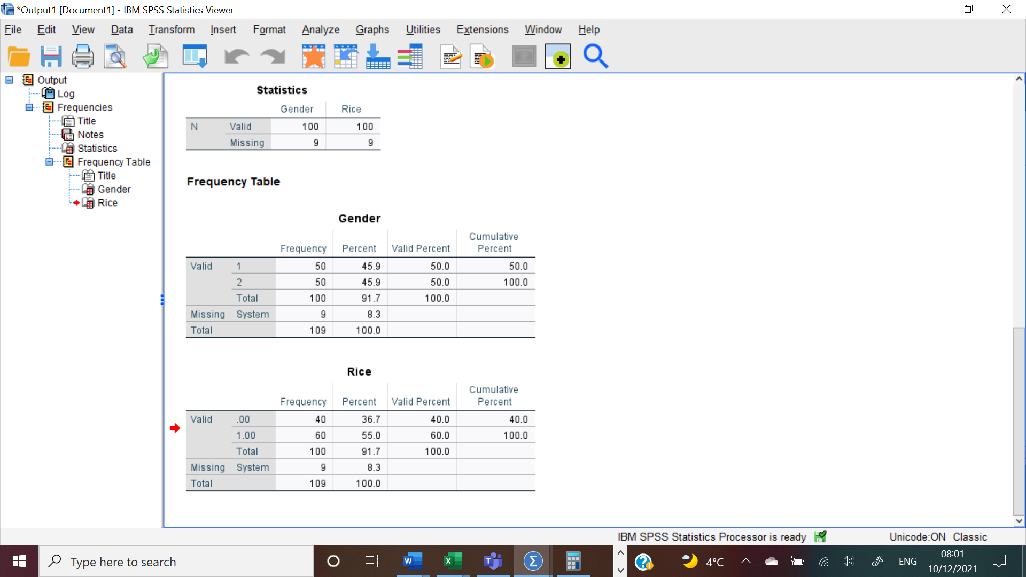
We can see that the total number of customers is 100. 50% are Male and 50% are Female, so we have equal number of male customers and female customers. Referring to the next question, how many customers eat rice and how many customers don’t, 60% of the customers eat rice and 40% of the customer don’t eat rice.
The next question is to find out the Mean and Medium of the ages in the data. To answer this question I used the same steps as for the previous two questions, except for the values I entered this time being Age.
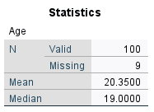
As seen in the table generated by the software, Mean is 20.35, meaning the average age of the customers. Median is 19, meaning that 50% of the customers are younger than 19 and 50% of the customers are older than 19.

The last question is what is the Mean and Median of customers who eat rice. Her we are only interested in the 60% of the customers that eat rice. To generate this information from out dataset I used the Analyse tool from SPSS, then selected Compare Means, and introduced in the Dependent List Age value and in the Independent List Rice value and selected Mean and Medium from the Options list. The table generated shows that the Mean, meaning the average age of the customers who eat rice is 20.2167 and the Median is 19, meaning that 50% of the people who eat rice are younger than 19 and 50% are older than 19. The findings are also illustrated by the chart I attached.
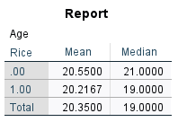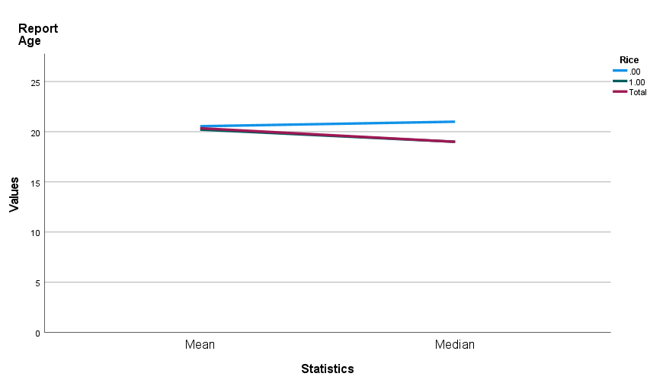

To better understand the information in our dataset we need to break the data using clustering, which is fundamental operation in data mining. “Clustering methods partition a set of objects into clusters such that objects in the same cluster are more similar to each other than objects in different clusters according to some defined criteria.” (Huang, 1997, p.1)
I used clustering so I could analyse the data and understand it in a better way. I generated it from the Smile Clinic dataset using the same Analyse tool, then selecting Classification tab and then selecting Gender and Rice in the Categorical Variables box and Age in the Continuous Variables box.
the findings are very interesting and offer us a better understanding of the data. We can see that 30% of the customers are females that don’t eat rice and their average is 20.80. Also, from the second column we understand that 24% of the customers are males that eat rice and their average age is 17.19. So, male customers that eat rice are younger that the females that don’t eat rice. We can interpret the third columns as 20% of the customers that eat rice are females with the average age of 20.45, so we can see that the percent of females who don’t eat rice is higher that the percent of females that eat rice and they have the same age. In the fourth column we see that 16% of the customers are males who eat rice, and their average age is 23.56, so, comparing this information with the information we have in the second column we understand that more young males eat rice that older males. The last column shows us that 10% of the customers are males who don’t eat rice and their average age is 19.80, meaning that more males eat rice than females, if we compare the information in this column with the findings in the first column.
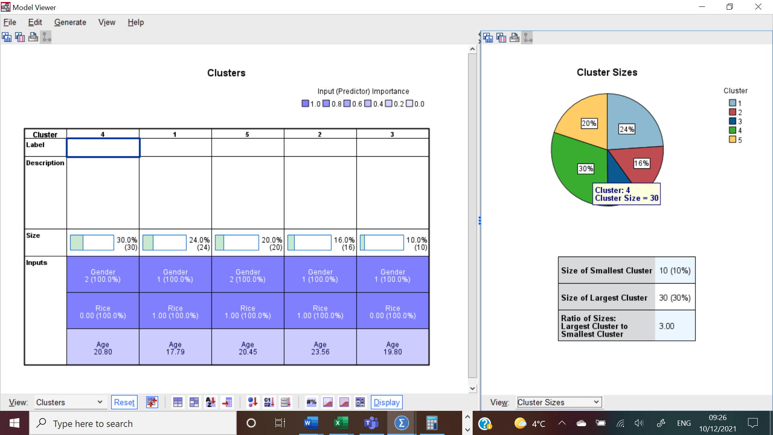

Data mining is “a process that uses statistical, mathematical, and artificial intelligence techniques to extract and identify useful information and subsequent knowledge from large sets of data” (Sharda et all, 2014, p. 223)
Data mining methods are divided into:
- Association
- Classification
- Clustering analysis
- Prediction
- Sequential Patterns
- Decision Trees
- Outlier Analysis
- Neural Network
Classification is one of the most common data mining methods. It is used to analyse the historical data from a database and generate a pattern that can predict future behaviour (Sharda et all, 2014). This method id very useful in business helping the people running a company make decisions. Classification is used, for example, when a bank wants to determine who they should offer a loan to.
Microsoft Excel and SPSS are two software programs that have similar characteristics, they both have menus, spreadsheets, and built-in statistical functions. When using them for data analysis, SPSS has more advantages than Excel:
- Easier way to use the basic functions. For my report I used SPSS software because it was an easier and faster get the information I needed from the dataset by using descriptive statistics.
- SPSS has a wider range of more detailed charts and graphs
- It offers faster access to statistical tests
- Effective data management
- Wide range of options
- Better output organization
- The software prevents data entry errors (worldpress.com)

References:
- Huang, Z., 1997. A fast clustering algorithm to cluster very large categorical data sets in data mining. DMKD, 3(8), pp.34-39.
- Sharda, R. Delen, D. Turban, E. (2014) Business Intelligence and Analytics. System for Decision Support. Tenth Edition. England: Pearson Education Limited.
- https://pgdabm1618.wordpress.com/2017/01/14/spss-over-excel/
- https://ppcexpo.com/blog/analyze-data-with-excel
- https://people.umass.edu/evagold/excel.html

