
Marketing Plan for
“Terra Delights”:
A Farm-to-Fork Culinary Experience

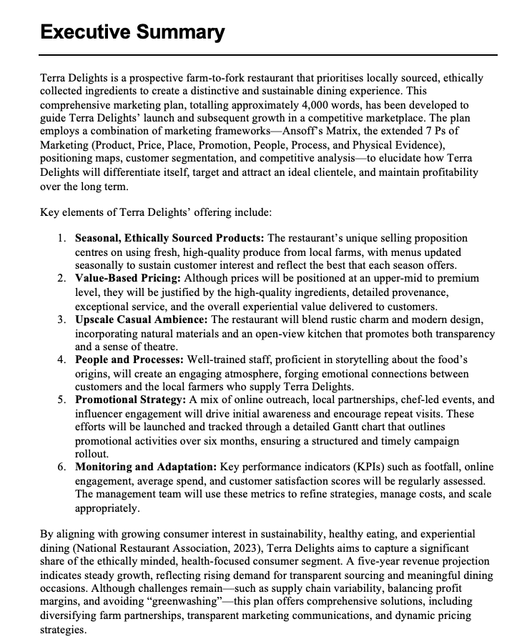

Table of Contents
Executive Summary 2
Introduction 3
Product 5
1. Product Description 5
2. Relevance to Current Trends 5
3. Target Market and Customer Profiles 6
4. Differentiation and Value Proposition 7
Physical Evidence 8
1. Location Selection and Justification 8
2. Restaurant Type and Style 8
3. Service Style 9
4. Physical Layout and Ambiance 10
5. Operational Logistics and Environmental Considerations 10
People and Processes 11
1. The Service Experience 11
2. Staff Recruitment and Training 11
3. Process Flow and Customer Journey 12
4. Technology Integration 12
5. Service Recovery and Feedback Loops 13
Price 13
1. Pricing Strategy Foundations 13
2. Competitive Landscape 14
3. Positioning Maps 14
4. Sample Price Points 15
5. Promotional Pricing Tactics 15
Promotions and Distribution 16
1. Promotion Strategy Overview 16
2. Specific Promotional Tactics 17
3. Distribution Strategy 18
4. Ghantt Chart for Promotions and Distribution Plan 19
5. Measuring Success 20
Challenges and Recommendations 21
CONCLUSION: 21

Introduction
Marketing helps firms grow, communicate, and provide value. It involves discovering what your target audiences want and need and providing it better than your competition. A marketing plan guides a business to long-term success and profits by meeting these needs and wants. A marketing plan involves understanding human behavior, creating a product or service that fits needs, and measuring success to improve future efforts.
This file contains a detailed marketing plan for "Terra Delights." a new restaurant concept. The strategy details where the restaurant will be, how it will connect with potential consumers, how it will stand out in a congested market, and how it will retain customers and grow. This marketing plan provides a step-by-step guide to help Terra Delights start and flourish over the following three years. The plan will also help investors, management, and other key players determine the business's short- and long-term success.
Farm-to-fork restaurant Terra Delights uses sustainable, locally sourced products, inventive seasonal cuisine, and a welcoming atmosphere. Terra Delights' top managers, potential investors, and operational teams that will implement the plans are the main targets of the plan. This detailed plan will explain how Terra Delights wishes to address modern customers' shifting needs—healthy, ethically sourced cuisine, unique cooking experiences, and authenticity in restaurants.
The marketing plan will be organized using many key models. The major study will begin with the 7 Ps of Marketing: Product, Price, Place, Promotion, People, Process, and Physical Evidence. In the service industry, especially restaurants, where visible and intangible characteristics like environment and customer service have a large impact on consumer satisfaction, these new marketing mix components are especially valuable. Second, Ansoff's Matrix will highlight growth goals including entering new markets, developing existing ones, manufacturing new items, and expanding. The restaurant opening is the main focus of this plan. However, Ansoff's Matrix teaches Terra Delights how to expand and gain clients.
Pricing and consumer targeting decisions will be supported by positioning maps and trend analysis from trustworthy industry reports. These tools will assist Terra Delights compare its price, quality, service style, and corporate identification against competitors. Terra Delights' product and brand offer will better match market demands by including customer trends, food preferences, and changing social attitudes on sustainability.
The concept will leverage real-life examples and best practices for farm-to-fork restaurants and sustainable dining to demonstrate Terra Delights' potential. Finally, this marketing plan will incorporate KPIs and statistics to help the management team track progress, adjust strategies, and justify the investment.
The marketing plan is detailed below:
Product: Terra Delights' seasonal meals and adaptability to consumer tastes.
Physical Evidence: The restaurant's location, interior, atmosphere, and customer experience are considered.
People and Processes: How workers are trained, how they give service, and how the firm maintains the brand promise.
Price: Using competitive analysis and market perception to set prices that will help Terra Delights succeed.
Promotions and Distribution: A strategy to raise brand awareness, attract the proper customers, and retain them.
Conclusion: Main issues, proposals, and progress measures.
This marketing plan intends to make Terra Delights a profitable, community-focused farm-to-fork restaurant by focusing on each of these areas. The next sections will explain each one with well-reasoned reasoning and data-driven insights to ensure success.

Product

1. Product Description
Terra Delights, a modern farm-to-fork restaurant, employs environmentally friendly ingredients to provide a unique dining experience. Make a menu with the best local meats, vegetables, and artisan goods. Terra Delights' seasonal menus will keep customers engaged in new flavors. This method tells a tale about supporting local farmers, reducing food miles, and accepting the seasons.
Instead of making recipes complicated, each dish will highlight the products' taste and quality. Terra Delights wants to provide nutritious, high-quality meals. Menu contains more than meals. A farm-to-fork-inspired drinks menu includes local wines, artisan brews, and house-made non-alcoholic drinks.
2. Relation to contemporary trends
The National Restaurant Association reports that consumers are increasingly interested in ethical food production, organic sourcing, and sustainability. It was found in 2023 that over 70% of urban eaters would pay more for organic and local ingredients. They think freshness and social responsibility motivate them. As individuals discover how industrialized food systems harm the environment and people, the farm-to-fork movement has risen rapidly.
Analysis of Trends:
Nearby and durable: Local cuisine has become 20% more popular in the past five years. Major restaurant journals think people will want to know more about their food's origins.
Health and Wellness: Growing health concerns have increased demand for plant-based foods and healthy eating. For special diets, Terra Delights will offer vegetarian, vegan, and gluten-free options.
Experience-based dining: Millennials and Gen Z prefer restaurants that offer more than food. An open-view kitchen, seasonal tasting meals, and chef-led farm excursions can engage this demographic.

3. Target Market and Customer Profiles
Its target demographic is health-conscious eaters, foodies, and eco-conscious shoppers with moderate to high spending income, according to its concept. This group includes workers, couples, and families who prefer farm-to-fork and are willing to spend more for ethical food.
Consider these three typical consumer profiles:
Emily, 29, is a health-conscious IT marketing associate.
Likes: Fitness, wellness getaways, and social media trends.
She wanted to explore new, healthier foods to attain her health objectives. aggressively seeks food-sourcing transparency.
Problems: Short on time, works late, and wants healthy, quick food.
In their 40s, Samuel and Olivia adore food. Samuel is an architect, Olivia a financial analyst.
Enjoys traveling, fine dining, and trying new foods.
Why I Want to Visit: I want unique date spots and new dining experiences. Enjoy the art of artisanal drinks and their stories.
Pain Points: Customers expect quality service and atmosphere and are willing to spend more, but they also want value and authenticity.
Rebecca, 35, operates a small business and is an eco-friendly parent.
Interests: organic farming, neighborhood gatherings, and environmental protection.
She wants to locate a family-friendly place to teach her kids how to eat.
Pain Points: Concerned about kid-friendly, ethical, and local menu items.
These profiles prioritize health, ethical sourcing, and dining experience. Terra Delights can attract health- and environment-conscious customers when its food, marketing, and restaurant experience match these criteria.

4. Differentiation and Value Proposition
Terra Delights is known for its high-quality, locally sourced goods, distinctive atmosphere, and great service. The restaurant may streamline the supply chain and ensure fresh, high-quality food by partnering directly with farms. Terra Delights' storyline, which includes item origins, is another highlight. This dedication to sustainability and local communities offers the restaurant an edge in a market where restaurants compete on price and branding.
Additionally, seasonal menus change frequently to keep food fresh and attract customers. Terra Delights will gain value from farm-to-table events and hands-on cooking workshops as a restaurant with more than just cuisine.

Physical Evidence

1. Location Selection and Justification
Physical evidence is crucial in the service marketing mix since it forms customers' first impressions and assists restaurant positioning. Terra Delights will be in an urban region with diverse cultures, modern preferences, and a history of food innovation. In particular, a rebuilt downtown area with galleries, artisanal stores, and farmers' markets provides a continual flow of visitors seeking unique experiences.
Key reasons for the location:
Easy access: Near public transportation, huge office buildings, and commercial centers will provide a consistent lunch population during the week and large weekend crowds.
The area has more professionals and families with greater disposable income. These populations prefer ethically sourced artisanal products, according to surveys.
Because there are many small, organic farms within 50 miles, local farms work well together. This proximity simplifies arrangements and fulfills the restaurant's green commitment.

2. Restaurant Type and Style
- Terra Delights aims to be both casual and fancy, making it suitable for special occasions but not everyday use. According to farm-to-fork, the interior design incorporates modern rural themes and natural materials. Reclaimed wood, metal elements, and live plants will warm the area and indicate that the restaurant cares about the environment.
- The plan's open kitchen complements the brand's honesty by showing customers how food is created. There are standard tables, a communal table, and a chef's table near the kitchen for extra interaction. Color schemes often combine rich greens, browns, and gentle grays to make people feel connected to nature.
- Ideas for mood boards:
- Photos of organic barn wood, stone tiles, linen napkins, and clay dishes.
- Nature-inspired accents include indoor herb gardens, potted plants, and vertical green walls.
- Edison bulb pendant lights, large windows, and lanterns on each table create a comfortable atmosphere.

3. Service Style
- Terra Delights provides courteous, helpful service without being intrusive. Customers' detailed questions will be answered by professionals who know where and how each dish is created. The goal is "informative hospitality," which implies balancing formal service (such informed staff and a well-kept appearance) with welcoming community-building contact.
- True because:
- Farm-to-fork eaters desire real food and a connection to its source. By teaching personnel to tell stories, the restaurant adds humanity and learning.
- Friendly, eco-friendly service encourages repeat business and referrals.

4. Physical Layout and Ambiance
For the farm-to-fork concept, the atmosphere was meticulously planned:
A blend of natural light during the day and softer, warmer illumination at night calms you.
To maintain a nice atmosphere, play soft jazz or solo folk music.
Scents: Fresh herbs like rosemary and thyme near the entrance or open kitchen enrich the air.
All of this creates a Terra Delights-worthy dining experience. Restaurant setup affects client satisfaction and return, making it a potent marketing tool.

5. Operational Logistics and Environmental Considerations
Customers may not see operational decisions, but they can experience them through brand values and messaging. Terra Delights will demonstrate its environmental responsibility by installing energy-efficient cooking appliances.
Established a strong recycling and composting program.
Transporting food in biodegradable or reusable bags.
Working with neighborhood water-saving programs.
These back-end processes boost brand credibility. Many target market members are leery about "greenwashing," thus open communication and environmental actions create confidence and affection.

People and Processes
1. Service Experience
People and processes are crucial to Terra Delights' marketing strategy because they affect customers' dining experiences. The restaurant's individualized service shows its community participation.
The crew will learn how to upsell, serve, and "tell stories" about where each menu item comes from on the farm. This degree of involvement exploits the emotional connection people have when they know where and who farmed their food. Everyone will be greeted kindly, seated swiftly, and briefed about the daily promotions. The service personnel will be instructed to be alert, answer inquiries, and make the meal casual but sophisticated.
2. Hiring/training staff: Hiring is formal and seeks people who value sustainable food and service.
New hires must undergo a rigorous orientation that covers the brand's values, SOPs, and customer service philosophy.
To do:
Technical Skills: Menu knowledge, food safety, drink matching, and POS system operation.
Soft talents include empathy, listening, conflict resolution, and communication.
Culture-Brand Alignment: Knowing the business's local farm partners and eco-friendly practices is crucial.
Training programs keep staff informed of menu changes, seasonal updates, and field collaborations. Regular briefings will teach staff to explain each dish. The dish will taste more upscale, distinguishing Terra Delights from other casual restaurants.
3. Process Flow and Customer Journey
Terra Delights customers begin their visit before entering. Online reservations and social media interactions can provide potential consumers a sense of the restaurant's vibe and menu. Hosts greet and seat guests. Choose between conventional sitting or the communal or chef's table for increased interaction.
Important process steps:
When and where to sit: A hearty greeting and Christmas deals report.
Ordering: Staff discuss the menu and answer inquiries about food origins and preparation.
Dining: Great table service, regular check-ins, and enough time between meals.
Payment and Feedback: Payment is simple, and there's one last chance to provide feedback or recommend reward programs.
Sending email newsletters or discount codes to encourage return.
True because:
Smooth, straightforward processes reduce wait times and improve service.
Clear supply chains and personnel tales make customers feel more connected to a business.
4. Combining tech
In modern eateries, technology speeds up labor and pleases guests. Terra Delights will:
Online booking platforms: use OpenTable or your own scheduling system to swiftly turn tables and gain consumer data for targeted advertising.
Real-time inventory control and billing are simplified by cloud-based POS solutions.
Social media engagement: Instagram and TikTok may showcase cuisine, farm visits, and staff, making the business feel more real.
5. Service Returns and Feedback Loops
Service failures can occur despite good processes. A proper service repair strategy is crucial.
Give your team the power to make quick decisions (like giving a free dessert or a bill discount) to solve difficulties.
Create a digital poll, comment card, or follow-up email for consumer feedback.
Discuss consumer feedback themes in monthly review sessions to improve or generate new ideas.
Terra Delights wishes to maintain its honest and responsible dining image with these measures. This will assist the company retain customers.

Price

1. Pricing Strategy Foundations
Terra Delights will use value-based pricing. This model focuses prices on what customers think the thing is worth, not how much it costs or other items cost. Terra Delights employs fresh, local, and organic foods, thus costs may be more than at a bulk-buying restaurant. However, the target audience will pay more for ethical, sustainable, and high-quality food.
To set prices, Terra Delights will consider:
COGS: Cost of goods sold Seasonal ingredient prices vary. Forward contracts with local farms may limit variance, but pricing systems must adjust to market fluctuations.
Rent for an urban site, salary for staff (particularly trained individuals who can tell the brand story), and marketing costs are overhead.
Profit margin desired: Enough to sustain the business, allow reinvestment, and repay owners' money.
2. The competing market
While "farm-to-fork" isn't new, many communities lack competition in this area. Terra Delights will distinguish out by telling tales, engaging with the community, and experimenting with food. Competitor analysis is about:
Straight from farm to table Other firms: Restaurants that emphasize local ingredients and charge mid- to high-range pricing.
Traditional high-end restaurants may appeal to those who desire a luxurious experience, but typically don't emphasize sustainability or local foods.
Boutique cafés and vegan bistros may share ethical principles, but they differ in full-service dining and menu diversity.
3. Positioning Maps
Terra Delights' market position can be determined via a price vs. quality positioning map and a casual vs. formal eating map. Terra Delights aspires for a price-quality ratio just above full-service restaurants. However, its high-quality ingredients, well-trained staff, and unique experiences make it high-quality.
On the casual vs. formal eating map, Terra Delights is "upscale casual". It's elegant without being stuffy like a fine-dining establishment. It capitalizes on millennials and young workers' need for informal, high-quality cuisine.
4. Possible Prices
$8–$15 appetizers
Main dishes: $18–$30
$7–$12 desserts
Prix fixe or tasting menus for three to four meals cost $45–$60.
Plus $15–$20 per person for wine pairings.
These statistics may fluctuate as Terra Delights develops new menu items and strengthens local supplier relationships. Regularly monitoring profit margins and competitive activity will help you adjust.
5. Discount Strategies
Terra Delights can employ smart promotions to make its products more accessible and encourage more people to try them while maintaining its high-end status:
Off-peak small meals and local artisan beers and wines are cheaper at happy hour. Lots of folks come after work.
Seasonal specials: meals that serve an ingredient only in its optimal season for a brief time, possibly at a discount.
Customer loyalty programs offer discounts or points to frequent diners, encouraging them to return without devaluing the brand.
Terra Delights maintains product appeal and profits by balancing value-based pricing with rare discounts. This maintains the brand's reputation and attracts core and peripheral customers.
Once Terra Delights is well-known, it should explore flexible expansion options to produce money while maintaining brand integrity.

An more suggestion:

Catering: Customize farm-to-table business and event menus.
Retail: Sell trademark sauces, organic vegetables, and meal kits to encourage farm-to-table cooking.
Option 2: Open a second location or offer pop-up dining to test your popularity before opening a second restaurant.
Online and subscription boxes: Offer meal kit subscriptions with pre-measured Terra Delights partner farm items.
6. Using technology to streamline operations
Technology simplifies and improves client experiences. Terra Delights can improve service, save expenses, and increase brand involvement with digital solutions.

An more suggestion:

AI-powered reservation system: Use AI-powered booking tools to manage table turnover, busiest periods, and personalized restaurant choices.
Smart Point-of-Sale (POS) System: Track consumer preferences with a cloud-based POS system that integrates inventory and CRM capabilities.
Ordering without touching: Offer QR code menus, internet bookings, and app-based order monitoring to simplify customer service.
Sustainability Tracking Dashboard: Track food waste, carbon footprint, and ingredient sources in real time with AI.

Promotions and Distribution

1. Promotion Strategy Overview
Terra Delights will be promoted through traditional media, online platforms, and venue experiences. Terra Delights invests heavily in social media advertising, influencer partnerships, and community events to promote brand awareness because their target audience is tech-savvy and influenced by others. The brand's promotional platforms should always emphasize sustainability, freshness, and community involvement.
2. Social network marketing promotion strategies
Instagram and TikTok attract users with short videos and vivid food photographs. To add authenticity, they broadcast farm highlights, chefs at work, and "behind the scenes" video every week.
Facebook and LinkedIn are useful for formal brand announcements, event invitations, and community outreach to older workers.
User-generated content campaigns like #TerraDelights and #FarmToForkExperience encourage customers to submit their stories, photos, and reviews.
Local partnerships and sponsorships
Farmers host events with both brands at local farms where guests can tour and talk to farmers. This promotes transparency and brand origin.
Terra Delights also participates in local culture by teaching cookery or sustainability in local schools and community organizations.
Charity Events: Working with food security and environmental non-profits. Terra Delights supports the community by hosting benefit lunches and donating a portion of purchases.
Using Influencer Marketing
Invite food bloggers and local reviewers to complimentary samples and urge them to write honest evaluations.
Lifestyle and Wellness Influencers: Healthy living, organic food, and eco-friendly lifestyle advocates can help you reach a relevant audience.
Regular News Sources
Local print and radio: regular ads or pieces highlighting menu changes, chef spotlights, and special events.
Local food-section newspapers and publications should receive formal press releases regarding new relationships, farm visits, and menu launches.
On-site promotions
Autumn harvest dinners like "Autumn Harvest Feast" with pumpkin, squash, and root veggies are seasonal.
The chef personally describes each course at Chef's Table Experiences, private dinners with numerous courses. Gets people talking and can be sold as a small group or special event experience package.
3. Distribution plan
"Distribution" in restaurants means how customers obtain food:
Terra Delights has one location in a fantastic city. Easy parking, public transportation, and a pleasant shop promote accessibility.
You may reach more people by using trusted delivery services like Uber Eats or DoorDash. A "To-Go Farm Box" containing fresh supplies and recipe cards may be available for home cooks. This approach takes the company experience outside the store.
Event Catering: Terra Delights may grow and cater local weddings, company parties, and community events. This increases company exposure, corporate client relationships, and revenue.

4. Ghantt Chart for Promotions and Distribution Plan
Below is a simplified representation of a six-month promotional timeline. (Note: Actual implementation may require more detailed planning and budgeting.)
Activity | Month 1 | Month 2 | Month 3 | Month 4 | Month 5 | Month 6
Launch Social Media Campaign | X | Ongoing | Ongoing | Ongoing | Ongoing | Ongoing
Press Releases (Opening Announcement) | X
Influencer Pre-Launch Tastings | X
Grand Opening Event |  | X
Local Farm Tour + Community Workshop |  |  | X
Seasonal Menu Launch (Autumn) |  |  |  | X
Happy Hour / After-Work Promotions |  | X | X | X | X | X
Sponsorship at Local Food Festival |  |  |  |  | X
Evaluate & Refine Promotional Strategy |  |  |  |  |  | X
Month 1: Watch social media teasers, press releases, and influencer previews.
Month 2: Launch with a large opening and additional local marketing.
Month 3: Advertise and offer farm tours or workshops to retain consumers.
Month 4: Promote fall-themed foods.
Month 5: Support local activities and stay active on social media.
6th month: Assess progress, adjust methods, and prepare the next seasonal menu launch.
5. Finding What Works
Promotion success will be measured using many KPIs:
Check walk-ins, bookings, and daily reservations.
Average customer spend: Assessing menu price effectiveness.
Comments, likes, and direct messages on brand-related social media posts; user-generated content.
Customer Reviews: Google, Yelp, TripAdvisor, and internal feedback systems.
Influencer news mentions and posts: Number and tone.
Surveys every three months can indicate customer awareness, value, and satisfaction changes. Terra Delights uses these insights to adapt its marketing to shifting customer tastes and market situations.
Terra Delights can address customer demand for sustainable, socially sourced, and experience-based dining. This marketing plan details how to create and launch the restaurant to appeal to health, authenticity, and environmentalists using the 7 Ps framework and industry research. Terra Delights can succeed in a competitive market by emphasizing its seasonal and farm-to-fork products, creating a welcoming space, investing in people and processes that create a memorable service experience, and pricing its products accordingly.
Social media initiatives and local gatherings will help promote the restaurant and change perceptions. Distribution strategies like the restaurant's location and potential delivery and catering expansion can help establish and strengthen its brand. Setting defined KPIs and feedback loops helps management improve marketing strategy to remain ahead of industry developments and meet client needs.
Supply Chain Fluctuations: Problems and Actions Local ingredients' cost and supply may change. Advice: Maintain solid relationships with different farms to avoid supply issues and inform customers of menu changes.
Customer Education and Awareness: Farm-to-fork matches contemporary health and environmental trends, although others don't understand it. Marketing materials should be instructional and narrative to demonstrate local sourcing's benefits.
Balancing Profit and Ethics: Premium sourcing raises company costs. Offer value-based prices and promote in ways that maintain perceived value instead of large reductions.
Maintaining Service Quality: Good service is vital for a brand's image, but it demands constant staff training and encouragement. Give personnel resources for professional advancement, acquire regular feedback, and celebrate successes to boost morale.
Despite their farm-to-fork approach, high-end casual eateries compete fiercely. Add new items to your menu, host unique eating events, and collaborate with the community to stay in consumers' minds.

CONCLUSION:
Finally, Terra Delights attracts customers who want distinctive and meaningful dining experiences with its ethical food and classy but pleasant atmosphere. This marketing plan can help Terra Delights lead the farm-to-fork revolution and become a local food destination. Clear product positioning, brand storytelling, operational excellence, and focused marketing are examples. The approach also lets the restaurant track and adjust its efforts to stay open and develop.
Terra Delights' launch is supported by a well-planned marketing strategy that matches client preferences and industry trends. extra city residents are paying extra for a sustainable, ethical, and unique farm-to-table experience. Terra Delights offers seasonal menus, courteous service, and powerful web marketing to stand out in the culinary industry.

The largest challenges include supply chain changes, farm-to-fork eating education, and balancing cheap costs and high-quality ingredients. However, employing several providers, giving honest tales, and establishing prices wisely helps reduce these issues. Target customers can easily find the restaurant due to its location, environment, and sustainability.

Marketing efforts will be evaluated by social media participation, foot traffic, consumer feedback, and financial success. Regular data analysis improves marketing, management, and service excellence. Partnering with local farms, sponsoring events, and engaging with the community will boost brand loyalty and image.

In conclusion, Terra Delights markets itself as a high-end restaurant that prioritizes experience and responds to customer needs. If the business follows this method, it may develop, stand out, and gain devoted customers.

Research and ideas will continue.
Growth Opportunities: As the restaurant grows, adding sites or a farm-to-table meal kit delivery service can boost revenue.

Customer loyalty and membership programs: Offer early access to seasonal meals, discounts, or farm tours to members to keep them coming back.

Technology integration: Apps that allow table orders or an AI-powered recommendation system that generates tailored menu ideas can improve the eating experience.

Sustainability Certification: LEAF (Leaders in Environmentally Accountable Foodservice) and Green Restaurant Certification can increase your reputation and attract eco-conscious customers.

Competitive Benchmarking: Terra Delights will analyze its competitors every three months to stay current on industry developments.

Strategic Partnerships: Fitness clubs, health influencers, and organic food brands can help you reach new clients and market your business.

Review of Financial Performance: Comparing profit margins, cost efficiency, and revenue growth to expected levels aids data-driven decision-making and long-term improvement.

Terra Delights can get recognition and become an ethical dining star by focusing on these areas.

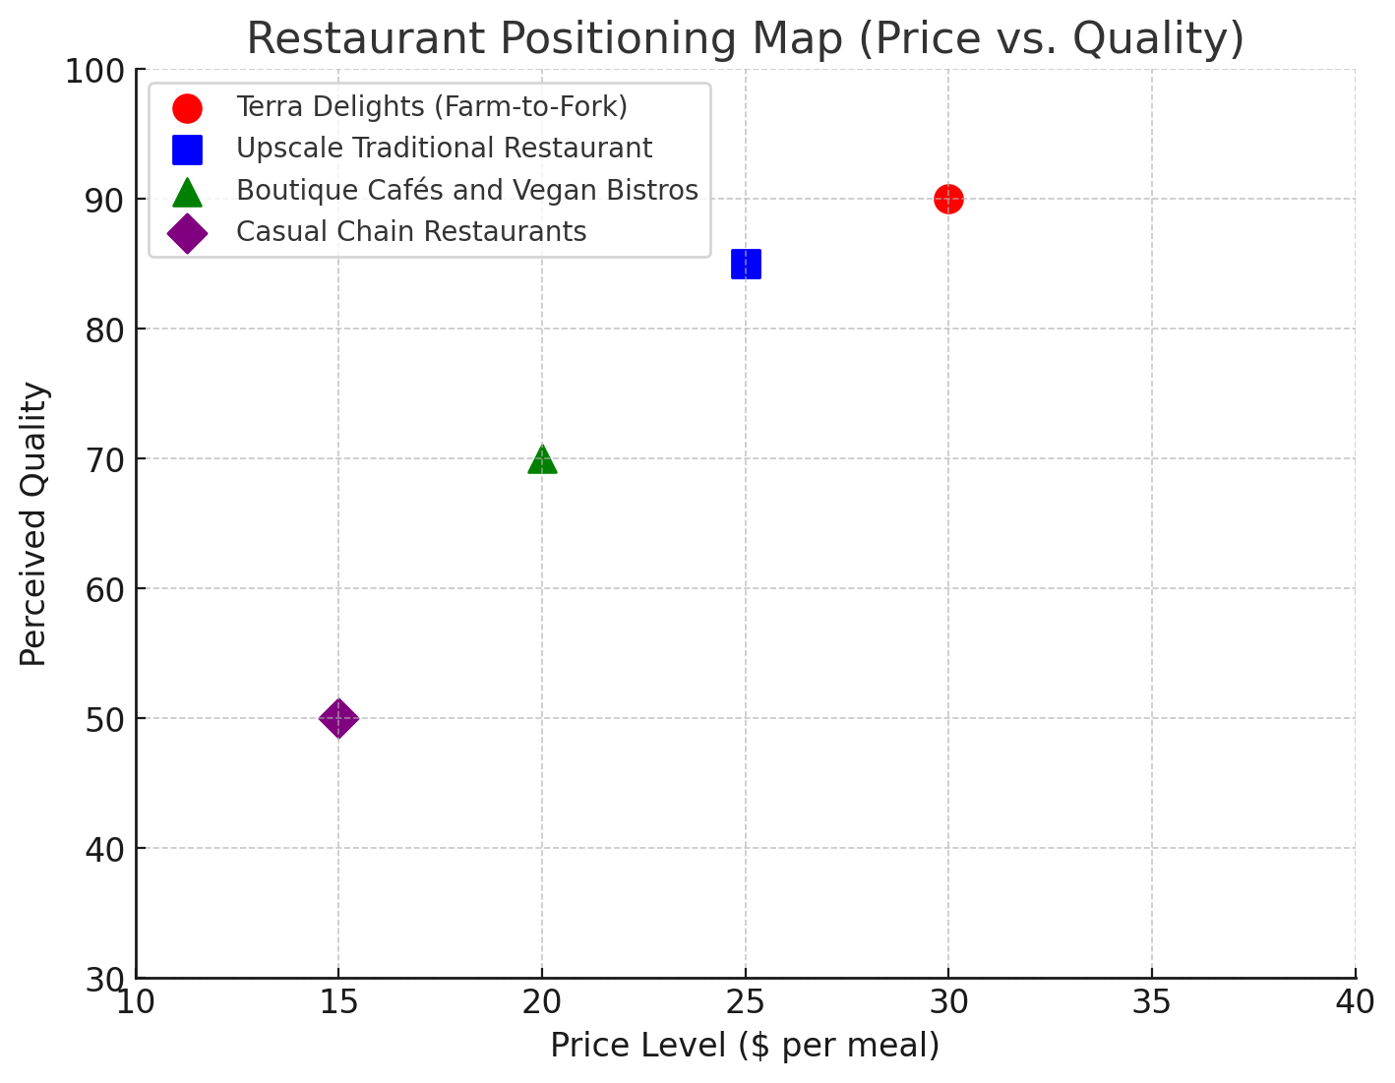
Marketing Promotions Gantt Chart
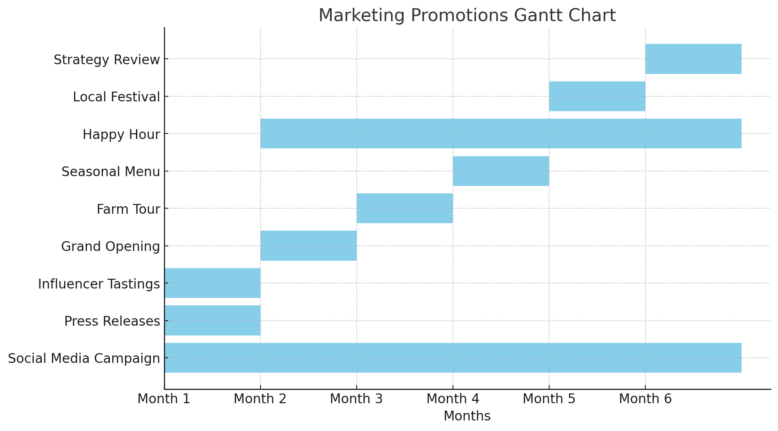
Target Market Segmentation for Terra Delights
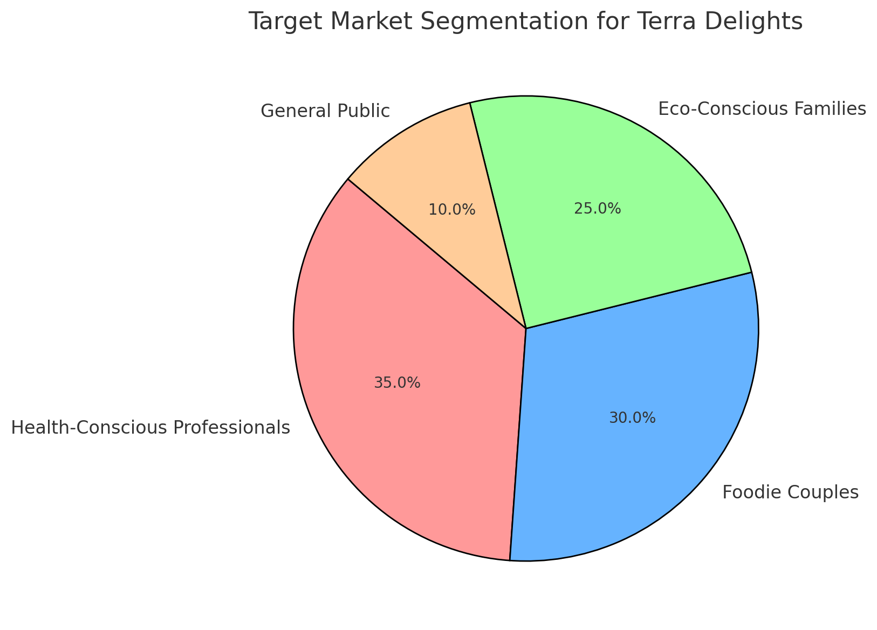
Projected Revenue Growth Over 5 Years
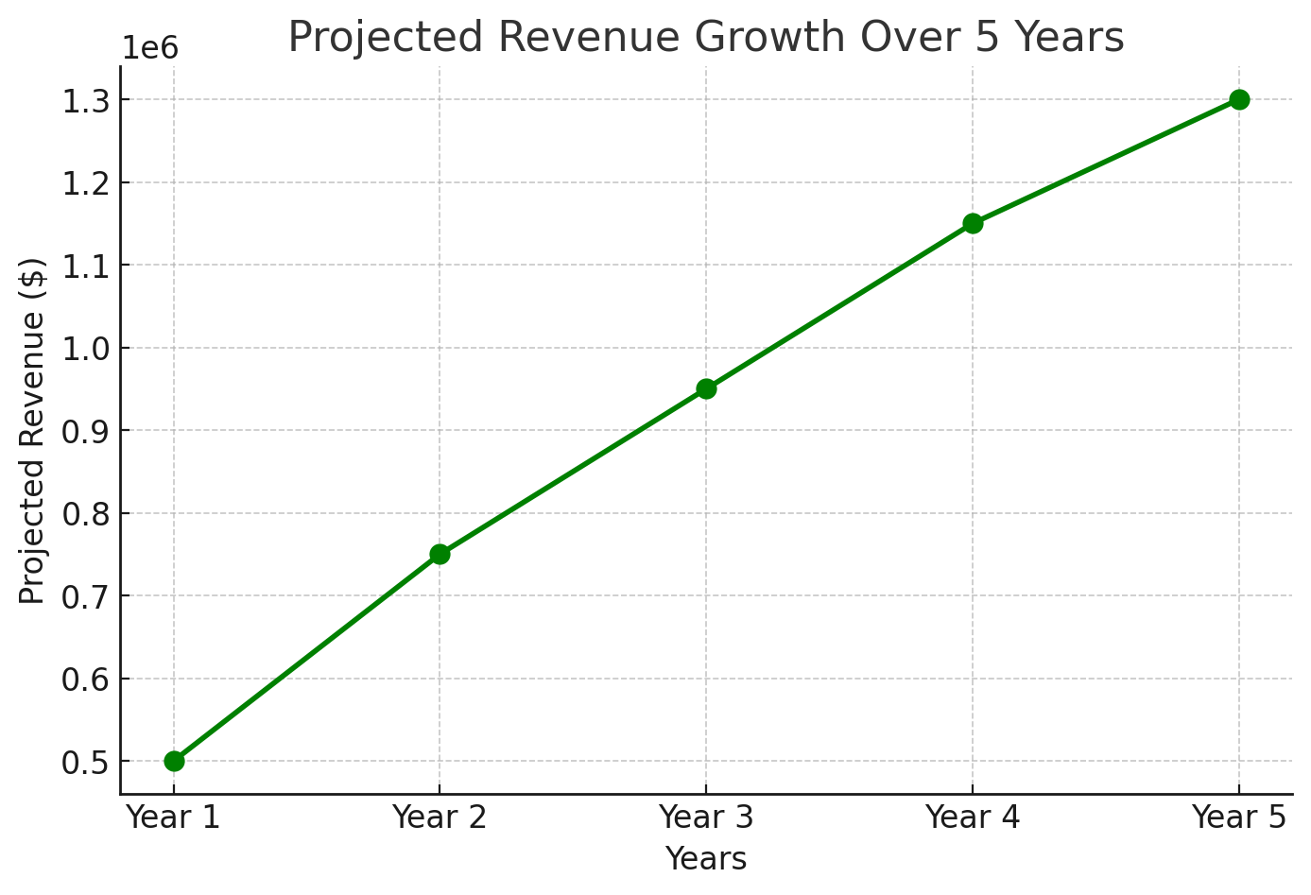
Cost Structure Breakdown for Terra Delights
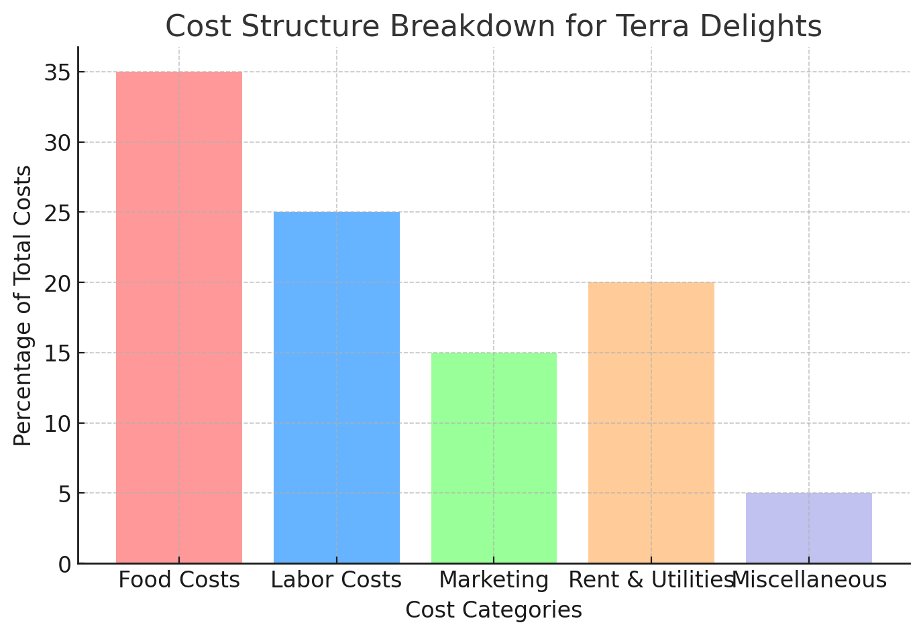
Top of Form
Bottom of Form

