Jorna Ali 1706149

Introduction
Simply put, culture is “the way we do things around here” (Deal & Kennedy cited in Buchanan & Huczynski, 2017, p. 109). There can be many aspects of culture, but this report focuses on organisational culture. Organisational culture can be strong, when core values and behaviours are shared, or weak when there is little agreement of values and what is expected of staff (Buchanan & Huczynski, 2017). This report will look at the cultural web (Mullins, 2016) model of organisational culture to analyse Netflix.

The Cultural Web
Corporate culture can have a huge impact on an organisation’s work environment and output. This is why so much research has been done to pinpoint exactly what makes an effective corporate culture, and how to go about changing a culture that is not working (Mullins, 2016).
Culture often becomes the focus of attention during periods of organisational change (Mind Tools, 2019):
- When companies merge and their cultures clash
- When growth and other strategic change mean that the existing culture becomes inappropriate
In more static environments cultural issues may be responsible for low morale, absenteeism and high staff turnover (Mind Tools, 2019).

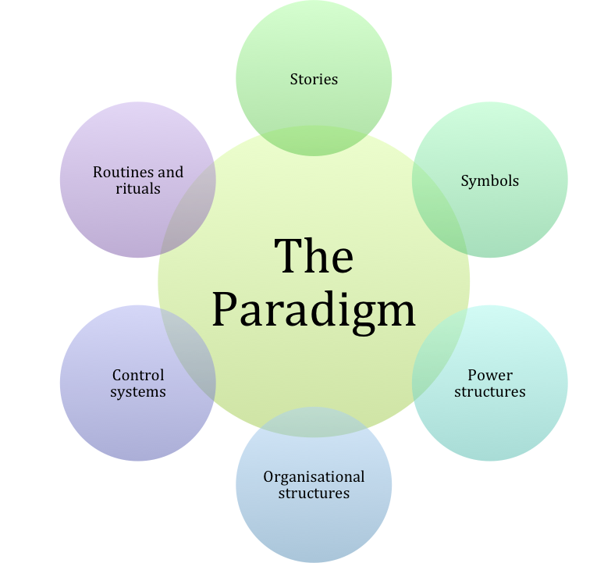
The cultural web developed by Gerry Johnson and Kevan Scholes, provides a framework for changing an organisation’s culture (Buchanan & Huczynski, 2017). The framework is useful tool to identify the cultural aspects of an organisation. Within the cultural web, there are six interlinked elements and a centre point that is the beliefs, attitudes and values of the organisation (paradigm). The organisation’s leaders usually define these beliefs, attitudes and values. These elements can help to guide employees on appropriate behaviour and attitudes within the organisation. Using this model can expose cultural assumptions and practices, and set to work on aligning organisational elements with one another, and with strategy (Sun, 2008). By analysing the factors in each, a company can begin to see the bigger picture of your culture: what is working, what is not working, and what needs to be changed (Mind Tools, 2019).
Figure 1:Rahman, 2015

The paradigm – what people within the organisation perceive as being normal.
- Stories – the past events and people talked about inside and outside the company. Who and what the company chooses to immortalize says a great deal about what is value, and perceives as a great behaviour.
Success Story (2019) outlines the history of Netflix. The story of Netflix started with the idea of creating a website where it would be easy for people to buy and rent DVD’s sitting at their homes. They invested 2.5 million to get the business started in a big way. The very first scheme they offered was a seven-day DVD rental. Netflix was also putting new titles for sale and offering customers 30% discount to attract customers.
- Symbols – the visual representation of the company including logos, how plush the offices are, and the formal or informal dress code.
The Netflix logo has gone through some changes since 1997 but it has always featured the name of the website, with the letter ‘N’ sometimes used as a short version of the logo (1000 Logos, 2019). In 2014 they changed their logo and launched a new website, to create the brand new identity. Netflix chose the combination of red and white colour as their emblem to signify passion and to make it stand out (1000 Logos, 2019).
The office at Netflix is also a symbol of their company. Netflix interior design blurs the distinction between work and social area. Different types of spaces were created through the use dividers, furniture grouping and architectural elements. There are warm colours and different kind of texture to give that home vibe. The design is created to have relaxed and collaborative workplace. This reflects the culture of the organisation (Office Snapshots, 2019).
- Power structure – the pockets of real powers in the company. This may involve one or two key senior executives, a whole group of executives, or even a department.

Netflix puts a lot of responsibility in all of their employees and take measures to keep their staff competitive and highly skilled (Stenovec, 2017). Though there are managers for different departments, Netflix is known for listening to their employees. This may be because they only hire top level employees (Thi Van, 2019). Netflix CEO makes fewer decisions and lets his employees make more decisions so they feel more ownership (Croiter, 2017).
- Organisational structure – this includes both the structure defined by the organisation chart, and the unwritten lines of power and influence that indicate whose contributions are most valued.
The organisational structure of Netflix could be described as a matrix culture. This means that the power radiates from a few individuals, but overall there is little bureaucracy and few rules (Bartlett & Ghoshal, 1990). The company believes that in order for employees to perform well, they should be given the freedom to make their own decisions and dictate their schedules. By having a highly talented and competitive employees throughout the business, it maintains enough pressure for employees to keep doing well and excelling in their respective roles (Thi Van, 2019). Netflix works on a structure of ‘distributed decision making’, which makes it move faster than other studios (Dotan, 2018).

- Control systems – the ways that the organisation is controlled. Theses include financial systems, quality systems, and rewards.

Netflix does not control their employees in the same way as other companies. They do not track vacation time and they base their systems on trust, and this means they do not have to monitor staff as they believe they will get the best work out of people by offering them freedom (Sutphin, 2015). According to Netflix CEO Reed Hastings (Croiter, 2017), although Netflix do make forecasts, they do not make any long terms plans. He goes on to explain that this is because the behaviour model of the company is to move quickly and be adaptive to changing demands and changing technology. Hastings states that, for Netflix, this is more important than plan compliance.

- Rituals and routines – the daily behaviour and actions of people that signal acceptable behaviour. This determines what is expected to happen in given situations, and what is valued by management.
The daily workforce in Netflix are given expectations and tasks with a vast amount of freedom; “If you trust and empower people and give them a chance to rise to the higher expectations” (Stern, cited in Stenovec, 2017, para. 3). By allowing flexible hours and insightful work, it is met with exceptional work from Netflix’s employees, as opposed to gruelling hours and average work (Stenovec, 2017).




Netflix’s Cultural Web: Key Points
Control System:
There are no rigid or long-term plans within Netflix. They are more flexible and agile.
Organisational
Structure:
There is a high freedom culture in the company.
Matrix culture
Symbols:
- Red and White logo
- Social office space
- Home-feeling vibe
Routines and Rituals:
The daily ritual of freedom instilled within the company is met with a high level of work.
The Paradigm:
- Innovative
- Creative
- Competitive
- Successful

Stories:
Netflix is getting better as they get bigger.


Like a sports team. Not about seniority but about performance.
The CEO applies one of Stephen Covey’s habits; understand to be understood
Power Structure:

References
1000 Logos, (2019). Netflix Logo. [Online]
Available at: https://1000logos.net/netflix-logo/
[Accessed 18 February 2019].
Bartlett, C. A. & Ghoshal, S. (1990). Matrix Management: Not a Structure, a Frame of Mind. Harvard Business Review, Issue July–August .
Buchanan, D. & Huczynski, A. (2017). Organizational Behaviour. 9th ed. London: Pearson Education Limited .
Croiter, D. (2017). Netflix culture deck via Reed Hastings. [Online]
Available at: https://youtu.be/2fuOs6nJSjY
[Accessed 1 March 2019].
Dotan, T. (2018). How Netflix’s Management Structure Is Rewriting the Hollywood Script. The Information, 30 May.
Mail Online, (2018). Netflix no chill: Employees describe climate of fear at streaming service where peers are encouraged to rate each other, emails are sent slamming former workers and managers feel under constant 'pressure to fire people'. [Online]
Available at: https://www.dailymail.co.uk/news/article-6318259/Netflix-employees-reveal-companys-culture-fear.html
[Accessed 18 February 2019].
Mind Tools, (2019). The Cultural Web. [Online]
Available at: https://www.mindtools.com/pages/article/newSTR_90.htm
[Accessed 16 February 2019].
Mullins, L. (2016). Management & organisational behaviour. 11th ed. Upper Saddle River: Pearson.
Office Snapshots, (2019). Netflix Headquarters – Los Gatos. [Online]
Available at: https://officesnapshots.com/2018/05/21/netflix-headquarters-los-gatos/
[Accessed 18 February 2019].
Stenovec, T. (2017). One Reason For Netflix's Success -- It Treats Employees Like Grownups. Huffpost, 6 December.
Success Story, (2019). Netflix, Inc. SuccessStory. [Online]
Available at: https://successstory.com/companies/netflix-inc
[Accessed 18 February 2019].
Sun, S. (2008). Organizational Culture and Its Themes. International Journal of Business and Management , 3(12), pp. 137-141.
Sutphin, A. (2015). Spotlight On: What It’s Like to Work at Netflix. [Online]
Available at: https://talentmanagement360.com/spotlight-on-what-its-like-to-work-at-netflix/
[Accessed 18 February 2019].
Thi Van, Q. (2019). Netflix and Chill…Organizational Structure. Fox School of Business, 19 February .



