Investigating The Board Game Scrabble /
Evidence Provided

Nathan Evans
Software Engineering / Analysing & Problem Solving
Submitted to:
UWTSD – Waterfront Campus
Adam Head
18/01/2022

Report on the board game Scrabble
Abstract/ Contents Page:

The following report is based on the commonly known board game, Scrabble. It details the rules and core fundamental, Inputs, Process, and outputs, using such as MosCow, Flowcharts and Pseudocode.
- Section 1: Describing the Rules
- Section 2: MosCow for Scrabble
- Section 3: Providing a solution for an Implementation
- Section 4: Inputs, Process and Outputs – Flowchart and Pseudocode
 | Page Number
- Section 1: Describing the Rules | 3
- Section 2: MosCow for Scrabble | 4
- Section 3: Providing a solution for an Implementation | 5
- Section 4: Inputs, Process and Outputs – Flowchart and Pseudocode | 6
- Reference List | 7

The work of this report completed under the supervision of (name supervisors). I declare that this report is the product of my own work and is not being submitted for any other degree etc.

N. Evans

Describing the Fundamentals & Rules

Describing the rules:
Note: You should have a game board, 100 letter tiles, a letter bag, and four racks.
Prior to the game starting, each player must agree on the dictionary that is used throughout the game; a dictionary is essential for clarification of spelling. Slang words and words of foreign origin such as “Paparazzi” are permitted. Words that require hyphens or apostrophes are not permitted. To begin, all letters must be placed in the pouch or a place where they are mixed up and out of sight. Each player draws a letter from the bag and the player closest the first letter in the alphabet “A”, plays first. Re-mix the pile of letters then each players draws seven letters to keep on their letter racks. The board offers 15 cells vertically and 15 cells horizontally.
Player 1 a chosen amount of their letters to form a word, either horizontally or vertically. It is essential that players try to keep count of their personal score and to replenish the letters on their rack, keeping a constant number of 7.
New words can bee added to the board by placing 1 or more letters to a word the is already on the board but cannot be placed diagonally at any time if you are looking to score points. Also, no tile can be shifted after it has been played.
There are 100 tiles that are used during the game, 98 of which are letters with letter scores. The 2 remaining tiles are blank and can be used as wild tiles to take the place of any letter. When a blank is played, it will remain in the game as the letter it substituted for.
During your turn the player can chose weather they would like to exchange a chosen number of letters, this can range from all 7 to a single letter. This infect ends the players turn, leaving them unable to score points on the board.
Each letter in the game will have its own point value. This depends on how rare the letter is and how difficult it may be to lay that letter. Blank tiles have no point values. Depending on where the tile lands, the players will be able to deem if the word or letter is eligible for a double lor triple score.
If a player is a suspect of cheating or playing a word that is nonsensical; other players around them are in fact aloud to challenge them and if found guilty; the original play is disqualified thus making the player lose their turn completely.
The game then ends when every letter has been drawn from the bag and when all possible plays have been made.

MosCow For Scrabble

MosCow is anacronym for “must-have, should-have, could-have, and won’t-have, or will not have right now” This method prioritises each requirement for the game of scrabble by listing them in order in terms of how important and fundamental they are for the game to work. Below is a detailed table of the student using MosCow for the game of Scrabble

Requirements | MUST HAVES | SHOULD HAVES | COULD HAVES | WOULD LIKE TO HAVE
Each player must agree on the dictionary that is used
Permitted use of slang words
Unpermitted use of words with apostrophes
Letters must be mixed
Letter must be unseen while chosen
Player closest to the letter A goes first
Each player starts with equal letters
Display timer between each players turn
Allow a player to pause the game
Ambient music
Display instructions prior to the game starting

Providing a solution for an Implementation
Variables are shortened names to represent values that need to be used later. The value will be stored and record so that they are easily accessible when needed. Blow is a list of variables for Scrabble.
List of Variables:
L – Letters
P1 – Player 1
P2 – Player 2
P3- Player 3
P4 – Player 4
T – Tiles
DL – Double letter score
TL – Triple letter score
DW – Double word score
TW – Triple word score
PS – Player skips turn
PE – Player exchanges letter

Inputs, process’ and outputs
Labelling Inputs process and out puts is essential for your program pseudocode and helps determine each step effectively with little confusion.
Inputs:
Player places a tile
Player decides to exchange tiles
Player decides to pass turn
Process’:
Program adds each letter score
Program checks if the word is valid for a double or triple
Outputs:
Program displays each player score
Program notifies players if their words score can be doubled or tripled
Flow Chart on a Solution for Scrabble
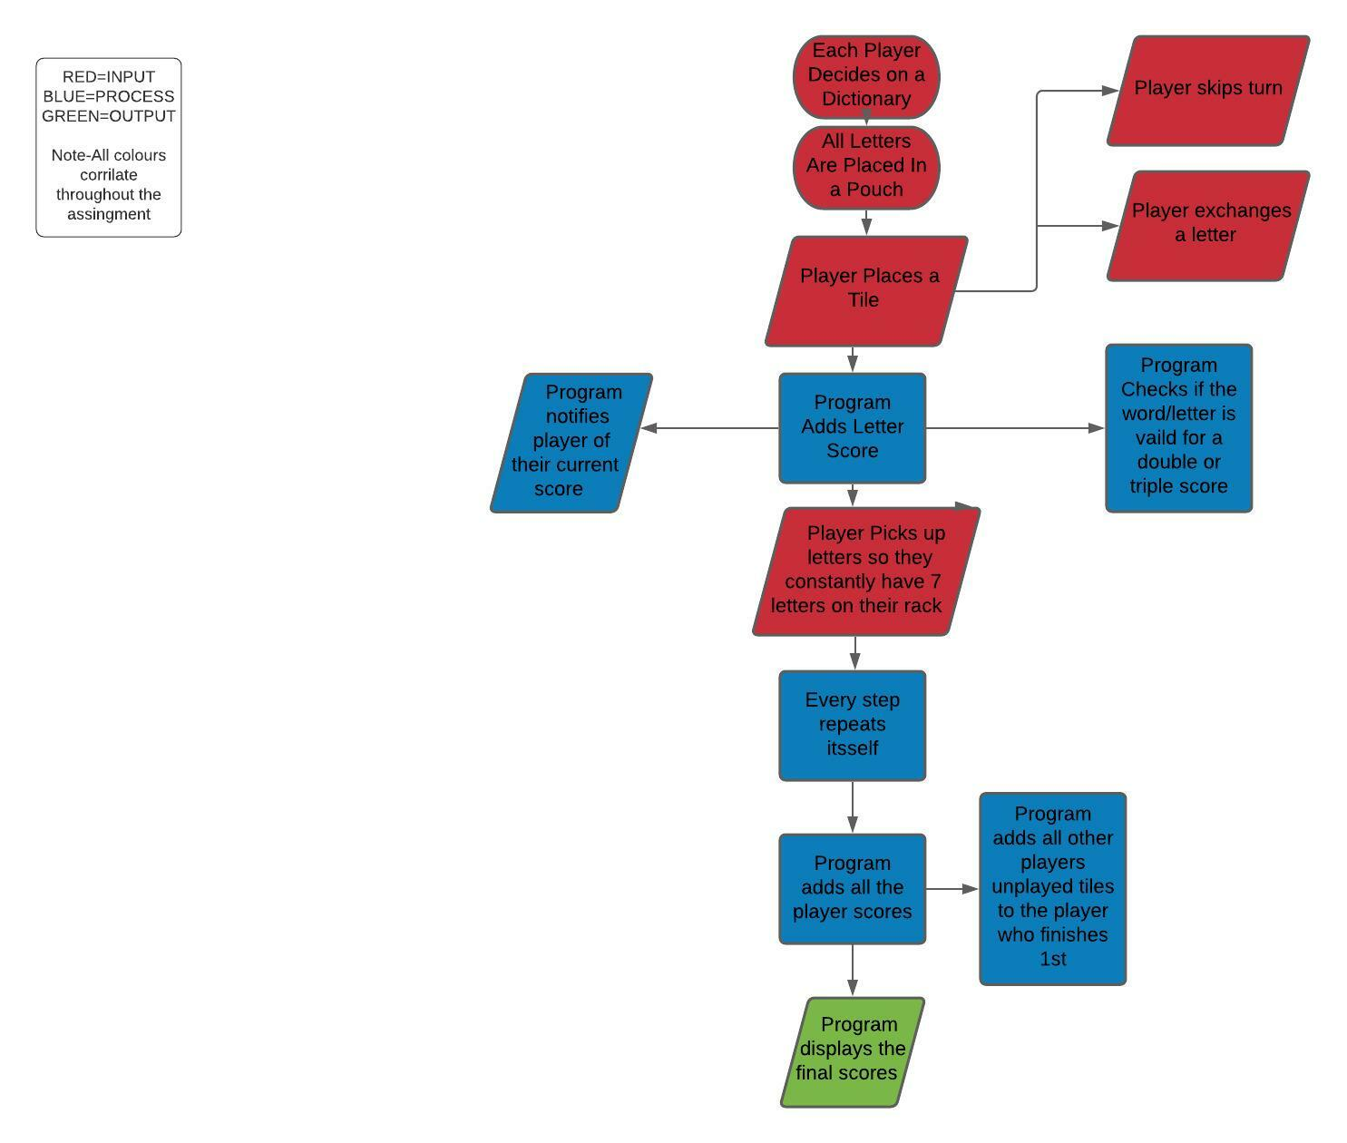
Blow is a detailed flow chart depicting the inputs, process, and outputs for scrabble. This is a clear and effective way of describing the fundamental aspect of how a program works.

Pseudocode for process’
1 DISPLAY(OUTPUT): “P1 - Please place a letter”
2 INPUT(D1): Player places a letter
3 PROCESS(R1): Program adds each letter score
Program checks if the word is valid for a double or triple
4 DISPLAY(OUTPUT): “player 1 scored a total of …. Points!
5 Display(OUTPUT): “ P1 – Please replenish your letter rack for 7 letters!”
6 INPUT(D2): P1 replenishes letter rack for 7 letters
7 Display(OUTPUT): Program constantly displays the current elapsed time and each player’s score
Each step repeats itself for every player until there are no letters left or no possible combinations left to play
8 Display(OUTPUT): Program displays final scores and congratulates the winner!

Reference List:
[1]"Scrabble Rules | Official Word Game Rules | Board Games", scrabble, 2022. [Online] . Available: https://scrabble.hasbro.com/en-us/rules.
[2]"MoSCoW Prioritization", Productplan.com, 2022. [Online] Available: https://www.productplan.com/glossary/moscow-prioritization/.
[3]"Intelligent Diagramming | Lucidchart", Lucidchart, 2022. [Online]. Available: https://www.lucidchart.com.

