Strategies for resilience and prosperity

By Lucy Harratt
Tutor – Glenn Behenna


Table of contents

- Executive summary……………………………………………….

- Introduction ………………………………………………………..

- Main body …………………………………………………………
- Starbucks Background and Principles ……………………...
- Starbucks Strategy ……………………………………………
- Pestle Analysis ………………………………………………...
- Swot Analysis ………………………………………………….
- Stakeholder Analysis ………………………………………….
- Competitors …………………………………………………….

- Conclusion ………………………………………………………...

- References ………………………………………………………..

Executive summary
The major purpose of this report is to examine how Starbucks manages their business strategically. A SWOT, Pestle, and stakeholder analysis will be included in the report to establish all of the aspects that Starbuck's must consider. This will include suggestions for how to modify and enhance the company. Because of customer views toward health and wellbeing, it will explore Starbuck's primary important concepts, such as revamping their menus to incorporate a more organic and healthier food mix. This will also discuss their work with communities like the LBGTQ community and movements like the Black Lives Matter. It will discuss how, since they believe in cooperation, they place equal emphasis on their employees and suppliers as they do on their consumers.

Introduction
This report will explore how Starbucks has strategically run their business for nearly 50 years and have manage to stay successful. To understand this, different strategy methods will be studied to ensure which style Starbucks is using. To gain a better understanding, their strategy will be analysed in three different ways to explore all aspects on the company. Using SWOT, Pestle, and stakeholder analysis. For evaluating stakeholders, this strategy considers the influence and interest-based matrix. The major goal of using this approach is to assess the opinions of the most significant stakeholders to maximise advantages and achieve success. A matrix of interest vs. power will be used to describe it. SWOT will tell us what the micro internal factors effect how the company is run. Pestle will show what external macro effects there are, and the analysis will explain how they can adapt to these.
Starbucks background and principles
Starbucks first opened its doors in 1971, and that very store is still operational today (Seattle). The company had only one store at the time, in Seattle's historic Pike Place Market. Starbucks served some of the world's best fresh-roasted whole bean coffees from a small shopfront. The name was inspired by Moby Dick and suggested the romanticism of the high seas as well as the early coffee merchants' seafaring tradition. (Our Heritage | Starbucks, 2021) Starbucks has strived to remain unique since 1971, relying on its Mission and Values to stay focused. To encourage inclusivity and transform its stores into a safe place where everyone is welcome, the company has embraced three principles which they respect throughout all its stores. Starbucks' first principle states that everyone who enters one of its coffeehouses should be treated like a customer, regardless of whether they make a purchase or not. The company embraces and supports the LGBT community by requiring staff to wear PRIDE T-shirts on Pride Day. (Stempel, 2020) The second principle ensures that all staff understand that creating a safe place is a collaborative effort. Following the death of George Floyd in June 2020, Starbucks offered $1 million to fund groups that promote racial fairness. (Lucas, 2020) Starbucks also made 250,000 shirts for its staff with slogans like "Black Lives Matter" and "No Justice, No Peace.” Starbucks pride themselves on their principles and values, it is a part of their image. (Culture and Values: Starbucks Coffee Company, 2020)
Starbucks strategy
Starbucks mission statement – “Our mission to inspire and nurture the human spirit – one person, one cup, and one neighbourhood at a time.” (About Us | Starbucks, 2021) Starbucks' mission statement explains how the firm operates to address the needs of its consumers, employees, suppliers, and other stakeholders. Starbucks adheres to four core beliefs that set it apart from the competition and ensure its long-term viability.
- Creating a culture of warmth and belonging, where everyone is welcome.
- Delivering our very best in all we do, holding ourselves accountable for results.
- Acting with courage, challenging the status quo, and finding new ways to grow our company and each other.
- Being present, connecting with transparency, dignity, and respect.
Embracing differences is important to Starbucks. To make sure that everyone feels at home, the organisation is cultivating a sense of community among its employees. To encourage an inclusive workplace, the organisation has implemented several policies and programmes. Starbucks is well-known for constantly seeking out fresh opportunities for expansion. The company is constantly looking for new ways to challenge the status quo. Starbucks is fast expanding in China, where most Western food manufacturers have had difficulty. Starbucks has made plans for ‘China Coffee Innovation Park’ in Jiangsu Province, which is scheduled to open soon, will feature cutting-edge roasting technology that can reduce carbon emissions by as much as 30%. (Starbucks innovation park construction begins in China - Xinhua | English.news.cn, 2020). Starbucks is always present and willing to assist in the search for solutions, whether it be transparency, social dignity, or environmental challenges. (Maynard, 2020) On its 50th anniversary, the company has established one of the most important sustainability goals for 2030, which will begin in 2021. (Culture and Values: Starbucks Coffee Company, 2020)

Pestel analysis
A PESTLE study is a methodology for analysing the primary elements impacting an organisation from the outside (Political, Economic, Sociological, Technological, Legal, and Environmental). (Srdjevic, 2012)
Political | Environmental | Social | Technological | Economic | Legal
Staying ahead of competition | Changed their cups, lids etc, to slow down how much single use plastic they were using | Adjusted their menus to be healthier | Used technology to help them improve throughout the pandemic | Customer impacted by household incomes | Changed their labelling which may have an impact on sales

Analysis
Food and beverage companies have tailored their menus to include a more organic and healthier product mix because of consumer attitudes toward health and wellbeing. Starbucks has capitalised on this trend by launching new growth platforms such as Refreshers natural energy drinks and Evolution Fresh super-premium bottled juices to appeal to health-conscious customers. Rapid technological breakthroughs and innovations have created new opportunities for organisations to expand and exploit in the Digital Age. Starbucks has been using digital channels such as the internet and mobile applications to reach customers in addition to its traditional distribution routes. Growing public awareness of environmental decline has prompted companies to make changes to become more ecologically responsible and move towards the more sustainable business model. Starbucks has utilised its sustainable and ethical sourcing policy to set itself apart from competitors. The food and beverage sector is affected by macroeconomic issues that influence a household's disposable income. Consumers' buying decisions might be influenced by changes in disposable income. Starbucks' labelling methods have been modified because of food labelling rules and legislation, which may have an impact on product sales.
Swot
(Dac Teoli et al., 2021) (SWOT) is a formula that stands for Strengths, Weaknesses, Opportunities, and Threats. It's a useful technique for establishing a successful business and growth plan.
Strengths | Weaknesses | Opportunities | Threats
known worldwide  supportive of all communities  Known for charity work  Support many coffees bean farms | High prices | Collaborate with other companies to battle economic issues. | Other companies, McDonalds café, Costa, etc

Strengths
They are a globally well-known organisation that is the world’s most successful coffee company. They are known for being supportive of challenged communities such as LGBTQ and many others. This gives them a good name and shows they are following their policies.
Weaknesses
As incomes are changing in homes, more and more are becoming unemployed, less people are drawn into Starbucks because of its prices, especially when you have McDonalds promising the same product for a fraction of the price.

Opportunities
Starbucks should host Global Summits and conferences on important socioeconomic issues that need to be tackled, such as fighting climate change, to bring companies and suppliers together with enthusiastic customers. They'll be able to establish common ground and collaborate on additional CSV projects as a team.
Threats
Other competitors such as McDonald’s café are selling their products at the fraction of Starbucks price. They also promise to deliver faster which the same quality of products. This can be a threat, but Starbucks relies on its policy to be friendly and welcoming which is not one of McDonalds’ policies.
Stakeholder analysis
Starbucks must account for stakeholder demands or interests to fulfil its corporate social responsibility obligations. Starbucks' current strong brand and corporate image reflects its attempts to involve stakeholders in its success.
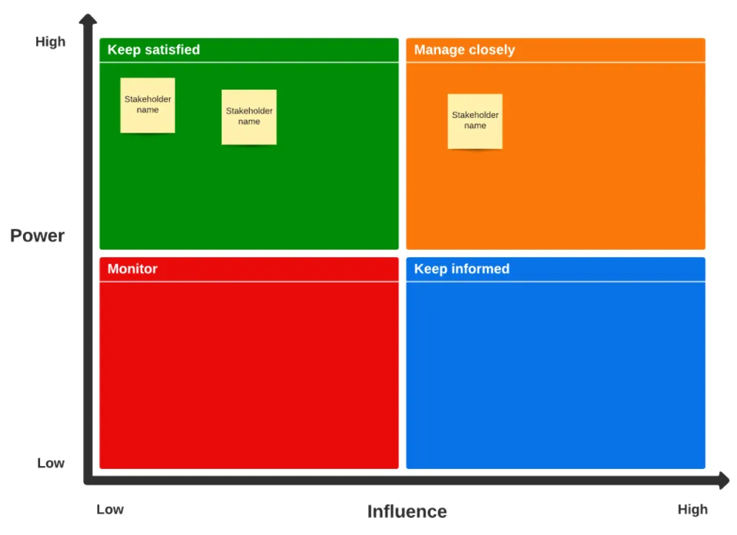

- Environment

- Governments
- Investors
- Competitors
- Employees (baristas, partners)
- Suppliers (supply firms, coffee farms)
- Customers

Analysis
Starbucks has a strong corporate social responsibility programme that addresses the needs of most of its stakeholders. From the analysis, Starbucks concentrates on its employees, customers, and suppliers. They care about their workers immensely and talk about this a lot across their platforms. They also have many policies in place to ensure all customers, whether they are purchasing something or not, are welcome. There is not much mention in competitors, Starbucks tend to focus on their satisfaction rate rather than competition. Starbucks is heavily influenced by the environment; they have made many changes to become more environmentally friendly. Opposite to this, investors and governments have high power but low influence, Starbucks doesn’t focus on adapting the company to them.
Competitors
The pandemic provided great motivation for quick-service establishments such as McDonalds, Costa, and burger king to get with the trends and adapt with more technical advancements. When in door sitting became obsolete, quick-service restaurants realised they needed to shift to make it easier for customers to take their food home. That meant embracing many new technical advancements that had been common for a few years, such as mobile order-ahead, digital loyalty programmes, and expanded curb side and delivery options. Starbucks, perhaps more than any other company in this industry, had the advantage of starting this before the pandemic when it came to digitally pushing its core coffee product a long time ago. (PYMNTS, 2021) However, the chain has relied on all those digital advancements to get through what has been a rocky ride so far. Starbucks has had to drastically change its operations to stay relevant in a world that appears to be continuously changing.

Conclusion
Starbucks continues to be a leader in the sector of sustainable business and innovation as the world's largest coffeehouse company. Despite the difficulties, Starbucks has maintained its vision of leadership, ethical and environmental responsibility, innovation, and transformation. There are still several unexplored potential growth areas that need to be investigated, and Starbucks could move ahead, setting an example for others to follow in order to foster an atmosphere and mentality of creating shared value. Starbucks should collaborate with a wide range of sustainable businesses and suppliers that share similar social and environmental principles. Starbucks may profit from cross-sector cooperation by implementing social value measures that benefit both parties. Starbucks should capitalise on technological advancements to advertise their Starbucks Card. Customers are becoming more and more technical, Starbucks would reach more customers using their Starbucks Mobile App as mobile phone usage rises. For product branding and marketing, social media has become an essential tool and channel which is a huge factor to consider. Starbucks could conduct events like Global Summits and conferences around significant socioeconomic issues that need to be addressed, such as battling climate change, to connect organizations and suppliers with enthusiastic customers. They will be able to find common ground and work on other CSV initiatives as a collective.

References
About Us | Starbucks. (2021). Starbucks.co.uk. https://www.starbucks.co.uk/about-us
Our Heritage | Starbucks. (2021). Starbucks.co.uk. https://www.starbucks.co.uk/Our-Heritage
Culture and Values: Starbucks Coffee Company. (2020). @Starbucks; Starbucks. https://www.starbucks.com/careers/working-at-starbucks/culture-and-values
Starbucks innovation park construction begins in China - Xinhua | English.news.cn. (2020). Xinhuanet.com. http://www.xinhuanet.com/english/2020-11/16/c_139520104.htm
Starbucks. (2021). Starbucks.com. https://stories.starbucks.com/stories/2020/our-commitment-to-inclusion-diversity-and-equity-at-starbucks/
Lucas, A. (2020, June 12). Starbucks to allow baristas to wear Black Lives Matter attire and accessories after social media backlash. CNBC; CNBC. https://www.cnbc.com/2020/06/12/starbucks-to-allow-baristas-to-wear-black-lives-matter-attire-and-accessories-after-backlash.html
Stempel, J. (2020, November 25). Starbucks Barista Who Declined to Wear Gay Pride T-Shirt Sues Over Firing. Insurance Journal. https://www.insurancejournal.com/news/east/2020/11/25/591969.htm
PYMNTS. (2020, September 15). Starbucks’ Big Payments Pivot To Boost Loyalty. Pymnts.com; PYMNTS.com. https://www.pymnts.com/digital-payments/2020/starbucks-big-payments-pivot-to-boost-customer-loyalty/
Maynard, M. (2020, January 21). Starbucks Lays Out Its Green Targets For 2030 As Pressure Grows For Faster Steps. Forbes. https://www.forbes.com/sites/michelinemaynard/2020/01/21/starbucks-lays-out-its-green-targets-for-2030-as-pressure-grows-for-faster-steps/?sh=7ad8e336758c
Image used, Homepage | Starbucks. (2021). Starbucks.co.uk. https://www.starbucks.co.uk/
Starbucks Coffee’s Stakeholders: A CSR Analysis - Panmore Institute. (2015, September 14). Panmore Institute. http://panmore.com/starbucks-coffee-stakeholders-csr-analysis
Clarkson, M. B. E. (1998). The Corporation and Its Stakeholders Classic and Contemporary Readings. Toronto; Buffalo; London University Of Toronto Press. https://www.degruyter.com/document/doi/10.3138/9781442673496-008/html
Management and the World’s Work. (1988, September). Harvard Business Review. https://hbr.org/1988/09/management-and-the-worlds-work
Fiscal 2016 Annual Report. (n.d.). https://www.annualreports.com/HostedData/AnnualReportArchive/s/NASDAQ_SBUX_2016.pdf
Srdjevic, Z., Bajcetic, R., & Srdjevic, B. (2012). Identifying the Criteria Set for Multicriteria Decision Making Based on SWOT/PESTLE Analysis: A Case Study of Reconstructing A Water Intake Structure. Water Resources Management, 26(12), 3379–3393. https://doi.org/10.1007/s11269-012-0077-2

‌

‌

‌
‌

‌

‌

‌

‌

‌

‌

‌

‌

‌

