Principles of Pedagogy: Effective Learning and Teaching in the Primary Context
Effective teaching and learning pedagogy in the primary context have been researched and evaluated throughout this assignment. Collins (2018) defines pedagogy as the study and theory of the methods and principles of teaching. For evaluation and reflection purposes, observations in a primary school setting were carried out to determine the most effective learning theory in relation to the topic of child emotional well-being in the primary school. The setting is located within a rural town on the outskirts of the City of Swansea. There are four hundred and eighty-one pupils aged three to eleven years on roll and 14 single-year classes from Reception to Year 6. Estyn (2018) reported that around 21% of pupils are eligible for free school meals which is slightly above the average for Wales of 19%. The school is a pioneer school that is working with the Welsh Government and other schools to proceed with developments relating to professional learning (Estyn, 2018).
Harding et al (2000) states that observation is an invaluable professional tool. They believe that observation should become an intrinsic part of practice for all professionals working with children. Observers can learn about children, build up a body of knowledge about individuals which enables the educator to play a unique part in a child’s life. In the context of education, observation can facilitate curriculum planning within the classroom (Sharman et al, 2007). Many observation researchers suggest that the environment in which we assess children is important and that researchers must take this into consideration when carrying out any type of observation (Harding et al, 2000).

The observation was carried out using anecdotal records. Anecdotal records are used to focus on a behaviour or event which may occur intermittently (Harding et al, 2000). The reason this method was used is because I was unaware of what I wanted to observe before entering the classroom. This method was most suitable as it allowed me to choose an event that occurred naturally and gave a natural representation of the child in a familiar setting, following her daily routine, while surrounded by people she knew. It was also important the observation was covert. This was to ensure the child’s behaviour was not affected by my presence. As the observer, when recording the event, I avoided using my opinion and was aware that this type of record does not offer continuity.
It is important to note that the child observed was aware of my presence although they were unaware that an observation was taking place. Simpson (2015) believes that in covert observation the observer has less influences on the research and that written records are a much more flexible approach. Sharman et al (2007) states that this type of observation is less ethical as participants are not aware they are taking part and cannot give fully informed consent. However, in accordance with British Educational Research Association (2018) I have taken the necessary precautions to avoid the identification of all participants and as a result, the child observed will be referred to as G throughout the observation.
The aim of this assignment is to evaluate the emotional well-being pedagogy and to identify the best practice for supporting children in this area within teaching. As Harding et al (2000) suggests, the learning theories related to the event will also be discussed and evaluated to establish a possible reason for the behaviour witnessed.
The observation was carried out in a Year 3 classroom with 32 children of mixed race, gender, and religion. The observation took place at 12:55 in the afternoon. The children had been playing in the playground following lunch. On arrival to the classroom, the whole class walked in chatting and giggling. G entered the room - crying - alongside a peer who had her hand on her shoulder as if to comfort her. The teacher caught sight of this and asked the member of staff on duty what had happened. According to the National School Public Relations Association (2006), effective two-way communication is a necessary trait for success at all levels of education between support staff, volunteers, teachers and senior leadership teams.
It was communicated that the child had disclosed to the member of staff that she thought there was a hurricane because she had seen on the television that there was currently a disastrous hurricane in America. While playing outside, G noticed that the weather was stormy and applied her existing knowledge and understanding to the weather she was witnessing and formed a connection with the news report she had witnessed. The combination of the two triggered a panic reaction because G assumed this meant it was a hurricane. G was crying and put her hands in her mouth as if to display anxiety. Knorr (2017) reported that no matter how old children are, threatening or upsetting news can affect them emotionally. Many can feel worried, frightened, angry, or even guilty and these anxious feelings can last long after the news event is over (Knorr, 2017).
On entering the classroom G was reassured - by the class teacher - that the weather was normal and that there was nothing to worry about. The teacher had decided to reassure the class that we are lucky enough not to experience hurricanes in the United Kingdom. Following this, G displayed a change in behaviour that implied she had accepted the teacher’s attempt at reassurance, the teacher noticed G’s body language – she seemed to relax and removed her hands from her mouth - and continued to begin the afternoon session. Before the teacher had chance to start the register, another child asked out loud “what is a hurricane?” at which point the teacher explained to the whole class that it is an extreme weather event but is not something for them to worry about.
Later in the afternoon the teacher told the children that they were going to the gymnasium for a gymnastics lesson. The gymnasium was in the school premises but in a separate building, meaning the children had to cross the playground to get to the building. Upon hearing this, G displayed behaviours of anxiety. She continuously looked out of the windows to check the weather, put her hands in her mouth and asked peers if they liked gymnastics. While walking through the building to access the playground G was talking to a peer. Figure 1 shows the dialogue between peers.

G: I don’t want to walk outside, do you?
Peer: It’s only raining.
G: Will you be my walking partner?
Peer: I’m her partner, you can go with him!
G: No, I’ll go at the front with Miss.

Figure 1
On analysis of the dialogue it is evident that G was in search of a person she felt she could trust. After being turned away by a trusted friend she was aware that her next option was a reliable adult with whom she felt safe and secure. During the observation it was clear that G was in search of someone who made her feel secure as she did not seek comfort from a member of support staff who was standing close by.
G joined the front of the line – just behind the class teacher – and walked through the playground while trying to make a conversation with the teacher about the previous gymnastics lesson. On arrival, G walked into the changing rooms with confidence and displayed behaviour that implied she was in a familiar setting that made her feel safe. Her behaviour implied that she was content throughout the lesson and she was happy to participate.
As the children were cooling down at the end of the lesson the teacher asked all the children to lie on their backs with their arms and legs stretched out. G complied and followed her peers. The room went silent and the sound of wind and rain echoed through the room. G sat up from her flat position and put her hand up in the air. The teacher saw this reaction and purposely pointed out that the wind was very noisy today. G screwed her face up and began to cry, at this point the teacher continued to talk to the children to help them relax while G sat crying, with her hand in the air. A presumably concerned peer pointed out to the teacher that G was crying. Figure 2 shows the dialogue between teacher and peer.
Peer: Miss, G is crying.
Teacher: Yes, I know. I will talk to G in a minute.
Peer: Okay. I think she’s scared.

Figure 2
Shortly after this conversation the teacher dismissed the class and kept G behind to talk. This conversation consisted of the teacher asking her what was wrong and G putting her hands in her mouth and shrugging her shoulders. The teacher once again reassured G that if it was the weather that was bothering her then she should try and relax about it because nothing serious was happening. She then directed G to the changing rooms and paired her with another child to ‘look after her’. G was compliant and willingly let her peer become her confidante.
Once the children had changed it was the end of the day. The teacher seemed concerned about the behaviour G displayed regarding the weather and mentioned it to the adult who collected her from school.
Part 2
Education is defined by Jordan et al (2008) as the acquisition of mental training necessary to comprehend ideas. Jordan et al (2008) commit to the view that theory has many practical implications and owns value in supporting, confirming and optimising best practice. They argue that the educator’s role is to facilitate learning. It is essential that educators are aware of and understand the theory behind learning as there is nothing as practical as good theory (Lewin, 1943: 35). The educator’s role as a facilitator of student learning is dependent upon the theory of learning held (Jordan et al, 2008).

Abraham Maslow is one of the best-known theorists in the field of humanism. He presented his theory in the form of a pyramid. Figure 3 shows Maslow’s Hierarchy of Needs.

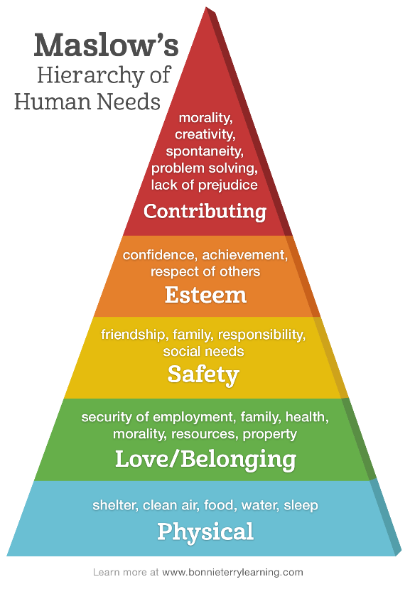

Figure 3

Maslow theorised that if the physiological needs are not satisfied then the body cannot function optimally. This means that meeting children’s physical needs, such as, food, drink, shelter and sleep are essential before learning can take place (Walker and Reece, 2007). The next stage of the pyramid displays the need for love and belonging – this involves the child being made to feel loved and cared for. This layer includes the need to trust, acceptance and affection. According to Bruney (2012) validating student feelings fosters trust and emotional intelligence; good classroom management is contingent on a trusting environment.

The humanist learning theory is concerned with personal growth and suggests that child educators pay full attention to students’ personal attributes such self-concept, values, and emotions (Johnson, 2014). This suggests that the learning theory and approach used to deal with the incident in the observation humanistic. The humanistic learning style, education should focus on forming trusting relationships, validating thoughts and feelings, human development and personal growth – including emotional well-being (Johnson, 2014). This theory relates to the incident observed because the teacher immediately validated the child’s feelings, gave an explanation that helped the child understand her thoughts and feelings, and later gave the child time to process her time to process and manage those feelings before intervening. Johnson (2014) believes that the goal of education should be human development and personal growth. He also believes that focussing on these will naturally increase intellectual achievement and prepare students to contribute to global as well as local societies. Walker and Reece (2007) support this style of learning and agree that the teacher’s role is to increase the range of experiential learning so that the student can reach their own personal conclusion, based on real life facts.
According to Boniwell (2008) the term ‘emotion’ is notoriously difficult to define and is often viewed as an umbrella term for various negative and positive emotions, moods and feelings. These are the emotions, moods and feelings we encounter daily and can recognise. Positive psychology is a science of positive aspects of human life, such as, happiness, well-being and flourishing (Boniwell, 2008). The main aim of positive psychology is to discover and promote the factors that allow individuals and communities to thrive.

One of the aspects that is associated with positive psychology is emotional intelligence (EQ). This phrase was made popular by author and psychologist, Daniel Goleman, whose approach centred around the theory of humanism. Goleman defines emotional intelligence as knowing one’s feelings and using them to make good decisions in life. The term refers to the capacity to recognise and manage our own emotions. Goleman argues that EQ is more important than IQ for career success and for the achievement of life goals.
The theories and opinions reviewed so far are becoming more popular in teaching practice. Schools, educational professionals and local authorities are beginning to realise that considering the emotional well-being of children and young people is beneficial to their learning and overall development; this is the result of a recent curriculum review carried out by Graham Donaldson. In addition to this, an Annual Report of the Chief Medical Officer (2012) found that the most common mental health problems for children and young people are depression and anxiety. It is estimated that 300,000 young people in Britain suffer from anxiety, making it one of the most common mental health disorders in the country (Royal College of Psychiatrists, 2014).
At present, all schools in Wales follow two forms of curriculum-based documentation that demand the inclusion of well-being within both learning and the classroom environment. The curriculum for children starting school as young as three years is the Foundation Phase Framework. One of the seven areas of learning within the Foundation Phase curriculum is referred to as Personal, Social Development, Well-being and Cultural Diversity (Welsh Government, WG, 2015).

The framework sets out the skills children are expected gain as they move through the programme of study from aged three to seven years. The skills of well-being are identified as the ability to express and communicate different feelings and emotions – their own and those of others, to become aware of their own feelings and develop the ability to express them in an appropriate way (WG, 2015). From the ages of three to seven years the curriculum states that these skills are gained solely through structured and non-structured play experiences. Froebel was a theorist who believed that play was essential in children’s learning and understanding. His belief was that play fostered enjoyment, emotional well-being and was a fundamental source of benefit (Pound, 2005:15).
At the time the child was observed she had recently moved into a year 3 class which is the first year in which children begin to follow the Key Stage 2 curriculum. This curriculum differs greatly from the Foundation Phase Framework because it does not encompass play, meaning that it is no longer at the heart of all learning. The Foundation Phase Outcomes have been developed to support the end of phase statutory teacher assessment and facilitate teachers in creating a continuum of learning for all children (Welsh Government, 2015).

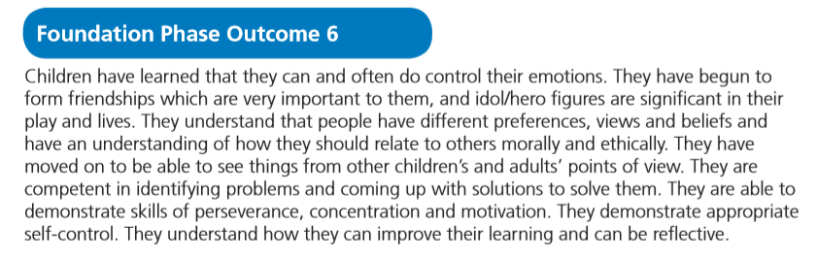
When children leave Foundation Phase and enter key stage two they are expected to have reached at least outcome five, but ideally outcome six of the Foundation Phase Framework in all core areas of learning; including Personal and Social Development, Well-being and Cultural Diversity. Figure 4 shows the expected skills of outcome six.

Figure 4
On evaluation of these skills it is possible that the child observed had not yet reached this expected outcome. This could have been one of the reasons she had struggled to manage her emotions upon receiving the information from the news report.
Froebel’s theory on play was one of the influences in the development of the Foundation Phase Framework. Interestingly, Froebel viewed women as fundamental in the education of young children. According to Pound (2005) it owed much to the deprivation that Froebel believed he had suffered because of the death of his mother in his early years.
Research in the field of attachment and anxiety suggests that one of the reasons for the anxious behaviour displayed in the observation could be the result of what is known as ambivalent attachment. This is a form of insecure attachment and is where the main care giver is inconsistent, sometimes sensitive and sometimes neglectful (Segal et al, 2018).

This can result in the child displaying behaviours of anxiety, anger and insecurity because the child cannot rely on their needs being met. This does not mean however, that the caregiver does not respond; it just means that at times the caregiver may respond in a sporadic, unpredictable and at times insensitive manner. Children of this nature can become clingy and needy (Howard et al, 2017).
On the contrary, the Mental Health Foundation (1997) although dated, suggests that excessive clinging is a sign that a child is extremely anxious because of what is happening or has happened within their immediate environment. On this occasion, it is feasible that the child’s anxiety was the result of the news report she had been exposed to on the television at the start of the day. Interestingly, recent research shows that exposure to news programming and fictional media such as video games, movies, and television shows can cause children to experience fear and anxiety (Boston Children’s Hospital; BCH, 2018). BCH (2018) suggests that media can alter a child’s view of the world, affect their sense of well-being, and influence their decision-making. Subsequently, it is important for parents, carers and childcare professionals to understand the relationship between children’s media use and the fear and anxiety it can cause them, both in the long and short term (BCH, 2018).
Howard et al (2017) argue that a whole school approach to mental health and well-being is vital, as children and young people will be learning how to recognise and manage their emotions. Providing pupils with the inner resources they can draw upon when something negative or stressful happens can promote resilience to mental health issues (DfE, 2016). On the contrary, Stirling and Emery (2016) believe that schools focussing on mental health and well-being are losing focus with regards to budget constraints, the changing curriculum and teaching standards.
The key stage two curriculum follows the Personal and Social Educational Framework (Welsh Assembly Government, 2016). This framework aims to support learners in maintaining their emotional and physical health and well-being, sustain their growth and development, and know how to keep themselves safe (WAG, 2016). The framework refers to this as ‘Emotional intelligence’. This involves the successful management of feelings and emotions and has a great impact upon personal and social effectiveness.
Pound (2005) suggests that schools need to create environments that are: safe, secure, rich in sensory stimuli, able to meet learner needs, empowering, supports decision making and making choices, free from negative stressors (hunger, thirst, threat), emotionally positive so that feelings are recognised, understood and dealt with effectively and promotes self-esteem. Long and Fogell (1999) stress that emotions motivate us to learn new information. They help us organise our thoughts and actions. It is suggested that teachers and educators must ensure the classroom is an emotionally supportive learning environment. Figure 5 shows the effects of a supportive learning environment.

Figure 5
More recent attention has focused on the provision of well-being within the current curriculum in Wales. A review of the Welsh curriculum was carried out by Professor Graham Donaldson in 2015. Following the review Donaldson wrote; The title of the report, Successful Futures, signals the vital importance of schools to the future success and well-being of every child and young person in Wales (Donaldson, 2015). One of the responses from school leaders and teachers highlighted that support is needed with regards to the health and well-being of children and young people in Wales.

The report also demands for an emphasis on the importance of well-being; including mental health. Donaldson (2015) states that schools need to care both for children and young people’s physical and emotional needs and help them to take responsibility for their own lives. The report continuously stresses the importance of child health and well-being, including emotional well-being.
“Children and young people need to experience social, emotional and physical well-being to thrive and engage successfully with their education.” (Donaldson, 2015, p. 45)
To conclude, research and evaluation of learning theories suggests that the learning theory and approach used to deal with the incident in the observation is humanistic. Froebel was a theorist who believed that play was essential in children’s learning and understanding. BCH (2018) suggests that media can alter a child’s view of the world, affect their sense of well-being, and influence their decision-making. According to humanistic learning theory, education should focus on human development and personal growth – including emotional well-being (Johnson, 2014). Froebel’s theory on play was one of the influences in the development of the Foundation Phase Framework. On this occasion, it is feasible that the child’s anxiety was the result of the news report she had been exposed to on the television at the start of the day. Subsequently, it is important for parents, carers and childcare professionals to understand the relationship between children’s media use and the fear and anxiety it can cause them, both in the long and short term (BCH, 2018).
The area of learning within the Foundation Phase curriculum that relates to well-being is titled Personal, Social Development, Well-being and Cultural Diversity. The educator’s role as a facilitator of student learning is dependent upon the theory of learning held (Jordan et al, 2008). Figure 3 shows importance of meeting children’s basic needs, unless this happens children are not equipped to learn. This tells us that the humanist learning theory is concerned with personal needs, growth and includes paying full attention to students’ personal attributes such self-concept, values, and emotions (Johnson, 2014). It is essential that educators are aware of and understand the theory behind learning as there is nothing as practical as good theory (Lewin, 1943: 35).

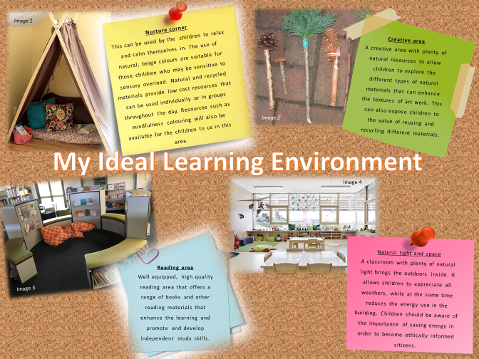

The learning environment I have created is targeted towards the lower end of Key Stage 2 – year 3 and 4. This is because it is my belief that when children leave the Foundation Phase (at the end of year 2) it can be difficult for them to automatically adjust to a formal learning environment that does not encourage play. This learning environment involves key elements of the Foundation Phase vision without interfering with the statutory Key Stage 2 curriculum. The ethos of the classroom is centred around the classroom becoming a learning community. Coyle (2007) suggests that this type of environment encourages the teacher to develop and articulate her own theory of practice, which in turn helps to clarify strategic development in learners. Long and Fogell (1999) believe that an environment which is too heavily controlled can have a negative impact on behaviour, thus leading to a poor outcome from learners. Although dated, Davie and Galloway (1996) state that for effective learning to take place, children need to be involved, know what it is they are learning and be given the opportunity to practise new skills.
The first innovation I believe is essential for inspiring children to learn, develop and explore the changing curriculum is a nurture corner. The Department for Education (2017) state that central to the philosophy of nurture is the theory of attachment, and the need for a child to be able to form secure and happy relationships with others in the formative years of their lives. Providing children with a nurture corner will discretely give them opportunity to revisit early nurturing experiences – whether they are positive or negative. However, DfE (2017) believe that nurture groups should be held for children with particular social, emotional and behavioural difficulties which are creating a barrier to learning within a mainstream class. Personally, I believe that every child’s emotional needs should be considered and could at any point – regardless of their life experiences or background - become a barrier to their learning, therefore I intend to consider the emotional well-being of all children in the classroom by providing an inclusive, non-discriminate nurturing area for any child to use at the appropriate time during their school day. This is in accordance with article 24 of The United Nations Convention on the Rights of the Child (1989) which states that educators must provide good quality education on health and well-being so that children can stay healthy.
The practice of mindfulness is useful when focusing on nurture and managing emotions. This is because it improves an individual’s ability to adapt their emotions accordingly within the classroom, improves ability to tolerate a wide range of emotions and sensations without attempting to avoid or reduce them and also improves the ability to notice early indicators of strong emotions and to manage them (Vickery and Dorjee, 2016). This concept relates heavily to the New Curriculum in Wales which will be introduced by 2021. One of the drafted areas of learning experiences (AOLE) is titled health and hell-being. Donaldson (2015) published in his Successful Futures report that the health and well-being AOLE is concerned with how the school environment supports children and young people’s social, emotional, spiritual and physical health and well-being.
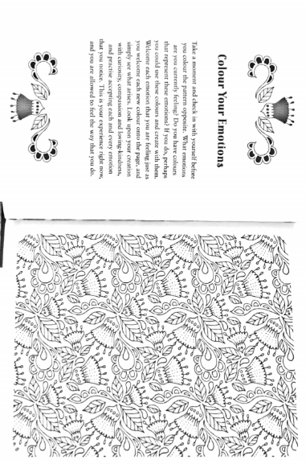
The nurture corner provided within the classroom will be constructed using natural materials and natural colours. It will make use of the floor space by housing cushions and blankets to sit on. The area will not be overloaded with resources but will remain a tranquil space for use by all children in the class. The children will be made aware that it is not a place to play, but a place for them to gather their thoughts and feelings. The limited resources provided will change weekly and be planned according to the response and behaviour of the class as a whole. Figure 6 shows an example of the self-directed mindfulness resources that will be made available to the children.

Figure 6
Another innovation I wish to integrate into the classroom is a flexible reading area. The idea of this is to utilise all space the classroom and remove the stigma that becomes attached to the ‘reading area’. The main purpose is to encourage children to read for pleasure. Williams (2014) states that the biggest challenge for teachers is getting children to enjoy reading. The National Literacy Trust has noted that becoming a lifetime reader is based on developing a deep love of reading. Williams (2014) understandably argues that this love should begin at home and be extended to education, however, it is not always possible to get parents on board, meaning that teachers need to innovate new and exciting ways to encourage children to read for pleasure.
Although extravagant and bold, my idea stems from making reading a fun task. Not just calling it fun, but getting the feedback from the children that it’s fun. The idea is to ask children about their likes and dislikes, once the feedback is received, suitable books, eBooks and audiobooks will be outsourced and provided. A suggestion box will be provided in the area for children to write down what they enjoyed with regards to the book available e.g. genres, authors and illustrators. Following this, every term the process will repeat to ensure the resources provided are new, fresh and relate to the continuing change of interests in the classroom. In turn, children will begin to recognise authors, illustrators and writing styles they prefer, while unknowingly developing their reading fluency, understanding and literacy skills.
The flexible aspect of the reading area derives from the concept of using it for other sessions. Support staff and groups of children will be encouraged to carry out various small activities in the area. This will help children become familiar with the area, learn how to use the area appropriately and ultimately enjoy being there.
The overall inspiration of the learning environment created comes from the work of theorist, Loris Malguzzi. Malguzzi pioneered the Reggio Emilia approach to education which is student-centred and utilises self-directed, experiential learning in relationship-driven environments. This approach places great emphasis on the use of natural materials to create a neutral learning environment. I believe that in the 21st century, this idea is important because it teaches adults and children that reusing materials is a great way to create exciting new resources while looking after our planet. Again, this idea links to the new curriculum as it encourages children to become ethically informed citizens.
The concept adopted from this educational model is the use of natural resources. The children will be encouraged to use materials found in their immediate environment to create art, for example, the children could make paintbrushes out of twigs, string and different shaped leaves. Ackerman (2001) also believes that natural resources are easily accessible and should be utilised wherever possible. He argues that they are renewable; their creation and disposal has minimal harm to the environment.
Finally, it is a well-known fact that classroom design has an impact on student learning. Barrett et al (2015) found that colour, lighting, and other classroom design choices have a much larger impact of student attainment than we could have ever imagined. Their study found that classrooms with the most daylighting had a 20% better learning rate in math and 26% improved rate in reading compared to classrooms with little or no daylighting (Barrett et al, 2015). This compelling research has had a significant impact on my view of a traditional classroom. On top of student success and attainment, I believe reducing the amount of artificial lighting and increasing the number of windows in schools will dramatically reduce running costs for local authorities, meaning that money can be spent on areas within education that are evolving such as the need for support staff and innovative technology.

Reference List
- Ackerman. D (2001) Cultivating Delight: A Natural History of my Garden. New York: HarperCollins
- Annual Report of the Chief Medical Officer (2012) Our children deserve better: Prevention pays. Available at: https://assets.publishing.service.gov.uk/government/uploads/system/uploads/attachment_data/file/255237/2901304_CMO_complete_low_res_accessible.pdf (Accessed 12th October 2018)
- Barrett. P, Zhang. Y, Davies. F, Barrett. L (2015) Clever Classrooms: Holistic Evidence and Design. [Online] Available at: http://www.salford.ac.uk/cleverclassrooms/1503-Salford-Uni-Report-DIGITAL.pdf (Accessed 16th October 2018)
- Boston Children’s Hospital; BCH (2018) Fear and Anxiety. [Online] Available at: http://cmch.tv/parents/fear-and-anxiety/ (Accessed 27th September 2018)
- British Educational Research Association; BERA (2018) Ethical Guidelines for Educational Research. Available at: https://www.bera.ac.uk/wp-content/uploads/2018/06/BERA-Ethical-Guidelines-for-Educational-Research_4thEdn_2018.pdf?noredirect=1 (Accessed 27th September 2018)
- Bruney. D (2012) The Teacher-Student Relationship: The Importance of Developing Trust and Fostering Emotional Intelligence in the Classroom. [Online] Available at: https://tspace.library.utoronto.ca/bitstream/1807/35096/1/Glenda%20MTRP%20Complete.pdf (Accessed 13th October 2018)
- Collins (2018) Definition of ‘Pedagogy’. [Online] Available at: https://www.collinsdictionary.com/dictionary/english/pedagogy (Accessed 13th October 2018)
- Davie. R and Galloway. D (eds) (1996) Listening to Children in Education. London: David Fulton
- Department for Education (2016) Mental health and behaviour in schools. [Online] Available at: https://assets.publishing.service.gov.uk/government/uploads/system/uploads/attachment_data/file/508847/Mental_Health_and_Behaviour_-_advice_for_Schools_160316.pdf (Accessed 12th October 2018)
- Department for Education; DfE (2017) Nurture Group Provision. [Online] Available at: https://www.education-ni.gov.uk/sites/default/files/publications/education/Nurture%20Group%20Provision%20-%20Guidance%20for%20Schools.pdf (Accessed 16th October 2018)
- Donaldson. G (2015) Successful Futures: Independent Review of Curriculum and Assessment Arrangements in Wales. [Online] Available at: https://gov.wales/docs/dcells/publications/150225-successful-futures-en.pdf (Accessed 13th October 2018)
- Estyn Report (2018) A report on xxXXXXXX Primary School. [Online] (Accessed 10th October 2018)
- Figure 3: Bonnie Terry Learning (2018) Hierarchy of Basic Human Needs. [Online] Available at: https://www.bonnieterrylearning.com/blog/how-homework-can-help-build-self-esteem-and-confidence/ (Accessed 5th October 2018)
- Figure 4: Welsh Government (2015) Curriculum for Wales: Foundation Phase Framework. Department for Education and Skills: Cardiff
- Figure 6: REFERENCE MINDFULNESS BOOK
- Harding. J and Meldon-Smith. L (2000) How to make observations and assessments. 2nd Ed. London: Hodder Headline
- Howard. C, Burton. M, Levermore. D and Barrell. R (2017) Children’s Mental Health and Emotional Well-being in Primary School. Sage: London
- Image 1: Google Images (2018) Available at: https://www.disneybaby.com/blog/creating-a-cozy-calm-down-area-for-your-toddler/ (Accessed 16th October 2018)
- Image 2: Google Images (2018) Available at: http://pre-schoolplay.blogspot.com/2011/09/make-your-own-autumn-brushes.html (Accessed 16th October 2018)
- Image 3: Google Images (2018) Available at: https://dlb.sa.edu.au/stemworks/mod/book/view.php?id=5&chapterid=2&lang=de (Accessed 16th October 2018)
- Image 4: Google Images (2018) Available at: https://inhabitat.com/daylit-austrian-kindergarten-mixes-with-the-out-doors/neufeld-an-der-leitha-kindergarten-by-solid-architecture-7/ (Accessed 16th October 2018)
- Johnson. A.P (2014) Education Psychology: Theories of Learning and Human Development. National Science Press: Minnesota State University
- Knorr. C (2017) Explaining the News to Our Kids. [Online] Available at: https://www.commonsensemedia.org/blog/explaining-the-news-to-our-kids (Accessed 10th October 2018)
- Long. R and Fogell. J (1999) Supporting Pupils with Emotional Difficulties: Creating a Caring Environment for All. David Fulton Publishers: London
- National School Public Relations Association; NSPRA (2006) How strong communication contributes to student and school success: Parent Family Involvement. [Online] Available at: https://www.nspra.org/files/docs/Strong_Communication_Students_School_Success.pdf (Accessed 6th October 2018)
- Pound. L (2005) How Children Learn. Practical Pre-school: Leamington Spa
- Royal College of Psychiatrists (2014) Worries and anxieties – helping children to cope: Information for parents, carers and anyone who works with young people. Mental health and growing up factsheet. [Online] Available at: www.rcpsych.ac.uk/healthadvice/parentsandyouthinfo/parentscarers/worriesandanxieties.aspx (Accessed 12th October 2018)
- Segal. J, Glenn. M and Robinson. L (2018) What is Secure Attachment and Bonding? Understanding the Different Ways of Bonding and Communicating with Your Infant or Child. [Online] Available at: https://www.helpguide.org/articles/parenting-family/what-is-secure-attachment-and-bonding.htm (Accessed 12th October 2018)
- Sharman. C, Cross. W and Vennis. D (2007) Observing Children: A Practical Guide 4th ed. London: Continuum
- Simpson. E (2015) Advantages and disadvantages of covert and overt participation. [Online] Available at: http://www.markedbyteachers.com/as-and-a-level/sociology/advantages-and-disadvantages-of-covert-and-overt-participation.html (Accessed 27th September 2018)
- Stirling. S and Emery. H (2016) A whole school framework for emotional well-being and mental health. [Online] Available at: https://www.ncb.org.uk/sites/default/files/field/attachment/NCB%20School%20Well%20Being%20Framework%20Leaders%20Resources%20FINAL.pdf (Accessed 12th October 2018)
- United Nations Convention on the Rights of the Child (1989) A Summary of the UN Convention on the Rights of the Child. [Online] Available at: https://www.unicef.org.uk/wp-content/uploads/2010/05/UNCRC_summary.pdf (Accessed 16th October 2018)
- Vickery. E. C. and Dorjee. D (2016) ‘Mindfulness Training in Primary Schools Decreases Negative Affect and Increases Meta-Cognition in Children’. Frontiers in Psychology. 6:2025 DOI: 10.3389/fpsyg.2015.0202
- Walker. S and Reece. I (2007) Teaching, training and learning. 6th Ed. Business Education Publishers Limited: Great Britain
- Welsh Assembly Government (2016) Personal and social educational framework for 7 to 19-year-olds in Wales. [Online] Available at: http://learning.gov.wales/docs/learningwales/publications/130425-personal-and-social-education-framework-en.pdf (Accessed 12th October 2018)
- Williams. M (2014) ‘How to encourage students to read for pleasure: teachers share their top tips’ The Guardian. 3rd June. Available at: https://www.theguardian.com/teacher-network/teacher-blog/2014/jun/03/how-to-encourage-students-read-for-pleasure-teacher-top-tips (Accessed 16th October 2018)

