Consider the provided scenario of an older person who is experiencing social exclusion later in life: Critically discuss historical and contemporary explanations of potential cognitive, emotional and social effects of this social exclusion on continuing development and how negative effects might be ameliorated.

For the purpose of this case study, we have been presented with a scenario involving an elderly woman who is experiencing social exclusion (See appendix A). Barbara, a seventy-six-year-old woman, who resides alone in her home village ever since her husband passed away four years ago. Barbara has one son, who has since moved away with his wife and three children. She is known to be a sociable woman with an optimistic perspective on life. She cherishes her previous role as a teacher, where she developed acquaintances with many of the families in the village. During their retirement, Barbara and her husband took pleasure in ballroom dancing and embarked on many coach trips across the UK and Europe. Following her husband’s passing, Barbara has stopped traveling and attending ballroom dancing club due to the absence of her partner. With many of her friends preoccupied with family commitments, and her inability to drive to visit her son, Barbara relies on weekly to monthly phone calls for connection to her family. Consequently, she finds herself spending most of her time alone at home, taking naps, gardening, and reading. Barbara longs for a sense of community within the village, and frequently experiences loneliness. It is not uncommon for elderly people to become disconnected from their social circles, as they often find it challenging to engage in community activities and socialise as they once did (Singh & Misra. 2009). This can pose challenges in developing new friendships or finding the confidence to seek out new social opportunities (Singh & Misra. 2009). Additionally, the health and well-being of older adults can suffer due to social exclusion and loneliness, leading to potential problems with blood pressure, immune system function and sleep, worsening of any existing physical ailments and can even cause premature death (Newall & Menec, 2017; Hossain et al. 2022). While social exclusion and loneliness can indeed lead to various physical health issues, this case study will focus solely on exploring the social, emotional and cognitive impacts of loneliness and social isolation.

Potential emotional effects of social exclusion and loneliness.
Social exclusion refers to the absence of relationships and social interactions, whereas loneliness is a distressing emotional experience or feeling (Coyle & Dugan, 2012). The experience of isolation and loneliness can significantly impact a person’s mental health and emotional well-being (Tragantzopoulou & Giannouli, 2021). Anxiety has been identified as a significant factor within social exclusion and loneliness among older adults (Tragantzopoulou & Giannouli, 2021). A study involving over 1,100 adults who tracked their feelings of loneliness over a six-month period found that their initial feelings of loneliness could predict subsequent occurrences of depression, social anxiety and even paranoia later on in their life (Tragantzopoulou & Giannouli, 2021). This may relate to Barbara, as she might be experiencing feelings of anxiety and worry when venturing out of her home to socialise, or when phoning her son and grandchildren, fearing she might impose on or burden him during his working days. Furthermore, a second study sought to investigate the correlation between social exclusion and anxiety among older individuals during the COVID-19 pandemic (Aslan & Kant, 2022). The study discovered that levels of social exclusion were notably more significant among individuals who were single or widowed, lived in isolated or rural areas, had low income, or suffered with chronic illnesses (Aslan & Kant, 2022). This study identified an overall negative yet significant relationship between geriatric anxiety and social exclusion (Aslan & Kant, 2022). Many of these factors resonate with Barbara’s circumstances, and while she may not be experiencing a global pandemic, they still have a notable impact on her exclusion from the community and social interactions. Being a widow residing in a rural village far away from her family, Barbara finds herself left to navigate life alone, which can be extremely daunting, especially after having relied on lifelong support from her partner.
The loss of significant relationships often results in feelings of depression and emptiness (Singh & Misra, 2009). Barbara is experiencing the loss of her husband, as well as the physical and emotional distance from her son and grandchildren, which contributes to a sense of loss. Experiencing depression and low mood as an older adult is linked to several risks, including morbidity, self-neglect, an elevated risk of suicide, and a decline in physical, social and cognitive functioning (Fiske et al. 2010). Individuals who are experiencing periods of depression often find themselves having a decreased appetite, low energy levels, disrupted sleep patterns or sleeping too much, trouble focusing, and a lack of interest in their usual activities (NAP, 2020). Barbara has mentioned that she tends to take herself up to bed early in the evenings and takes daytime naps, possibly due to potential low and depressive moods, or due to the boredom from being alone. The feeling of social isolation and loneliness can have a significant impact on a person’s psychological well-being, often resulting to feelings of anger, resentment and longing for their past life (Weir, 2012). Humans crave a sense of belonging and have a strong need for meaningful relationships. Barbara’s isolation resulting from the distance and limited communication with her family has the potential to develop into feelings of resentment, jealously and anger. It is understandable that she may feel rejected or unwanted by them. Even though her son is focusing on his own life and family, Barbara is likely to experience a sense of being left behind. After experiencing a period of social isolation, Barbara may find it challenging to reintegrate herself into social settings, attend events and initiate new friendships. However, maintaining social connections, whether with friends or family, will greatly improve Barbara’s well-being, instil confidence and enhance her energy levels. This, in turn, will enable her to fully engage in activities that bring her happiness and joy.

Potential cognitive effects of social exclusion.
The World Health Organisation officially declared loneliness as a major health concern, with many studies indicating that social disconnection poses a health risk comparable to smoking 15 cigarettes daily, and is even more predictive of early mortality than factors such as poor diet and insufficient physical activity (Cardona & Andres, 2023). However, social exclusion can also have adverse effects on an individual’s cognitive processes. Humans possess inherent neural, hormonal and genetic mechanisms to facilitate social interactions, and when deprived of social engagement, there may be detrimental effects to the cognitive abilities (Lam et al. 2021). A systematic review of the neurobiology of loneliness has revealed that loneliness correlates with both structural and functional differences in regions of the brain including the prefrontal cortex, hippocampus, amygdala, insula, and posterior temporal cortex (Lam et al. 2021). This systematic review highlights that social rejection or exclusion triggers similar brain regions as physical pain, as supported by the activation of the bilateral anterior insula with feelings of loneliness (Lam et al. 2021). Lam and Colleagues (2021), in their meta-analysis utilising fMRI scans, discovered connections between loneliness and varied activation within attentional and visual networks. Additionally, they observed an association between loneliness and biological markers linked to Alzheimer’s disease (Lam et al. 2021).
A second meta-analysis has revealed that loneliness and social exclusion are also linked to a 26% higher risk of dementia among older adults than those who are not socially isolated (Lara et al. 2019). However, there is stronger evidence to support the link between Alzheimer’s disease and social isolation than dementia (Lara et al. 2019). Lara and Colleagues (2019) note in their study that individuals categorised as ‘lonely’ display reduced grey matter volume within the brain, and experience accelerated cognitive decline compared to those who are not classed as lonely. Boss et al (2015) noted that loneliness was significantly linked with diminished cognitive function, decline in processing speed, as well as immediate and delayed episodic memory recall. This stems from the fact that social isolation is classed as a ‘modifiable’ risk factor for dementia and Alzheimer’s, alongside smoking, depression and physical inactivity (Guarnera et al. 2023). Approximately 40% of dementia cases worldwide are linked to modifiable risk factors, suggesting that nearly half of dementia diagnoses could be preventable (Guarnera et al. 2023). Experimental research indicates that feelings of loneliness and isolation can reduce human executive function by inducing persistent and subconscious activation of heightened alertness to social threats (Zhong et al. 2016). Additionally, loneliness can result in decreased engagement in stimulating sensory and cognitive tasks, thereby diminishing the ability to counteract age-related neurological deterioration (Zhong et al. 2016). Loneliness and isolation are also linked to chronic inflammation of brain regions, compromised immune function, and prolonged stimulation of the hypothalamic-pituitary-adrenal axis, which in turn prompts the synthesis of brain-derived neurotropic factor, contributing to neurodegenerative changes associated with dementia related conditions (Zhong et al. 2016). It appears to interfere with neural activity associated with cognitive function, social behaviours and cognitive control (Finley & Schaefer, 2023). Barbara takes pleasure in staying organised with her gardening tasks and dedicates a significant portion of her time to reading. However, despite still engaging in mentally stimulating tasks and activities, there is the concern that her cognitive abilities could decline over time if she does not actively seek social interactions or explore beyond her home and relying too heavily on her television for entertainment and company.

Potential social effects of social exclusion.
Individuals aged 50 and above are prone to encountering numerous risk factors that can contribute to or worsen the feelings of social exclusion or loneliness, such as the loss of a close relative, declining health or retirement (Social Isolation and Loneliness of Older Adults, 2020). Likewise, social characteristics like lifestyles and values can shape an individual’s daily interactions, whether with family, friends, neighbours, or community members, thus influencing their lifestyle choices and how they perceive their place within society (Social Isolation and Loneliness in Older Adults, 2020). The social support network of an individual directly influences their interactions with and perceptions of their environment, playing a significant role in limiting the risk of social exclusion and loneliness in their life (Social Isolation and Loneliness in Older Adults, 2020). Older adults need the support from a network of family and friends, with research indicating that individuals with larger social circles tend to experience greater happiness and overall well-being compared to those who engage less in social situations (Tomini et al. 2016). Nevertheless, various factors can constrain the size of an individual’s social circle. Social and economic factors may lead to shorter-lasting relationships, with work or family obligations limiting availability for social interactions (Tomini et al. 2016). Additionally, barriers such as transportation issues and distance might hinder one’s access to their community or those within their social network (Tomini et al. 2016). Moreover, the availability and reliance on social media and virtual connections could also potentially weaken interpersonal bonds as they lack the depth of in-person contact and support (Tomini et al. 2016).
Older adults without close family connections are more likely to face social isolation and encounter higher levels of loneliness (Verdery & Margolis, 2017). The ability to communicate and share thoughts, along with feeling cared for and supported, fosters a sense of belonging (Hussain et al. 2023). Family support can provide older adults with meaningful roles within their family dynamics, thereby enhancing their well-being, optimism and the adoption of healthy behaviours (Hussain et al. 2023). In addition to family, friends and neighbours serve as a source of support, as neighbours can offer assistance during times of need and can have a positive effect on elderly women who live alone by providing a sense of security and safety (Hussain et al. 2023)
Barbara is a highly respected figure in her community, having dedicated many years to teaching and forming strong connections with her students and their families throughout her career. She was also an active member in the ballroom dancing club, where she enjoyed connecting with others who shared her love for dancing, a hobby she and her late husband enjoyed together. Recently, however, Barbara has withdrawn from her usual activities, refraining from attending her dance classes and going on coach trips. Her outings are now mainly limited to grocery shopping, and she spends much of her time at home. Reconnecting with her community by joining clubs aligned with her interests and reaching out to old friends would be extremely beneficial for Barbara’s well-being, although it may be difficult and daunting at first.

Potential solutions to feeling socially excluded.
There are many potential ways in which Barbara can increase her social interactions and hopefully diminish her feelings of loneliness and social exclusion. For instance, she could consider volunteering at an organisation that she feels passionate about, or participating in events tailored for older adults, such as bingo, trivia nights or coffee mornings (Landeiro et al. 2017 ). Engaging in these activities would enable her to break out of her routine, socialise, and boost her physical activity levels, hopefully leading to increased energy levels, happiness and overall better well-being (Landeiro et al. 2017). Furthermore, exploring opportunities to learn new skills or enrol in short educational courses on topics like cooking, technology, gardening or self-care could offer Barbara a fresh way to occupy her mind while discovering new interests and hobbies (Landeiro et al. 2017). Introducing a pet into her life, especially a cat or dog, could offer Barbara invaluable companionship, that will potentially aid her in also rekindling human social connections (Needell & Mehta-Naik, 2016). Pets are known for their unconditional love, and can significantly benefit older adults by encouraging physical activity and routine into their lives, offering both physiological and psychological benefits, particularly for those living alone who lead more sedentary lifestyles (Needell & Mehta-Naik, 2016). Gradually reintroducing herself into her community would be extremely beneficial for Barbara’s wellbeing and health.

Barbara’s situation exemplifies the profound impact of social exclusion and loneliness on the well-being of older adults. Research has indicated that loneliness and social exclusion not only contribute to adverse mental health outcomes, but also pose significant risks to cognitive function, neurological health, physical health and emotional well-being. Nonetheless, by prioritising strategies to combat social exclusion and cultivate inclusive communities, these risks can be avoided. Ensuring that individual’s feel included, valued and supported is paramount to their well-being. Barbara’s experience highlights the significance of seemingly small activities such as daily walks, socialising over coffee, reading, or pursuing new hobbies, and how they can have significant benefits in someone’s life.
Appendices

A – Scenario

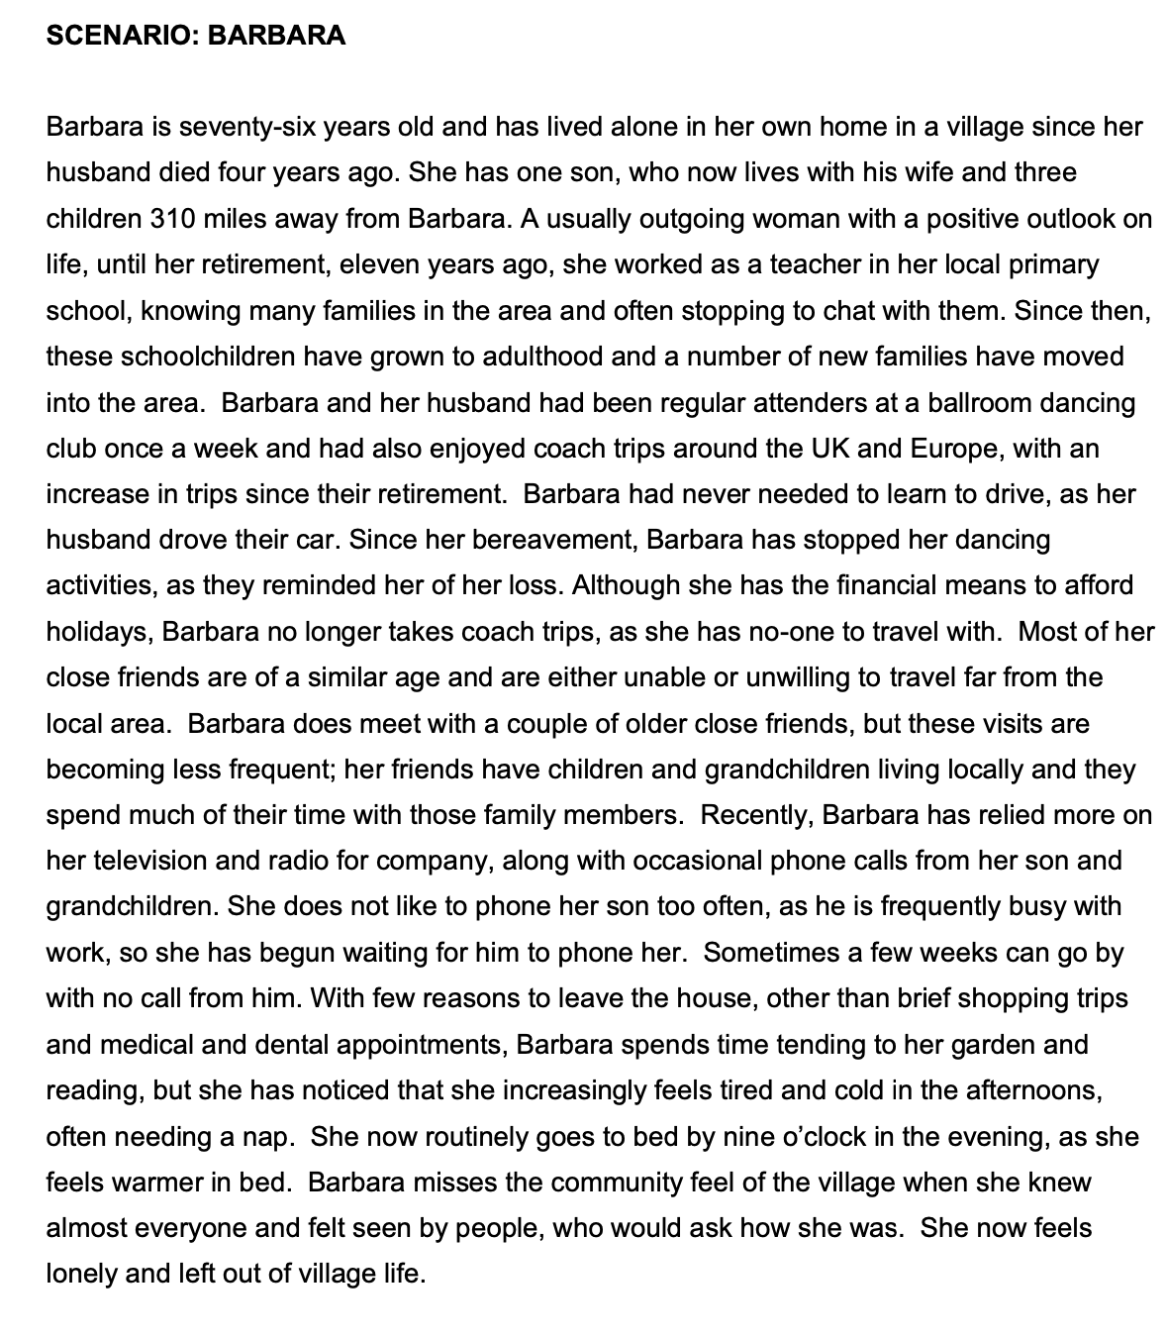

Reference list
Aslan, G., & Kant, E. (2022). Relationship between social exclusion and anxiety in older people during the COVID-19 pandemic. Geriatrics & Gerontology International, 22(3), 240-245. https://doi.org/10.1111/ggi.14335
Boss, L., Kang, D., & Branson, S. (2015). Loneliness and cognitive function in the older adult: A systematic review. International Psychogeriatrics, 27(4), 541-553. Doi:10.1017/S1041610214002749
Cardona, M., & Andres, P. (2023). Are social isolation and loneliness associated with cognitive decline in ageing? Frontiers in Ageing Neuroscience, 15. https://doi.org/10.3389%2Ffnagi.2023.1075563
Coyle, C.E., & Dugan, E. (2012). Social isolation, loneliness and health among older adults. Journal of Aging Health, 24(8). https://doi.org/10.1177/0898264312460275
Finley, A.J., & Schaefer, S.M. (2023). Affective neuroscience of loneliness: Potential mechanisms underlying the association between perceived social isolation, health and well-being. Journal of Psychiatry and Brain Science, 7(6), https://doi.org/10.20900%2Fjpbs.20220011
Fiske, A., Wetherell, J.L., & Gatz, M. (2010). Depression in Older Adults. Annual Review of Clinical Psychology, 5, 363-389. https://doi.org/10.1146%2Fannurev.clinpsy.032408.153621
Guarnera, J., Yuen, E., & Macpherson, H. (2023). The impact of loneliness and social isolation on cognitive aging: A narrative review. Journal of Alzheimer’s Disease Reports, 7(1), 699-714. https://doi.org/10.3233%2FADR-230011
Harrington, K.D., Vasan, S., Kang, J.E., Sliwinski, M.J., & Lim, M.H. (2023). Loneliness and cognitive function in older adults without dementia: A systematic review and meta-analysis. Journal of Alzheimer’s Disease, 91(4), 1243-1259. https://doi.org/10.3233%2FJAD-220832
Hossain, B., Nagargoje, V.P., Sk, M., Das, J. (2022). Social exclusion and mental health among older adults: Cross-sectional evidence from a population-based survey in India. BMC Psychiatry, 22. https://doi.org/10.1186%2Fs12888-022-04064-1
Hussain, B., Mirza, M., Baines, R., Burns, L., Stevens, S., Asthana, S., & Chatterjee, A. (2023). Loneliness and social networks of older adults in rural communities: A narrative synthesis systematic review. Frontiers in Public Health, 11. https://doi.org/10.3389%2Ffpubh.2023.1113864
Lam, J.A., Murray, E.R., Yu, K.E., Ramsey, M., Nguyen, T.T., Mishra, J., Martis, B., Thomas, M.L., & Lee, E.E. (2021). Neurobiology of loneliness: A systematic review. Neuropsychopharmacology, 46, 1873-1887. https://doi.org/10.1038/s41386-021-01058-7
Landeiro, F., Barrows, P., Nuttall Musson, E., Gray, A.M., & Leal, J. (2017). Reducing social isolation and loneliness in older people: A systematic review protocol. BMJ Open, 7. 10.1136/bmjopen-2016-013778
Lara, E., Martin-Maria, N., Torre-Luque, A., Koyanagi, A., Vancampfort, D., Izquierdo, A., & Miret, M. (2019). Does loneliness contribute to mild cognitive impairment and dementia? A systematic review and meta-analysis of longitudinal studies. Ageing Research Reviews, 52, 7-16. https://doi.org/10.1016/j.arr.2019.03.002
Needell, N.J., & Mehta-Naik, N. (2016). Is pet ownership helpful in reducing the risk and severity of geriatric depression? Geriatrics, 1(4), 24. https://doi.org/10.3390/geriatrics1040024
Newall, N.E., & Menec, V.H. (2017). Loneliness and social isolation of older adults: Why it is important to examine these social aspects together. Journal of Social and Personal Relationships. https://doi.org/10.1177/0265407517749045
Singh, A., & Misra, N. (2009). Loneliness, depression and sociability in old age. Industrial Psychiatry Journal, 18(1), 51-55. https://doi.org/10.4103%2F0972-6748.57861
Social Isolation and Loneliness in Older Adults: Opportunities for the Health Care System. (2020). United States: National Academies Press. https://www.ncbi.nlm.nih.gov/books/NBK557974/
Tomini, F., Tomini, S.M., & Groot, W. (2016). Understanding the value of social networks in life satisfaction of elderly people: A comparative study of 16 European countries using SHARE data. BMC Geriatrics, 16. https://doi.org/10.1186/s12877-016-0362-7
Tragantzopoulou, P., & Giannouli, V. (2021). Social isolation and loneliness in old age: Exploring their role in mental and physical health. Psychiatriki, 32(1), 59-65. https://psychiatriki-journal.gr/documents/psychiatry/32.1-EN-2021.pdf#page=51
Verdery, A.M., & Margolis, R. (2017). Projections of white and black older adults without living kin in the United States, 2015 to 2060. Proceedings of the National Academy of Sciences, 114(42), 11109-11114. https://doi.org/10.1073/pnas.1710341114
Weir, K. (2012). The pain of social rejection. American Psychological Association, 43(4). https://www.apa.org/monitor/2012/04/rejection#:~:text=Being%20on%20the%20receiving%20end,%2C%20depression%2C%20jealousy%20and%20sadness.
Zhong, B., Chen, S., Tu, X., & Conwell, Y. (2016). Loneliness and cognitive function in older adults: Findings from the Chinese longitudinal health longevity survey. The Journals of Gerontology, 71(1), 120-128. https://doi.org/10.1093/geronb/gbw037

