Financial Management for the Hotel Industry
BMIH5007

Lecturer: Tristan Hawkins
Student id: 2234760
Student name: Constantin Alexandru Toma
Word count: 2163

Table of Contents
Introduction 3
Financial analysis 3
Market position 5
CSR practices 8
Conclusion 8
Recommendations 9
References 10

Introduction
Financial management is critical for any organisation since it comprises the planning, organisation, direction, and control of financial operations. It ensures efficient and effective money management, which is critical for meeting corporate goals and increasing value for stakeholders (Atrill and McLaney, 2021). Effective financial management facilitates strategic decision-making, risk management, and long-term sustainability. This research analyses and compares the financial management techniques of two major hotel chains, Shangri-La Hotels and Travelodge Hotels. This study, which focuses on important financial parameters, looks at their revenue generation strategies, market positioning, development prospects, and commitment to Corporate Social Responsibility. Shangri-La Hotels and Resorts is a global luxury hotel chain headquartered in Hong Kong that is noted for its Asian hospitality and high-quality service. Shangri-La, founded in 1971, runs over 100 luxury hotels and resorts across the world, providing premium accommodations and great guest services to business and leisure travellers seeking luxurious experiences (Shangri-La Group, 2020). Travelodge Hotels Ltd is a UK-based budget hotel company known for offering low-cost lodging alternatives. Travelodge, founded in 1985, operates over 570 hotels mostly in the United Kingdom, Ireland, and Spain, catering to budget-conscious business and leisure travellers with an emphasis on simplicity and value (Travelodge Corporate Website, n.d.).

Financial analysis
The hospitality industry generates money from core operations like lodging, food and beverage, and ancillary services like spas and conferences. Financial success is frequently evaluated in terms of income sources, sustainability, and development potential (Wild, 2018). Income management, a vital strategic tool in the hospitality business, entails setting prices and forecasting consumer behaviour to maximise income (Guilding, 2014). The Income Statement, Balance Sheet, and Cash Flow Statement all play important roles in determining financial strategy and success. The Income Statement provides a full assessment of operational success, including income streams from accommodation reservations, food services, and auxiliary items like wellness centres and event hosting. It also precisely records expenditures, from direct operating costs to administrative charges, giving a clear picture of net profitability over a fiscal year (Bhimani, 2006). This statement is critical for determining how successfully income is converted into profit, since it highlights areas where efficiency can be improved or cost reductions are required. Similarly, the Balance Sheet gives a picture of a hotel's financial stability and health by displaying its assets, liabilities, and equity at a given point in time. Assets include tangible objects such as property and equipment required for everyday operations and guest services, whereas liabilities are financial obligations that must be properly managed to ensure long-term viability (Atrill and McLaney, 2021). Equity indicates the owner's investment and retained earnings, providing insight into the company's financial strength. Lastly, the Cash Flow Statement is critical, especially in an industry with considerable seasonal changes and high capital expenditures. It breaks down the cash earned and consumed in operating, investing, and financing activities, providing information about the hotel's ability to generate cash to fund operations, reinvest in the business, and service debt (Seal, 2019). This statement is critical in ensuring that there is enough liquidity to meet both short-term operational needs and long-term strategic goals, which highlights all aspects of financial planning and investment decisions (Atrill and McLaney, 2021). Shangri-La Hotels recorded total revenue of $2.75 billion for the most recent fiscal year, with room revenues accounting for 35% and food and beverage services accounting for 30%, respectively. The remaining percentage comes from other services such as event hosting and wellness centres. Despite these significant revenues, the company's net income was $450 million, showing high operational costs, largely related to luxury service provisions and property maintenance (Shangri-la, 2023). In comparison, Travelodge reported total revenue of $1.2 billion, with room sales accounting for almost 80% of total revenue. Their streamlined operational style reduces expenses, resulting in a net income of $180 million (Travelodge, 2023). This displays effective cost management geared to their budget accommodation focus, albeit with lower profit margins than luxury categories (Atrill and Mclaney, 2021). Shangri-La's balance sheet shows total assets of $10 billion, including large property holdings worth $7 billion, highlighting their investment in premium premises and facilities. Their liabilities reach $6 billion, with long-term debt accounting for $3 billion, showing a leveraged but asset-backed financial structure. Travelodge's assets comprise $3 billion, with a smaller property portfolio worth $1 billion. Their liabilities are significantly smaller at $1.5 billion, with long-term debt accounting for only $600 million, indicating a less leveraged position that is consistent with their operational agility and reduced capital expenditure requirements (Travelodge, 2023). Shangri-La generated $800 million in net cash from operating activities, demonstrating its strong revenue production capabilities. However, cash flows from investing activities resulted in a net outflow of $500 million, owing to continuous investments in property upgrades and expansions. The cash flow from financing activities was a net outflow of $200 million, owing primarily to loan repayments and dividend payments, demonstrating a balanced approach to growth and shareholder returns (Shangri-la, 2023). Travelodge reported $300 million in net cash from operations. Their investment operations resulted in a modest net outflow of $100 million, indicating prudent capital expenditure. Financing activities resulted in a net inflow of $50 million, indicating good debt management and less aggressive dividend policies, as is characteristic of corporations focused on growth and operational stability (Travelodge, 2023).

Market position
Brand equity, client loyalty, and market segmentation all have an impact on a hospitality company's market position (Walker, 2021). Strategic positioning is crucial since it influences the client base, pricing tactics, and the hotel's competitiveness in the marketplace. Travelodge's market position in the UK indicates excellent brand awareness and a loyal client base. Travelodge has a high brand awareness among hotel clients in the UK, with 91% recognising the brand when shown the logo and name (Statista, 2024). This high degree of awareness demonstrates the strength of Travelodge's branding initiatives and its established presence in the UK hotel industry. Despite its widespread familiarity, the true affinity for the brand has room for improvement. While 34% of all hotel customers say they like Travelodge, the proportion jumps to 37% among those who are familiar with the brand. This implies a modest level of favourability, pointing to possible areas for improvement in customer perception and brand appeal. Travelodge has a considerable market share, with 27% of hotel clients in the United Kingdom using its services. This equates to 30% utilisation among those who recognise the brand, demonstrating a good conversion of brand awareness to actual usage (Statista, 2024). This degree of market penetration demonstrates Travelodge's appeal to a wide range of demographics, which is most likely due to its value-oriented positioning. Loyalty among Travelodge customers is relatively high, with 22% indicating a willingness to utilise the brand again. This shows 81% loyalty among current users, indicating high consumer satisfaction and brand reliability. Such devotion is critical for long-term economic success, particularly in a service-oriented industry like hospitality. However, there is little buzz about Travelodge in the media and online. Only 16% of hotel guests had heard about Travelodge in the media, social media, or advertising in the three months preceding the study, with the figure improving slightly to 18% among those familiar with the brand (Statista, 2024). This implies that, while Travelodge has a significant market presence, there may be chances to increase awareness and engagement through more aggressive or creative marketing efforts.
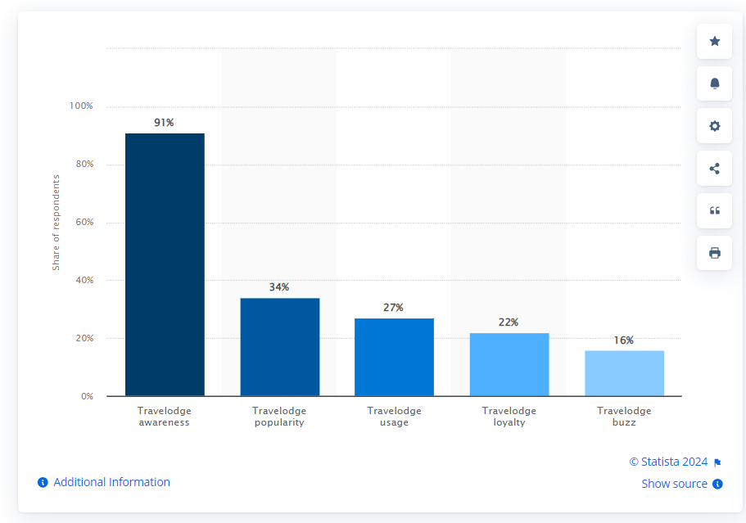
Fig 1. Statista (2024). Travelodge brand awareness, usage, popularity, loyalty, and buzz among hotel customers in the UK in 2022

On the other hand, Shangri-La Hotels, is well-known in the UK luxury hotel sector, particularly for its high-end properties such as the Shangri-La Hotel at The Shard in London. This hotel represents the brand's luxury ethos and strategic location in key cultural and economic hubs, catering to affluent travellers seeking distinctive Asian hospitality and local cultural experiences (Heffernan and Droulers, 2007). Despite its distinction and outstanding service standards, Shangri-La's brand awareness and market influence in the UK are challenged. It competes in a market where major worldwide chains such as Marriott, Hilton, and Hyatt hold a significant market share. These organisations collectively account for almost 25% of the worldwide luxury hotel industry, demonstrating the level of competition Shangri-La confronts in expanding its presence and securing greater market share outside of Asia, particularly the United Kingdom (Lock, 2019). Shangri-La's popularity among millennials in the UK is quite low when compared to other brands, indicating a niche appeal that caters to luxury seekers rather than the general market. Travelodge, on the other hand, is a brand that stands out from Shangri-La in terms of market strategy and consumer base (Statista, 2023). Travelodge, positioned as a low-cost choice, targets a broader market group by emphasising affordability and convenience. This positioning is reflected in its increased appeal among the same demographic. Travelodge's large network across the UK, which provides basic accommodations without the frills of luxury, efficiently caters to budget-conscious travellers and transient customers, gaining a significant presence in the hospitality industry. The disparities in market position between the two emphasise various strategic approaches. Shangri-La focuses on luxury and exclusive experiences, which, while appealing to a specific group, may not be as widely embraced as Travelodge's value-oriented and accessible offerings.
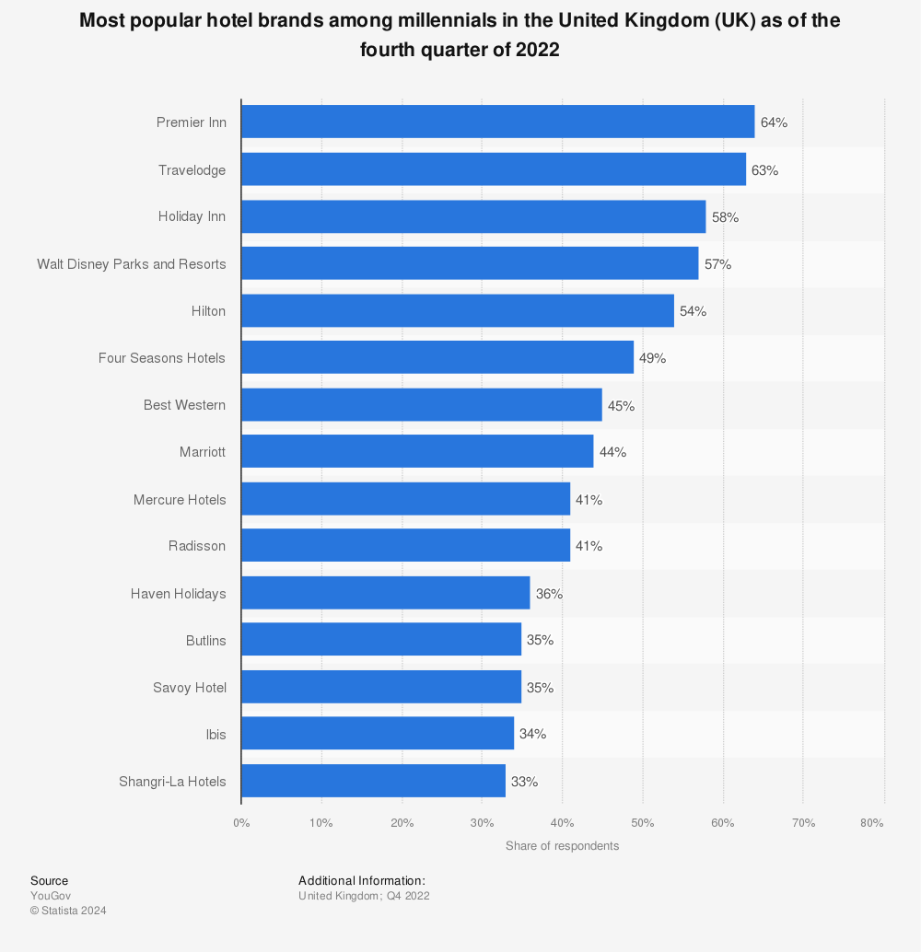
Fig 2. Statista(2023). Most popular hotel brands among millennials in the United Kingdom (UK) as of the fourth quarter of 2022

CSR practices
CSR in hospitality management entails environmentally friendly methods, community engagement, and ethical governance. Financial commitment to CSR can improve a company's brand and match operations with global sustainability goals (Drury, 2021). Shangri-La and Travelodge allocate financial resources to Corporate Social Responsibility programmes in accordance with their respective strategic aims and market positioning. Shangri-La Hotels is noted for its strong dedication to sustainability and social responsibility, which is consistent with the luxury brand image. The group's CSR programmes are wide, with an emphasis on environmental sustainability, social welfare, and cultural heritage. Shangri-La's sustainability initiatives include considerable expenditures in energy efficiency, trash reduction, and environmentally friendly building methods (Shangri-La, 2024). Furthermore, the hotel company regularly participates in social programmes that help the communities surrounding its properties, such as educational programmes, health and wellness campaigns, and local cultural preservation activities. Shangri-La is committed to lowering its environmental footprint by investing significantly in sustainability projects. For example, they plan to reduce potable water consumption per guest night by 40% by 2025 compared to 2018 levels (Shangri-La, 2024). Travelodge Hotels, on the other hand, focuses exclusively on the inexpensive hotel category and takes a different approach to CSR. Travelodge's CSR actions are mainly focused on operational savings, such as lowering energy use and waste, which is directly related to the company's goal of maintaining affordability (Travelodge Corporate Website, 2023). Their sustainability reports include measures such as increasing energy efficiency across their facilities and participating in community service activities, which are smaller in scale than Shangri-La but aim to improve their operating impact on the environment and communities. Travelodge has prioritised carbon reduction by introducing energy-efficient measures throughout its hotels. They reported a 5% decrease in overall energy use per room night over the previous year, owing to the implementation of LED lighting and energy-efficient appliances throughout their hotel chain (Travelodge Corporate Website, 2023).

Conclusion
In conclusion, the comparison of Shangri-La and Travelodge demonstrates their respective financial and operational strategies in the hospitality industry. Shangri-La's commitment to luxury and extensive CSR activities is consistent with its upscale brand identity, as it caters to a niche demographic that values premium services. In contrast, Travelodge's emphasis on efficiency and cost-effective solutions appeals to a wider audience by emphasising accessibility and value. Both brands demonstrate strong integration of their business goals and market positioning, highlighting their unique strengths in the premium and budget markets. Moving forward, each hotel company may benefit from further leveraging their distinct market positions to gain a competitive edge and increase stakeholder value.

Recommendations
- Shangri-La Hotels' market positioning and customer base could benefit from localised marketing methods suited to unique regional tastes and cultural subtleties. This strategy, known as geo-targeting, can assist Shangri-La in efficiently connecting with local markets and tailoring services to satisfy a wide range of customer needs. According to Dion and Sitz, (2020), localising marketing efforts not only boosts brand relevance, but also increases customer engagement and loyalty across geographic regions. Shangri-La might strengthen its relationship with local communities and improve the visitor experience by incorporating local culture, cuisine, and customs into its service offerings and marketing materials, strengthening the brand's cultural awareness and responsiveness.
- A key recommendation for Travelodge Hotels is to improve its digital marketing techniques in order to capitalise on brand familiarity and attract digitally savvy budget travellers. This includes optimising online booking platforms and engaging younger consumers through social media (Khatri, 2019). Furthermore, Travelodge might broaden its value proposition by diversifying its services to include premium budget options, which can appeal to a larger spectrum of clients looking for affordability without sacrificing basic amenities. This strategy may assist to mitigate the effects of economic changes by appealing to budget-conscious travellers who nonetheless respect quality (Egan and Haynes, 2019).

References

Atrill P, McLaney E (2021) Management Accounting for Decision Makers, FT Prentice Hall

Bhimani A, (Ed) (2006) Contemporary Issues in Management Accounting , Oxford

Dion, D. and Sitz, L., 2020. Regional affiliations: Building a marketing strategy on regional ethnicity. In Marketing management (pp. 47-58). Routledge.

Drury C (2021) (11th Ed) Management and Cost Accounting, London, Prentice Hall

Egan, D. and Haynes, N.C., 2019. Manager perceptions of big data reliability in hotel revenue management decision making. International Journal of Quality & Reliability Management, 36(1), pp.25-39.

Guilding,C.(2014) (3rd Edition) Accounting Essentials for Hospitality Managers, London, Routledge

Heffernan, T. and Droulers, M. (2007). When great service leads to great customers: Relationship Marketing Summit. Time to integrate perspectives, [online] pp.1–11. Available at: https://researchoutput.csu.edu.au/en/publications/when-great-service-leads-to-great-customers-the-case-of-shangri-l.

Khatri, I., 2019. Information technology in tourism & hospitality industry: A review of ten years’ publications. Journal of Tourism and Hospitality Education, 9, pp.74-87.

Lock, S. (2019). Topic: Hotel industry. [online] www.statista.com. Available at: https://www.statista.com/topics/1102/hotels/.

Seal W (2019) (6th Ed) Management Accounting, London, McGraw Hill

Shangri-la (2023). Annual Report 2023. Public disclosures. [online] Available at: https://www.shangri-la.com/group/investors/public-disclosures.

Shangri-la (2024). Sustainability Raport 2023. Available at: https://www.shangri-la.com/group/sustainability/report [Accessed 2 May 2024].

Shangri-La Group (2020). Our Presence. [online] Shangri-la.com. Available at: https://www.shangri-la.com/group/.

Statista. (n.d.). Top hotel brands among UK millennials 2020. [online] Available at: https://www.statista.com/statistics/951264/most-popular-hotel-brands-millennials-uk/.

Statista. (2024). Travelodge brand profile UK 2022. [online] Available at: https://www.statista.com/forecasts/1335657/travelodge-hotels-brand-profile-in-the-uk.

Travelodge (2023). Annual report 2023. Travelodge Investor Site. [online] Available at: https://www.travelodge.co.uk/investors/home

Travelodge Corporate Website. (n.d.). Company Overview. [online] Available at: https://travelodge.co.uk/our-business/about-us/company-overview/.

Travelodge Corporate Website. (2023). Better Future Report 2023. Sustainability. [online] Available at: https://travelodge.co.uk/our-business/sustainability/.

Walker J (2021) Introduction to Hospitality, Harlow, Pearson

Wild J (2018) Fundamental Accounting Principles, New York, McGraw Hill
‌

‌

