

Black Powder Gin Consultancy Project


Black Powder Gin/AA Events
Authored by: Austen Hudson

Acknowledgements

A great thank you and appreciation to Black Powder Gin and AA Events who conceived of this project and provided essential information throughout. A special thank you to everyone completing the online questionnaire. Without their response, this report would not be able to complete. Thank you to Jacqui Jones, Senior Lecturer at University of Wales Trinity Saint David for ongoing support, feedback and encouragement to do this project.

Executive Summary
The aim of the following consultancy project is to investigate marketing strategies which will help increase the attendance of Black Powder Gin and AA Events ‘Ginsperience’, amongst the target demographics post Covid-19 lockdown measures being lifted within the UK.

The following marketing plan has been created on behalf of Black Powder Gin Distillery which is a family run business that has produced fruit infused gins for a number of years and AA Events who are a creative events team who specialize in the planning, production and management of live events at the Black Powder Gin Distillery as well as being available for private hire externally. The management of both Black Powder Gin and AA Events have requested for a consultant to increase attendance amongst a target demographic through effective advertising strategies and efficient marketing plans.

Whilst consulting the following marketing plan the focus points were primarily the use of social media for advertising purposes and developing the website to be more attractive to the target demographics. The marketing plan has been successful as a result of using verifiable and qualitive research methods in order to gain statistics which will make the marketing plan achievable. With both Black Powder Gin and AA Events in mind the marketing plan will investigate the most effective methods of marketing the ‘Ginsperience’ as the United Kingdom begins to come out of Covid-19 quarantine measures.

Contents Page
- Introduction
  - Terms of Reference
  - Project Justification
  - Aims and objectives

- Findings
- Suggestions
  - Social Media
  - Theming
  - Pricing
  - Post Covid-19 restrictions
  - Virtual Experience
- Limitations
  - Legal legislations
  - Changes to the experience
  - Potential costs
- Conclusion
- Appendix
  - Evidence of Submitting Questionnaire
  - Gantt chart
  - Proof of Correspondence and Ethics Form
- Bibliography

- Introduction
The purpose of the following consultancy project is to independently investigate which demographics would be more inclined to spend their available income on alcohol-based event. With the cooperation and support of the management, the focus is to investigate effective methods of marketing Black Powder Gin and AA Events ‘Ginsperience’ to said demographics efficiently and in a cost-effective manner.

The Black Powder distillery is a family run business that has been producing fruit infused gins for a number of years. All of their gins are made from select fruits and botanicals, harvested from their estate located in Weeton, Preston. They also offer a variety of other spirits and services which include private hire for weddings and parties and their Ginsperience. The Ginsperience is an experience available to the public hosted on the estate of the distillery which features live music, a variety of drinks and cocktails and food in a picturesque setting and is available all year round across select dates and are accessible at the expense of £54 for a ticket.

  - Terms of Reference
The following report has been produced for Black Powder Gin, AA Events and University Wales Trinity St. David by Austen Hudson, Events Management student. The report will assess the current market with the aim of producing and providing a successful marketing strategy which can be utilized in the future by Black Powder Gin and AA Events.

  - Project Justification
The management team from Black Powder Gin and AA Events require an independent marketing consultant to investigate efficient and effective marketing strategies with the intention of increasing attendance amongst the target demographic. The event is received by an array of customers aged between 20 and 65, however after identifying that those aged between 20-31 and 50-65 are more likely to invest their time and available expenditure into the ‘Ginsperience’ the purpose of the report is to primarily attract them without deterring the usual attendees.
Due to unforeseen circumstances, the current impacts of Covid-19 have resulted in restrictions being placed across the UK by the government restricting events and gatherings in public places making it impossible for the ‘Ginsperience’ to take place until these measures are lifted. As a result, Black Powder Gin have begun a delivery service of their products in order to ensure they are able to survive. The following report will also investigate how Black Powder Gin and AA Events can successfully and effectively market the ‘Ginsperience’ as the nation begins to ease out of the restrictions put into place as a result of Covid-19.

  - Aims and Objectives
The aim of the following report is to evaluate the effectiveness of present marketing strategies which attract the target demographic and further this by identifying separate successful strategies which directly relate to the target demographic and the Ginsperience as the United Kingdom starts to come out of lockdown measures related to Covid-19. As a result of an effective marketing plan the organization will likely receive:
- Increased revenue and profit levels
- Increased attendance at future events
- Greater awareness of Black Powder Gin company’s products and AA Events services offered in the surrounding areas.

- Findings
In order to determine the most effective methods of attracting our target demographic there has been a variety of research methods undertaken, mostly secondary, including case studies, journals, internet resources and statistical analysis. In order to fully understand the potential of the market in the surrounding areas a location analysis has been conducted on various areas within the Fylde district surrounding the Black Powder Estate.

The general attendee of the Ginsperience is aged between 30-45 and are usually middle class. The location analysis indicates that this is the most popular age range in the target areas which means it would make sense to target this demographic specifically, however this demographic does not necessarily have the most available expenditure for events. The purpose of the following consultancy project has been to identify which demographics are more likely to spend on the ‘Ginsperience’ and which are more likely to become repeat attendees. The report identifies efficient marketing methods in order to attract a demographic aged between 25-65, with the main target areas being ‘millennials’ and ‘baby boomers’ (people aged between 45-65) from the distillery’s surrounding areas specifically. According to Erin Yurday, 2019 ‘The average UK household spends £868 on alcohol each year, based on an average household size of 2.4 people—£452 for consumption at home and £416 on drinks out of the house.’ And ‘Those in the North West spend more on alcohol than any other region in the UK—£17 per week.’ This would suggest that the demographic and area which we are operating around would be perfect target, although this suggests people across the UK are more likely to spend money on alcohol for consumption at home, on average the UK citizen will only spend £46 less yearly on alcohol consumption out of the house at events such as the Ginsperience so there is certainly a market available.

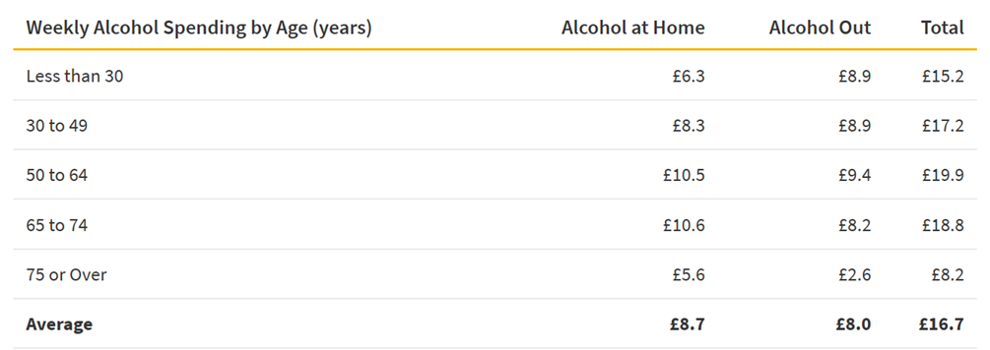-(Erin Yurday, 2019)

Above is a table which indicates the weekly alcohol spending of the average UK citizen by Age. Although our target demographic age range is rather broad (25-65) the table indicates that people aged 50-64 are likely to spend the most on alcohol and have more time to spend on events such as the Ginsperience due to their children being older ‘people have more potential to attend concerts in their older years. The survey found 44 percent of boomers (ages 51 to 70) that attend live events said they attend more events now than 10 years ago. In addition, more than half of boomers (54 percent) reported having more time for live experiences now that their children are older.’ (Billboard, 2015)

The general attendee of the Ginsperience is aged between 30-45 and are usually middle class. The location analysis indicates that this is the most popular age demographic in the surrounding target areas. However, Millennials and ‘baby boomers’ are the focus of the report as they are the most likely age groups to repeatedly attend an event such as the Ginsperience. Millennials, although most are still yet without things such as their own property, are more likely to attend events due to the amount of free time they have as they usually do not have a family to look after and as a result of not having their own property or family yet, usually have more expendable income than people who are middle aged making them an ideal target. With the knowledge that these age groups are more likely to attend such an event research has primarily focused on how to attract these demographics in a cost-effective manner.

‘While many Millennials have not hit their peak purchasing power due to student loans and starting a family, they are certainly heading that way, and brands realize the importance of getting in front of them early. But marketers should take care in making sure that they aren't alienating other groups of consumers in the process.’ (Kim Speier, 2016)

The location analysis indicates that millennials are not that large of a demographic in the target areas meaning that there is a limited market, however with the knowledge that they are more likely to invest their time and income into events such as the Ginsperience this makes them an ideal target with the potential of longevity if a good customer-company relationship is maintained.
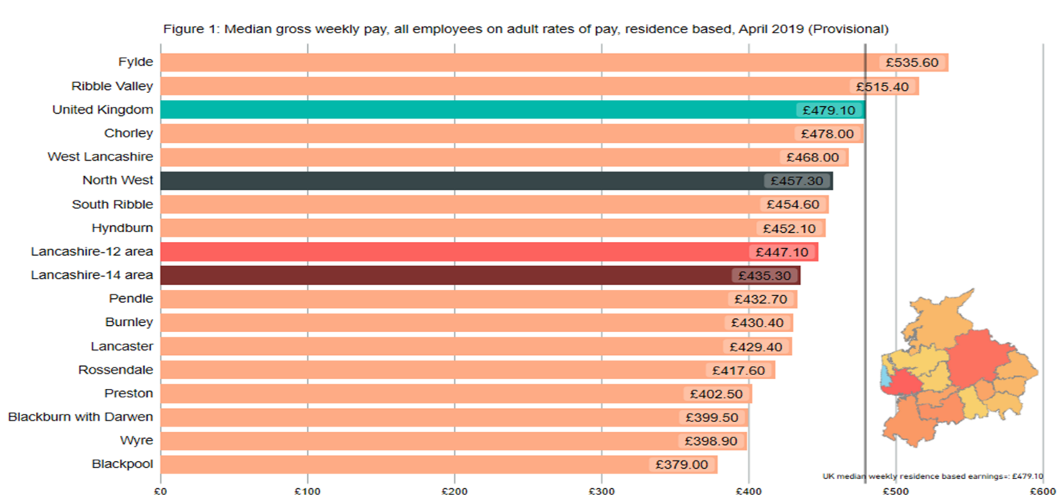

In 2019, Fylde and Chorley were the only two local authority areas in Lancashire where the residence-based median annual gross earnings exceeded the UK figure of £24,897. This indicates that within the region of Fylde, there is potentially a greater amount of available revenue for events such as the Ginsperience.

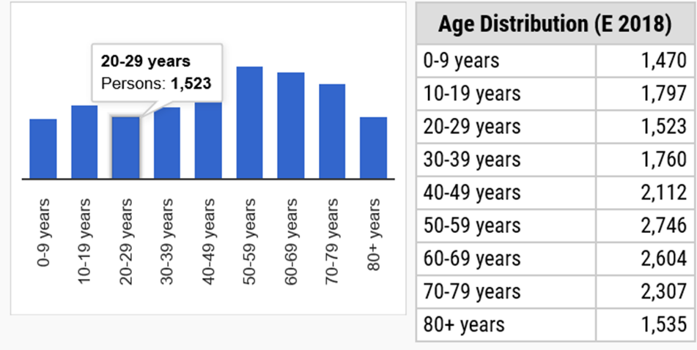
Within Staining and Weeton, the two closest areas within proximity of the distillery, the average age is 38, falling below the national average perhaps indicating that there is potential to attract a greater amount of millennials from these areas specifically and being the within the closest proximity of the distillery, the market here are more likely to become repeat customers.

Poulton’s age range falls in suit with the region of Fylde with many of its residents being aged between 40 and 65. The percentage of millennials who are residents of Poulton is 18.4% meaning that there is potentially an opportunity to develop a market here amongst millennials also.
Esprick and Elswick has an average age of 44 years old, however 21.7% of the residents are millennials meaning that although this is not the greatest demographic in the area, there is a potential market to attract in this area also.
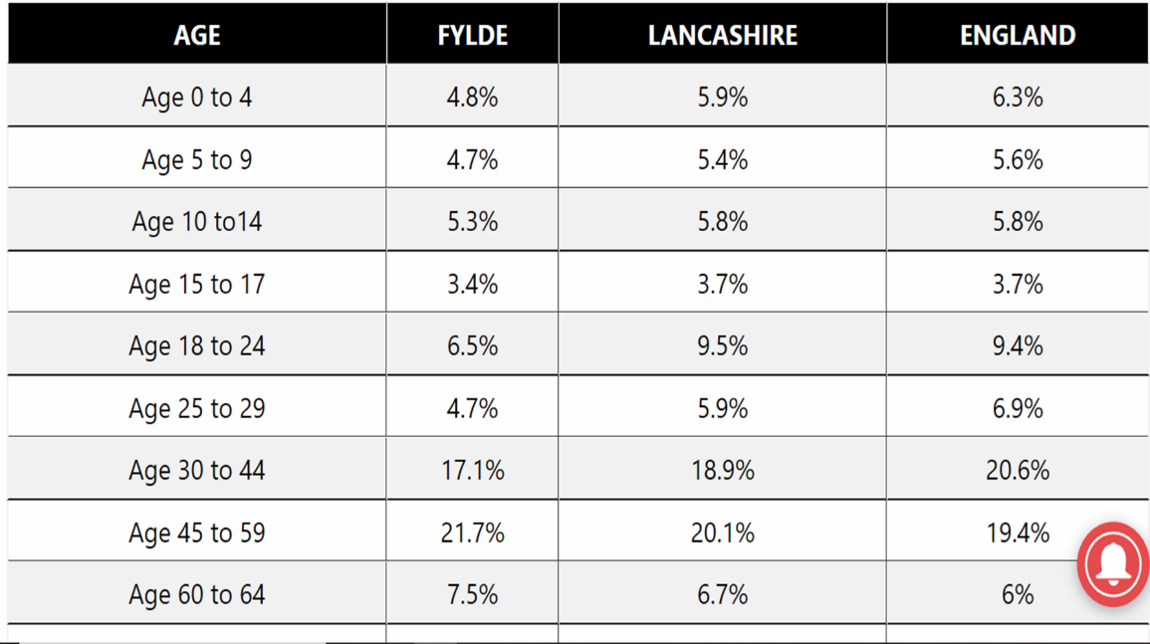

- Suggestions

  - Social media
Social media continues to grow in popularity across the globe day by day. Social media has evolved into so much more than just online personal profiles used for socializing and today offers a variety of effective marketing platforms.
‘Additionally, over the last two decades, it has risen as one of the primary marketing channels.
With over 40% of the world's population on social media, it is critical your business devise an effective social media strategy to reach your intended audience.
With the knowledge that these age groups in particular are more likely to attend such an event research has primarily focused on how to attract these demographics through the available social media platforms.

‘60% of people in the 50 – 64-year age group, which is most of the boomer population, are now on at least one social media site. Facebook is by far the most popular social media site for baby boomers’ (Colorado University, 2016)
With the knowledge that this age group in particular are more likely to have expendable income for an event such as the Ginsperience due to many now being ‘empty nesters’ and some perhaps retiring, it would make sense to consider the option to advertise alongside Facebook as it is a proven cost effective method of reaching this area of our target demographic. The option to advertise with Facebook lets you decide how much you would like to invest into the advert and even gives you the option to select details about the demographic you would like to target, with the knowledge that from location analysis all of the surrounding areas have a larger population of ‘baby boomers’ this would make Facebook Advertisement an efficient method of reaching them as there would be the option to select the areas and ages to target.
Facebook Advertising Costs
Expense | Average Cost
Monthly Ad Spend | $200 to $1500 per month
Monthly Campaign Management | $1000 to $2500 per month
Minimum Budget | $1 per day for impressions  $5 per day for clicks, likes, or views  $40 per day for conversions
Bid Type
CPC | $0.97 per click
CPM | $7.19 per 1000 impressions

Although Facebook is again rated the most popular platform amongst millennials, a more effective choice of reaching millennials would be Instagram. Instagram is becoming increasingly popular and gives businesses the chance to present an advertisement post amongst their target demographics newsfeed as if it were a post from anybody else that they might follow. Instagram has also, in recent years, developed an influencer culture which has seen some of it’s users acquire massive amounts of followers and as a result of having such a vast audience, they are willing to sponsor products and services for a price. They can not only share and promote the ‘Ginsperience’ but can be approached about attending an event and posting their experience. Advertising with influencers are an effective method of marketing because it feels more genuine than an advert and therefore usually has a stronger impact on the audience, this is because the influencers and their followers usually have similar interests and therefore feel like they would relate with their experiences.
‘The app offers the perfect space for brand ambassadorship, with influential users authentically recommending products and services to their loyal audience. With the influencer space estimated to grow to a $5-10 billion industry by 2021, it’s clearly a marketing force that isn’t going anywhere.’ (Nicola Cronin, 2020)
Instagram Advertising Costs
Expense | Average Cost
Monthly Ad Spend | $200 to $1500 per month
Monthly Campaign Management | $1000 to $2500 per month
Minimum Budget | $1 per day for impressions  $5 per day for clicks, likes, or views  $40 per day for conversions
Bid Type
CPC | $3.56 per click
CPM | $7.91 per 1000 impressions

  - Theming
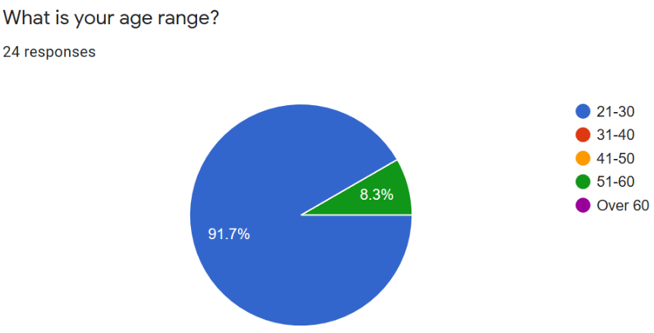
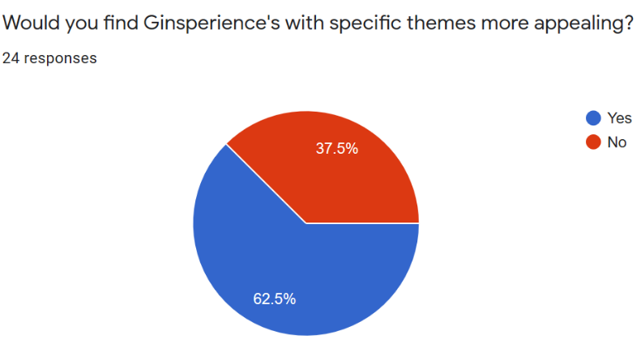
Of the 24 recipients of the survey, 15 (62.5%) agreed that themes such as fancy dress and film themed nights would make the Ginsperience more appealing to them, considering that 22 (91%) of those were aged between 21-30 this indicates that themed based events would attract this demographic in particular.

Particular themes could also work in attracting new audiences who might not usually consider the Ginsperience due to their interest in the specific theme. The recipients of the survey were then offered the chance to suggest themes they would be interested in and the majority suggested themes related to fancy dress such as 80s night and movie themed evenings. The rest of the recipients suggested a lady’s night which could prove effective marketed well, however this will limit the attendance to only females.
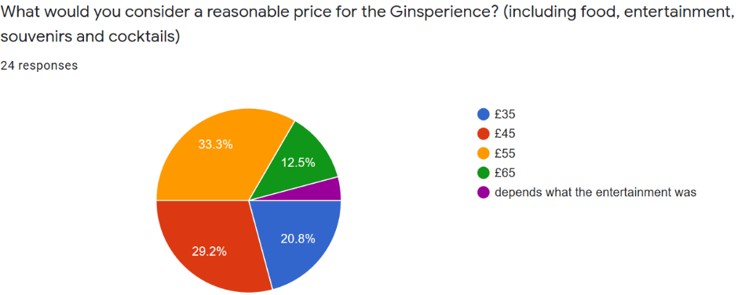
  - Pricing

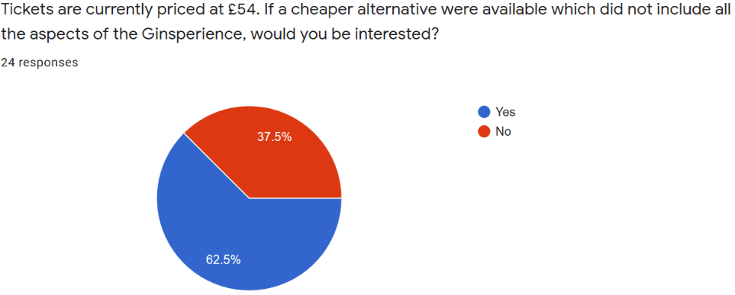
- When the recipients were questioned about what they considered a reasonable price for the Ginsperience 11 (45.8%) thought that the event could be worth more than it costs, where as 12 (51.1%) thought that the tickets should be cheaper.
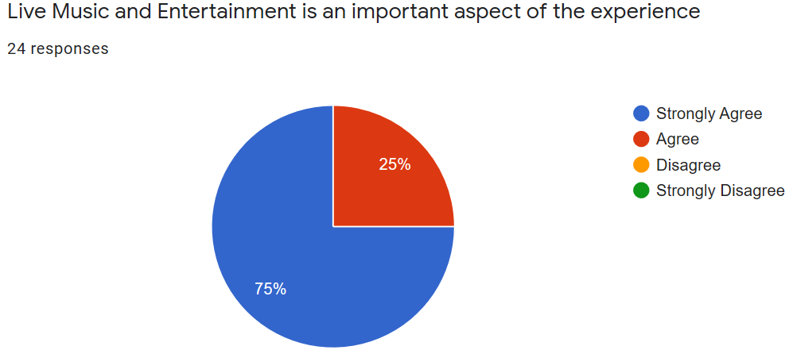
- 15 (62.5%) of the recipients agreed that a cheaper alternative to the Ginsperience which does not include all the usual aspects included would be more appealing to them.
- Recipients were then asked which aspect how important they considered each aspect of the experience.
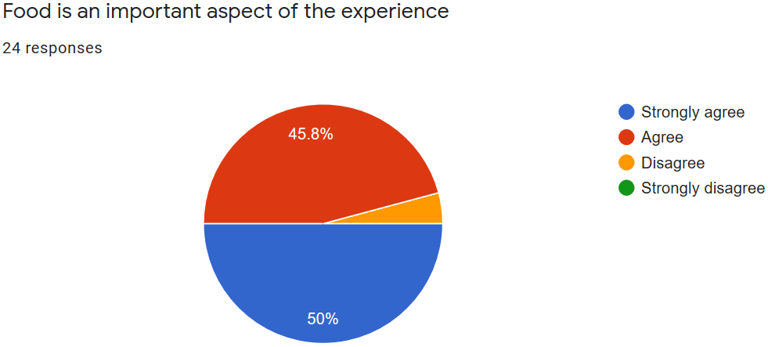
- 18 (75%) of recipients strongly agreed that live music and entertainment was important and 6 (25%) agreed.
- Only 1 (4.2%) recipient thought that food was not an important aspect of the event with 12 (50%) strongly agreeing and 11 (45.8%) agreeing.
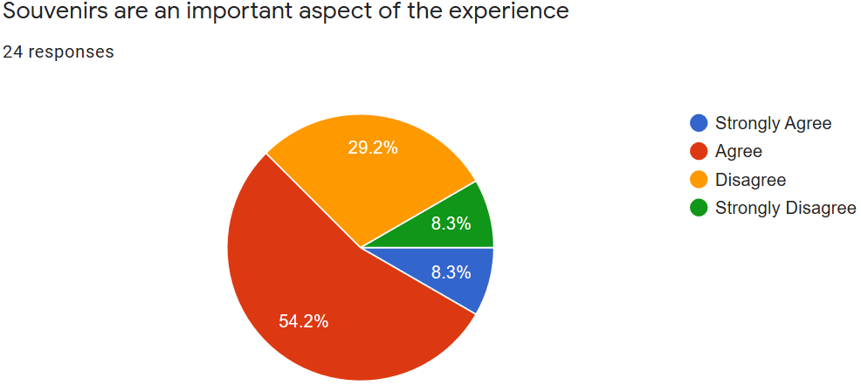
- Souvenirs received mixed results from the recipients with only a total of 9 (37.5%) considering them to not be important to the experience.
The results from the survey would suggest that the least important aspect of the event would be the souvenirs as the other aspects only had 1 recipient who considered them not to be important between them. From these results souvenirs are likely the best removed aspect if a cheaper alternative of the Ginsperience were designed. However, it is worth considering the importance of souvenirs as they leave a long-lasting impression which will stay with the customer and remind them of the experience.

  - Post Covid-19 Restrictions
There haven’t been any specific dates set for when events such as the Ginsperience will be legal to take place again due to Covid-19 restrictions placed by the government. There is no doubt that for some time after restrictions are lifted, measures such as private booths, social distancing and PPE will all be made mandatory at events in order to prevent a further spike in Covid-19 cases.
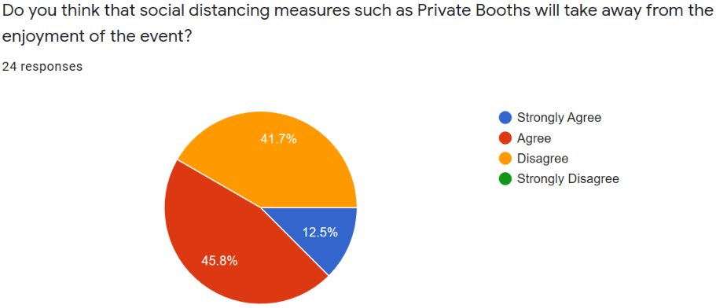
When recipients of the survey were asked how these measures would affect the experience the results were as followed:
- 14 (58.3%) of the recipients either agreed or strongly agreed that private booths will make the experience less enjoyable.
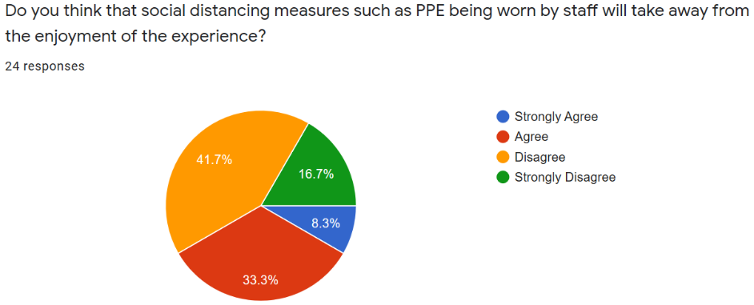
- Only 10 (41.6%) of recipients strongly agreed or agreed that PPE worn by staff would make the experience less enjoyable with 14 (58.4%) of the recipients disagreeing or strongly disagreeing that it would be an issue.
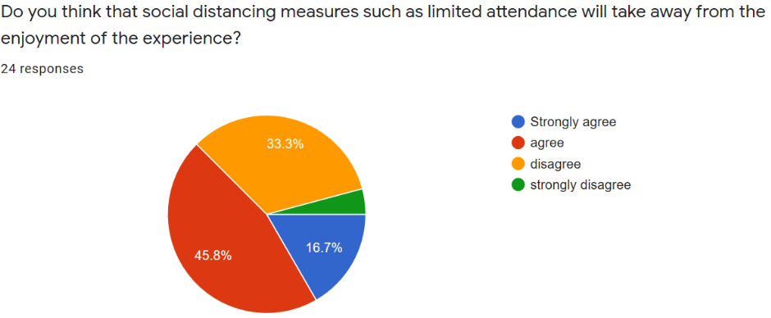
- 15 (62.5%) of the recipients either agreed or strongly agreed that social distancing (2 meters apart from others) would take away from their experience.
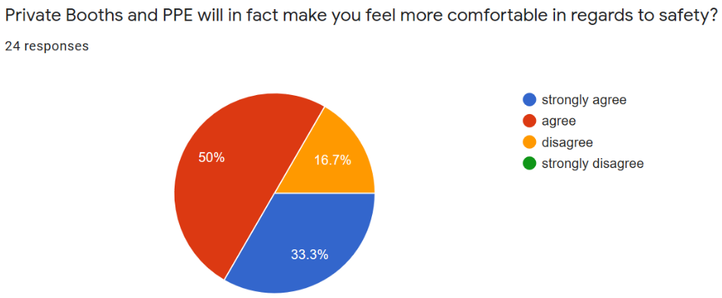
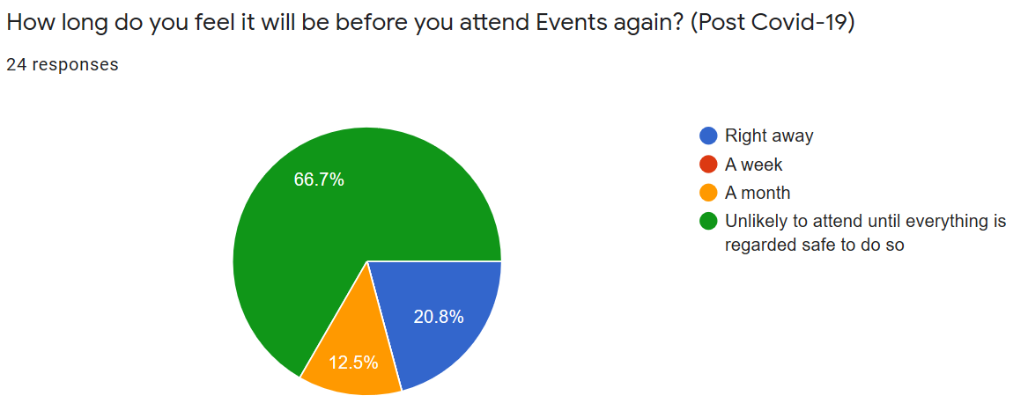
However, when recipients of the survey were asked whether or not they would feel more comfortable with the previously mentioned equipment such as private booths and PPE and measures in place such as social distancing, 20 (83.3%) of the recipients either agreed or strongly agreed that they would feel more comfortable with the measures in place. This would suggest that despite the majority believing the experience wouldn’t be as enjoyable with these requirements, they might possibly consider twice about attending the Ginsperience if they weren’t in place for the sake of their own safety. Considering that 16 (66.7%) of the recipients stated they would not attend events again until everything is regarded safe to do so, it is unlikely that many of the recipients would consider attending without the mentioned safety measures in place.

  - Virtual Experience
Since the majority of the world was put under Covid-19 restrictions, many companies have turned to making their events available via a virtual experience. Although a virtual experience certainly cannot offer the personal feel and enjoyment of attending an event with friends, it is a thoughtful alternative.
Since Lockdown restrictions were put in place across the UK, Black Powder Gin have successfully developed a delivery service of their products for their customers. With this in mind, customers could be approached about attending a virtual Ginsperience from the comfort of their own homes. The products required for the cocktails they would usually enjoy would be delivered and considering the venue and food would not be an aspect the price could be significantly reduced and the entertainment would need to be live streamed using a platform such as zoom or skype. There is even the possibility of hosting live virtual cocktail making classes or even have quiz nights.
Despite this obviously not being the experience which customers would be used to at the Ginsperience, it is unfortunately at this time the only experience which can be offered and it would help to continue the relationship shared between Black Powder Gin/AA Events and their customers.
‘Exhibitions are tactile, and offer opportunities that simply can’t be reproduced electronically, even in the most realistic VR world. Anyone who has ever attended the Edinburgh Festival, Glastonbury or a World Cup match knows the visceral excitement of being part of a live event and a like-minded group of human beings.
However, what the pandemic has taught us is that there are benefits to streaming, VR and online collaboration and it will accelerate the use of these technologies as enhancements and added value to live event programmes.’ (PMLive, 2020)

- Limitations

  - Legal Legislations
When undergoing any project, one must consider what could considered a constraint towards it. The organization may not have a willingness to accept the recommendations given by the consultant to improve their business once research has been collected and collated.
‘Legal legislations and licenses that need to be adhered to whilst undertaking online advertising, including the business protection from misleading marketing regulations 2008’ (UK Government, 2008).
Covid-19 restrictions will likely see many legal requirements surrounding events when they are able to continue, limited attendance could make this awkward for Black Powder Gin and AA Events as they will be require a larger initial investment and will not be able to return their usual revenue due to limited customers.

  - Changes to the experience

Attracting particular age demographics can potentially result in driving away others. If the Ginsperience is changed in any way to suit one demographic this might not appeal to others and therefore could leave a negative impression with the usual customers as they might consider their interests less important than that of those they are trying to attract. This has to be handled carefully as two target demographics interests can be generational, therefore it is important that the event is not focused primarily on one or the other but focuses broadly across all ages making changes that won’t deter certain demographics from attending the Ginsperience.

  - Potential Costs

With the main marketing strategy being focused on advertising through popular media sites the costs can be kept minimal. Social media sites such as Facebook and Instagram give the customer the option to invest as much as they would like to over a period of time, the more the businesses wish the invest the more their advert will be present amongst their target demographics social media feeds.
Any costs included will more than likely require finance from management, however the costs of advertising on social media are reasonable and the extent of the investment is entirely dependent on how much management are willing to invest. (See costs in 3.1)
Creating a virtual experience would be also be cost effective due to the fact that it can be arranged at very little expense. The only costs which would be required are for the staff who run the event, the entertainment and the delivery of the products required for the experience.
Post Covid-19 restrictions being lifted, if the Ginsperience were to be hosted with PPE and social distancing measures in place this will likely require extra investment than usual, however this will likely be legal requirement for the event to take place.

- Conclusion

In conclusion the Ginsperience can be effectively and cost efficiently marketed amongst the target demographic (25-65) using a variety of social media platforms for different ages. Instagram would be a better choice for attracting the younger side of this demographic (25-40) as it is becoming increasingly popular amongst this demographic in particular where as Facebook would be a more efficient method of marketing to the older side of the demographic (40-65) as this is the most popular social media network amongst people this age. Both social media platforms allow Black Powder Gin and AA Events the opportunity to advertise amongst certain age groups and areas which are applicable to their target making it simpler to reach the audience they want and avoid advertising to people who wouldn’t consider attending due to reasons such as living to far from the estate in Weeton where the Ginsperience is hosted.

Post Covid-19 the Ginsperience will likely see many changes in order to meet legal requirements which will be placed on events. PPE, limited attendance and social distancing will likely be law and as the results of the survey suggest this will affect the experience which the customer is used to. There is a possibility that these requirements could in fact negatively effect the opinion of the Ginsperience which new customers might have as they are unaware of the experience which is usually well received pre Covid-19 restrictions. For this reason, caution should be taken when arranging events under social distancing restrictions as the reputation of the Ginsperience could be tainted going forward.

In order to attract the younger side of the target demographic a cheaper alternative would certainly appeal as suggested by the results of the survey. An experience which perhaps doesn’t include souvenirs with a reduced ticket price would effectively attract the younger demographic and managed properly can still make as much turnover as the usual Ginsperience. Recipients of the survey stated that they found food and entertainment crucial towards the experience where as far less of the recipients considered souvenirs an important aspect and so this would be what I suggest removing first in order to make the experience available for less of a price.

- Appendix

  - Evidence of submitting Questionnaire
https://docs.google.com/forms/d/e/1FAIpQLSfbggO2UemDnE02rXzopr4e1AND0vmIcWWA4rAogYaS86X-4g/viewform

  - Gant Chart
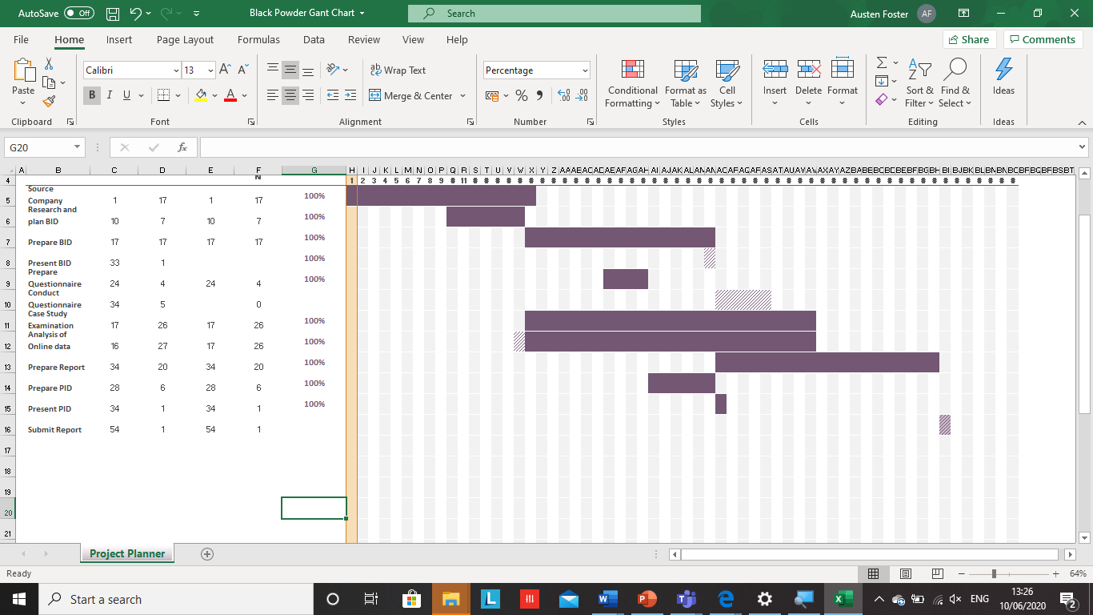

  - Proof of Correspondence

Dear Mr Hudson,

Firstly we are delighted to hear that you have completed your consultancy project involving Black Powder Ginsperience Events. We hope that your findings have been insightful and you have been able to find the relative information in order to complete your project. We hopefully will be able to take some of your ideas on board to further assist us in the success of the events we hold here at the distillery. You have our full cooperation to access any relative sources or information you may need to further conclude your research. Once again we thank you for taking the time to complete your consultancy project on our cooperation and should you need any further assistance please do not hesitate to let us know. We would be more than happy for you to research further. Thank you and take care.

Kind regards
Rachel.G Pendleton
Events Manager



Rachel Pendleton
Events Manager
AA Events
Black Powder

 |  |  | E3 FORM
APPLICATION FOR ETHICAL APPROVAL – BA level

CAIS AM GYMERADWYAETH MOESEGOL – Lefel BA

Mae'r ffurflen hon i'w chwblhau gan bob BA myfyrwyr. Rhaid i bob ffurflen gael ei ystyried gan diwtor y modiwl.  Dylai un copi o'r ffurflen yn cael ei roi ar y ffeiliau Gyfadran ac un copi cadw ar y ffeil myfyrwyr. |  | This form is to be completed by all BA students conducting research, projects or productions. This form should be completed by the student. All forms must be considered by the Module tutor. A copy of the form must be kept centrally and on the student file.
ADRAN 1 – MANYLION MYFYRIWR |  | SECTION 1 - STUDENT DETAILS
Enw Llawn  Full Name | Austen Lewis Benjamin Hudson
Ysgol/Cyfadran/  School/Faculty | UWTSD Swansea |  |  | Rhif Myfyriwr Student Number | 1482309
Cydlynydd prosiect / Tiwtor  Module Tutor/ Programme Co-ordinator | Jacqui Jones |  |  | Enw'r Gradd  Name of Degree | Events Management
Teitl dangosol yr Traethawd Hir: |  |  |  | Indicative Title of Dissertation:
Consultancy Project

ADRAN 2 – MANYLION CYFRANOGWYR / CYNULLEIDFA |  |  | SECTION 2 - PARTICIPANT / AUDIENCE DETAILS
Pwy yw’r cyfranogwyr arfaethedig? |  | Who are the intended participants? |  |  | Ydw / Yes | Na / No
Myfyrwyr / staff Y Drindod Dewi Sant |  | Students / staff of Trinity Saint David |  |  | Yes
Oedolion (dros oed 16 ac yn gymwys i gydsynio) |  | Adults (over the age of 16 and competent to give consent) |  |  | Yes
Plant a phobl ifanc dan oed |  | Children / legal minors |  |  |  | No
Cleifion neu gleientiaid gweithwyr proffesiynol |  | Patients or clients of professionals |  |  | Yes
Rhywun sy’n cael ei gadw yn y ddalfa neu y mae’r llys wedi cymryd cyfrifoldeb amdano |  | Anyone in custodial care or for whom the court has assumed responsibility |  |  |  | No
Aelod o unrhyw sefydliad lle mae’n bosibl bod angen i unigolyn arall hefyd gydsynio. |  | A member of any organisation where another individual may also need to give consent. |  |  |  | No
Eraill: Nodwch: / Others: please identify:

Nifer, Oed a Ffynhonnell y Cyfranogwyr  Rhowch fanylion yr demograffeg y cyfranogwyr / gynulleidfa. |  |  |  | Participant / Audience Number and Age  Provide details of the demographics of the participants / audience.
Nifer o Gyfranogwyr / yn y Gynulleidfa | Participant/ Audience number |  |  | 30
Grŵp oedran y Cyfranogwyr/y Gynulleidfa | Participant/ Audience age group |  |  | 21-55

ADRAN 3 – GWEITHGAREDD YMCHWIL |  |  | SECTION 3 – RESEARCH ACTIVITY
1. | Ydy’r prosiect yn cynnwys: | Does the project include: |  | Ydy / Yes | Nac ydy/No
Defnyddio holiadur neu offeryn ymchwil tebyg |  | Use of questionnaire or similar research instrument |  | Yes
Defnyddio prawf ysgrifenedig neu gyfrifiadurol |  | Use of written or computerised test |  |  | No
Cyfweliad (cysylltwch gwestiynau posibl) |  | Interview (attach provisional questions) |  |  | No
Dyddiaduron |  | Diaries |  | Yes
Arsylwi ar gyfranogwyr a hwythau'n ymwybodol o hynny |  | Participant observation with their knowledge |  | Yes
Arsylwi ar gyfranogwyr a hwythau ddim yn ymwybodol o hynny |  | Participant observation without their knowledge |  |  | No
Recordio fideo neu sain |  | Video or audio-taping |  |  | No
Mynediad i wybodaeth bersonol neu gyfrinachol heb gydsyniad penodol y cyfranogwyr |  | Access to personal or confidential information without the participants specific consent |  |  | No
Defnyddio unrhyw gwestiynau, ysgogiadau prawf, cyflwyniad y gallai rhai cyfranogwyr eu profi fel rhywbeth sy'n achosi niwed / tramgwydd corfforol, meddyliol neu emosiynol |  | Administration of any questions, test stimuli, presentation that may be experienced as physically, mentally or emotionally harmful / offensive |  |  | No
Cyflawni unrhyw weithredoedd allai achosi embaras neu effeithio ar hunan-barch |  | Performance of any acts which may cause embarrassment or affect self-esteem |  |  | No
Ymchwilio i gyfranogwyr sy’n ymwneud â gweithgareddau anghyfreithlon |  | Investigation of participants involved in illegal activities |  |  | No
Gweithdrefnau lle defnyddir twyll |  | Procedures that involve deception |  |  | No
Gweini unrhyw sylwedd, cyfrwng neu blasebo |  | Administration of any substance, agent or placebo |  |  | No
Dull arall o gasglu data neu fformat cyflwyno (esboniwch) |  | Other method of data collection or presentation format (please explain) |  |  | No

2. | Restru eich dull o gasglu data | List your method of data collection:

3. | Risg Posibl:  (corfforol, seicolegol, cyfreithiol, cymdeithasol neu economaidd) | Potential Risk:  (physical, psychological, legal, social or economic)
A oes unrhyw risg bosibl i: |  | Is there any potential risk to: | Ydw / Yes | Na / No
A | Cyfranogwyr? | Participants? |  | No
B | Ymchwilydd? | Researcher? |  | No
C | BrifYsgol/Cyfadran? | University? |  | No

4. | Rheoli Risg:  Os oes, beth yw'r risg a sut y bydd yn cael ei reoli? | Management of Risk:  If yes, what is the risk and how will it be managed?

5. | Os ydych yn delio â phlant a / neu oedolion agored i niwed, rhaid i chi gyflwyno eich tystysgrif DBS i'ch tiwtor goruchwylio i'w cymeradwyo cyn i unrhyw gysylltiad â cyfranogwyr hyn. | If you are dealing with children and/ or vulnerable adults you must present your DBS certificate to your supervising tutor for approval before any contact with these participants.
 |  |  |  | Ydw / Yes | Na / No
A | Ydych chi wedi gwneud cais am dystysgrif DBS? |  | Have you applied for a DBS certificate? |  | No
B | A yw eich tiwtor weld a'i gadarnhau eich tystysgrif DBS? |  | Has your tutor seen and approved your DBS certificate? |  | No

6. | A fyddwch yn cael cydsyniad gwybodus ysgrifenedig gan eich cyfranogwyr? |  | Will you obtain written informed consent from your participants?
 |  |  |  |  |  | Ydw / Yes | Na / No
A | Os na fyddwch, pam hynny? |  |  | If no, why not? |  |  | No
B | Os byddwch, sut byddwch yn sicrhau cydsyniad gwybodus? |  |  | If yes, how will you secure informed consent?
Rhowch eglurhad / Please explain:

Cynhwyswch gopi o’r ffurflen gydsynio os ydych yn defnyddio un. |  |  |  | Please include a copy of the consent form if you are using one.

ADRAN 4 |  | SECTION 4
CEFNOGWYD /APPROVED |  | NIS CEFNOGWYD/  NOT SUPPORTED
Datganiad  Mae'r wybodaeth a gynhwysir yma yn gywir, hyd eithaf fy ngwybodaeth a’m cred. Rwyf wedi ceisio dynodi unrhyw risgiau a phroblemau sy’n gysylltiedig â’r prosiect / ymchwil neu gynhyrchiad ac rwyf yn cydnabod f’ymrwymiadau innau a hawliau’r cyfranogwyr. |  |  | Declaration  The information contained herein is, to the best of my knowledge and belief, accurate. I have attempted to identify any risks and issues related to the project/research or production and acknowledge my obligations and the rights of the participants.
Llofnodau  Dylai'r ffurflen hon gael ei chwblhau a'i llofnodi gan y myfyriwr a'r Cydlynydd y prosiect /Twitor |  |  | Signatures  This form should be completed and signed by the student and the Module tutor/Programme Co-ordinator.
Myfyriwr / Student  Austen Lewis Benjamin Hudson |  |  |  |  | Dyddiad: / Date:  16/05/2020
Cydlynydd y prosiect /Twitor  Project co-ordinator / Tutor |  |  |  |  | Dyddiad: / Date:

- Bibliography

Black Powder Gin 2020- About Us
Available at: https://blackpowdergin.co.uk/pages/about-us

Overview of the Research Process for Students 2020
Available at: https://phdessay.com/overview-of-the-research-process-for-business-students/

A.D. Jankowicz 1995- Business Research Projects
Available at: https://books.google.co.uk/books/about/Business_Research_Projects.html?id=lTdZAAAAYAAJ&redir_esc=y

LocalStats UK ™ - 2020
Available at: http://localstats.co.uk/uklocalstats.cgi?search_suburb=poulton-le-fylde&search_state=&type=search&x=0&y=0

Average earnings and hours of work, provisional estimates 2019
Key findings for the Lancashire-12 and Lancashire-14 area
Available at: https://www.lancashire.gov.uk/media/910886/average-earnings-and-hours-ashe-report-web-final.pdf

Alex Scrivens 2019- Fylde District Profile
Available at: https://new.fylde.gov.uk/wp-content/uploads/2019/07/Fylde-District-Area-Profile-2019-v1.1.pdf

CityPopulation 2019- Poulton-le-Fylde Built-up Area Subdivision
Available at: https://citypopulation.de/en/uk/northwestengland/lancashire/E35001393__poulton_le_fylde/

Office for National Statistics & Department for Work & Pensions 2019- Socio-economic statistics for Esprick, Lancashire
Available at: https://www.ilivehere.co.uk/statistics-esprick-lancashire-12686.html

Lancashire Gov- Personal Incomes 2017
Available at: https://www.lancashire.gov.uk/lancashire-insight/economy/income-earnings-and-benefits/personal-incomes/

Jessica Wade 2017- Baby Boomer Marketing Statistics
Available at: https://www.smartinsights.com/digital-marketing-strategy/baby-boomer-marketing-statistics/

Goldmansachs 2020- Millenials Coming of Age
Available at: https://www.goldmansachs.com/insights/archive/millennials/

Jenny Stanley 2018- Top five tips to attract a younger audience
Available at: https://www.thedrum.com/opinion/2018/11/30/top-five-tips-attract-younger-audience

Kim Speier 2016- Why Are Marketers So Obsessed With Millennials?
Available at: https://www.socialmediatoday.com/marketing/why-are-marketers-so-obsessed-millennials

Digital Marketing Community 2018- Digital Marketing Statistics & Metrics
Available at: https://www.digitalmarketingcommunity.com/indicators/social-networks-millennials-usage-2018/

Edkent Media 2017- 5 Benefits of Advertising on Social Media
Available at: https://edkentmedia.com/5-benefits-advertising-social-media/

Blue Fountain Media 2019- 10 Advantages to Social Media Marketing for Business
Available at: https://www.bluefountainmedia.com/blog/advantages-of-social-media-marketing

Webfx 2020- Top 13 Advantages and Disadvantages of Social Media
Available at:https://www.webfx.com/internet-marketing/social-media-marketing-advantages-and-disadvantages.html

Instagram 2020- Advertising
Available at: https://business.instagram.com/advertising/

Facebook 2020- Advertising Pricing
https://en-gb.facebook.com/business/ads/pricing

PMLive 2020- How will the events and exhibitions industry change post-Coronavirus?
Available at:
http://www.pmlive.com/pmhub/exhibitors/Apex_Conferences,_Events_and_Exhibition_Stands/press_releases/how_will_the_events_and_exhibitions_industry_change_post-corona_virus

Nicola Cronin 2020- A Simple Guide To Instagram Influencer Marketing in 2020
Available at: https://www.hopperhq.com/blog/instagram-influencer-marketing-2020/

WebFX 2020- Social media advertising costs in 2020
Available at: https://www.webfx.com/how-much-does-social-media-advertising-cost.html

Emily Coates 2020- 77 Essential Social Media Marketing Statistics for 2020
Available at: https://blog.hubspot.com/blog/tabid/6307/bid/23865/13-mind-bending-social-media-marketing-statistics.aspx

