Name: Kimia Mansoory Kinevarsi
Student ID: 2242261
Module Name: Changemakers: Building your Personal Brand for Sustainable Employment
Module Code: BMHP5015
Lecturer: Caroline Salami
Submission date: 05/12/2025
Component 1

Table of Contents
Introduction 3
Task 1 – Reflection on Unit 1: Brand You 4
Task 2 – Reflection on Unit 2: It’s a Small World 7
Task 3 – Reflection on Unit 3: Opportunity Knocks 10
Task 4 – Reflection on Unit 4: The Pursuit of Happiness 12
Conclusion 14
References 15

Introduction
This assignment reflects on my learning across the four units of the Changemakers: Building Your Brand for Sustainable Employment module. Throughout the module, I explored key themes relating to personal branding, global interconnectedness, opportunity development, and wellbeing within the context of health and social care. Each unit provided structured activities, online tasks, and guided discussions that strengthened my understanding of how professional identity, cultural awareness, employability, and personal resilience contribute to sustainable career development. My reflections draw on academic theories and models, including Personal Branding Theory, the Johari Window, Strengths-Based Development, SMART Goals, Experiential Learning, Emotional Intelligence, Serendipity Mindset, PERMA, and Antifragile Thinking, to demonstrate how my learning has evolved and how these ideas are relevant to my present studies and future career in health and social care. The assignment is organised into four reflective sections, each focused on one unit, followed by a conclusion summarising the overall value of the module. For each unit, I include screenshots of the online activities that supported my engagement and understanding. Overall, this assignment highlights how the knowledge and skills gained have contributed to my professional growth, increased confidence, and readiness to progress within the sector.

Task 1 – Reflection on Unit 1: Brand You
Unit 1 focused on developing my understanding of personal branding and the importance of self-awareness in shaping a professional identity. During the lectures and online tasks, I realised how essential it is to understand my own strengths, values, and professional aspirations when communicating who I am as a future health and social care practitioner. One of the key concepts explored in this unit was personal branding theory, which suggests that individuals must consciously create a consistent and authentic professional image (Montoya & Vandehey, 2009). I learned that personal branding is not about self-promotion alone but about presenting a trustworthy and competent identity that aligns with the expectations of employers and service users.
Another influential concept was Johari’s Window, a model that helped me reflect on how open, hidden, blind, and unknown aspects of myself influence how others perceive me (Luft & Ingham, 1955). Through class discussions, I recognised the importance of increasing my “open area” by actively seeking feedback and being more confident in expressing my skills.
Additionally, the unit explored strengths-based development, which encouraged me to identify what I naturally do well. This approach aligns with Clifton and Anderson’s (2001) emphasis on using personal strengths to enhance professional effectiveness. By completing the online tasks, I became more aware of how my communication skills, empathy, and experience in mental health support can form the foundation of my professional brand.

Screenshots from Unit 1 Activities

Figure 1 from week 1 forum:
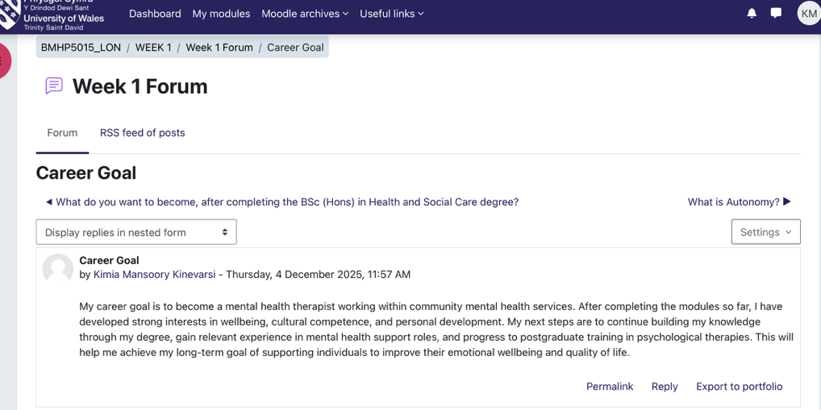
Reflecting on this activity has helped me clarify my career goal of becoming a mental health therapist within community mental health services. Through the unit, I recognised how much my interests in wellbeing, cultural competence, and personal development have grown. The module encouraged me to think about the steps I need to take, such as gaining practical experience and continuing my academic development. This reflection has strengthened my motivation and given me a clearer sense of direction toward postgraduate training and eventually supporting individuals to improve their emotional wellbeing.

Figure 2 from week 2 forum:
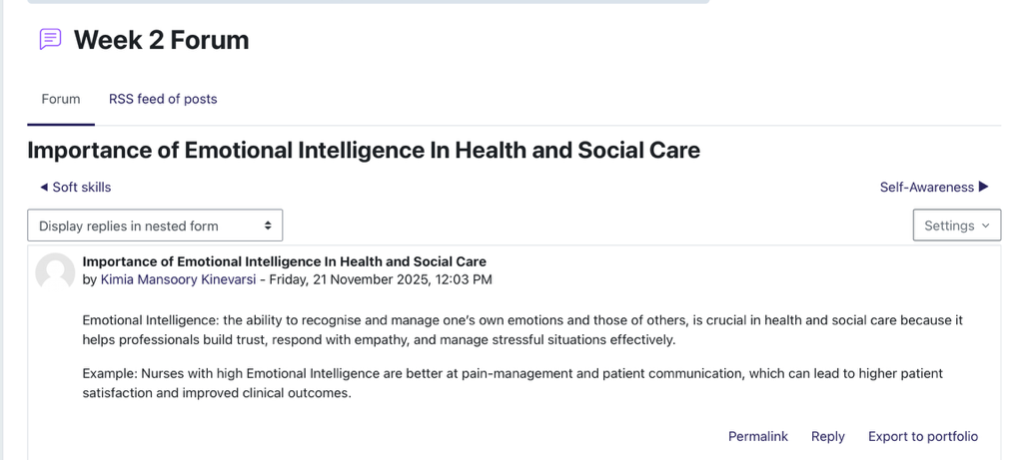
Reflecting on this activity helped me understand the importance of Emotional Intelligence in health and social care. By exploring how recognising and managing emotions supports empathy, communication, and trust, I can see how essential these skills are for working effectively with service users. The example of nurses using Emotional Intelligence to improve pain management highlighted how emotional awareness can directly impact the quality of care. This reflection has strengthened my understanding of why developing my own Emotional Intelligence will be vital for my future practice.

Task 2 – Reflection on Unit 2: It’s a Small World
Unit 2 deepened my understanding of global connections within health and social care. The unit highlighted how cultural diversity, international policy influences, and global migration patterns shape the experiences of service users and professionals. Through lectures, I became more aware of how interconnected modern societies are, and how global issues such as health inequalities, pandemics, and workforce shortages, directly affect care delivery in the UK.
One key topic in this unit was cultural competence, which refers to the ability to work effectively with people from diverse cultural backgrounds (Betancourt et al., 2002). I realised that developing cultural competence is essential for reducing health disparities and improving communication with service users. This learning helped me understand why cultural humility and awareness are vital within my future role.
Another important theory explored was Hofstede’s Cultural Dimensions, which provided insight into how cultural values influence behaviour, communication, and expectations. Applying this theory helped me recognise how differences in power distance, collectivism, and uncertainty avoidance can affect interactions in care settings.
Unit 2 also emphasised how technology and global networks create opportunities for international collaboration. Completing the online tasks, especially the discussion forums, made me think critically about how global events such as climate change or digital innovation, directly shape health and social care services.

Screenshots from Unit 2 Activities

Figure 3 from week 3 forum:
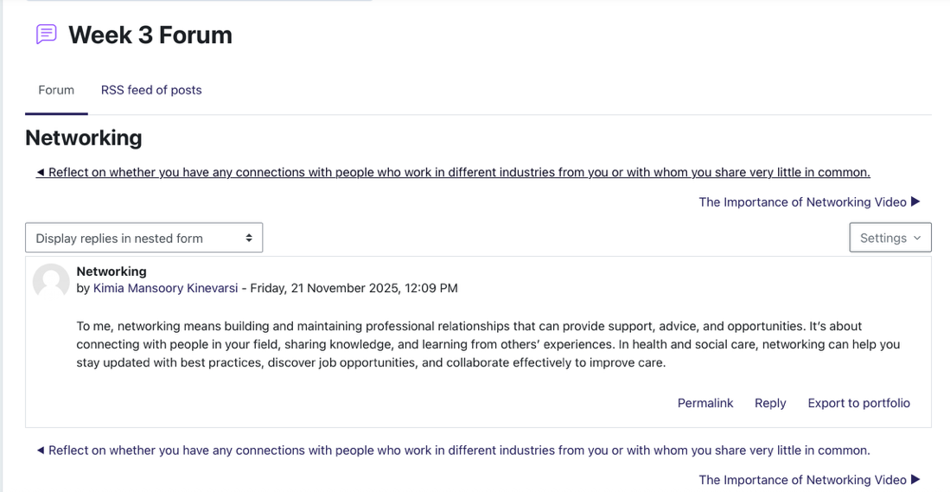
Reflecting on Emotional Intelligence in this activity helped me understand its importance in health and social care practice. By exploring how recognising and managing emotions supports empathy, communication, and trust, I now see how essential these skills are in providing person-centred care. The example of nurses using Emotional Intelligence to improve pain management showed me how emotional awareness can directly enhance outcomes. This reflection has encouraged me to continue developing my own Emotional Intelligence, as it will strengthen my ability to support service users effectively in future practice.

Figure 4 from week 4 forum:
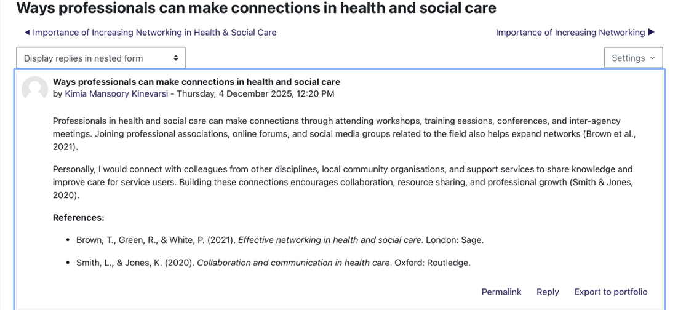
Reflecting on this activity helped me understand how important networking is within health and social care. Writing my post made me think more deeply about the different ways professionals can build connections, such as through training, conferences, and inter-agency collaboration. I also recognised how connecting with colleagues and community organisations can improve the support we provide to service users. This activity strengthened my awareness of how networking contributes to professional growth, shared learning, and better-quality care, and it motivated me to be more proactive in developing these connections throughout my career. I acknowledge certain challenges accompanied with networking, for example, staff burnt out, information. Overload and stress especially as I am slightly introverted, to overcome this I will set achievable goals and network online

Task 3 – Reflection on Unit 3: Opportunity Knocks
Unit 3 helped me recognise and evaluate opportunities for personal and professional development. Through the lessons and activities, I learned that opportunities do not only appear by chance; often, they must be identified, planned for, and actively pursued. The unit emphasised the importance of goal setting as a tool for structuring career development. I used the SMART goals framework to refine my short- and long-term ambitions, which allowed me to break down larger aspirations into more achievable steps (Doran, 1981).
Another key topic in this unit was personal development planning (PDP). Engaging with PDP activities enabled me to think more critically about the skills I already possess and those I need to develop for my future career. This reflective approach aligns with Kolb’s experiential learning theory (1984), which emphasises that learning occurs through the cycle of reflection, conceptualisation, and action.
The unit also encouraged me to reflect on the concept of employability, including networking, seeking mentorship, and staying aware of emerging opportunities in the sector. Through online activities, I gained confidence in identifying training, volunteer roles, and professional experiences that could strengthen my CV and updated my professional social media profiles, to enhance my readiness for employment in health and social care.

Screenshots from Unit 3 Activities

Figure 5- Serendipity Mindset Week 5:
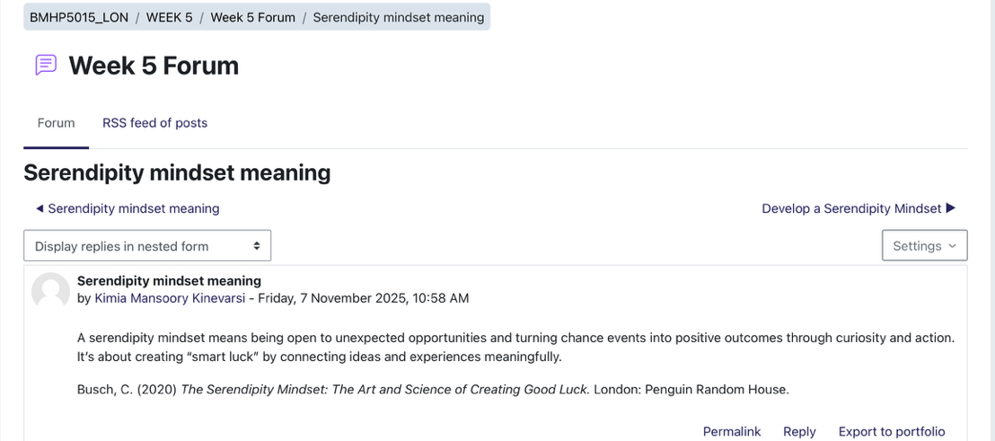
Reflecting on the concept of a serendipity mindset helped me appreciate the value of being open to unexpected opportunities in both personal and professional life. Writing my post made me realise how curiosity, adaptability, and connecting experiences can create “smart luck” and lead to positive outcomes. This activity encouraged me to approach challenges with a more flexible and proactive mindset, which I believe will be beneficial in my future career in health and social care.
Figure 6- Video Reflection Week 6:
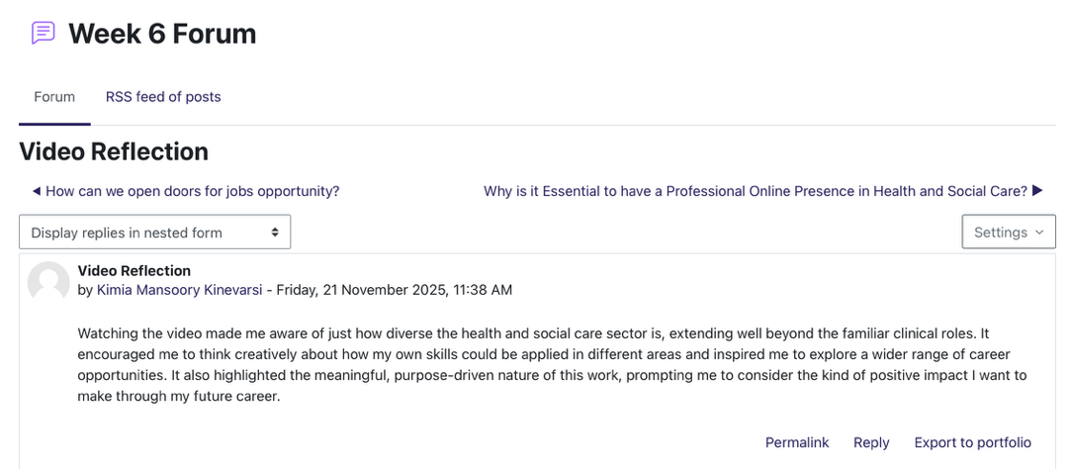
Reflecting on the video helped me understand the diversity of roles within health and social care and think more creatively about how my skills could be applied across the sector. It also highlighted the meaningful impact professionals can have, inspiring me to consider the type of positive difference I want to make in my future career. This activity encouraged me to explore a broader range of opportunities and reinforced my motivation to pursue a purpose-driven role in health and social care.

Task 4 – Reflection on Unit 4: The Pursuit of Happiness
Unit 4 explored wellbeing, resilience, emotional intelligence, and work–life balance. This unit helped me recognise the importance of maintaining my own wellbeing when working in demanding health and social care environments. One of the central ideas in this unit was Seligman’s PERMA model, which highlights the five components of wellbeing: Positive Emotion, Engagement, Relationships, Meaning, and Accomplishment (Seligman, 2011). Reflecting on this helped me understand how wellbeing affects both personal satisfaction and professional performance.
The unit also explored resilience theory, which emphasises the ability to adapt positively to stress and adversity. Through class activities, I learned that developing resilience is not about avoiding challenges, but about building strategies such as self-care, reflection, and seeking support, while recognising that high stress, emotional exhaustion, and work–life pressures can make staying resilient difficult.
Additionally, the concept of emotional intelligence (Goleman, 1995) helped me reflect on how self-awareness, empathy, and emotional regulation are core skills in health and social care. I realised that strengthening these skills will not only enhance my communication with service users but also support better teamwork and leadership.

Screenshots from Unit 4 Activities

Figure 7- Quiz Refection Week 7:

Reflecting on the quiz results helped me recognise some limiting beliefs I hold, like doubting my abilities and avoiding new opportunities. Writing my post made me aware of how staying in my comfort zone can restrict my growth. This activity has motivated me to take more risks, trust my decisions, and embrace learning from new experiences to reach my full potential.
Figure 8- Unachieved Goals Week 8:
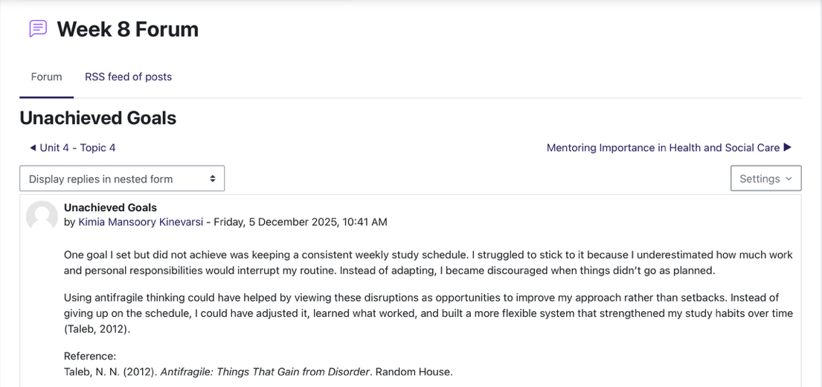
Reflecting on my goal of maintaining a consistent study schedule helped me recognise the challenges of balancing responsibilities and the impact of setbacks on motivation. As also highlighted by Kolb’s reflection cycle. Writing my post made me see how adopting an antifragile mindset, viewing disruptions as opportunities to adapt and improve, could have helped me develop a more flexible and resilient approach. This activity has encouraged me to embrace challenges as learning opportunities to strengthen my personal and academic growth.

Conclusion
Reflecting on all four units has helped me gain a clearer understanding of the skills, values, and knowledge required for sustainable personal and professional development within health and social care. Unit 1 strengthened my awareness of personal branding and self-reflection. Unit 2 expanded my understanding of cultural diversity and global influences. Unit 3 enabled me to recognise and pursue professional opportunities, while Unit 4 deepened my appreciation for wellbeing and resilience. Together, these units have helped me build confidence in my ability to grow within the sector. The theories, models, and practical activities explored throughout the module have provided me with valuable strategies for improving my employability, communication, cultural competence, and self-care. This learning will continue to shape my development as I progress toward a rewarding career in health and social care.

References
Betancourt, J.R., Green, A.R., Carrillo, J.E. & Ananeh-Firempong, O. (2002) ‘Defining cultural competence: A practical framework for addressing racial/ethnic disparities in health and health care’, Public Health Reports, 118(4), pp. 293–302. Available at: https://journals.sagepub.com/home/phr (Accessed: 28 November 2025).
Clifton, D.O. & Anderson, E. (2001) StrengthsQuest: Discover and Develop Your Strengths in Academics, Career, and Beyond. Washington, DC: Gallup Press. pp. 3–18. Available at: https://www.gallup.com/ (Accessed: 28 November 2025).
Doran, G.T. (1981) ‘There’s a S.M.A.R.T. Way to Write Management’s Goals and Objectives’, Management Review, 70(11), pp. 35–36. Available at: https://mgmtreview.com/ (Accessed: 28 November 2025).
Goleman, D. (1995) Emotional Intelligence: Why It Can Matter More Than IQ. New York: Bantam Books. pp. 40–60. Available at: https://www.penguinrandomhouse.com/ (Accessed: 28 November 2025).
Hofstede Insights (2024) Hofstede’s Cultural Dimensions. Available at: https://www.hofstede-insights.com/models/national-culture/ (Accessed: 28 November 2025).
Kolb, D.A. (1984) Experiential Learning: Experience as the Source of Learning and Development. Englewood Cliffs, NJ: Prentice-Hall. pp. 20–38. Available at: https://www.pearson.com/ (Accessed: 28 November 2025).
Luft, J. & Ingham, H. (1955) ‘The Johari Window: A Graphic Model of Interpersonal Awareness’, Proceedings of the Western Training Laboratory in Group Development. Los Angeles: UCLA. pp. 10–15. Available at: https://www.ucla.edu/ (Accessed: 28 November 2025).
Montoya, P. & Vandehey, T. (2009) The Brand Called You: Create a Personal Brand That Wins Attention and Grows Your Business. New York: McGraw-Hill. pp. 12–25. Available at: https://www.mheducation.com/ (Accessed: 28 November 2025).
Seligman, M.E.P. (2011) Flourish: A Visionary New Understanding of Happiness and Well-being. New York: Free Press. pp. 23–45. Available at: https://www.simonandschuster.com/ (Accessed: 28 November 2025).

