Dissertation Proposal

Jordan Gittins (1700700)

BA Graphic Design

This proposal will outline my future dissertation topic. For my dissertation, I plan to be investigating and exploring how music influences visual art, further exploring on how it impacts us as people. This will be followed by with a further look into several theories and papers written by professors and thinkers, that support these influences music has on the visual arts. I will also be exploring the concept of synaesthesia and how that plays a role into my question. As a practising graphic designer and being associated with visual arts, I regularly find that music can influence my creative decisions or use it as a source of inspiration.

Key Artist: Wassily Kandinsky
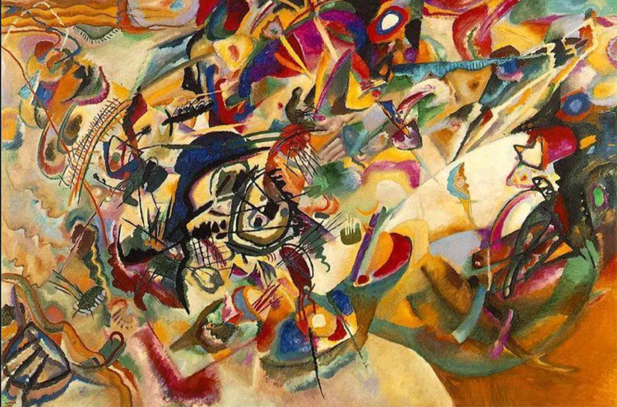

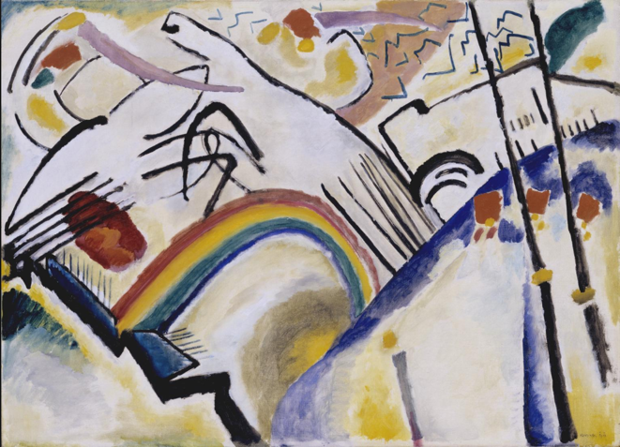
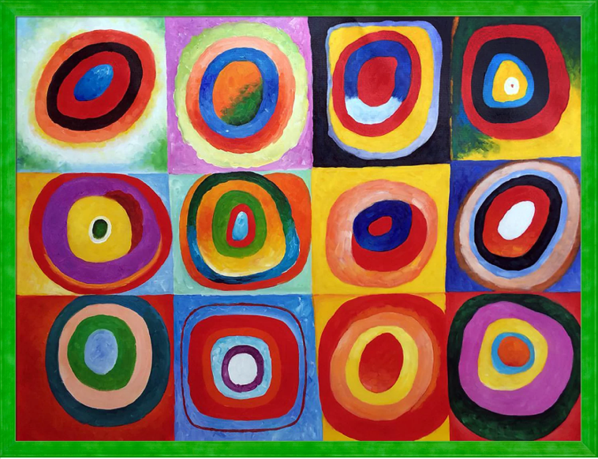

Synaesthesia
Before we explore the impact, it has we need understand what Synaesthesia is. There are often misconceptions on what Synaesthesia is, in which it is a “neurological condition that causes the brain to process data in the form of several senses at once. For example, a person with synesthesia may hear sounds while also seeing them as colorful swirls. The condition isn't fully understood, but it is thought to be genetic, and it affects more women than men.” (Bradford, 2017). It is generally perceived as only exclusively as the fusion between the senses of sight and sound. This generalisation will be focused on for the most part in terms of the subject matter as it directly correlates with my exploration of how music influences visual art, however it is more and comes in multiple forms such as tasting words, smelling scents influenced by sounds, visualising colour when feeling pain, as well as more. Synaesthesia is said to make up around 4% of the population, however, 1% of us apparently experience some form of synaesthesia in our lifetime.

The condition was first referred as Pseudo-Chromesthesia, in which dates back to the first scientific reports conducted by George Sachs in 1812. (Krohn, 1892)

Most cases of Synaesthesia contain an emotional baseline. Emotion is a huge factor and reactor when it comes to art. When we consume art, it is often through visual as well as music, where the elements or techniques from the artist communicate a motive or have a theme in mind, which can trigger emotional reactions based on the context. The majority of artists aim to illicit an emotional response through their work, as it is often with remembering art is not the direct material, but how the material makes the audience feel. That typically happens even if it wasn’t intentional.

One of the most famous artists associated with the condition was Wassily Kadinsky. Kadinsky is regarded as a pioneer in his art and it is well documented the impact synaesthesia has on his work, and his life. He described his first encounter with the condition at an orchestra performance – “I saw all my colours in spirit, before my eyes. Wild, almost crazy lines were sketched in front of me. “ (Kandinsky, 1910). He also described his process of painting and compares it to a musical composition “Colour is the keyboard, the eyes are the harmonies, the soul is the piano with many strings. The artist is the hand that plays, touching one key or another, to cause vibrations in the soul.”

His descriptions are symbolic in his paintings, resulting in some very abstract outcomes.
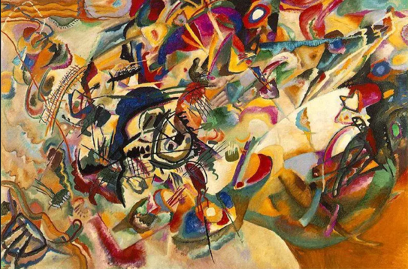

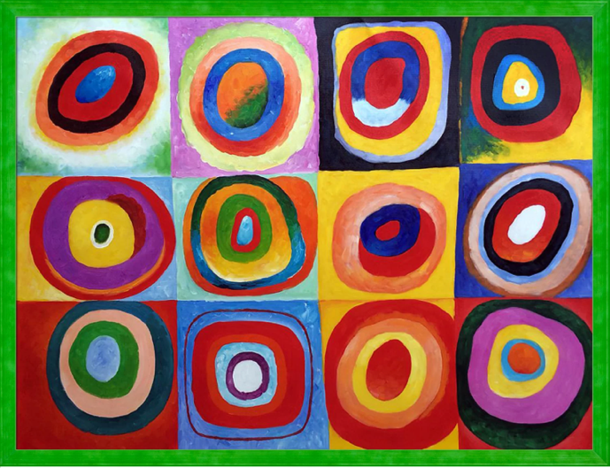

The examples above give an insight into where the music listened by Kadinsky led him. For example, in the first painting, the chaotic nature of the brush strokes and mixing of colours suggests that the music that he responded to was of a frantic nature, with a heavy amount of instrumentation clashing together. There is a lot of layers which would be parallel to the arrangement in the composition listened to. The second example of his work is of a similar frantic nature as the first, in the way of the contrast of the stroke directions. However, this piece seems contain less detail and seems to depict a landscape, in abstract fashion. This would be symbolic of a musical piece that was perhaps less spontaneous and contained classic structure: a direction. In contrast to the first example, this painting is brighter and contains less colour, in which Kadinsky says "The deeper the blue becomes, the more strongly it calls man towards the infinite, awakening in him a desire for the pure and, finally, for the supernatural… The brighter it becomes, the more it loses its sound, until it turns into silent stillness and becomes white."( (Ward, 2014). This symbolises that the music in this instance was calmer, more ambient to his environment.

The third painting depicts a grid of swirls in a variation of colour combinations. This directly refers back to Bradford’s quote of synaesthesia allowing people to see sounds as “colourful swirls.” This example depicts more so the generalisation of a synaesthesia example in the modern world.

Emotion

With understanding the background of Synaesthesia, there is clearly a heavy emotional influence into the workings of it.

“Synesthesia is emotional. The experience is accompanied by a sense of certitude (the "this is it" feeling) and a conviction that what synesthetes perceive is real and valid. This accompaniment brings to mind that transitory change in self-awareness that is known as ecstasy. Ecstasy is any passion by which the thoughts are absorbed and in which the mind is for a time lost.” (Cytowic, 1995)

How does this translate into Kadinsky’s artworks?

As mentioned previously, art and music illicit an emotional response regardless of intention. In Kadinsky’s case, the outcomes of his paintings were a result of emotionally responding to the music listened to at the time of painting, in which there is an influence via the sound evidently. For example, the first painting with the heavy layers and contrast could be a representation of the feeling of anxiety, fear, dread of simply confusion, as a result of the music. The music may have triggered an emotional response in Kandinsky in turn led him to express that emotion on the canvas. There is a strong relativity between what was heard, felt and conveyed. A musician by the name of Alexander Scriabin reported “that his synesthesia was not always of the same quality and intensity. Normally, he would have a faint "feeling" of color when listening to music. But as he got more emotionally involved in the music, the synesthetic sensations of color would become stronger, more intense, and pass over to give an "image" of color. And not every piece of music would elicit synesthetic responses in Scriabin. Beethoven's music was too intellectual and did not evoke synesthesia, according to Scriabin, while modern music, which was more psychological, i.e. more emotional, evoked much better synesthetic sensations. “ (Campen, 1997)

For many musicians, emotion is a key factor and is important to visual represent that synonymously as an experience. One of the modern generations most influential artists with Synaesthesia in Kanye West explained “I see music in colour and shapes and all and it’s very important for me when I’m performing or doing a video that the visuals match up with the music – the colours, y’know. A lot of times it’s a lonely piano [that] can look like a black and white visual to fit that emotion, even though pianos are blue to me and bass and snares are white; bass lines are like dark brown, dark purple.” (Bassett, 2015)

Music genres seem to profile and categorise what emotional response the listener wants, based on historic convention associated with that genre. For example, the convention to listen to electronic/house music is to gain excitement or to deliver the feeling of freedom whilst listening to hip-hop is to gain perspective due to the poetry and story-telling, responding to it in a more conscious way. This is a broad taken into account as it does depend on the listener and their emotional states/experiences.

Subjectivity

The emotional responses stemming from the music is the main influencer in the expression of the visual art composed. However, as mentioned previously, there’s a complexity into how each person responds. It is subjective in this sense. The subjectivity also not only lies with the listener, but also the artist as explored with Wassily Kadinsky, as well as the intentions set out by the musicians.

Musicians Perspective:

When a musician composes, the composition is reflective of their expression.

“When we speak of the expressive properties of music, they may be distinguished
from the expressive properties of sound. Sounds may be loud, shrill, acoustically
rough or smooth, and so on. These acoustic qualities have expressive correlates and
may trigger emotional responses, and of course one cannot have music without
sound. However, musical expression is more than this: it requires the attention to
the music qua music, rather than as mere sounds. The opening "0 Fortuna" of
Orff's Carmine Burana may shock (and indeed scare) the listener due to its sudden
loudness (especially when the bass drum starts whacking away), but this shock is not
a musical effect, as we may have the same reaction when we here a sudden "bang"
at a fireworks display or when a car backfires. By contrast, in hearing the opening of
Mozart's 40th symphony as having a quality of restless melancholy, we are attending
to both the musical syntax and its sonic embodiment.” (London, 2002)
Listener/Viewer’s Perspective:

The recipient will most likely consume and acknowledge the conventions and intentions by the artist’s compositions and the elements within. However, this may trigger a different emotional response as that text could remind them of a memory i.e a person, an event, a place, an activity – providing emotions such as nostalgia, joy, sadness, pain and so on. It is open to interoperation for the consumer and therefore that is where the subjectivity lies.

Overall, there is plenty of evidence to suggest that music does indeed influence visual arts, in which synaesthesia is a phenomenon that can fuse both together and is widely documented. Exploring these themes has led me to explore this further in my dissertation, where I intend to explore further texts such as film, graphic design and more into music catalogues as well as delving deeper into the psychology behind these parallels.

Dissertation question –

“Synesthesia : How does music have an influence on Artistic expression?”

Bibliography
Bassett, J., 2015. Meet The Famous Musicians With Synaesthesia, A Condition That Means You Hear Colours. [Online]
Available at: https://www.nme.com/blogs/nme-blogs/meet-the-famous-musicians-with-synaesthesia-a-condition-that-means-you-hear-colours-14511
[Accessed 17 July 2019].
Bradford, A., 2017. What is Synesthesia?. [Online]
Available at: https://www.livescience.com/60707-what-is-synesthesia.html
Campen, C. v., 1997. Synesthesia and Artistic Experimentation, s.l.: PSYCHE.
Cytowic, R. E., 1995. Synesthesia: Phenomenology And Neuropsychology A Review of Current Knowledge, s.l.: PSYCHE.
Kandinsky, W., 1910. Concerning the Spiritual in Art. s.l.:s.n.
Krohn, W. O., 1892. [Online]
Available at: https://www.jstor.org/stable/1410812?seq=2#metadata_info_tab_contents
London, J., 2002. Some Theories of Emotion in Music and Their Implications for Research in Music Psychology, s.l.: Justin London.
Simner, J., 2010. Defining synaesthesia. s.l.:The British Psychological Society.
Ward, O., 2014. How Wassily Kandinsky's synaethesia changed art. [Online]
Available at: https://www.telegraph.co.uk/art/artists/wassily-kandinsky-who-was-he/

