RICHARD MAGNESS

P144400

BA FILM AND TV

YEAR 3

FINAL MAJOR PROJECT STAGE

About
Title: The Hidden
Logline: A detective discovers there’s a serial killer on the loose but with a rather strange objective.

Description: A Detective returns home from work after being dismissed by the Chief Detective, only to discover her work has followed her home. This detectives time is up and the only way to prevent the inevitable is to solve the case.

Genre: Horror, Thriller
Time period: Current Day

Research Summary
This films aim was to create a psychological horror. However, it does fit other genres.
Names of films linked to project:
- Paranormal Activities (Jump Scares)
- Shutters Island (Trip/Illusion)
- Of Mice and Men (mental health/obsession)
- Split (mental health)
- Prometheus (Sound)
Names of TV Shows linked to the project:
-Sherlock *BBC* (Visual Styling/Character Influence)
-Pretty Little Liars (Murder Mystery/ Puzzle Solving)
-Gotham (Gothic Styling/Character influence)

Research into the creation of the narrative.

TV SERIES: GOTHAM
HOW: 1.) The riddles love story arch which lead him to develop split personality disorder.
2.) Gotham is a TV series based upon the fictional GCPD (Gotham City Police Department) which are from DC comic books Batman universe. However, the TV series followed the Police mainly a detective called James Gordon. This Show uses elements of gothic horror and at times can be considered a thriller.
WHY: I personally have been a big fan of the show since its inception and have been very interested in making a gothic styled police thriller. This alongside my fondness of BBC’s Sherlock it seemed like such a good blend to help me mould my own story and story world in which to set it.

TV SERIES: SHERLOCK
HOW: 1.) I wanted my main character to be unique but be a good example in strength and intelligence for younger women to look up to. I wanted to create a female interpretation of sherlock Holmes but having a female play the Sherlockess character allowed me to address current issues with equality in the workplace and it also allowed me to play with the idea that it doesn’t always have to be a man who’s the serial killer it could be a woman who has become so blinded and enraged with love for the protagonist. It just makes for a very interesting change of pace to the norm.

WHY: PLEASE SEE ABOVE ON PREVIOUS.

The Story
Explained

The story for this short is about a female detective who is constantly undermined by male co-workers. After going a little too far on her last case she is dismissed by the chief of police. She returns home to discover a case file waiting outside her door. She soon begins to investigate the case this is where the background information is given to the audience. Partial information is given throughout the film like pieces of a jigsaw and once all pieces are assembled the culprit is revealed. During the investigation or case study she starts to have paranoid thoughts and starts to imagine things that aren’t there. Little does she know she’s been drugged by the murder she is investigating. By the 3rd act of the short the killer is revealed as a friend of the detective who has had an obsession with the lead character for quite some time and now it’s time to make action on those feelings. But before it is revealed to the audience that the colleague is behind it all we get a conversation between the two whilst discussing the case at hand and our main character during this scene will finally be able to complete the puzzle.

The challenging evolution of ‘The Script’
Originally the script started off as a Modern-day Victorian Ghost story. However, this eventually transpired into the current story. During the creation of the narrative the first issue that I came across was time restraint. This however was over come by removing scenes that could be implied to rather than needed to be shown on the screen. Such as when the detective gets put on suspension this scene was then changed to a series of voice overs during the opening scene where the main character is driving home from being dismissed. Another challenge that was faced during the narrative was the plausibility of the paranormal events that take place. I couldn’t find a logical explanation as to how the events were taking place until however I decided to implement the idea that she had been spiked and during these events she was actually hylosnogenically tripping from the LSD. I choose LSD as the drug of choice as when research was carried out it was the ideal choice for giving visions and having a low time in which it remains in the blood so wouldn’t show up on a toxicologist report which would be shown in the case file.

Locations:
Main Characters House: Trefran Farm House.
Description: Big, old house, White exterior with a vintage feel inside. Just outside the town of Pencoed this makes an ideal place to fit our Main Characters characteristics and the overall visual aesthetics required for this project.
Travel: Train Station/ Bus Stops
Located: 2.2 miles from the property.
Cost: Taxi- £5
Car- Free Provided by Director.

Request to film at location : Accepted
Cost: No Fee
Days required: 2/3 Days

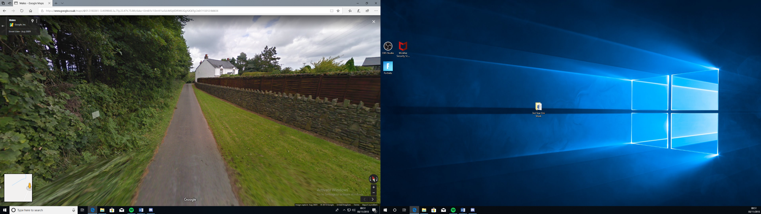
Photos of Property:

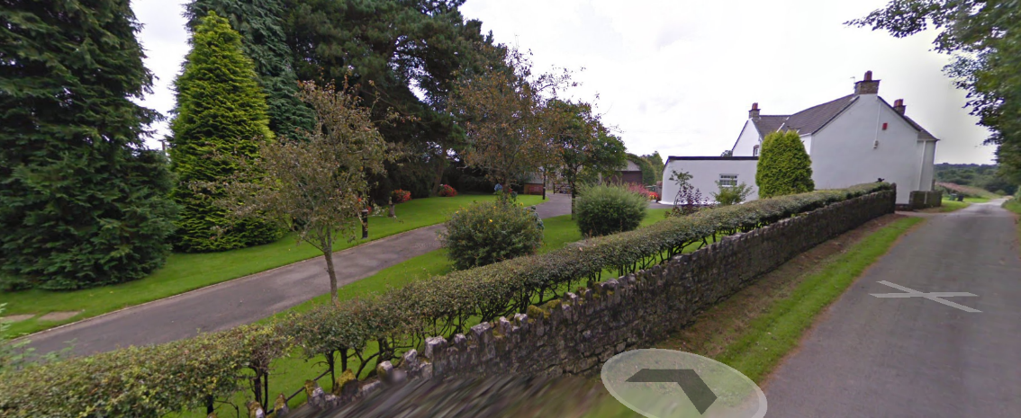

Police Station Offices: Hafod Housing HQ
Description: Large V shape Building with a modern entrance. Nice open stairs and a large office space. Also included will be use of the computers and meeting room.

Travel: (a)Train Station/ (b)Bus Stops
Located: 2.2 miles from the property.
Cost: Taxi- £10-15 Est.
Car- £5*

*£1 per mile will be paid to runners who provide transport for filming. This will be paid at the end of production and runners will be asked to keep a log of millage before and after carrying out a transport job.

Request to film at location: Accepted
Cost: No Fee
Days required: 1 Day
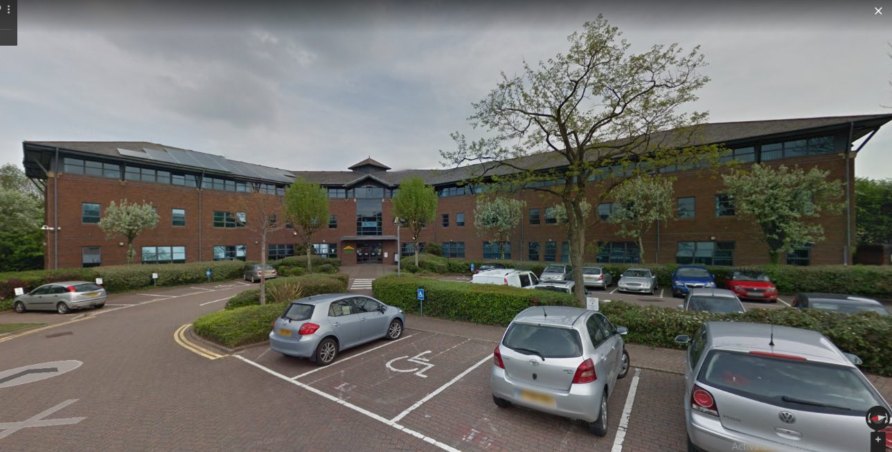
Photos of property:

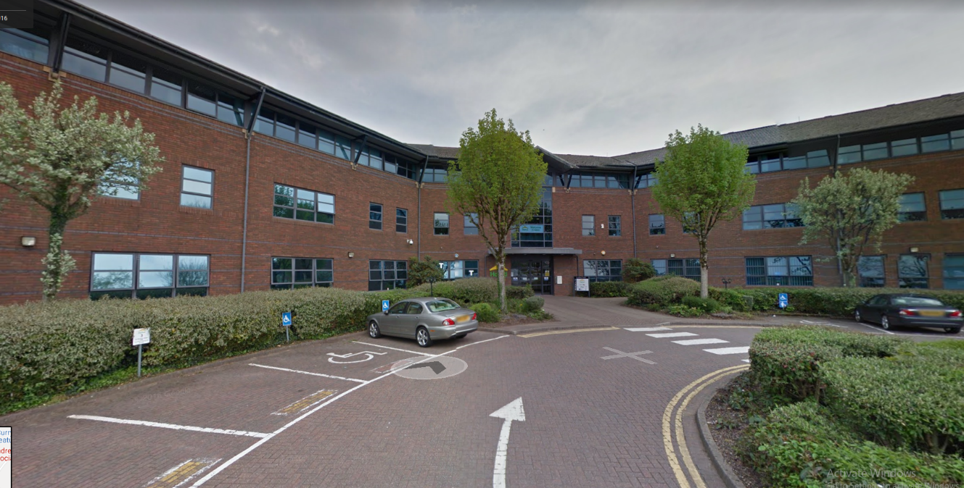

Forest: Llanilid Forest
Description: Large depth plenty of room for crew and cast. However, a site Health and safety check will be required first.
Travel: Train Station/ Bus Stops
Located: 2.2 miles from the property.
Cost: Taxi- £5
Car- Free Provided by Director.

Request to film at location: Pending
Cost: TBC
Days required: 1 Day1

Visual Styling
Inspirations: Lee Smith
Films that inspire the Visual/Narrative styling:
- Dunkirk, Inception, Interstellar.
Reasoning: The reason as to why I have homed in on one Editor is because I want my own editor to have clarity in what exactly the visual styling of this piece should be. Lee is known for his ability to combine sound with the moving image which ultimately allows for a visual message to be displayed. He has worked closely with Christopher Nolan who is the main influence for me as a director, so it makes sense to focus in on this editor.
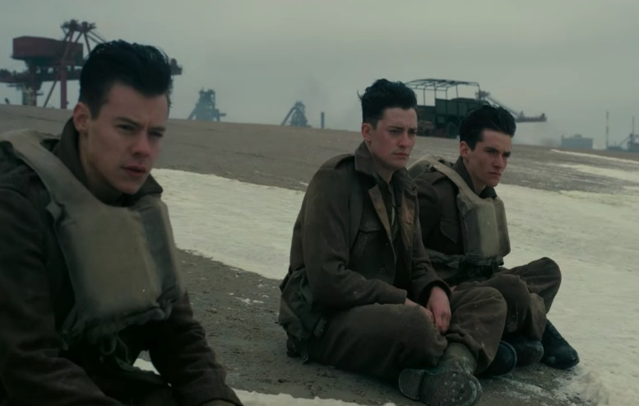
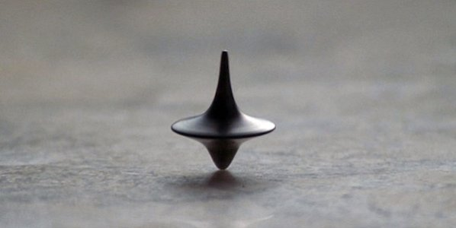
Example shots:

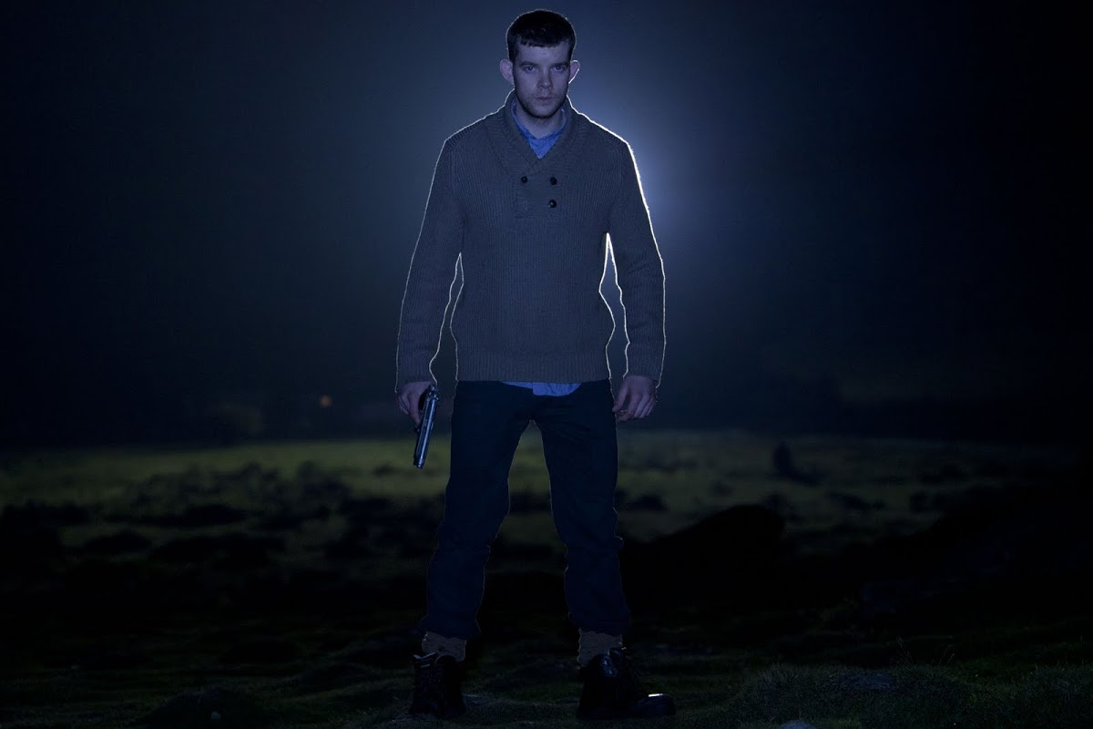
Examples of other visual influences:
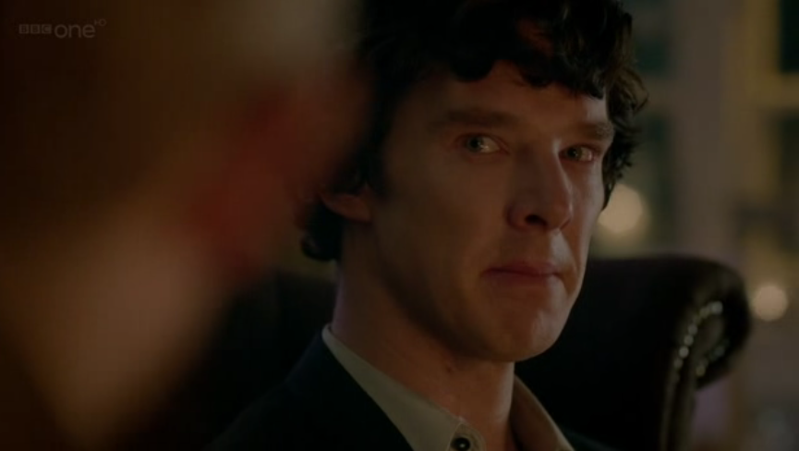
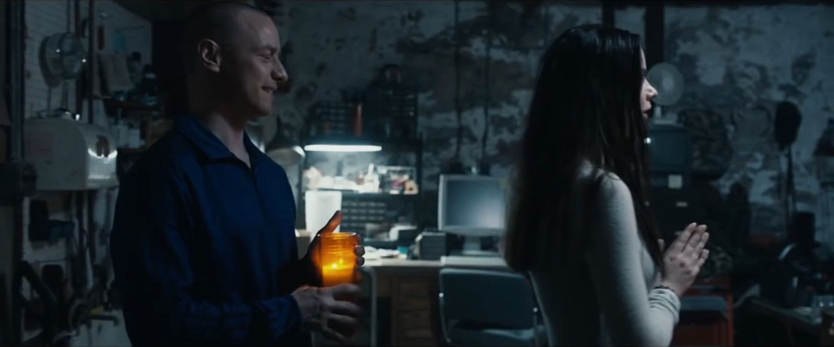

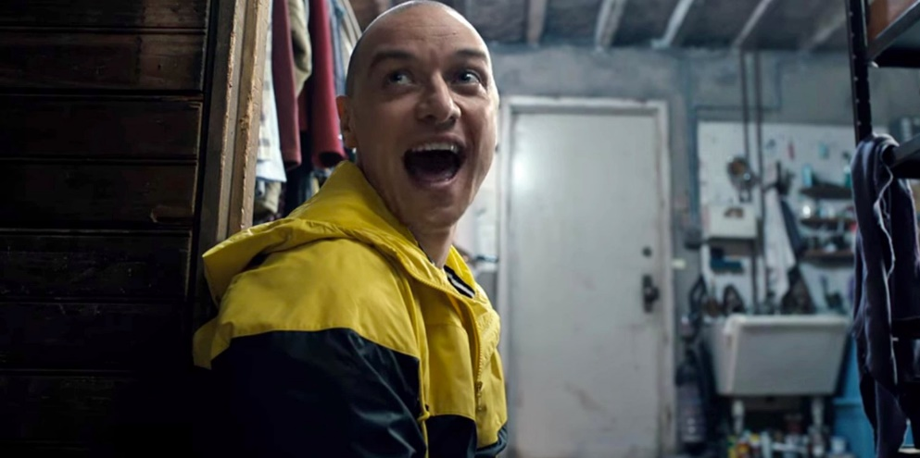
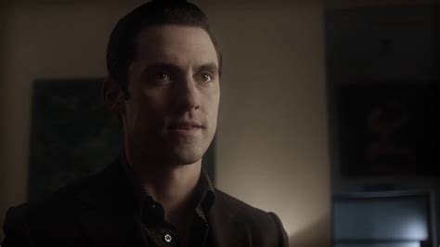

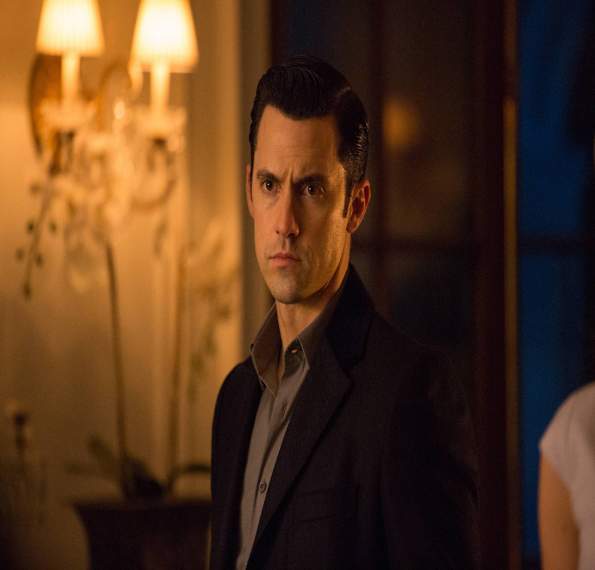
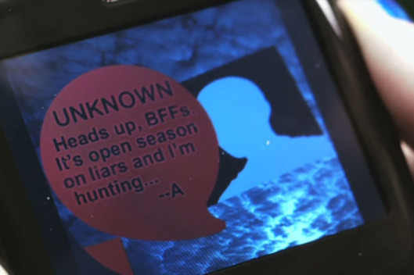

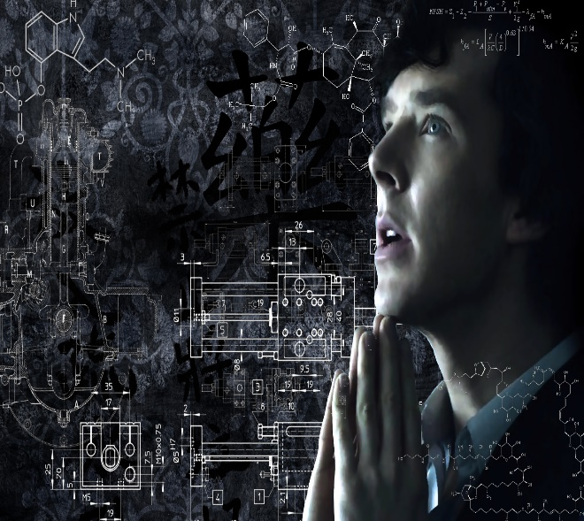
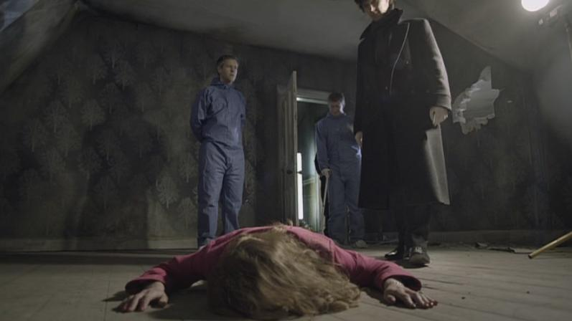

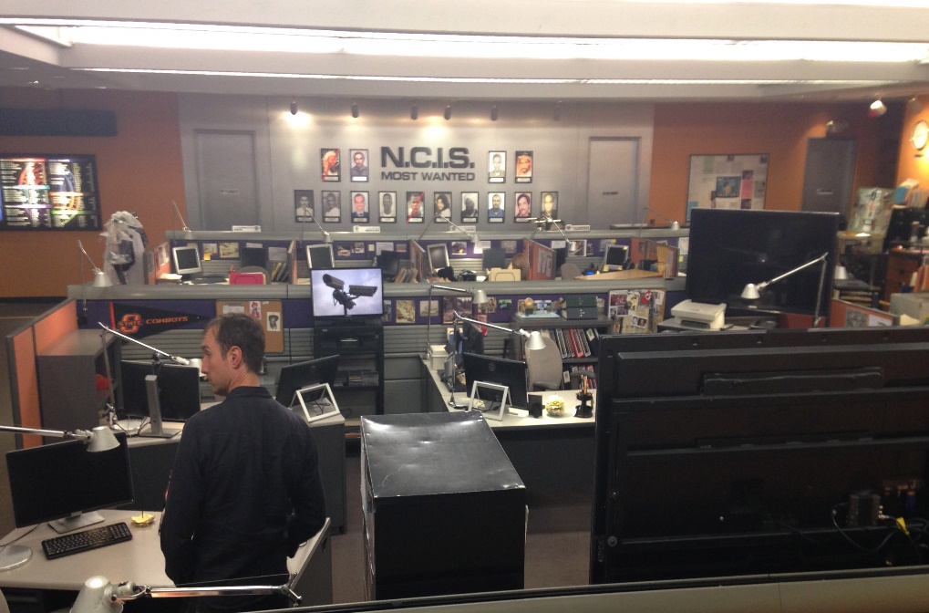
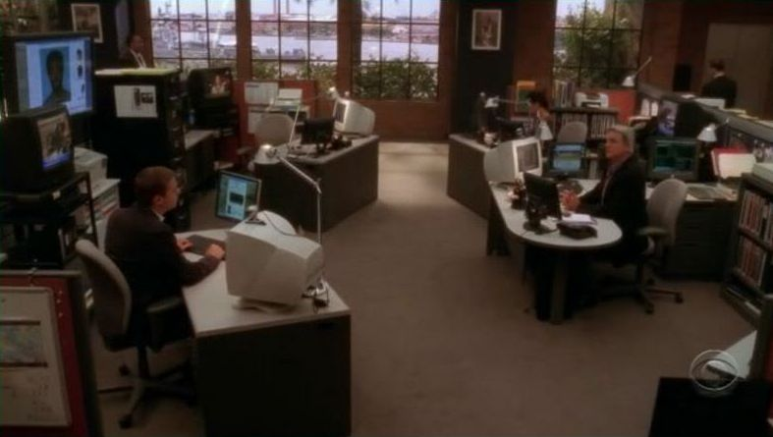

Main Character (Inspirations)



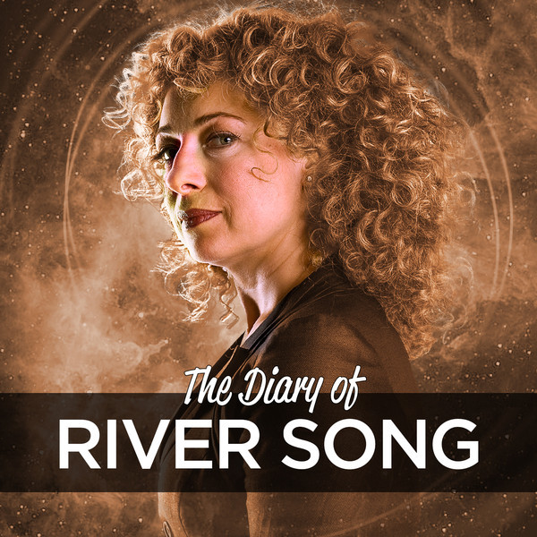

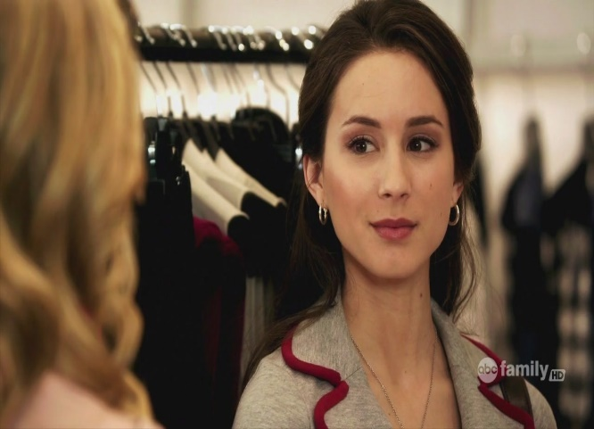



Main Character: Breakdown

Name: Stephanie Hamilton
Age: 24-30
Characteristics: Observant, Intelligent, Strong, Confident, Independent, Under Appreciated, Lonely.
Styling: Classic look with a contemporary feel and a touch of Gothic.
Extra:
This character has all the hallmarks of classic Sherlock Holmes styled character. Sometimes they are too busy thinking about how smart they can be and that can lead sometime to missing the obvious. Throughout this film this main character will experience a sense of disappointment, loneliness, excitement, fear and shock.

Key Emotional drives for the Character:
- She feels constantly as though she must justify her brilliance because of the Male superiority work environment she finds herself in.
- Before this film takes place in her timeline she has recently broken up with her long-term boyfriend. This is hinted at in the film but not greatly dwelled upon from her perspective.
- She is a hard-working detective with an interest in the more unusual cases so upon receiving the case when she gets home she’s filled with a sense of excitement and anticipation as to what it could be about.

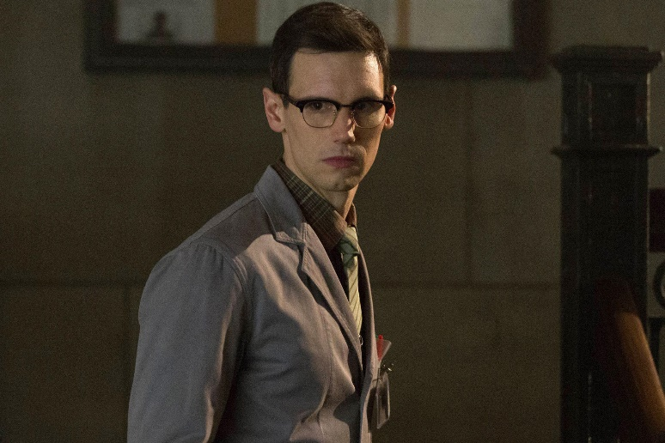
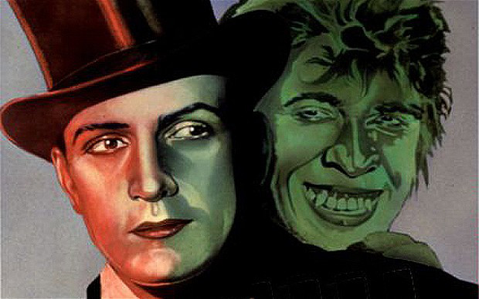
Antagonist

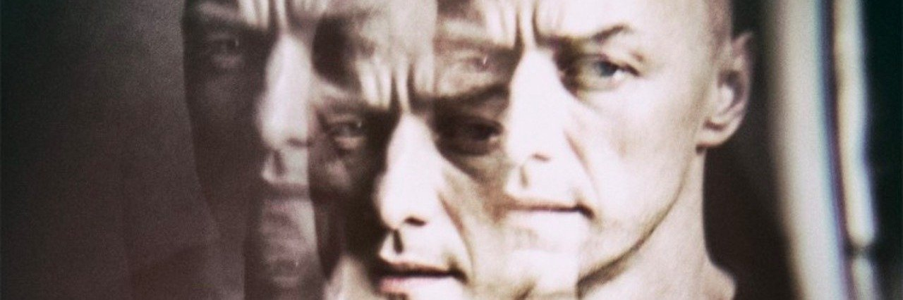
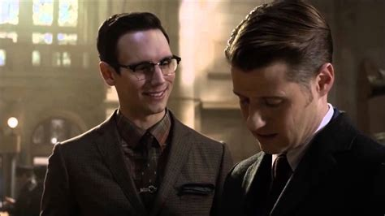

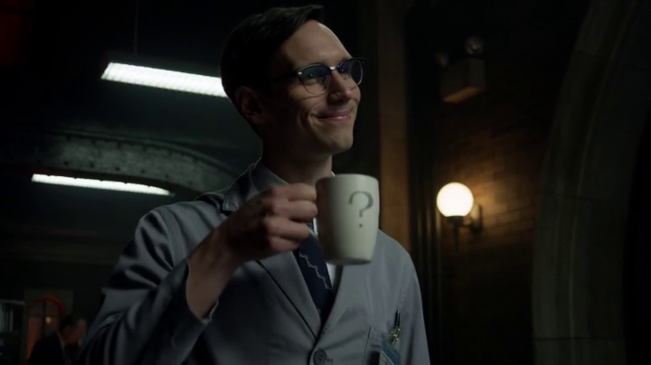
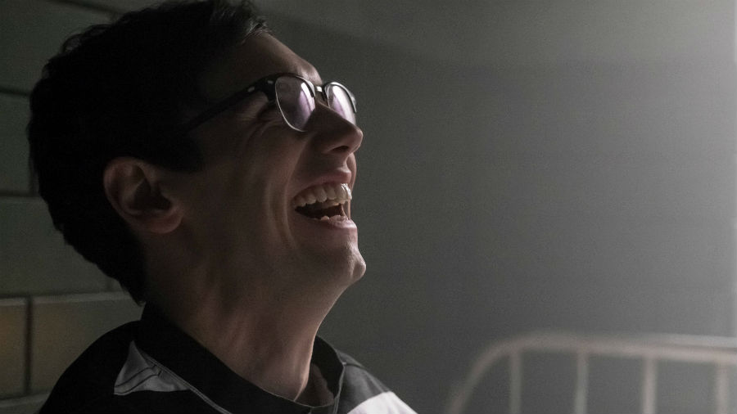

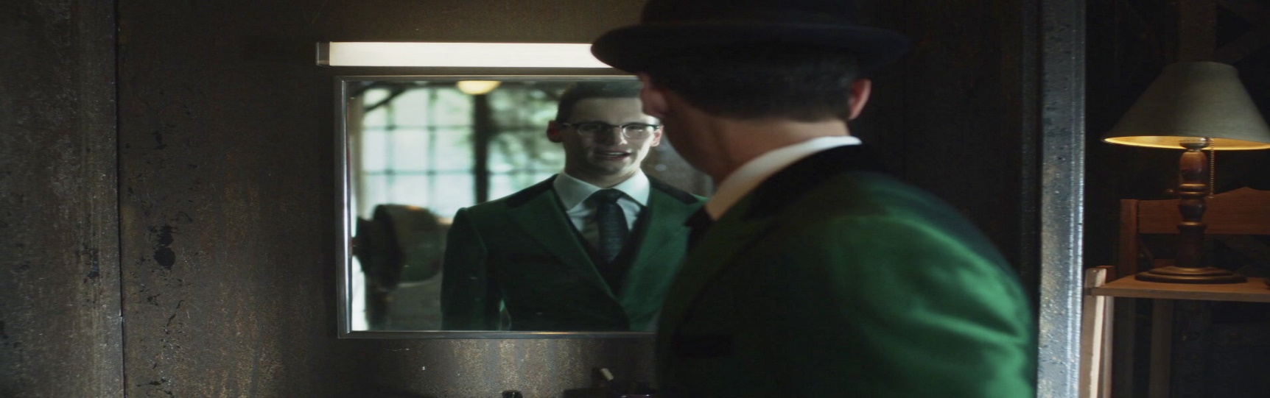

Name: Elinor North
Age: 22-28
Characteristics: Obsessive, Delusional, Quiet, Jekyll and Hyde. Neediness.
Extra: This Character is driven by the obsession of the main character after murdering her abusive ex-lover. She now seeks to take her moment to be the warm shoulder that she thinks our main character needs. She’s constantly snubbed by our main character and often left wondering why she likes her but the passion and absurd obsession with her flares up once again. Doesn’t matter whether its just her smile or just here presence, it is felt by this character no matter what. How ever this character is based upon Fox’s Tv series Gotham’s Character Edward Nygma who is in a similar situation and deals with split personality disorder on a criminal level.

Why should I Direct this short? Challenges and Inspirations.
As the Director and writer of this project, I intend to work closely with the actors on the project particularly with the protagonist and antagonist and trying to form an off set relationship between the two so that when the actresses perform it will be easier for them to channel the emotions and make for a more relaxed environment and this will ultimately result in better quality interactions for this ‘short’. This is something that actors who have previously worked with Christopher Nolan have said has helped them and there is an article online that asks the question has Nolan ever made a bad film. In my opinion Nolan is one of the most intellectually talented writers and a mastermind of a director with immense amount of passion and determination and the willingness to work closely with the actors to make a comfortable environment to work in for them. These are the aspects I want to take forward in this project. This will be the largest cast I have worked with to date and crew. This is a challenge and the reason why I feel that I should be the one to direct this short. I feel like this would be the perfect stepping stone for myself into the world of directing.

Scheduling
Approximate Dates;
18th February 2019 – 24th February 2019.

Day 1
Start time – 7PM*
Finish time – 11PM*
Scenes to be shot: A1, B1
Date – Monday, February 18th, 2019

Day 2
Start time – 5PM*
Finish time – 9/10PM*
Scenes to be shot: A2 (kitchen, living room) B2
Date – Tuesday, February 19th, 2019
Day 3
Start time – 6PM*
Finish time – 11PM*
Scenes to be shot: A2 (Bathroom, Bedroom, Landing)
Date – Wednesday, February 20th, 2019

Day 4
Start time – 6PM*
Finish time – 9PM*
Scenes to be shot: B2, B3
Date – Thursday, February 21th 2019

Required Casting
Main Character:
-Female, Early 20’s
Colleague
Female Early 20s
Chief Inspector:
Male 40-50s
Extras: TBD

Hiring Crew
UK states that the Minimum wage for over 25’s is currently as of 2018 £7.50 per hour. This list represents the already approached and signed on Members of the Crew as of the date of this submission and is subject to change by production.
Required crew
Director – Richard Magness
Lighting crew (2/3) –
Director of Photography – Celyn Rees
ADOP-
Sound Crew (2)-
Producer - Richard Magness
Runner -Toby Panasar/ Chris Jones
Assistant Director-
Head Of props- Richard Magness
Hair and Make Up- (Laura Evans)
Casting Director- Richard Magness
Editor-
TOTAL COST PER HOUR Est* = £ 82.50
Per Day:
Day 1= £330
Day 2=£412.50
Day 3=£412.50
Day 4=£247.50
Total Cost = £1,402.50
Catering
£3 Meal deals from Tesco’s will be provided at each shoot to each cast and crew members.
Day 1: £36
Day 2: £36
Day 3: £36
Day 4: £36
Overall Total Cost: £144

Estimated Cost of Film = £1,546.50*

*This total does not include the cost of casting/ travel expenses which mean it will be subject to change in the future when further figures are known.
Funding and Marketing
BFI
- Lead organisation for film in the UK. They distribute lottery funds for film and has a wide range of supporting schemes. This option however may not be applicable to this type of project and mostly not a viable option.

FFilm Cyrmru Wales
- Schemes include ‘The Horizons Fund’ and short film schemes ‘Beacons’ They award up to £15K to Welsh born or Welsh residential film makers. This option however may not be applicable to this type of project and mostly not a viable option.

Go Fund/ Indy Go Go
- Go fund is a website used to collect sponsorship money. That means you can set a goal for your own personal needs. This can be shared via social media to address a wider range of audience which ultimately will help to raise money for your cause.

Personal Funding
As this is my First Major project I plan to invest a sum of £300 towards the film.

Short Horror Genre Festivals
Possible festivals in which our short could enter. *
- Scream Fest
- Toronto After Dark
- Portland Horror Film Festival
- A Night of Horror
- Midnight Movie Horror Festival
- Hollywood Horror Festival.

*These are subject to change as the project develops. These are also subject to requirement restrictions.
Reflection

“The purpose of reflection is therefore to bring our reasoning processes and behaviour patterns to the surface and make them explicit. However, uncovering these can be difficult because so much of this knowledge is tacit and spontaneous. When we develop a pattern of behaviour that works in certain situations, we will tend to repeat it until it becomes automatic. We can’t describe the processes involved because we are not aware of what is going on.. It is only when something goes wrong or something unexpected happens that we may stop and think about what we did and what we could or should have done in the situation.”
For this project we were tasked with the job of creating a narrative in which we would start preproduction of this and would include looking at the following areas in depth; Pitches, Scripts, Scheduling, Crew and Casting, Financial Plan, Visualisation, Location reports and production design plans. Once I had carried out the necessary research I then had to condense the information down into a 2000-word booklet. This should highlight ever area previously mentioned.

During this process problems arose and were solved using various methods and example of the different problems that occurred are: The first issue I found once I had developed a narrative was time restriction. The narrative developed so much that it would have been just short of a 40-minute-long episode similar to BBC’s length of Sherlock episode. This was over come mainly by rewrites of the script and in one case a whole scene was cut and instead is then alluded too via a voice over instead. Another example would be when I realised that there was no logical explanation for the reason why the main character experienced paranormal events this was then given the explanation of these were just visions in a paranoid trip from her
tea being spiked with LSD which is a hallucinogenic substance. Another problem that arose and was solved would be the script itself this was something that I had intended to create with plenty of depth and layers to keep the audience guessing the only question on their mind ‘Who did it’ this was something that was inspired by not only BBC’s Sherlock but by Christopher Nolan. The way I found a solution was by multiple attempts of writing and rewriting scripts until I was fully satisfied. To test that my idea had worked, and I had succeeded in creating an interesting and alluring script I gave it to a couple of people and got feed back from them the general consensus was that it was very interesting, and they wanted to see the finished piece.

Personally, I am very pleased with how this pre-production has gone on this specific project. As a screenwriter I wanted to challenge myself and go a little bit out of my comfort zone by creating multi-layer characters that have an element of human connection for the audiences to be able to feel the pain of the antagonist and for the audience to see the brilliance of the protagonist as they try to solve their greatest puzzle yet. The one thing I learnt when writing this script was not everything has to be said aloud and can be alluded to via other routes such as suggested or even visually on screen such as in this short, the main character is a very keen puzzle solving enthusiast this is alluded to during a few difference scenes an example of which is a newly completed word search on a news paper that a few shots before we saw was empty. This again is another way I have tried to provide the audience with information without using dialog. Another aspect of preproduction I am happy with and glad to have tried was trying to take time off the original script doing this enlightened me to new method in which to portray information and to be more concise with what is needed and what isn’t needed really. Also, being the director of this short has aided me writing the script as I was able to visualise scenes as I was writing which will ultimately aid me when it comes to directing the actors in production as I will have a good knowledge depth of the whole project including the ability to break down each character to its core so that when I’m communicating with my actors and crew they have a good since of clarity about the task in hand.

Looking back thought there are a few adjustments I would make next time I carry out preproduction; the first would be to allocate more time to the development stage of the character this would make for more rounded and grounded characters. The second thing I would take into consideration are film festival requirements whether that is time restrictions or something else. The final thing I will take forward from this is to get as much feed back as possible in the preproduction stage this can ultimately lead to a more successful script or even a more successful idea than your original thoughts. I will try to get as much feed back as possible from now on from both people in the same line as work as myself and from potential audience members to get a broader range of feed back which will lead to stronger projects.

Reference
Carolyn Maughan, “Learning how to learn: the skills developer’s guide to experiential learning” in Julian Webb & Caroline Maughan, eds., Teaching Lawyers’ Skills, (London: Butterworths, 1996) 59 at 76.

