

Postgraduate/Distance Learning
Assignment coversheet & feedback form

THIS SHEET MUST BE THE FIRST PAGE OF THE ASSIGNMENT YOU ARE SUBMITTING (DO NOT SEND AS A SEPARATE FILE)

For completion by the student:
Student Name: Iza Steiner

Module code: HPCA7009  Module title: Skyscapes, Cosmology and Archaeology | Student ID number:  1811470 |  |  | Educational support needs:  No
Module tutor: Bernadette Brady

Assignment due date: August 13, 2020
If your module has multiple submissions please indicate which piece of work this is.

1st x 2nd 3rd x 4th 5th 6th
I confirm that this is my original work and that I have adhered to the University policy on plagiarism.
Signed ……………………………………………………………
Email submission: if you are submitting this form via email, please tick this box x
(as a substitute for your signature) to confirm that you agree to the above declaration.
Assignment Mark
1st Marker’s Provisional mark
2nd Marker’s/Moderator’s provisional mark
Agreed Internal Mark:

External Examiner’s mark (if relevant)
Final Mark

NB. All marks are provisional until confirmed by the Final Examination Board.

For completion by Marker 1 :
Comments:

Marker’s signature: |  |  | Date:
For completion by Marker 2/Moderator:

Comments:

Marker’s Signature: |  | Date:
AGREED INTERNAL MARK (where necessary):

Comment on process of arriving at agreed mark:

External Examiner’s comments (if relevant)

External Examiner’s Signature: |  | Date:

Skyscape Dynamics and Light and Shadow on the ‘Simple Spiral’ Petroglyph.
In a natural rockfall in Castle Valley, Utah, a petroglyph panel including two spirals and a ‘snake’ figure was discovered in the fall of 2011. An overhanging slab shades the panel throughout winter and fall and the sun only reaches it for a short time in spring and summer before setting behind the adjacent cliff. This research addresses whether the spirals were placed to mark significant solar dates, especially equinoxes and the summer solstice. The patterns of light and shadow on the panel were observed beginning before the vernal equinox and concluded after summer solstice. Interpretation through a skyscape approach, assessed the potential use of the western cliff as a horizon calendar and the use of landscape features for orientation to cardinal points or solar events.

The ‘Simple Spiral’ Petroglyph Site
In 2011 a petroglyph, or rock art image pecked into stone, containing two spirals, and a snake-like figure was discovered in a natural rockfall on the east side of Castle Valley, Utah and named ‘Simple Spiral’. A slab of sandstone 6 m wide by 8 m high and 2 m thick overhangs a pile of cracked boulders and is tilted at 45 degrees. (Figure 1.) The site is about 100 m east of the base of Porcupine Rim, a 700 m high Wingate cliff ending with a jagged skyline at 28-36 degrees altitude. The spiral petroglyphs are located directly under the slab on an almost horizontal face. (Figure 2.) The overhanging slab shades the petroglyph until about 16:00 throughout spring and summer and keeps it in shade during most of winter and fall.
The larger spiral measures 50 cm wide by 42 cm high with 5.5 rotations. To the right of this spiral is a densely pecked shape 30 cm long and then a wavy line extending 28 cm to a smaller spiral 12 cm in diameter with 3.5 rotations. Below the spirals on the vertical face of the petroglyph stone is a wavy line, 1 m by 15 cm, with nine peaks terminating in a straight upward stroke on the right and a small circle on the left, which may represent a snake. (Figure 5.) The panel shows no signs of vandalism or overwriting. The ‘Simple Spiral’ site is a rare example of a horizontal petroglyph with limited sun exposure and a relatively hidden position up against Porcupine Rim.
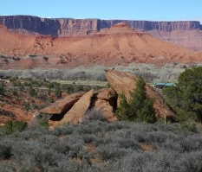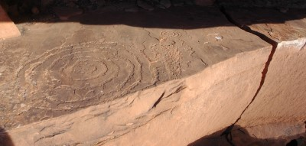
Figure 2. The shadow touches the eastern edge of the small spiral. Note the pecked anthropomorph between the spirals. The tail of the snake can faintly be seen on the lower face, terminating at the crack. Photograph: Author.
Figure 1. The rockfall seen from the south, the overhanging slab is on the right and the black arrow points to the petroglyph. The blue line is north and dissects the crack below the petroglyph. Photograph: Author.

Literature Review
The significance of the ‘Simple Spiral’ site requires analysis of the regional, archaeological, and academic contexts. Per personal email from Lori Hunsaker, archaeologist in the Moab Field Office of the Bureau of Land Management (BLM), there are roughly 7,000 archaeological sites spanning 6,000 years of prehistory within her jurisdiction. Hunsaker estimates that less than 20% of this area has been surveyed. The only site within Castle Valley known to the BLM is a petroglyph panel of three anthropomorphs, or human-like figures, and one zoomorph, an animal-like figure resembling a bighorn sheep, about 2 km away from ‘Simple Spiral’. There are known petroglyph panels in Castleton 12 km away and another upstream near the Colorado River, 7 km away.
According to Sally J. Cole, Archaic rock art left by hunter-gatherer tribes in the Canyonlands region dates from 4,000-3,000 BCE to 500 CE. In Cole’s analysis, during the Archaic era, Castle Valley was included in regions representing Glen Canyon 5 style from the canyons to the southwest, Archaic Uncompahgre Complex style from mountains to the east, and Barrier Canyon Style from plateaus to the north. Castle Valley lies 4 km south of the Colorado River, which formed what Cole referred to as a natural, but culturally porous boundary between the two major prehistoric groups of Native Americans in the southern Utah. (Figure 3.) To the north and the west of the Colorado River, the Fremont Indians lived between 400-700 through 1,300-1,600 CE, according to Polly Schaafsma. Basketmaker II and III (~1000 BCE to 750 CE) were predecessors to the Ancestral Puebloans I-IV (~700-750 CE to 1450 CE) who built their communities primarily east and south of the Colorado River, according to Cole. Historical petroglyphs of the Ute (1500 CE to present) are also found in the Canyonlands region, according to Carol Patterson.
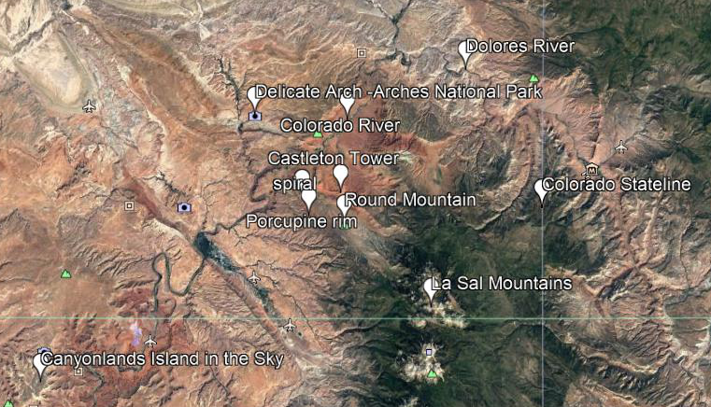
Figure 3. The geographical layout of Castle Valley relative to well-known rock art regions and prehistoric migration patterns. Image: Google Earth Pro

Direct methods of dating rock art have not been developed for petroglyphs, which are pecked, scratched, or abraded into rock, while pictographs, which are painted on rock, have occasionally yielded enough pigment to date panels, according to Cole. Schaafsma stated that associated material culture, superimposition, and stylistic variations, especially in the anthropomorphic and zoomorphic forms, have been the primary means of dating petroglyphs.
The academic rationale for researching light and shadow patterns on spirals began with Anna Sofaer’s discovery of the ‘three slab site’ on Fajada Butte in 1977. Anna Sofaer, Volker Zinser, and Rolf Sinclair described two spirals on a boulder behind three fallen slabs, which appeared to mark the solstices and equinoxes, when ‘daggers’ of sunlight passed between the boulders around noon and dissected at summer solstice, or outlined at winter solstice the larger spiral . The ‘sun dagger’ aroused heated debate, including Jonathon Reyman’s critique that this site lacked the context of similar sites and showed ethnographic discontinuity. By 1985, Dietrick Thomsen reported that Robert A. Preston and Ann L. Preston had collected data on eighteen petroglyph sites throughout the Four Corners region, with shadow and light patterns that touch either the center or edges of spirals during equinoxes and solstices. Additionally, the Prestons reported anthropomorphs and zoomorphs, touched by sunlight typically on heads, tails, or phalli on the solstice and/or equinox. J. McKim Malville described Hovenweep’s Holly House petroglyph, ‘where residents of the area had pecked two spirals and a set of three concentric circles with a dot in the center. There also is a wavy line that may represent a plumed serpent, and two connected circles each with a dot in the center.’ Malville related how a ‘sun dagger’ enters from the left and pierces the centre of the first spiral forty-five minutes after local sunrise. A second shaft of light pierces the concentric circles below centre before the two shafts conjoin and move downward as the sun rises. The ‘three slab site’, Holly House and most of the Preston’s sites have been attributed to Ancestral Puebloans. Cole described two Barrier Canyon Style rock art sites where ‘bursts of light extend from the “mouths” of painted forms’ as the solstice sun rises. The evidence shows that shadow and light effects on petroglyphs are not an anomaly.
Malville showed that Ancestral Puebloans incorporated knowledge of the paths of the sun and moon, and geographic orientations into the architecture of Chaco Canyon, Chimney Rock, Mesa Verde, and Hovenweep. Florence Ellis Hawley’s ethnography of the Hopi Indians explained how ‘sun-watchers’ used movements of the sun and moon and ‘horizon calendars’, which marked sunrise or sunset positions along a distinctive horizon, to schedule celebrations and agricultural events.
The intention of this research was to determine if shadows cast on the ‘Simple Spiral’ petroglyph by the overhanging rock matched the patterns found in other solstice and equinox interactive petroglyphs. The potential use of this site as a horizon calendar and the site’s cardinal orientation to natural landscape features were assessed.

Methodology
The methodology used in this research involved several techniques for establishing ways in which cultural relationships to the sky could have determined the choice of site and the configuration of the petroglyph panel. Patterns of shadow and light on the spirals were photographed primarily at sunset from Feb 26 – July 15, 2020. Azimuth and altitude of the setting sun were recorded using a Suunto Tandem Satellite compass and clinometer. Horizon positions of the setting sun were recorded photographically. Time was recorded using military times, adjusted to Daylight Savings time in the local Mountain Standard Time. The orientation to other features of the landscape, was measured by compass and local magnetic declination of -9.70 was added and then verified using Google Earth Pro. The steep angle of Porcupine Rim made it difficult to obtain accurate azimuth and declination measurements. The data includes timestamped light and shadow photographs, a horizon line marking sunsets and dates, one sunrise observed two weeks past solstice, and a map of the petroglyph site’s orientation to landmarks.
Skyscape archaeology was incorporated into this research as Fabio Silva described to, ‘encompass the heavens and the celestial bodies and how they relate back down to human beliefs and practices, to their notions of time and space, to their structures and material culture.’ Using a phenomenological approach, which, according to Christopher Tilley, ‘…means that the anthropologist/ researcher needs to be there, to experience the landscape through the sensual and sensing body, through his or her corporeal body.’ The sense of ‘being-in-place’ allowed observation of solar interactions with the horizon and the shadow and light on the panel to reveal phenomena that would be difficult to calculate given the chaotic, natural environment.

Findings and Discussion
The evidence during this research is presented and analysed in three sections: light and shadow patterns on the spirals; potential use of the site for observing a horizon calendar or relationship to cardinal directions, and the geographical and cultural context of the region.

Light and Shadow on the ‘Simple Spiral’
The potential for observing special shadow or light effects on the equinox and solstice required viewing the site before, during, and after these solar events. The first observation on Feb 26, 2020, noted the sun set behind the cliff before any portion of the spiral panel was illuminated. By March 4th, the larger spiral was just receiving light along the edge before sunset. At sunset on the equinox at 16:22, March 19, 2020, both spirals were fully illuminated for the first time. (Figure 4.) The spirals received full illumination throughout the late afternoon as the days grew longer until on summer solstice, June 20, 2020 the sunset occurring at 18:10 had shone on the panel for two hours. No special light effects were created by the setting sun’s shadow.
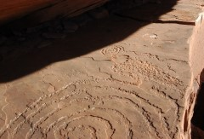
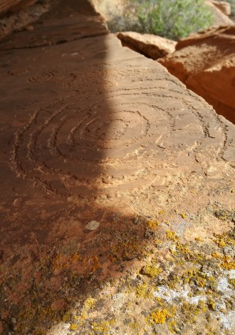

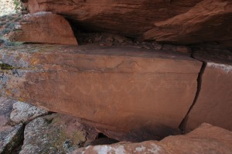
Figure 5. The snake figure is clearly visible from the west side. It is about one meter long. The steep angle of the crevice in which the spirals were pecked can be seen in this photograph. Photograph: Author.
Figure 4. Equinox shadow line at sunset on March 19, 2020, 16:00. Photograph: Author.
Figure 6. June 28, 2020, one week after solstice. The bump shadow seen in the foreground only touched the edge of the spiral when the shadow dissected the large spiral at 16:09. Photograph: Author.

One of Reyman’s objections to the ‘three slab site’ on Fajada Butte use as a solstice marker is that the shaft of light dissecting the spiral occurs around noon, arguing that it was more culturally appropriate to observe solstitial markers at sunrise or sunset. To avoid a sunrise/sunset bias, the ‘Simple Spiral’ site was then observed on July 8, 2020, as the sun first illuminated the panel in the afternoon. At 16:00 the shadow from the overhanging slab had dissected the larger spiral and an extension of that shadow, elongated from a small bump on the slab above about 4 cm thick, 10 cm high by 10 cm wide came within 2 cm of the north edge of the larger spiral. As the sun descended, the spiral became fully illuminated and the bump shadow moved away again from the edge of the petroglyph. (Figure 6.) The bump shadow only touched the edge of the spiral while the normal slab shadow dissected the large spiral. One week earlier, a slightly more northerly position of the sun would have pushed the shadow bump even closer to the edge of the spiral. The evidence indicates that special shadow effects, which touched the edges of the larger and the smaller spiral occur on the solstice and equinox respectively, when the panel is first illuminated in late afternoon.
While Sofaer, Zinser, and Sinclair originally stated that the midday sun created the ‘sun dagger’ at Fajada Butte, which pierces the center of the larger spiral on summer solstice, this was revised in a later publication by Sofaer and Sinclair, which stated that the ‘three slabs site’ does ‘not accurately mark noon.’ On the ‘east site’ at Fajada Butte, Sofaer and Sinclair claimed, ‘A shadow edge crosses the spiral glyph within 10 minutes of noon throughout the year.’ The ‘east site’ on Fajada Butte also has a snake glyph where, ‘an unrelated shadow edge crosses the snake, touching all parts at once: the head, the body and the rattles,’ on the equinox, close to noon, according to Sofaer and Sinclair. Malville noted the effect of the ‘sun dagger’ entering the overhang at Holly House petroglyph 45 minutes after local sunrise. The evidence indicates that ‘Simple Spiral’, Holly House petroglyph, ‘three slab site’ and ‘east site’ did not display distinctive light and shadow effects at sunrise or sunset on the equinox and solstices.

Horizon Calendar
From the “Simple Spiral’ site, sunsets along the craggy horizon of Porcupine Rim were measured for potential use as a horizon calendar. Ellis described, ‘The succession of horizon points over which the sun rose or set became calendar markers,’ among the historic Pueblo tribes. The spirals receive no direct sunlight until after 15:30, by which time the sun has set behind Porcupine Rim throughout most of autumn and winter. Standing in front of the petroglyphs, the sunset points on Porcupine Rim are unique. (Figure 7.) Yet this cliff is so jagged that any segment could be memorized by a consistent observer, leading to the conclusion that the western horizon may not have been a decisive factor in choosing this site. Ellis noted Hopi ‘horizon calendars’ marked important agricultural and ceremonial events in addition to equinox and solstices. The local culture and microclimate of Castle Valley, would have resulted in a regional set of important dates. 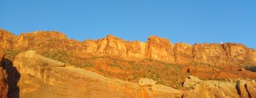
Solstice: June 20,2020
May 1, 2020
Figure 7. Porcupine rim, just west of the ‘Simple Spiral’, is marked for horizon calendar dates. Photograph: Author.
Equinox: March 19 19191930

March 30
March 8, 2020
Only one sunrise was observed. On July 8th, 2020 at 6:09, the sun rose between Parriot Mesa and a distant mesa at the lowest point of the horizon, filling the valley with a single shaft of light. Even a non-Native American, whose survival is not tied to this landscape, and who lacks ancestral and mythological ties to this land could appreciate the first light reaching across the dark valley on the longest day of the year to illuminate this spot. The deep ‘V’ between the mesas revealed a nipple-shaped rise at 68 degrees azimuth, 3 degrees altitude, above which the sun rose. (Figure 8.) Although this observation occurred eighteen days after summer solstice, the ‘V’ would have constrained further apparent movement of the sun to the north. Even though the petroglyph receives no sunlight in the morning, the rockfall may have been chosen as a viewpoint of the first sun on the longest day of the year. According to Ellis, the nipple in the ‘V’ would have been the ‘summer house’ or ‘northern house’ of the sun, which in her historic example, was situated over a small hill seen from within the ‘V’ of an arroyo.
On July 8, 2020, the second shaft of light entering the valley emerged from the gap between Castelton Tower and Adobe Mesa, which lies east of the petroglyph site at 92 degrees azimuth and 3.5 degrees altitude, indicating that the equinox sun is likely to rise within that broader ‘V’. On equinox only one shaft of light would enter the valley at first light. A small cave under the slab, could have provided protection for a ‘sun-watcher’ and the small opening to the NNE would have allowed awareness of dawning light, although no evidence of occupation, other than a sandy level floor, remains.
Midwinter sunrise appears near the peak of Round Mountain, an extinct volcano cone, located within the valley and the La Sal peaks 20 km beyond. The western horizon shows potential for use as a ‘horizon calendar’, but the remarkable experience of first light on summer solstice and equinox could have earmarked this location for solar observations.
,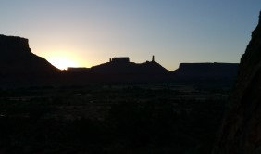
Figure 8. View of the eastern horizon on July 8, 2020 at sunrise, 6:09. The nipple is visible in the deep part of the ‘V’. Far right is the edge of the overhanging slab of the petroglyph site. Photograph: Author.
Castleton Tower
Parriot Mesa
Adobe Mesa
East

Castle Valley Skyscape
The orientation of this petroglyph site to cardinal directions can only be deduced from its relationship to remarkable landscape features. Unlike Chaco’s Great Houses studied by Malville, the circular spirals and boulder pile show no single orientation. From the south, Pace Hill lies just 5.67 degrees east of north. A sightline due north lies along the crack that naturally forms the west face of the petroglyph panel. (Figure 1.) Looking east past the overhanging slab, Castleton Tower comes into view at 82.72 degrees, seven degrees north of due east. Views to the west and south are clipped by Porcupine Rim. Viewed from the ‘Simple Spiral’ petroglyph the orientation to prominent features of the landscape are rough (less than 10 degrees), while the dips between mesas correspond much more precisely to the solar turning points of summer solstice and the equinoxes. (Figure 9.)
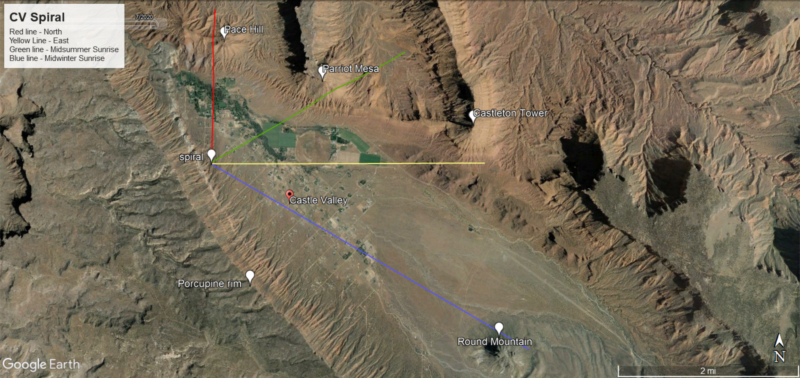
Figure 9. The major landscape features of Pace Hill and Castleton Tower are within a few degrees of north and east respectively. The base of Parriot Mesa and the peak of Round Hill are within a few degrees of midsummer and midwinter sunrise from this site, giving an observer a general reference to the cardinal points and major solar events. Image: Google Earth Pro.

The cultural and geographical context
The ‘Simple Spiral’ site could lend a new perspective on the importance of astronomy to a given culture or group, if the petroglyph could be dated. Unfortunately, the spirals and ‘snake’ found in the ‘Simple Spiral’ petroglyph have parallels to all ten of the styles listed by Cole as indigenous to the Castle Valley area.
The ‘Simple Spiral’ petroglyph resembles Cole’s description of Archaic rock art of hunter-gatherers in the emphasis on geometric forms, proximity to rivers (Glen Canyon Style 5), and petroglyph panels which wrap around two or more faces of the boulder. Cole’s description of Barrier Canyon Style anthropomorphs as ‘elongate and tapering with rounded, hunched, and sloping shoulders’ recalls the shape between the spirals, where the round indentation, may be considered a head. Cole attests headless anthropomorphs in the Barrier Canyon Style and that geometric forms were at times found with Barrier Canyon Style. According to Polly Schaafsma, geometric forms were uncommon in Barrier Canyon Style.
Spirals were used more frequently in the Basketmaker and Ancestral Puebloan styles, often with anthropomorphs in Cole’s assessment. The juxtaposition of two spirals and a snake has been documented by Malville at the Holly House petroglyph and by Sofaer and Sinclair at Fajada Butte, both of which are Ancestral Puebloan and show distinctive light patterns, in the shape of ‘sun daggers’ on the petroglyphs during summer solstice. Other similarities noted by Sofaer and Sinclair of the ‘three slabs site’, which are shared with ‘Simple Spiral’ are one larger spiral and one smaller spiral that terminates in a wavy line; on Fajada Butte there is a snake figure on the ‘east site’ about 100 m away from ‘three slabs site’; the sites are located in natural rockfalls at the base of cliffs and both sites achieve their visual effects at times other than sunrise and sunset. Some significant differences are that the Castle Valley site is not located near a major Ancestral Puebloan center, the shadows never form a dagger or shaft, and the Castle Valley spirals are readily accessible to farming areas. The ‘Simple Spiral’ shares with numerous spirals studied by the Prestons a shadow edge touching the side or center of a spiral on solstice or equinox. Although Castle Valley is on the fringe of Ancestral Puebloan region, the spiral and snake glyphs and the shadow effects on solstice and equinox show a strong resemblance to Ancestral Puebloan sites.
Malville stated that the Ancestral Puebloans who built Chaco Canyon Complex between 900 CE and 1130 CE migrated south from the Dolores River Valley around McPhee. Cole illustrates that Basketmaker II and Ancestral Puebloan rock art is also found down the Dolores drainage, which deposits into the Colorado River 15 km east of Castle Valley. According to Cole, the region around Castle Valley was depopulated between 1150 -1250 CE. Malville stated that, ‘Around 1250 CE, bad things began to happen among the canyons and mesas of the Southwest. There was a rapid movement of people living north of the San Juan River into defensible villages, often on canyon rims incorporating water supplies,’ referring to Mesa Verde and Hovenweep. Castle Valley, Moab, and Canyonlands are considered part of the Basketmaker and Ancestral Puebloan region, but no great houses have been found north of Montezuma Creek, about 150 kilometer south of Castle Valley, according to James Allison. The continuity of rock art across eastern canyonlands and up the Dolores river, as evidenced by Cole, could indicate that a migration from the north toward McPhee and eventually on to Chaco Canyon could have passed through eastern canyonlands and potentially Castle Valley, but it is also possible the Moab area simply remained an outpost during the fluorescence of Chacoan culture.
According to Patterson, historical rock art of the Utes (1500 CE to present) typically included horses, hats, guns or other evidence of European contact: all elements not found in the ‘Simple Spiral’ petroglyph. Without accurate dating methods and a paucity of material culture, it is stylistically, chronologically, and geographically not feasible to eliminate, nor confirm any of the Archaic, Basketmaker, Ancestral Pueblaon or historical groups defined by Cole as the creators of the ‘Simple Spiral’ petroglyph.

Conclusion
The ‘Simple Spiral’ petroglyph in Castle Valley displayed glyphs and light and shadow patterns consistent with Ancestral Puebloan sites in the Chaco region. The equinoctial sun cast a shadow touching the far edge of the smaller spiral at sunset. One week after solstice, on June 28, 2020, a shadow bump lined up within two centimeters of the outer edge of the larger spiral at the same time as the overhanging slab’s shadow dissected the larger spiral in the late afternoon. Similar shadow patterns are attested on spirals by Malville at Holly House, Sofaer and Sinclair on Fajada Butte and by the Prestons at multiple locations in northern Arizona.
The eastern horizon revealed dramatic effects at sunrise, shortly after solstice, when the ‘Simple Spiral’ site received first light in the valley. A second shaft of light coming through a gap to the east, will presumably be the sunrise location on the equinox. The eastern horizon could have been used as a ‘horizon calendar’, while the western horizon, which interacts with the petroglyph showed potential, but not promise for such a use. The cardinal directions did not line up with remarkable landscape features as well as the solstitial and equinocitial sunrise points did.
Until this site can be dated or affiliated with a specific culture within the 6,000 years of known habitation of the region, it will be impossible to further contextualize the meaning of the ‘Simple Spiral’ petroglyph.

Appendix A
Date | Time | Azim. | Alt. | Light and Shadow Pattern
Feb. 26, 2020 |  |  |  | Light did not reach the petroglyph panel before sunset.
Mar. 2, 2020 | 15:45 | 220 | 36 | Light did not reach the petroglyph panel before sunset.
Mar. 4, 2020 | 15:50 | 221 | 35 | Light reached the western edge of the large spiral.
Mar. 12, 2020 | 16:26 | 237 | 34 | Double sunset half-light 26 min. long;
Mar. 14, 2020 | 16:00 |  |  | Large spiral dissected in middle by shadow line.
Mar. 14, 2020 | 16:15 | 237 | 34.5 | Sunset: Shadow two lines shy of outside of large spiral.
Mar. 17, 2020 | 16:00 |  |  | Large spiral dissected in middle by shadow line.
Mar. 17, 2020 | 16:21 | 239 | 34 | Shadow two lines shy of east edge of small spiral.
Mar. 19, 2020 | 16:00 |  |  | Large spiral dissected in middle by shadow line.
Mar. 19, 2020 | 16:22 | 239 | 34.5 | Equinox: Shadow line at far edge of small spiral.
Mar. 22, 2020 | 15:59 |  |  | Large spiral dissected in middle by shadow line.
Mar. 22, 2020 | 16:26 | 241 | 36 | Sunset: Shadow 1.5 cm beyond small spiral.
Mar. 30, 2020 | 16:30 | 243 | 34.5 | Sunset: Both panels fully illuminated.
Apr. 5, 2020 | 16:36 | 247 | 34.5 | Sunset: Both panels fully illuminated.
May 1, 2020 | 17:00 | 263 | 34 | Sunset: Both panels fully illuminated.
May 27, 2020 | 17:34 | 266 | 31 | Sunset: Both panels fully illuminated.
June 20, 2020 | 18:10 | 280 | 29.5 | Sunset: Both panels fully illuminated.
June 28, 2020 | 16:00 |  |  | Sunrise on the panel: Large spiral dissected, shadow bump along left edge.
Appendix A. Table of shadow and light observations on the ‘Simple Spiral’ Petroglyph including sunset times, azimuth and declination. Correction of Azimuth applied at rate of +9 due to local magnetic declination.

Bibliography

Secondary Sources:
Allison, James R., ‘Surface Archaeology of the Red Knobs Site, a Southeastern Utah Great House’ Kiva, Summer, 2004, Vol. 69, No. 4 (Summer, 2004), pp. 339-360.
Cole, Sally J., Legacy on Stone: Rock Art of the Colorado Plateau and Four Corners Region, Revised and Updated (Boulder: Johnson Books, 2009)
Ellis, Florence Hawley, ‘A Thousand Years of the Sun-Moon-Star Calendar’ in Foundations of New World Cultural Astronomy: A Reader with Commentary, edited by Anthony Aveni, (Boulder: University of Colorado Press, 2008) pp. 647-669.
Malville, J. McKim, Guide to Prehistoric Astronomy in the Southwest, (Boulder: Johnson Books, [2003], Revised and Updated, 2008)
Patterson, Carol, ‘Petroglyphs of Western Colorado and the Northern Ute Indian Reservation as Interpreted by Clifford Duncan’, Transactions of the American Philosophical Society, New Series, Vol. 105, No. 5(2015), pp. i-v, vii-xi, 1-9, 11-107, 109-111, 113-119, 121, 123-135, 137-145, 147-151.
Reyman, Jonathan E., ‘An Anasazi Solar Marker?’ Science, New Series, Vol. 209, No. 4459 (Aug. 22, 1980), pp. 858+860.
Schaafsma, Polly, ‘Form, Content, and Function: Theory and Method in North American Rock Art Studies’, Advances in Archaeological Method and Theory, 1985, Vol. 8 (1985), pp. 237-277.
Schaafsma, Polly, The Rock Art of Utah, (Salt Lake City: University of Utah Press, 1971)
Silva, Fabio, ‘The Role and Importance of Sky in Archaeology Skyscapes: An Introduction’ in Skyscapes: The Role and Importance of Sky in Archaeology, edited by Fabio Silva and Nicolas Campion, (Oxford and Philadephia: Oxbow Books, 2015)
Sofaer, Anna, Volker Zinser and Rolf M. Sinclair, ‘A Unique Solar Marking Construct’ Science, New Series, Vol. 206, No. 4416 (Oct. 19, 1979), pp. 283-291.
Sofaer, Anna, and Rolf M. Sinclair, ‘Astronomical Markings at Three Sites on Fajada Butte’ in Foundations of New World Cultural Astronomy: A Reader with Commentary, edited by Anthony Aveni, (Boulder: University of Colorado Press, 2008) pp. 669-693.
Thomsen, Dietrick E., ‘Sunwatchers of the American Southwest’, Science News, Vol. 123, No. 25 (Jun. 18, 1983), pp. 394-395.
Tilley, Christopher, and Kate Cameron-Daum, ‘The anthropology of landscape: materiality, embodiment, contestation and emotion’, in Anthropology of Landscape: The Extraordinary in the Ordinary, (London: UCL Press., 2017)

Lori Hunsaker, e-mail message to author, July 15, 2020.
Sally J. Cole, Legacy on Stone: Rock Art of the Colorado Plateau and Four Corners Region, Revised and Updated (Boulder: Johnson Books, 2009), p. 11.
Cole, pp. 44-46, 30-31, 59-62.
Cole, p. 243.
Polly Schaafsma, The Rock Art of Utah, (Salt Lake City: University of Utah Press, 1971), p. 7.
Cole, p. 117.
Carol Patterson, Petroglyphs of Western Colorado and the Northern Ute Indian Reservation as Interpreted by Clifford Duncan, Transactions of the American Philosophical Society, New Series, Vol. 105, No. 5(2015), pp. 4-7.
Cole, p. 61.
Polly Schaafsma, ‘Form, Content, and Function: Theory and Method in North American Rock Art Studies’, Advances in Archaeological Method and Theory, 1985, Vol. 8 (1985), pp. 237-277 pp. 241-253
Anna Sofaer, Volker Zinser and Rolf M. Sinclair, ‘A Unique Solar Marking Construct’ Science, New Series, Vol. 206, No. 4416 (Oct. 19, 1979), pp. 283-291.
Sofaer, Zinser and Sinclair, p.284; Anna Sofaer and Rolf M. Sinclair, ‘Astronomical Markings at Three Sites on Fajada Butte’ in Foundations of New World Cultural Astronomy: A Reader with Commentary, edited by Anthony Aveni, (Boulder: University of Colorado Press, 2008) pp. 669-693.
Jonathan E. Reyman, ‘An Anasazi Solar Marker?’, Science, New Series, Vol. 209, No. 4459 (Aug. 22, 1980), p. 858.
Dietrick E. Thomsen, ‘Sunwatchers of the American Southwest’, Science News, Vol. 123, No. 25 (Jun. 18, 1983), p. 394.
Thomsen, p. 394.
J. McKim Malville, Guide to Prehistoric Astronomy in the Southwest, (Boulder: Johnson Books, [2003], Revised and Updated, 2008), p. 142.
Malville, pp. 142-143.
Sofaer, Zinser and Sinclair, p. 283; Malville, p. 142; Thomsen, p. 394.
Warner and Rayl, 1990, Fig. 5, 7, cited in Cole, p. 66.
Malville, pp. 11-150.
Florence Hawley Ellis, ‘A Thousand Years of the Sun-Moon-Star Calendar’ in Foundations of New World Cultural Astronomy: A Reader with Commentary, edited by Anthony Aveni, (Boulder: University of Colorado Press, 2008), pp. 655, 658-659.
Fabio Silva, ‘The Role and Importance of Sky in Archaeology Skyscapes: An Introduction’ in Skyscapes: The Role and Importance of Sky in Archaeology, edited by Fabio Silva and Nicolas Campion (Oxford and Philadelphia: Oxbow Books, 2015), p. 3
Christopher Tilley and Kate Cameron-Daum, ‘The anthropology of landscape: materiality, embodiment, contestation and emotion’, in Anthropology of Landscape: The Extraordinary in the Ordinary, (London: UCL Press., 2017), p. 4.
Reyman, ‘An Anasazi Solar Marker?’, p. 858.
Sofaer and Sinclair, p. 671.
Sofaer and Sinclair, p. 673.
Sofaer and Sinclair, p. 675.
Ellis, p. 650.
Ellis, pp. 650-667.
Ellis, pp. 663-664.
Malville, pp. 54-64.
Cole, p. 30, p. 43, p.62, pp. 116-118, p. 148, p.150, p.174, p.192, p.224, pp. 243-245, p. 271
Cole, p. 30, p. 43, p. 30
Cole, p. 61
Cole, p. 62
Schaafsma, The Rock Art of Utah, p. 14
Cole, p. 174
Malville, pp. 143-145; Sofaer and Sinclair, pp. 672-683.
Sofaer and Sinclair, pp. 669-682.
Thomsen, p. 394
Malville, pp. 15-16, 55
Cole, pp. 148-151.
Cole, pp. 116-117.
Malville, p. 21
Cole, p. 14; James R. Allison, ‘Surface Archaeology of the Red Knobs Site, a Southeastern Utah Great House’ Kiva, Summer, 2004, Vol. 69, No. 4 (Summer, 2004), pp. 339-360 p. 340
Cole, p. 167
Patterson, pp. 22-23.
Cole, p. 30, p. 43, p.62, pp. 116-118, p. 148, p.150, p.174, p.192, p.224, pp. 243-245, p. 271
Malville, pp. 143-145; Sofaer, pp. 672-683; Thomsen, p. 394

