

Quality Assurance and Service Improvements
LCHS7006
Component 2: Service Improvement Report
SERVICE IMPROVEMENT REPORT: COUNTESS OF CHESTER HOSPITAL NEONATAL UNIT
A Quality Management Analysis and Implementation Strategy

Student name: Jhanvi Shivabhai Chauhan
Student Number: 2430269
Lecturer: Shepherd Ziko
Word count: 3000
Submission Date: 12th December 2025

Executive Summary
In 2015-2016, Countess of Chester hospital neonatal unit recorded a total of 325% rise in mortality rates and systemic quality failures. The root cause analysis exposes severe shortcomings: the nursing workforce is 20% below the standards of the British Association of Perinatal Medicine (BAPM), the covering of a consultant neonatologist is not available, and the long-term environmental contamination with Pseudomonas aeruginosa, as well as ineffective escalation procedures (Thirlwall Inquiry, 2024). The present report is based on the Structure-Process-Outcome framework of Donabedian, the Fishbone analysis, and the SWOT analysis in order to analyze systemic failures. The planned improvement strategy combines both the Plan-Do-Study-Act (PDSA) cycles and the Lewins change model of workforce readiness and Kotters model to get through the resistance. The main quantifiable objectives will be 50 percent reduction in mortality rates in a period of twelve months, eradication of healthcare-associated infections, and 95 percent adherence to escalation protocols. The recommendations that are based on evidence focus on staffing, infection control, strengthening governance, and optimisation of network capacity.

Table of Contents
1 Introduction 3
1.1 Background and Context 3
1.2 Policy Framework 4
1.3 Aim and Structure 4
2 Root Cause Analysis 4
2.1 Fishbone (Ishikawa) Analysis 4
2.2 Five Whys Analysis 6
2.3 Structure-Process-Outcome Donabedian Framework 7
3 STRATEGIC Environment: SWOT Analysis. 8
3.1 Strengths 8
3.2 Weaknesses 8
3.3 Opportunities 8
3.4 Threats 8
3.5 Quality Management Integration. 8
4 Transformational Leadership Strategies. 9
4.1 Leadership Approaches 9
4.2 Distributed Leadership 9
5 Preparing The Workforce: Lewin's Change Model 9
5.1 Unfreeze: Making Preparations. 10
5.2 Change: An Implementation of Improvement. 10
5.3 Refreeze: Installing Sustainability. 10
6 Improvement framework: Plan-Do-Study-Act methodology. 10
6.1 Justification of PDSA Choice. 11
6.2 Measurable Aims 11
6.3 Measurement Framework 11
6.4 PDSA Cycle Implementation 11
6.5 Strengths and Limitations 12
7 Overcoming Barriers: Kotter's Eight-Step Framework 13
8 Recommendations and Roadmap of Implementation. 14
8.1 Workforce Optimisation 14
8.2 Infection Control and Environmental Security. 14
8.3 Governance Strengthening 15
8.4 Network Integration and Capacity Management. 15
8.5 Implementation Timeline 15
9 Conclusion 15
10 References 16

Introduction

Background and Context
The case of the Countess of Chester Hospital neonatal unit is one of the largest patient safety failures in the recent UK healthcare history. In 2015-2016, the unit had a record-high neonatal death and severe collapse spike, and the mortality rates rose by about 325% as compared to the 2014 baseline levels (BBC News, 2024). Although the focus of criminal activities is personal acts of crime, the Thirlwall Inquiry (2024) has revealed the deep-seated systemic quality flaws that allowed the harm to inflict the damage without detection over a long period of time.
The neonatal unit became a Local Neonatal Unit (Level 2) based on the national framework but often provided Level 3 intensive care exceeding the number of beds commissioned (NHS England, 2019). The mismatch of capabilities and potentials, combined with shortages in staff, environmental pollution, and governance failures, put the situation in which they failed to notice warning signs of deterioration and put families at a risk of harm that could have been avoided (Royal College of Paediatrics and Child Health, 2024).

Policy Framework
The Service Specification of Neonatal Critical Care (2019; updated 2024) provided by NHS England creates effective standards of staffing, clinical competencies, and the pathways of escalation in Operational Delivery Networks (ODNs). The design guidance on preventing healthcare-associated infections is given by Health Building Note 09-03 (NHS England, 2013/2024), whereas optimal service arrangements and quality standards are identified by BAPM standards (2018; 2022). The staffing pressures and the governance issues were spotted by the Care Quality Commission (CQC) inspection of February 2016, but the complete range of clinical incidents was still shrouded in secrecy (CQC, 2016). This regulatory control lapse is indicative of greater systemic concerns noted in such investigations as the Francis Report (Department of Health and Social Care, 2013), the Berwick Review (2013), the Morecambe Bay Investigation (Kirkup, 2015), and Ockenden Review (2022).

Aim and Structure
This report critically evaluates the root causes of quality failure based on the known theoretical frameworks, the strategic context is assessed based on SWOT analysis, the needs of the leadership are considered and an evidence-based improvement plan has been proposed using PDSA methodology combines with the change management model by Lewin and the eight-step framework proposed by Kotter.

Root Cause Analysis

Fishbone (Ishikawa) Analysis
The use of the Fishbone diagram framework facilitates the use of contributory factors systematically by looking into six areas (Langley et al., 2009):
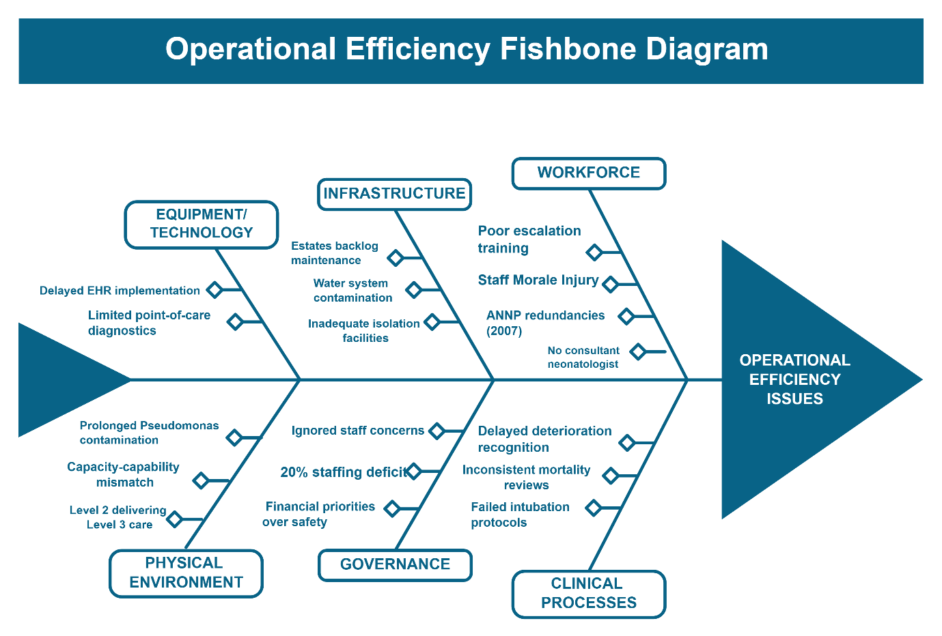
Figure 1: Fishbone Diagram
People (Workforce): The ratio of nursing establishments to BAPM recommended ratios was about 20% lower (BAPM, 2018). In 2007, due to redundancies, the unit lost Advanced Neonatal Nurse Practitioner (ANNP) coverage, and without the critical knowledge in neonatal resuscitation and stabilisation (Thirlwall Inquiry, 2024). Lack of presence of consultants neonatologist on duty posed supervision gaps, especially in out-of-hours hours. The literature indicates that poor staffing of nurses is directly associated with high mortality and adverse acute care settings (Aiken et al., 2014; Massachusetts Nurses Association, 2014).
Process (Clinical Pathways): There was a lack of clarity and uniformity in the implementation of protocols to escalate clinical deterioration. It is documented that there was a delay in the awareness of sepsis and metabolic decompensation, as well as there was a lack of opportunity to transfer to tertiary centres in time (Royal College of Paediatrics and Child Health, 2016). Unsuccessful intubation attempts in the absence of proper escalation mechanisms subjected infants to the risk of hypoxia. According to Ball et al. (2014), the concept of care left undone during nursing shifts is highly linked with both the intensity of workload and the adverse work quality outcomes.
Environment (Physical Infrastructure): Contamination of water systems with Pseudomonas aeruginosa had lasted more than a year and a half, which violated the basic rules of infection prevention (Thirlwall Inquiry, 2024). Poor environmental monitoring contravened the provisions of the Health Building Note 09-03 on neonatal facilities (NHS England, 2013/2024).
Equipment and Technology: Late adoption of electronic patient record systems compromised the instantaneous clinical monitoring and mortality pattern identification. The size of the point-of-care diagnostic service meant that remote laboratory dependencies were required, which led to delays in treatment in the event of time-sensitive illnesses like neonatal sepsis (NICE, 2021).
Policy and Governance: Incident reporting mechanisms did not consolidate and attempt to analyse clusters of adverse events. The issues that clinical staff was concerned with were not researched in a systematic way using strong governance mechanisms (BBC News, 2024). Lack of proper culture of speaking up, which was further aggravated by the lack of proper mortality review mechanisms, facilitated the lack of early detection of systemic problems, which was recorded in the Francis Report (Department of Health and Social Care, 2013).
Measurement and Surveillance: There were no real time mortality measurements, which could not identify statistical outliers. The unit did not have any systematic comparison of its results with the data of the national audit programme of neonatal care, which distorted the deterioration of the performance (NHS England, 2024).

Five Whys Analysis
Using iterative questioning to the principal issue of recurrent late identification of clinical deterioration:
Why 1: Why was deterioration identified later? → There was not clarity in the nursing capacity to retain continuous observation and escalation policies.
Why 2: Why was the nurse capacity constrained? → Staffing was some 20 per cent less than ideal with gaps.
Why 3: Why were posts not filled? → ANNP positions had been rendered unnecessary; there were recruitment difficulties with specialised neonatal nurses.
Why 4: What was the rationale behind the ANNPs redundancy? Cost-reduction programs during austerity period focused on advanced practitioner posts without assessment of their impact.
Why 5: Why was the disconnect between the workforce planning and clinical need? → The governance structures were prioritised to financial balance and disregarded systematic workforce-to-workload analysis and patient safety impact evaluation.
This discussion shows that the process of resource allocation, which lacked a strong quality impact evaluation, provided the grounds within which further damage occurred (Health Education England, 2017).

Structure-Process-Outcome Donabedian Framework
The model by Donabedian (1988) offers a conceptual framework to discuss the quality dimensions:
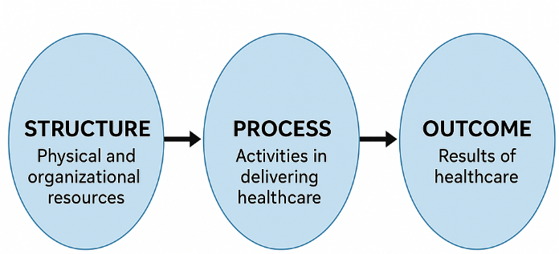
s
Structure (Resources and Organisation): The lack of adequate nurse to patient ratios, non-existence of consultant neonatologist, loss of ANNP expertise, environmental contamination and poor governance infrastructure was a systemic failure of evidence-based workforce practices (BAPM, 2022).
Process (Clinical and Managerial Activities): Structural deficiencies were translated into process failures, which included delay in gaining awareness, inconsistent compliance with clinical guidelines, ineffective infection monitoring, and ineffective processes of mortality review.
Outcome (Patient and System Results): Adverse outcomes were structural and process failures, which were observed as high mortality, healthcare-associated infections, staff moral injury, and disastrous reputational damage. It is worth noting, that after downgrading the unit to Level 1 designation, mortality rates returned to normal, which gives natural experiment evidence that capacity realignment with capability leads to better results (Thirlwall Inquiry, 2024).

STRATEGIC Environment: SWOT Analysis.

Strengths
After undergoing an examination by the general population and being reconfigured in its operations, the organisation will boast improved mechanisms of accountability and board level dedication to quality enhancement. The effective functioning of the unit at Level 1 designation suggests the competence of the staff when the workload is not excessive to work with (CQC, 2025). There is high potential of multiprofessional collaboration as demonstrated by the fact that the clinicians have continued to ensure safety issues are raised.

Weaknesses
There are still deficits in legacy infrastructure, and the ongoing infection control vulnerabilities are caused by the maintenance of the estates backlog (NHS Providers, 2024). The implementation of electronic health records still remains a hindrance to real-time surveillance. Damage to the organisational reputation makes it difficult to recruit and retain specialised employees. The cultural change is not a comprehensive one and the defensive mechanisms that may remain behind may prevent free reporting (Nuffield Trust, 2025).

Opportunities
National policy projects ensure favourable infrastructure to enhance. The Neonatal Critical Care Network Specification (2024) by NHS England requires something to enforce better governance of ODN and uniform clinical pathways. The Global Action on Patient Safety (WHO, 2019) of the World Health Organization focuses on learning cultures and systems-based approaches. The frameworks of environmental safety enhancement are provided in Health Building Note 09-03 updates. Knowledge sharing and optimisation of capacity management is made easier by integration with regional neonatal networks.

Threats
There is a continuous lack of capital funding in the NHS that restricts the ability to invest in infrastructure (Nuffield Trust and Policy Exchange, 2022; NHS Confederation, 2025). Shortages of staff in the neonatal nursing and consultant neonatology sectors at the national level pose a challenge in terms of recruitment (Health Education England, 2017). Patient choice and clinician applications may be put off by the reputational impact. Professional and public trust needs to be rebuilt through excellence found in the long term.

Quality Management Integration.
This strategic evaluation symbolises Swisse cheese model of organisational accidents developed by Reason (2000) in which a series of failures of the defensive layers all paired to allow injury. The systems approach to patient safety by Vincent (2010) focuses on latent organisational states and not direct active failures. The modern concept of quality management acknowledges that sustainable development must be technologically focused, people-capability focused, culture-leadership focused, and environmentally focused (PSNet, 2019/2024).

Transformational Leadership Strategies.

Leadership Approaches
Transformational leadership is also critical in basic culture change, with a special focus on vision articulation, psychology safety development, and promotion of learning, as opposed to blame (Berwick, 2013). Leaders need to lead by example and openly seek opposing opinions and show that bringing up a complaint leads to investigation and strengthening of the system. Nonetheless, neonatal units need leadership that is hybrid with transformational culture change and transactional reliability in the areas of critical safety. The escalation protocols, infection control bundles, and mortality review procedures require uncompromising compliance with procedures that are facilitated by monitoring and accountability structures

Distributed Leadership
Improvement should be shared by consultant neonatologists, ANNPs, senior nurses, infection prevention specialists, and governance leaders. Distributed leadership models make organisations more sustainable since capability is entrenched all over the organisation as opposed to the reliance on individual leaders (Kotter, 1996). Francis Report (Department of Health and Social Care, 2013) highlighted the importance of increasing the protection of whistleblowing and making sure that the concerns are taken seriously as they are under serious investigation.

Preparing The Workforce: Lewin's Change Model
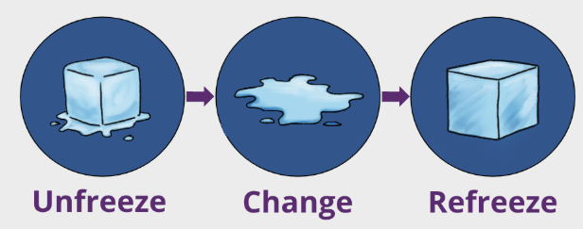
Figure 2: Lewin’s Change Model (Lewin, 1951)

Unfreeze: Making Preparations.
In this fundamental model, Lewin (1951) starts with the stage of unfreezing the current practices by creating a sense of urgency and decreasing resistance. Employees will need clear display of mortality data and infection rates, shortage of staffing, and reference to the national standards. The development of common knowledge of the need to improve is achieved through town hall forums and departmental briefings. The force-field analysis is used to identify the driving forces (patient safety imperative, regulatory requirements, professional values), and restraining forces (resource constraints, change fatigue, fear of blame) that can be used to inform the barrier mitigation strategy (Bridgman et al., 2016; Wounds UK, 2023).

Change: An Implementation of Improvement.
Specific interventions are carried out in the change phase: ANNP role restoration, recruitment of a consultant neonatologist, training on the use of the protocols of the prevention of Escherichia coli infections, implementation of the infection control bundle, and improvement of transport coordination. PDSA cycles offer systematic approach of testing and adaptation. Statistical process control and run charts visually represent the progress that helps maintain positive momentum (Institute for Healthcare Improvement, n.d.).

Refreeze: Installing Sustainability.
The new practices should be formalised by policy, competency testing, audit, recognition programme and in orientation and continuing professional development (Lewin, 1951). Modern theorists note that the three-stage model of linear change by Lewin is simplistic in the complex adaptive systems (Bridgman et al., 2016). However, the framework by Lewin can be of pragmatic use in organizing workforce interaction within a clinical setting in combination with such an iterative approach as PDSA.

Improvement framework: Plan-Do-Study-Act methodology.
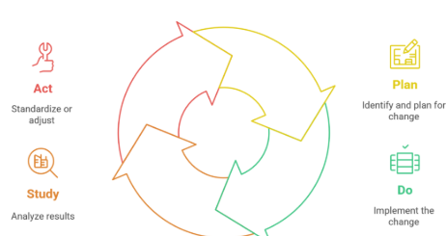
Figure 3: Plam-Do-Study-Act Cycle

Justification of PDSA Choice.
PDSA cycles as the operationalisation of the Institute of Healthcare Improvement Model is more appropriate to clinical microsystem improvement than the Lean or Six Sigma methods developed in manufacturing industries (Langley et al., 2009; Stratis Health, 2023). PDSA focuses on small-scale testing, quicker learning, and adapting to the local situation, and offers strict measurement frameworks (Agency for Healthcare Research and Quality, 2017).

Measurable Aims
Particular, targets are made time bound goals: (1) Decrease neonatal mortality by 50 percent in 12 months to reach rates below national average; (2) Zero contamination of the environment with Pseudomonas at 12 months and a lasting zero rate; (3) 95 percent adherence to the order to escalate protocols in clinical deterioration; (4) Median tertiary transfer time under two hours when clinically necessary.

Measurement Framework
Balanced measurement is based on the structure-process-outcome taxonomy by Donabedian (Institute for Healthcare Improvement, n.d.):
Outcome Measures: Mortality rate, incidence of healthcare-associated infections, unplanned readmissions, experience as reported by parents.
Process Measures: compliance with escalation protocols, success rates of intubation, compliance with the antimicrobial prescribing based on the NICE guidelines (NG195), transport coordination in a timely manner.
Balancing Measures: Staff overtime hours, delay in transferring to other services, parent complaints, staff satisfaction.
Stratification in equity based on ethnicity, deprivation index, and gestational age will mean that all the populations will receive equitable interventions (NHS England, 2024).

PDSA Cycle Implementation
Week 1-4: Cycle 1 Airway Management Checklist.
Plan: Produce evidence-based intubation checklist that includes the equipment preparation, the presence of senior clinician, and the backup airway plans.
Do: Night shift piloting and weekends with five intubation episodes.
Measures: First-pass success rate, complications, and time.
Act: Refine checklist; carry to all shifts, in case of success; offer simulation training in case of shortcomings found.
Cycle 2 (Weeks 5-10): ANNP- Supported Escalation Huddles.
Plan: Introduce ANNP-led multidisciplinary huddles, twice daily, to discuss the acuity of infants and the existence of the escape plan.
Prescription: Physiotherapy on six-bed pod six weeks.
Research: Determine escalation response time and unplanned intensive care admissions.
Act: Replace entire unit in the case of its effectiveness; change huddle structure in response to feedback.
Week 11-18, Cycle 3: Infection Control Bundle.
Action: Introduce a better environmental monitoring (weekly tap cultures), hand hygiene-checks, antimicrobial stewardship (in accordance with NICE NG195).
Do: Implement bundle daily monitored and feedbacked.
Study: Monitor the positivity rates of Pseudomonas and healthcare-associated infection.
Action: Persist in successfully available features, enlist estates to remediation.
Week 19-24 (Cycle 4): Transport Escalation Protocol.
Plan: Design standardised pathway where local transport service of the neonatal is required and trigger criteria and time limits stated.
Do: In place real time tracking protocol.
Measure: The time between decision of escalation and arrival of transport.
Action: Cleanse protocol; establish stronger ODN relationships; deal with system bottlenecks.

Strengths and Limitations
The PDSA approach encourages staff involvement by supporting frontline co-design, encouraging quick learning, and supporting the complexity of clinical situations (Langley et al., 2009). Yet, it needs to be very effective by being measured carefully, sponsored by leaders, quality improvement time, and not superficially implemented without real testing and adaptation (Stratis Health, 2023).

Overcoming Barriers: Kotter's Eight-Step Framework
The barriers that are common to implementation are culture of fear and blame, estates, staffing vacancies, digital roll out, and inter-organisational coordination problems. These are systematically covered by Kotters (1996) model which deals with eight consecutive steps:
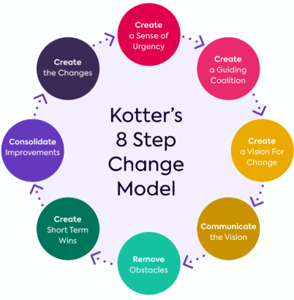
Figure 4: Kotter’s 8-Step Change Model (Kotter, 1996)
Step 1 - Create Urgency: Stated in a clear and transparent way, provide mortality statistics, infection rates, and benchmarking to provide strong motivation to act immediately (Kotter Inc., n.d.).
Step 2 - Building Guiding Coalition: Assemble multidisciplinary team (clinicians, managers, estates representatives, infection prevention specialists, and patient advocates) who have authority to promote change (Kotter, 1996).
Step 3 – Form Strategy Vision: Build effective vision by connecting patient safety excellence and organisational values with BAPM standards, which formulates the desired future state (Ausmed, 2024).
Step 4 - Communicate Vision: Publicize vision: Disseminate vision in town halls, departboards, newsletters, and one-on-one discussions via use of patient stories and data to establish emotional attachment (Kotter Inc., n.d.).
Step 5 – Remove Barriers: overcome the hampering factors such as delays in procurement, guarded training time distribution, electronic health records optimization, and estates remediation funding (Kotter, 1996).
Step 6 - Generate Short-Term Wins: Are there any initial successes that can be celebrated like zero ICU-transfer delays in thirty consecutive days, zero environmental contamination in one month or 100 percent compliance with escalation protocols (Ausmed, 2024).
Step 7 - Sustain Acceleration: Extend the early successes by focusing on subsequent areas of improvement, escalating successful PDSA cycles, and keeping up the momentum by continuing to measure and provide feedback (Kotter, 1996).
Step 8 - Anchor Changes: Consolidate the desired changes in a permanent manner by designing policy changes, competency frameworks, orientation mechanisms, skills validation schemes, recognition systems, board level accountability measures (Kotter Inc., n.d.).

Recommendations and Roadmap of Implementation.

Workforce Optimisation
Immediate (0-3 months): Hire one consultant neonatologist with a specific location; reassign two ANNP posts; providing a detailed competency assessment of all nursing staff with individualised development programs based on the needs of the escalation, airway management, and infection prevention (BAPM, 2022).
Medium-term (4-8 months): Internationalize nursing establishments to the standards of BAPM by recruiting gradually; introduce the position of supernumerary shift co-ordinator; introduce formal preceptorship of newly qualified neonatal nurses (Health Education England, 2017). Aiken et al. (2014) have provided evidence that every 10 percent in nurses with a bachelor level will decrease mortality by 7 percent.

Infection Control and Environmental Security.
Immediate: Audit of independent water system by the Commission; installation of point-of-use filters until the remediation is done; increase the frequency of environmental surveillance to weekly cultures; strict isolation measures (NICE, 2021; NHSGGC, 2023).
Medium term: Complete estates remediation according to the requirements of the Health Building Note 09-03; modernize the ventilation systems; assign the improved isolation facilities (NHS England, 2013/2024). The constraints of capital funding require it to be prioritised in accordance with the criticality of patient safety and to explore the capital routes available to Integrated Care Systems (NHS Confederation, 2025).

Governance Strengthening
Short-term: Introduce weekly multidisciplinary mortality and morbidity review meetings and record learning and action follow-ups; introduce real-time statistical process control charts and mortality and infection rates; require executive participation in governance forums; enhance whistleblowing procedures and provide independent channels of investigation (WHO, 2020).
Medium-term: Institutionalize systematic incident reporting and learning mechanisms; be actively involved in benchmarking of the National Neonatal Audit Programme; have a quarterly independent quality watch; be able to report both quality metrics to staff, families and the public (Berwick, 2013).

Network Integration and Capacity Management.
Consistently follow transfer criteria in NHS England Service Specification E08; formalise service level agreements with regional neonatal transport and tertiary units stating two-hour targets in terms of transfers; be an active member of the operation of Operational Delivery Network (NHS England, 2024).

Implementation Timeline
Phase 1 (Months 1-3): Unfreeze (data transparency, staff involvement); start PDSA-Cycles 1-2; recruitment; start with the intensification of infection control.
Phase 2 (Months 4-8): Implement PDSA Cycles 3-4; realize early workforce success; formalize governance functions; reward early victories in order to keep the momentum (Kotter, 1996).
Phase 3 (Months 9-12): Refreeze when embedding policies, competencies validation, and mechanisms of sustainability; engage in as much evaluation as possible; redefine the priorities of continuous improvement.

Conclusion
The Countess of Chester Hospital neonatal unit disaster is an excellent example of how structural workforce, environmental, and governance deficits combine in process failures to produce disastrous results. The interdependencies described by Donabedian (1988) framework shed light on the interdependencies and the systems perspective by Reason (2000) proves that individual actions take place within an organisational environment that facilitates or limits safe practice. Evidence-based enhancement involves a concomitant enhancement in workforce capacity, infrastructure integrity, system robustness and network consolidation. The PDSA approach offers stringent learning cycles and iterative plans, whereas the change model by Lewin makes staff ready to change and the Kotter framework overcomes the obstacles to implementation. Leadership should create a setting of psychological safety in which issues lead to investigation instead of defensiveness which can be seen as the vision of Berwick (2013) of learning organisations. Constant excellence requires continuous measurement, transparency, and continuous adaptation as opposed to the occasional reaction to crises. The global patient safety action provided by the WHO (2019) focuses on the systemic approaches, and the lessons of the UK inquiries, Francis, Kirkup and Ockenden, remind organisations of the responsibility to provide the conditions under which individuals can provide safe care. Healthcare organisations cannot fulfil their basic responsibility of ensuring that vulnerable patients avoid unnecessary harm unless they focus on systemic factors and not on scapegoating the individuals.

References
Agency for Healthcare Research and Quality (2017) Ramping up PDSA cycles toolkit. Available at: https://www.ahrq.gov/sites/default/files/wysiwyg/evidencenow/tools-and-materials/q80-ramping%20up%20PDSAs%20revised.pdf (Accessed: 19 November 2025).
Aiken, L.H., Sloane, D.M., Bruyneel, L., Van den Heede, K., Griffiths, P., Busse, R., et al. (2014) 'Nurse staffing and education and hospital mortality in nine European countries: a retrospective observational study', The Lancet, 383(9931), pp. 1824–1830.
Ana, E. and Hendricks-Jackson, L. (2017) 'Change theories for nurse leaders', Nursing Management, 48(7), pp. 14–20.
Ausmed (2024) Driving change: an 8-step process. Ausmed Education. Available at: https://www.ausmed.com/learn/articles/a73a6c8c-16cd-48e5-a0e0-64b2e71dc030 (Accessed: 25 November 2025).
Ball, J.E., Murrells, T., Rafferty, A.M., Morrow, E. and Griffiths, P. (2014) '"Care left undone" during nursing shifts: associations with workload and perceived quality of care', BMJ Quality & Safety, 23(2), pp. 116–125.
BAPM (2018) Optimal arrangements for Local Neonatal Units and Special Care Units in the UK: A Framework for Practice. London: British Association of Perinatal Medicine. Available at: https://www.bapm.org/resources/2-optimal-arrangements-for-local-neonatal-units-and-special-care-units-in-the-uk-2018 (Accessed: 20 November 2025).
BAPM (2022) Service and Quality Standards for Provision of Neonatal Care in the UK. London: British Association of Perinatal Medicine. Available at: https://www.bapm.org/resources/service-and-quality-standards-for-provision-of-neonatal-care-in-the-uk (Accessed: 20 November 2025).
BBC News (2024) 'Thirlwall Inquiry: Coroner not told of Letby concerns', BBC News. Available at: https://www.bbc.com/news/articles/cx2y5zqw0jdo (Accessed: 25 November 2025).
Berwick, D. (2013) A promise to learn – a commitment to act: Improving the safety of patients in England. London: Department of Health and Social Care. Available at: https://www.gov.uk/government/publications/berwick-review-into-patient-safety (Accessed: 17 November 2025).
Bridgman, T., Cummings, S. and Brown, K.G. (2016) 'Unfreezing change as three steps: Rethinking Kurt Lewin's legacy for change management', Human Relations, 69(1), pp. 33–60.
CQC (2016) The Countess of Chester Hospital – Quality Report (February 2016). Newcastle: Care Quality Commission. Available at: https://api.cqc.org.uk/public/v1/reports/7d84e4fd-bdbe-4e99-839d-df83baa36adc?20160628234518 (Accessed: 19 November 2025).
CQC (2025) The Countess of Chester Hospital – latest inspection summary. Care Quality Commission. Available at: https://www.cqc.org.uk/location/RJR05 (Accessed: 29 November 2025).
Department of Health and Social Care (2013) Report of the Mid Staffordshire NHS Foundation Trust Public Inquiry (Francis Report). GOV.UK. Available at: https://www.gov.uk/government/publications/report-of-the-mid-staffordshire-nhs-foundation-trust-public-inquiry (Accessed: 16 November 2025).
Donabedian, A. (1988) 'The quality of care: How can it be assessed?', JAMA, 260(12), pp. 1743–1748.
GIRFT (2021) Getting It Right First Time: Neonatal Critical Care programme – overview. NHS England.
Health Education England (2017) Facing the Facts, Shaping the Future – A draft health and care workforce strategy for England to 2027. Available at: https://www.hee.nhs.uk/our-work/workforce-strategy (Accessed: 21 November 2025).
Institute for Healthcare Improvement (n.d.) Model for Improvement: Establishing Measures. Available at: https://www.ihi.org/library/model-for-improvement/establishing-measures (Accessed: 19 November 2025).
Kirkup, B. (2015) The Report of the Morecambe Bay Investigation. London: The Stationery Office. Available at: https://assets.publishing.service.gov.uk/government/uploads/system/uploads/attachment_data/file/408480/47487_MBI_Accessible_v0.1.pdf (Accessed: 18 November 2025).
Kotter, J.P. (1996) Leading Change. Boston, MA: Harvard Business School Press.
Kotter Inc. (n.d.) The 8 Steps for Leading Change. Available at: https://www.kotterinc.com/methodology/8-steps/ (Accessed: 25 November 2025).
Langley, G.J., Moen, R.D., Nolan, K.M., Nolan, T.W., Norman, C.L. and Provost, L.P. (2009) The Improvement Guide (2nd ed.). San Francisco: Jossey-Bass.
Lewin, K. (1951) Field Theory in Social Science. New York: Harper & Row.
Massachusetts Nurses Association (2014) 'Study links nurses' workload and education to survival after surgery', briefing on Aiken et al. Available at: https://www.massnurses.org/files/file/Legislation-and-Politics/Evidence-based_Research_Showing_Impact_of_RN_STaffing_on_Patient_Outcomes_%28Linda_Aiken%29_Feb_2014.pdf (Accessed: 15 November 2025).
NHS Confederation (2025) Capital efficiency: how to reform healthcare capital spending. London: NHS Confederation. Available at: https://www.nhsconfed.org/publications/capital-efficiency (Accessed: 5 December 2025).
NHS England (2013/2024 update) Health Building Note 09-03: Neonatal units. Available at: https://www.england.nhs.uk/publication/neonatal-units-planning-and-design-hbn-09-03/ (Accessed: 22 November 2025).
NHS England (2019; page updated 2024) Service specification: Neonatal critical care. Available at: https://www.england.nhs.uk/publication/service-specification-neonatal-critical-care/ (Accessed: 20 November 2025).
NHS England (2024) Equality and Health Inequalities Impact Assessment (EHIA) – Neonatal Critical Care Service Specification. Available at: https://www.england.nhs.uk/wp-content/uploads/2024/03/neonatal-critical-care-service-ehia.pdf (Accessed: 20 November 2025).
NHS England (2024) Neonatal Critical Care Clinical Network Specification (PRN231107). Available at: https://www.england.nhs.uk/wp-content/uploads/2024/05/PRN231107-neonatal-critical-care-network-specification-2023-.pdf (Accessed: 20 November 2025).
NHS Providers (2024) Briefing on NHS capital funding. London: NHS Providers. Available at: https://nhsproviders.org/resources/briefing-on-nhs-capital-funding (Accessed: 22 November 2025).
NHSGGC (2023) 'Early onset sepsis in the neonate: prevention and treatment (1060)', NHS Greater Glasgow and Clyde Paediatric Guidelines. Available at: https://www.clinicalguidelines.scot.nhs.uk/ggc-paediatric-guidelines/ggc-paediatric-guidelines/neonatology/early-onset-sepsis-in-the-neonate-prevention-and-treatment/ (Accessed: 23 November 2025).
NICE (2021; updated 2024) Neonatal infection: antibiotics for prevention and treatment (NG195). London: National Institute for Health and Care Excellence. Available at: https://www.nice.org.uk/guidance/ng195 (Accessed: 17 November 2025).
Nuffield Trust (2025) Report for the Thirlwall Inquiry: Analysis of questionnaires from 120 NHS trusts. London: Nuffield Trust. Available at: https://www.nuffieldtrust.org.uk/research/report-for-the-thirlwall-inquiry-analysis-of-questionnaires-from-120-nhs-trusts (Accessed: 24 November 2025).
Nuffield Trust and Policy Exchange (2022) NHS capital and infrastructure: delivering the manifesto and unlocking potential. London: Nuffield Trust. Available at: https://www.nuffieldtrust.org.uk/resource/nhs-capital-and-infrastructure-delivering-the-manifesto-and-unlocking-potential (Accessed: 22 November 2025).
Ockenden, D. (2022) Final report of the Ockenden review. Department of Health and Social Care. Available at: https://www.gov.uk/government/publications/final-report-of-the-ockenden-review (Accessed: 18 November 2025).
PSNet (2019/2024) Systems Approach – Patient Safety Primer. Agency for Healthcare Research and Quality. Available at: https://psnet.ahrq.gov/primer/systems-approach (Accessed: 16 November 2025).
Reason, J. (2000) 'Human error: models and management', BMJ, 320(7237), pp. 768–770.
Royal College of Paediatrics and Child Health (2024) 'RCPCH 2016 reviewers to provide evidence to Thirlwall Inquiry'. Available at: https://www.rcpch.ac.uk/news-events/news/rcpch-2016-reviewers-provide-evidence-thirlwall-inquiry (Accessed: 25 November 2025).
Stratis Health (2023) 'QI Basics: The Model for Improvement and PDSA – Transcript'. Available at: https://stratishealth.org/wp-content/uploads/2023/10/Transcript-QI-Processes-The-Model-for-Improvement-and-PDSA.pdf (Accessed: 19 November 2025).
Thirlwall Inquiry (2024) 'INQ0017433 – Pages 1 and 106–108 of CQC Quality Report (Feb 2016)'. Available at: https://thirlwall.public-inquiry.uk/evidence/inq0017433-pages-1-and-106-108-of-care-quality-commissions-quality-report-for-the-countess-of-chester-hospital-regarding-the-quality-of-care-at-the-hospital-on-inspection-visit-date-february-201/ (Accessed: 25 November 2025).
Vincent, C. (2010) Patient Safety (2nd ed.). Oxford: Wiley-Blackwell.
WHO (2019) Global action on patient safety (Resolution WHA72.6). Geneva: World Health Organization. Available at: https://apps.who.int/gb/ebwha/pdf_files/WHA72/A72_R6-en.pdf (Accessed: 19 November 2025).
WHO (2020) Patient safety incident reporting and learning systems: technical report and guidance. Geneva: World Health Organization. Available at: https://www.who.int/publications/i/item/9789240010338 (Accessed: 19 November 2025).
Wounds UK (2023) 'Managing change, the Lewin model 1: Unfreezing', Wounds UK, 19(2). Available at: https://wounds-uk.com/journal-articles/managing-change-the-lewin-model-1-unfreezing/ (Accessed: 24 November 2025).

