

Certificate of Higher Education in Employability Skills LEVEL 4
Module Name: Personal and Professional Growth
Module Code: (BMSW4008)
Assignment Name: Evidence of Learning (E Portfolio)
Student Name: Barbara Dorota Bak
Student Number: 2317808
Lecturer: Muhammad Cassamo
Deadline Date: 12/12/2025



(Freepik, n.d.)

AI Acknowledgement

I confirm that I have not presented any AI generated materials as my own work.
I confirm that I have copies of my drafts, notes, and other resources I used, which I may be asked to provide in evidence.

Task 1.

Bak Hideaways Ltd – Data Analysis and Market Insights

Introduction
Bak Hideaways Ltd is a newly established company specialising in short-term holiday rentals and glamping accommodation in South and Mid Wales. The business currently operates two properties on long-term rental agreements; however, the long-term strategy is to convert all properties into short-term holiday lets following the launch of the flagship project, The Bus Stop. This project involves the conversion of three double-decker buses into luxury, cosy “tiny homes”, offering a distinctive glamping experience. The purpose of this report is to analyse primary research findings from a customer questionnaire and evaluate how these insights have informed the development of the business concept, website design, marketing materials, audience segmentation, and search engine optimisation (SEO) strategy.

Questionnaire Design and Data Collection
Primary research was conducted using a questionnaire created in Microsoft Forms. The survey consisted of 15 questions, including multiple-choice, Likert-scale, open-ended, and demographic questions. The questionnaire explored travel frequency, accommodation preferences, preferred locations, important amenities, willingness to pay, and interest in unique accommodation concepts such as The Bus Stop. The survey was distributed to a target audience of adults aged 25–45 who have an interest in domestic tourism, short leisure breaks, and visually appealing or “Instagrammable” accommodation. This approach ensured the data collected was relevant, reliable, and aligned with the objectives of the study, following recognised principles of effective primary research design (Cooper and Schindler, 2014).

Data Analysis and Key Findings
The analysis focused on four key questionnaire areas that were most relevant to the business concept: travel frequency, location preferences, importance of amenities, and responses to the converted bus accommodation concept.

Travel Frequency
Survey results indicated that most respondents travel for leisure between two and three times per year, with a smaller but significant proportion travelling four to six times annually, and some travelling more than six times per year. This trend suggests a stable demand for short leisure breaks, particularly weekend stays or holidays lasting between three and seven days. This finding is significant for Bak Hideaways Ltd, as it supports a business model based on frequent short stays rather than long-term occupancy. Understanding travel frequency assists with forecasting demand, setting seasonal pricing strategies, and managing availability during peak tourism periods, which is consistent with wider UK staycation trends (Sykes Holiday Cottages, 2023; Visit Britain, 2022).

Location Preferences
Respondents expressed a clear preference for coastal areas, mountainous regions, and quite rural or village locations. Wales is widely recognised for its beaches, national parks, waterfalls, and scenic countryside, making it an attractive destination for domestic tourism. The chosen location for The Bus Stop near Aberystwyth directly aligns with these preferences by offering privacy, scenic views, and proximity to nature. This reinforces the suitability of Wales as a destination for Bak Hideaways Ltd and supports the strategic focus on rural and nature-based tourism rather than urban accommodation (Visit Wales, 2022; DEFRA, 2021).

Importance of Amenities
The questionnaire findings demonstrated that respondents place high importance on privacy, comfort, scenic views, and well-designed amenities when selecting short-term accommodation. Additional features such as a hot tub, modern kitchen, and outdoor space were considered particularly attractive. These results influenced the design and specification of The Bus Stop, ensuring that the converted buses meet guest expectations while offering a premium and comfortable experience. Research indicates that high-quality amenities and unique features play a key role in guest satisfaction, positive online reviews, and repeat bookings within the short-term rental sector (Airbnb, 2022; Mintel, 2021).

Responses to The Bus Stop Concept
All respondents expressed interest in staying in a converted double-decker bus, highlighting the strong appeal of unique and visually distinctive accommodation. The novelty and “Instagrammable” nature of the concept were perceived as major strengths. Planned outdoor features, such as a small playground and the potential inclusion of alpacas or goats, were also viewed positively, particularly by families. This combination of luxury accommodation and playful outdoor experiences reflects wider tourism trends that prioritise experiential travel and memorable stays, further supporting the viability of The Bus Stop as a flagship project (Mintel, 2021; Euromonitor International, 2022).

Implications for Business Strategy, Website Design, and Marketing
The findings confirm strong demand for unique, high-quality accommodation that offers comfort, privacy, and memorable experiences. These insights reinforce the strategic direction of Bak Hideaways Ltd, which aims to differentiate itself through distinctive properties and a high standard of guest experience.
Based on the research findings, a two-page website was developed and is ready to go live. The homepage features a high-quality image of Rhossili Bay, selected to immediately communicate the natural beauty of Wales and appeal to emotionally driven travel decisions. The website includes detailed property descriptions, professional images, location information, the company mission, and online booking functionality. Guest reviews will also be incorporated to build trust and credibility. However, industry research and personal experience indicate that third-party booking platforms such as Airbnb and Booking.com remain the most effective channels for reaching holiday rental customers, supported by visual social media platforms including Instagram, TikTok, and Facebook (Booking.com, 2022; Airbnb, 2022).
Marketing materials, including short-form video content, were designed to reflect the questionnaire findings by showcasing scenic locations, luxurious interiors, and unique features that encourage social sharing and engagement.

Audience Segmentation
The survey data enabled clear audience segmentation for Bak Hideaways Ltd. Demographically, the primary target audience consists of adults aged 25–45, many of whom are in full-time employment and have disposable income for domestic travel. Behaviourally, this group travels multiple times per year and demonstrates a willingness to pay for comfort, privacy, and additional amenities. Psychographic ally, respondents value relaxation, escape from daily routines, connection with nature, and visually appealing environments that can be shared on social media. This segmentation approach supports more targeted marketing campaigns and ensures the business offering aligns closely with customer motivations and expectations (Visit Britain, 2022).

SEO Strategy
An effective SEO strategy is essential to support the website and increase organic visibility. Based on the questionnaire findings, the SEO approach focuses on location-based and experience-driven keywords such as “unique accommodation Wales,” “glamping Wales,” “luxury glamping near Aberystwyth,” and “coastal stays Wales.” Website content will incorporate these keywords naturally within headings, property descriptions, and supporting content. Image optimisation, mobile responsiveness, and clear site structure will further enhance search engine performance. This strategy complements third-party booking platforms and social media marketing by capturing demand from users actively searching for distinctive holiday experiences in Wales (Booking.com, 2022; Visit Wales, 2022).

Conclusion
The questionnaire and subsequent data analysis provided valuable insights into customer travel behaviour, accommodation preferences, and expectations regarding amenities and location. The findings demonstrate strong interest in unique and visually distinctive accommodation such as The Bus Stop, alongside a clear preference for scenic Welsh locations and high-quality facilities. These insights directly informed the business concept, website design, marketing materials, audience segmentation, and SEO strategy. Combined with over 20 years of experience in property management, this research positions Bak Hideaways Ltd well for expansion within the short-term and glamping accommodation market in Wales, supporting the delivery of high-quality, memorable guest experiences while contributing to sustainable domestic tourism (Welsh Government, 2021).

References:
Airbnb (2022) Host and traveller insights. Available at: https://www.airbnb.co.uk/ (Accessed: 17 November 2025).
Booking.com (2022) Global accommodation market report. Available at: https://www.booking.com/ (Accessed: 17 November 2025).
Cooper, D.R. and Schindler, P.S. (2014) Business research methods. 12th edn. New York: McGraw-Hill Education.
DEFRA (2021) Rural tourism in the UK. London: Department for Environment, Food and Rural Affairs.
Euromonitor International (2022) UK hospitality and tourism market. London: Euromonitor International.
Mintel (2021) UK glamping trends. London: Mintel Group Ltd.
Sykes Holiday Cottages (2023) UK holiday trends and statistics. Available at: https://www.sykescottages.co.uk/insights/ (Accessed: 17 November 2025).
Visit Britain (2022) Travel trends and consumer behaviour. London: VisitBritain.
Visit Wales (2022) Domestic tourism in Wales: annual report. Cardiff: Welsh Government.
Welsh Government (2021) Economic impact of tourism in Wales. Cardiff: Welsh Government.

Task 2:
Microsoft Excel – Spreadsheet
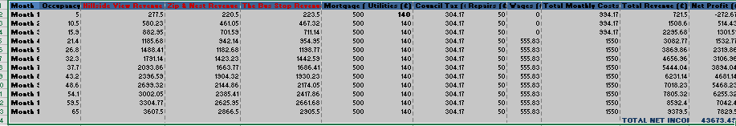

The Importance of the Excel Financial Summary for Bak Hideaways Ltd
Creating the financial summary in Excel has provided a comprehensive overview of how Bak Hideaways Ltd could perform financially over a 12-month period. By listing monthly revenue, costs, and net profit for each property – Hillside View, Zip & Nest, and the upcoming Bus Stop project – I can see not only the potential income but also the relationships between occupancy, costs, and profitability. Excel allows me to organise these figures clearly, apply formulas to calculate totals and profits, and visualise trends with charts, which makes analysis more efficient and accurate.
Looking at the summary, I can clearly see how occupancy affects revenue. For example, in the first month, when occupancy is low at 5%, the business shows a small loss. As occupancy increases month by month, revenue grows, and by the twelfth month, net profit reaches £7,829.50. This insight highlights the importance of attracting guests, implementing effective marketing strategies, and ensuring that properties remain appealing to maintain high occupancy throughout the year. Excel makes it easy to adjust these assumptions and see their impact on profitability.
The breakdown of costs in the summary is equally valuable. Separating fixed costs (mortgage, utilities, council tax) from variable costs (repairs, wages) helps me understand which expenses are predictable and which can fluctuate depending on business activity. This clarity allows for better budgeting, cash flow management, and identification of areas where cost control can improve profitability. Using Excel, these calculations are automated, which reduces errors and saves time compared to manual calculations.
I can also analyse individual property performance. For example, the Bus Stop project is new, so monitoring its revenue and expenses closely will help identify opportunities for improvement, such as upgrading interiors, adding family-friendly features like a small playground or alpacas, and optimising pricing strategies. This property-level insight allows me to make informed decisions about where to invest resources for maximum return.
The total net income for the year, projected at £43,673.49, gives confidence in the business’s potential. It demonstrates that, with careful management and strategic marketing, Bak Hideaways Ltd can generate sustainable income, reinvest in its properties, and continue to grow its portfolio. Excel allows for dynamic adjustments to revenue projections, occupancy rates, and expenses, enabling scenario planning and risk assessment before committing to real-world investments.
Finally, having this financial summary supports strategic decision-making and future planning. It provides a clear picture of potential outcomes, identifies periods of risk, and helps prioritise opportunities for growth.
In summary, creating a financial summary using Excel has been instrumental in understanding the full picture of Bak Hideaways Ltd. It allows me to track revenue and costs, monitor property performance, forecast profitability, and make informed, confident decisions to ensure the successful growth of the business.

References:
- AdvantEdge Training & Consulting (2024) Leveraging Excel for Data-Driven Decision Making. Available at: https://www.advantedge-training.com/2024/09/leveraging-excel-data-driven-decision-making/ (Accessed: 13 December 2025).
- IBM (2025) IBM Planning Analytics for Excel. Available at: https://www.ibm.com/products/planning-analytics/excel?utm_content=SRCWW&p1=Search&p4=1409660129017&p5=b&p9=169118374021&gclsrc=aw.ds&gad_source=1&gad_campaignid=22027252986&gbraid=0AAAAA-oKwicQaZ3jMdPJqXc_wajNaRElL&gclid=Cj0KCQiAuvTJBhCwARIsAL6Demj5IxCnW7vR0WkJCrXWUA1K4HJQLBhOc_LzBoBfl7Hph7K5ryq7TT4aAoymEALw_wcB (Accessed: 13 December 2025).
- Insightsoftware (2025) Jet Reports for Dynamics GP. Available at: https://www.insightsoftware.com/promos/dynamics-gp/?utm_source=google&utm_medium=cpc&utm_campaign=sea-indirect-jet-europe-uk-ir-den-tofu&utm_content=117703676538&utm_term=gp%20excel&gclid=Cj0KCQiAuvTJBhCwARIsAL6DemjAtVudlkWTKD9sBM8vyIYzbkno4L6UWzSf2zDx5N7y2RrcSNxEvBMaAvQ6EALw_wcB (Accessed: 13 December 2025).
- Microsoft (2025) Create Business Spreadsheets in Excel. Available at: https://excel.cloud.microsoft/create/en/business-spreadsheets/ (Accessed: 13 December 2025).
- Microsoft (2025) Manage Business Finances. Available at: https://support.microsoft.com/en-us/office/manage-business-finances-8962ab93-ed71-45b7-90e1-b9c2fc385427 (Accessed: 13 December 2025).
- MRPeasy (2023) Production Planning with Excel – Opportunities and Limitations. Available at: https://www.mrpeasy.com/blog/production-planning-excel/?utm_source=google&utm_medium=cpc&utm_campaign=23095485296_&gclid=Cj0KCQiAuvTJBhCwARIsAL6DemjAtVudlkWTKD9sBM8vyIYzbkno4L6UWzSf2zDx5N7y2RrcSNxEvBMaAvQ6EALw_wcB (Accessed: 13 December 2025).
- School of Coding UK (2023) Importance of Microsoft Excel in Business: 10 Reasons. Available at: https://schoolofcodinguk.com/blog/importance-of-microsoft-excel-in-business/ (Accessed: 13 December 2025).

The appendices:
Appendix 1.
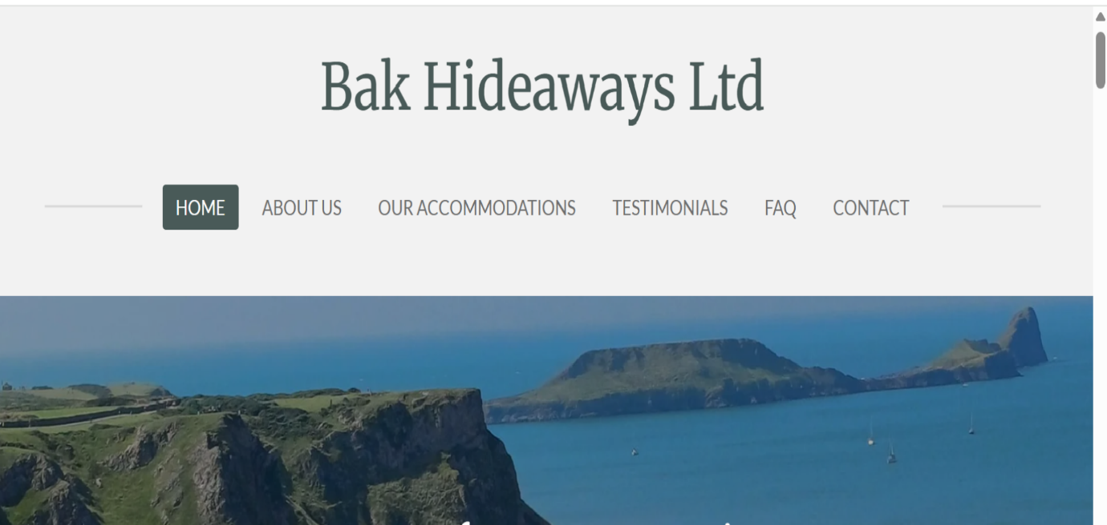
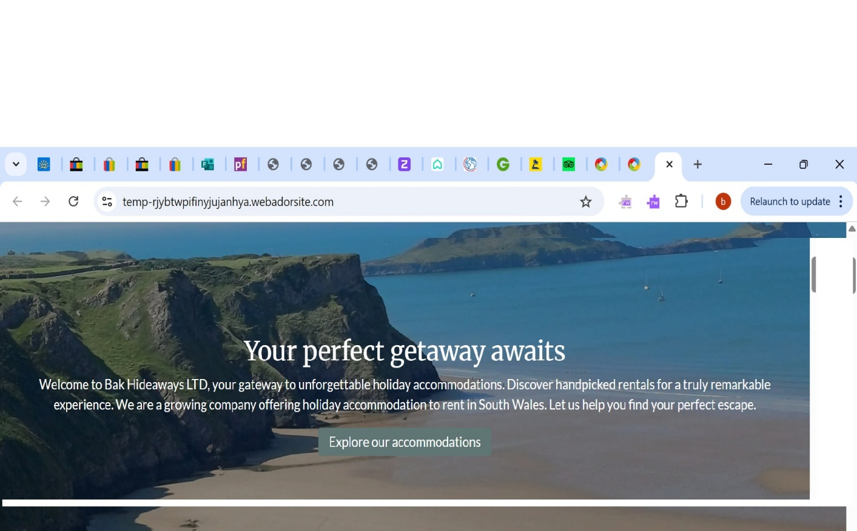
(Webador, 2025)
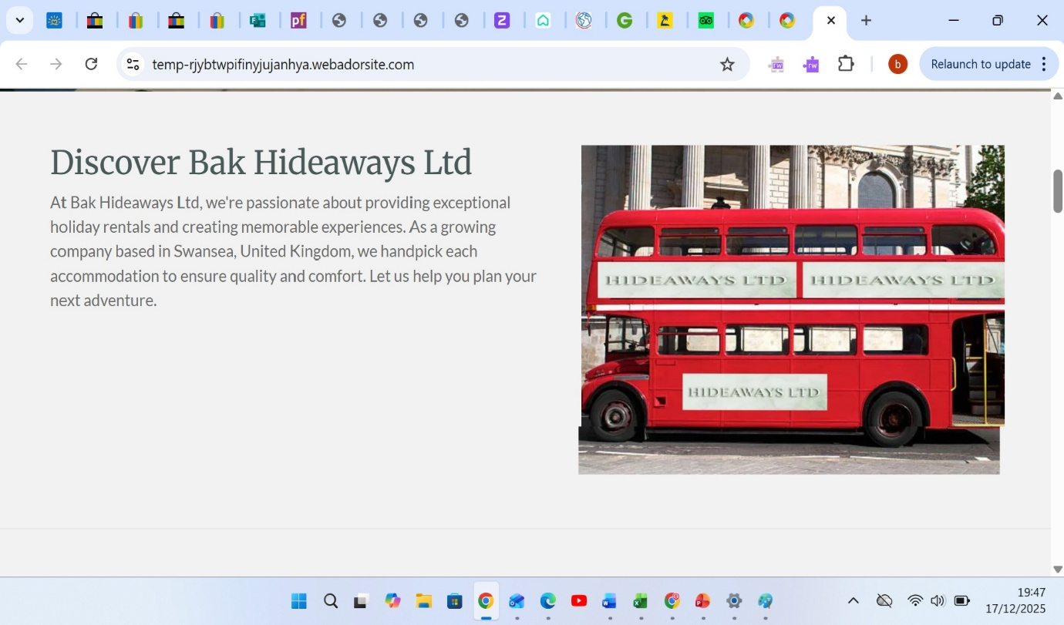
(Webador, 2025)

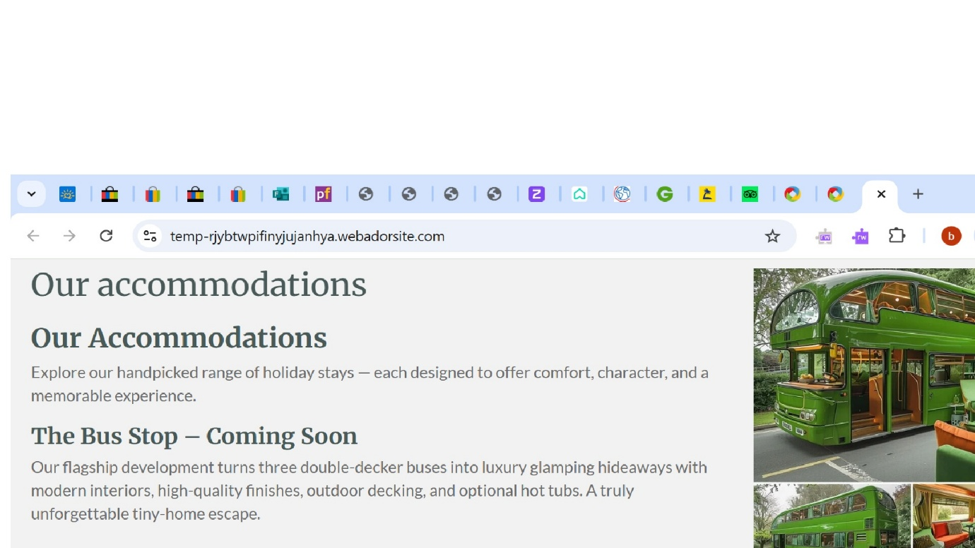
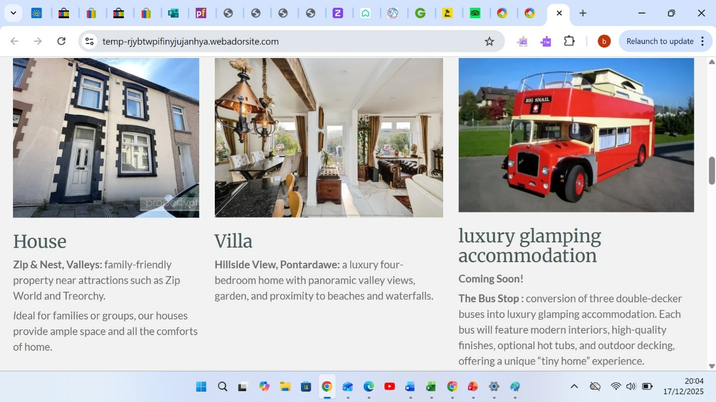
(Webador, 2025)

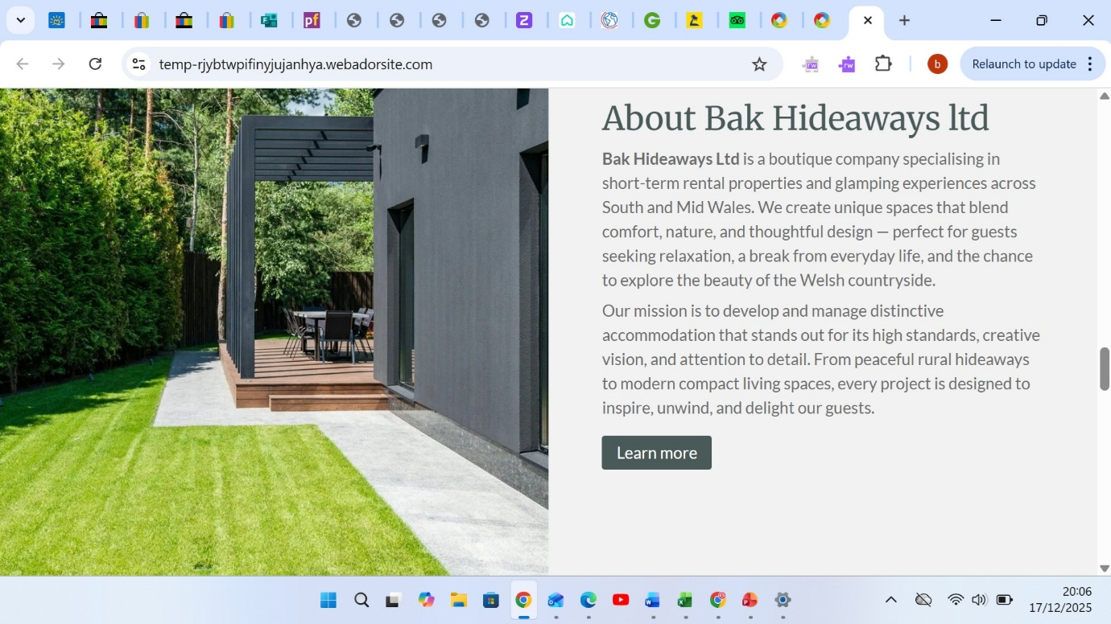
(Webador, 2025)

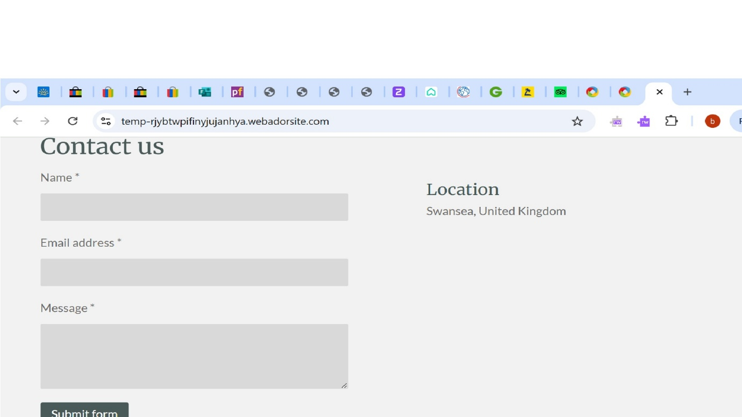
(Webador, 2025)

(Webador, 2025)
Appendix 2.
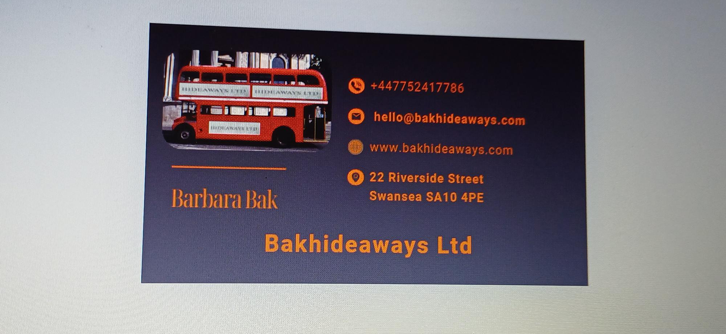
(Canva, 2025)
Appendix 3.
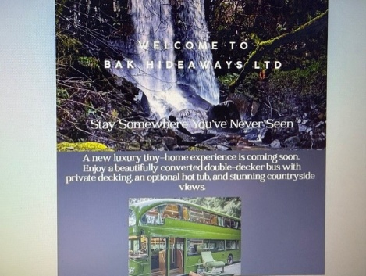
(Canva, 2025)
Appendix 4. 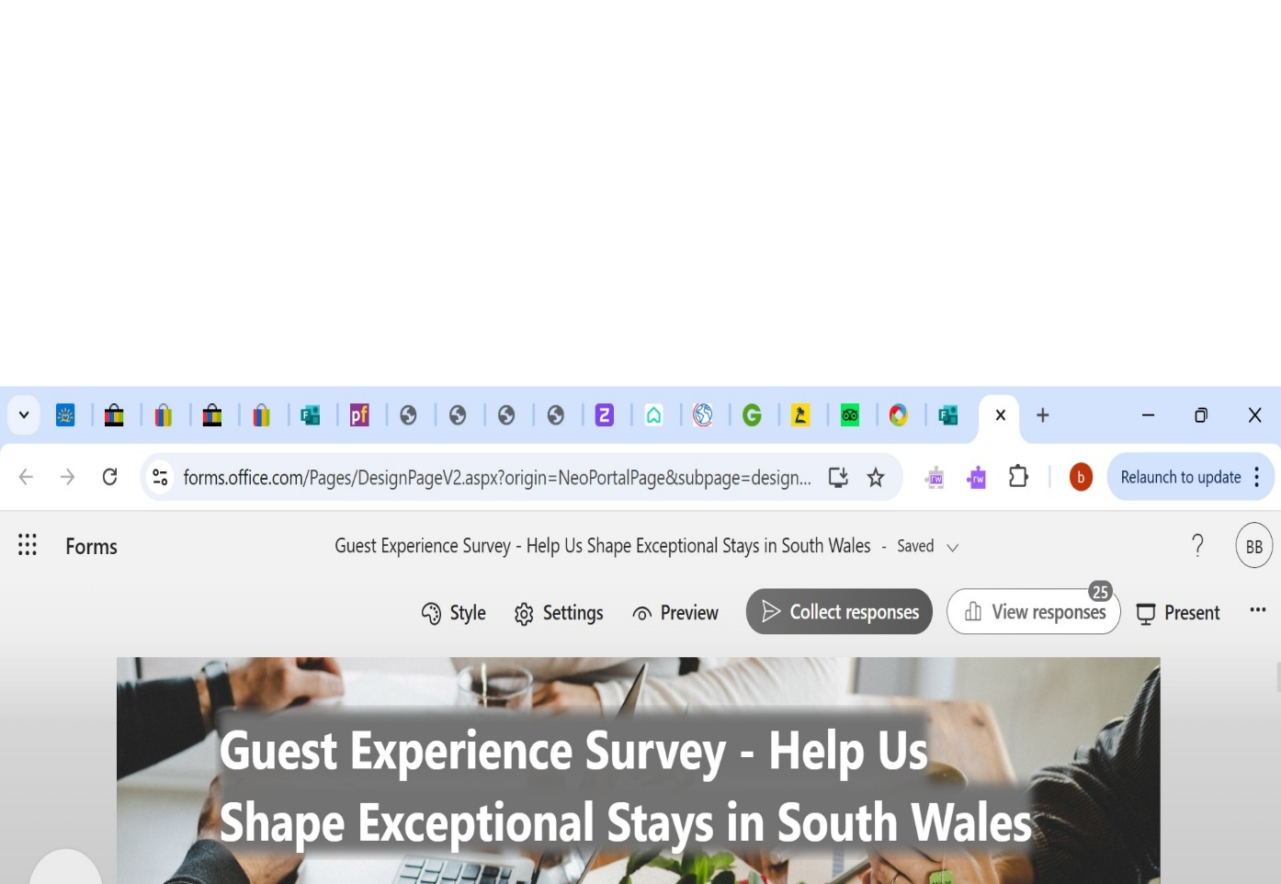
(Microsoft Forms, 2025)

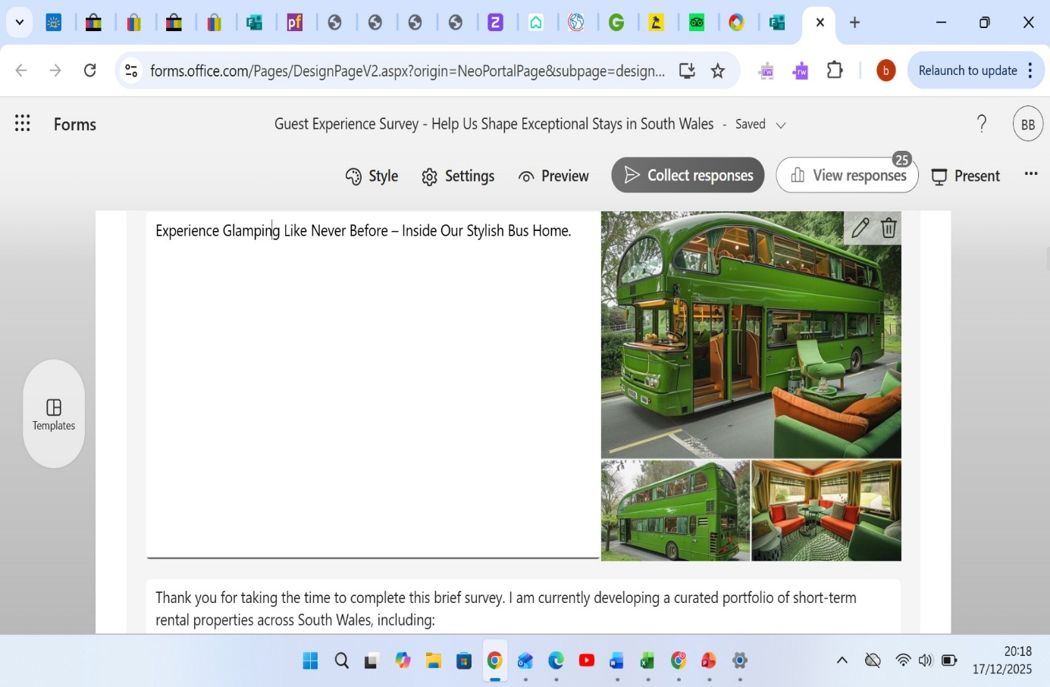
(Microsoft Forms, 2025)

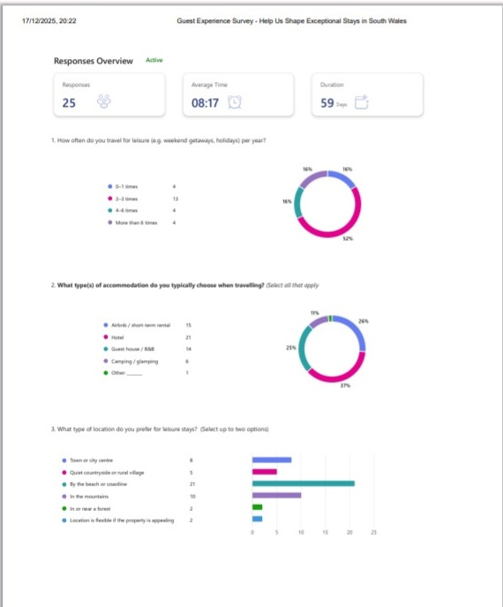
(Microsoft Forms, 2025)

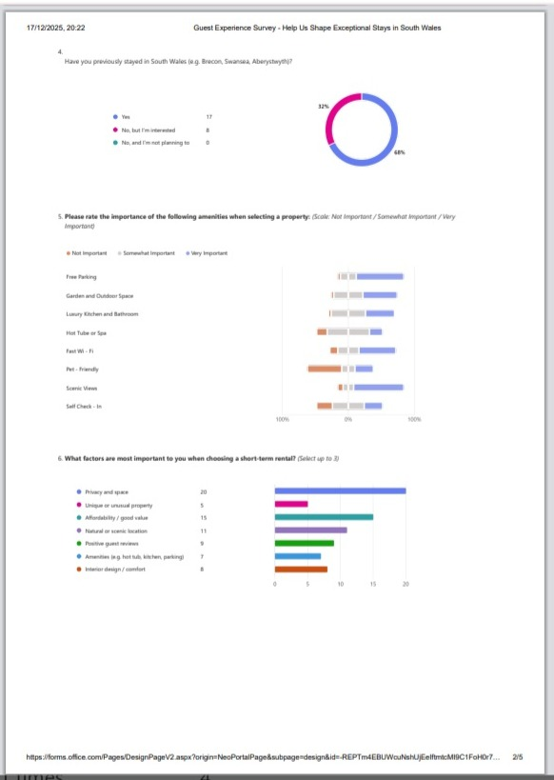
(Microsoft Forms, 2025)

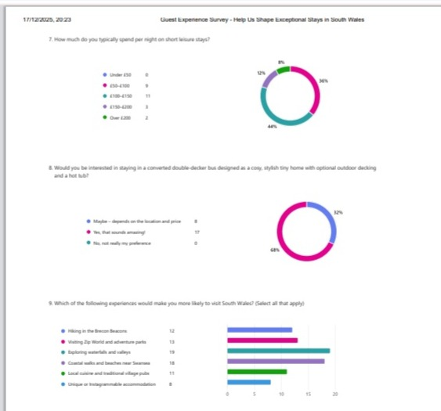
(Microsoft Forms, 2025)

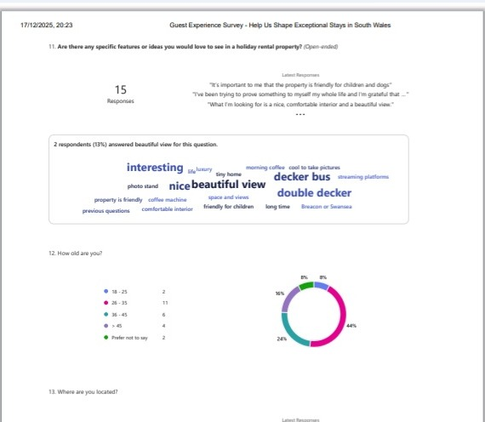
(Microsoft forms, 2025)

