Advanced Project Management
Report Development Plan

Mark Preston – ID 2223676
HND / BSc Construction Management

Table of Contents
Table of Contents 1
1. Introduction 3
2. Existing Building: Historical Information, Location and Condition 3
2.1 Site Context and Location 3
2.2 Existing Dwelling Characteristics 4
2.3 Existing Condition and Limitations 5
2.4 Planning Constraints Identified in Pre-Application Response 5
3. Proposed Development Scheme 6
3.1 Overview of the Proposed Development 6
3.2 Architectural Design and Materiality 7
3.3 Site Layout and Landscape Integration 7
3.4 Parking and Access 8
3.5 Policy Compliance 8
4. Capital Expenditure (CapEx) 8
4.1 Land Acquisition 8
4.2 Demolition Costs 9
4.3 Construction Costs 9
4.4 External Works 9
4.5 Professional Fees 9
4.6 Contingency 9
4.7 Finance Costs 10
4.8 Total Development Cost (TDC) 10
5. Gross Development Value (GDV) 10
5.1 Market Context 10
5.2 Comparable Evidence 10
5.3 Gross Development Valuation (GDV) Calculation 11
5.4 Sensitivity Analysis 11
6. Case Study Example 12
6.1 Case Study 1: Tide Crest, Slade 12
7. Risk and Opportunity Evaluation 13
7.1 Planning Risks 13
7.2 Construction Risks 13
7.3 Market Risks 13
7.4 Opportunities 13
8. Return on Investment (ROI) 14
8.1 Financial Performance Overview 14
8.2 Profit Calculation 14
8.3 ROI Calculation 14
8.4 Sensitivity Analysis 14
9 Sustainability and Ethical Enhancements 15
9.1 Low-Carbon Building Materials 15
9.2 Energy Efficiency Measures 15
9.3 Renewable Energy Integration 15
9.4 Water Management and SuDS 15
9.5 Biodiversity Net Gain 16
9.6 Ethical Procurement and Social Responsibility 16
10. Key Recommendations 16
11.Risk Register 17
12. Project Timeline 18
13. Summary 19
14. Conclusion 19
15. References 20

1. Introduction

This development appraisal looks at whether it is feasible to demolish Haere-Mai in Slade, Oxwich and build two luxury contemporary detached homes, and what the main risks and returns are. Because the site is in the Gower AONB, the proposals need to meet strict landscape, design and ecology requirements. The appraisal uses the pre-application response (City & County of Swansea, 2025), estate agent information (The Greenroom Estate Agency, 2026) and the planning framework, including the Swansea LDP (City & County of Swansea, 2019), the Gower AONB Design Guide (City & County of Swansea, 2012) and TAN 12 (Welsh Government, 2016).

2. Existing Building: Historical Information, Location and Condition

2.1 Site Context and Location

The site is in Slade, a small coastal village between Oxwich and Horton on the Gower Peninsula. The area is characterised by low-density rural housing, agricultural land and coastal scenery. The estate agent describes Slade as “a quiet coastal hamlet with unspoilt beach access and peaceful walking trails” (The Greenroom Estate Agency, 2026), which helps explain its appeal to high-value buyers seeking privacy and proximity to the coast.

The site is in the Gower AONB, so proposals must conserve and enhance landscape character in line with Policy ER4 of the Swansea LDP (City & County of Swansea, 2019) and the Gower AONB Design Guide (City & County of Swansea, 2012). As it sits near a conservation area, the “preserve or enhance” test also applies under Policy HC2 (City & County of Swansea, 2019).

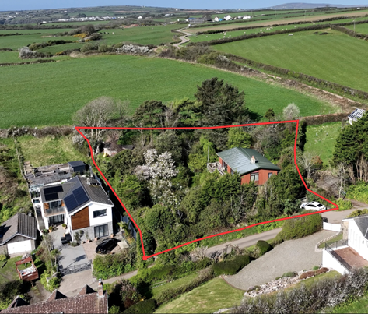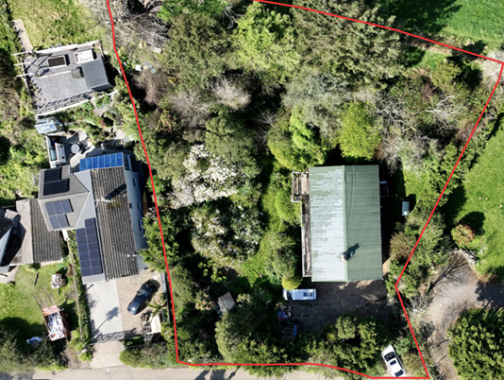
(The Greenroom Estate Agency, 2026)

2.2 Existing Dwelling Characteristics

The existing dwelling, Haere-Mai, is a three-bedroom detached property with a gross internal area of approximately 1988 sq. ft. (The Greenroom Estate Agency, 2026). The property has two levels, with the main living space located above a significant double garage/workshop (The Greenroom Estate Agency, 2026).

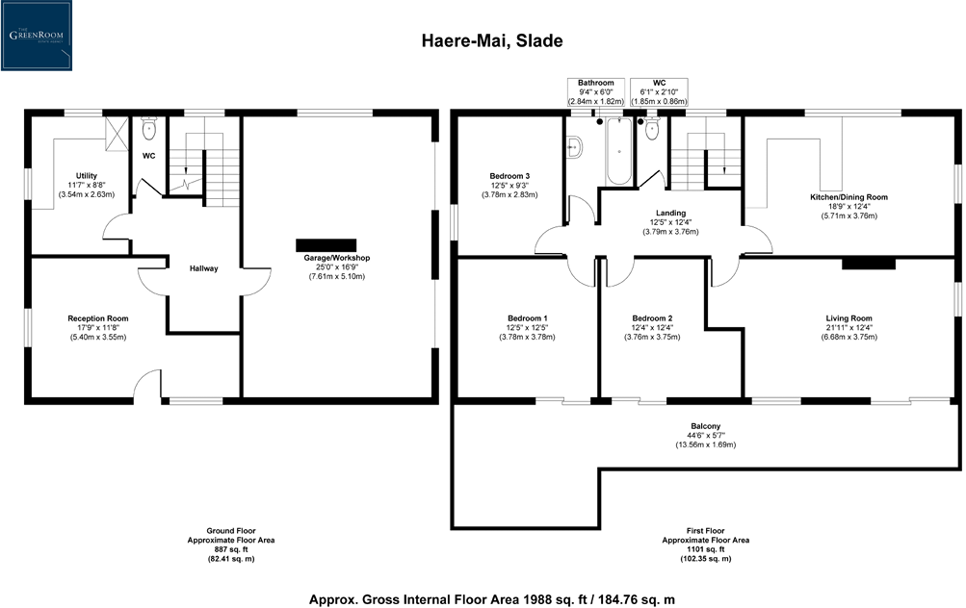

The property sits on a 0.42-acre elevated plot, with mature gardens, established hedgerows, and a sloping topography that contributes to its visual status. (The Greenroom Estate Agency, 2026). The estate agent particulars note that the dwelling “requires modernisation” and has an EPC rating of E, indicating poor energy performance and outdated building fabric (The Greenroom Estate Agency, 2026).

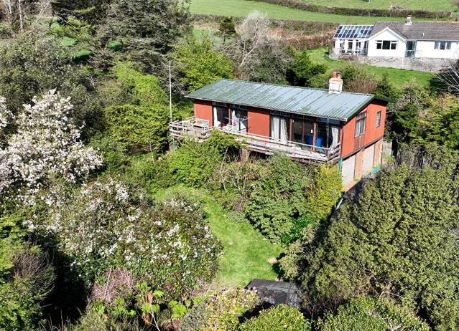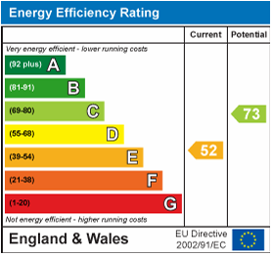
(The Greenroom Estate Agency, 2026)

2.3 Existing Condition and Limitations

The buildings construction type is typical of late-20th-century coastal homes, with limited insulation, oil-fired heating, and dated internal finishes. The EPC rating of E suggests poor thermal performance, which would need substantial investment to bring it up to modern standards (The Greenroom Estate Agency, 2026).

The pre-application response identifies several limitations of the existing structure:

- The building does not reflect the contemporary vernacular encouraged in the AONB.
- The massing and form do not optimise the site’s potential for sensitive redevelopment.
- Fenestration lacks alignment and coherence.
- Energy performance is below modern expectations.

These limitations support the case for demolition and replacement rather than refurbishment.

2.4 Planning Constraints Identified in Pre-Application Response

The pre-application response (City & County of Swansea, 2025) sets out constraints that will shape both the design and the risk profile of the scheme:

- AONB visual sensitivity: the design must clearly conserve and enhance landscape character; natural materials (timber and slate) are strongly preferred.

- Fenestration alignment: ground and first-floor windows should align vertically to avoid a fragmented elevation.

- Outbuilding integration: outbuildings should match the main dwellings in palette and detailing.

- Hedgerow retention: boundary hedgerows should be retained to protect character and provide screening.

- Ecology (EPS bats): bat surveys and, if required, mitigation will be needed before determination.

- Parking and access: a clear parking/turning layout is required as the site currently lacks off-road facilities.

- Site levels and Retaining: detailed sections must show how the buildings sit within the slope and how retaining is handled.

Addressing these items early should reduce the likelihood of redesign and delay.

3. Proposed Development Scheme

3.1 Overview of the Proposed Development

The proposal is to demolish the existing dwelling and replace it with two contemporary detached homes. The design approach follows the Gower AONB Design Guide (City & County of Swansea, 2012). Swansea Council’s pre-application response supports timber cladding, slate roofing and aluminium-framed glazing as a “sensitive contemporary vernacular” for this AONB setting (City & County of Swansea, 2025). This also fits with TAN 12’s focus on context-driven design (Welsh Government, 2016) and wider work showing that outcomes are influenced by how the planning process is managed in practice (Carmona, 2023).

The proposed dwellings will each have an approximate gross internal area of 2,200–2,500 sq ft, showing a significant jump in quality, energy performance, and market value compared to the existing structure. The scheme includes associated landscaping works, retaining structures, and two outbuildings designed to match the main dwellings in materials and form.

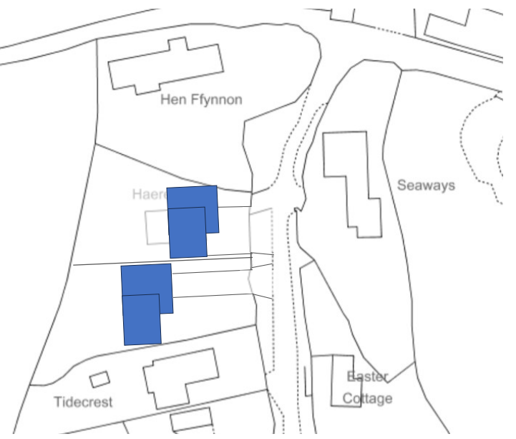
(Cuthbert, T., 2026)

3.2 Architectural Design and Materiality

The architectural approach is natural and landscape-led. Vertical timber cladding and natural Welsh slate help the buildings sit within the setting, and aluminium-framed glazing is practical for a coastal environment. Larger openings are mainly kept to the sea-facing elevations to reduce glare and light spill. The pre-application response also says windows should align vertically between floors to avoid a fragmented elevation (City & County of Swansea, 2025), so this needs to be shown clearly in the final drawings.

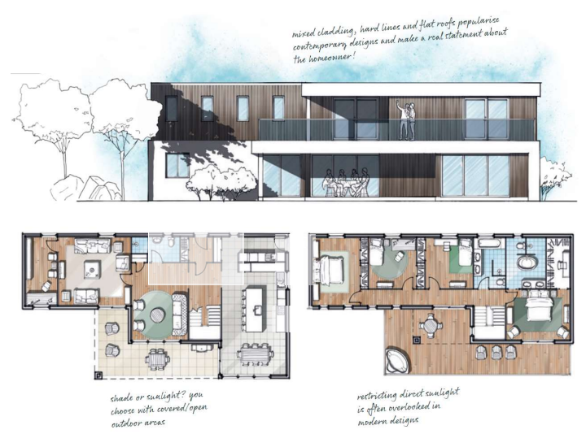
(Cuthbert, T., 2026)

3.3 Site Layout and Landscape Integration

The sloping topography requires careful levels, retaining and landscape treatment, supported by clear sections as requested by the Council (City & County of Swansea, 2025).

- Terraced landscaping to reduce visual massing
- Retaining walls constructed from natural stone
- Preservation of existing hedgerows to maintain biodiversity and screening
- A shared access arrangement with individual parking areas

3.4 Parking and Access

A detailed parking/turning layout is required (City & County of Swansea, 2025). The proposal provides:

- 2–3 parking spaces per dwelling
- A turning area to allow vehicles to exit in forward gear
- Permeable surfacing to comply with SuDS requirements

3.5 Policy Compliance

The proposed development aligns with several key policies:

- Policy PS2 (Placemaking) — high-quality design responding to local context (City & County of Swansea, 2019)
- Policy ER4 (AONB) — conservation and enhancement of natural beauty (City & County of Swansea, 2019)
- Policy HC2 (Conservation Areas) — preservation of character and setting (City & County of Swansea, 2019)
- TAN 12 (Design) — emphasis on context-driven design (Welsh Government, 2016)
- Future Wales: The National Plan 2040 — support for sustainable rural development (Welsh Government, 2021)

The scheme is therefore well placed to secure planning permission, provided the submission directly addresses the specific points raised in the pre-application response.

4. Capital Expenditure (CapEx)

This section sets out the capital expenditure required to acquire and deliver the scheme, including land acquisition, demolition, construction, external works, professional fees, contingency and finance. Allowances are based on SPONS 2023 (Taylor & Francis Books Ltd, 2023), local benchmarks and the pre-application requirements.

4.1 Land Acquisition

The land acquisition cost is based on the estate agent’s listing price of £599,995 (The Greenroom Estate Agency, 2026). This reflects the premium associated with coastal plots in the Gower AONB.

4.2 Demolition Costs

Demolition of the existing 1,988 sq. ft dwelling is estimated at £40,000, based on SPONS rates and local contractor quotations (Taylor & Francis Books Ltd, 2023). This includes strip-out, demolition, disposal and clearance, with a small risk uplift due to the sloping site and potential unknowns at formation level.

4.3 Construction Costs

Construction costs are based on SPONS 2023 rates for high-quality detached homes in rural Wales, estimated at £2,200–£2,600 per m² (Taylor & Francis Books Ltd, 2023). I have used £2,400 per m² as a realistic midpoint because this scheme includes a higher-end envelope, extensive glazing, and AONB-appropriate materials (timber and slate), which typically sit above standard new-build specification.

Each dwelling is approximately 230 m², giving a total construction area of 460 m².

460 m² × £2,400 per m² = £1,104,000.

This figure covers the main build package (structure, roof, cladding, internal finishes, MEP services and high-performance glazing) at a luxury specification appropriate to the AONB setting.

4.4 External Works

External works are estimated at £145,000, covering retaining and terracing works, driveway/parking provision and landscaping to suit the site’s sloping topography.

4.5 Professional Fees

Professional fees total at £256,860, covering architect, structural and MEP engineering, quantity surveying, planning/legal, building control and ecology inputs, in line with typical percentage allowances for a two-unit scheme.

4.6 Contingency

A contingency of 10% is applied to construction and external works:

10% of £1,249,000 = £124,900

This reflects the increased risk associated with AONB sites and sloping ground conditions.

4.7 Finance Costs

Finance costs are estimated at £75,000, assuming 6% interest over an 18-month programme with staged drawdown.

4.8 Total Development Cost (TDC)

Cost Category | Amount
Land Acquisition | £599,995
Demolition | £40,000
Construction | £1,104,000
External Works | £145,000
Professional Fees | £256,860
Contingency | £124,900
Finance Costs | £75,000
Total Development Cost (TDC) | £2,345,755

5. Gross Development Value (GDV)

5.1 Market Context

The Gower Peninsula is one of the most desirable residential locations in Wales, with sustained demand for high-quality coastal homes. According to Savills Research (2024), coastal properties in South Wales continue to outperform regional averages due to lifestyle migration, increased remote working, and limited supply.

Slade is a micro-market within this broader context. Its secluded nature and proximity to Slade Bay create a premium environment where contemporary homes command significant value. The estate agent particulars for Haere-Mai emphasise the rarity of such opportunities, describing the site as offering “endless potential in one of Wales’ most coveted locations” (The Greenroom Estate Agency, 2026).

5.2 Comparable Evidence

Current asking prices in nearby coastal markets such as Langland, Southgate and Horton (Fine & Country, n.d.) suggest that contemporary homes with sea views and high-end specification commonly sit in the £1,100,000–£1,800,000 range, with the upper end driven by outlook, plot position and design quality (Savills Research, 2024). Because there are limited directly comparable new-build sales in Slade, the appraisal adopts a cautious base-case for GDV. Savills also note demand in Wales has been supported by lifestyle migration and constrained supply, with activity gradually recovering as mortgage rates ease (Savills Research, 2024), and the estate agent particulars emphasise the scarcity of this type of coastal plot (The Greenroom Estate Agency, 2026).

5.3 Gross Development Valuation (GDV) Calculation

Given the sites:

- Elevated position
- Sea views
- AONB location
- Luxury specification
- Contemporary vernacular design
- Large plot size,

a GDV of £1,450,000 per dwelling is considered realistic and conservative.

Total GDV: £1,450,000 × 2 = £2,900,000

This figure aligns with market expectations and comparable evidence.

5.4 Sensitivity Analysis

To account for market uncertainty, a sensitivity analysis was conducted:

Scenario | GDV per Dwelling | Total GDV
Best Case | £1,600,000 | £3,200,000
Base Case | £1,450,000 | £2,900,000
Worst Case | £1,300,000 | £2,600,000

Even under the worst-case scenario, the scheme remains potentially viable, although profit margins would reduce.

6. Case Study Example

6.1 Case Study 1: Tide Crest, Slade

Tide Crest, Slade, Oxwich, Swansea, 3A3 1NA is a useful comparator because it is the neighbouring property directly downhill from Haere-Mai, sharing the same coastal setting, access road and AONB context. Although not a new build, it provides a relevant £/m² benchmark for high-value homes in Slade.

The house is around 185 m², compared with 230 m² for each proposed dwelling at Haere-Mai. Zoopla estimates Tide Crest at £630,000–£770,000; the upper figure is used to reflect the higher specification proposed. Using £770,000, the implied value per square metre is:

£770,000 ÷ 185 m² = £4,162 per m²

Applying this rate to 230 m² gives an indicative value of:

£4,162 per m² × 230 m² = £957,260

This indicates that even older homes in Slade can achieve strong values. Allowing for the additional premium associated with new-build, AONB-compliant contemporary design supports the GDV assumption of £1,450,000 per dwelling used in this appraisal.

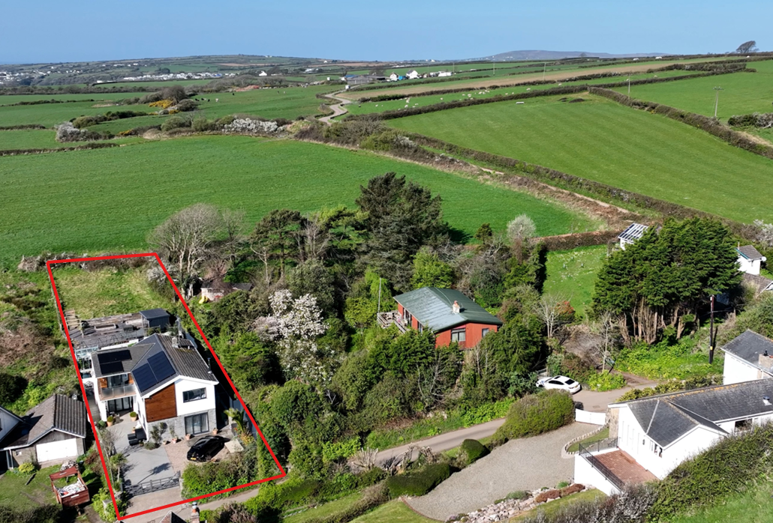
(The Greenroom Estate Agency, 2026)

I have endeavoured to find 2 additional coastal redevelopment case studies like the proposed in Gower AONB for reference via the Swansea Planning Portal although many have been rejected for not meeting certain criteria mentioned in this report (City & County of Swansea, 2026).

7. Risk and Opportunity Evaluation

This section outlines what I think are the main risks to programme, cost and sale value, and the opportunities that could strengthen the scheme if they are considered early in the design and delivery plan.

7.1 Planning Risks

The biggest risk is planning, mainly because the site is within the Gower AONB and close to a conservation area. Refusal is more likely if the buildings look too bulky on the slope or if the elevations feel unresolved. To reduce this, the submission needs to be landscape-led and backed up with clear site sections, a consistent natural palette (timber and slate), and elevations that follow the pre-application advice (City & County of Swansea, 2025). Wider guidance also suggests that early design review and ongoing engagement can reduce late-stage conflict (CABE, 2006; Carmona, 2023).

7.2 Construction Risks

Construction risk is mainly driven by the slope, which increases retaining, drainage and temporary works, and by continued cost pressure on labour and materials (Taylor & Francis Books Ltd, 2023). Risk can be reduced by confirming ground conditions and the drainage strategy early (geotechnical and SuDS) and agreeing the retaining approach before tender so the contractor prices a defined scope. Access via rural lanes is also a constraint, so deliveries should be managed through a construction management plan.

7.3 Market Risks

Market risk is moderate. The buyer pool for £1,300,000–£1,600,000 homes is smaller and higher rates can slow decisions, but Slade has limited comparable new-build stock and demand for coastal lifestyle property is still supported by scarcity (Savills Research, 2024). Because the GDV is benchmarked from nearby comparables and kept cautious, the bigger risk is time-on-market rather than headline price; early marketing and, if needed, phased release would help protect sales pace.

7.4 Opportunities

The main opportunity is value uplift through design quality. In this location, buyers pay a premium for privacy, sea views and a well-detailed contemporary vernacular, and the AONB guidance supports that approach when it is handled carefully (City & County of Swansea, 2012). Building in strong fabric performance, SuDS and biodiversity enhancements from the outset should also strengthen the planning case and buyer proposition, helping defend the base-case GDV.

8. Return on Investment (ROI)

8.1 Financial Performance Overview

This section compares the total development cost (TDC) of £2,345,755 with the total Gross Development Value (GDV) of £2,900,000 to show profit and ROI.

8.2 Profit Calculation

Profit in this appraisal is:

Based on a total GDV of £2,900,000 and a TDC of £2,345,755, the scheme produces a profit of £554,245.

8.3 ROI Calculation

The resulting ROI is:

This equates to an ROI of 23.6% (profit of £554,245 divided by a TDC of £2,345,755).

An ROI of 23.6% provides a cushion against moderate cost increases or small movements in sales values.

8.4 Sensitivity Analysis

A sensitivity test was carried out to show how changes in GDV or build cost affect profit and ROI.

Scenario | GDV | Profit | ROI
Best Case | £3,200,000 | £854,245 | 36.4%
Base Case | £2,900,000 | £554,245 | 23.6%
Worst Case | £2,600,000 | £254,245 | 10.8%

In the worst-case scenario, the scheme remains marginally viable, but ROI falls below typical developer targets.

The main financial drivers are:

- planning outcomes in a sensitive AONB setting
- construction complexity from the slope and associated retaining/drainage
- wider cost inflation (Taylor & Francis Books Ltd, 2023).

Overall, market risk is moderate: the buyer pool at this price point is smaller, but demand for coastal lifestyle property on the Gower remains supported by scarcity (Savills Research, 2024). The base-case ROI of 23.6% provides some cushion, but success depends on controlling scope, managing site constraints and avoiding redesign.

9 Sustainability and Ethical Enhancements

For this scheme, sustainability measures help with both deliverability and value. The main priorities are reducing operational energy demand, managing surface water safely on a sloping site, and dealing with ecology early, in line with the constraints raised at pre-application stage (City & County of Swansea, 2025).

9.1 Low-Carbon Building Materials

Using timber cladding aligns with the AONB Design Guide and can reduce embodied carbon compared with more masonry-intensive solutions. Where possible, specify FSC-certified timber and durable, repairable detailing to avoid early replacement. Natural slate is long-life and low-maintenance, improving whole-life performance and supporting decarbonisation objectives (Welsh Government, 2021).

9.2 Energy Efficiency Measures

The new homes should avoid repeating the existing dwelling’s weak EPC performance. This means a fabric-first approach (high insulation, airtightness and high-performance glazing), low-temperature heating via air-source heat pumps, and MVHR to limit ventilation losses. The specification should aim to meet or exceed the RIBA 2030 operational energy benchmarks, supporting lower running costs and improved comfort (RIBA, 2021; UKGBC, 2019).

9.3 Renewable Energy Integration

PV panels (ideally roof-integrated) with battery storage would reduce grid demand and improve self-consumption. Given the target buyer profile, EV charging should be included as standard. These measures follow common net zero pathways that prioritise demand reduction and on site renewable generation (UKGBC, 2019; RIBA, 2021).

9.4 Water Management and SuDS

Because the site falls away, SuDS should be designed at concept stage rather than left to a late condition. Permeable surfacing, attenuation and rainwater harvesting are all suitable here, with native planting used to support infiltration and reduce runoff rates, consistent with The SuDS Manual (CIRIA, 2015).

9.5 Biodiversity Net Gain

Biodiversity measures can reduce planning risk. As an EPS bat survey is flagged at pre-application (City & County of Swansea, 2025), the scheme should assume mitigation and habitat retention will be required. Retaining and strengthening boundary hedgerows, using native planting and adding bird/bat boxes are low-cost measures that help demonstrate net benefit. This aligns with Natural Resources Wales guidance that survey timing and robust mitigation evidence are central where bats may be affected (Natural Resources Wales, 2015).

9.6 Ethical Procurement and Social Responsibility

Ethically, the project should set basic procurement standards: FSC-certified timber where possible, fair labour expectations, and waste reduction through reuse and recycling. Using local contractors can support the regional economy and reduce transport impacts.

10. Key Recommendations

The recommendations below focus on actions that materially improve the likelihood of consent and control cost/programme risk:

- Planning and design: correct fenestration alignment; match outbuilding materials; provide a clear parking/turning layout; submit detailed site sections showing retaining and how the scheme sits in the slope; keep an active pre-submission dialogue with the case officer.

- Ecology: commission the EPS bat survey early and design mitigation in (rather than relying on late conditions).

- Construction: complete geotechnical and drainage investigations before tender; use a construction management plan for access; lock scope early and tender on a defined specification.

- Commercial: start marketing early to the target buyer profile and consider phased release if the market softens; retain at least 10% contingency.

11.Risk Register

Risk | Impact | Likelihood | Detailed Mitigation Strategy
AONB Planning Refusal | High | Medium | Ensure full compliance with the Gower AONB Design Guide; use natural materials; provide landscape-led design; engage in pre-submission consultation with the planning officer.
Fenestration Misalignment | Medium | Medium | Revise elevations to ensure vertical alignment of windows as required in the pre-application response; provide annotated drawings demonstrating compliance.
Outbuilding Material Non-Compliance | Medium | Low | Match outbuilding materials (timber, slate, aluminium) to the main dwellings; include material samples in the planning submission.
Ecology Constraints (Bats) | High | Medium | Commission a European Protected Species (EPS) bat survey early; integrate bat roosts into the roof structure; implement ecological mitigation measures.
Hedgerow Removal Objections | Medium | Low | Retain all boundary hedgerows; enhance with native species; demonstrate biodiversity net gain in planning documents.
Sloping Topography and Retaining Wall Failure | High | Low | Undertake geotechnical investigation; appoint structural engineer to design retaining structures; use staged construction to reduce ground movement.
Surface Water Runoff and Drainage Issues | Medium | Medium | Implement SuDS measures including permeable paving, rainwater harvesting, and attenuation tanks; comply with Welsh SuDS legislation.
Material Cost Inflation | Medium | High | Secure fixed-price contracts; procure long-lead items early; maintain a 10% contingency.
Access Constraints for Construction Vehicles | Medium | Medium | Prepare a Construction Management Plan; schedule deliveries during off-peak times; use smaller vehicles where necessary.
Contractor Insolvency | High | Low | Conduct financial due diligence; use staged payments; retain 5% retention until completion.
Market Downturn Reducing GDV | Medium | Low | Target high-net-worth buyers; begin early marketing; consider phased release of units.
Weather-Related Delays | Medium | Medium | Schedule groundworks outside winter months; include weather contingency in programme; use temporary protection measures.

12. Project Timeline

Task | M1 | M2 | M3 | M4 | M5 | M6 | M7 | M8 | M9 | M10 | M11 | M12 | M13 | M14 | M15 | M16 | M17 | M18 | M19
Pre-application review
Ecology & bat surveys
Architectural design
Planning submission
Planning determination
Demolition
Groundworks & retaining walls
Superstructure construction
Roofing & cladding
MEP installation
Internal finishes
Landscaping & externals
Marketing & sale

13. Summary

Project overview: Demolition and replacement of Haere-Mai (Slade, Oxwich) with two luxury contemporary dwellings designed in line with the Gower AONB Design Guide.

Key strengths:

- Premium coastal setting with sea views and scarce new-build supply.
- AONB-appropriate contemporary palette (timber, slate, aluminium) supported at pre-application stage.
- Clear sustainability pathway (high-performance fabric, ASHP, PV/battery, MVHR, SuDS).

Financial summary:

- Total Development Cost (TDC): £2,345,755
- Gross Development Value (GDV): £2,900,000
- Profit: £554,245
- ROI: 23.6%

Key planning considerations: fenestration alignment; outbuilding materials; hedgerow retention; EPS bat survey; landscape-led levels/sections.

Headline risks: AONB visual sensitivity, ecology constraints, cost inflation, and access/logistics during construction.

14. Conclusion

Overall, redeveloping Haere-Mai into two contemporary dwellings is viable on the base-case assumptions and defensible in policy terms, provided the design is landscape-led. The main risks sit in planning detail (elevations, levels and ecology) and in cost control on a sloping site; both can be reduced through early surveys, clear drawings and a tightly defined tender package. On that basis, the projected ROI of 23.6% appears achievable and the scheme should be capable of securing consent and delivering an acceptable return.

15. References
CABE (2006) Design Review: How CABE Evaluates Quality in Architecture and Urban Design. London: Commission for Architecture and the Built Environment. Available at: https://studylib.net/doc/18131300/design-review--how-cabe-evaluates-quality-in-architecture... (Accessed: 4 May 2026).

Carmona, M. (2021) Public Places Urban Spaces: The Dimensions of Urban Design. 3rd edn. Abingdon: Routledge. Available at: https://api.pageplace.de/preview/DT0400.9781351656627_A40251838/preview-9781351656627_A40251838.pdf (Accessed: 4 May 2026).

Carmona, M., Bento, J. and Gabrieli, T. (2023) Urban Design Governance: Soft Powers and the European Experience. London: UCL Press. Available at: https://uclpress.co.uk/book/urban-design-governance/ (Accessed: 4 May 2026).

CIRIA (2015) The SuDS Manual (C753). London: CIRIA. Available at: https://www.ciria.org/CIRIA/Books/Free_publications/C753F.aspx (Accessed: 4 May 2026).
Carmona, M., Bento, J. and Gabrieli, T. (2023) Urban Design Governance: Soft Powers and the European Experience. London: UCL Press. Available at: https://uclpress.co.uk/book/urban-design-governance/ (Accessed: 4 May 2026).

City & County of Swansea (2012) Gower AONB Design Guide. Swansea: City & County of Swansea. Available at: https://www.swansea.gov.uk/media/2877/Gower-AONB-Design-Guide/pdf/clGower_AONB_Design_Guide.pdf (Accessed: 4 May 2026).

City & County of Swansea (2019) Swansea Local Development Plan 2010–2025 (Adopted). Swansea: City & County of Swansea. Available at: https://www.swansea.gov.uk/ldp?lang=en (Accessed: 4 May 2026).

City & County of Swansea (2026) Planning application search. Swansea: City & County of Swansea. Available at: https://www.swansea.gov.uk/planningsearch?lang=en (Accessed: 8 May 2026).

Cuthbert, T. (2026) Block plan 2. Advanced Project Management (MACBA6010). PDF. Available at: https://uowtsd.sharepoint.com/:b:/r/teams/AdvancedProjectManagementMACBA6010_GRP/Shared%20Documents/Week%2014%20---%20assignment%20intro---important/block%20plan2.pdf?csf=1&web=1&e=ScjGSr (Accessed: 8 May 2026).

Cuthbert, T. (2026) Elevation. Advanced Project Management (MACBA6010). PDF. Available at: https://uowtsd.sharepoint.com/:b:/r/teams/AdvancedProjectManagementMACBA6010_GRP/Shared%20Documents/Week%2014%20---%20assignment%20intro---important/elevation.pdf?csf=1&web=1&e=m4DCPf (Accessed: 8 May 2026).

Fine & Country (n.d.) Swansea Estate Agents – Property for Sale. Fine & Country. Available at: https://www.fineandcountry.co.uk/swansea-estate-agents/sales/property-for-sale (Accessed: 8 May 2026).

Healey, C. (2026) Pre-app response 2. Advanced Project Management (MACBA6010). PDF. Available at: https://uowtsd.sharepoint.com/:b:/r/teams/AdvancedProjectManagementMACBA6010_GRP/Shared%20Documents/Week%2014%20---%20assignment%20intro---important/pre%20app%20responce%202.pdf?csf=1&web=1&e=3yNAQ4 (Accessed: 8 May 2026).

Natural Resources Wales (2015) NRW Approach to Bats and Planning (Good Practice Guide GPG 3). Cardiff: Natural Resources Wales. Available at: https://cdn.naturalresources.wales/5436/gpg-3-nrw-approach-to-bats-and-planning-english.pdf (Accessed: 4 May 2026).

Royal Institute of British Architects (RIBA) (2021) RIBA 2030 Climate Challenge (Version 2). London: RIBA. Available at: https://www.riba.org/media/ykxpwv4p/riba-2030-climate-challenge.pdf (Accessed: 4 May 2026).

Royal Institution of Chartered Surveyors (RICS) (2019) Valuation of Development Property. 1st edn. London: RICS. Available at: https://www.rics.org/content/dam/ricsglobal/documents/to-be-sorted/valuation-of-development-property---first-edition.pdf (Accessed: 4 May 2026).

Savills Research (2024) Welsh Housing Market and Supply Update – April 2024. London: Savills. Available at: https://en.savills.de/research_articles/259694/358506-0 (Accessed: 4 May 2026).

Taylor & Francis Books Ltd (2023) SPONS Architects and Builders Price List 2023. PDF. Available at: https://uowtsd.sharepoint.com/:b:/r/teams/AdvancedProjectManagementMACBA6010_GRP/Shared%20Documents/Week%2014%20---%20assignment%20intro---important/SPONS%20Architects%20and%20Builders%20Price%20List%202023.pdf?csf=1&web=1&e=31GRO7 (Accessed: 8 May 2026).

The Greenroom Estate Agency (2026) Haere-Mai Property Particulars. The Greenroom. Available at: https://thegreenroomhomes.com/property/slade-oxwich-swansea-34549682/ (Accessed: 8 May 2026).

UK Green Building Council (UKGBC) (2019) Net Zero Carbon Buildings: A Framework Definition. London: UKGBC. Available at: https://ukgbc.org/resources/net-zero-carbon-buildings-a-framework-definition/ (Accessed: 4 May 2026).

Welsh Government (2016) Technical Advice Note (TAN) 12: Design. Cardiff: Welsh Government. Available at: https://www.gov.wales/technical-advice-note-tan-12-design (Accessed: 4 May 2026).

Welsh Government (2021) Future Wales: The National Plan 2040. Cardiff: Welsh Government. Available at: https://www.gov.wales/future-wales-national-plan-2040 (Accessed: 4 May 2026).
Zoopla (n.d.) Property details (UPRN: 10011727582). Zoopla. Available at: https://www.zoopla.co.uk/property/uprn/10011727582/ (Accessed: 8 May 2026).

