

LOCATION: Swansea | LLEOLIAD: abertawe
LEVEL 6 | LEFEL 6
EXAMINATION PERIOD | CYFNOD ARHOLIADAU
January 2018 | Ionawr 2018

MODULE CODE: ACCA6001
Network & Data Centre Management
TIME: 2 HOURS

answer THREE quESTIONs out of FoUR

Equipment or materials required – None
Adnoddau neu ddefnyddiau sydd eu hangen - Dim

ANSWER THREE QUESTIONS

Q1.

- In reference to Network Management:

  - The International Organization Standards (ISO) divided it into five functional areas, name and discuss them.
(20 Marks)

Solutions: (1 mark each for naming and 4 marks each for discussing them)
  - Fault Management
  - Configuration Management
  - Security Management
  - Performance Management
  - Accounting Management

Fault management involves
    - Detection of faults found on the network
    - Isolating the faults found on the network
    - Correction of faults found on the network
  - Preemptive approach is better for reducing downtime
  - The MOST widely implemented network management elements.

Performance Management:
- Involves monitoring performance aspects of the network including:
    - Downtime
    - Available Bandwidth
    - Latency
    - Broadcast storms
  - Maintain at a certain level, have a system to notify if level falling
Or discussion can base on:
- Performance metrics
  - Throughput
  - Response time
  - Utilization
- Steps involved
Gather data Analyze Set threshold Monitor

Configuration Management:
- Monitor network and system configuration.
- Involves all configuration aspects of the network including:
    - Configuration file management
    - Inventory management
    - Software management
    - Known naming conventions
    - Contact person

Create Standards
Implement
Maintain Documentation
Validate & Audit
Review Standards

Accounting Management:
- Involves monitoring usage aspects of the network including:
  - What services are used?
  - When are they used?
  - Who uses the services?
  - All aspects of logging and auditing
- Measure utilization of all important network resources
- Analysis of the results provides insight into current usage

Security Management:
- Control access to the network resources
- Involves monitoring security aspects of the network including:
  - Access to network devices by only authorized individuals
  - Access to corporate resources by only authorized individuals
- Notify the administrator if anyone trying to breach security not after malicious aftermath

  - Network Management platform is a software package, state some basic features that are included in it. (5 Marks)
Solutions: (any five, full marks)
Basic features for any platform to include are:
  - Graphical User Interface (GUI)
  - Network Map
  - Database Management System (DBMS)
  - Standard Method to Query Devices
  - Customizable Menu System
  - Event Log

Q2.

Figure 1 below is a poorly designed network that is being implemented by a medium size business. The network personnel who are responsible for managing the network are quite inexperienced. You are required to:
- Make a list of all the problems you can identify.
(6 Marks)
Solutions: (6 marks for any 6 listed problems)
Answers may include –
- No Redundancy
- No Server Information
- No User Information
- No Subnet / Notation
- Sub-netting inconsistent
- UTP not Fibre incoming
- No Firewall for incoming
- Over use of Lease Lines
- Older style of HUBS being used
- Many Brands of Equipment being used

- State the job function/responsibility for:
  - Network Manager
Solutions: (2 marks for four listed)
Answers may include:
- Oversees every aspect of network
- Manages Staff
- Verifies the connectivity
- Ensures efficiency
- Assigns roles
- Maintaining Network
- Implements Policies and Procedures
- Contingency Planning
- Recovery Planning
- Training of Staff
- Recruitment of Staff
- Procurement of New Technologies
- Ensuring that Network growth matches the companies
- Work with the Network Administrators and Planners

  - Network Administrator
Solutions: (2 marks for any 4 listed)
Answers may include:
- To ensure the smooth running of the network
- User Management
- Removal of old devices
- Updating Firmware on devices
- Reporting to Management
- Implementation of Recovery and Contingency plans
- Monitoring of Network Performance
- Monitoring of Network Intrusion
- Implementing Security Policies and Procedures
- Assist the network manager
- Actively ensures the network is up

(4 Marks)
- Rebuild/design the current network infrastructure

  - All problems and weaknesses identified in ‘a.’ above must be addressed and measures taken to correct them explained.

  - The improvement of network infrastructure should incorporate VOIP and a PBX server as part of a server farm.

  - State all assumptions made.
(15 Marks)
Solutions:
Sample answers but not limited to these and design may vary –
- Inclusion of VLANs across the network
- Voice VLAN implementation for VOIP Network
- Introduction of Sub-netting across the floors
- Fibre to be used on incoming lease line
- Implementation of Firewall at entry point
- Standardisation of the equipment use
- Implement Redundancy across the network
- Cisco Proprietary SNMP ver3

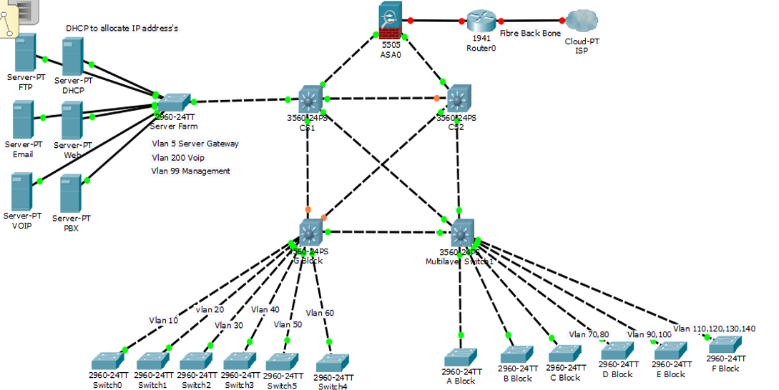

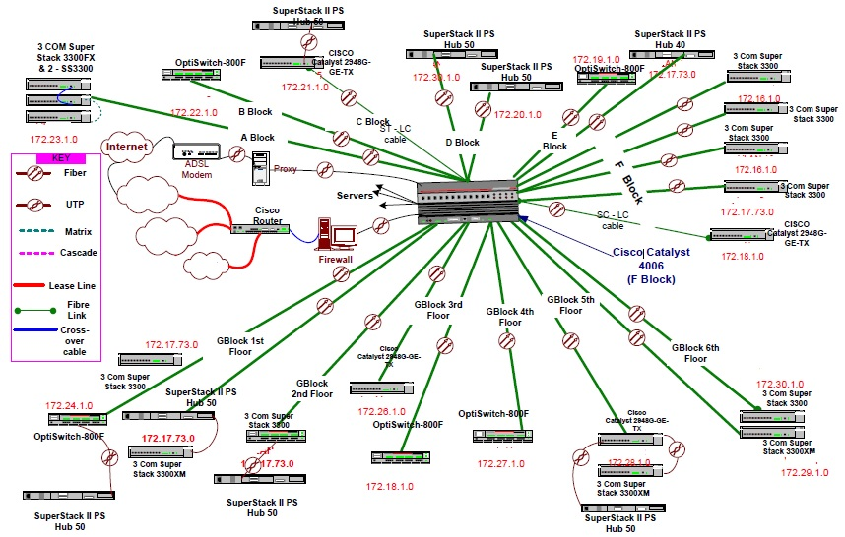
Figure 1: Poorly design network

Q3.

- Server virtualisation comprises several components working in synergy to deliver a holistic solution. With reference to this explain the following:

- Type-1 and Type-2 Hypervisors
(10 Marks)

- Virtual machines
(5 Marks)

- Virtual switching
(5 Marks)

- Management tools
(5 Marks)
Solutions:

a i  ii  iii  iv | Hypervisor: Hypervisor, also known as the Virtual Machine Monitor, is a piece of software running on the bare metal x86 server, which allows virtualizing underlying physical server resources and presenting them as components to be consumed by the virtual machines running on top. All major server hardware  components, such as CPU, disk, memory, and network, can be virtualized by the hypervisor.  Type-1 hypervisors, also known as bare metal, run directly on top of the physical server hardware, and they represent the original idea behind server virtualization developed by IBM in the 1960s and 1970s. Virtual machines run on top, and guest operating systems installed on those virtual machines leverage virtual hardware exposed by the hypervisor. More popular examples of Type-1 hypervisors include Microsoft Hyper-V, VMware ESXi, XenServer, and KVM.  Type-2 hypervisors, also known as hosted, do not run directly on top of the physical server hardware. Instead, they run as an application on top of the server operating system. Type-2 hypervisors coordinate a call to the physical server resources through the host operating system installed on the server. The actual virtual machines run one level higher. Examples of Type-2 hypervisors include  VMware Workstation, VMware Fusion, Oracle VM VirtualBox, and others.  A virtual machine is a software construct operating on top of the hypervisor. Virtual machines emulate operation of the physical computing environment and rely on the hypervisor for access to the physical server resources. Virtual machines can also be created within the virtualization environment running on top of the server operating system, also known as the host operating system. It is important to note that not all guest operating systems are supported on all hypervisor products, but if they are, they can be installed on top of virtual machines the same as they would be installed on top of physical server hardware. For example, a guest operating system can have several network interface cards defined in its settings, when in reality those network interfaces are presented and scheduled by the hypervisor for access into the actual physical server network interfaces.  Servers were attached through either IEEE 802.1Q VLAN trunks or single-VLAN switch ports sending their network traffic toward the data center access layer switches, which in turn forwarded it to its destination. Virtual switches took care of forwarding the network traffic between the virtual machines residing on the  same or different physical hosts. They also leveraged physical network interfaces to send traffic between the virtual machines and non-virtualized servers  The virtualization management tool is also referred to as Virtual Machine Manager. Virtual Machine Manager products exist for all the major types of server virtualization solutions. They help create, edit, clone, start, stop, and move virtual machines. They help view performance characteristics and utilization of the individual VMs and a virtualization system as a whole. Through a set of application programming interfaces, known as APIs, virtual machine management tools also provide a programmatic way of interacting with server virtualization environment. | 2  4  4  5  5  5

Q4.

- Data centres are designed to host business applications in a centralised place. When you scale out and add new servers, a server load-balancing solution is required to distribute the client load between these servers.
i. What is Server Load Balancing (SLB)?
(5 Marks)
ii. List some of the benefits of SLB?
(4 Marks)
iii. Explain server-based and network-based load-balancing solutions.
(16 Marks)
Solutions:

Q 4 | Question | Marks
a i  ii  iii | Server load balancing means to spread the workload among the servers hosting the same application content. Server Load Balancer (SLB) is a device that performs the load-balancing function. A load balancer receives the client request, analyzes the information in the request, and based on the loadbalancing algorithm, it divides the load appropriately between the servers. Load balancing can be done for client-to-server traffic, and for server-to-server traffic.  Some of the advantages of Server load-balancing:  Scalability  Increases capacity  High availability  Disaster recovery  Security  Server-based load-balancing solutions: The load-balancing function is performed by the server itself. This can be achieved using features such as load-balancing server clusters or special software that runs on the server and performs the load balancing of traffic between the servers. Server clustering is a feature where servers are grouped to perform a common task. Typically, all the servers in a cluster must be using the same software. In a load-balanced cluster, two or  more servers are combined to operate as one platform and are managed as a single entity. In a clustering solution, servers must be able to access common resources such as disk data. Server-based load balancing can also be done without clustering. In this case each server runs a separate copy of the desired server applications, and the load is balanced using software that runs on each server. This software receives the request from the client and either serves the request or sends it to another server among all the independent servers participating in the load balancing.  Network-based load-balancing solutions: Server load balancing can also be achieved within the network. In this solution servers can perform the application function while the network can take care of the load balancing. This approach takes advantage of hardware acceleration within the network device; hence it improves the performance of the solution. Network-based loadbalancing  services are deployed at the aggregation layer of the data center. These load  balancers could be a router with the IOS SLB feature or a specialized switch, such as Cisco Application Control Engine (ACE). | 5  4  8  8

Diwedd/End

