Assignment 1: E-Portfolio
Universitey of Wails trinatey St David | Swansea
Changemakers: Creativity and Value Creation
Joseph Gillespie (2214885)
[2023]
Table of Contents
Introduction 2
1.0 Mined Map 3
1.1 Mined Map 1 3
1.2 Mined Map 2 3
2.0 What’s the Problem 4
2.1 Research Philosophy 4
2.2 The Appropriate Databases 5
2.3 Research Strategies 5
3.0 The Worst Possible Idea 6
3.1 Quantitative and Qualitative Research 6
3.2 Identifying Strategies 7
3.3 Questionnaire 8
4.0 Presentation Screen Shots 8
Bibliography 12

Introduction

This document provides screen captures as evidence that the tasks asked for in Assessment 1, E-Portfolio, have been completed. The following link is to the full E-portfolio where access to the questions can be found:
Changemakers (Accessibility view) (office.com)

Mined Map

Mined Map 1

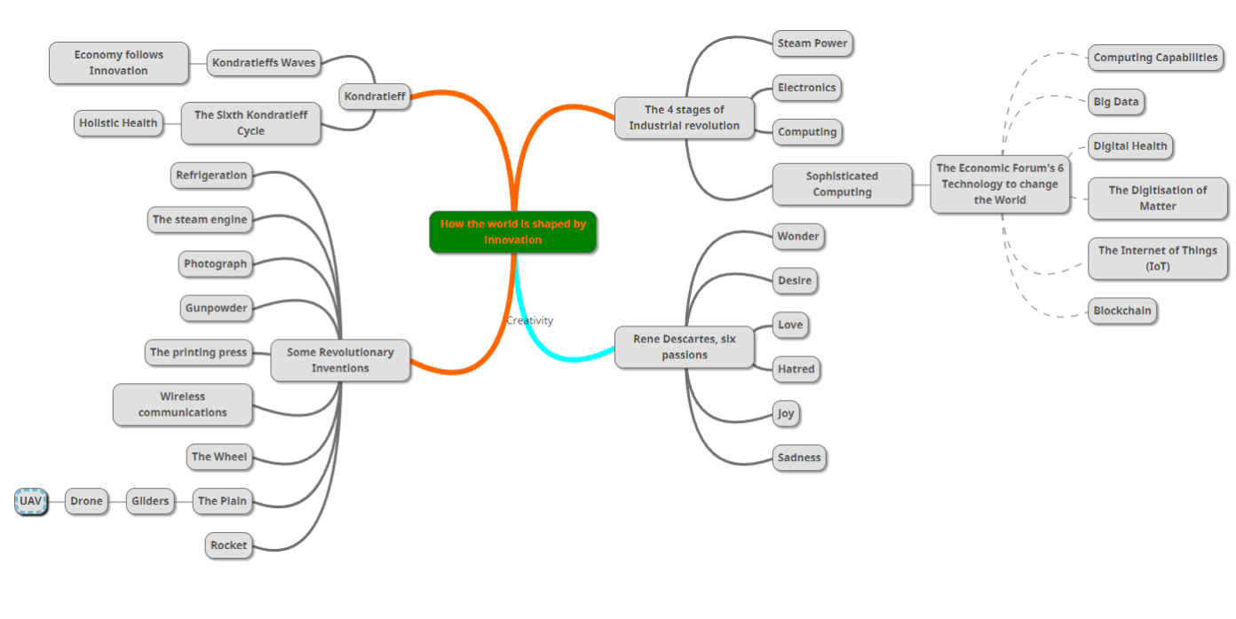

Mined Map 2

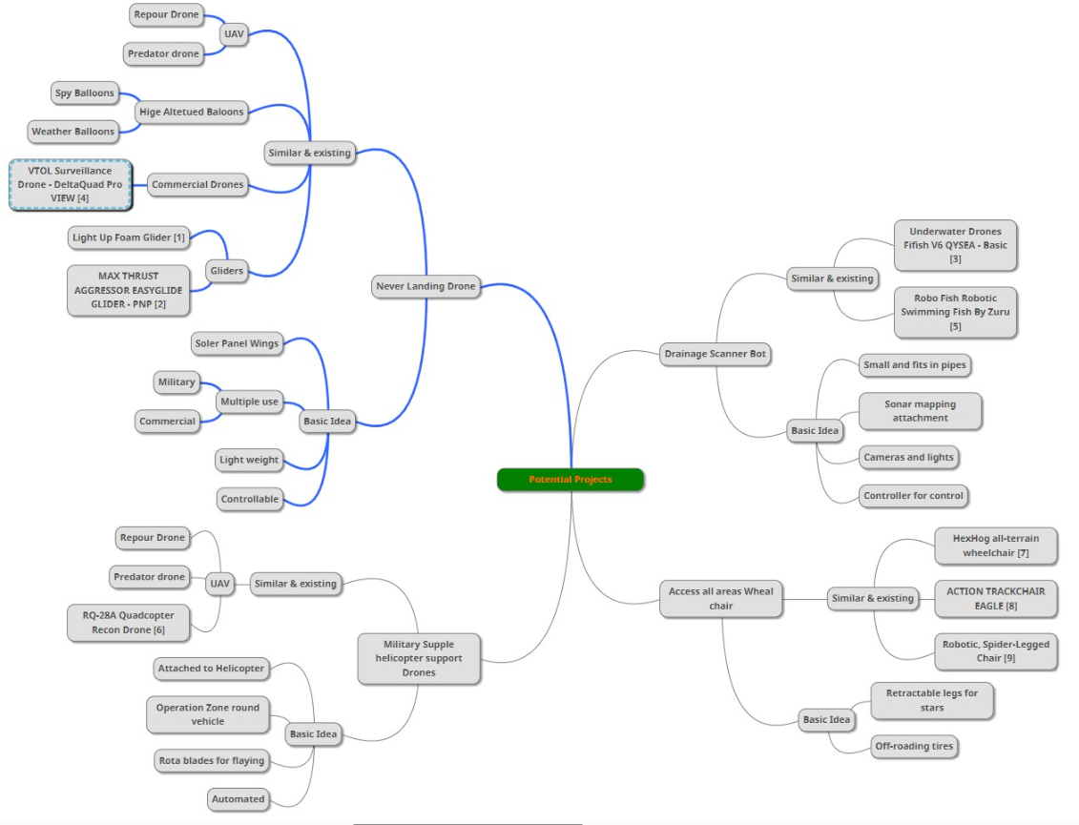

2.0 What’s the Problem

2.1 Research Philosophy

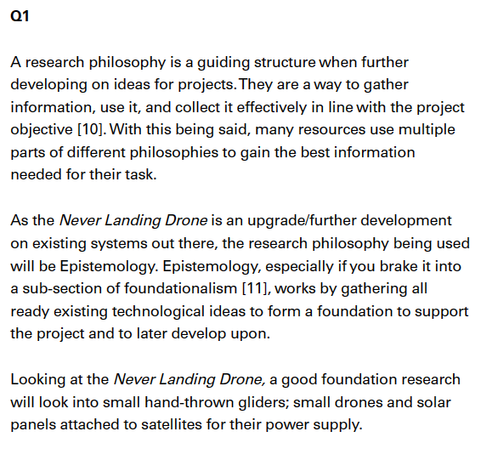

2.2 The Appropriate Databases

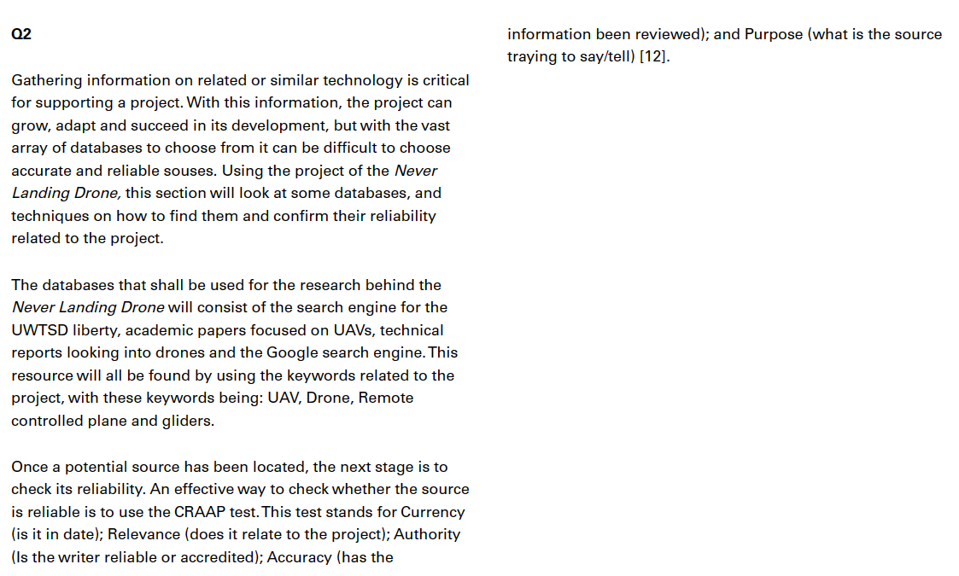

2.3 Research Strategies

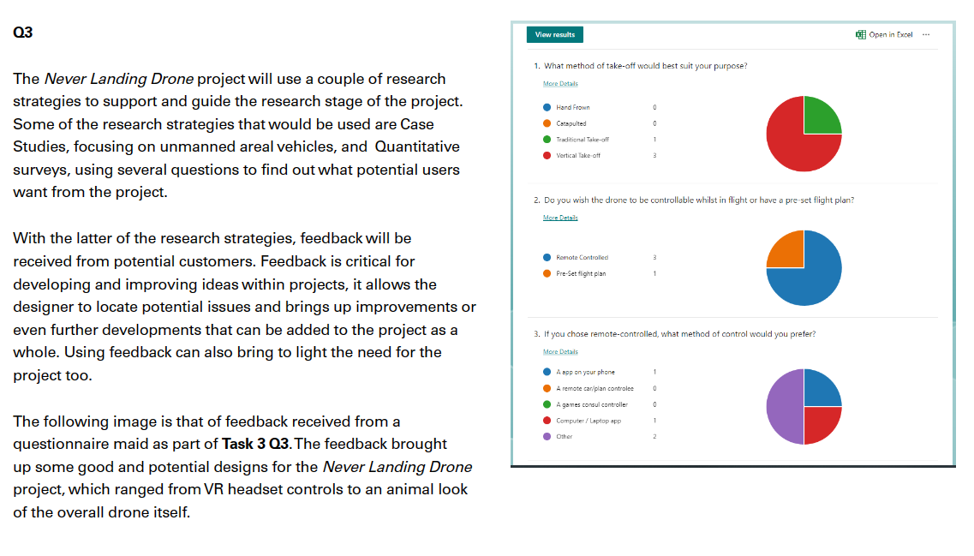

3.0 The Worst Possible Idea

3.1 Quantitative and Qualitative Research

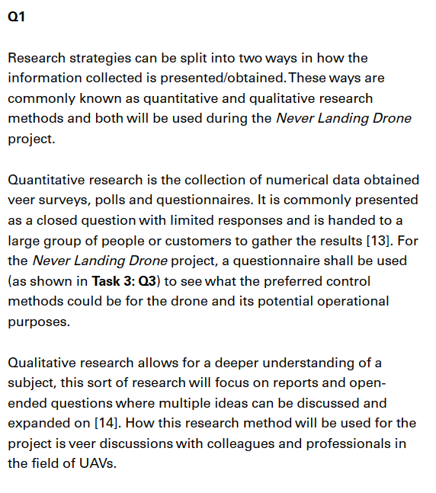

3.2 Identifying Strategies

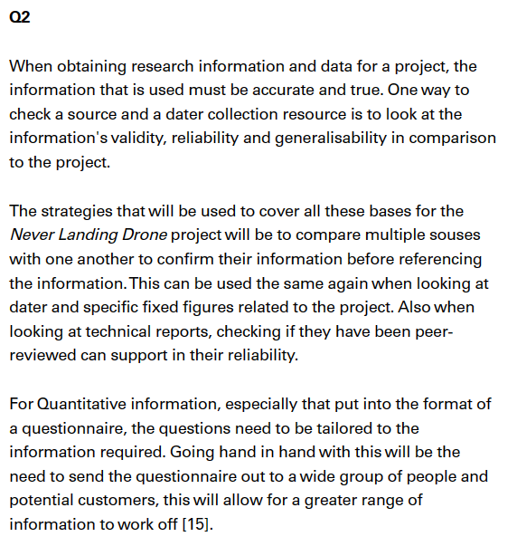

3.3 Questionnaire

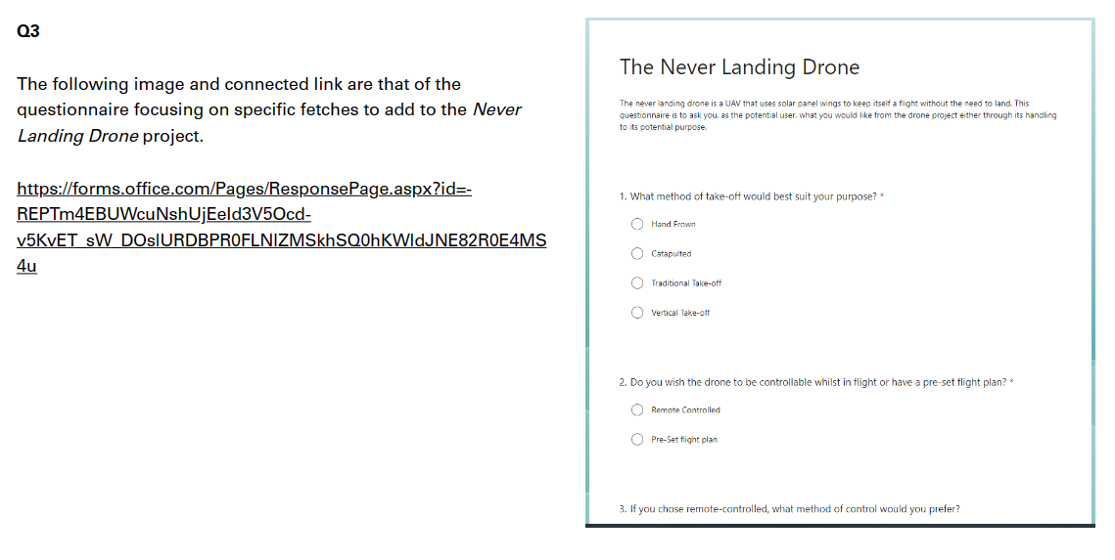

4.0 Presentation Screen Shots

The following screen captures are to prove participation in the presentations found within the UWTSD Moodle page within the change makers module.

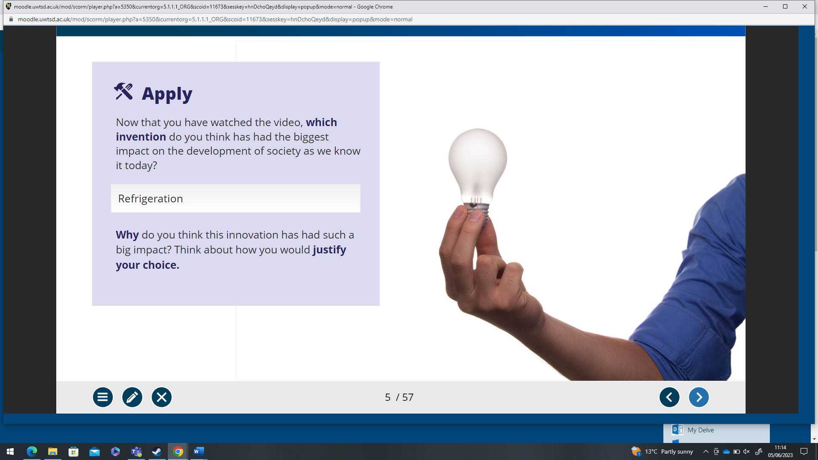
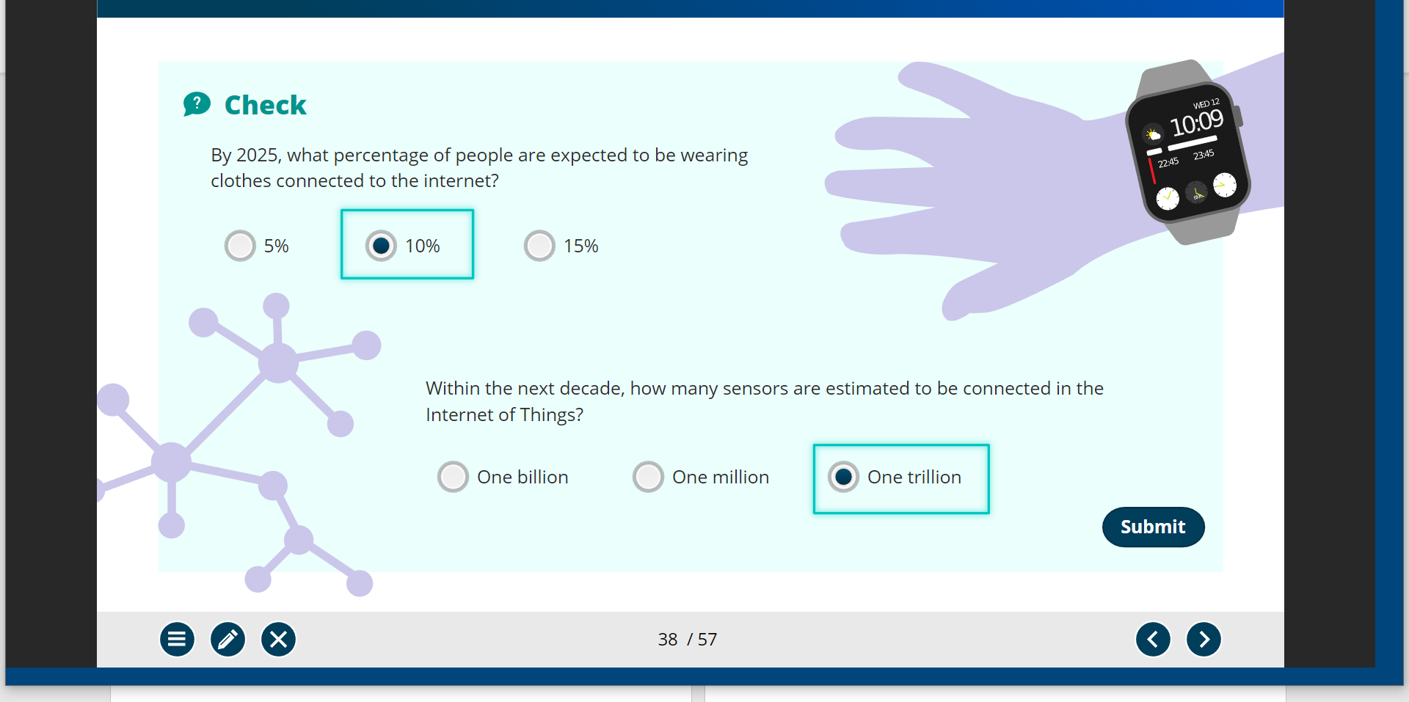
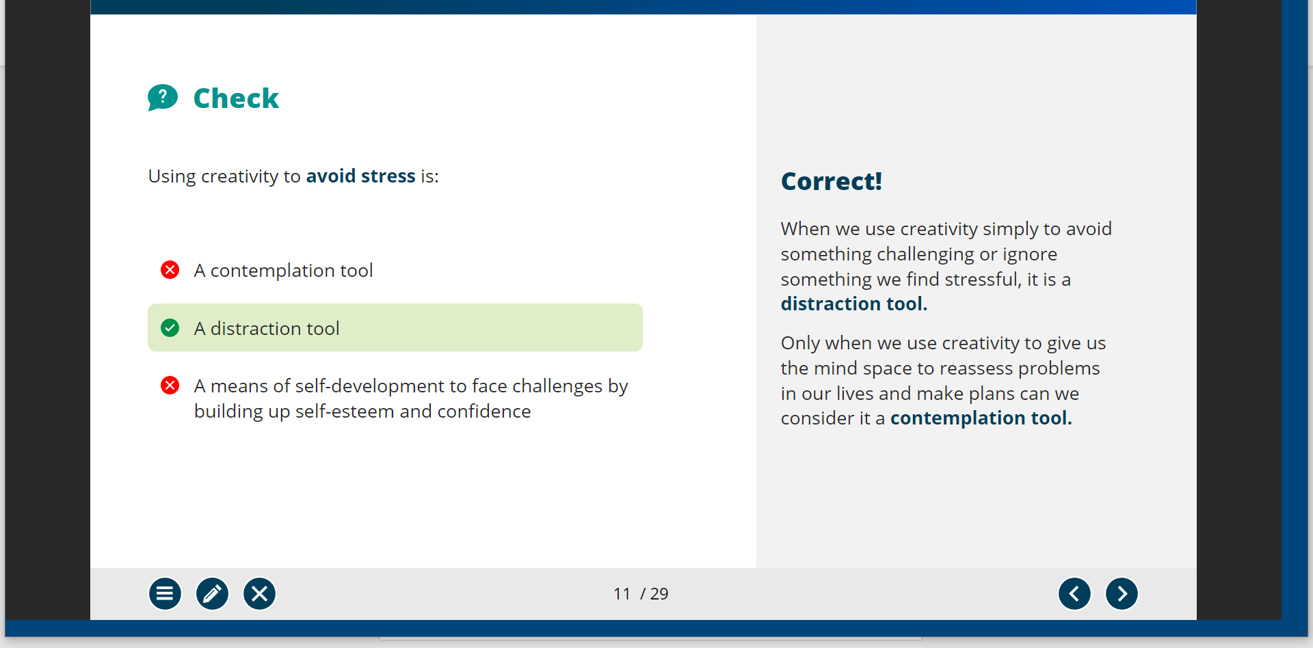
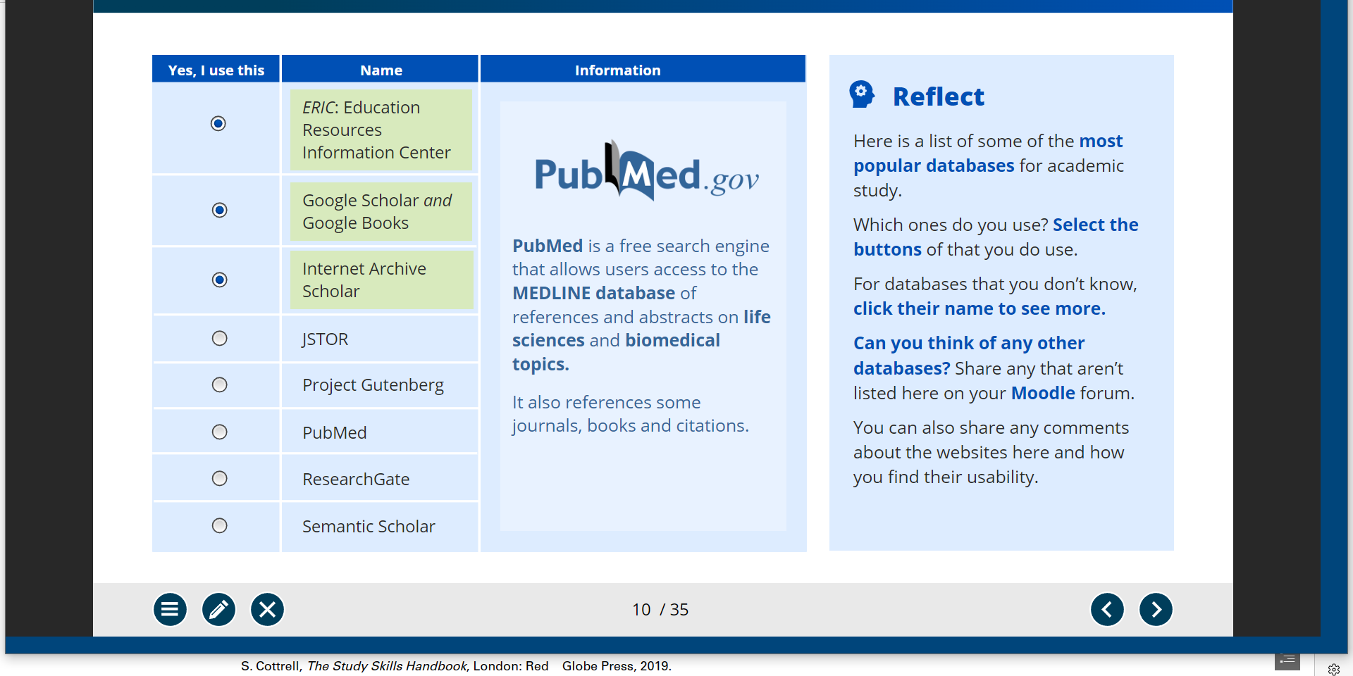
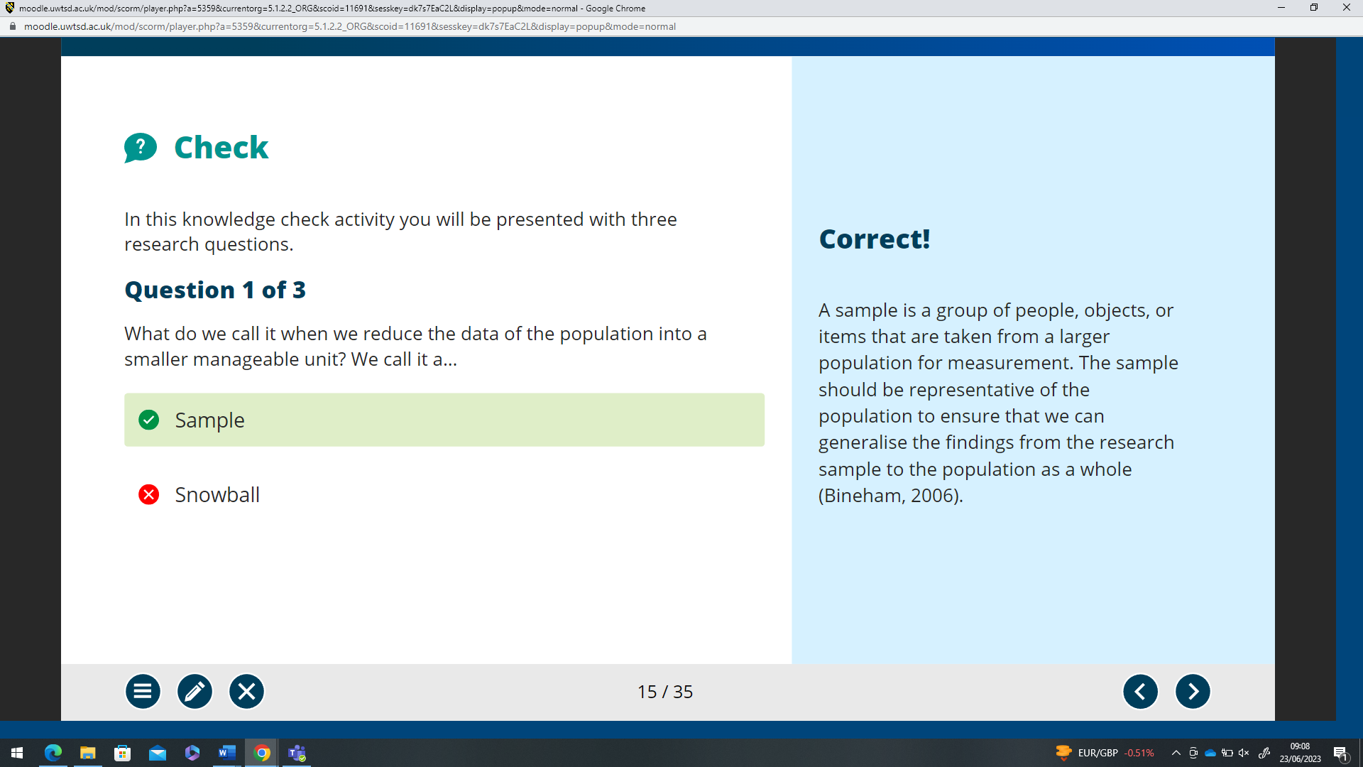
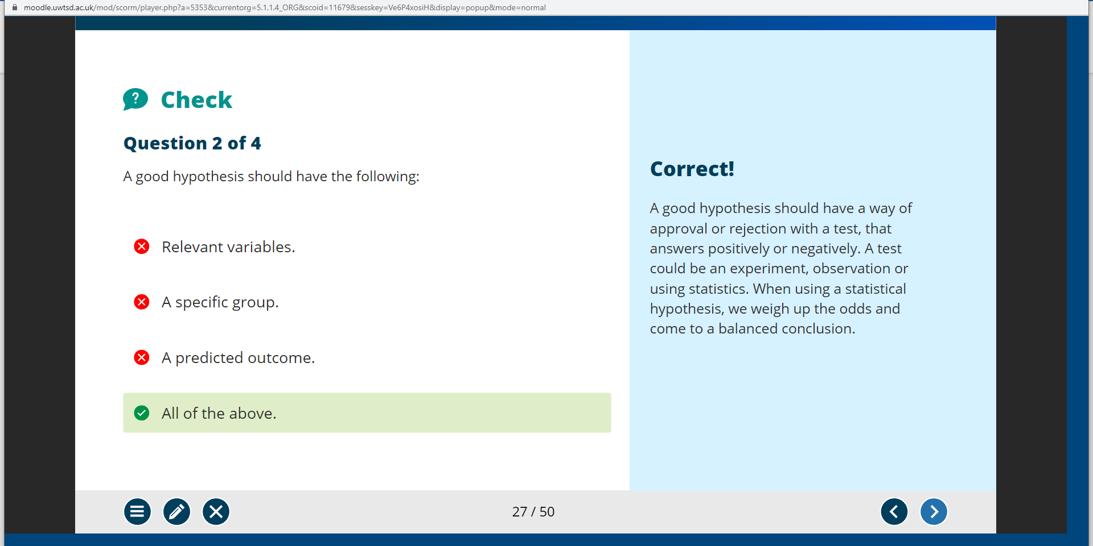
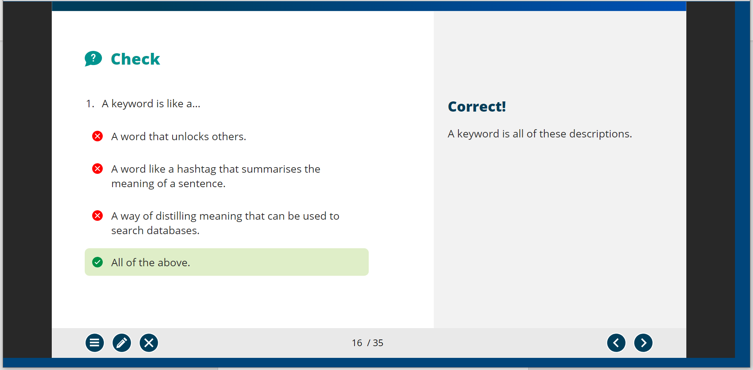
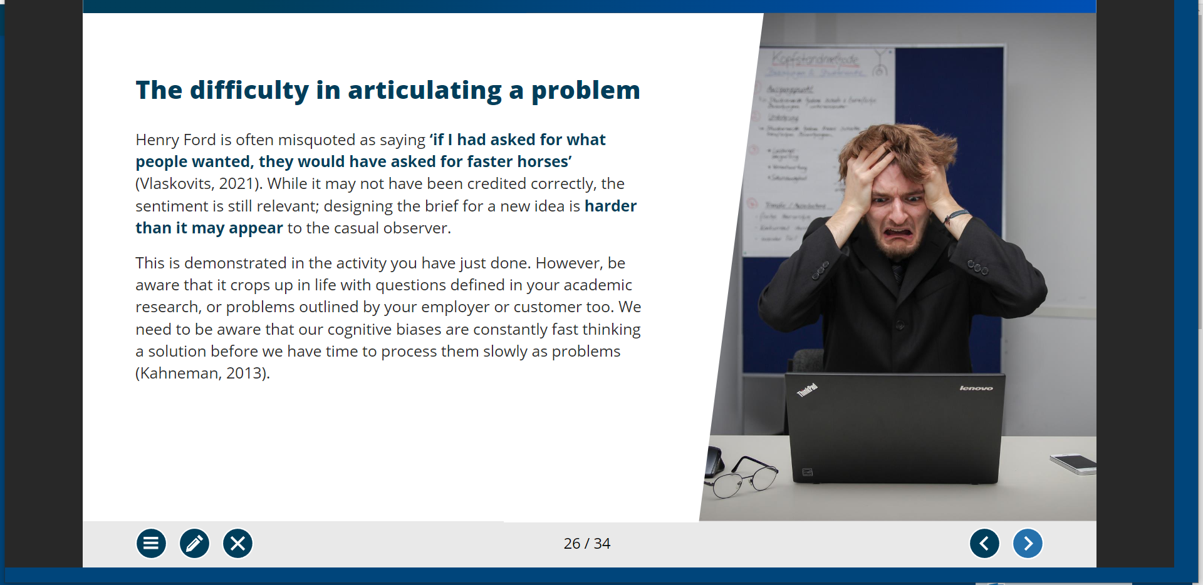
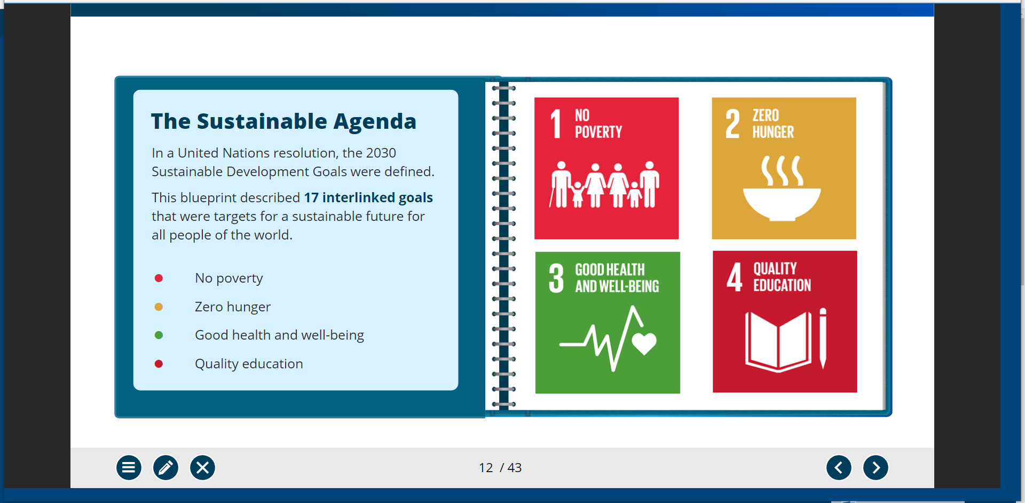
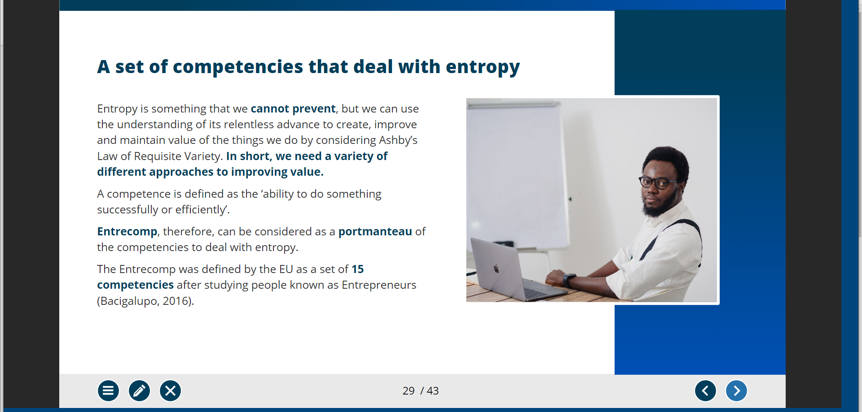

Bibliography

[1]“Light Up Foam Glider: Assorted From 4.00 GBP | The Works,” www.theworks.co.uk. https://www.theworks.co.uk/p/outdoor-toys/light-up-foam-glider-assorted/5052089289437.html?utm_source=google&utm_medium=cpc&utm_campaign=free-clicks&srsltid=AR57-fBRSvWl4O8G3MceLMPilKIpH9l3qI3OaVVuppp0yFFoVCyyiu2a7sQ
[2]“Max Thrust Aggressor Easyglide Glider - PNP,” www.elitemodelsonline.co.uk. https://www.elitemodelsonline.co.uk/Aircraft/By-Manufacturers/Max-Thrust/163053-/Max-Thrust-Aggressor-Easyglide-Glider-PNP?fo_c=3984&fo_k=01613e76fa189ac09a7121015cc61cb8&fo_s=gsuruk&srsltid=AR57-fCxCj68WWqiHBhd_w3282sKZc2busg7iMmQ4Bki9W1LRSu3b2e5vAc
[3]“Underwater Drones Fifish V6 QYSEA - Basic,” Movesea. https://movesea.co.uk/products/underwater-drones-v6?variant=42879816106152&currency=GBP&utm_source=google&utm_medium=organic&utm_campaign=United%20Kingdom-EN&utm_content=Underwater%20Drones%20Fifish%20V6%20QYSEA&utm_source=google&utm_medium=gb&utm_campaign=uw-drones&gad=1&gclid=CjwKCAjw-IWkBhBTEiwA2exyO-LkFXQ4k8YgeGwM_RUwyC4ycdUsynWgcYuDKv8z74k3ruQDL8Fm1xoCtNwQAvD_BwE
[4]V. Technologies, “Long range VTOL surveillance UAV with smart technology | DeltaQuad Pro,” https://www.deltaquad.com/. https://www.deltaquad.com/vtol-drones/view/?src=gm
[5]“Robo Fish Robotic Swimming Fish By Zuru,” Sainsbury’s. https://www.sainsburys.co.uk/gol-ui/product/robo-fish-robotic-star-warsimming-fish-by-zuru?istCompanyId=1e096408-041f-4238-994e-a7cf46bf9413&istFeedId=689af7a8-5842-4d88-be59-1ee5688a81b5&istItemId=iatpmpwmp&istBid=t
[6]E. Helfrich, “Army Fields Its New RQ-28A Quadcopter Recon Drone (Updated),” The Drive, Dec. 07, 2022. https://www.thedrive.com/the-war-zone/army-fields-its-first-u-s-designed-quadcopter-reconnaissance-drone
[7]“HexHog all-terrain wheelchair enters production,” Farmers Weekly, Jun. 30, 2019. https://www.fwi.co.uk/machinery/atvs/hexhog-all-terrain-wheelchair-enters-production
[8]“Action Trackchair EAGLE - Action Trackchair,” May 16, 2022. https://actiontrackchair.com/models/action-trackchair-eagle/
[9]S. Cole, “This Robotic, Spider-Legged Chair Looks Like It Crawled Out of a Supervillain’s Workshop,” Vice, May 24, 2018. https://www.vice.com/en/article/435xz3/strandbeest-wheelchair-burning-man
[10]L. Niada, “LibGuides: Dissertations 4: Methodology: Introduction & Philosophy,” libguides.westminster.ac.uk. https://libguides.westminster.ac.uk/methodology-for-dissertations/introduction#:~:text=Research%20Philosophy&text=It%20is%20belief%20about%20the
[11]“UWTSD Moodle 2022/23: Log in to the site,” moodle.uwtsd.ac.uk. https://moodle.uwtsd.ac.uk/mod/scorm/player.php?a=5351&currentorg=5.1.1.2_ORG&scoid=11675&sesskey=1RftIOaZpp&display=popup&mode=normal
[12]S. Kurpiel, “Research Guides: Evaluating Sources: The CRAAP Test,” researchguides.ben.edu, 2023. https://researchguides.ben.edu/source-evaluation#:~:text=CRAAP%20is%20an%20acronym%20for
[13]R. V. Labaree, “Research Guides: Organizing Your Social Sciences Research Paper: Quantitative Methods,” libguides.usc.edu, 2021. https://libguides.usc.edu/writingguide/quantitative#:~:text=Definition
[14]S. Tenny, J. M. Brannan, and G. D. Brannan, “Qualitative Study,” PubMed, Sep. 18, 2022. https://www.ncbi.nlm.nih.gov/books/NBK470395/#:~:text=Qualitative%20research%20is%20a%20type
[15]L. Leung, “Validity, reliability, and Generalizability in Qualitative Research,” Journal of Family Medicine and Primary Care, vol. 4, no. 3, pp. 324–327, 2015, doi: https://doi.org/10.4103/2249-4863.161306.

