Student Name: Emma Spreadborough
P Number: 2004843
Programme of Study: Photography in the arts Module: Independent Project (ADAA6000)
Word Count: 5930 words

To what extent is identity in Ireland determined by its landscape, and how have photographers explored the relationship between people and land?

Contents
List of Figures Page 3
Introduction Page 4
The importance of Landscape in identity Page 5 - 9
Perceptions of Ireland in the 1100’s Page 10 - 12
Representations of Ireland Page 13 - 19
The Northern Irish Identity Page 20 - 25
What remains In the landscape manifests indoors Page 26 - 33
Conclusion Page 34 - 35
Bibliography Page 36 - 37
Appendix A – Interview with Rebecca O’Flaherty Page 38
Appendix B – Interview with Andrew Johnson Page 39 - 42

List of Figures

Fig 1: The Gathering Ground, Poulson, 2020, Available Via: https://www.abbypoulson.co.uk/the-gathering-ground
Fig 2: Other Lands, Spreadborough, 2021
Fig 3: Other Lands Book, Spreadborough, 2021
Fig 4: Bonfires, Duncan, 2008, Available via: http://www.johnduncan.info
Fig 5: Untitled, Johnson, n.d, Available via: https://www.irishnews.com/arts/2019/08/28/news/belfast-photographer-andrew-johnston-on-documenting-belfast-as-it-is--1695091/
Fig 6: Battle of the Bogside in Derry, Ferraz, Northern Ireland, 1969 https://www.history.com/news/the-troubles-northern-ireland
Fig 7: The Eyes of Gutete Emerita, Jaar, 1996 Available via: https://www.wikiart.org/en/alfredo-jaar/the-rwanda-project-the-eyes-of-gutete-emerita-1996
Fig 8: The Other Side, Doherty, 1986, Available via: https://issuu.com/darragh-kerlin/docs/doherty_unseen_issuu/280 [
Fig 9: Map of Northern Ireland, 2022, Available via:
Fig 10: Clash of Contiguity, Rebeccas O’Flaherty, 2020, Available Via: https://roflaherty7.myportfolio.com/clash-of-contiguity
Fig 11: St. Patricks Well, Belcoo, n.d, Available Via: https://www.irishcentral.com/travel/best-of-ireland/ireland-holy-well
Fig 12: Untitled, Spreadborough
Fig 13: Untitled, Spreadborough
Fig 14: Mnemosyne Atlas, Warburg, n.d Available via: https://artreview.com/how-art-historian-aby-warburg-changed-the-way-we-see/

When one person sees something awful…it will affect how they relate to everyone else, including how they relate to their children, their grandchildren… being parented by people who’ve been traumatised, you are going to be affected by that, even if you’ve never seen anything. Even if they never tell you the stories
(McKee, 2020, p.74)

On reading the writings of Lyra McKee, I began to understand why the matters of Northern Ireland have sat at the forefront of my photographic practice for so long. In an investigation of how the troubles have affected the generation born after the Good Friday Agreement, the phenomena ‘intergenerational transmission of trauma’ was brought up.

As a post-trouble’s baby myself, I have not witnessed the events of that time. However, Northern Irish history still sits at the top of the list of conversations I can’t discuss at the dinner table. This silence behind the recent scars of Ireland have sparked my interest in landscape and its effect on identity.

Within my thesis I explore the discourses of Irish Identity and the colloquial languages which surround Northern Ireland. I have focused primarily on politics and religion in the landscape, the identification of Northern Ireland, and how these things affect the people living there. To understand the importance of identity I will be discussing the effect of projection and representation on how identity is perceived.
- The importance of Landscape within identity

I have begun my exploration of Identity with the importance of context in landscape. The root of the problems in Northern Ireland manifested through the ownership of landscape. This is particularly important to understand in the case of Ireland, as the North’s contested landscape was only properly given the separate name of ‘Northern Ireland’ 100 years ago.

For humans, Identity can come from a range of places, but it is where we live that forms our earliest memories of who we are. Growing up in the countryside on the outskirts of Belfast, my comfort has always been within the identity my parents have raised me in. It wasn’t until I moved from Northern Ireland to Wales for university, that I started to see the impact of environment on my nationality.

‘Nature’ comes into debate as a contested human idea. ‘There is no singular nature as such, only ‘natures’ which are historically, geographically and socially constituted” (Brill, 2012, p. 70). If this is the case, then landscapes sit within human boundaries. The natural space around us has been changed over time into what it is today through human conflicts and invasions. Landscape may seem that it is entirely disconnected from human politics, however it is “political and ideological... a product literally filled with ideologies.” (Brill, 2012, p. 18)
Landscape is constantly changing in the same way that Identity constantly changes, there is no end to this process. These fixed ideas relate to our sense of belonging and nostalgia (Brill, 2012, p. 21). Being attached to these spaces are stopping us from seeing identity as fluid, an incompleteness which is never fully set.
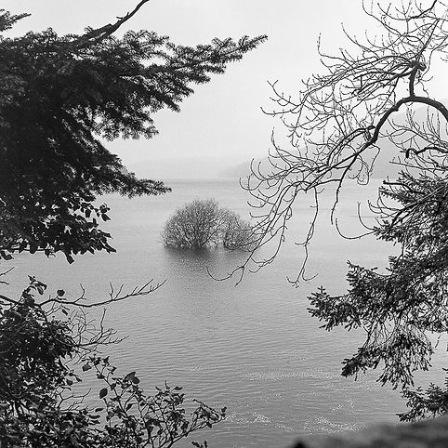

Fig 1

Artist Abby Poulson’s Gathering Ground uses landscape in Wales to rediscover the links between Wales and England. Beginning as an inquiry into the importance of Welsh independence, The Gathering Ground followed the story of a small village that was drowned to make a reservoir supplying water to Liverpool. The Gathering Ground is a poetic approach to the ownership of Welsh water.
“Landscape is not one thing but always multiple and connected relationally to a host of other cultural and political concerns” (Brill, 2012, p. 221). In the same way, when considering this project, it seems that landscape is as much about human impact, as it is the land itself.

Taking a mixed media and archival approach towards the project helps to open more questions around the topic of Welsh water. The use of archives within this project brings the contemporary use of media into the history which inspired the work. When considering progress in my own practice, The Gathering Ground makes me question how tough topics in landscape and history can be approached softly. Artists can easily fall into the cliches of landscape photography when dealing with themes of ownership. In choosing to use Northern Ireland as the background for my photographic work, it is important that I am aware of what contexts Northern Irish landscape sits within. In such a political setting, the landscape of Northern Ireland is bound by pain.

In my own practice, I have found the work of Abby Poulson to be an inspiration. There are many ways that artists can choose to create political work but when an artist is able to create something which subtly marries landscape with history, as Abby does, the viewer is challenged to see the impact of this on the people that we are. Why we think and act the way we do as individuals. Landscape, with all its politics, showcases the complexities of how destructive humans can be.

Other Lands was the first iteration of my investigation into landscape in identity. My research was leading me in the direction of why Northern Ireland was dually recognised as both British and Irish. I was starting to wonder if there was any part of Ireland which could sit between or completely outside of these restrains.

The more that I researched the history in Ireland, the more I began to see Northern Ireland as an alien space. It began to resonate less with me politically.
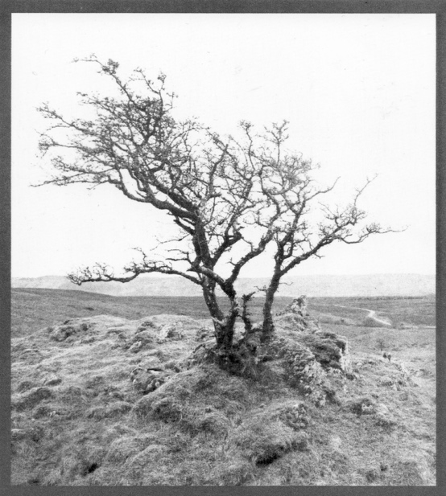
I started to wonder if I was Irish after all or if it was possible to identify outside of the boundaries which confined ‘British’ or ‘Irish’ in Ireland.

Fig 2

After researching the location of the boarder lines in Northern Ireland I found the natural reserve of Cuilcagh, a barren bogland which allowed me to move from North to South with the only indication being through a text message. However, no message is sent to say that you have moved back into Northern Ireland. The lack of knowing which side I was on physically, served as a metaphor for my own questioning during the project.

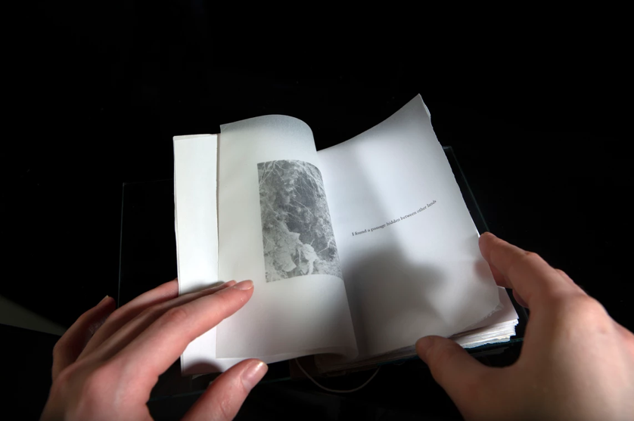

Fig 3

The outcome was a book which was inspired by fragility and used a multitude of materials to mirror this. The enigma of this project was the rhetorical question, if I did not have a phone would it even matter that I had just crossed into the South?

- Perceptions of Ireland in the 1100s

I went to school in a predominantly protestant area and the history I learnt about Ireland was relatively recent. I never fully understood when the conflict began. The ‘troubles’ only began 80 years ago, but Ireland has struggled with bloodshed for centuries. All the years of Irish rebellion were effects of past events caused by England.

In the book Topographica Hibernica, Gerald of Wales writes a report on the Irish landscape and its people (The Blindboy Podcast, 2021). Beginning with Irish land, Gerald of Wales beguiled the English with wonderous tales of green land and never seen animals. After discussing all the beauty in the natural spaces he had seen, his reports turned to documentations of women kissing goats and other explicit accusations.
This book became a reference for how ‘uncivilised’ Ireland was. I will be discussing further these how these representations are affecting the Irish even today, later in this thesis.

By the time Topographica Hibernica was written, St. Patrick had already brought Christianity to Ireland. However, before Saint Patrick’s arrival, Ireland was a predominantly pagan country. After trying to convert the Irish people and realising conversion would not be easy, parts of paganism were picked to move into the fabrication of the church.

Missionaries could not completely eradicate the long-standing belief in a God-like race of fairies, so the myths were manipulated and reinterpreted to enforce Christian ideals but still remain as a concession to early fairy belief systems.
(Schlotterback, 2015)

Many of the Gods in paganism became part of the catholic beliefs. These Gods still exist as saints in the Irish church today.
When the English were made aware of the behaviours described in Topographica Hibernica they called for a reform of the Church in Ireland to bring the Irish back to civilisation (The Blindboy podcast, 2021). Having Christian churches in Ireland intertwined with pagan Gods scared the English as they believed pagan beliefs and rituals were barbaric.

After plantations of Protestism in Ireland during the 16th and 17th century, ‘opposing’ identities started to cause friction. The Catholic Irish were still disliked by the English and the new Protestant settlers in Ireland. These negative connotations of Catholicism spanned from the English dislike of paganism. Even though the accusations written in Typographica Hibernica have long since been forgotten, the impacts of this book run from the 1100’s to today’s Northern Ireland. Identity in the north is still dominated by religious background.

Through my practice, I have been exploring the way in which these perceptions have affected conflictions in identity and nationality. Growing up in a family which identifies as Protestant, I struggled with the friction between my upbringing and Northern Irish politics.

- Representations of Ireland

For this reason, it is important how Identity in Northern Ireland is presented today. I think that the light Northern Irish artists choose to show this country in is especially important. Typographica Hibernica’s revelations came from the fascination of the conflict which occurred in Northern Ireland. Today this same interest has resulted in photographers representing this country through sectarian holidays such as the twelfth of July. This is not representative of the Northern Ireland of the present or future.

Creator of source magazine, John Duncan documented the traditional Twelfth of July Bonfires in Belfast. A protestant tradition which “celebrates the defeat of James Stuart in the Battle of the Boyne” (Lensculture, 2022). His images showcase the urban backgrounds of Belfast alongside the scale and structures of the Bonfires, relating each to unique architectural design.

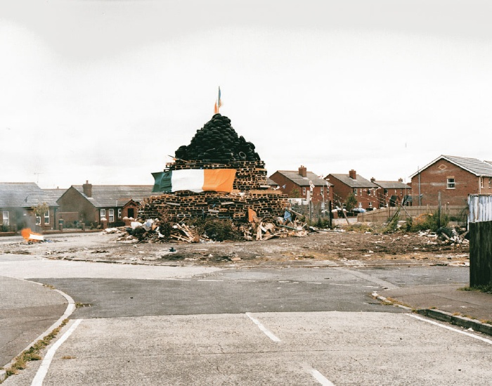

Fig 4

Publishing these images in 2008, he showcased Northern Ireland through the eyes of the destructive behaviour which happens under the name of Protestantism each year.
In The Burden of Representation, Jon Tagg argues that the link between instinct and reality (or phantasy) means that we “have no choice but to work with the reality that we have” (Tagg, p. 4). Discussing this in relation to Camera Lucida where Barthes writes about a reality “one can no longer touch” (Tagg, p. 4). The importance of photography in the modern age becomes more so than it ever has been before. When there are topics that we cannot represent, they cannot be fully articulated, therefore we must be aware of how imagery is perceived when conflict is represented. The history of how Ireland has been represented, especially within the last 100 years, showcasing the Twelfth of July and all the destruction within it, feeds into the idea that Ireland is still barbaric and in need of civilisation. In the 1100’s when Topographica Hibernica was written, there was no way of photographing the Irish, but today during the 21st century so much power is given to the documentation of history.

Andrew Johnson is a Belfast born documentary Photographer who “Documents Belfast as it is” (Bell, 2019). His photographs feature ‘candid’ representations of the people and scenes in Belfast through depth and emotion. Speaking to the Irish Times Johnson said, "I enjoy capturing the authenticity of people and places and really just keeping everything as it is, in that one moment of time." (Bell, 2019)

I interviewed Johnson on 15th November 2022, with some questions about how he uses his photographic practice to see Northern Ireland. In discussing if it is difficult documenting polar-opposite sides of Belfast with a neutral stance, Andrew said:

I have my own views. I know where I stand on certain issues, but I don’t believe it affects my ability to photograph the situation through the lens of reality - although it may affect my interests which can ultimately mean there are some things I photograph more often than others.
(Johnson, 2022)

‘Through the lens of reality’ is an interesting phrase, as it suggests that all depictions he makes of Northern Ireland are set up that way, and not perceived through the eyes of a photographer with certain intent.

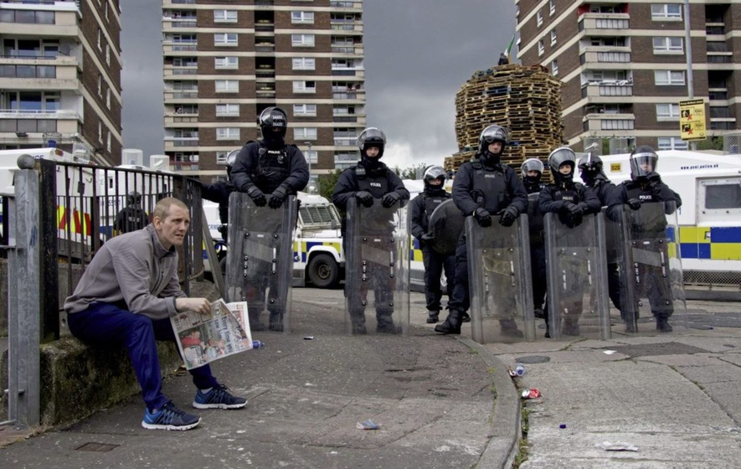

Fig 5

In this image taken by Andrew Johnson, undertones of ‘life as normal in Belfast’ show just how abnormal the ‘normal’ is through the eyes of photographers. In this photo the police stand waiting to intercede a procession where a seemingly unfazed man is reading a newspaper.
Whether a certain juxtaposing scene is laid out as in this photo, or not, there is still an element of the story the photographer is trying to tell.

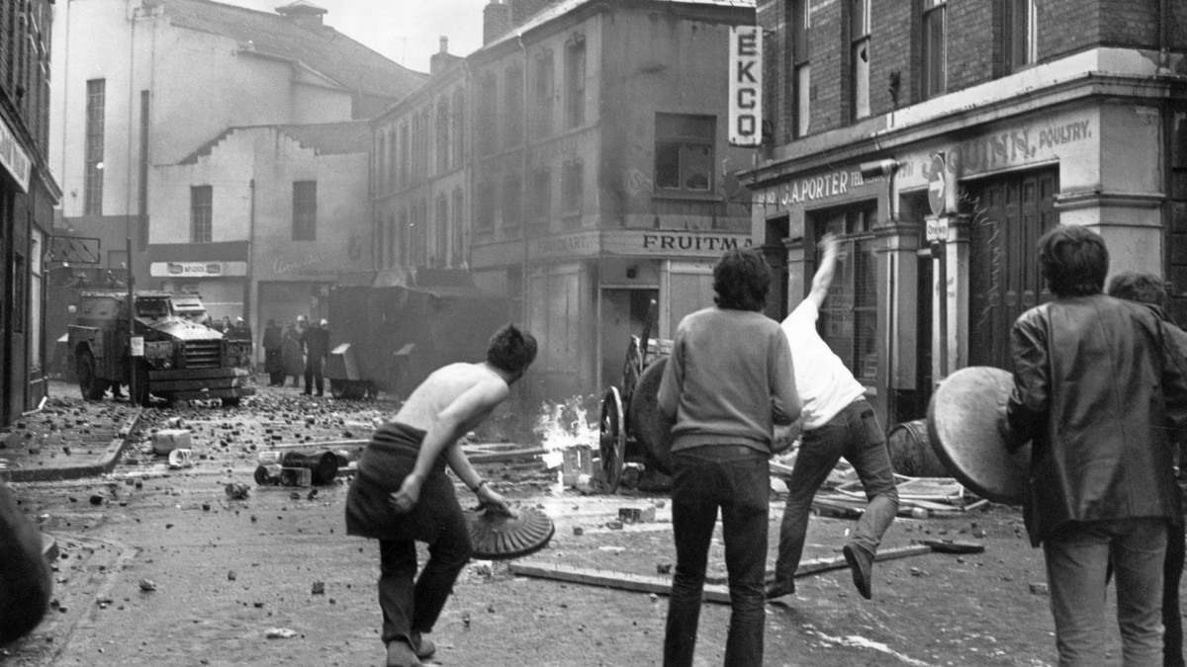

Fig 6

When Northern Ireland came to the height of the troubles, news reports shot to UK TV of the horrors which were happening across the water. Reporters coming to the North saw the war through eyes which could not fully contemplate the years of history which led to the rebellion. The destruction of the troubles had been building since the first English invasion of Ireland in 1169 (Barnes, 2022). During the troubles, it was important how the Irish were portrayed. The fear coming from the television showcased the Irish as barbaric once again. These depictions of war within photography have had massive implications on the marginalised.

Photography has documented the destruction of conflict for decades. However, one of history’s worst events was showcased horrifically through photographs. This was the Rwandan Genocide of 1994. During the genocide (Strauss, 2005, p. 81) newspapers showcased harrowing images of bloodshed: “Rwanda: The name now calls forth a flood of images- corpses clogging the Kagera River, bloated and bleached white” (Strauss, 2005, p79). This form of photography was widely accepted and marvelled at without action (Strauss, 2005, pg 81). Leaving the question can photographs of war cause any good for the oppressed? Thinking around the parameters of showcasing grief to the rest of the world, artist Alfredo Jaar concluded that this emotion was ineffable and could not be articulated - even within photography.

To combat representation of Rwanda’s horror, Jaar photographed the eyes of a woman that witnessed these horrors first hand. This image was replicated 100,000 times as colour photo slides sat on a light box, alongside the words ‘I remember her eyes. The eyes of Gutete Emerita’ (Wikiart, 2016).

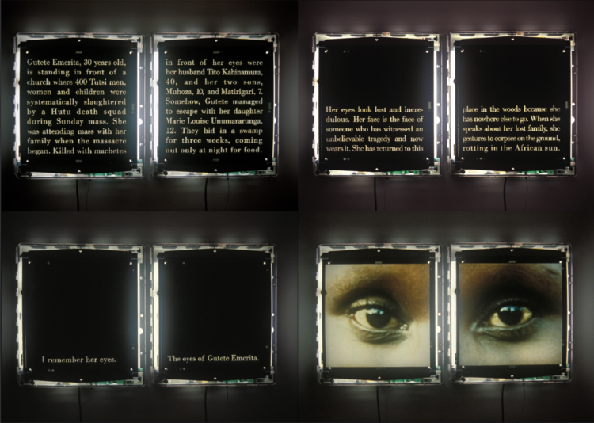

Fig 7

In Alfredo Jaar’s 2014 interview with Musee, the interviewer brought up a quote by Susan Sontag “Literature can train, and exercise, our ability to weep for those who are not us.”. Jaar responded saying that photography couldn’t be trusted in the wake of an event such as a genocide, but even words would not do it justice.

I started using more text and less images. I distrusted photography’s capacity to affect change in the wake of the genocide. But words failed me too. As Adrienne Rich wrote, “tonight no poetry will serve”
(Musee, 2014)

Silence was feeding the problem, leaving Jaar with the unsolvable question, “How do you make art out of information that people would rather ignore?” (Musee, 2014)

Although the horrors of a genocide cannot be compared to the troubles in Northern Ireland, there are lessons which photographers can take from Jaar’s approach of representing a country and its identity.

Jarr’s photography is completely different to that of Andrew Johnston, who uses a more direct form of imagery. Both photographers deal with the issues of heavy topics, but Alfredo Jaar has found a way around the topics which Tagg suggests can’t be fully articulated. Although Johnson’s images have value for historical documentation, I feel that they bring Northern Ireland back to the troubles, when the same style of images were being produced. It is worrying that now, nearly 25 years on, the same poignant images are being created.

- The Northern Irish Identity

In this year’s census review, it was revealed that there has been a shift with how today’s generation identify in Northern Ireland. For the first time in 100 years more people identified as Catholic than Protestant (McClements, 2022). This was a majorly significant revelation because it compromises Northern Ireland’s British majority (McClements, 2022). The results of the census came just after the 2022 election, which saw Sinn Fein become first minister over the unionist DUP party.

In this census it was revealed that the number of people politically identifying as ‘Northern Irish’ dropped from 21% in 2011 to 19.78% in 2021 (@tanistry,2022). Despite this seeming like a small decline, it shows that fewer people are seeing Northern Ireland as representative of their values politically. However, this has made me question what it means to ‘politically identify’ as ‘Northern Irish’.
Alternative Ulsters by Mark Carruthers suggests that identifying as Northern Irish means that you have faith in the development and stability of a future there:

When I tick a box that says I am Northern Irish, I am saying that my strongest identification is with this region and its people and that I want political stability here in a Northern Ireland that is connected to Ireland, Britain, and Europe. I am saying that I see a decent prospect of that being achievable and that I put my political hopes in that future.
(Carruthers, p. 9)
This same idea was also brought up by photographer Andrew Johnson when I asked him if he thought that political issues in Northern Ireland still affects the way we discuss the identity of Northern Ireland:

I think there’s an emerging Northern Irish identity. This is something people can find common ground with. People recognise that this place is unique – it’s different from the Republic of Ireland and it’s different from the rest of the United Kingdom. Maybe that’s a possible solution to the age-old problem?
(Johnson, 2022)

In Alternative Ulsters, Mark Carruthers discusses Britain, Ulster, and Ireland through interviews with some of Ireland’s most infamous figures. The term Ulster refers to the province also known as Northern Ireland, but there are discussions that this is a location name which is bias towards Britain. “Ulster teems with apparent contradictions. It is Irish and it is British” (Carruthers, 2013, p.8). Carruthers starts the interviews with an introduction in which he mentions that Ulster is where “identity tends to form a great deal of the day-to-day civic debate” (Carruthers, 2013, p.8). It is not a surprise that there should be such a confusion around identity as unity does not yet exist within Stormont. Even the very foundations of the political system are split between a first and second minister, who are polarly opposed in their politics.

Through an interview with Gerry Adams, the ex leader of Sinn Fein said he doesn’t associate as fondly with the term Ulster, as Ireland. “I wouldn’t say I was an Ulsterman; I would say I was Irish first of all” (Carruthers, 2013, p. 15). When asked about his connections with the word Ulster, Adams said “I don’t have any hang ups about Ulster. I have a greater hang up about Northern Ireland” (Carruthers, 2013, p.16). To Gerry Adams, ‘Northern Ireland’ is more politically British than ‘Ulster’ is. These small changes in languages are the eggshells which Ireland walks on.

Asking a similar question to Ian Paisley, Carruthers was told “I would never deny I was an Irishman” he continued saying, “before Northern Ireland, we were Irish unionists”. (Carruthers, p. 32) To Ian Paisley, there is a difference between Republican and Irish. He sees a duality in Irish identity within Unionism. For Gerry Adams, however this is not the case. There seems to be no separation between Ulster and Britain.

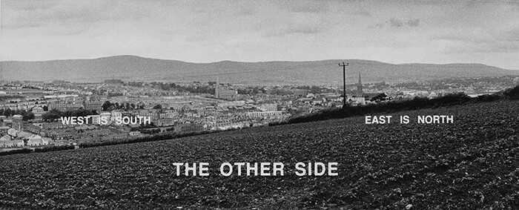
Fig 8

The photography of Willie Doherty incorporates language in a similar way. Doherty uses ominous words to overlay his contrasted images. Marrying these words with the landscape shows just how linked the two have become. West is South, East is North, is connected to the discomfort in speech. Even today these same colloquial phrases are dividing. The Other Side depicts the boarder in Derry, where both Northern and Southern Ireland are divided by an invisible boarder. Putting text on either side of the image seems to have a correlation between how far one area sits politically from the other.

Even the name ‘Derry’ is opinionated. There is division over whether Derry should still be called ‘Londonderry’ today. It wasn’t until 1613 that King James I added the prefix to create the name Londonderry but it still causes debate. For this reason of dual identity, Derry has been a particularly troubled area throughout the past 100 years of Northern Ireland’s existence.

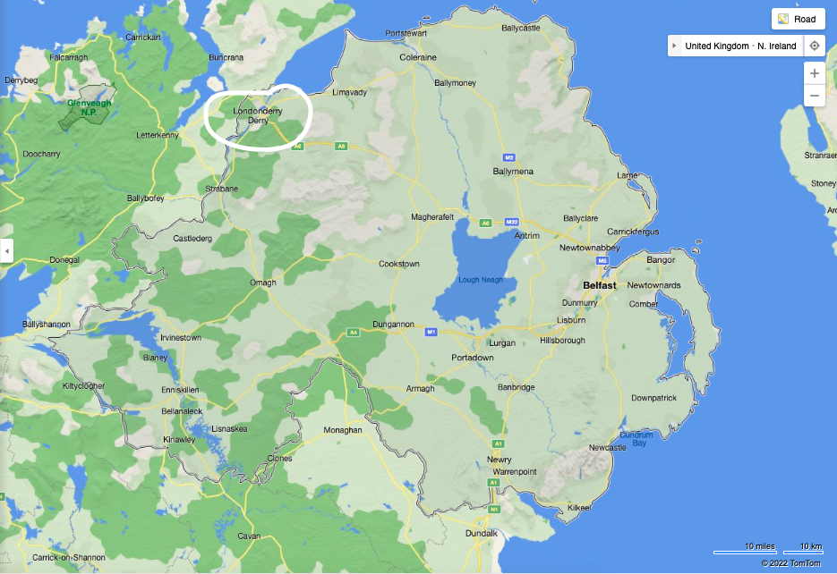

Fig 9

During Gerry Adams’ Interview, Adams mentions how his three-year-old granddaughter discusses Northern Ireland: “‘Am I not English?’I said, ‘No, you’re Irish’. And she says, ‘Am I not just Irish when we go to Donegal?’”. These same confusions are bleeding into even the youngest of generations within Northern Ireland.

The new Wave of artists growing up in Northern Ireland are challenging the constructs of Northern Irish Identity. Ulster university graduate Rebecca O’Flaherty uses photography as a tool for documenting performance.
I interviewed O’Flaherty on her art practice.
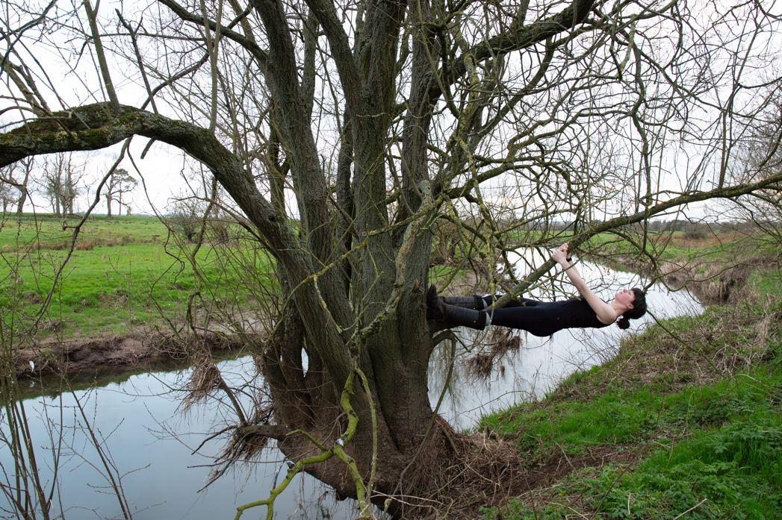

Fig 10

Clash of Contiguality was created as a response to the Brexit riots that began in 2021. When discussing her work, Rebecca mentioned the reports of police arresting two young people aged thirteen and fourteen during this time:

Seeing all them young children out bombing places and bombing the buses. What the hell? They're younger than me. Or they’re my age and I don't understand it. So how? How did they get their heads around that.
(O’Flaherty, 2022)

These riots brought the crisis back to the younger generations in loyalist areas of Belfast.

O’Flaherty recalled the same experiences as Adams in Alternative Ulsters, when she was growing up, she also knew about the boarders and certain areas of Northern Ireland where her Nationality was ‘English’ and other areas where it was ‘Irish’.

I was brought up and we lived on our own so if you went to certain place, you said you were from here. You didn’t tell people what your surname was encase something happened
(O’Flaherty, 2022)

Rebecca is only 22, but she has still grown up with tensions around something as trivial as her surname.

- What remains in the Landscape manifests indoors too

If landscape is ‘political and ideological... a product literally filled with ideologies’ (Bril, 2012, p. 18) according to Memory and Landscape, then the landscape of Ireland must still have the remnants of early Irish histories must still be existent in Irish landscape today. This includes the pagan past.

As my photographic project begins to move past the recent history of boundary lines, searching for traces of the supernatural have begun to sit at the forefront of my investigations. As the landscape of Ireland has influence on political identity, it also derived from an earlier friction.

Before the friction between Protestant and Catholic in Ireland, the Irish were living in their own spiritual world. By 500AD, Christianity had already reached Ireland but the conversion of Ireland to Christianity did not erase the pagan belief completely,
“In Irish Christianity, belief in independent spiritual beings was never completely disregarded, but was changed to a belief in folklore.” (Fusion, 2015). This belief in folklore derived from original pagan beliefs.
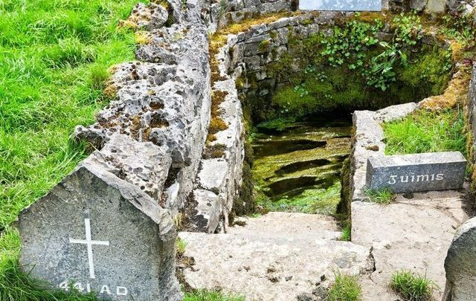

Fig 11

This transition also happened in the landscape, through historical sites. For instance, St. Patrick’s well in Belcoo was originally a pagan altar for Crom Dubh, the Pagan God of harvests. This site was ‘converted’ when it was given its new Christian name. This shows that the landscape still holds essence of some contexts which were assigned to it from before the writing of Typographica Hibernica.

The importance of the land and its connection to the myths of Ireland can be found in Listen to the Land Speak. Magan writes about how the maps of Ireland existed in the minds of the Irish, “passed down through mythology” (Magan, 2022, p.141). So Irish territory was known through its connection to the ancient stories rather than boundary lines, as it is today.

My personal investigation into the spiritual landscape began as a summer project which spanned the North and South of Ireland. My main mission was to investigate why the North seems to have less of the pagan traces which are existent in the south of Ireland. Through my research, I started to see that pagan ideology in the North has been covered over by the troubles.
What I found in the South of Ireland was completely different.
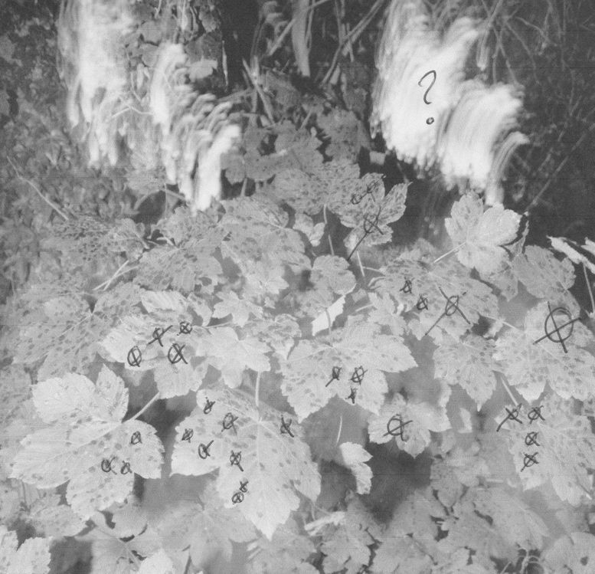

Fig 12

When photographing the South, I worked nearly entirely with film. As I had been investigating the traces of what still exists in the historical landscape, I wanted to use a media which also in itself was a trace. Analogue photography becomes a documentation of the light which has had contact onto the film. In experimenting with the magic of this media, I knew that if I was to use digital, I would not achieve similar qualities with the physicality or colours.
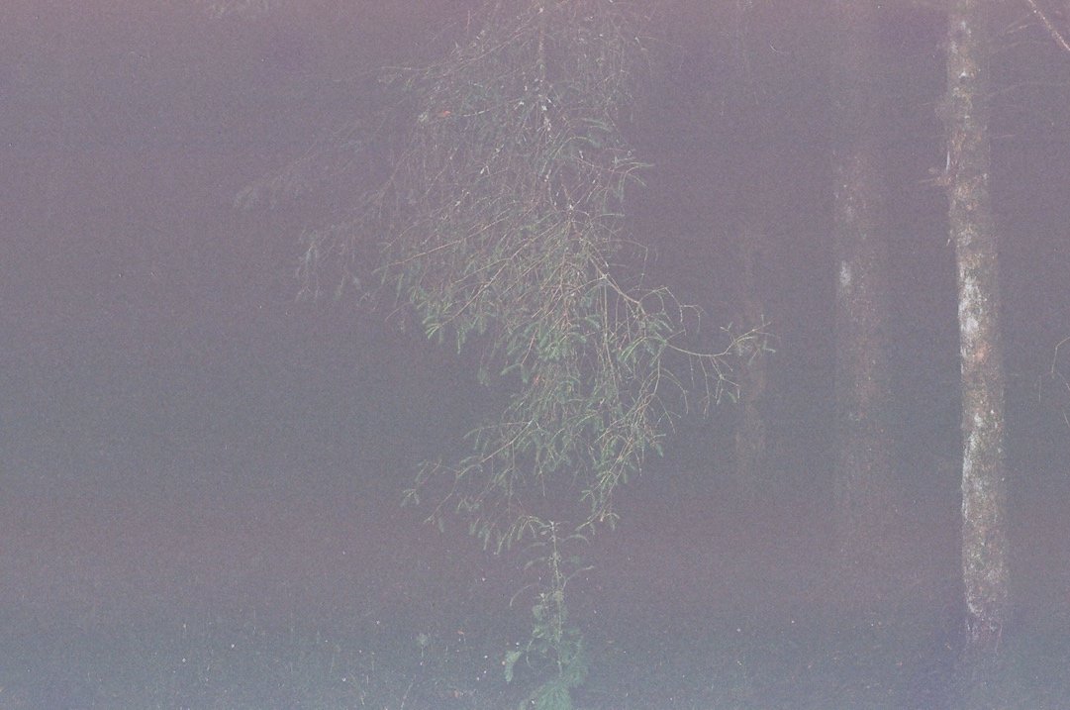

Fig 13

The developed images had a supernatural quality to them. In this image the camera was able to capture a magical essence which I could not see with my own eyes.
Alongside these images I was having discussions with the Irish people who were living in Sligo and telling them about my project idea. At the time I was searching for evidence of Irish Faeries. I had more than one conversation where I was told not to go looking for them.
In Southern Ireland there is still a fear that anybody who angers the faeries can be cursed.

The battle between Christianity and Paganism in Ireland was not just in the landscape but also in the home space. Dancing at Lughnasa, an Irish play set after the Catholic imperialism in Ireland talks about the issues that occur in a devout Catholic home. The duality of beliefs in this play also cannot co-exist in identities. Friel uses themes of Christianity and Spiritualism to contrast each other as sensibility and fantasy. Despite it’s setting in the world of the 1930’s, there are still frictions between religion and paganism, just as was in the 1100’s. This is not far removed from the confinements of religion in Northern Ireland today, where anything outside of the two political groups is frowned upon.

Within this play, the Mundy sisters are told by their eldest sister Kate that they mustn’t become involved in the pagan festival of Lughnasa. Eventually the confinement of Christianity on the family causes the sisters to break and move away from each other. Pagan desires are referred to as ‘fever’, a sickness which is behind the cracks forming in the sister’s lives. In Ireland today, the cloak of religion has caused issues for the Irish language and folklore. It seems that both Christianity and Lore are still conflicted.

Looking at this play from the context of its creation in 1990, with the troubles still ongoing in Northern Ireland, I think that Brian Friel is trying to say more about the troubles than the 1930’s. Could it be that through looking outside of religion that Northern Ireland can see a free space, like paganism opened within Dancing at Lughnasa? Is there an equivalent in politics that can break out of those boundaries and bring a new perspective to the confinements of ‘Protestant or Catholic?’ I think that through a new generation who are working to make Northern Ireland more than two set identities there is hope of change.

In the development of work which I have created in the past, Dancing at Lughnasa has been an inspiration to me. Looking at my own family’s dynamic, Christian values have overshadowed a lot of the conversations about Ireland which we don’t discuss at the dinner table. However, the undertone of paganism still exists as part of Irish Christianity, both are co-existing within each other.

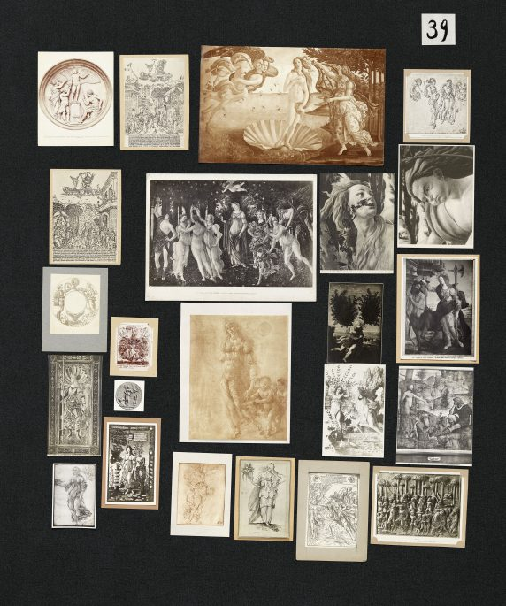
Looking at the history of paganism in Christianity, Aby Warberg’s Mnemosyne Atlas studies the “function of collective memory” through the “civilisation of pagan antiquity as a constant” (Kalkstein, 2022). During the renaissance movement, there was imagery taken from paganism to make Christian, Warberg created each panel to portray the polarities between Renaissance art and the “afterlife of pagan symbolism” (Rappolt, 2021).

Fig 14

Using a series of black fabric boards and image arrangements, Mnemosyne Atlas changed in many iterations, which included more than 2,000 images throughout the time Warburg worked on it (Johnson, 2012, p.10). The panels were memory spaces with ‘syncretic vision of the afterlife of pagan symbolism and cosmography in medieval, Renaissance, and post-Renaissance art and thought’ (Johnson, 2012, p.10).

In my own art practice, I have been trying to link the mystic to the Christian history of Ireland. Even in art history, Christian art has derived from pagan ideals, this is showcased in Aby Warburg’s Mnemosyne Atlas. Understanding some of the shared identity between paganism and Christianity, within art context, drew some parallels with the research that I had been doing regarding Irish Christianity and it’s links to Ireland’s pagan landscape. Warburg managed to display this in a way which follows complex themes that all weave into each other, his work took the form of investigation. I am also trying to investigate, however the themes I have chosen all fall under Ireland but encapsulate identity, religion, history, and politics.
While conducting my research I have focused mainly on identity in Ireland but as I have been concluding my thesis, I have seen how Mnemosyne Atlas shows that all histories are collective and complexly intertwined.

The topics I have discussed throughout my thesis are also complexly linked. However, while describing my practice, I have noticed that the themes surrounding Northern Ireland do link to each other. It is through my experiences in the country I have been brought up in that I have started to connect histories with themes of landscape and identity.

Conclusion
When discussing Irish Identity in relation to land, there are a multitude of factors which come into the language used. From discussions around whether ‘Derry’ should still be named ‘Londonderry’ and the emerging change in the number of citizens identifying under ‘unionist’ and ‘republican’.

The recent politics which caused the troubles are still affecting families and the young generation of Ireland. As discussed at the start of my thesis, there are still conversations which need to be had.

As I have researched the origins Northern Irish Identity, I have seen how politics have affected the boundaries of the landscape. In discussions I have had with young artists who are making work around themes of the North of Ireland, I heard a mixture of opinions on how life in Northern Ireland has affected their photographic outlook.
In an interview with Andrew Johnson, Johnson spoke about how he finds comfort in the Northern Irish nationality, but my research has brought me to a point of wondering if there will be such thing as ‘Northern Ireland’ years from now. Can this identity be solid with the possibility of a united Ireland?

In my art practice I have been through a journey of trying to understand how boundaries have affected me in my family life and throughout my childhood. I have used the Northern and Southern landscape of Ireland to question where my own identity lies. In Other Lands landscape gave me the opportunity to freely explore this.
The conclusion which I came to in Other Lands was that I could be neutral towards politics. If there are spaces of Ireland which can be unidentifiable as one place or the other then I could also live outside of the two camps existing in Northern Ireland.
To an extent I believe that Irish Identity can go beyond politics. Therefore my interest lay with the landscape. There is something very interesting in how the landscape boundaries in Northern Ireland were sculpted by humans but still manage to hold the magic of a pre-conflicted Ireland, in a time before English invasion. This is why today my art practice has shifted from the conflicted landscape to searching for pointers of identity through the pre-Christian landscape.

Landscape and Identity in Northern Ireland will always be a tricky topic, but it is up to the next generation to decide that they can be outside of the camps which hold this country in the past.

Bibliography

Websites

Art Agenda Reviews (2013) Willie Doherty’s “Unseen”
September 27, 2013–January 4, 2014 [online] Available at:
https://www.art-agenda.com/criticism/235230/willie-doherty-s-unseen
Barnes, D (2022) WHEN DID BRITISH INVADE IRELAND? [online] Available at:
https://theuseoffurnitureanditsfeatures.com/qa/when-did-british-invade-ireland.html
Bell, G (2019) Belfast photographer Andrew Johnston on 'documenting Belfast as it is' [online] Available at:
https://www.irishnews.com/arts/2019/08/28/news/belfast-photographer-andrew-johnston-on-documenting-belfast-as-it-is--1695091/
Britannica (2022) Londonderry, Northern Ireland, United Kingdom [online] Available at:
https://www.britannica.com/place/Londonderry-city-and-district-Northern-Ireland
Foster, W (2021) Capturing the Essence with Abby Poulson [online] Available at:
https://www.pupilsphere.co.uk/home/capturing-the-essence-with-abby-poulson
Fusion (2015) The Pagan And The Priest: An Inquiry Into The Religious Colonization Of Ireland [online] Available at:
https://www.fusionmagazine.org/the-pagan-and-the-priest-an-inquiry-into-the-religious-colonization-of-ireland/#:~:text=The%20Catholic%20church%2C%20which%20appropriated%20these%20images%20to,values%20footed%20in%20moderation%2C%20humility%20and%20personal%20restraint
Irish History Podcast (2011) Saints, Scholars and Pagans? The impact of Paganism on Medieval Irish Christianity [online] Available at:
https://irishhistorypodcast.ie/saints-scholars-and-pagans-the-impact-of-paganism-on-medieval-irish-christianity/#:~:text=Saints%2C%20Scholars%20and%20Pagans%3F%20The%20impact%20of%20Paganism,Christianity%20Published%20March%2030%2C%202011%20in%20Medieval%20History
John Duncan (n.d) John Duncan: Bonfires [online] Available at:
http://www.johnduncan.info
Lensculture (2022) Bonfires by John Duncan [online] Available at:
https://www.lensculture.com/books/10289-bonfires
McClements, F (2022). Northern Ireland census: Another psychological blow for unionism [online] Available at:
https://www.irishtimes.com/ireland/social-affairs/2022/09/22/northern-ireland-census-results-analysis/
Rappolt, M (2021) How Art Historian Aby Warburg Changed the Way We See [online] Available at:
https://artreview.com/how-art-historian-aby-warburg-changed-the-way-we-see/
Rutgers Art Review (2022) “Aby Warburg’s Mnemosyne Atlas: On Photography, Archives, and the Afterlife of Images,” by Molly Kalkstein [online] Available at: https://rar.rutgers.edu/aby-warburgs-mnemosyne-atlas/
SuperSummary (n.d) Dancing at Lughnasa [online] Available at: https://www.supersummary.com/dancing-at-lughnasa/themes/
The Walberg Institute (n.d) Aby Warburg Bilderatlas Mnemosyne Virtual Exhibition [online] Available at:
https://warburg.sas.ac.uk/aby-warburg-bilderatlas-mnemosyne-virtual-exhibition
Thompson, M (2010) Britain's propaganda war during the Troubles [online] Available at:
http://news.bbc.co.uk/1/hi/uk/8577087.stm
Ulster University (2019) Remains: The Other Side – Borderlands in Contemporary Irish Art [online] Available at:
https://pure.ulster.ac.uk/en/publications/remains-the-other-side-borderlands-in-contemporary-irish-art
https://www.supersummary.com/dancing-at-lughnasa/themes/
WikiArt, (2022) The Rwanda Project: The Eyes of Gutete Emerita [online] Available at:
https://www.wikiart.org/en/alfredo-jaar/the-rwanda-project-the-eyes-of-gutete-emerita-1996

Social Posts
@tanistry, (2022) ‘The Northern Ireland Census Results: Shifting grounds and Consequences’ [Instagram] 22/09 Available at: https://www.instagram.com/p/CizoLrdjmC6/

Podcasts
Blindboy Podcast (2022) Irish Folklore and Environmentalism with Manchán Magan [Podcast]. 12/10 Available at: https://play.acast.com/s/blindboy/irish-folklore-and-environmentalism-with-manchan-magan (Accessed: date).
Blindboy Podcast (2022) Topographica Hibernica [Podcast]. No specific date/11 Available at: https://open.spotify.com/episode/4vhSWvafeL2KEVS1C3RPqN (Accessed: date).
https://play.acast.com/s/blindboy/irishfolklorewitheddielenihan

Books
Brill, (2012) Land & Identity: Theory, Memory, and Practice. New York: Brill
Carruthers, M (2013) Alternative Ulsters: Conversations on Identity. Dublin: Libertines Press
Magan, M (2022) Listen to the Land Speak: A Journey into the Wisdom of What Lies Beneath Us. Dublin: Gill Books
McKee, L (2020) Lyra Mckee In Her Own Words. London: Faber and Faber
Strauss, D.L (2005) Between The Eyes: Essays on Photography and Politics. London: Thames and Hudson
Tagg, J (1988) The Burden of Reprosentation. Essays on Photography and Histories. New York: Palgrave MacMillan

Articles
Johnson, C. D. (2012) Memory, Metaphor, and Aby Warburg’s Atlas of Images. Cornell University Press, JSTOR, http://www.jstor.org/stable/10.7591/j.ctt2jbph1. Accessed 2nd Nov. 2022.

Appendix A –
Interview with Rebecca O’Flaherty (8th November 2022)

Full 1 hr 43 min hour Video and Transcript Available on Request

Appendix B –
Online Interview with Andrew Johnson (15th November 2022)

Q1: Can you explain some of the background around your photographic practice?

A: Regards my own photographic practice, I would describe myself as a social
documentary photographer that has a keen interest in the relationships between
people, politics, and the land. I’m fascinated by Irish history, sociology and the
complexities surrounding religious/cultural identity in Northern Ireland. I try to
make sense of this through the processes surrounding my own photography.

Q2: Who are some of the main influences shaping the way that you photograph Northern Ireland?

A: Due to the fact one of my main interests is Irish history, I have a tendency to
look to the past when it comes to finding inspiration. When I first got into
photography I took part in various workshops in Belfast Exposed. Although
Belfast Exposed has now become a vibrant space for contemporary art in
Northern Ireland, its origins lie in community social documentary photography.
It was here where I discovered the work of local documentary photographers
such as Frankie Quinn, Sean McKernan and Sean Allen etc. These are local
photographers who recorded ordinary life within their own communities
throughout the tumultuous years of the Troubles.

Instagram has been a wonderful tool in regards to finding other like-minded
photographers whose work maybe isn’t as well publicized as others. People like
Andrew Moore and Mark Pinder are creating interesting work to do with the
historical problems surrounding the north-south divide in England post Brexit.
Other photographers like Toby Binder and Gareth McConnell are among some of
my favourities – particularly Gareth’s portrait series entitled ‘Albert Bar 1999’
where he photographed members of the loyalist community in Carrickfergus not
long after the signing of the Good Friday Agreement. This series is rooted in time
and place, which is also something I find fascinating.

Q3: How did you get into photographing the people and landscapes of Belfast?

A: Building trust is the most important aspect of my practice. It can be really
difficult to approach a stranger, however I’ve found that the majority of people
are open to being photographed - they want to be listened to. When I first took
up the camera I used to roam the inner-city streets of Belfast looking for
interesting people and locations. My practice has evolved over the years – I still
roam the streets on the odd occasion however I try to pick out locations/events
and plan ahead. I still use the tactic of ‘small chat’ to approach an individual and
usually that will open up the space for a conversation. Then I explain what I’m
doing and 9 times out of 10 people are interested. I also try and ask leading
questions, something that I think they’ll be interested in talking about – for
example what it was like growing up in the area they live in/ how it’s changed etc.

Q4: Is it difficult to document such polar opposite sides of Belfast with a neutral stance?

A: The neutrality stance is an interesting topic. Is anyone truly neutral? I
believe we’re probably all unconsciously biased to some degree or another. I
suppose when it comes to my own work, I take the line that I’m documenting the
area, the person or event; therefore I have no reason to distort reality. I may not
agree with everything I photograph or the opinions of the individuals that I
choose to capture however I approach every situation with an open mind, with
the knowledge that people have had different experiences throughout Northern
Ireland and therefore view things differently. I have my own views, I know
where I stand on certain issues but I don’t believe it affects my ability to
photograph the situation through the lens of reality - although it may affect my
interests which can ultimately mean there are some things I photograph more
often than others, but that’s not down to be being biased – it’s because I’m
interested in the topic I’m choosing to capture.

Q5: Do you think that political issues in Northern Ireland still affect the way we discuss the identity of Northern Ireland?

A: Yes, however I think things are slowly changing as Northern Ireland evolves.
I think if you look at the media’s representation of Northern Ireland, they would
often have you believe that Northern Ireland is stuck in some sort of never-
ending cycle of identity politics. To a certain extent that’s probably correct if
you’re only thinking about the Northern Irish political institutions. I think there’s
a huge difference between the people and the politicians. The politicians are
years behind ordinary people whenever it comes to peace and reconciliation.
Identity has always and (probably) will always be a point of contention in this
part of the world. This is nothing new and to understand this better, you only
have to look at our recent past to understand why.
Part of my work last year was about the Northern Ireland centenary – when this
place turned 100 years. Whilst there will always be people who describe
themselves as either British or Irish, I think there’s an emerging Northern Irish
identity. This is something people can find common ground with. People
recognise that this place is unique – it’s different from the Republic of Ireland
and it’s different from the rest of the United Kingdom. Maybe that’s a possible
solution to the age-old problem?

Q6: Has your photographic practice affected the way you see yourself within Northern Ireland?

A: I suppose it has a little. In terms of identity, I’m increasingly finding myself
feeling slightly alienated by both of the traditional ‘camps’ – instead, I’m starting
to view myself through the lens of a Northern Irish identity. I still have my own
views and opinions but throughout my own photographic practice, I’ve come to
realise just how complex this place is. This has possibly softened by own stance
slightly.

Q7: How do you feel about the new generation of artists who are relating to Northern Irish issues?

A: It’s really refreshing, and interesting, to see a new generation from NI born after the Good Friday
making new work about this place. I think this can only be
a positive thing. Anyone who’s genuinely committed to making work that
explores our relationships with this contested land (in a respectful way) is
helping to contribute to the conversion surrounding Northern Ireland’s
progression. It can only be a good thing so keep it up!

