Component 2: Early Help Signposting
BMHP5201
Student Name: Davina Sawyers
Student number: 2407363
Lecturer: Gillian Weaver

Contents Page

Component 2: Early Help Signposting 1
Contents 2
1. Introduction page 1 2
Introduction 3
Leeds Family Hubs Website Summary 5
Leicester Family Hub Website Summary 5
Staffordshire Family Hub Website Summary 6
Conclusions 7

A Comparative Report on Early Help and Family Hub Website Accessibility

Introduction
In 2018, the inter-agency guidance Working Together to Safeguard Children highlighted the importance of Early Help, which provides support to children and families as soon as problems begin to emerge (Department for Education, 2023). Early Help can be offered from pregnancy through childhood up to the age of 18, or beyond if a young person is in full-time education, training, or unemployed and living with their family (Spinks, 2023). The Early help hub scheme was established by the government (Gov.UK, 2022).

The Troubled Families Programme was originally introduced in 2011 to provide coordinated, multi-agency support to vulnerable families. In 2021, it was renamed the Supporting Families Programme to reduce stigma and encourage more families to access support. The 10 Supporting Families Outcomes Framework is the national framework used by local authorities in England to identify eligible families, provide support, and measure outcomes (Ministry of Housing, Communities and Local Government, 2022). To qualify, a family must include a dependent child or expectant parent and meet at least three of the ten outcome areas. Below is a graphical representation of the 10 outcomes:

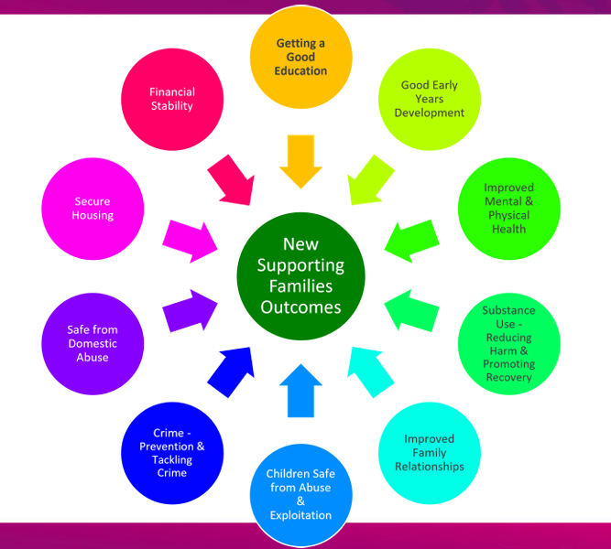

The Supporting Families Programme helps thousands of families across England by addressing a range of challenges through a whole-family approach. Support is provided by key workers from local authorities and partner organisations, helping families improve their wellbeing and achieve better long-term outcomes (Department for Education, 2023). This report compares the Early Help websites for Leeds, Staffordshire, and Leicestershire. It evaluates how easy the websites are to use, the information they provide, and how accessible their services are to identify which website offers the best support for families.

Section 10 of the Children Act 2004 states that local authorities must work to improve children's well-being by collaborating with other agencies. Early Help follows this guidance by encouraging multi-agency working to identify families' needs early, provide support quickly, and build positive relationships with families and professionals. The Supporting Families Programme is based on four main principles: early help and intervention, working with the whole family, multi-agency working, and measuring outcomes and data.
This report compares the Early Help websites for Leeds, Staffordshire, and Leicestershire. It evaluates their availability, accessibility, content, and ease of use to identify which website is the most user-friendly and provides the clearest information.

According to the NSPCC (2023), Early Help supports families who are facing challenges such as poverty, mental or physical health problems, domestic abuse, substance misuse, child exploitation, crime, anti-social behaviour, and poor school attendance. The Domestic Abuse Act 2021 states that children who witness domestic abuse should be recognised as victims because the experience can have a serious effect on their development (legislation.gov.uk, 2021).

Early Help aims to improve outcomes for vulnerable children and families by preventing problems from becoming more serious and reducing the need for statutory intervention. Services may include parenting support, emotional wellbeing services, play groups, mentoring, speech and language support, help with domestic abuse or financial problems, and support with childcare, education, or employment (Department for Education, 2023). These services also help reduce the impact of Adverse Childhood Experiences (ACEs), which can affect health and wellbeing throughout life. Around half of adults in England have experienced at least one ACE, while 10% have experienced four or more (Liverpool CAMHS, 2025).

Partnership working improves outcomes by bringing together professionals, organisations, and families. Sharing knowledge and resources helps provide coordinated, person-centred support and reduces gaps between services. Good communication and shared decision-making also improve service quality, accountability, and long-term outcomes (Glasby and Dickinson, 2014).

Leeds Family Hubs Website Summary
The Children and Families section of the Leeds website is easy to access on mobile, with clear categories and helpful illustrations (Leeds City Council, 2025). However, the Family Hubs page is difficult to find because it is the sixth option on the next page, making an important service less visible. The website also lacks important contact information. Individual hubs do not provide email addresses, opening hours, or direct telephone numbers. This makes it harder for families to contact services and often means they must search elsewhere for information.

Accessibility is also limited by the hubs' locations. There are no Family Hubs in central or north Leeds, meaning many families must travel to the east or south of the city. This is especially difficult for people who rely on public transport. With a high number of people in Leeds living in poverty (Department for Work and Pensions, 2024), travel costs and time may prevent families from accessing support.

The website also provides limited information about the services available at each hub. It does not explain what support is offered, when services are available, or whether outreach or online services are provided. This makes it difficult for families, particularly those with mobility issues, to access the help they need. In addition, there are no signposting links to other organisations or sources of further information.

Leicester Family Hub Website Summary
The Leicester website has a very simple look, showing only a list of services with small icons on the left side of the screen. At first, it is very hard to start searching because the initial list of services does not mention "Early Help" or "Families First" at all. Finding the right page requires a lot of deep searching. A user has to click on "Education and Children," scroll past a long list of phone numbers, and then find and click "Social care and supporting families," which is the sixth item on the next list. The signs are unclear, but a user can finally find what they need by clicking "Leicestershire Children and Families Partnership" because the name sounds correct. From there, they have to scroll down to find "Early Help Partnership" listed as a smaller subgroup. Overall, this is the hardest website for finding basic Early Help information. It forces users to make multiple clicks and guess the right path rather than following clear directions.

Once a user finds the right page, the information is very thorough and covers the partnership's goals, visions, and future in great detail. The review highlights the "Holiday, Activities and Food programme" as a highly valuable service that helps families dealing with food poverty and a lack of holiday options. Regarding local wealth and fairness, the review notes that Leicestershire was ranked as the 18th most deprived area in England, with nearly twenty percent of the population experiencing income poverty in 2019 (Leicester City Council, 2019). This shows the area has slightly less financial hardship than places like the West Midlands or Yorkshire (Ministry of Housing, Communities and Local Government, 2021).

The holiday food program is praised as a great example of fair support because it helps low-income families solve two issues at the same time by tackling food poverty (Office for National Statistics, 2023) and the high cost of holiday activities together.
The website explains the goals and purposes of both the Children and Families Partnership and the Early Help Partnership very clearly. However, the review stresses that because people using this site are often dealing with complicated problems or dangerous situations, the website must be incredibly easy to find and use so it can help the most vulnerable people. In conclusion, the information itself is helpful and detailed, but the poorly designed website structure fails to provide the quick, easy access that vulnerable families urgently need.

Staffordshire Family Hub Website Summary
The Staffordshire website looks bright, and the overall design is simple and clear. However, even though the layout is clean, there is an initial navigation issue because there is no separate tab or button for "Early Help" on the main homepage. There is also a browsing barrier because the website automatically defaults to showing the most popular pages. A user must manually click on a button that says "Browse Website" just to see the full list of available services. Once the user clicks that button, finding the sub-page for "Children and Family Services" is fairly easy because it is the sixth item down and is visible without needing to scroll. After clicking into that section, the internal navigation is good because "Early Help" is listed third out of ten categories, making it easy to spot.

The main page gives a short, helpful description of the Early Help team and who they support. It also includes a useful link to read more about their goals through the Families First service overview. All the necessary actionable information is included, as the page provides phone numbers and clear links that explain exactly how to get in touch and access the right services. This specific review did not include any details about where physical hubs are located or any specific local fairness and poverty challenges in Staffordshire (House of Commons Library, 2025).

The website is packed with clear, useful information and details for anyone involved with the Family First project. The description of what the team does and what they want to achieve is very easy to understand. In conclusion, the website has great information and a good layout once a user gets to the right service page. However, it is held back by a confusing setup and a lack of clear signs on the homepage, which means finding the service in the first place is still not easy.

Conclusions

This report compared the Early Help websites for Leeds, Staffordshire, and Leicestershire by looking at their availability, accessibility, and the information they provide. Although all three websites aim to support children and families through the Supporting Families Programme, they differ in how easy they are to use and the amount of information they offer.

The Leeds Family Hubs website was easy to access and had clear categories, but important information such as opening hours, direct contact details, service timetables, and signposting links was missing. The location of the Family Hubs may also make it difficult for some families to access support, particularly those living in north Leeds or without their own transport. The Staffordshire website has great information once reached, but lacks direct homepage signposting, whereas the Leicestershire site has a very complicated, deep structure that makes finding information very difficult for vulnerable users.

Overall, Early Help plays an important role in supporting vulnerable children and families by providing help before problems become more serious. Working together with different agencies allows families to receive the right support at the right time, improving outcomes and reducing the need for statutory intervention. Improving website accessibility, providing complete contact information, and clearly explaining available services would make it easier for families to access the support they need.

References

Children Act 2004, c. 31. London: The Stationery Office.
Department for Education (2023) Working Together to Safeguard Children: A guide to inter-agency working to safeguard and promote the welfare of children. London: HM Government.

Department for Work and Pensions (2024) Children in low-income families: local area statistics, financial year ending 2024. Available at: https://www.gov.uk/government/statistics/ (Accessed: July 11th, 2026).

Domestic Abuse Act 2021, c. 18. Available at: https://www.legislation.gov.uk/ukpga/2021/18/contents (Accessed: July 10th, 2026).

Glasby, J. and Dickinson, H. (2014) Partnership Working in Health and Social Care: What is integrated care and how can we deliver it? 2nd edn. Bristol: Policy Press.

GOV.UK. (2022, April 2). Supporting Families: Early Help System guide. GOV.UK. https://www.gov.uk/government/publications/supporting-families-early-help-system-guide (Accessed July 18th, 2026)

House of Commons Library (2025) Poverty in the UK: Statistics. Research Briefing. London: House of Commons.

Leeds City Council (2025) Welcome to Leeds: Children and Families. Available at: https://www.leeds.gov.uk (Accessed: July 11th, 2026).

Leicester City Council (2019) The Index of Multiple Deprivation (IMD) Report. Leicester: Leicester City Council.

Liverpool CAMHS (2025) What are Adverse Childhood Experiences (ACEs). Liverpool: Liverpool Child and Adolescent Mental Health Services.

Ministry of Housing, Communities and Local Government (2021) Exploring local income deprivation. Available at: https://www.gov.uk/government/publications/ (Accessed: July 10th, 2026).

Ministry of Housing, Communities and Local Government (2022) Supporting Families Programme Guidance: The National Supporting Families Outcome Framework. London: HM Government. Available at: https://www.gov.uk/government/publications/supporting-families-programme-guidance-2022-to-2025/ (Accessed: 11th July 2026).

NSPCC (2023) Early help and early intervention. London: National Society for the Prevention of Cruelty to Children. Available at:https://learning.nspcc.org.uk/child-protection-system/early-help-early-intervention (Accessed: 11th July 2026).

Office for National Statistics (2023) Impact of increased cost of living on household food security in the UK. London: ONS.
Spinks, S. (2023) Early Help: A guide for educational and care professionals. London: SSS Learning. Available at: https://www.ssslearning.co.uk/ (Accessed: 10th July 2026).

https://www.worcestershire.gov.uk/sites/default/files/2023-01/Supporting%20Families%20outcomes%20update%20-%20website.pdf

