

Student Name: ABDULSAMAD MALEK

Student ID:2432626

Module Name: Marketing Management

Module Code: LCMB7024

Lecturer’s Name: DR. LAILA MAAZOUZ

POSTER

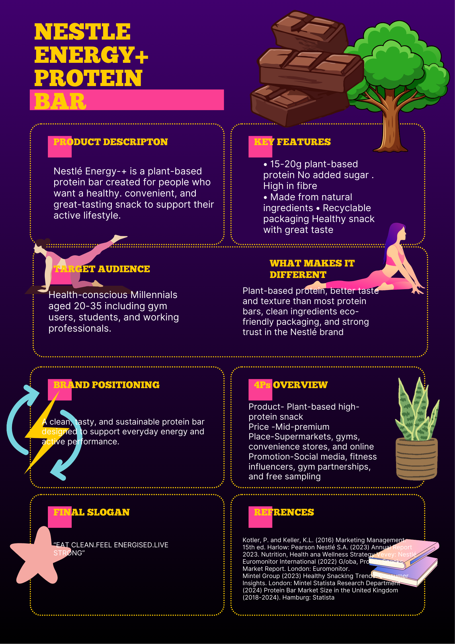
Term 1

