VLOG notes

- Discussion of a sustainability leadership challenge for business

Hi there! My name is Elinor and today I am going to be chatting to you about universities and their role in the climate crisis, contributing to the journey to net zero and problems leaders can face in this area.

So, for this vlog, I will briefly discuss the challenges of implementing sustainability in universities from a leadership perspective and the journey to net zero. As you probably already know, we are face with a climate emergency and things rapidly need to change in the coming years.

Firstly, we are going to look at the structure of a typical university. There is usually some form of a brick and motor campus, with students attending from all around the world, with various buildings, departments and services on site. Most often there is a form of catering, both cooking meals for students and a small supermarket selling goods. There is space for cars to park and various types buildings for work, research or studies.

Now we have a picture in our heads of a typical university setting, we are going to move on to some of the challenges of sustainability leadership within this kind of environment.
It was stated at the COP26 Universities network briefing in January 2021 - “A primary purpose of UK further and higher education (FHE) institutions is to support the wellbeing of future generations, which is in part dependent on society at large achieving the goal of net zero emissions.”

Paris Agreement:

So, let’s look at the Paris Agreement (2015) – the Paris Agreement is an international treaty on climate change (United Nations) which in part aims to limit the rise in global temperatures to below 1.5°C for the sake of people, planet and all living things on it. To meet this target, global carbon emissions will need to reach net zero by 2050. Which some are questioning if that is perhaps too late, and net zero needs to be reached before this time.

Net zero and carbon neutral:

Net zero is when we (humans) stop adding to greenhouse gas emissions in the atmosphere.
Carbon neutral is when people or organisations offset their greenhouse gas emissions by donating to causes that take the same amount of carbon emitted out of the atmosphere. (Kantamaneni, 2020).

There are few debates regarding the use of carbon-offsetting initiatives. Some argue that they have a key place in the sustainability world, whilst others argue that it isn’t enough just to offset emissions.
“Beware carbon offsets reducing motivation to mitigate – In some cases offsetting can appear cheaper in the short-term compared with investing in infrastructure or technologies that reduce emissions on an enduring basis. This can risk redirecting attention and limited financial resources away from meaningful mitigation.” (Gunther et al, 2020)
It is generally accepted that when we discuss the climate emergency and when aiming for net zero, reducing emissions should always be the priority before offsetting emissions.

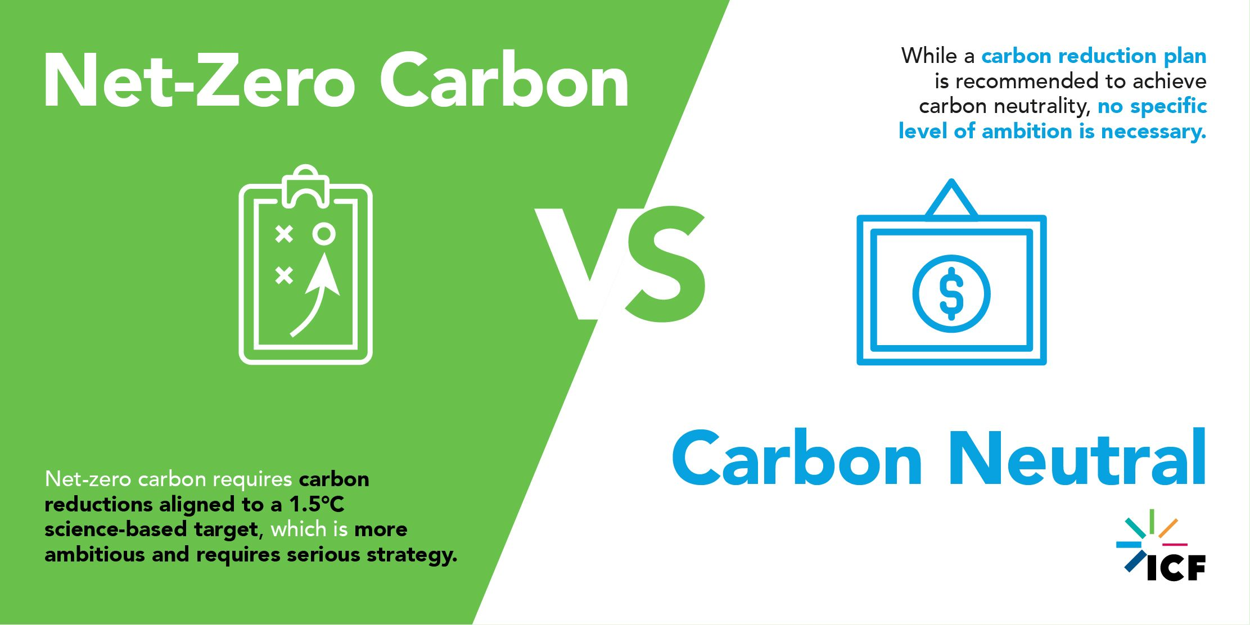
https://www.icf.com/insights/environment/net-zero-carbon-versus-carbon-neutral

Why should universities be a leader in achieving net zero?
-leaders in future
-resources to do so
-can support and empower others

How can universities achieve net zero?

There are multiple areas within a university setting that contribute to carbon emissions in some form or another and will need robust strategies to combat this.

PEOPLE AND PARTNERSHIPS:
There is a multitude of people at universities, so being a leader in this industry means you will need to lead people on different journeys - from students, to staff to external stakeholders. This can be challenging in many ways as different people will need different approaches. There will also need to be a general understanding and implementation of values across the board of the universities goal to become one of the leaders in achieving net zero emissions. It is a collaborative effort, and getting staff, students and stakeholders to buy in to our goals will be extremely important.

ENERGY CONSUMPTION:
Energy will be a key focus for universities. Moving to renewable energy and improving the energy efficiency of buildings, work areas and learning spaces will be essential to achieving net zero. Implementing and moving to renewable energy will be a challenge for university leaders, as they will need to weigh up the pros and cons.

TEACHING, LEARNING AND RESEARCH:
Teaching students about the effect of their chosen degree on the planet, for example environmental law, sustainable buildings etc. Responsible Futures has been set up for universities to use as a framework when embedding sustainability into the informal, formal and subliminal curriculum. This is an important step to grade universities and allow them to audit and for leaders in this area, it is a handy tool to track their progress in this area year upon year. It is even more useful because universities are graded against each other in this area. However, on the flip side this can be a time-consuming audit, and staff who are part of responsible futures will need to know the methodology and grading system to be able to correctly implement this.

ESTATES AND OPERATIONS:
Responsibly purchasing goods, making sure the supply chain is ethical – for example is everyone down the chain paid fairly? Are the materials used damaging to the environment? How long before they will need to be replaced?

TRAVEL AND TRANSPORT:
There is a mix of travel to the university, from car transport, public transport, to electric vehicles and push bikes. It is also important to mention that some students who perhaps live overseas, will be travelling internationally – which is known as indirect emissions. This is an extremely tricky area, as the university would need to rely on sustainable airlines, which is somewhat out of their control if they want to attract students from around the world.
When looking local travel to the campus and/or workplace, it is slightly different – university leaders can incentivise staff and students by putting cycle stations on campus, priority spaces for electric vehicles and car share, reduced price buses etc. Some universities (Winchester) have a fleet of only electric vehicles on campus, which also acts a nice visual queue to reinforce sustainable values.

WASTE AND RECYCLING:
Reducing waste from all resources, including student waste, staff waste, visitor waste and contractor’s waste. taking responsibility and ensuring everyone on site knows how and where to recycle goods, or reuse goods. When it comes to water waste, aim to efficiently reduce, reuse and recycle water in a loop type cycle.

BIODIVERSITY:
Nature as a stakeholder is often overlooked, by universities can take up a lot of physical space, often by natural areas such as beaches, parks or woodlands where biodiversity needs to be protected.

We have now seen a number of elements that pose a leadership challenge for universities, but there is also the face that universities need to measure their impact correctly. This must be done properly from when goals and initiatives to achieve net zero are set. The way this is measured then must be measured in line with professional guidelines and used going forward to achieve a true timeline of the goal to net zero.

All in all, implementing sustainability inside an organisation such as a university can be tricky and complex, and as discussed today, often there are barriers that face leaders making IN implementing these initiatives.
As Fiona Goodwin said, who is a director at the Environmental Association for Universities and Colleges – “Universities are key in equipping the next generation to have the knowledge, skills, attitudes and values needed to address the climate crisis”.
I think Fiona Goodwin is right, Universities have what is needed to be a leading the way in the goal to net zero. They can lead and inspire and encourage the next generation to live in a cleaner and safer world that is more equal for all.
Thank you

References:
Günther, S. A., Staake, T., Schöb, S. & Tiefenbeck, V. The behavioral response to a corporate carbon offset program: A field experiment on adverse effects and mitigation strategies. Glob. Environ. Change 64, 102123 (2020).
Mitchell-Larson, E., Green, T., Lewis-Brown, E., Jennings, N., Joly, C., Goodwin, F., Reay, D., Rothman, R., Scott, C., Allen, M. and Forster, P. (2020) How can carbon offsetting help UK further and higher education institutions achieve net zero emissions? COP26 Universities Network Briefing.
Ravi Kantamaneni. (2020). Net-zero carbon versus carbon neutral – what is your ambition? Available: https://www.icf.com/insights/environment/net-zero-carbon-versus-carbon-neutral. Last accessed 17/03/2021.
UNFCCC. Climate Neutral Now. https://unfccc.int/ climate-action/climate-neutral-now (2020).

