Utilizing the Entrecomp Framework, critically evaluate your own creativity and enterprise and consider how you might be able to develop the creative and enterprising skills of primary learners through your own pedagogy

‘Creativity and enterprise are central features of modern life that should be developed and extended throughout a school career.’ (Donaldson, 2015: 28)

When posed with the question- “Are you creative?” the writer’s initial response would be: “not really, I am not very good at drawing.” However, this is a self- destructive (Korchagin, 2018) and fixed mindset (Dweck, 2015) attitude that could pre-determine restricted learning and experiences (Hochanadel and Finamore, 2015). It would prevail that creativity is not just about drawing, or composing music, but the ability to seek and explore different avenues in order to understand and complete a task (Grigg, 2015; Robinson and Aronica, 2015).
Within this paper, the writer will discuss creativity and its role within enterprise education and how it is a fundamental part of development for future generations in Wales (Cook, 2014). Using the Entrecomp framework (Bacigalupo etal, 2016), the writer will critically discuss their own creativity and enterprising skills in order to set personal development goals. The paper will explore and provide valid arguments of pedagogical practice that provide creative and enterprising environments, discussing benefits and challenges, that could support children in the development of key transferable skills required for future success (Tes, 2013).

In two thousand and twenty the new Curriculum for Wales is due to be launched. Guided by Donaldson’s (2015) four purposes of learning (Appendix 1), the Welsh Government (2017) set a priority of embedding enterprise skills and creativity into learning to promote critical thinking (Estyn, 2017 and 2016), with an ambition to develop children’s transferability of skills in preparation for change and adaptability (Welsh Government, 2017) in a fast paced, uncertain future (Donaldson, 2015; Scottish Government, 2016).
According to Penaluna (2018) “creativity is connecting things that weren’t connected before.” This, supporting the consensus that creativity is thought to be an outcome of originality (Torrance, 1966 and 1974 cited in Tan, 2007; Sternberg, 1999 and Cherry, 2018). NACCCE (1999, p.54) also agree with those mentioned. However, they further interoperate that originality need not be original or unique to everyone. They further suggest that as it is ‘original to one’s own previous work or to the work of one’s peers’ it can be recognised as creative (NACCCE 1999, p.54).
In addition to originality, it is agreed that creativity requires value (NACCEE, 1999 and Sharp, date unknown, cited in Meredydd, 2018) or purpose (Stenberg etal, 2001). The writer agrees with such statement, but also considers, as with originality, that a creative contribution does not need to be of value or purpose to everyone, but only of value or purpose to one self. To put into context, a child who develops an alternative method to suit their understanding, but the method need not necessarily support others’ understanding.
Creativity is thought to be developed through different modes of thinking (Wilson, 2019). The two commonly spoke about are divergent thinking and convergent thinking (Craft, 2000). Divergent thinking (Appendix 2) is identified as an important process in generating creativity as it allows: fluency, flexibility, originality and elaboration to generate multiple ideas (Guildford, 1967, as cited in Razumnikova, 2012 and Torrence, 1966 & 1974). Buzan (2016) suggests that with the use of ‘mind- mapping’ divergent thinking can be supported as learners record their initial ideas.
Within education, it is thought that multiple ideas are best generated through collaborative learning (Vygotsky, 1971). On the other hand, De Bono (1995) suggests that creativity does not require collaboration and even discusses that collaboration can restrict creative thinking due to fear of being critiqued or ridiculed for one’s idea (Vozza, 2018). Although it is thought that divergent thinking is the cognitive process of creativity (Runco and Yoruk, 2014). It is important to consider the views of Cropley (2006), who suggests that divergent thinking, as a process on its own, would only allow quasi-creativity, suggesting that creativity also requires further development.
Convergent thinking (Appendix 3) is a process that allows critical thinking, as it requires the application of knowledge (Sternberg, date unknown) and facts to develop an original idea (divergent thinking) into a successful and valuable outcome (Razumnikova, 2013). It is therefore suggested, that the fusing together of both divergent and convergent thinking (as illustrated in appendix 4), enhances creativity (Wilson, 2019, Fisher,1992 and CEF, 2019). However, how can learners be supported in such fusion? Teachthought (2019) suggests that this fusion of convergent and divergent thinking creates lateral thinking. De Bono’s six thinking hats (1985) (Appendix 5) could allow such thinking, as it provides learners with specific thinking agendas. It could therefore be considered, that teachers’ questioning technique within the classroom should allow higher-order thinking (Bloom, 1965)
While reading and researching convergent and divergent thinking, it was assumed by the writer, that creativity required conscious and purposeful thinking (Baumeister, Schmeichel and Dewall, 2014). However, it is suggested that creativity can derive from the unconscious mind (Ritter and Dijksterhuis, 2014). Yoruk and Runco (2014:2) refers to this as a period of ‘incubation.’ According to Wallas (1926), the incubation period assists with the development of creative ideas as displayed in his 4-stage model. (Appendix 6)
Ritter and Dijksterhuis (2014) suggests that, although there is more research to be carried out in regards to the reason why the incubation period develops creativity. Acknowledged by Dijksterhuis and Meurs (2006), it was concluded that distraction or time away from a task at the stage of divergent thinking developed more original ideas. Thus, suggesting, that it is this period that helps the development of creativity.
As well as different modes of thinking, imagination is also an important aspect of creativity (Stokes, 2014), as it allows the development of original ideas (Most, 1987.ed). However, it is of debate that the use of the terms creativity and imagination as synonyms are used correctly. It would seem that imagination is not the same as creativity (Christensen, 2010). Robinson (2009) supports this ideology and discusses the distinction between the two terminologies (imagination and creativity) rationalising that imagination is the thinking of things that simply aren’t around, whereas, creativity is the ability to do something meaningful with an imaginative thought (Robinson, 2009).
Through synthesis of research, it has been demonstrated that creativity involves not just imagination and originality, but also requires critical thinking and application of knowledge (Sternberg, date unknown). Furthermore, Hennessey (2000) suggests that motivation also plays a vital role within the development of creativity. Amabile (1985) hypothesises that intrinsic motivation allows deeper creativity and that external motivation does the opposite. Dunkers (1945, as cited by Wilner and Birnberg, 1986) referred to this as functional fixedness. Glucksberg (1962) demonstrates this with his ‘power of incentives’ test (Appendix 7). It concluded that when participants were offered a reward for completing a task. They scored lower than the group of participants who were purely conducting a task with no incentive (Glucksberg, 1962). This suggests that offering an incentive could have a negative effect on creativity, and therefore it could be suggested that creativity requires intrinsic motivation in order to reach its full potential (Pink, 2015).
Tina Seelig (2012) supports this with her ‘Innovation engine’ (Appendix 8). However, Seelig (2012) further suggests that imagination attitude and knowledge isn’t enough. She suggests that providing children with thoughtful questions such as ‘reframing’ a mathematical problem, will help children discover interesting answers. It is suggested by Oech (1983) that creativity is restricted by ten mental blocks. One of which is the need to have the right answer (Cambridgeinterantional, date unknown). It could therefore be evident that by ‘challenging assumptions’ (Seelig, 2012) children will be encouraged to overcome ‘mental- blocks’ and unlock their creativity.
As previously discussed, there are, but not limited to, many aspects of creativity. It is the interlinking of these aspects that could provide learners with a holistic approach to their learning (Sternberg, date unknown). Although suggested through many different theories such as; behaviourist (Skinner, 1953), cognitive (Gardner, 2008), socio-construction (Vygotsky, 1971 and Fisher, 1992 as cited in Lindqvist, 2003), and humanistic (Rogers, 1954), it is of good reasoning that the teaching of these aspects are contributed by the pedagogical input (Dawson and Mcwilliam, 2008), the environment (Jeffrey and Craft, 2004) and the learner’s attitudes to learning (Craft, 2005).
It is suggested, that a way in which creativity within education can be developed is providing a caring and safe environment (Al-Dababneh et al, 2010), supporting and growing intrinsic motivation (Hennessey and Amabile, 1998), including that of growth mindset (Dweck, 2015). As well as developing autonomy (Small, 2017) and meeting learner’s basic needs (Maslow, 1974).
This paper, so far, has discussed the importance of creativity in education. It has also touched upon important factors that can affect creativity. However, up until now there has been no consideration to the challenges of developing creativity.
Creativity has been an ongoing discussion within education since the 20th century (Merenbloom and Kalina, 2013). However, the meaning of creative teaching and teaching for creativity has been and still can be confused and mis understood (Craft, 2003). According to NACCCE (1999) the both can be explained as follows:
-Teaching creatively: is the use of imaginative ideas to provide learning that is more interesting and effective. Developing this part of teaching can be, in personal experience, not just engaging for learners but also facilitators. Providing a learning environment that is interesting can make learning more meaningful for children (National Research council, 2000) therefore supporting and encouraging autonomy (Pink, 2009).
-Teaching for creativity: is the development and encouragement of children’s own creativity, identifying their creative abilities while fostering curiosity, and providing a hands-on approach to learning. Such as enquiry-based learning (Lawton, 2007). It is the provision of enriching experiences, that provide ownership to learners that will aid imagination (Vygotsky, 2014)
As previously mentioned, one of the four purposes of the new curriculum for Wales is not to only promote creative thinking, but also support enterprise to ensure the future generations are prepared to be a full participant in work and life (Donaldson, 2015). Enterprise learners are resilient, motivated and determined (Collingwood College, 2019). It is the fostering of such skills and the application of creativity (Jarman, 2018) that will enhance the chances and choices of future generations (Education Scotland, 2018).
The writer is a strong believer in leading by example. As a child, the writer’s mother always advised: ‘do as I do’ therefore suggesting that for learners to be creative, one would be required to adopt the same tendencies and lead by example. Painting pictures and drawing artefacts was never a strong point for one self. However, creating debate has always, and still is a strong characteristic that demonstrates creativity (Wierzbicki and Gu J, 2007).
Referring to the Entrecomp Framework (Bacigalupo etal, 2016), a description of creativity is the ability to ‘combine knowledge and resources to achieve valuable effects’ (Bacigalupo et al, 2016. P. 12). This is a skill that is demonstrated in the preparation of debate, as one would be required to gather knowledge and critically discuss an issue or topic. It is acknowledged, by the writer, that debating is normally a more ‘one sided’ critical approach, but never the less, a good preparation for a debate is to be aware of the opponent’s (s’) conflicting ammunition as well as one’s own.
For those who may argue that conflict ‘kills creativity’ (Meier, date unknown), a study carried out by Nemeth et al. (2004) demonstrated the opposite. The research concluded that a debate group displayed more creative thinking than a mind mapping group by producing 25% more ideas. Linking to what has been previously discussed within this paper, mind mapping is thought to be an important process of creative thinking (Buzan, 2016), so where would that leave debating?
The writer also presents the idea that debating can demonstrate motivation and perseverance, an element found within the ‘Resource’ aspect of the Entrecomp framework (Bacigalupo etal, 2016). The writer believes that it takes perseverance to be good at debating. The logic of this statement could be supported by the way in which our democratic government conducts itself. It has been highlighted within the news of the various debates that are taking place in Westminster and any other Government establishment. There will not be any sharing of political view within this paper. However, it is suggested by the writer that there can be some recognition and commending that parties of local and national Government display true dedication of motivation and perseverance. Overcoming boundaries and set-backs on a daily or even hourly basis. As these are the people who represent our nation, then surely it is fair to recognise that it is their motivation and perseverance that should be developed in children ready for the next generation.
Not only is it through debating skills that the writer feel she demonstrates motivation and perseverance, but it has also been demonstrated within the past three years while undertaking a degree.
The current assessment of one’s own motivation is referencing the Entrecomp framework (Bacigalupo etal, 2016). One of the current skills believed to be displayed within motivation is to stay driven. It is not of harm in suggesting that one self, at most times, displays characteristics found within the advanced category of the Entrecomp Framework. It has taken self- drive and motivation to ensure that work is completed on time, that school is attended with time to spare. However, it is recognised on personal reflection that it has been at times supported by colleagues to overcome barriers.
Determination is what the writer believes has driven the near completion of her degree. At home with two young children, and working part-time is somewhat of a challenge, and to then undertake a degree, is what some people have fed back, a busy lifestyle to maintain. However, it is the drive to achieve the goal of becoming a Primary school teacher that will ensure completion. This displays characteristics of an advanced levelling within the Entrecomp framework. In order to move up through the levels, the writer self-acknowledges that learning from failures is not of a personal strength. The writer, when failure is met, can sometimes turn and run from the goal, in panic of repeating such failure. However, it is a characteristic that is currently being developed, especially since PTE two, where failure was on the horizon. The writer was not going to allow a bad experience prevent success, and came back better than before, taking on criticism and critique that helped develop determination to prove success. It is through development of autonomy and listening to critical feedback (Deci and Ryan, 2002) that will help develop further determination.
Resilience is another descriptor found within the motivation aspect of the Entrecomp framework. According to The American psychology Association (2004, as cited in Southwick, 2014) is ‘‘the process of adapting well in the face of adversity, trauma, tragedy, threats or even significant sources of stress (para. 4).’’ Without too much personal discussion, resilience is the writers most proven characteristic. Through reflection, there have been some hard-personal experiences to overcome, including that of bereavement. It is only through resilience that these have been managed.
The final descriptor in which the writer wishes to refer to is that of not giving up. The writer does not believe that she is currently sitting at an expert level of this. However, demonstration of an advanced level would be fair to suggest. The celebration of obtaining a ‘first’ on a degree, of experiencing a learner engage with an activity with full dedication, even though that learner had been labelled by a class teacher as ‘never completing a task’ demonstrates that giving up is not a characteristic found within the writer.

- Bacigalupo, M., Kampylis, P., Punie, Y. and Van Den Brande, G. (2016) Entrecomp: The Entrepreneurship Competence Framework. Luxembourg: Publication office of the European Union.
- Baumeister, R. F., Schmeichel, B. J., & Dewall, C. N. (2014). ‘Creativity and consciousness: Evidence from psychology experiments. In E. S. Paul & S. B. Kaufman’ (ed.), The philosophy of creativity: New essays (pp. 185-198). New York, NY, US: Oxford University Press.
- CEF. (2019b). Convergent thinking. Available at: http://www.creativeeducationfoundation.org/creative-problem-solving/convergent-thinking/. (Accessed: 20th January, 2019)
- Cherry, K. (2018) The psychology of creativity, what does it take to be a creative person. Available at: https://www.verywellmind.com/what-is-creativity-p2-3986725 (Accessed: 18th January, 2018)
- Collingwood college. (2019) What is enterprise education. Available at: https://www.collingwoodcollege.com/page/?title=What+is+Enterprise+Education%3F&pid=525. (Accessed on 19th January, 2019)
- Cook, P. (2014) The Welsh Dragon: The success of enterprise education in Wales. Available at: https://d1ssu070pg2v9i.cloudfront.net/pex/carnegie_uk_trust/2016/02/pub1455011485.pdf (Accessed: 15th January, 2019)
- Craft, A. (2000) Creativity across the primary curriculum, framing and developing practice. London: Routledge

Creative Eductaion Foundtion. (2019a) The CPS Process. Available at: http://www.creativeeducationfoundation.org/creative-problem-solving/the-cps-process/ (Accessed: 20th January, 2019)
- Croupley, A. (2006). ‘In praise of convergent thinking.’ Creativity research journal. 18 (3), pp. 391-404. DOI: 10.1207/s15326934crj1803_13 (Accessed: 20th January, 2019)
- Deci, E and Ryan, R. (2002). Handbook of self -determination research. Rochester Press: Suffolk
- Dijksterhuis, A and Meurs, T. (2006) ‘Where creativity resides: The generative power of unconscious thought.’ Consciousness and cognition. 15 (1). pp.135-146. DOI: https://doi.org/10.1016/j.concog.2005.04.007 (Accessed: 20th January, 2019)
- Dodds
- Dodds, R; Ward, T and Smith, S. (Date unknown) A review of experimental research on Incubation in problem solving and creativity. [PDF] Available at: https://pdfs.semanticscholar.org/25b1/f7904e63271fbb6b106e610b4cd69930bff1.pdf (Accessed: 24th January 2019)
- Donaldson, G. (2015) Successful futures. Cardiff: Crown
- Education Scotland. (2018) Enterprise in education. Available at: https://education.gov.scot/improvement/learning-resources/Enterprise%20in%20Education. (Accessed on: 18th January, 2019)
- Estyn. (2016) Building Pupil’s learning power. Available at: https://www.estyn.gov.wales/effective-practice/building-pupils-learning-power. (Accessed: 14th January 2019)
- Estyn. (2017) Creative strategies that encourage thinking and high attainment. Available at: https://www.estyn.gov.wales/effective-practice/creative-strategies-encourage-thinking-and-high-attainment. (Accessed: 14th January, 2019)
- Fisher, R. (1992) Teaching Children to Think. Hemel Hempstead: Simon and Schuster
- Glucksberg, S. (1962). ‘The influence of strength of drive on functional fixedness and perceptual recognition’. Journal of Experimental Psychology, 63(1), 36-41.
- Grigg, R. (2015) Becoming an outstanding primary teacher 2nd Edition. Oxon: Routledge.
- Guardian News. (2019) Prescriptive national curriculum restricts teachers. Available at: https://www.theguardian.com/education/2009/apr/13/national-curriculum-restricts-teachers. (Accessed: 18th January 2019)
- Hochanadel, A and Finamore, D. (2015) ‘Fixed and Growth Mindset in education and how grit helps students persist in the face of adversity’ Journal of international education research, 11(1), pp.47-50. Available at: https://files.eric.ed.gov/fulltext/EJ1051129.pdf (Accessed: 18th January, 2019)
- http://citeseerx.ist.psu.edu/viewdoc/download?doi=10.1.1.536.4415&rep=rep1&type=pdf
- Jarman. (2018) What is enterprise education and how does it work in the UK. Available at: https://entrepreneurhandbook.co.uk/enterprise-education-about-for-or-through/. (Accessed: 19th January, 2019)
- Jeffrey, Bob and Craft, Anna (2004). ‘Teaching creatively and teaching for creativity: distinctions and relationships.’ Educational Studies, 30(1) pp. 77–87.
- Kanematsu, H and Barry, D. (2016) STEM and ICT Education in Intelligent Environments, Intelligent Systems Reference Library 91, DOI 10.1007/978-3-319-19234-5_2. (Accessed: 19th January 2019
- Korchagin, A. (2018) If you think you’re not creative, you’re right. Available at: https://medium.com/swlh/if-you-think-youre-not-creative-you-re-right-a1693dbad8e5 (Accessed: 11th January, 2019)
- Lindqvist, Gunilla. (2003). Vygotsky's Theory of Creativity. Creativity Research Journal. 15. 245-251. 10.1080/10400419.2003.9651416.
- Martin. (2015) Idea generation: Divergent Vs Convergent thinking. Available at: https://www.cleverism.com/idea-generation-divergent-vs-convergent-thinking/. (Accessed: 20th January, 2019)
- Maslow, A. (1968) Toward a psychology of being (2nd edition). Princeton, NJ: Van Nostrand Reinhold.
- Miere, J. (date uknown). Available at: http://sourcesofinsight.com/conflict-enhances-creativity/-
- NACCEE. (1999) All our futures: creativity, culture and education. Available at: http://sirkenrobinson.com/pdf/allourfutures.pdf (Accessed: 18th January, 2019)
- Nemeth, C and et al. (2004) ‘The liberating role of conflict in group creativity: A study in two countries’ European journal of social psychology 34. PP 365 -374. DOI: 10.1002/ejsp.210
- Razumnikova O.M. (2012) Divergent Thinking and Learning. In: Seel N.M. (eds) Encyclopedia of the Sciences of Learning. Springer, Boston, MA
- Razumnikova O.M. (2013) ‘Divergent Versus Convergent Thinking’. Carayannis E.G. (eds) Encyclopedia of Creativity, Invention, Innovation and entrepreneurship. Available at: https://link.springer.com/referenceworkentry/10.1007%2F978-1-4614-3858-8_362#howtocite . (Accessed: 22nd January, 2019
Reference list
- REFERENCE PENALUNA, 2018 LECTURE
- Ritter, S. and Dijksterhuis, A. (2014. ‘Creativity- the unconscious foundation of the incubation period’ Frontiers in human Neurosciance. 215(8). DOI: 10.3389/fnhum.2014.00215. (Accessed: 20th January, 2019)
- Robinson, K and Aronica, L. (2015) Creative schools: The grassroots revolution that’s transforming education. New York: Penguin.
- Robinson, T. (2014) Do schools kill creativity [video]. Available at: https://www.ted.com/talks/ken_robinson_says_schools_kill_creativity?language=en. (Accessed: 18th January, 2019)
- Rogers, C. (1954). ‘Toward a Theory of Creativity’ ETC: A Review of General Semantics, 11(4) 249-260.
- Runco and Atar (2012). ‘Divergent thinking as an indicator of creative potential.’ Creativity research journal, 24 (1), pp. 66-75. DOI: 10.1080/10400419.2012.652929 (Accessed: 20th January, 2019)
- Runco, M.A. & Yoruk, S. (2014) ‘The neuroscience of divergent thinking’. ANS Journal for neurocognitive research. 56 (1). DOI: https://doi.org/10.1007/BF03379602. (Accessed: 24th January, 2014)
- Scottish Government. (2016) Creativity and learning, what is the key? Available at: https://education.gov.scot/improvement/documents/creativity/cre36-creativity-thought-piece-paul-collard-june-2016.pdf (Accessed: 18th January, 2019)
- Southwick, S and etal. (2014) ‘Resilience definitions, theory and challenge, disciplinary perspectives’ European journal of psychotraumatology. 5(1).
- Sternberg, R. (1999) Handbook of creativity. Cambridge: Cambridge university press
- Sternberg, R. (2006) ‘The Nature of Creativity.’ Creativity Research Journal, 18 (1), pp. 87-98. DOI: 10.1207/s15326934crj1801_10. (Accessed: 25th January, 2019)
- Sternberg, R. (date unknown) Available at: http:/www.robertjsternberg.com/investment-theory-of-creativity/ (Accessed 21st January, 2019)
- Sternberg, R; Kaufman, J and Pretz, J. (2001) The propulsion model of creative contributions applied to the art and letters. Available at: https://onlinelibrary.wiley.com/doi/pdf/10.1002/j.2162-6057.2001.tb01223.x. (Accessed: 18th January, 2019)
- Tes. (2013) Big 13 Enterprise skills and associated activities. Available at: http://www.tesguide.eu/tool-method/big-13-enterprise-skills-associated.htm (Accessed: 15th January, 2019)
- Webster, P. (1990) ‘Creativity and creative thinking.’ Music Educators journal, 76 (9), pp. 22-28. DOI: doi.org/10.2307/3401073 (Accessed: 24th January, 2019)
- Welsh Government. (2017) Expressive Arts AOLE: Submission to Curriculum and Assessment Group: December, 2017. Available at: https://beta.gov.wales/sites/default/files/publications/2018-07/expressive-arts-aole-december-2017.pdf (Accessed: 14th January, 2019)
- Wilson, L. (2019) Types of creative thinking. Available at: https://thesecondprinciple.com/creativity/creativity-essentials/types-of-creative-thinking/. [Accessed: 20th January, 2019)

- http://lchc.ucsd.edu/mca/Mail/xmcamail.2008_03.dir/att-0189/Vygotsky__Imag___Creat_in_Childhood.pdf
- https://books.google.co.uk/books?hl=en&lr=&id=CmECErqsv_AC&oi=fnd&pg=PA59&dq=imagination+and+creativity&ots=XOmANpNOk5&sig=mMGqmhCsDzZX7VLJOLrmEVvDLww#v=onepage&q=imagination&f=false
- http://www.oxfordscholarship.com/view/10.1093/acprof:oso/9780199836963.001.0001/acprof-9780199836963-chapter-9- is this the same? https://philarchive.org/archive/STOTRO-17v1
- https://www.llas.ac.uk/resources/paper/2685.html
- https://books.google.co.uk/books?id=idlhZ31vyKoC&printsec=frontcover&source=gbs_ge_summary_r&cad=0#v=onepage&q&f=false
- https://creativesomething.net/post/452327772/imagination-is-not-creativity
- https://www.amazon.com/gp/product/0143116738?ie=UTF8&tag=simmakmon-20&linkCode=as2&camp=1789&creative=9325&creativeASIN=0143116738
- https://www.youtube.com/watch?v=gyM6rx69iqg
- https://books.google.co.uk/books?hl=en&lr=&id=uM10geBB8o4C&oi=fnd&pg=PP1&dq=intrinsic+and+extrinsic+motivation,+education&ots=DCz6e8BZ7J&sig=ZqF46Vql-GDECIgEVM_j7XJtOHA#v=snippet&q=the%20process%20of%20creative%20thinking&f=false- edited henesey,
- https://pdfs.semanticscholar.org/a2f7/272fe76ce1adfc873382b398a514256f5324.pdf
- http://www.thesageschool.org/wp-content/uploads/Drive-by-Daniel-Pink.pdf
- Craft, A. 2005, http://oro.open.ac.uk/23285/
- https://www.amazon.co.uk/Science-Human-Behavior-Skinner-1953-01-30/dp/B01K2QYKYI
- https://books.google.co.uk/books?id=2BMDYRRF1WcC&dq=cognitive+theory+of+creativity,+gardener&hl=en&sa=X&ved=0ahUKEwj_7qmJg47gAhX0RhUIHfR9BYgQ6AEIKDAA
- https://www.youtube.com/watch?v=gyM6rx69iqg
- https://www.amazon.co.uk/Whack-Side-Head-More-Creative/dp/0446404667
- https://www.teachthought.com/critical-thinking/3-modes-of-thought-divergent-convergent-thinking/
- https://search.proquest.com/openview/b867602babfb901628af868f33ea6603/1?pq-origsite=gscholar&cbl=37083
- https://www.cambridgeinternational.org/Images/426483-chapter-4-innovation-and-creativity.pdf (date unkown)
- https://www.youtube.com/watch?v=MLW8_BYayEY
- https://www.fastcompany.com/40549394/brainstorming-is-killing-your-creativity
- https://www.amazon.co.uk/Edward-Bonos-Masterthinkers-Handbook-Innovative/dp/0961540028
- https://www.researchgate.net/publication/233015181_Promoting_Kindergarten_children's_creativity_in_the_classroom_environment_in_Jordan
- https://pdfs.semanticscholar.org/ada3/42af4a8d49eda89dcf20ea5b05dd3f19ec2e.pdf
- http://citeseerx.ist.psu.edu/viewdoc/download?doi=10.1.1.475.5985&rep=rep1&type=pdf
- https://uk.sagepub.com/sites/default/files/upm-binaries/71403_Desailly_Creativity_in_the_Classroom.pdf
- https://www.researchgate.net/publication/41202259_Teaching_for_Creativity_Towards_Sustainable_and_Replicable_Pedagogical_Practice
- https://www.lkmco.org/creativity-links-autonomy/
- https://books.google.co.uk/books?lr=&id=wmxZIaW03QkC&dq=maslows+and+creativity&q=copyright#v=snippet&q=copyright&f=false
- https://books.google.co.uk/books?id=-Ds4DQAAQBAJ&pg=PA166&dq=Creativity+has+been+an+ongoing+discussion+within+education+since+the+20th+century&hl=en&sa=X&ved=0ahUKEwjgsMyDqo_gAhX_RhUIHYx2BBgQ6AEILTAB#v=onepage&q=Creativity%20has%20been%20an%20ongoing%20discussion%20within%20education%20since%20the%2020th%20century&f=false
- https://books.google.co.uk/books?id=XjZeI8MndBQC&printsec=frontcover&dq=Providing+a+learning+environment+that+is+interesting+can+make+learning+more+meaningful+for+children&hl=en&sa=X&ved=0ahUKEwiRuri1qo_gAhWvShUIHY5iDK0Q6AEIKDAA#v=onepage&q=Providing%20a%20learning%20environment%20that%20is%20interesting%20can%20make%20learning%20more%20meaningful%20for%20children&f=false
- https://www.amazon.co.uk/Drive-Surprising-Truth-About-Motivates/dp/1786891700/ref=sr_1_1?ie=UTF8&qid=1548639408&sr=8-1&keywords=pink+drive
- https://www.llas.ac.uk/resources/paper/2685.html
- https://link.springer.com/chapter/10.1007/978-3-540-71562-7_6#citeas
- 23/10/2018- Meredydd- reference lecture

Images:

Appendix 1: http://www.cradoc.powys.sch.uk/?page_id=1207&lang=cy

Appendix 2: https://blogs.elon.edu/innovationstudio/design-thinking-and-social-innovation-overview/

Appendix 3: http://thepeakperformancecenter.com/educational-learning/thinking/types-of-thinking-2/convergent-divergent-thinking/)

https://blog.edisonnation.com/2016/03/inventing-101-the-creative-process/

Appendix 4: https://blogs.elon.edu/innovationstudio/design-thinking-and-social-innovation-overview/
Appendix 5: https://mgrush.com/blog/wp-content/uploads/2017/06/SixThinkingHats.png)
Appendix 6:
Appendix 7: http://thepsychreport.com/books/how-incentives-hinder-innovation-creativity/)

Appendix 8: https://uk.images.search.yahoo.com/search/images;_ylt=AwrJS9aJjE9c7BUARRcM34lQ;_ylu=X3oDMTB0ZTgxN3Q0BGNvbG8DaXIyBHBvcwMxBHZ0aWQDBHNlYwNwaXZz?p=tina+seelig+innovation+engine&fr2=piv-web&fr=mcafee#id=0&iurl=https%3A%2F%2Fsidlaurea.files.wordpress.com%2F2014%2F09%2Fideas-creativity.jpg%3Fw%3D714&action=click

Appendices

Appendix 1
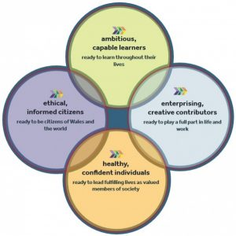
(Source taken from: http://www.cradoc.powys.sch.uk/?page_id=1207&lang=cy)

Appendix 2
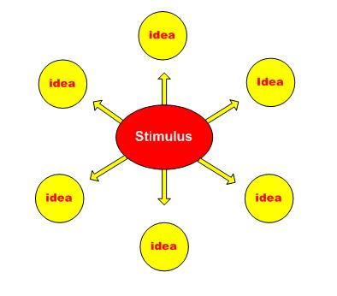

(Source taken from: http://thepeakperformancecenter.com/educational-learning/thinking/types-of-thinking-2/convergent-divergent-thinking/)

Appendix 3
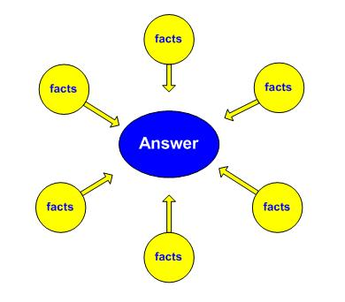
(Source taken from: http://thepeakperformancecenter.com/educational-learning/thinking/types-of-thinking-2/convergent-divergent-thinking/)

Appendix 4
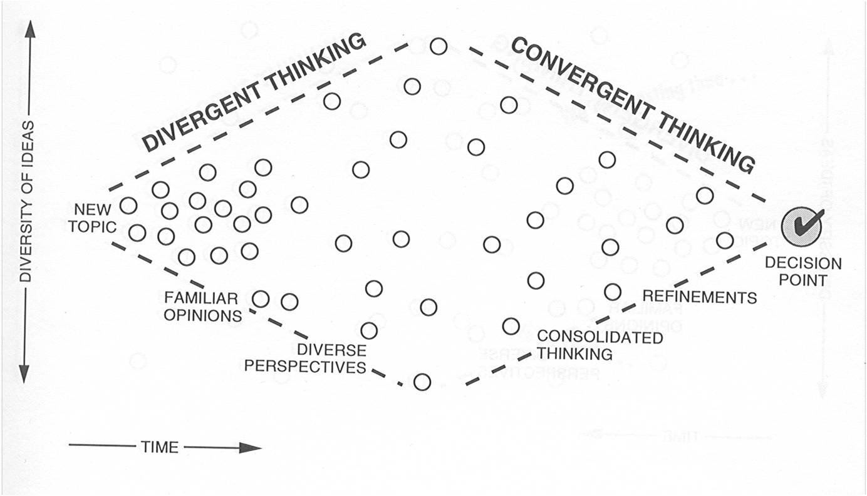
(Source taken from: https://blogs.elon.edu/innovationstudio/design-thinking-and-social-innovation-overview/)

Appendix 5
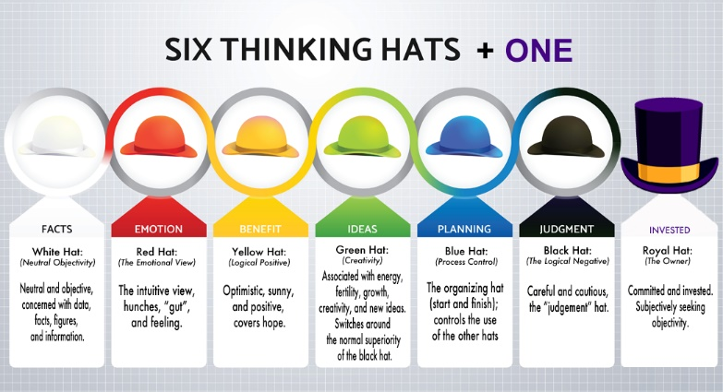
(Source taken from : https://mgrush.com/blog/wp-content/uploads/2017/06/SixThinkingHats.png)

Appendix 6

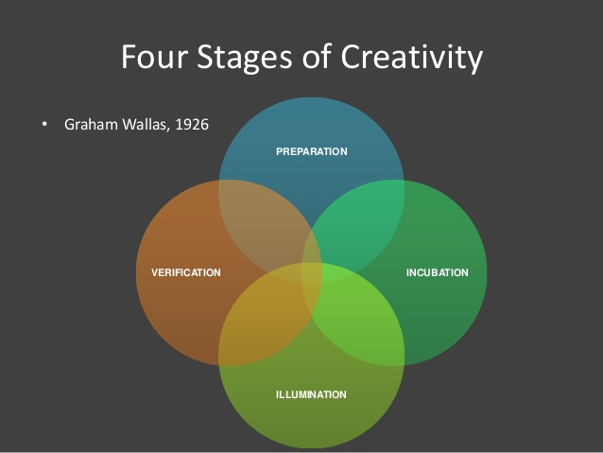
(Source taken from:

Appendix 7
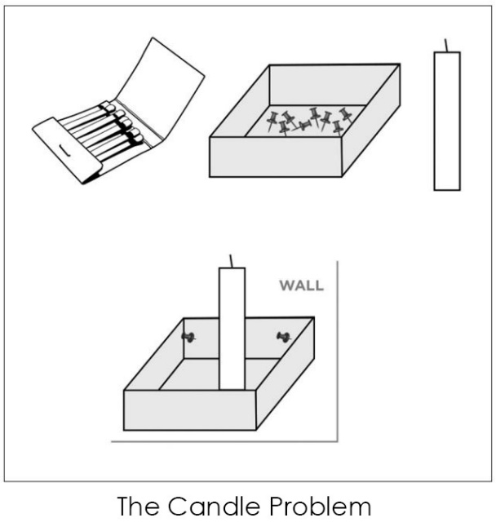
(Source taken from: http://thepsychreport.com/books/how-incentives-hinder-innovation-creativity/)

Appendix 8

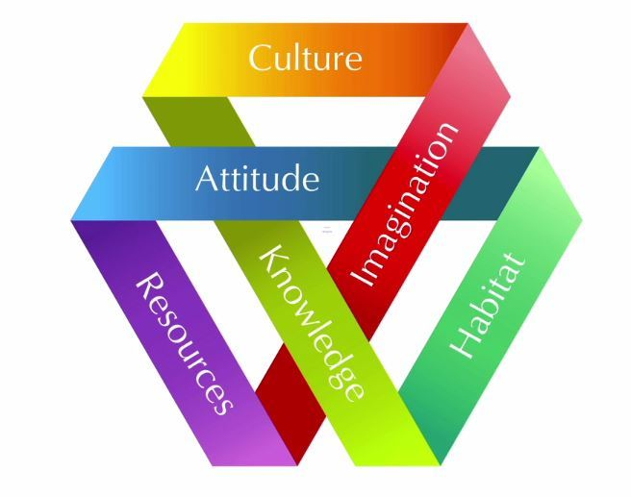
Source taken from: (https://uk.images.search.yahoo.com/search/images;_ylt=AwrJS9aJjE9c7BUARRcM34lQ;_ylu=X3oDMTB0ZTgxN3Q0BGNvbG8DaXIyBHBvcwMxBHZ0aWQDBHNlYwNwaXZz?p=tina+seelig+innovation+engine&fr2=piv-web&fr=mcafee#id=0&iurl=https%3A%2F%2Fsidlaurea.files.wordpress.com%2F2014%2F09%2Fideas-creativity.jpg%3Fw%3D714&action=click)

