

Developing a Smart Automated Medication Dispenser to Assist Patients with Cognitive and/or Motor Impairment

by
Matthew Dene Lewington

Supervisor: Dr Nik Whitehead
Second Marker: Gaynor Thomas

Project submitted as part of the requirements for the award of BSc (Hons) Computing (Software Engineering)

April 2020

DECLARATION

I, Matthew Dene Lewington declare that I am the sole author of this Project; that all references cited have been consulted; that I have conducted all work of which this is a record, and that the finished work lies within the prescribed word limits.

This work has not previously been accepted as part of any other degree submission.

FORM OF CONSENT

I, Matthew Dene Lewington hereby consent that my Project, submitted in candidature for the B.Sc. (Hons) Computing (Software Engineering) degree, if successful, may be made available for inter-library loan or photocopying (subject to the law of copyright), and that the title and abstract may be made available to outside organisations.

ABSTRACT
There are several diseases and conditions that can cause impairment of a person’s cognitive and/or motor abilities potentially impacting their quality of life and taking away some aspects of their independence. One key area to help alleviate the symptoms of these conditions is a medication schedule that needs to be adhered to. Combining the possible burden of these conditions with an active medication schedule can sometimes be difficult as shown in the literature review of this project, and a way to assist a person with adhering to their medication schedule is proven to help combat these conditions.
A prototype for an automated smart medication dispenser has been developed utilising an ESP32 microcontroller (and associated software technologies), PHP for a web service, and a database to store relevant information.
This prototype was both tested from a functionality perspective, by testing over a seven-day period, and provided a 100% success rate in generating the appropriate alarms to show when the user should take their medication, and also being tested via in-house usability evaluation and being successfully evaluated as fit for purpose.

Table of Contents
Table of Figures viii
Table of Tables x
Acronyms xi
1 Introduction 1
1.1 Background 1
1.2 Purpose 1
1.3 Aims and Objectives 1
2 Background and Related Works 3
2.1 Potential Target Groups 3
2.1.1 Dementias 3
2.1.2 Parkinson’s Disease 5
2.1.3 Motor Neurone Disease 5
2.1.4 Multiple Sclerosis 5
2.1.5 Huntington Disease 6
2.1.6 Muscular Dystrophies 6
2.1.7 Diabetes Mellitus 7
2.1.8 Target Group Conclusion 8
2.2 Medication Adherence 8
2.2.1 User Reminder 9
2.3 The Internet of Things 14
2.3.1 What is the IoT? 14
2.3.2 IoT Hardware 15
2.3.3 IoT Security 17
2.3.4 Existing IoT Products 18
2.4 Pill Container 19
2.4.1 Medication Storage 20
2.4.2 Existing Products 22
2.5 Smart Medication Dispenser 22
2.5.1 Existing Systems 22
2.5.2 Proposed Systems 24
2.6 Prototyping 25
2.6.1 Rapid Prototyping (3D Printing) 25
2.7 User Interface 26
2.7.1 Web Interface 26
2.7.2 Mobile Application 26
2.8 Conclusion 27
3 Methodology 28
3.1 Research Methodology 28
3.1.1 Philosophy 28
3.1.2 Strategy 28
3.1.3 Approaches 28
3.1.4 Risks & Limitations 29
3.1.5 Validity, Reliability & Generalisability 30
3.1.6 Data Evaluation Methods 31
3.2 Development Methodology 32
3.2.1 Software Development Methodology 32
3.3 Resources 32
3.3.1 Hardware Resources 32
3.3.2 Software Resources 32
3.3.3 External resources 33
3.4 Conclusion 33
4 Design 34
4.1 Requirements 34
4.1.1 Hardware Requirements 34
4.1.2 Software Requirements 35
4.2 Hardware Design 35
4.2.1 Draft 1.0 36
4.2.2 Draft 2.0 36
4.2.3 Draft 3.0 37
4.2.4 Draft 3.1 39
4.2.5 Draft 4.0 40
4.3 Software Design 42
4.4 Conclusion 43
5 Implementation 44
5.1 Container 44
5.1.1 MCU 45
5.1.2 Modules 48
5.1.3 Wiring 50
5.1.4 End Hardware 50
5.2 Database 51
5.3 PHP Web Service 53
5.3.1 UpdateData.php 53
5.3.2 GetData.php 54
5.3.3 UpdateLog.php 54
5.3.4 GetLog.php 55
5.4 Node Device Code 56
5.4.1 HostAP 56
5.4.2 SQLConnection 58
5.4.3 DateTime 59
5.4.4 User 61
5.4.5 Schedule 62
5.4.6 WebHandler 63
5.4.7 Dispenser 65
5.4.8 Alert 66
5.4.9 Log 66
5.5 Conclusion 67
6 Evaluation 69
6.1 Feature Testing 69
6.2 Dispensing Log 72
6.3 Cognitive Walkthrough 72
6.4 Conclusion 72
7 Conclusions and Recommendations 74
8 Reflection 77
9 References 79
Appendix A Test Cases 91
Appendix A.1 HostAP Test Cases 91
Appendix A.2 SQLConnection Test Cases 94
Appendix A.3 DateTime Test Cases 95
Appendix A.4 User Test Cases 99
Appendix A.5 Schedule Test Cases 100
Appendix A.6 Dispenser Test Cases 102
Appendix A.7 Log Test Cases 102
Appendix B Web Application Screenshots 106
Appendix C User Log 114
Appendix D Cognitive Walkthrough 116
Appendix E User Manual 124

Table of Figures
Figure 2-1 Target user group disease prevalence and predicted increase within the UK 8
Figure 2-2 Microsoft Outlook appointment window 11
Figure 2-3 Android calendar reminder screen 11
Figure 2-4 Alexa reminder screen 12
Figure 2-5 7 day pill organiser (single dose per day) [99] 19
Figure 2-6 7 day pill organiser (four doses per day) [100] 20
Figure 2-7 Fisherbrand amber glass vials [110] 22
Figure 2-8 Pivotell opaque plastic lid 23
Figure 2-9 Pivotell clear lid 23
Figure 2-10 e-pill Med-Time XL 24
Figure 2-11 e-pill MedSmart PLUS 24
Figure 4-1 “Trapdoor” method 35
Figure 4-2 Draft 1.0 36
Figure 4-3 Draft 2.0 37
Figure 4-4 Drawing of draft 3.0 38
Figure 4-5 Draft 3.0 38
Figure 4-6 Draft 3.1 39
Figure 4-7 Draft 3.1 back 39
Figure 4-8 Draft 3.1 back 2 40
Figure 4-9 Draft 4.0 front 41
Figure 4-10 Draft 4.0 top view 41
Figure 4-11 Application login page 42
Figure 4-12 Application navigation 42
Figure 5-1 Draft 2.0 3D print 1 45
Figure 5-2 Draft 2.0 3D print 2 45
Figure 5-3 ESP32 pin layout [124] 46
Figure 5-4 74HC595N shift register [126] 46
Figure 5-5 74HC595N layout 47
Figure 5-6 Breadboard with 74HC595 bit shift register 48
Figure 5-7 Screw stepper motors (2p for size comparison) 49
Figure 5-8 Push button 49
Figure 5-9 Piezo buzzer (2p for size comparison) 50
Figure 5-10 Final breadboard circuit 51
Figure 5-11 Fritzing sketch of breadboard 51
Figure 5-12 JSON array declaration 51
Figure 5-13 Database ERD 52
Figure 5-14 UpdateData.php UML diagram 54
Figure 5-15 GetData.php UML diagram 54
Figure 5-16 UpdateLog.php UML diagram 55
Figure 5-17 GetLog.php UML diagram 55
Figure 5-18 Date comparison in PHP 55
Figure 5-19 HostAP class UML diagram 57
Figure 5-20 SQLConnection class UML diagram 58
Figure 5-21 DateTime class UML diagram 59
Figure 5-22 User class UML diagram 61
Figure 5-23 Schedule class UML diagram 62
Figure 5-24 WebHandler class UML diagram 64
Figure 5-25 Dispenser class UML diagram 65
Figure 5-26 Alert class UML diagram 66
Figure 5-27 Log class UML diagram 67

Table of Tables
Table 1 Comparison of top 8 apps on Google Play Store (as of 11/12/19) 13
Table 2 Hardware MoSCoW requirements 34
Table 3 Software MoSCoW requirements 35
Table 4 Wiring scheme 50
Table 5 Software Requirements 70
Table 6 Hardware Requirements 71

Acronyms

AD
Alzheimer's Disease 4
AI
Artificial Intelligence 14
BBC
British Broadcasting Corporation 20
BLE
Bluetooth Low Energy 17
BMD
Becker Muscular Dystrophy 6
CAD
Computer Aided Design 25
CRUD
Create, Read, Update, Delete 53
DCMS
Department for Digital, Culture, Media and Sport 18
DHT
Digital Humidity and Temperature 32
DMD
Duchenne Muscular Dystrophy 6
ERD
Entity Relationship Diagram 52
FDD
Feature Driven Development 32
FSHD
Facioscapulohumeral Dystrophy 6
FTD
Frontotemporal Dementia 4
GSM
Global System for Mobile Communication 17
HD
Huntington Disease 6
IEEE
Institute of Electrical and Electronics Engineers 15
IFTTT
If This, Then That 15
IoT
Internet of Things 14
IoTSF
Internet of Things Security Foundation 18
IP
Internet Protocol 63
JSON
JavaScript Object Notation 51
LAN
Local Area Network 60
LBD
Lewy Body Dementia 4
LDR
Light Dependant Resistor 16
LED’s
Light Emitting Diode 34
LoRaWAN
Long Range Wide Area Network 17
LTE-MTC
Long Term Evoluation Machine type Communication 17
MCU
Microcontroller Unit 15
MD
Muscular Dystrophy 6
MND
Motor Neruone Disease 5
MS
Multiple Sclerosis 5
NB-IoT
Narrow Band Internet of Things 17
NFC
Near Field Communication 17
NTP
Network Time Protocol 59
OOP
Object-Oriented Programming 56
OWASP
Open Web Application Security Project 18
PD
Parkinson's Disease 5
PDD
Parkinson's Disease Dementia 4
PHP
Hypertext Preprocessor 44
QoL
Quality of Life 1
QR
Quick Response 34
RFID
Radio Frequency Identification 17
RTC
Real Time Clock 60
SQL
Structured Query Language 26
SSID
Service Set Identifier 34
T1DM
Type 1 Diabetes Mellitus 7
T2DM
Type 2 Diabetes Mellitus 7
UML
Unified Modelling Language 54
URL
Uniform Resource Locator 58
VaD
Vascular Dementia 4
VR
Virtual Reality 14
WAMP
Windows, Apache, MySQL, PHP 33
WSN
Wireless Sensor Network 17

Introduction

Background
The reduction in a patients’ own ability means that someone suffering from dementia would become increasingly reliant on a carer to assist them with daily activities such as remembering when to take medication which is a vital part to managing symptoms of these diseases and to help with maintaining or even improving a patients’ quality of life (QoL) throughout all stages of the disease [1], [2].
With various forms of disease that can cause dementia, a symptom can also be a motor problem such as bradykinesia (slowness of movement) or tremors, thus potentially impacting a patients’ ability to open a medication box or blister pack and further increasing reliance on other parties to assist them with this task. These patients could be greatly supported in their independent living by providing them with a means to provide them with their medication and reminders when to take it.

Purpose
This project is to design and develop a prototype pillbox that can automatically dispense medication for a patient at timed intervals and alert them to the medication to assist with adherence to their medication schedule. Although this will not be tested in the patient or care environment, this can still be tested within a controlled development environment to ensure the end product works correctly and to make sure it would be fit for purpose going forward. A product such as this can not only assist with medication adherence, but also alleviate some of the stresses on the patient, the caregiver, and the family of the patient being confident that the medication reminder has been set.

Aims and Objectives
The aim for this project is to build a programmable, automated medication dispensing pillbox. The objectives to ensure the success of this project are:
- Build a prototype hardware for the medication dispensing pillbox,
- Build a prototype software to allow the medication schedules to be set up and the pillbox be programmed,
- Evaluate the pillbox in a controlled, non-consumer environment with extensive testing,
- Create an accompanying user manual for the product.
The development of the hardware will allow a physical product to be available for demonstration. The software will allow the hardware functionality to be used by the end user. The evaluation will provide the assurance that the product would be fit for purpose going forwards, and the user manual will show the user how to use the end product.

Background and Related Works
This section will give an outline of the potential target groups for this project which will mainly surround users that face issues in their day-to-day lives with motor impairment, cognitive impairment and their mental health. This will build upon the initial literature review which was documented in the submitted research proposal.

Potential Target Groups
Many people suffer from illnesses that can potentially require complex medication schedules which can be hard to follow for various reasons such as:
- Deteriorated cognitive abilities; the way that someone can think or remember what is classed as a simple task like remembering when to take a medication.
- Motor impairment; the partial, or total loss of function of a part of the body which usually affects the limbs [3], potentially hindering the patients’ ability to retrieve medication from its packaging or even taking the medication, depending on the severity of the condition.
- General forgetfulness.
The smart pillbox will be developed with these different user groups in mind to assist with medication adherence. This section will discuss these potential user groups and state why they may be suitable.

Dementias
Large groups of patients with cognitive impairment come under the umbrella of dementia. It is a term for many progressive diseases that affect the brain and is associated with cognitive impairment (the ability to understand, remember, reason, communicate and ultimately function in their day-to-day lives [4, p. 6]), behavioural features (agitation, wandering and aggression), neuropsychiatric symptoms (depression and psychosis) , physical impairment (mobility, dexterity and stamina), sensory impairment (sight or hearing loss) and premature death [5].
Dementia is a symptom of many highly prevalent diseases amongst the population and it is estimated that over 850,000 people in the UK are currently living with dementia. It is projected that a further 300,000 UK citizens will be affected by 2025, and a further 1,000,000 by 2051, taking the total to over 2,000,000 affected by one of these neurodegenerative diseases going into the second half of the century [4, p. 1], [6, p. 45]. With increase healthcare comes an increase in life expectancy, however, age is seemingly the single biggest risk factor for developing dementia [6, p. 45].
The most common types of affiliated diseases and dementias are Alzheimer’s Disease (AD) vascular dementia (VaD), Lewy body dementia (LBD), frontotemporal dementia (FTD) and Parkinson’s disease dementia (PDD) [6]–[8].

Alzheimer’s Disease
Alzheimer’s Disease (AD), originally described by Alois Alzheimer over 100 years ago [9], is the most common form of dementia that accounts for over 60% of dementia cases [6, p. 52], [10] and one of the greatest healthcare challenges of the 21st Century [11]. AD is most often characterised by initial memory loss and executive (cognitive) dysfunction interfering with daily activities. However, it cannot be definitively diagnosed until a post-mortem pathology evaluation is completed [11].

Vascular Dementia
Vascular Dementia (VaD), though the next prevalent form of dementia, at first does not show memory loss as a symptom. This usually occurs later as the disease progresses [9]. It is more common in VaD patients to present with a broader case of problems with their high order cognitive processes such as self-awareness, planning and organisation [12], [13, p. 95].

Lewy Body Dementia
Lewy Body Dementia (LBD) patients present with symptoms of shifting cognitive impairment, visual hallucinations and Parkinsonism [9], [14]. Parkinsonism develops in the majority of patients that are affected by LBD, with further motor symptoms such as postural instability, bradykinesia (slowness of movement) and tremor.

Frontotemporal Dementia
Frontotemporal Dementia (FTD) is often diagnosed from progressive degeneration of either of the aforementioned lobes [13, p. 149], [15]. Patients may not initially display memory difficulties, instead showing symptoms of aphasia [13, p. 150] or changes in their personality [9]. It can also be common for motor symptoms such as motor neurone disease (MND) [13, p. 150].

Parkinson’s Disease Dementia
In up to 40% of patients of Parkinson’s Disease (PD) dementia is displayed as a symptom. PD Dementia (PDD) shares both clinical and neuropathological phenotypes with LBD and it is difficult to distinguish and diagnose between either LBD or PDD [13, p. 127].

Parkinson’s Disease
Parkinson’s Disease (PD) is manifested with both motor and cognitive symptoms [16]. Along with PDD discussed in section 2.1.1, up to three quarters of PD patients display some form of motor impairment such as bradykinesia, rigidity and tremors [17, p. 33], [18]. In a report produced by the Parkinson’s UK charity, of those aged over twenty years old, the prevalence of PD will almost double rising from 137,000 affected to 256,000 between 2015 - 2065 [19, p. 19].

Motor Neurone Disease
Motor Neurone Disease (MND) is a fatal neurodegenerative condition that is associated with motor, communication and breathing impairment which severely impacts the patient’s quality of life. Due to the average life expectancy after diagnosis of MND only being from three to five years, the treatment provided is focussed on symptom management, slowing disease progression and palliative care [20], [21]. Between 1990 and 2016 in the UK, the prevalence of MND had hit roughly 13,250 people [22].

Multiple Sclerosis
Multiple Sclerosis (MS) is the most common demyelinating disorder (a disorder that causes the destruction of nerve tissue) of the central nervous system. MS patients show various symptoms including cognitive impairment, stiffness, spasms, tremor, etc [23], [24]. Figures in a report produced by the MS Society charity [25] state that there are over 100,000 people with MS in the UK, and that each year around 5,000 people are newly diagnosed.

Huntington Disease
Huntington disease (HD) is a rare genetic progressive neurodegenerative disease which is manifested by motor, behavioural and cognitive impairment, and due to complex symptoms, the patient’s quality and longevity of life is greatly affected [26]. There currently is no cure for HD, or any way to slow the disease progress.
HD studies that look over the past two decades state that the estimated prevalence of HD has increased in the UK population from 5.4 per 100,000 people to 12.3 per 100,000 [27], [28].

Muscular Dystrophies
Muscular dystrophies (MD) are a group of genetic neuromuscular diseases, the most common of which being Duchenne muscular dystrophy (DMD), Becker muscular dystrophy (BMD), facioscapulohumeral dystrophy (FSHD) and myotonic dystrophy [29], [30]. It is estimated in a report by the Muscular Dystrophy Campaign [31] that as of 2010 there were over 70,000 people affected by the group of MD.

Duchenne Muscular Dystrophy
DMD affects up to 8.3 per 100,000 boys [29] making this the most common MD. DMD and BMD both occur due to mutations in the DMD gene. DMD is the more severe dystrophy, with BMD being a milder dystrophy [30], [32]. Symptoms of DMD (along with previously mentioned motor impairment) include respiratory complications [29], cardiovascular dysfunction [33], speech problems and muscular weakness [34].

Becker Muscular Dystrophy
BMD occurs in roughly 7.3 per 100,000 boys [29], making this the second most common MD. BMD presents with similar symptoms to DMD such as muscular weakness [32], although less severe and slightly later in childhood.

Myotonic Dystrophy
Myotonic dystrophy is the most common form of MD in adults, affecting roughly 10.6 per 100,000 people [29]. In addition to muscle weakness and stiffness, patients can develop cognitive impairment, cataracts and cardiovascular dysfunction [30].

Facioscapulohumeral Dystrophy
FSHD is another part of the dystrophy group affecting 3 per 100,000 people [29]. It primarily affects the facial, shoulder and upper arm muscles causing weakness, and hearing and sight degeneration [29], [30], [35].

Diabetes Mellitus
There are two common types of diabetes mellitus; type 1 diabetes mellitus (T1DM) and type 2 diabetes mellitus (T2DM). Both are related to pancreatic problems with varying degree of insulin production. The lack of insulin means that the body is unable to regulate blood glucose levels which can lead to hyperglycaemia and the related complications.
T1DM, although rarer than T2DM, is becoming more prevalent [36]. T1DM develops when the immune system destroys pancreatic cells, leading to organ death, resulting in an insulin deficiency and a dependence on exogenous insulin via either a subcutaneous injection or an insulin pump [36], [37].
T2DM makes up for over 90% of diabetes mellitus cases [37], [38] and rather than an insulin deficiency, is an insulin resistance and dysfunction of the pancreatic cells (rather than organ death) which causes defective insulin secretion [38]. Blood sugar levels for T2DM can be managed by medication or diet.
Both T1DM and T2DM have been associated with reduced cognitive function on multiple levels, including a higher risk for VaD and AD [39], and they can both contribute to complications such as cardiovascular disease, nerve damage, kidney damage and eye damage.
As of 2015, over 3,500,000 patients were affected by one of the types of diabetes in a report by Diabetes UK [40], an increase from 1,400,000 in 1996.

Target Group Conclusion
Due to the discussion on the potential target groups, and the graph outlining the predicted increase in people with the listed debilitating conditions as shown in Figure 2-1, it is clear that there are potentially many millions of people affected by various conditions that may benefit from a system to help them with day to day tasks such as remembering their medication schedule.
The following section will discuss medication adherence, potential non-adherence and its importance in a structured medication schedule.

Figure 2-1 Target user group disease prevalence and predicted increase within the UK

Medication Adherence
Medication non-adherence in general is a common and costly problem that can lead to undesirable treatment outcomes. It can be intentional by the patient to deviate from their schedule, or unintentional where the patient merely forgets [41].
From the research completed for the potential target groups, it is clear that adhering to a structured medication schedule is key to improve a patients’ quality of life, whether it be to alleviate various symptoms, to slow disease progression, or to ensure comfort during palliative care. This will also have a reduction in cost of healthcare for health services [42].
This project will be focusing on unintentional non-adherence, and this section will discuss various ways to assist with medication adherence such as user reminders [41], [43], [44], pillboxes [45], [46], remote medication monitoring systems [47], [48] and even wearable medication monitoring systems [49].

User Reminder
A reminder can comprise of various forms; either something as simple as days of the week possibly along with AM/PM written on the medication packaging [43], [44], or as an alert [41] to remind the user to take their medication.
An alert could be generated from a simple application on a smart device such as a calendar to remind the user when to take their medication dose, however depending on the dose regimen the alerts may become annoying and the user may eventually phase out and ignore the reminder. Once, or if, they realise their mistake they may end up taking extra medication, or medication doses may be too close together potentially causing unwanted side effects and/or overdose [41]. There are two main ways that a user can usually receive a reminder; a physical reminder/alert and a software-based alert.

Physical Reminder
A physical reminder, as previously stated, could be something as simple as the days or times stamped on the medication packaging. A trial performed by Shen et al [43] has shown that this method can prove beneficial for medication adherence.
Another form of physical reminder could be something like a small buzzer, alarm or speaker that could notify the user that a medication dose is required. A trial to increase medication adherence via alerts by Liu et al [50] where one group of patients had a medication box which was used alongside an audio reminder where if the box is not opened at first alert, there are up to eight further reminders, and another group had their reminder via text alert. The alerts from the medication box reminder improved medication adherence, but the text message reminders did not.

Software Reminder
A software reminder could be something as simple as a calendar alert in a mail client or an application on a smart device, or like the second group from the Liu et al trial, a text message alert. Contrasting the Liu et al trial, another trial conducted by Vervloet et al [51] found that in patients with T2DM, medication adherence increased by 50% when they received text message alerts.
This again can fall into the trap of a patient ignoring the text messages if they become too frequent in the case of a complicated/extensive medication regime.

Existing Alert and Reminder Products
As previously stated, some simple alert products that are already available which have calendar functionality are mail clients like Microsoft Outlook such as Figure 2-2, or a smart phone calendar application in Figure 2-3. The drawbacks with these systems would be that for Microsoft Outlook the user would need to be on their computer each time the alert occurred, which would be useful if they were at their machine and medication was scheduled at the same time (for example normal working hours 9-5), however this is not always viable if the user is not working, or if the medication schedule is more intense – longer than these hours, through the night, etc… For mobile phones, reminders are very easy to dismiss so the user could end up dismissing the reminder if it becomes annoying, rather than having to go to the medication box to dismiss the reminder or alert.
There are home automation products such as the Google Home and Amazon Alexa assistants that allow the users to set reminders (as shown in Figure 2-4) and alerts for the product to either give an audible or visual alert, or allow the user to receive an alert on devices that are linked to these products.

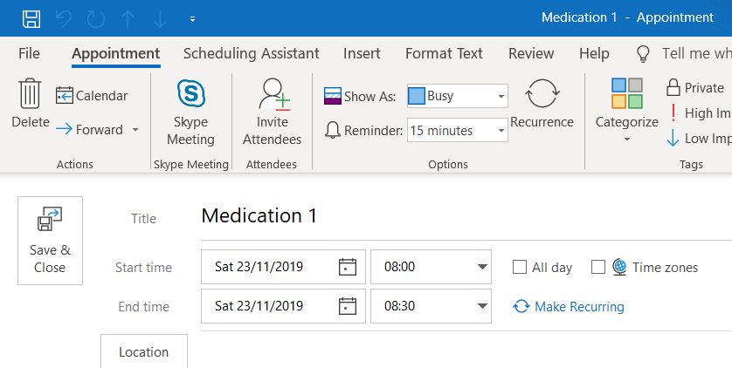
Figure 2-2 Microsoft Outlook appointment window

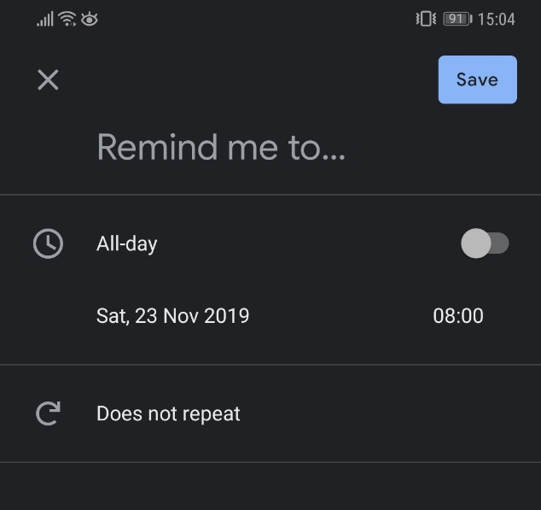
Figure 2-3 Android calendar reminder screen

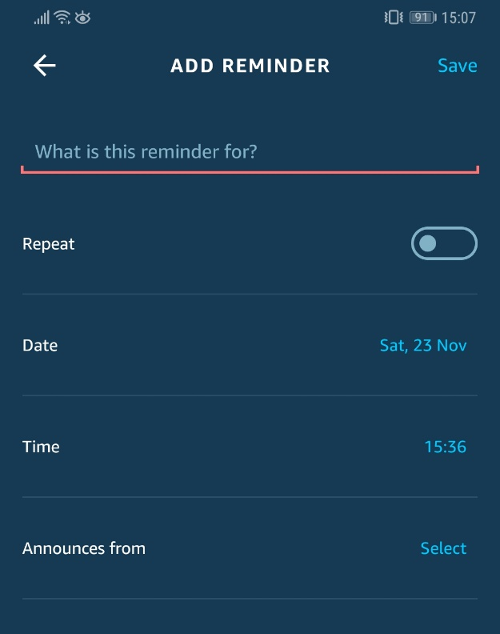
Figure 2-4 Alexa reminder screen

Several purpose-built mobile phone applications for medication reminders exist on the application stores. A comparison of these applications in Table 1 shows that there are standard applications which just have the function to remind and track medication, through to more advanced applications that have extra functionality including drug/overdose checker and monitoring for other conditions such as taking blood pressure, blood sugar levels, heart rate, etc...

App Name | Developer | Medication Reminder | Adherence Tracker | Flexible Dosing Schemes | Family Sharing | Other Condition Logging | Logbook | Drug Interaction Checker
Medication Reminder & Pill Tracker [52] | MyTherapy
Pill Reminder & Medication Tracker by MediSafe [53] | MediSafe
Medication Reminder [54] | level38
Medication Reminder, Pill Tracker & Refill: Medica [55] | MedicaApp
Pills Time Medication Tracker & Pill Reminder [56] | Mobile Creatures
Pill Reminder & Medication Tracker – TakeYourPills [57] | TakeYourPills |  |  |  |  |  |  | *
Pill Reminder & Medicine App – MedControl [58] | Przemysław Słota
Table 1 Comparison of top 8 apps on Google Play Store (as of 11/12/19)
* Checks potential over-dose rather than interaction

Future Proposed Products
A paper produced by Singh and Varshey [41] proposed a system that was context-aware, and the user would be alerted under three conditions:
- The medication is due
- The medication has not yet been taken
- The medication is still safe to take (in the case of any drugs interactions or overdose if the dosage has been delayed and is close to another dose time)
Ramljak [59] proposed a proof of concept system that could alert users via multiple methods by making use of a smart home:
- Automated phone call
- Automated text message
- Text to speech (home assistant)
- A message displayed on a smart TV

The Internet of Things
This section will discuss the Internet of Things (IoT), defining what IoT is, IoT benefits and drawbacks, and current IoT systems and products related to this project.

What is the IoT?
In 1999 the “IoT” was originally a term that referred to a computer network which can obtain a large amount and broad variety of data from embedded sensors in physical components within the offline world, as per Ashton, referenced by Lee and Kim [60, p. 92].
The IoT is still defined as a network of various components like sensors, however it now includes motors, actuators, etc. which can all be embedded into everyday objects that can perform a multitude of tasks such as collecting and analysing data, communicate with modules, humans, various electronic products such as computers and smartphones, and execute actions autonomously [61]–[63]. It is one of the core technologies (along with Artificial Intelligence (AI), Virtual Reality (VR) and robotics) which is driving toward a new revolution of the Internet age [60, p. 91], [64].
The task automation factor of IoT positively impacts several aspects of everyday life for both private and business users [65]. An example of such is by using the “If This Then That” (IFTTT) model, which is just a trigger and action; once the first thing happens, IFTTT actions the second [66]. An example of a basic IFTTT “recipe” is one that could simply alert a user if a temperature sensor has increased or decreased to a certain value; if temperature is less than or equal to, or if temperature is greater than or equal to, alert the user.

IoT Hardware
An IoT system is developed with at least an embedded communication unit such as a microcontroller (MCU) and various components like sensors or actuators [67].

Boards
A board comprises of an MCU and additional connectivity modules such as Wi-Fi and Bluetooth.
An MCU is one of the core of the main elements of a small computer (Control unit and arithmetic logic unit) and it controls the processes and functions of a system [68]. Its primary role is to processes the information relayed to it via the connected sensors and execute the required process or function [69], whether this be to read another sensor, send data to a user, or to perform an action with an attached sensor or actuator [70, p. 390].
There are various MCU platforms; the most common of which being Arduino [71], NodeMCU [72] and Raspberry Pi [73], though Raspberry Pi is classed as an actual computer it is still used on smaller scale projects. The selection of an MCU can be determined on whether it is being used for just prototyping, or development, and the varying features and specifications will play a part.

Sensors
A sensor is a device or component that can provide a useful output in response to physical, chemical or biological changes as outlined by the IEEE standards [74, p. 12]. Depending on the system being developed, there are a multitude of sensors available:
- Temperature and humidity
- Proximity
- Pressure
- Water quality
- Chemical
- Gas
- Smoke
- IR
- Motion detection
- Accelerometer
Sensors could be applicable to medication adherence, such as proximity or motion detection sensors – if the sensors detect the user is in a specific room, a system could alert the user on different systems that are in that room to save every system in the property being alerted. If the medication was perhaps being stored in an inappropriate area (direct sunlight, too hot, too humid, etc..), then this could potentially be alerted to the user to revise the medication storage area by utilising a temperature and humidity sensor, or a light dependant resistor (LDR) for sunlight.

Actuators
As defined by the IEEE, an actuator is a component that responds to a stimulating variable or signal by providing a physical output [74, p. 5]. In the everyday world, these are components that can manipulate the physical environment such as:
- Linear actuators
- Motors
- Relays
- Solenoids
Linear actuators or motors could be used in a pillbox to control a medication delivery/dispensing system.

Wireless Connectivity
One of the main, and possibly most important parts of an IoT system is the communication module [75] to allow the system to both transmit and relay information in a structured manner. An IoT system can use either a wireless or wired protocol, but the primary method of communication is wireless as the sensor system can easily be placed where it needs to go, and depending on future development and scalability, maintenance, energy efficiency and the use case, it can be implemented into a wireless sensor network (WSN) with ease [76].
There is a plethora of wireless communication protocols [77]–[79], each with their own defined standard. The most widely used include:
- Short-range radio protocols; Zigbee, Bluetooth low energy (BLE), Wi-Fi, near field communication (NFC) and radio frequency identification (RFID).
- Mobile networks; Global System for Mobile Communication (GSM) (2G – 5G).
- Long-range radio protocols; Long range wide area network (LoRaWAN) NarrowBand-IoT (NB-IoT) and Long-term Evolution Machine Type Communication (LTE-MTC).
The most suitable protocols for this project could be BLE or Wi-Fi. A mobile application could be developed that connects to the product via BLE. If using Wi-Fi, it could be possible to set the product to host a Wi-Fi network to allow devices to connect via this protocol.
Possible other methods could include NFC or RFID for user authentication, or to maybe dispense medication once the user scans their tag against a reader to disallow other people from taking the users medication.

IoT Security
In a report produced by the European Union Agency for Cybersecurity [80, p. 11], it is predicted that the number of IoT devices will reach 20 billion by the year 2020. Security measure and good practices will be paramount and will need to be considered during development of an IoT system to ensure information security (confidentiality, integrity and availability [81, pp. 185–186], [82, p. 5]) and for maximum threat mitigation.

Threats
The types of threat to an IoT system can be attacks on the system itself (physical), the network (communication method), the service and the user [83].
The Open Web Application Security Project (OWASP) organisation have completed a project and released the 2018 top 10 IoT security vulnerabilities [84], such as encryption, authentication and access control, which could allow access to an IoT system or network potentially leading to not only information insecurity, financial loss and system downtime, but possibly a risk to life due to the types of industry (automotive [85], agriculture [86], and the previously referenced smart homes and medical sector) that the IoT is utilised in.

Threat Mitigation
ISO/IEC 30141 [87] provides an internationally standardised conceptual model, reference model and architecture view specifically for the IoT, the IoT Security Foundation (IoTSF) has provided a framework [88] for guidance for businesses moving from standalone products to networked connected devices and services, and the Department for Digital, Culture, Media and Sport (DCMS) have produced a code of practice for IoT security [89]. These cannot mitigate every threat, but it can help to minimise the threat in the first instance.

Existing IoT Products
The list of existing IoT products and systems increases each day when users come up with new ideas. These products include environmental monitoring systems such as weather stations [90] and Geiger counters [91] as well as also covering the day-to-day aspect of the home automation area with toasters [92], coffee makers [93] and mirrors [94].

Existing IoT Products Within Healthcare
The step into IoT within healthcare has been relatively recent and aims to improve various aspects such as the patient’s quality of life and their medication adherence. Some existing healthcare products that utilise aspects of the IoT are the FreeStyle Libre continuous glucose monitor [95] which is aimed toward people that are affected by T1DM. This £2-coin sized device is attached to the patients arm and continuously monitors their blood glucose levels and stores them throughout the day for up to 8 hours. This product has been shown to improve medication adherence and quality of life in patients as per research performed by Pintus and Ng [96]. A trial performed by Peterson et al utilised sensors and mobile technology to remotely assess a patients vital signs and weight on a daily basis, which allowed them to recognise the early stages of dehydration and support early intervention to improve symptom management in head and neck cancer patients [97].

Pill Container
A pill container, pill box, pill organiser, or dosette box, is a container that can come in different shapes and sizes (Figure 2-5 and Figure 2-6) and its purpose is to help manage a patient’s medication regime. It can be an effective strategy to assist with medication adherence [98] in general, and a container can sometimes come with basic reminders such as dosage times and/or days to further improve adherence.

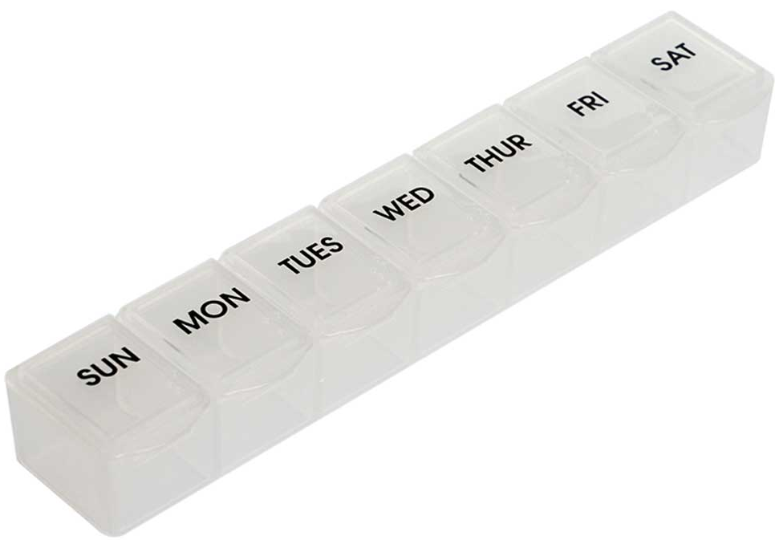
Figure 2-5 7 day pill organiser (single dose per day) [99]

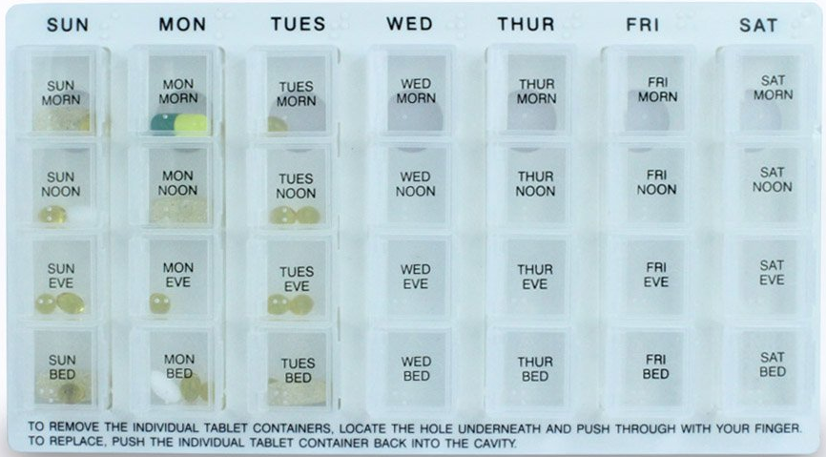
Figure 2-6 7 day pill organiser (four doses per day) [100]

In a BBC podcast between James Gallagher and Debi Bhattacharya of the University of East Anglia, the discussion of pill organisers was brought up and a study [101] shows that between 30 – 40% of patients that were given these pill organisers, they either did not want them or did not like them.
The possibility of losing slight independence by the patient previously having their own routine when taking medication, and now having to rely on these organisers can have a potentially negative effect. Along with this loss of independence may come some form of psychological detriment as the patient could possibly feel that they are no longer in control of some aspects of their lives and depending on the mental state of the patient it may seem daunting feeling that they are not able to complete, what may be perceived by some, as simple everyday tasks.
The second potential negative effect which was also outlined by the research in the podcast could be if a patient is not taking their medication as required and effectively under-dosing through the day, then a pill organiser is introduced, the consumed medication dose may be increased which can lead to undesired effects.

Medication Storage
A pill containers primary function is to store the medication within it. There are some variables to be considered with medication storage, such as the temperature and humidity of the environment, or with the need for medication to be stored in a dark place, rather than in sunlight. If medications are not stored correctly, they may not be able to maintain their physical, chemical or pharmacological properties [102]. If these storage standards are not met, the medications potency and patient safety may be at risk with alterations in the chemical compounds [103] .
Childproofing will need to be considered due to potential safety hazards to younger children getting into the pill container and taking the medication [104]. However, the design of the childproofing method will need to take into account the patients that may suffer with conditions such as the previously mentioned motor conditions as they may not be able to access the medication in some circumstances [105, p. 176].

Temperature & humidity
Ensuring medication is stored within recommended temperature ranges, regardless of the storage environment, is as it is shown that different medications can suffer varying degrees of degradation depending on the temperature, humidity and length of time stored, for example epinephrine, though not part of a regular medication schedule, can have its potency degrade by up to 64% if stored incorrectly for up to 12 weeks [106]. The majority of product information from pharmaceutical company’s state that the recommended temperatures are within the ≥2°C and ≤8°C range for refrigerated medications, and ≤25°C or ≤30°C for room temperature medications [107].
Though a pill container may not self-regulate its temperature, the environment needs to be considered where the patient may be keeping it.

Material & transparency
Photosensitive medications are a group of drugs that it is essential to be protected from sources of light [102], which includes drugs such as vitamin C, insulin, epinephrine and a number of other drugs [108]. These drugs can again have their chemical properties altered if stored in a source of sunlight, affecting potency and potentially patient’s safety, therefore the material used, and the transparency properties of the material would need to be taken into consideration when proposing a pill container.

Existing Products
Some current medication containers utilise amber glass as shown in Figure 2-7, or enclose the containers in opaque cartons to protect the integrity of the medication from sunlight [102], [109].

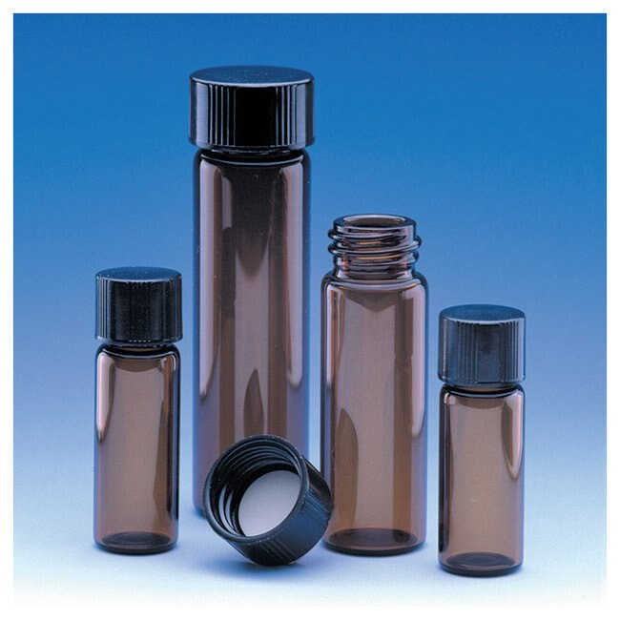
Figure 2-7 Fisherbrand amber glass vials [110]

Smart Medication Dispenser
Combining the IoT paradigm with pill containers has led to the development of smart medication dispensers. These are pill containers that at their very basic level, utilise timed dispensing to automatically dispense medications at the user specified dose time(s).
These can have additional features such as storing medication adherence history for a caregiver to review or potentially re-order medication automatically.

Existing Systems
There are multiple smart medication dispensing systems available on the market currently. Some of the more popular ones are the Pivotell Advance Dispenser [111] (Figure 2-8 and Figure 2-9) and e-pill Med-Time [112] (Figure 2-10), both taking a similar stance on a disk shaped design, which supports up to 28 doses that can either be timed and taken over the course of one day, or up to 28 days if only taking medication once a day.

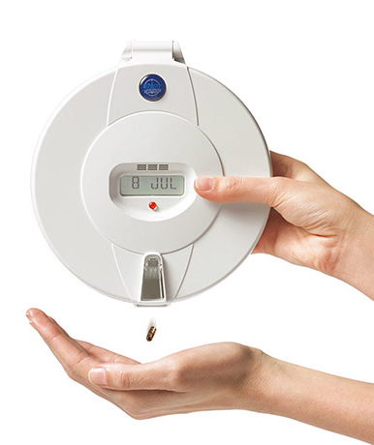
Figure 2-8 Pivotell opaque plastic lid

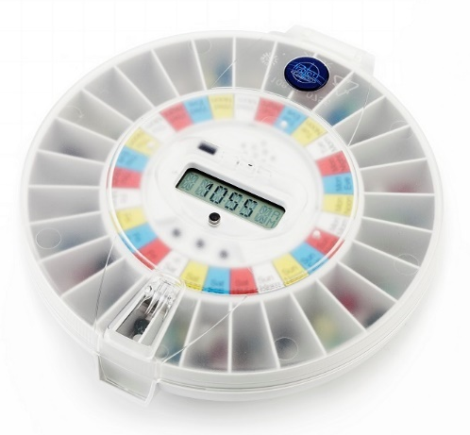
Figure 2-9 Pivotell clear lid

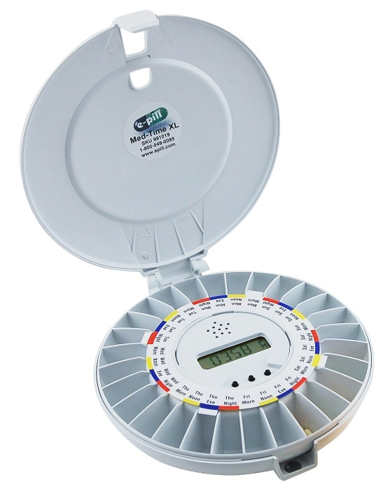
Figure 2-10 e-pill Med-Time XL

Another popular medication dispensing system under the e-pill umbrella is the e-pill MedSmart PLUS [113] (Figure 2-11). On top of following the previous model design, it has the ability to alert caregivers if a medication dose has been missed via either automated phone call, e-mail or SMS message.

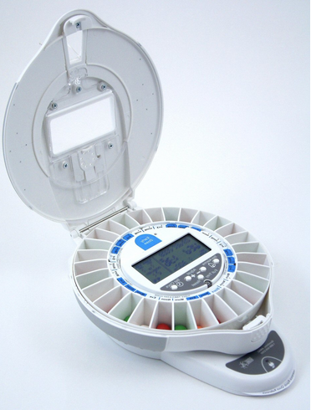
Figure 2-11 e-pill MedSmart PLUS

Proposed Systems
Multiple systems have been proposed over the years to build upon the existing smart medication dispensing systems.
Vial et al [114] describe a prototype dispenser that can deliver two different medications at (almost) the same time, utilises an interesting method of medication delivery (Archimedes screw), and incorporates visual communication with the patient by providing an LCD display and buttons for medication dispensing. The system has aptly been labelled a dual canister dispenser.
The intelligent medicine box (iMedBox) [115], proposed by Yang et al is highly technically advanced over the previously noted systems as the functionality it has is as follows:
- The ability for remote prescription management for a doctor or caregiver to remotely manage a medication schedule or dose,
- Medication reminders via audio or video reminding
- Medication adherence monitoring
- First aid alarm in case of adverse drug reaction, or potential overdose
There are several other features such as security, RFID tags, etc... however the one downfall is it does not dispense medication, it “opens” to allow the user access to medication. Though this is still a very good system, someone with motor disease may have problems opening the medication boxes from within the iMedBox system.

Prototyping
It is common to use a mock-up, model or another representation to explore a product or system before it is built [116]. This can range from something as basic as a model made of cardboard cut-outs through to graphical simulation, and now the ability to 3D print has been developed. Prototyping can help highlight potential design flaws and can assist with defining product or system requirements at an early stage.

Rapid Prototyping (3D Printing)
Rapid prototyping, also referred to as additive manufacturing, solid freeform fabrication and various other terms [117, p. 2], is a layer-based automated manufacturing and fabricating process for making 3D objects directly from CAD data. It can open many opportunities in numerous fields, medical included, though there are multiple strict medical laws regarding hygiene conditions of the machine(s) producing medical equipment [118].
There are a number of rapid prototyping technologies, the most accessible one being 3D printing due to its fast speed and low cost [119].

User Interface
A user interface is considered one of the key components in software applications, as it acts as an interface, or translator, between the end user and the applications functionality [120]. On this basis, a user interface will be a requirement for the smart pillbox as the caregiver, or patient, will need to be able to enter the medication schedule for the controller in the pillbox to be able to store it and perform its relevant processes of dispensing medication.
There are two main ways of implementing a user interface; a web interface or some form of iOS or android application. Both would need to have some form of login or authentication for patient safety, so the medication regime is not changed in a potentially malicious way.

Web Interface
A web interface would be accessible via Wi-Fi, so the interface in question would need to be hosted and allow the user to connect to it.
Due to limitations of a number of IoT boards, it may only be possible to have a simple login page with credentials stored locally, rather than being hosted in a database. Again, regarding the database, it may be a case of the medication schedule would need to be stored locally also. Going forward, if it is possible to implement an SQL database to store these pieces of information it would be better, or even have the boards connect to a server that hosts all of the information instead.

Mobile Application
A mobile application could either be an android or iOS application that connects to the pillbox via the Bluetooth protocol. An advantage a mobile application could potentially have would be the information could be stored locally to the phone instead, however this would not be useful if it was a caregiver’s phone that may have multiple clients, and there could potentially be some concerns with data protection.

Conclusion
From the given information it is clear that there is a large collection of people that can benefit from a smart medication dispenser. Though some relevant devices already exist, they are not all IoT or smart devices – it would be beneficial to have a device with network connectivity for a whole host of features such as practitioners or specialists being able to access a log of whether the patient has taken the medication. The next chapter will discuss both the research and development methodologies used for this project, along with the resources required.

Methodology
This section will discuss both the chosen research and development methodologies with relevant justification.

Research Methodology
Here the chosen research methodology, outlining the philosophy, strategy, and the three approaches taken, will be described.

Philosophy
Though one of the research approaches (case study) is better suited to a phenomenological approach, the positivism philosophy has been selected for this project. Both hardware and software will be developed, then testing will be performed to gather data on the product. Current software engineering and electronics theories and principles already exist, so these will be utilised and built upon to achieve the end product in a fully working state. Positivism is also the best choice for the chosen research strategy which will be discussed next.

Strategy
The research strategy to be implemented will be a deductive strategy. An experiment will be performed to ensure the product works correctly through in-house testing, rather than the medical or care world, and data will be gathered to endorse the products suitability and correctness.

Approaches
The three approaches taken for this project that will be discussed in this section are:
- Literature review,
- Case study,
- Software and hardware development
The following sub sections will justify why these approaches are required.

Literature Review
The first approach would be a literature review. This is required to investigate any current products that have been developed, or proposed systems that are maybe in the works and to also gather information about what could potentially work or not work through the project.

Case Study
The second approach selected is a case study. Though more suitable to a phenomenological methodology, the product is being developed for a specific problem. The case, or problem at hand, is as described in the background information; there are multiple groups of people that come under the umbrella of both motor and cognitive impairment that struggle with their day-to-day lives, and by completing this project it may be able to provide some improvement to their quality of life.

Software and Hardware Development
The third approach is software (and hardware) development. Both a physical product (the automatic medication dispenser) will be produced, and either an application or web interface will also be created to accompany the medication dispenser providing functionality to the end user.

Risks & Limitations
The potential risks to project completion include:
- Failure to develop the primary features,
- Failure to obtain relevant hardware,
- Failure to develop financially viable product,
- Failure to meet with project supervisor
In an attempt to combat these potential risks, a software requirement document will need to be produced to outline the core features and functionality of the product, along with a hardware requirement document to specify which hardware may be required with the product build. Combined with this could be a cost sheet outlining potential cost of parts, and this can be taken into consideration not only when developing a prototype, but when evaluating the end product.
Some risks may be out of reasonable control such as if specific parts need to be ordered from outside of the UK, it may take a long time to arrive here, however in this case it would be best to order parts early and continue with other parts of development.
Regular meetings will be required with the project supervisor to promote project timeline adherence, and also as the project supervisor will be assisting with the 3D printing.

Validity, Reliability & Generalisability
Specified here are the validity, reliability and generalisability aspects of this project.

Validity
It is believed that the previously mentioned approaches provide a viable means of investigation into the problem that this project aims to resolve. Without relevant background knowledge from a literature review and case study, the potential impairment the end users face would not be known and therefore the end product may not be fit for purpose.
Once the prototype has been designed and built, the software will be tested inhouse rather than in the real world or medical environment due to ethical concerns and test results logged.

Reliability
If this was being researched by another investigator, it is likely that they would obtain the same knowledge as has already been provided. If they were to develop a hardware and software solution for this problem, though it may appear visually different, it is likely that it would share similarities as has been outlined in the literature review – the majority of products and papers reviewed all share similar functionality, albeit some have more advanced features than others.

Generalisability
As outlined in the background information, there is a relatively large target user group that may benefit from such a project, so this project would be quite generalizable.

Data Evaluation Methods
This section will discuss the type of data that will be collected, the method of collection, and the evaluation of the total end data.

Data Collection
Through the testing phase of the project data will need to be gathered to fulfil two specific needs:
- Does it do what it is meant to do (dispense medication at specific days or times)?
- Is the user able to use the product without any problems?
To answer these two questions, originally a questionnaire would have been developed utilising the system usability scale [121], allowing the product usability to be measured, however due to the COVID-19 pandemic the testing method had to be changed to a cognitive walkthrough, allowing for in-house testing and feedback only. The dispensing functionality will be tested via monitoring of the product to see if it does dispense correctly, and also a log will be implemented and pushed to when dispensing is completed.

Data Evaluation
Carrying on from the data collection, as external user data will not be able to be obtained instead the cognitive walkthrough feedback will be used to look at further enhancing and producing a second version of the prototype, implementing the required features or making the changes relevant to making this product more usable to the possible untrained user.
Data from the dispensing log will need to be evaluated by comparing the actual dispensed time to the required dispensing time.

Development Methodology
This section will describe and justify the development methodology chosen for this project.

Software Development Methodology
From the various software development methodologies available, feature driven development (FDD) has been selected for this project as the software will be produced in a feature driven way in iterations. Each iteration of development will provide updated, or newer functionality. Each iteration could be classed as a version release.

Resources
This section will outline the resources that will be required to complete this project. It will entail hardware, software and external resources.

Hardware Resources
The main hardware resources that will be used are:
- A computer,
- A 3D printer,
- An IoT board,
- Sensors,
- Screw stepper motors,
- Piezo buzzer,
- Push button
The sensors required for the project would be primarily a digital humidity and temperature (DHT) sensor to read temperature and humidity, and an LDR to potentially read light values. However, these sensors would not be required for a basic product and could feature in a future version.

Software Resources
The main software used throughout the project will be:
- Autodesk Inventor Professional 2020,
- Microsoft Word,
- Microsoft Excel,
- Visual Studio Code,
- Arduino Sketch,
- WAMP,
- 3D printing software

External resources
The main external resources required would be a 3D printer. As these are not easily accessible for personal use, a 3rd party will be required for 3D printing of the medication dispenser.

Conclusion
With the research and development methodologies chosen, the next chapter will begin the design of the product and the methodologies will now be implemented.

Design
This section discusses the requirements and design for both the software and the hardware sides with the initial thoughts and planning.

Requirements
Most of the requirements were compiled during the literature review, but they surround patient safety and the functionality of the product itself. These were completed using the MoSCoW prioritisation method (rather than validated learning or walking skeleton) as it is suitable for a project with a small amount of functionality and with a clear aim for what is required from the literature review and case study [122].

Hardware Requirements
The hardware requirements mainly concentrated on the design of the dispenser itself and are outlined in Table 2.

 | Requirement
Must Have | Dispense medication
Must Have | Be accessible for medication re-fill
Must Have | Store medication securely
Must Have | Accessibly for electronics installation and maintenance
Must Have | Wireless chip for access point
Should Have | A buzzer to alert user that medication dispensed
Should Have | A button to disable the alert
Should Have | Child proofing
Should Have | Print of default SSID and credentials
Could Have | LED’s that light up to show user meds dispensed
Could Have | Temperature/humidity sensor to detect whether medication is stored correctly
Could Have | QR code for wi-fi connection and login
Will Not Have | None
Table 2 Hardware MoSCoW requirements

Software Requirements
The software requirements for the dispenser would be mainly around the user, schedule, time, and the dispensing functionality. These requirements are outlined in Table 3.

 | Requirement
Must Have | Host an access point
Must Have | Have a user login
Must Have | Allow user to input days/times of medication
Must Have | Store medication schedule locally
Must Have | Keep track of time
Must Have | User interface to interact with device
Should Have | Store schedule in a database
Should Have | Log of dispense times
Should Have | Offline functionality
Could Have | Customised logins for user personalisation
Will Not Have | None
Table 3 Software MoSCoW requirements

Hardware Design
The first steps tackled were the hardware design. There were several draft versions using a “trap door” method of dispensing the medication as show in Figure 4-1.

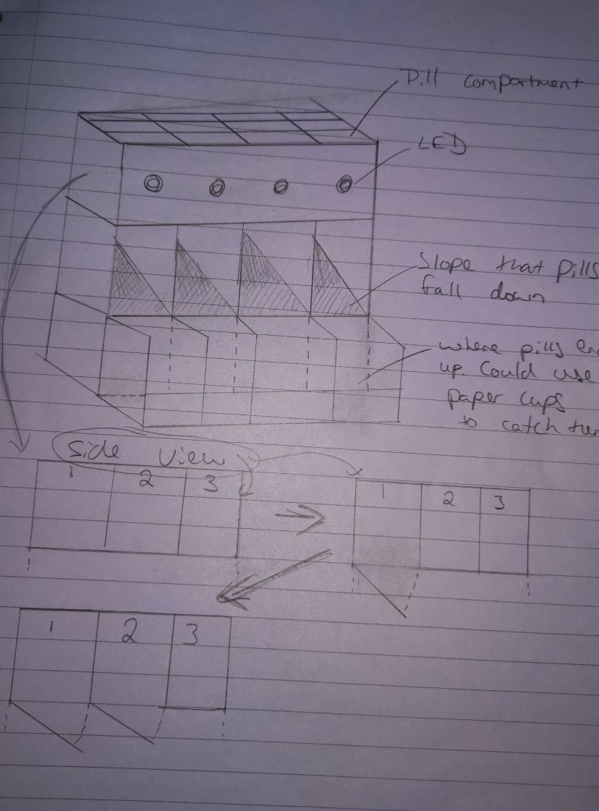
Figure 4-1 “Trapdoor” method

Draft 1.0
Draft 1.0 (Figure 4-2) originally was going have the bottom compartment open, then the second, third, etc. However, when looking at this realistically, the medication may end up being dispensed and accidentally bouncing off of the bottom dispensing ramp and away from the dispenser, and with a higher number of doses it may have difficulties remaining upright.

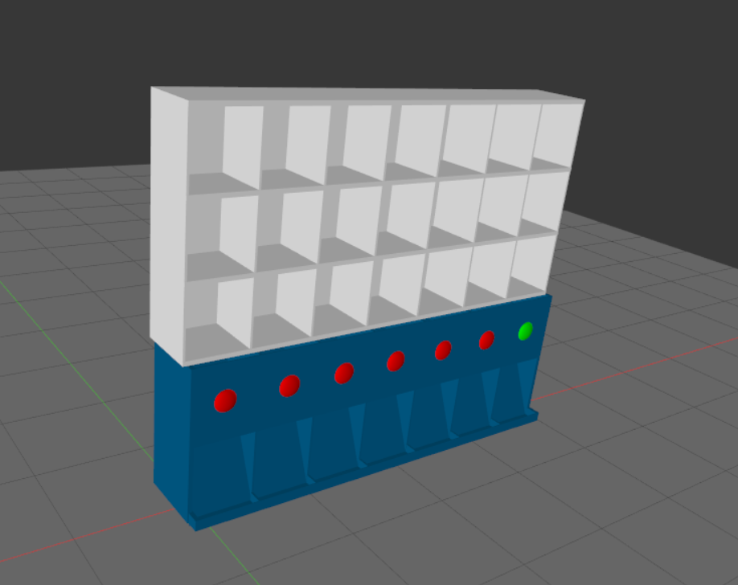
Figure 4-2 Draft 1.0

Draft 2.0
Draft 2.0 (Figure 4-3) attempted to resolve these potential problems by being more horizontally focussed, potentially more portable and more aesthetic, but could again be met with problems with medication being dispensed and falling off of ledges, under items, etc.

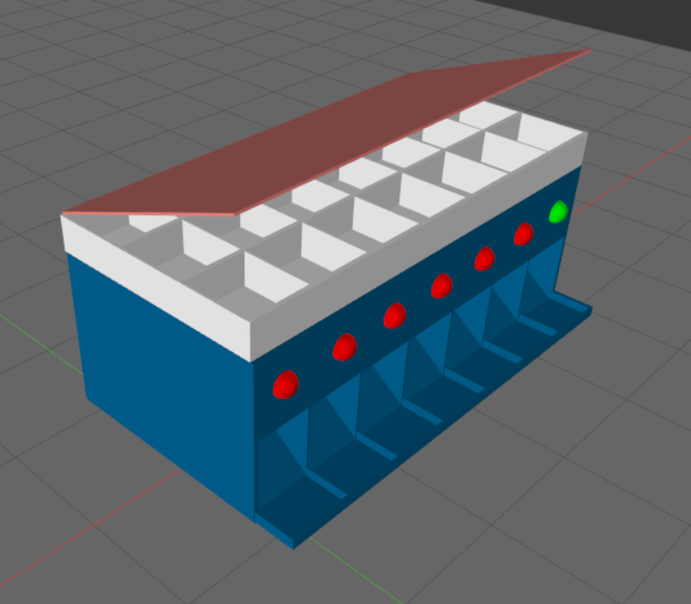
Figure 4-3 Draft 2.0

Draft 3.0
Draft 3.0 (Figures 4-4 and 4-5) was then implemented to tackle the dispensing issue completely by including a section where paper cups would go for medication to fall into. This could increase the ease of the user taking the medication also as they would not have to pick up individual tablets, just the paper cup.
Figure 4-4 Drawing of draft 3.0

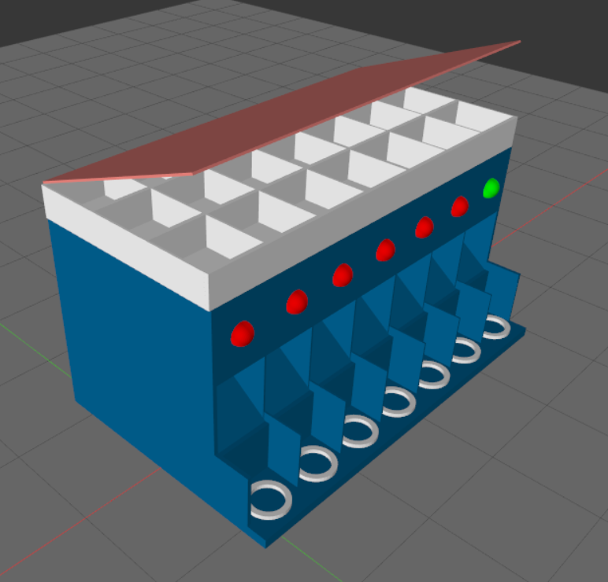
Figure 4-5 Draft 3.0

Draft 3.1
Thinking this was the most viable, draft 3.0 (Figures 4-6, 4-7 and 4-8) was then created in AutoDesk Inventor for the project supervisor to 3D print and some slight modifications were made; to allow for access to the electronics a removable back was added.

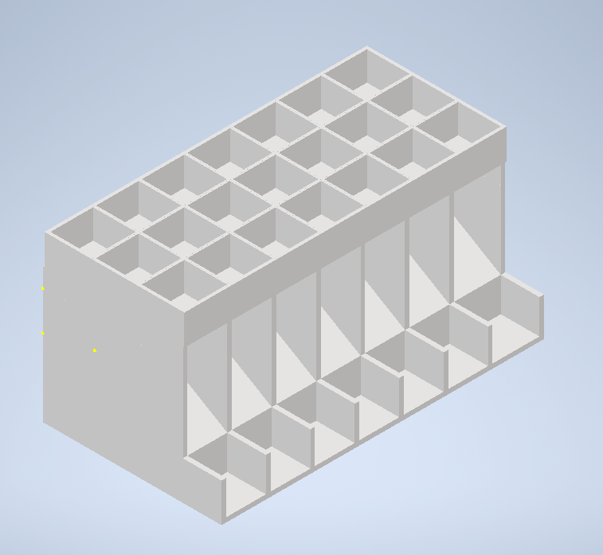
Figure 4-6 Draft 3.1

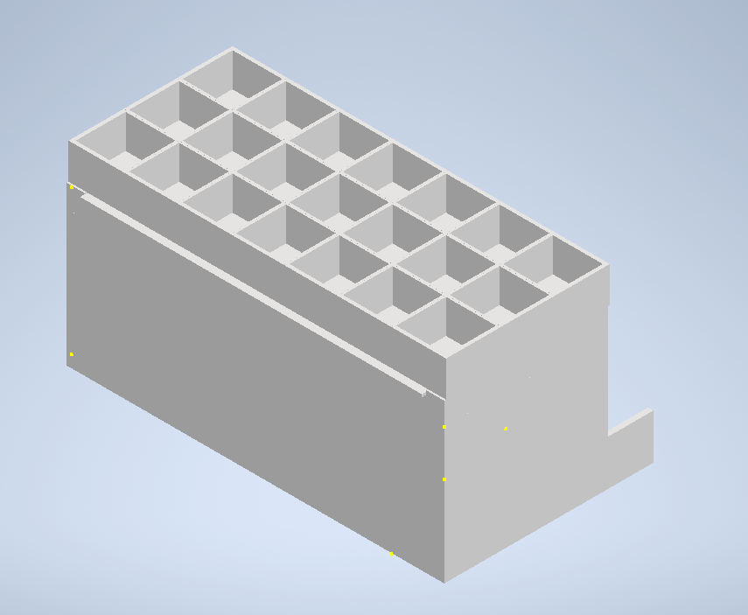
Figure 4-7 Draft 3.1 back

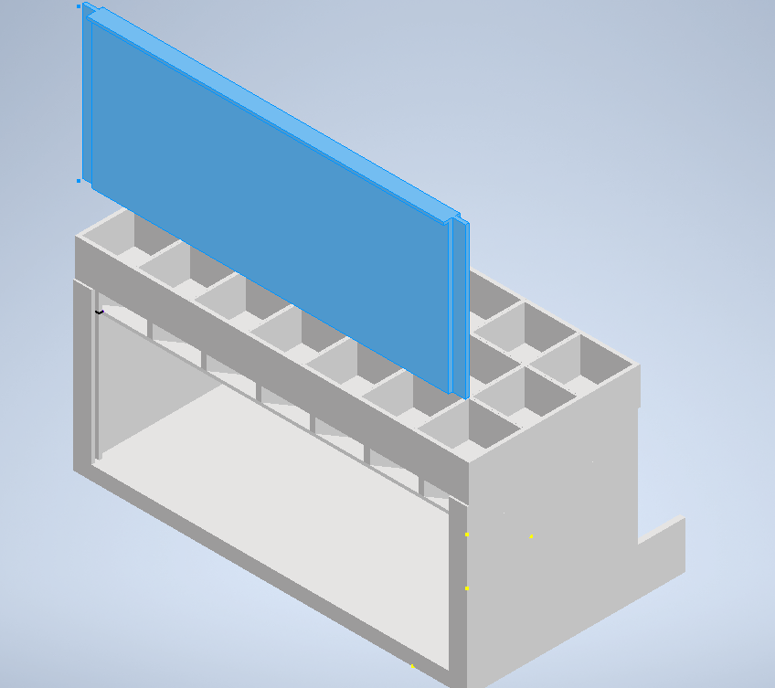
Figure 4-8 Draft 3.1 back 2

Draft 4.0
For a prototype, 3.1 could be viable, however utilising the trap door method would require up to 21 modules that can open these compartments. The only methods that were thought of were by using actuators, or screw motors. Both unfortunately would be rather expensive, especially as the dispenser should be set for up to 8-10 doses per day, meaning rather than 21 compartments it would be handling up to 56-80 doses per week. This would not be viable on a cost basis to the manufacturer nor to the consumer.
Draft 4.0 (Figure 4-9 and Figure 4-10) was implemented by using a similar design to Draft 1.0 but executing a different delivery method; a motor and a material such as a pliable plastic sheeting. As outlined in Figure 4-9, the electronics would be stored in the large section at the front and have motors across the width of the container. These would turn and as they turn for a set number of seconds, retracting a plastic sheet, and in turn that would release medication down to the funnel and into the paper cup at the bottom. The medication container would be removable to allow for replenishing of the medication.

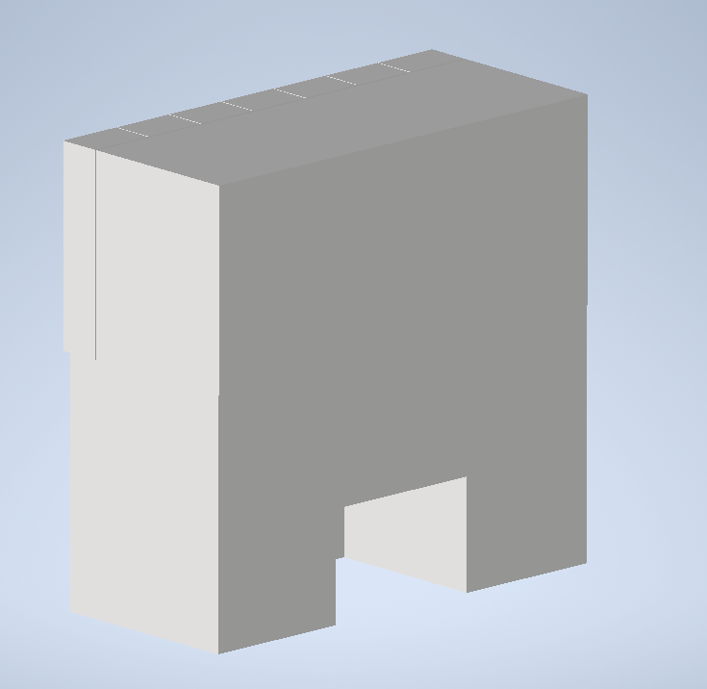
Figure 4-9 Draft 4.0 front

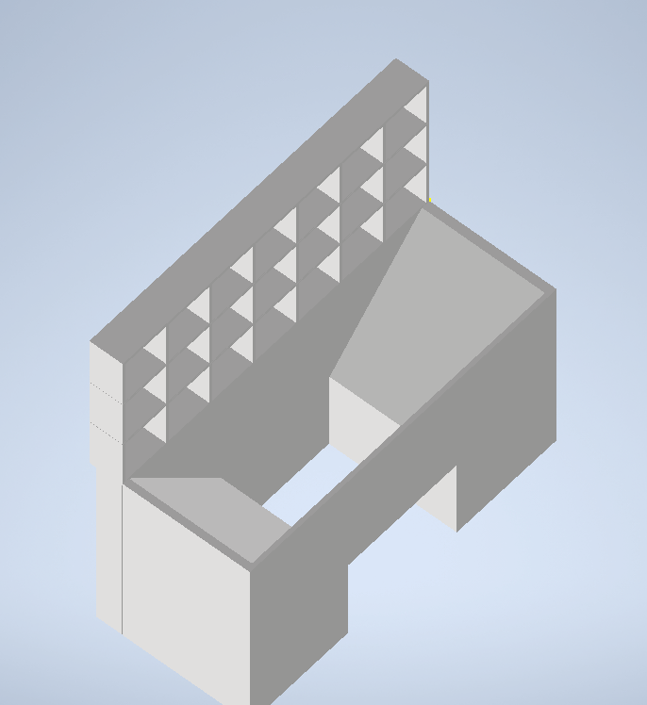
Figure 4-10 Draft 4.0 top view

Software Design
The software design originally was a basic application (Figures 4-11 and 4-12) allowing a login with navigation options for the user to access the functionality of the application.

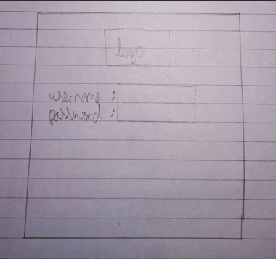
Figure 4-11 Application login page

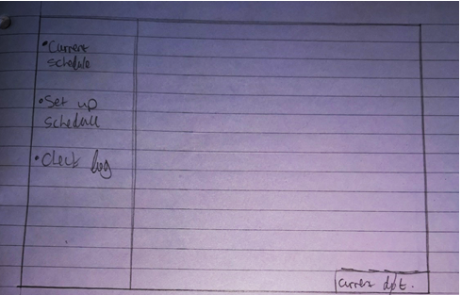
Figure 4-12 Application navigation

Conclusion
The requirements outlined should allow the product to meet the aims and objectives outlined at the beginning of the project. It is thought that through the iterations of product design, the final design (draft 4.0) is likely to be the best suited. The software design may need to be changed throughout development, depending on what additional features may be added.
The next chapter will describe the implementation of the product itself.

Implementation
As described in the methodology chapter, the development for the automated
medication dispenser was implemented via FDD, so each section herein will be aimed at discussing an implemented feature to meet the product requirements. Each section will have some form of feature testing. Due to the amount of functions developed not each one will be logged as a test case, though thorough testing was carried out throughout the development stage.
The hardware development comprises of two sections; the dispenser case itself and the wiring and modules.
The software development was split into three sections; the database, the PHP web service and the node device code. In the first instance, the node device code was developed first however upon realising flaws with the data storage described within the following sub-heading this was re-written after the database and web service was implemented. Originally this was completed in timeboxes.
The initial development idea for the project was to implement an Android application and utilise a Bluetooth connection to the Node device, however due to problems with getting any sort of working prototype in either Android Studio or Xamarin for Visual Studio, it was decided to still create a product but utilise a Wi-Fi connection instead for proof of concept.

Container
The container case was developed using 3D printing by the project supervisor from the provided CAD files that stemmed from the hardware design drafts. Unfortunately due to the COVID-19 pandemic it was only possible to get draft 1.0 printed (Figures 5-1 and 5-2) as there was a lot of decision making going into further drafts and design changes were happening relatively quickly, it was decided not to print each iteration and only to print the final draft to stop material and time wastage due to the amount of time it takes to print a 3D object on a personal 3D printer.
The original plan (pre-pandemic) was to have the final version of the prototype printed using one of the larger 3D printers at the university, as they have a larger print bed and would be able to print the model at a larger size which would be more suitable for the end product.
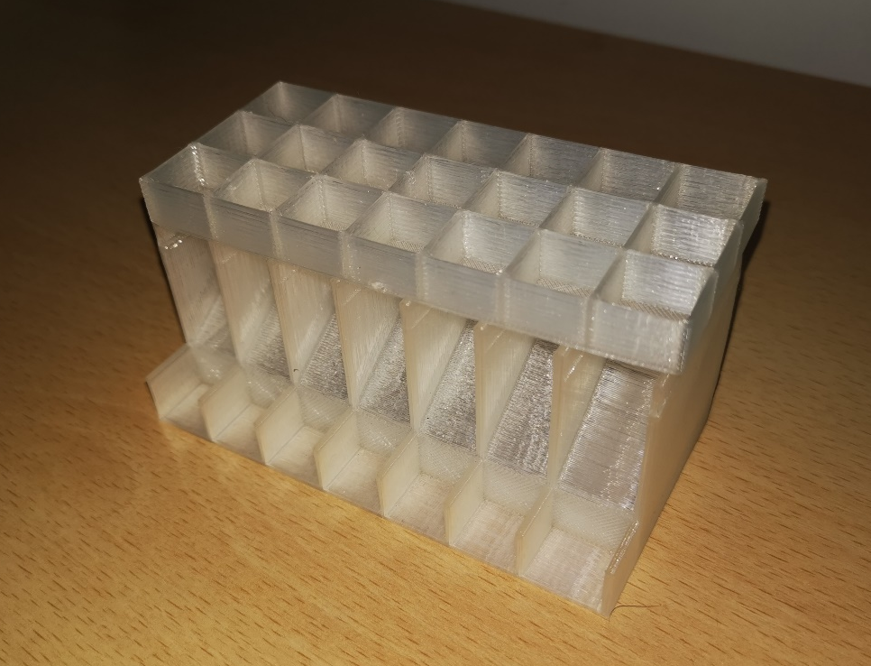
Figure 5-1 Draft 2.0 3D print 1

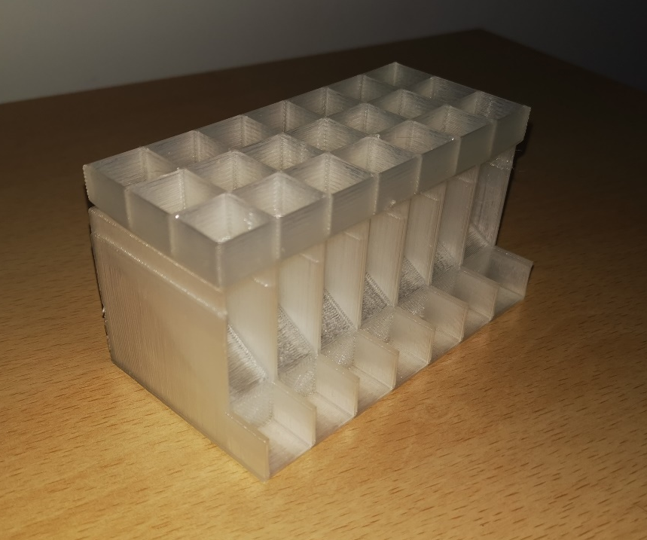
Figure 5-2 Draft 2.0 3D print 2

MCU
The MCU that was originally decided on was the Espressif ESP32 development board [123] as primarily the idea was to control a large amount of motors and it was thought this would be ideal as there are 32 general purpose in/out pins (Figure 5-3).
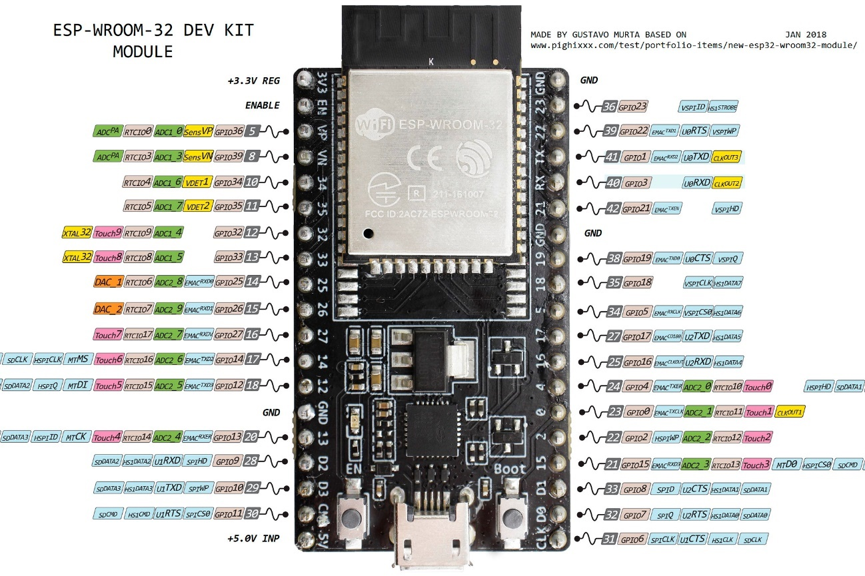
Figure 5-3 ESP32 pin layout [124]

This was fine for a prototype, however clearly with a potential for up to 56 – 70 doses per week, this would not be suitable. 74HC595N 8-bit shift registers [125] were then planned to be added.

8-Bit Shift Register
Each of these 8-bit shift registers (Figure 5-4) could theoretically control up to 8 modules ($Q_{A}$ to $Q_{H}$ in Figure 5-5), so only 7 will be required, 1 for each day over the course of a week.
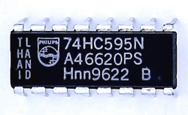
Figure 5-4 74HC595N shift register [126]

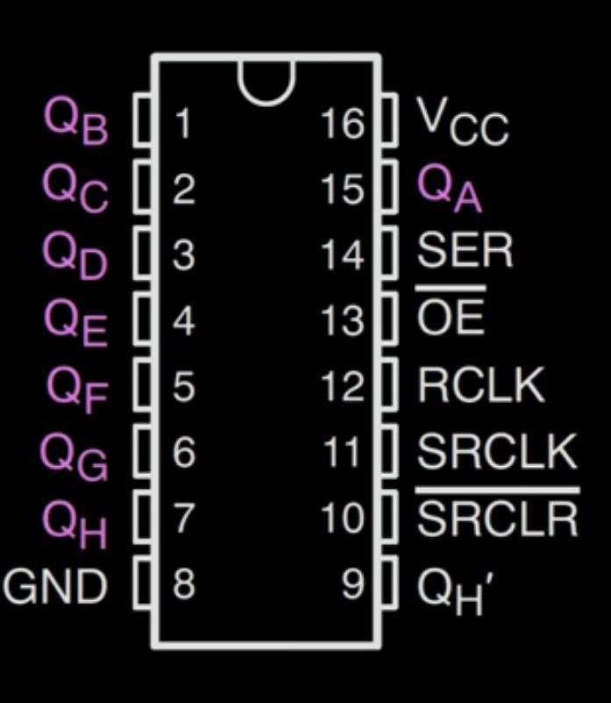
Figure 5-5 74HC595N layout

This worked correctly and it was possible to power up to 8 LED’s by only using one data pin (Figure 5-6), so it should have been possible to further develop this to power stepper motors. These could then be daisy chained by utilising the prime pin ($Q_{H^{'}})$ to connect to the data line on the next chip, passing the binary values through and allowing a further 8 modules.

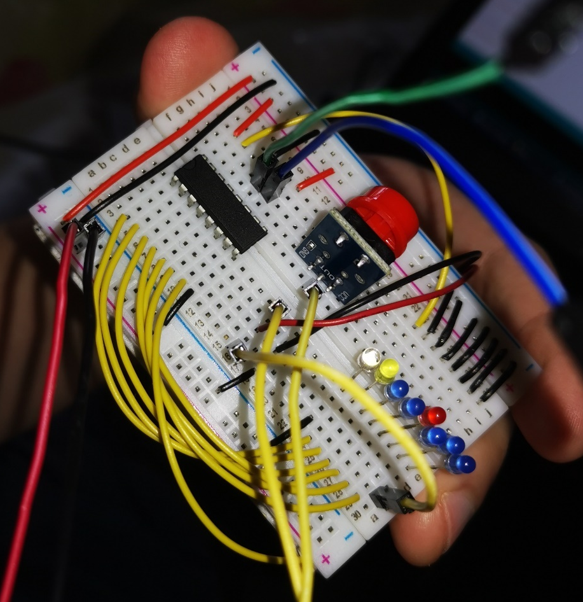
Figure 5-6 Breadboard with 74HC595 bit shift register

Modules
The main modules used for this project were the screw stepper motors, LEDs, a push button and a piezo buzzer.

Screw Stepper Motor
As previously described the idea was to utilise a screw stepper motor (Figure 5-7) to slowly lower and raise a trapdoor mechanism for the medication dispenser and several different motors were purchased to determine which size would be best per design, however through development it was deemed not feasible to utilise this method. The idea was to instead utilise these stepper motors to revolve and retract a plastic sheeting that could come between the dose compartment and the dispensing section of the container.

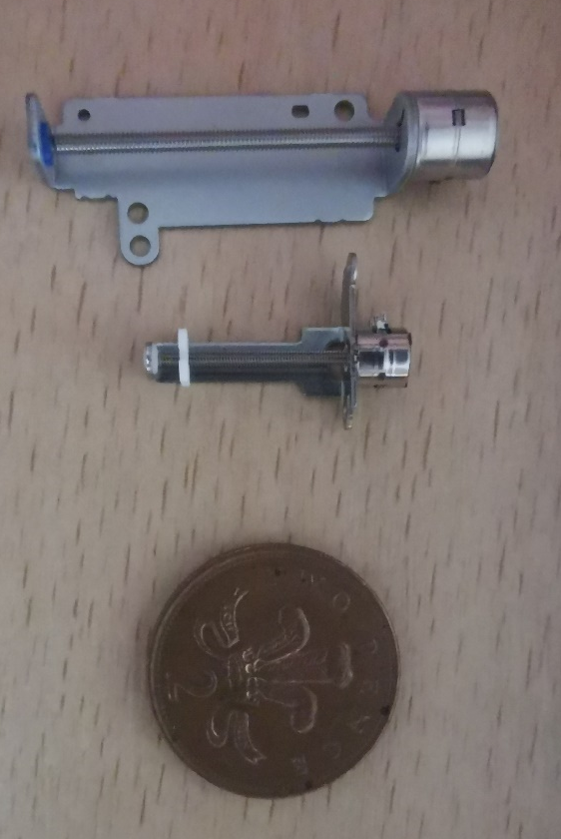
Figure 5-7 Screw stepper motors (2p for size comparison)

LED
A simple LED was to be used to alert the user that the medication had been dispensed, in the event that the user does not hear the piezo buzzer or to cater for people which may be hard of hearing.

Push Button
A push button (Figure 5-8) was utilised to allow the user to disable the alert.

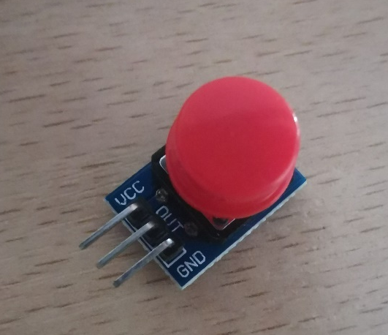
Figure 5-8 Push button

Piezo Buzzer
A piezo buzzer (Figure 5-9) is a device that produces a tone at a specified frequency and was connected to alert the user, along with the LED, that the medication had been dispensed.

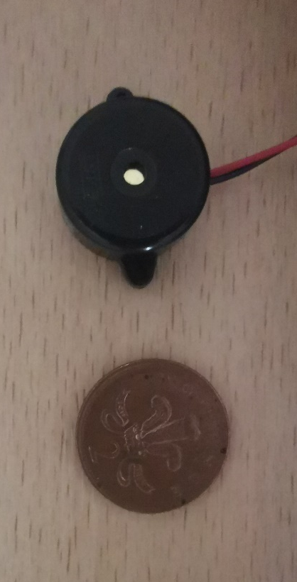
Figure 5-9 Piezo buzzer (2p for size comparison)

Wiring
A simple wiring scheme was followed (Table 4) for consistency and to make it simple to identify the circuitry.

Colour | Purpose
Red | Power
Black | Ground
Yellow | Data i/o
Table 4 Wiring scheme

End Hardware
Due to the previously mentioned issues with cost and the amount of stepper motors required, the container was re-designed to only use a single bit shift register to power the 7 stepper motors as described in section 5.1.2.1. At this point on the timeline, access was restricted to the electronics lab attributable to the COVID-19 pandemic and it was not possible to connect the stepper motors as they require soldering. As an alternative, the hardware was again re-designed (Figure 5-10 and Figure 5-11) to just include a single LED to light up, and piezo buzzer to alert once a dose was required, and the push button to disable the two.

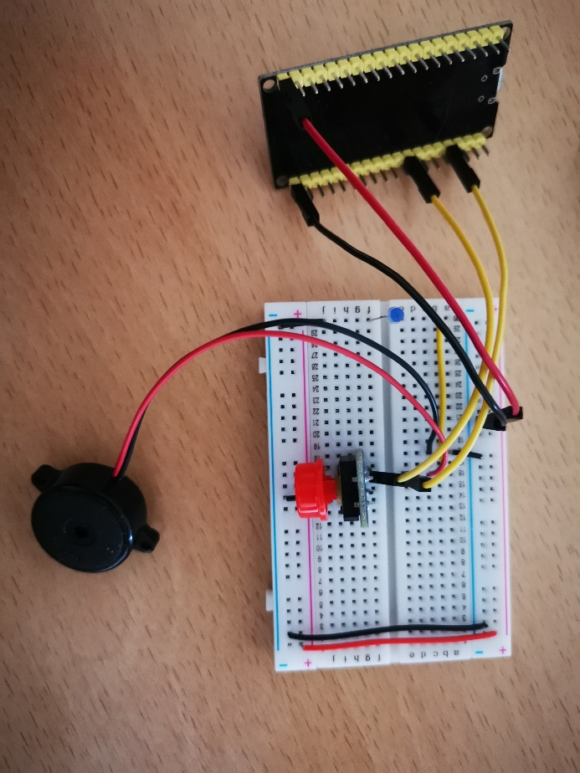
Figure 5-10 Final breadboard circuit

Figure 5-11 Fritzing sketch of breadboard

Database
Originally the idea was to implement data storage on the node device itself and utilise its on-board memory to store a JSON object, however upon development and testing of this it was found that JSON object storage is not ideal as the library utilises a monotonic allocator, meaning that it cannot release memory when objects were removed [127] as the JSON object size is declared during the setup function (Figure 5-12).

Figure 5-12 JSON array declaration

If a user was to remove a dose time and then add a new dose, once it had reached the maximum allocated memory it would fail to write again as memory de-allocation was not possible.
The next idea was to just store the data in an array on the node device, which works correctly, but the question was brought up; What happens if the device is reset? To answer this question, the data would be lost as the memory in this node device is volatile. However, in response to this an SQL database was implemented as shown in Figure 5-13.

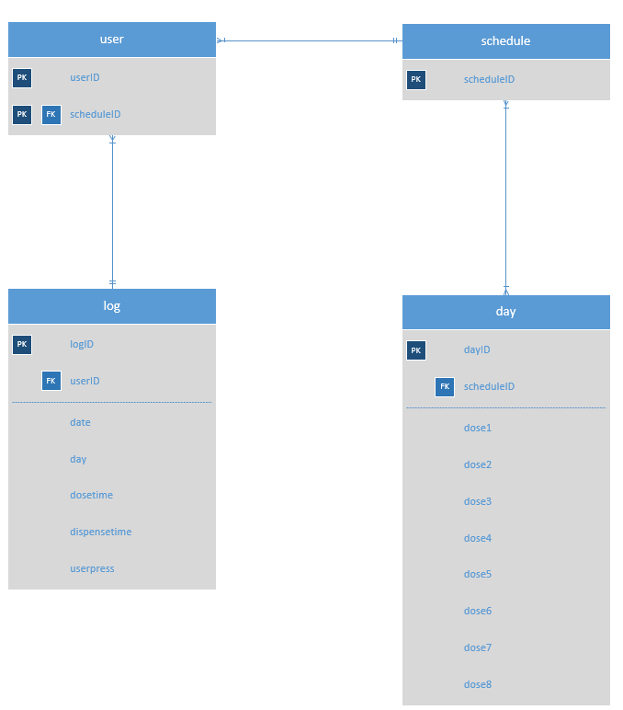
Figure 5-13 Database ERD

The database design is simple for a proof of concept however it can be expanded to include additional users and user credentials for a personalised experience. This was not implemented for this project due to potential data protection and ethics policies that would need to be adhered to for data storage. The day is also expandable; it would be possible to set up to 8-10 or more doses on the server, but the user could only set 2 or 3 on their device if that is all they need through the day.
Going forwards this also could act as a centralized server for many of these devices rather than just the single product developed for the project.
The requirements met with this feature were data storage – The dose schedule is stored locally to the node device and there is also a database set up for a backup.

PHP Web Service
The developed PHP web service acts as an intermediary between the node device and the database. The design has two core functions; to serve the device with data, and to store data from the device.
Two separate .php files control the storage and retrieval of the schedule information, and two more .php files control the storage and retrieval of the log information.

UpdateData.php
Though it could have been implemented in a single .php file as just “CRUD” manipulation, the choice was to keep them separate for simplicity. This object (Figure 5-14) inserts data into the database passed to it by the node device.
A main method is implemented to retrieve the referenced “GET” parameters from the device, append them to an SQL query, then execute the SQL query, inserting the values into the database. A simple bubble sort was implemented. Although this is poor in terms of complexity as on average the complexity is $O(n^{2}$), though only a small amount of data is being sorted it was believed to be acceptable and if the array was to house larger data stores, perhaps another sort such as merge sort would be more appropriate [128].

Figure 5-14 UpdateData.php UML diagram

GetData.php
The second .php file (Figure 5-15) has just one main method; read the weekly schedule. This performs an SQL query to get the users 7-day schedule from the server and echoes it back to the node device in a readable format that the node device can parse. It does this by converting the date and time to a time object and then echoing the required parameters.

Figure 5-15 GetData.php UML diagram

UpdateLog.php
Primarily this object (Figure 5-16) was implemented for the testing to retrieve whether the device had executed the dispense function, and to store the times of the dose along with the time it had dispensed the item.
It has been further updated to include the time that the user has pressed the button to confirm they have received their medication and disable the alert.
A simple SQL query updates the server to add the record of the date, day and time that the medication has dispensed and the time the user pressed the button to disable the alert.

Figure 5-16 UpdateLog.php UML diagram

GetLog.php
This object (Figure 5-17) simply reads and echoes out the log from the database depending on the UserID that is passed into it as a parameter. It has been coded to only show the previous 7 days of data (Figure 5-18) by using a date comparison. Obviously going forward if a proper reporting suite was to be created, this option could be made variable to select a week, a fortnight, a month, 3 months, 6 months, etc… However, for the purpose of a small log on a mobile device, only the previous 7 days of logging has been implemented.

Figure 5-17 GetLog.php UML diagram

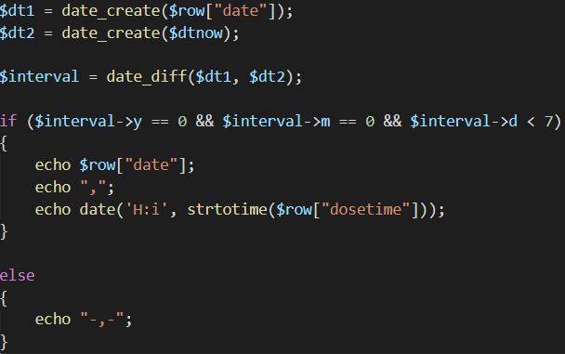
Figure 5-18 Date comparison in PHP

Node Device Code
Through the development of the software, several third-party libraries (along with the core Arduino libraries) were utilised to enhance the functionality of the device. These libraries were for NTP [129], ArduinoOTA [130], HTTPClient [131], ESP8266WiFi [132], Tone32 [133] and WebServer [134].
The node device code originally was written in a procedural programming manner, however as the project expanded and more functionality was included, it was deemed necessary to re-write in an object-oriented manner. The object-oriented programming (OOP) version has been broken up into core areas and the objects handle different functionality and were implemented in the following order as functionality developed:
- HostAP
- SQLConnection
- DateTime
- User
- Schedule
- WebHandler
- Dispenser
- Alert
- Log

HostAP
Though this project would ideally include building an Android and/or iOS application, this was not possible as stated earlier. The chosen communication technology was Wi-Fi to get a working proof of concept for this project.
The HostAP object (Figure 5-19) contains the network SSID and passphrase information for the user to connect to an access point that is hosted by the node device. The network address configuration needs to also be set.
Once this is set and executed, a soft AP is instantiated to allow users to connect to it. An SSID and passphrase will be printed on the product itself along with a QR code if possible, to allow ease of use for the user to connect.

Figure 5-19 HostAP class UML diagram

HostAP Test Cases
The access point needs to work correctly so will need to be tested to ensure it is active and allows a user to connect. The test cases for this are shown in Appendix A.1.
- Test case PB_AP_1a is to test whether the AP creates successfully.
- Test case PB_AP_2a is to test whether the user can connect to the AP.
As show in Appendix A.1, Figures A-1-1 and A-1-2, these are successful.

HostAP Evaluation
Basic functionality is being built upon for a minimum viable product. The current soft AP will allow the caregiver to connect to the MCU and access the functionality of this product for setting up a dose schedule.
The default credentials for the host AP will need to be printed somewhere on the pillbox itself or a quick response (QR) code for ease of use for less technically minded users. The decision hasn’t been made to allow the user to change them for ease of use as of yet due to possible user forgetfulness and having to perform a factory reset on the device.
This soft AP implementation satisfies the requirement for hosting an access point.

SQLConnection
The SQLConnection object (Figure 5-20) handles the connection to the network where the SQL server is being stored. Clearly in the ideal implementation where an application was developed, the server address would be hard-coded, and it would work off of the user device by pushing data to/from the server via the application. Instead in the implementation for the project, the Wi-Fi credentials need to be stored on the MCU in order to connect to the Wi-Fi.
The SQLConnection is able to build the URL to query data, depending on the UserID that is defined, and it handles the connection to the server to query or update the user schedule and log.

Figure 5-20 SQLConnection class UML diagram

SQLConnection Test Cases
The test cases for this object are shown in Appendix A.2.
- PB_SQL_1a test case was developed to ensure that the SQL connection was correctly reading the schedule from the SQL server by building and printing the URL to the serial connection along with the schedule being read and parsed from the server.
As shown in Appendix A.2, Figure A-2-1, this was successful.

SQLConnection Evaluation
The SQLConnection works correctly and allows the retrieval and update of information on the SQL Server. If the method of utilising Wi-Fi was to be used going forward, it would be an idea to allow the user to enter their Wi-Fi credentials once they have connected to the node device.
This would have been implemented; however, the Wi-Fi connection needs to be instantiated during the setup function of the node device and a way of circumventing this has not been found. The functionality for the user to update their SSID and passphrase has, however, been implemented.
The SQLConnection class completes the requirement that the schedule should be stored on a server.

DateTime
The DateTime class (Figure 5-21) utilises the network time protocol (NTP) to get the epoch time from the specified NTP server. From this value the day of the week is calculated, and the timestamp is set. A method of this object is called constantly in the main loop to keep the date and time updated.

Figure 5-21 DateTime class UML diagram

DateTime Test Cases
The test cases for this are shown in Appendix A.3. The DateTime needs to correctly display the day and time so the dose schedule works correctly.
- PB_DT_1a tests to ensure the day and time is correct.
- PB_DT_2a tests to ensure the day and time is correct while the device is offline.
- PB_DT_3a tests if the device still works when the clock changes due to BST.
- PB_DT_3b re-tests if the device still works when the clock changes due to BST.
As shown in Appendix A.3, Figure A-3-1, this shows that this works correctly while connected to the network. Appendix A.3, Figure A-3-2 unfortunately does not work correctly in the offline mode. Appendix A.3, Figure A-3-3 fails with the time zone change, but this is resolved in Appendix A.3, Figure A-3-4.

DateTime Evaluation
The DateTime class works correctly and is able to update the time for the users. However, if the user’s internet connection drops or is unavailable this can cause problems as the returned time will not be correct. Though there is an internal clock on the node device, there are numerous reports of inaccuracy [135]–[138] which would not be acceptable for a project such as this with a potential impact on QoL or a life and death scenario with drug interaction or overdose. To counteract this there are three possible workarounds that have been thought of:
- Utilise an external real time clock (RTC) module attached to the node device and update this only when the internet connection is available as this would allow the node device to keep the correct time whilst it is offline,
- Get the date/time from the database server,
- Allow the user to update the day and time themselves and rely on an external RTC module.
The first option has not been implemented due to time constraints with ordering modules and applying this into a working product. The second option will only work if the database is stored locally and on the same local area network (LAN) the pillbox is connected to. The third option would currently be the easiest to implement, however again the RTC module has not been implemented.
As long as there is a network connection, this satisfies the requirement for the timekeeping. Again, this would be optimal with an Android/iOS application and the data being pulled from the device.

User
The User class (Figure 5-22) could be expanded as previously described to allow user registration and customised logins based on usernames, e-mails and password authentication. As a proof of concept, this has not been implemented and instead credentials have been hard-coded for user login. This class allows different schedules to be bound to the user, so again the functionality is available to allow different users to have different schedules.

Figure 5-22 User class UML diagram

User Test Cases
The test cases for this are shown in Appendix A.4.
- PB_Us_1a tests the user login, to ensure that no one is able to connect to the node device and log into the site with malicious intent as there will be an extra layer of security.
As shown in Appendix A.4, Figure A-4-1, the user is prompted to login once connecting to the relevant page.

User Evaluation
The User class works as intended and again, could be taken further to implement personalised user logins.
This satisfies the requirement for there must be a login to keep the user dose schedule secure.

Schedule
The Schedule class (Figure 5-23) comprises of methods that deal with updating or retrieving the user schedule. The main methods of this class are to parse the user schedule when it is passed in from the SQLConnection and to calculate the next dose time.

Figure 5-23 Schedule class UML diagram

Schedule Test Cases
The test cases for this are shown in Appendix A.5.
- PB_Sched_1a tests to ensure the next dose is updated correctly.
- PB_Sched_2a is a test that ensures the schedule is not invalid if the user is offline, and the user still has the ability to set their dose schedule up. This instead will be saved locally to the device.
As per Appendix A.5, Figures A-5-1, A-5-2, A-5-3 and A-5-4, these work correctly.

Schedule Evaluation
The schedule array size is hardcoded on the node device to allow for (currently) up to 8 doses per day for a week. Users are able to enter up to 8 doses per day, including varying doses (e.g. 2 doses Monday, 4 doses Tuesday, 2 doses Wednesday, 6 doses Thursday, etc..) and it is able to reliably calculate when the next dose is required.
It is assumed that once a medication regime is set by a doctor or specialist and the correct doses and dose times are set, this regime would not change. However, in the instance that it may change on a weekly basis, it should be possible to expand the schedule array on the node device to allow for any number of days and doses, and the database is easily expandable.
This class fulfils the requirement for allowing the user to input days and times of medication, and the device storing the medication schedule (locally).

WebHandler
The WebHandler class (Figure 5-24) controls the web connection that the user sees. It is comprised of methods that change the output of the website depending on the link the user is browsing to. Though the container has external access for the DateTime class (to a specific NTP server) and SQLConnection (to a specific IP address), this WebHandler class has its connection restricted to only allow access to the web pages that the node device hosts and no external access at all.

Figure 5-24 WebHandler class UML diagram

WebHandler Evaluation
The WebHandler is able to correctly display every current page that is required across multiple browsers on two devices. Unfortunately, due to limited funding and devices it was not possible to test this on other platforms (Apple), nor on many different sized screens, but it is assumed it should work correctly as the browsers should be similar between devices.
No test cases were produced for the WebHandler due to the possibility of such a large amount of test cases being shown. Each page was shown appropriately when the relevant page was called so it is ensured that this works correctly, and instead screenshots of each page are available within Appendix B.
The WebHandler class satisfies the requirement for requiring a user interface for device interaction.

Dispenser
The dispenser class (Figure 5-25) checks to see if a dose is required to be dispensed and contains the dispensing function.

Figure 5-25 Dispenser class UML diagram

Dispenser Test Cases
The test cases for this are shown in Appendix A.6.
- PB_Dispense_1a checks to ensure the time comparison works between current time and the scheduled dose time. If day and time now is equal to the day and time of next dose, dispense.
As shown in Appendix A.6, Figure A-6-1, this works correctly and the dispense function is called.

Dispenser Evaluation
The dispenser class contains the “dispense” function, and though the hardware has not been implemented fully, this would only need to be included in the function and it should work correctly.
This would meet the requirement for dispensing the medication if it was possible to implement the hardware as the function would just need to be adjusted.

Alert
The alert class (Figure 5-26) contains the buzzer, button and LED functionality. If a dose is dispensed by the above Dispenser class, then an alert will be created by playing a tone and lighting up the LED until the user disables it by pressing the button.

Figure 5-26 Alert class UML diagram

Alert Evaluation
This class works correctly when required and satisfies the requirement of needing to alert the user via some form of alarm to notify when their medication has been dispensed. As with the WebHandler evaluation, no test cases were completed for this as it is not possible to show the buzzer being set off. The alert worked correctly each time a medication dose was required, and the push button correctly disabled the piezo buzzer and LED when pushed.

Log
The log class (Figure 5-27) contains the methods to update the log once the medication has been dispensed and when the user has received their medication to turn the alarm off. It also contains the method to parse the log file from the SQL server and to parse into an array for use with the WebHandler class to display the user log.

Figure 5-27 Log class UML diagram

Log Test Cases
The test cases for this are shown in Appendix A.7.
- PB_Log_1a checks to ensure the log is pushed to once the dose is dispensed.
- PB_Log_2a checks to ensure the log is read from the SQL server and displayed correctly.
As show in Appendix A.7, Figures A-7-1 and A-7-2, the log is correctly pushed to and updated on the SQL server. Appendix A.7, Figure A-7-3 shows that originally there were some problems with parsing incorrect values and displaying invalid characters, but this was corrected as shown in Appendix A.7, Figures A-7-4 and A-7-5 and the log works correctly on the node device.

Log Evaluation
The log class has been proven to be effective in sending the log to the SQL server, and it successfully parses the log from the SQL server into an array, allowing the user (patient, caregiver, specialist, etc…) to see the log file for the end user.

Conclusion
The software has been implemented fully to ensure project success, and the hardware development has been completed as best as possible. There are areas for future improvement as discussed within each evaluation section and there were some problems along the way, but it is believed that this is in a working state currently and the evaluation of the tests is now to be completed as discussed in the next section.

Evaluation
A large portion of the feature development test data was gathered and provided in section 5. Along with this, a test log was implemented that was added to each time the medication was dispensed as part of the long-term evaluation, and a cognitive walkthrough was also completed. Ideally a system usability test would have been performed, rather than a cognitive walkthrough, to gather different views of users testing the product, however it was not able to complete this due to the COVID-19 pandemic and instead a cognitive walkthrough was carried out to gauge appropriateness and to ensure that the pillbox would be in its ideal state as a finished product.

Feature Testing
As outlined in section 5 with the test cases, the majority of tests passed correctly, and the features that failed were resolved if it was not out of reasonable control.
From the conclusion in section 5, it is shown with the completed testing that each part works correctly and is fit for purpose, each increasing a step toward the end goal of a working product.
As shown in Table 5 and 6, each of the “must have” and “should have” requirements have been met if they have not been outside of reasonable control, and each sub-section from the implementation is noted to outline which functionality completes said requirement.

Software
 | Requirement | Completed | Comment
Must Have | Host an access point | Y | 5.5.1 HostAP
Must Have | Have a user login | Y | 5.5.4 User
Must Have | Allow user to input days/times of medication | Y | 5.5.5 Schedule / 5.5.6 WebHandler
Must Have | Store medication schedule locally | Y | 5.5.5 Schedule
Must Have | Keep track of time | Y | 5.5.3 DateTime
Must Have | User interface to interact with device | Y | 5.5.6 WebHandler
Should Have | Store schedule in a database | Y | 5.4.1 Update Data  5.5.2 SQLConnection
Should Have | Log of dispense times | Y | 5.4.3 Update Log  5.5.9 Log
Should Have | Offline functionality | Y | 5.5.5 Schedule
Could Have | Customised logins for user personalisation | N | Not implemented due to feature prioritisation
Table 5 Software Requirements

Hardware
 | Requirement | Completed | Comment
Must Have | Dispense medication | Y | 5.5.7 Dispenser
Must Have | Be accessible for medication re-fill | N | Not completed due to COVID-19
Must Have | Store medication securely | N | Not completed due to COVID-19
Must Have | Accessibly for electronics installation and maintenance | N | Not completed due to COVID-19
Must Have | Wireless chip for AP | Y | 5.5.1 Host AP
Should Have | A buzzer to alert user that medication dispensed | Y | 5.5.8 Alert
Should Have | A button to disable the alert | Y | 5.5.8 Alert
Should Have | Child proofing | N | Not completed due to COVID-19
Should Have | Print of default SSID and credentials | Y | QiFi used to generate QR code [139] (Figure E-1)
Could Have | LED’s that light up to show user meds dispensed | Y | 5.5.8 Alert
Could Have | Temperature/humidity sensor to detect whether medication is stored correctly | N | Not implemented due to feature prioritisation
Could Have | QR code for wi-fi connection and login | Y | QR code generator [140] used (Figure E-3)
Table 6 Hardware Requirements

Due to the COVID-19 pandemic, some hardware requirements were not completed due to a lack of access to the university resources such as 3D printers and the electronics lab. The code for a “Dispense” function had been written, and the electronics modules would just need to be defined and added to the code and the alert system was implemented using the modules available in a pre-purchased IoT pack.

Dispensing Log
Each time it was detected that a medication dose should be dispensed, a log record was created and updated with when the user pressed the button to say they have successfully received their medication and turn the alarm off. This allowed for the dispenser to be tested for its effectiveness and whether it is fit for purpose by completing the core task.
The medication dispenser successfully executed the dispense function on time with a 100% success rate over the course of a week and all within the first minute of the actual dispensing time. The original log is shown in Appendix C. There were 2 extra logs for a day during a demo for the project supervisor, hence there being 58 logs over a week rather than 56.

Cognitive Walkthrough
From the finished cognitive walkthrough as shown in Appendix D, ease of use was evaluated and though there were some issues, such as a user potentially not finding the correct option for what they wanted to do, fixes were implemented and the cognitive walkthrough completed again for the particular task showing a much better outcome for ease of use. Overall, it is believed that the user interface is fit for purpose and does not require the user to be overly technical.

Conclusion
As stated within this section, all of the software requirements were met, and some of the hardware requirements were met which were within control. As a result of this, the objectives to develop a software for the pillbox and to evaluate the pillbox have been met. Unfortunately, due to the COVID-19 pandemic it was not possible to complete the objective to develop a hardware for the pillbox.
Overall, some of the aims of the project were completed, however it is believed that without the pandemic hurdle then the project would have been completed successfully as everything that was able to be finalised without external resources was completed and evaluated effectively.
After the feature testing and cognitive walkthrough was completed, a user manual was also produced to guide the user through various functions of the dispenser itself and is shown in Appendix E.

Conclusions and Recommendations
As previously stated, the majority of the project was completed successfully with all of the software requirements being accomplished and the different evaluation methods implemented prove that the project is fit for purpose from a software perspective. If the COVID-19 pandemic was not ongoing then it would have been possible to completely fulfil the aims and objectives and have a fully functioning prototype by the end of the project.
If this project was to be repeated, in hindsight, the hardware would be completed first. Due to knowledge and expertise in the software field, this was completed as the primary objective and the hardware was built upon as the project grew.
From a resource perspective, it would be beneficial to self-provide items such as a 3D printer and electronics equipment, though the problem with this would be financing and time setting it up or getting items, such as a 3D printer, into a workable state. Regarding the 3D printer, rather than just a smaller residential size 3D printer, which was perfectly fine for the prototypes, a larger 3D printer would be required with sufficient print bed size to cater for a larger print for the full-scale model. Such a 3D printer could be the Creality CR-10S [141], which has a 30*30*40 cm print bed, the Form 3L [142], which has a 30*33.5*20cm print bed, or the Prusa i3 MK3 [143], which has a 25*21*21 cm print bed. Depending on the final version of the pillbox (if this is revised by someone with further hardware designed experience), these would be recommended.
If however there was a 3D printer available, it would have been possible to implement the rapid prototyping as outlined in section 2.6.1, then the production of a number of different physical models could have been used to decide which was physically, rather than theoretically, best and more suitable to install the electronics and network node devices to.
There are some future recommendations that could be made, such as using an RTC module as the device on board clock is not reliable, so accurate time keeping is not possible without that when the device is not connected to a network to utilise NTP and as previously stated in the requirements it may be an idea to include some form of sensors such as a humidity and temperature sensor to ensure that the medication is being stored in a correct way. A potentially suitable RTC module could be the Adafruit DS3231 [144].
The project could have been completed with something such as a raspberry pi, rather than the given ESP32, however this would have been completely impractical from a cost perspective due to being greatly over the required specification. Other than this, other node devices could have been used but depending on the implementation of the hardware and technologies it would be difficult to recommend a specific one. Some could include the NodeMCU LUA development board [145] for example as it is smaller scale and has less pins than the ESP32. The ESP32 was originally chosen due to wanting to implement a number of actuators or motors, however as stated in section 5.2 this became impractical and at the time the software development had progressed too far to change as it had already been designed using libraries specific to the ESP32.
The hardware and pillbox design may need to be revised by someone with experience in product design as the design itself was the most difficult thing to try and imagine.
Before beginning the project, it would have been beneficial to have some form of knowledge of mobile application development as going into this project with no knowledge was certainly ambitious. The learning curve, it seemed, was extremely steep going from prior programming knowledge to attempting to use either IDE.
Through the duration of the project, different features were developed and “bolted on” and regrettably some of them, such as the log, were developed much further into the project when decision had already been made to restrict the network connectivity of the node device. This meant that the log could not have been developed using any form of graphing suite for JavaScript or alike as it was not possible for the node client to connect to anything external to retrieve the 3rd party libraries required to build said suite, so as a potential recommendation it may be of use to develop this with external access to allow these 3rd party libraries to be utilised and produce a graphing suite within the interface.
The final item that would be changed if the project went through a second iteration would be to include user personalisation so this could be implemented on a wider scale. The addition of this to the database would allow different users to have their own personalised logins and schedules set up.

Reflection
The knowledge and application of experience throughout the degree course have proven crucial to the completion of this project to integrate the IoT technologies with a web service and database. Owing toward the background knowledge for this project were the following modules:
- Smart and connected devices, in which the basics of IoT development were explored through semester 1, and the basic PHP and database knowledge was acquired during semester 2.
- Distributed database management systems, providing knowledge for managing database systems and the theory behind database systems.
- Advanced web development for further and more advanced PHP development and database integration.
- Programming 1, programming 2 and advanced software development for providing the programming knowledge and enabling the skills to learn and develop object-oriented programming software.
- Introduction to web development and web application development for the skills for web development and design.
Further learning on application development has been highlighted by this project and allows for future professional development as a software engineer as the ability to design and create dedicated mobile applications could be highly beneficial in the toolset going into industry and career progression.
The literature review and initial research proved extremely interesting. Not only providing an insight to the daily lives and struggles of the possible target users of this product, but also allowing self-reflection and appreciation of good health.
Unfortunately, due to the COVID-19 pandemic there was no access to the electronics lab to complete the circuitry as some of the purchased motors (screw motors) required soldering. Along with the access to the electronics lab being cut off, as it was not possible to meet in person with the project supervisor it was also impossible to retrieve any further 3D prints of the designed pillbox. Into the testing phase, the original system usability testing would have been an excellent tool to gain user feedback and allow the testers “free reign” to potentially break the project so it can be fixed, and bugs resolved. Along with this feedback, being able to test on different user devices would definitely have been beneficial to the usability and attempting to make sure that the application worked on different mobile or tablet devices.

References
[1] S. Arlt, R. Lindner, A. Rösler, and W. Von Renteln-Kruse, “Adherence to Medication in Patients with Dementia: Predictors and Strategies for Improvement,” Drugs Aging, vol. 25, no. 12, pp. 1033–1047, 2008.
[2] S. A. Hendriks, M. Smalbrugge, C. M. P. M. Hertogh, and J. T. van Der Steen, “Dying With Dementia: Symptoms, Treatment, and Quality of Life in the Last Week of Life,” J. Pain Symptom Manage., vol. 47, no. 4, pp. 710–720, 2014.
[3] P. Raghavan, “Upper Limb Motor Impairment After Stroke,” Phys. Med. Rehabil. Clin. N. Am., vol. 26, no. 4, pp. 599–610, Nov. 2015.
[4] F. Lewis, S. Karslberg Scaffer, J. Sussex, P. O’Neill, and L. Cockroft, “The Trajectory of Dementia in the UK – Making a Difference,” 2014.
[5] Z. Jafari, B. E. Kolb, and M. H. Mohajerani, “Age-related hearing loss and tinnitus, dementia risk, and auditory amplification outcomes,” Ageing Res. Rev., vol. 56, Sep. 2019.
[6] M. Prince et al., “Dementia UK: Update Second edition.”
[7] K. Mikkelsen, L. Stojanovska, K. Tangalakis, M. Bosevski, and V. Apostolopoulos, “Cognitive decline: A vitamin B perspective,” Maturitas, vol. 93, Aug. 2016.
[8] “2019 Alzheimer’s disease facts and figures,” Alzheimer’s Dement., vol. 15, no. 3, pp. 321–387, Mar. 2019.
[9] E. Hogervorst, “Healthy lifestyles to prevent dementia and reduce dementia symptoms,” Work. With Older People, vol. 21, no. 1, pp. 31–39, 2017.
[10] M. A. DeTure and D. W. Dickson, “The neuropathological diagnosis of Alzheimer’s disease,” Mol. Neurodegener., vol. 14, no. 1, p. 32, Aug. 2019.
[11] P. Scheltens et al., “Alzheimer’s disease,” Lancet, vol. 388, no. 10043, pp. 505–517, 2016.
[12] O. D. K. E.-T. Heinbockel, “Cognitive Features of Vascular Dementia,” Rijeka: IntechOpen, 2012, p. Ch. 7.
[13] D. W. McKeel, Dementia. Oxford: Oxford : Atlas Medical Publishing Ltd, 2007.
[14] C. Holmes and J. Amin, “Dementia,” Medicine (Baltimore)., vol. 44, no. 11, pp. 687–690, Nov. 2016.
[15] J. D. Warren, J. D. Rohrer, and M. N. Rossor, “Frontotemporal dementia,” BMJ Br. Med. J., vol. 347, no. 7920, 2013.
[16] O.-B. Tysnes and A. Storstein, “Epidemiology of Parkinson’s disease.,” J. Neural Transm., vol. 124, no. 8, pp. 901–905, Aug. 2017.
[17] K. R. Chaudhuri, Fast facts Parkinson’s disease, 3rd ed. Abingdon, Oxford: Abingdon, Oxford : Health Press Ltd., 2011.
[18] M. T. Hayes, “Parkinson’s Disease and Parkinsonism,” Am. J. Med., vol. 132, no. 7, pp. 802–807, Jul. 2019.
[19] “The prevalence and incidence of Parkinson’s in the UK,” 2017.
[20] A. Moore, C. A. Young, and D. A. Hughes, “Health Utilities and Costs for Motor Neurone Disease,” Value Heal., Aug. 2019.
[21] E. V. Hobson, C. A. Harwood, C. J. McDermott, and P. J. Shaw, “Clinical aspects of motor neurone disease,” Medicine (Baltimore)., vol. 44, no. 9, pp. 552–556, Sep. 2016.
[22] G. Logroscino et al., “Global, regional, and national burden of motor neuron diseases 1990 - 2016: a systematic analysis for the Global Burden of Disease Study 2016,” Lancet Neurol., vol. 17, no. 12, pp. 1083–1097, Dec. 2018.
[23] A. Ochoa-Morales et al., “Quality of life in patients with multiple sclerosis and its association with depressive symptoms and physical disability,” Mult. Scler. Relat. Disord., vol. 36, p. 101386, Nov. 2019.
[24] A. Naser Moghadasi and M. A. Sahraian, “Aggressive course of cognitive impairment in multiple sclerosis: A new term for the management of patients,” J. Clin. Neurosci., Sep. 2019.
[25] MS Society, “MS in the UK,” 2018.
[26] C. M. Testa and J. Jankovic, “Huntington disease: A quarter century of progress since the gene discovery.,” J. Neurol. Sci., vol. 396, pp. 52–68, Jan. 2019.
[27] S. J. W. Evans, I. Douglas, M. D. Rawlins, N. S. Wexler, S. J. Tabrizi, and L. Smeeth, “Prevalence of adult Huntington’s disease in the UK based on diagnoses recorded in general practice records,” J. Neurol. Neurosurg. Psychiatry, vol. 84, no. 10, pp. 1156–1160, 2013.
[28] N. S. Wexler et al., “Incidence of adult Huntington’s disease in the UK: a UK-based primary care study and a systematic review,” BMJ Open, vol. 6, no. 2, 2016.
[29] J. C. Carter, D. W. Sheehan, A. Prochoroff, and D. J. Birnkrant, “Muscular Dystrophies,” Clin. Chest Med., vol. 39, no. 2, pp. 377–389, 2018.
[30] P. B. Shieh, “Muscular Dystrophies and Other Genetic Myopathies,” Neurol. Clin., vol. 31, no. 4, pp. 1009–1029, 2013.
[31] M. Pohlschmidt and R. Meadowcroft, “Muscle Disease: The Impact, Incidence and Prevalence of Neuromuscular Conditions in the UK,” 2010.
[32] K. M. Flanigan, “Duchenne and Becker Muscular Dystrophies,” Neurol. Clin., vol. 32, no. 3, pp. 671–688, 2014.
[33] L. C. Power, G. L. O’Grady, T. S. Hornung, C. Jefferies, S. Gusso, and P. L. Hofman, “Imaging the heart to detect cardiomyopathy in Duchenne muscular dystrophy: A review,” Neuromuscul. Disord., vol. 28, no. 9, pp. 717–730, 2018.
[34] M. Guglieri and K. Bushby, “Recent developments in the management of Duchenne muscular dystrophy,” Paediatr. Child Health (Oxford)., vol. 25, no. 11, pp. 505–514, 2015.
[35] R. J. M. Goselink et al., “Early onset facioscapulohumeral dystrophy – a systematic review using individual patient data,” Neuromuscul. Disord., vol. 27, no. 12, pp. 1077–1083, 2017.
[36] A. K. Brinkman, “Management of Type 1 Diabetes,” Nurs. Clin. North Am., vol. 52, no. 4, pp. 499–511, 2017.
[37] L. C. Martinez, D. Sherling, and A. Holley, “The Screening and Prevention of Diabetes Mellitus,” Prim. Care Clin. Off. Pract., vol. 46, no. 1, pp. 41–52, 2019.
[38] M. Laakso, “Biomarkers for type 2 diabetes,” Mol. Metab., vol. 27, pp. S139–S146, 2019.
[39] L. A. Zilliox, K. Chadrasekaran, J. Y. Kwan, and J. W. Russell, “Diabetes and Cognitive Impairment,” Curr. Diab. Rep., vol. 16, no. 9, p. 87, Sep. 2016.
[40] DiabetesUK, “Facts and Stats,” 2015.
[41] N. Singh and U. Varshney, “Medication adherence: A method for designing context-aware reminders,” Int. J. Med. Inform., 2019.
[42] R. L. Cutler, F. Fernandez-Llimos, M. Frommer, C. Benrimoj, and V. Garcia-Cardenas, “Economic impact of medication non-adherence by disease groups: a systematic review,” BMJ Open, vol. 8, no. 1, p. e016982, Jan. 2018.
[43] Y. Shen et al., “Effectiveness of low-cost reminder package combined with case-based health education to improve hypertensive patients’ medication adherence: a clustered randomized controlled trial,” Patient Prefer. Adherence, vol. 13, pp. 1083–1092, Jul. 2019.
[44] K. R. Mahtani, C. J. Heneghan, P. P. Glasziou, and R. Perera, “Reminder packaging for improving adherence to self-administered long-term medications.,” Cochrane database Syst. Rev., no. 9, p. CD005025, Sep. 2011.
[45] B. Abbey et al., “A remotely programmable smart pillbox for enhancing medication adherence.” pp. 1–4, 2012.
[46] D. S. Abdul Minaam and M. Abd-ELfattah, “Smart drugs:Improving healthcare using Smart Pill Box for Medicine Reminder and Monitoring System,” Futur. Comput. Informatics J., vol. 3, no. 2, pp. 443–456, Dec. 2018.
[47] J. Pak and K. Park, “UbiMMS: An Ubiquitous Medication Monitoring System Based on Remote Device Management Methods,” Heal. Inf. Manag. J., vol. 41, no. 1, pp. 26–30, Mar. 2012.
[48] K. Park, J. Park, and J. Lee, “An IoT System for Remote Monitoring of Patients at Home,” Appl. Sci., vol. 7, no. 3, p. 260, Mar. 2017.
[49] H. Kalantarian, B. Motamed, N. Alshurafa, and M. Sarrafzadeh, “A wearable sensor system for medication adherence prediction,” Artif. Intell. Med., vol. 69, pp. 43–52, May 2016.
[50] X. Liu et al., “Effectiveness of Electronic Reminders to Improve Medication Adherence in Tuberculosis Patients: A Cluster-Randomised Trial.,” PLoS Med., vol. 12, no. 9, p. e1001876, Sep. 2015.
[51] M. Vervloet et al., “SMS reminders improve adherence to oral medication in type 2 diabetes patients who are real time electronically monitored,” Int. J. Med. Inform., vol. 81, no. 9, pp. 594–604, 2012.
[52] “Medication Reminder & Pill Tracker – Apps on Google Play.” [Online]. Available: https://play.google.com/store/apps/details?id=eu.smartpatient.mytherapy. [Accessed: 11-Dec-2019].
[53] “Pill Reminder and Medication Tracker by Medisafe – Apps on Google Play.” [Online]. Available: https://play.google.com/store/apps/details?id=com.medisafe.android.client. [Accessed: 11-Dec-2019].
[54] “Medication Reminder – Apps on Google Play.” [Online]. Available: https://play.google.com/store/apps/details?id=com.devsoldiers.calendar.pills.limit. [Accessed: 11-Dec-2019].
[55] “Medication Reminder, Pill Tracker & Refill: Medica – Apps on Google Play.” [Online]. Available: https://play.google.com/store/apps/details?id=com.irwaa.medicareminders. [Accessed: 11-Dec-2019].
[56] “Pills Time Medication Tracker & Pill Reminder – Apps on Google Play.” [Online]. Available: https://play.google.com/store/apps/details?id=mobilecreatures.pillstime. [Accessed: 11-Dec-2019].
[57] “Pill Reminder & Medication Tracker - TakeYourPills – Apps on Google Play.” [Online]. Available: https://play.google.com/store/apps/details?id=com.bestfuncoolapps.TakeYourPills. [Accessed: 11-Dec-2019].
[58] “Pill Reminder & Medicine App - MedControl – Apps on Google Play.” [Online]. Available: https://play.google.com/store/apps/details?id=app.medcontrol.alarm.pillreminder. [Accessed: 11-Dec-2019].
[59] M. Ramljak, “Smart home medication reminder system,” in 2017 25th International Conference on Software, Telecommunications and Computer Networks (SoftCOM), 2017, pp. 1–5.
[60] H. J. Lee and M. Kim, “The Internet of Things in a Smart Connected World,” in Internet of Things - Technology, Applications and Standardization, InTech, 2018.
[61] Z. Mani and I. Chouk, “Consumer Resistance to Innovation in Services: Challenges and Barriers in the Internet of Things Era,” J. Prod. Innov. Manag., vol. 35, no. 5, pp. 780–807, 2018.
[62] R. Porkodi and V. Bhuvaneswari, “The Internet of Things (IoT) Applications and Communication Enabling Technology Standards: An Overview,” in 2014 International Conference on Intelligent Computing Applications, 2014, pp. 324–329.
[63] J. Ritz and Z. Knaack, “Internet of Things,” Technol. Eng. Teach., vol. 76, no. 6, pp. 28–33, 2017.
[64] I. Jacobson, I. Spence, and P.-W. Ng, “Is there a single method for the internet of things?,” Commun. ACM, vol. 60, no. 11, pp. 46–53, Oct. 2017.
[65] C. Metallo, R. Agrifoglio, F. Schiavone, and J. Mueller, “Understanding business model in the Internet of Things industry,” Technol. Forecast. Soc. Chang., vol. 136, pp. 298–306, 2018.
[66] H. Joshua, “Do try this at home,” New Sci., vol. 233, no. 3110, p. 55, Jan. 2017.
[67] S. Madakam, R. Ramaswamy, and S. Tripathi, “Internet of Things (IoT): A Literature Review,” J. Comput. Commun., vol. 03, no. 05, pp. 164–173, 2015.
[68] D. Ibrahim, “A New Approach for Teaching Microcontroller Courses to Undergraduate Students,” Procedia - Soc. Behav. Sci., vol. 131, pp. 411–414, 2014.
[69] M. Kelemen, E. Prada, T. Kelemenova, L. Mikova, I. Virgala, and T. Liptak, “Embedded Systems via Using Microcontroller,” Appl. Mech. Mater., vol. 816, pp. 248–254, 2015.
[70] D. Ibrahim, Arm-Based Microcontroller Projects Using Mbed. Newnes, 2019.
[71] “Arduino Official Store | Boards Shields Kits Accessories.” [Online]. Available: https://store.arduino.cc/. [Accessed: 05-Nov-2019].
[72] “NodeMcu -- An open-source firmware based on ESP8266 wifi-soc.” [Online]. Available: https://www.nodemcu.com/index_en.html#fr_54747661d775ef1a3600009e. [Accessed: 05-Nov-2019].
[73] “Buy a Raspberry Pi – Raspberry Pi.” [Online]. Available: https://www.raspberrypi.org/products/. [Accessed: 05-Nov-2019].
[74] 2000 IEEE Standard for a Smart Transducer Interface for Sensors and Actuators - Network Capable Application Processor Information Model. Place of publication not identified IEEE, 2000.
[75] R. Gorrepotu, N. S. Korivi, K. Chandu, and S. Deb, “Sub-1GHz miniature wireless sensor node for IoT applications,” Internet of Things, vol. 1–2, pp. 27–39, 2018.
[76] U. D. Ulusar, G. Celik, and F. Al-Turjman, “Wireless Communication Aspects in the Internet of Things: An Overview,” in 2017 IEEE 42nd Conference on Local Computer Networks Workshops (LCN Workshops), 2017, pp. 165–169.
[77] J. Liu, F. Wang, X. Ma, and Z. Yang, “Recent Advances in Wireless Communication Protocols for Internet of Things,” Wirel. Commun. Mob. Comput., 2017.
[78] Y. Idris and N. A. Muhammed, “A Comparative Study of Wireless Communication Protocols: Zigbee vs Bluetooth,” Int. J. Eng. Sci. Comput., vol. 6, no. 4, pp. 3741–3744, 2016.
[79] H. Huang, K. Lu, G. Pau, Y. Ren, and P. Chen, “Advanced Wireless Communications and Mobile Computing Technologies for the Internet of Things,” Wirel. Commun. Mob. Comput., vol. 2018, pp. 1–2, Apr. 2018.
[80] “Baseline Security Recommendations for IoT,” 2017.
[81] M. Cabric, Corporate Security Management. Elsevier, 2015.
[82] J. Andress, The Basics of Information Security, 2nd ed. Boston: Elsevier, 2014.
[83] D. Mendez Mena, “Internet of things: Survey on security.,” Inf. Secur. J. A Glob. Perspect., vol. 27, no. 3, pp. 162–183, 2018.
[84] “OWASP Internet of Things Project - OWASP.” [Online]. Available: https://www.owasp.org/index.php/OWASP_Internet_of_Things_Project. [Accessed: 15-Nov-2019].
[85] X. Krasniqi and E. Hajrizi, “Use of IoT Technology to Drive the Automotive Industry from Connected to Full Autonomous Vehicles,” IFAC-PapersOnLine, 2016.
[86] A. Khanna and S. Kaur, “Evolution of Internet of Things (IoT) and its significant impact in the field of Precision Agriculture,” Computers and Electronics in Agriculture. 2019.
[87] “ISO/IEC 30141:2018(en), Internet of Things (loT) — Reference Architecture.” [Online]. Available: https://www.iso.org/obp/ui/#iso:std:iso-iec:30141. [Accessed: 14-Nov-2019].
[88] IoTSF, “IoT Security Compliance Framework,” 2018.
[89] DDCMS, “Code of Practice for Consumer IoT Security,” 2018.
[90] “RPi - IoT Weather Station.” [Online]. Available: https://www.instructables.com/id/RPi-IoT-Weather-Station/. [Accessed: 24-Nov-2019].
[91] “Geiger Counter IoT.” [Online]. Available: https://www.instructables.com/id/Geiger-Counter-IoT/. [Accessed: 24-Nov-2019].
[92] “IoT Toaster (LoRa).” [Online]. Available: https://www.instructables.com/id/IoT-Toaster-LoRa/. [Accessed: 24-Nov-2019].
[93] “IoT Coffee Maker.” [Online]. Available: https://www.instructables.com/id/IOT-Coffeemaker-UFEE/. [Accessed: 24-Nov-2019].
[94] “Smart Mirror.” [Online]. Available: https://www.hackster.io/ben-eagan/smart-mirror-with-optional-alexa-874d43. [Accessed: 24-Nov-2019].
[95] “FreeStyle Libre | Glucose Monitoring System - Diabetes Care.” [Online]. Available: https://www.freestylelibre.co.uk/libre/. [Accessed: 02-Dec-2019].
[96] D. Pintus and S. M. Ng, “Freestyle libre flash glucose monitoring improves patient quality of life measures in children with Type 1 diabetes mellitus (T1DM) with appropriate provision of education and support by healthcare professionals,” Diabetes Metab. Syndr. Clin. Res. Rev., vol. 13, no. 5, pp. 2923–2926, 2019.
[97] S. K. Peterson et al., “Using mobile and sensor technology to identify early dehydration risk in head and neck cancer patients undergoing radiation treatment: Impact on symptoms.,” J. Clin. Oncol., vol. 36, no. 15_suppl, p. 6063, May 2018.
[98] J. Schwartz, “Pillbox Use and Effectiveness in Persons with Chronic Health Conditions,” Arch. Phys. Med. Rehabil., vol. 97, no. 10, p. e9, 2016.
[99] “7 Day Pill Organiser - NRS Healthcare.” [Online]. Available: https://www.nrshealthcare.co.uk/household-aids/medication-management/7-day-pill-organiser. [Accessed: 02-Dec-2019].
[100] “Economy Week Day Tablet Wallet - NRS Healthcare.” [Online]. Available: https://www.nrshealthcare.co.uk/household-aids/medication-management/economy-week-day-tablet-wallet. [Accessed: 02-Dec-2019].
[101] D. Bhattacharya et al., “The feasibility of determining the effectiveness and cost-effectiveness of medication organisation devices compared with usual care for older people in a community setting: systematic review, stakeholder focus groups and feasibility randomised controlled,” Health Technol. Assess. (Rockv)., vol. 20, no. 50, pp. 1–250, Jul. 2016.
[102] I. Sánchez-Quiles, M. D. Nájera-Pérez, A. Espuny-Miró, and J. C. Titos-Arcos, “Review of the Stability of Photosensitive Medications,” Farm. Hosp. (English Ed., vol. 35, no. 4, pp. 204–215, Jul. 2011.
[103] M. A. O’Donnell and J. Whitfield, “Analysis of Temperature Variability in Medication Storage Compartments in Emergency Transport Helicopters,” Air Med. J., vol. 35, no. 6, pp. 360–364, 2016.
[104] G. S. Wang, J. A. Hoppe, L. Brou, and K. J. Heard, “Medication organizers (pill minders) increase the risk for unintentional pediatric ingestions,” Clin. Toxicol., vol. 55, no. 8, pp. 897–901, Sep. 2017.
[105] H. Lohman, S. Byers-Connon, and R. Padilla, Occupational Therapy with Elders, Fourth. Elsevier, 2019.
[106] L. H. Brown, K. Krumperman, and C. J. Fullagar, “Out-Of-Hospital Medication Storage Temperatures: A Review of the Literature and Directions for the Future,” Prehospital Emerg. Care, vol. 8, no. 2, pp. 200–206, Jan. 2004.
[107] T. Wallace, “Transportation of Temperature-sensitive Medications in an Air Medical Setting,” Air Med. J., vol. 38, no. 3, pp. 165–167, 2019.
[108] D. I. G. University of Illinois at Chicago College of Pharmacy, “Light-sensitive injectable prescription drugs,” Hosp. Pharm., vol. 49, no. 2, pp. 136–163, Feb. 2014.
[109] G. A. Sacha, R. Miller, W. Saffell-Clemmer, K. Abram, and M. J. B. T.-R. M. in F. S. Akers, “Practical Fundamentals of Glass Packaging,” Elsevier, 2016.
[110] “FisherbrandTM Class B Amber Glass Threaded Vials.” [Online]. Available: https://www.fishersci.co.uk/shop/products/fisherbrand-class-b-amber-glass-threaded-vials-attached-caps-5/p-3972700. [Accessed: 02-Dec-2019].
[111] “Pivotell Advance Dispenser Pivotell Automatic Pill Dispenser, Alarmed Pill Box, Timed Pill Dispenser, Pill Dispenser.” [Online]. Available: https://www.pivotell.co.uk/PivoTell+Advance+Dispenser/0_CAAA001/PRAA001.htm. [Accessed: 12-Mar-2019].
[112] “e-pill | Med-Time XL | Automatic Pill Dispenser.” [Online]. Available: https://www.epill.com/medtime.html. [Accessed: 07-Dec-2019].
[113] “e-pill | MedSmart PLUS | Monitored Automatic Pill Dispenser Free Lifetime Monitoring.” [Online]. Available: https://www.epill.com/medsmartplus.html. [Accessed: 07-Dec-2019].
[114] P. J. Vial, J. Sansom, D. Stirling, P. Premaratne, L. C. Tran, and M. Ros, “A Dual Canister Medicine IoT Dispenser,” Inf. Technol. – New Gener. Adv. Intell. Syst. Comput., pp. 167–173, 2018.
[115] G. Yang et al., “A Health-IoT Platform Based on the Integration of Intelligent Packaging, Unobtrusive Bio-Sensor, and Intelligent Medicine Box,” IEEE Trans. Ind. Informatics, vol. 10, no. 4, pp. 2180–2191, 2014.
[116] L. Holmquist, “Prototyping,” Interactions, vol. 12, no. 2, p. 48, 2005.
[117] A. Gebhardt, Understanding additive manufacturing: rapid prototyping : rapid tooling : rapid manufacturing. Cincinnati, Ohio: Cincinnati, Ohio : Hanser Publications, 2011.
[118] Á. M. Horváth and P. Ficzere, “Rapid prototyping in medical sciences,” Prod. Eng. Arch., vol. 8/3(2015), pp. 28–31, 2015.
[119] B. Yuan, S. Zhou, and X. Chen, “Rapid prototyping technology and its application in bone tissue engineering,” J. Zhejiang Univ. B, vol. 18, no. 4, pp. 303–315, 2017.
[120] P. A. Akiki, A. K. Bandara, and Y. Yu, “Adaptive Model-Driven User Interface Development Systems,” ACM Comput. Surv., vol. 47, no. 1, pp. 1–33, 2014.
[121] “System Usability Scale (SUS) | Usability.gov.” [Online]. Available: https://www.usability.gov/how-to-and-tools/methods/system-usability-scale.html. [Accessed: 01-Feb-2020].
[122] R. V. Anand and M. Dinakaran, “Handling stakeholder conflict by agile requirement prioritization using Apriori technique,” Comput. Electr. Eng., vol. 61, pp. 126–136, 2017.
[123] “ESP32 Overview | Espressif Systems.” [Online]. Available: https://www.espressif.com/en/products/hardware/esp32/overview. [Accessed: 01-Apr-2020].
[124] “Conhecendo o ESP32 - Introdução (1) - Blog Eletrogate.” [Online]. Available: https://blog.eletrogate.com/conhecendo-o-esp32-introducao-1/. [Accessed: 01-Apr-2020].
[125] T. Instruments, “SNx4HC595 8-Bit Shift Registers With 3-State Output Registers,” 1982.
[126] “74HC595N Datasheet - 8-stage Serial Shift Register - Philips.” [Online]. Available: http://www.datasheetcafe.com/74hc595n-datasheet-philips-register/. [Accessed: 01-Apr-2020].
[127] “JsonDocument | ArduinoJson 6.” [Online]. Available: https://arduinojson.org/v6/api/jsondocument/. [Accessed: 29-Feb-2020].
[128] S. M. Cheema, N. Sarwar, and F. Yousaf, “Contrastive analysis of bubble & merge sort proposing hybrid approach,” in 2016 6th International Conference on Innovative Computing Technology, INTECH 2016, 2017, pp. 371–375.
[129] “GitHub - arduino-libraries/NTPClient: Connect to a NTP server.” [Online]. Available: https://github.com/arduino-libraries/NTPClient. [Accessed: 25-Apr-2020].
[130] “Arduino/libraries/ArduinoOTA at master · esp8266/Arduino · GitHub.” [Online]. Available: https://github.com/esp8266/Arduino/tree/master/libraries/ArduinoOTA. [Accessed: 25-Apr-2020].
[131] “arduino-esp32/libraries/HTTPClient at master · espressif/arduino-esp32 · GitHub.” [Online]. Available: https://github.com/espressif/arduino-esp32/tree/master/libraries/HTTPClient. [Accessed: 25-Apr-2020].
[132] “Arduino/libraries/ESP8266WiFi at master · esp8266/Arduino · GitHub.” [Online]. Available: https://github.com/esp8266/Arduino/tree/master/libraries/ESP8266WiFi. [Accessed: 25-Apr-2020].
[133] “GitHub - lbernstone/Tone: Tone library for ESP32.” [Online]. Available: https://github.com/lbernstone/Tone. [Accessed: 25-Apr-2020].
[134] “arduino-esp32/libraries/WebServer at master · espressif/arduino-esp32 · GitHub.” [Online]. Available: https://github.com/espressif/arduino-esp32/tree/master/libraries/WebServer. [Accessed: 25-Apr-2020].
[135] “Questions about internal RTC - ESP32 Forum.” [Online]. Available: https://www.esp32.com/viewtopic.php?t=9819. [Accessed: 12-Apr-2020].
[136] “RTC clock too fast by 2 Min in 10 hours? - ESP32 Forum.” [Online]. Available: https://www.esp32.com/viewtopic.php?t=5391. [Accessed: 12-Apr-2020].
[137] “RTC accuracy - ESP32 Forum.” [Online]. Available: https://www.esp32.com/viewtopic.php?t=3715. [Accessed: 12-Apr-2020].
[138] “ESP32 keep accurate time with deep sleep.” [Online]. Available: https://forum.arduino.cc/index.php?topic=595802.0. [Accessed: 12-Apr-2020].
[139] “pure JS WiFi QR Code Generator.” [Online]. Available: https://qifi.org/. [Accessed: 25-Apr-2020].
[140] “QR Code Generator.” [Online]. Available: https://www.the-qrcode-generator.com/. [Accessed: 26-Apr-2020].
[141] “Creality CR-10S.” [Online]. Available: https://www.3dprima.com/3d-printers/a-22544. [Accessed: 23-Apr-2020].
[142] “Form 3L: The First Affordable Large SLA 3D Printer | Formlabs.” [Online]. Available: https://formlabs.com/3d-printers/form-3l/. [Accessed: 23-Apr-2020].
[143] “Original Prusa i3 MK3 3D printer.” [Online]. Available: https://shop.prusa3d.com/en/3d-printers/181-original-prusa-i3-mk3-3d-printer.html#. [Accessed: 23-Apr-2020].
[144] “Adafruit DS3231 Precision RTC FeatherWing - RTC Add-on For Feather Boards - OKdo.” [Online]. Available: https://www.okdo.com/p/adafruit-ds3231-precision-rtc-featherwing-rtc-add-on-for-feather-boards/?cm_mmc=UK-PLA-DS3A-_-google&campaignid=9731398725&adgroupid=102102422040&network=g&device=c&product_partition_id=333726871566&product_id=1245501-gb&gclid=Cj0KCQjw4dr0BRCxARIsAKUNjWTw6gxJ2xAH5IBTqaHqAKA4Cw30NDd5Is5EVgKAshL-9ksfW4SjJ60aAvA4EALw_wcB. [Accessed: 15-Apr-2020].
[145] “MakerHawk 3pcs ESP8266 NodeMCU LUA CP2102 ESP-12F WiFi Internet Development Board Serial Wireless Module for Arduino IDE/Micropython New Version: Amazon.co.uk: Business, Industry & Science.” [Online]. Available: https://www.amazon.co.uk/MakerHawk-ESP8266-ESP-12E-Development-Internet/dp/B072LP8NFB. [Accessed: 15-Apr-2020].

Appendix A Test Cases
This appendix comprises of all of the test cases for the relevant object files.

Appendix A.1 HostAP Test Cases
These are the test cases for the HostAP to ensure the AP is created correctly and that the user can connect to the AP.
Test Case ID |  | PB_AP_1a
Test Title |  | Access Point Creation
Description |  | Ensure the access point is created correctly
Pre-conditions |  | 1. MCU is connected to power source  2. Previously mentioned configuration is set
Step | Test Step |  | Test Data | Expected Result | Actual Result | Status (Pass/Fail)
1 | Upload code |  | Configuration / code | AP up | AP up | Pass
Screenshot(s) (if applicable)
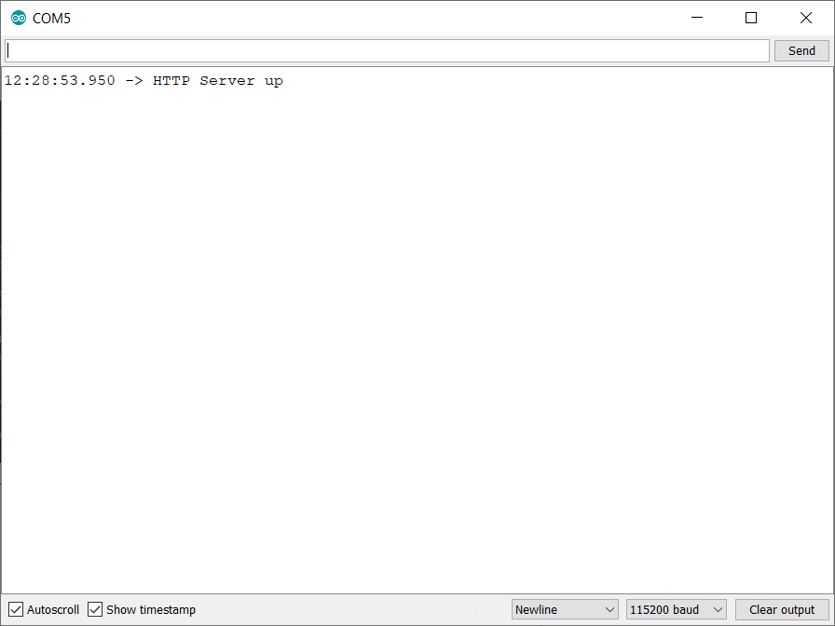
Figure A-1-1 Serial output showing server up

Test Case ID |  | PB_AP_2a
Test Title |  | Access Point Connection
Description |  | Ensure the user can connect to the access point
Pre-conditions |  | 1. MCU is connected to computer  2. Previously mentioned configuration is set  3. AP is up
Step | Test Step |  | Test Data | Expected Result | Actual Result | Status (Pass/Fail)
1 | Connect to access point |  | ESP32-Test | Ask for credentials | Ask for credentials | Pass
2 | Enter credentials |  | Username: testUser  Password: testPass | Connect | Connect | Pass
Screenshot(s) (if applicable)
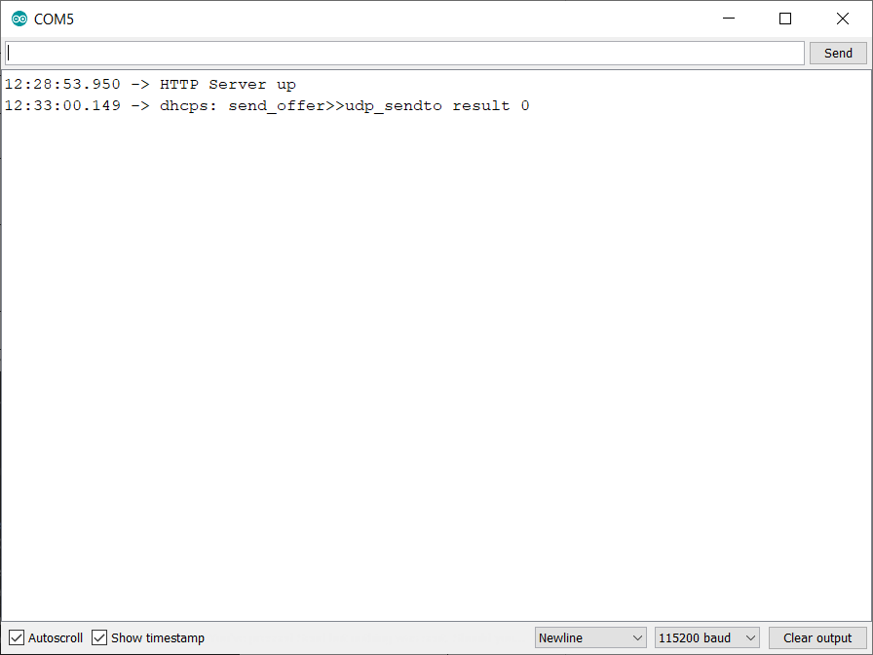
Figure A-1-2 Device connected successfully

Appendix A.2 SQLConnection Test Cases
This is the test case for the SQLConnection object, ensuring that the schedule is able to be read from the SQL server.

Test Case ID |  | PB_SQL_1a
Test Title |  | Read schedule from server
Description |  | Ensure the schedule is read from the SQL server
Pre-conditions |  | 1. User is connected to AP  2. User is on home page
Step | Test Step |  | Test Data | Expected Result | Actual Result | Status (Pass/Fail)
1 | Go to schedule |  | User input | Schedule page loads | Schedule page loads | Pass
Screenshot(s) (if applicable)
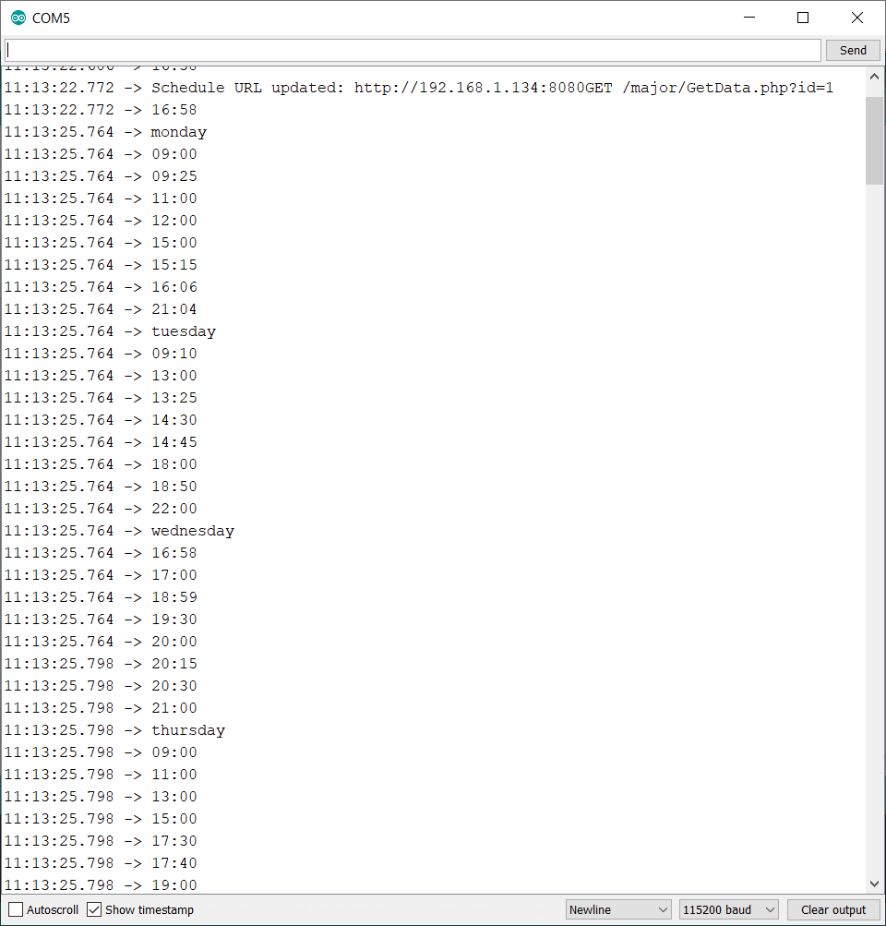
Figure A-2-1 Serial output of schedule

Appendix A.3 DateTime Test Cases
These are the test cases for the DateTime object, ensuring that the day and time is correct. There were some problems with the change in time zone and if the device was offline.

Test Case ID |  | PB_DT_1a
Test Title |  | Check timestamp
Description |  | Ensure the day and time is correct
Pre-conditions |  | 1. MCU is connected to power source  2. MCU is connected to Wi-Fi network
Step | Test Step |  | Test Data | Expected Result | Actual Result | Status (Pass/Fail)
1 | Check home page |  | User input to browse to home page | Day and time to display correctly | Day and time displayed correctly | Pass
Screenshot(s) (if applicable)
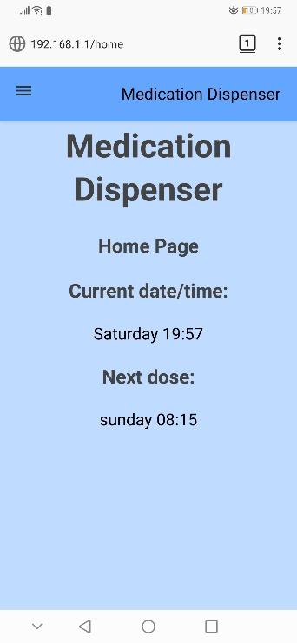
Figure A-3-1 Day and time correctly displayed

Test Case ID |  | PB_DT_2a
Test Title |  | Check timestamp (offline)
Description |  | Ensure the day and time is correct
Pre-conditions |  | 1. MCU is connected to power source  2. MCU is not connected to Wi-Fi network
Step | Test Step |  | Test Data | Expected Result | Actual Result | Status (Pass/Fail)
1 | Check home page |  | User input to browse to home page | Day and time to display correctly | Day and time displayed incorrectly | Fail
Screenshot(s) (if applicable)
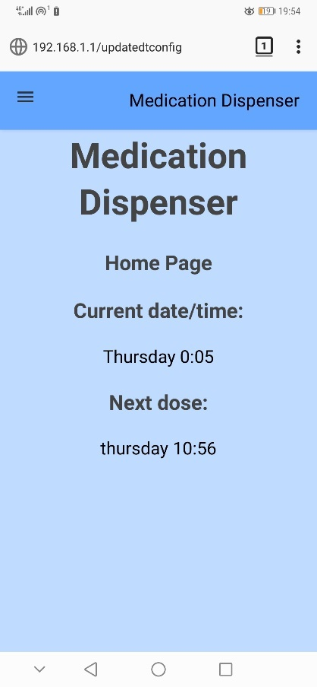
Figure A-3-2 Day and time incorrectly displayed (offline)

Test Case ID |  | PB_DT_3a
Test Title |  | Check timestamp (BST)
Description |  | Ensure the day and time is correct
Pre-conditions |  | 1. MCU is connected to power source  2. User is connected to node device network
Step | Test Step |  | Test Data | Expected Result | Actual Result | Status (Pass/Fail)
1 | Check home page |  | User input to browse to home page | Day and time to display correctly | Day and time displayed incorrectly | Fail
Screenshot(s) (if applicable)
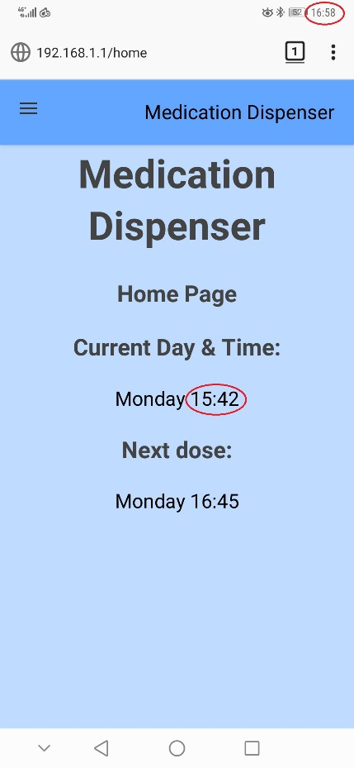
Figure A-3-3 Day and time incorrectly displayed (BST)

Test Case ID |  | PB_DT_3b
Test Title |  | Check timestamp (BST)
Description |  | Ensure the day and time is correct
Pre-conditions |  | 1. MCU is connected to power source  2. User is connected to node device network
Step | Test Step |  | Test Data | Expected Result | Actual Result | Status (Pass/Fail)
1 | Check home page |  | User input to browse to home page | Day and time to display correctly | Day and time displayed correctly | Pass
Screenshot(s) (if applicable)
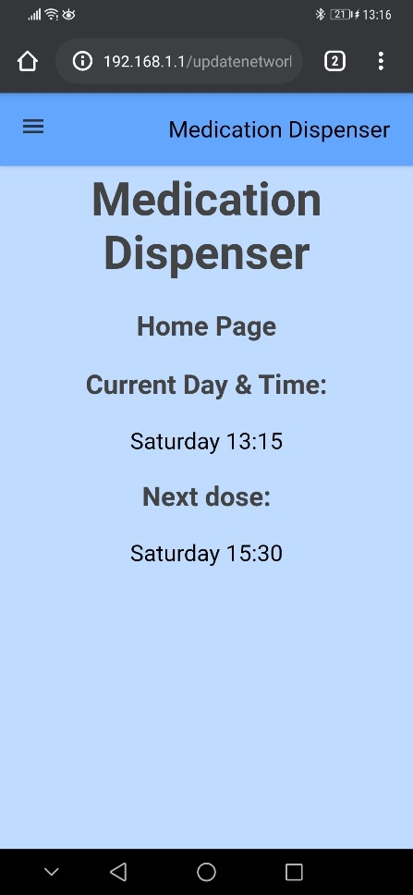
Figure A-3-4 Day and time correctly displayed (BST)

Appendix A.4 User Test Cases
This is the test case for the user object to ensure that the login functionality works correctly.

Test Case ID |  | PB_Us_1a
Test Title |  | Check login
Description |  | Ensure the login functionality works
Pre-conditions |  | 1. MCU is connected to power source  2. User device is connected to ESP-32 network
Step | Test Step |  | Test Data | Expected Result | Actual Result | Status (Pass/Fail)
1 | Load 192.168.1.1 |  | 192.168.1.1 | Request user login | Request user login | Pass
Screenshot(s) (if applicable)
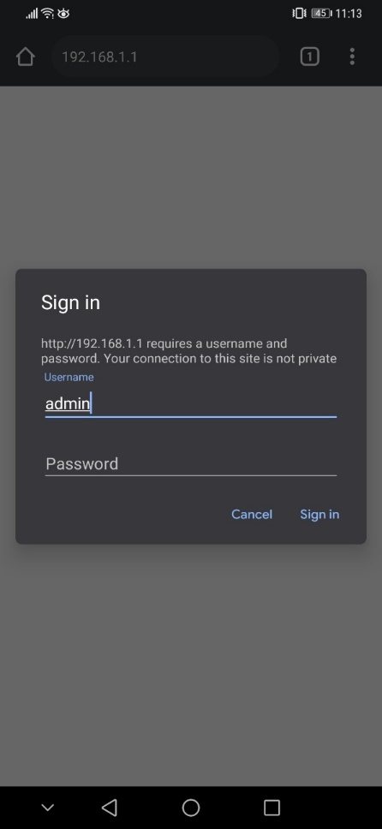
Figure A-4-1 Login requested

Appendix A.5 Schedule Test Cases
These are the test cases for the Schedule object to ensure it calculates the next dose correctly and still works offline.

Test Case ID |  | PB_Sched_1a
Test Title |  | Check next dose
Description |  | Ensure the next dose is calculated correctly
Pre-conditions |  | 1. MCU is connected to power source  2. Schedule is set up
Step | Test Step |  | Test Data | Expected Result | Actual Result | Status (Pass/Fail)
1 | Check home page |  | Click home | Show next dose | Show next dose | Pass
Screenshot(s) (if applicable)
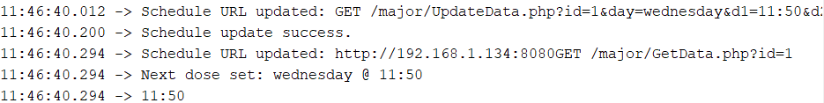
Figure A-5-1 Serial output of next dose being calculated and set

Figure A-5-2 Home page displaying next dose

Test Case ID |  | PB_Sched_2a
Test Title |  | Offline check
Description |  | Make sure it still functions without SQL server connection
Pre-conditions |  | 1. MCU is connected to power source  2. Schedule is set up
Step | Test Step |  | Test Data | Expected Result | Actual Result | Status (Pass/Fail)
1 | Check home page |  | Click home | Show schedule not set | Show schedule not set | Pass
Screenshot(s) (if applicable)
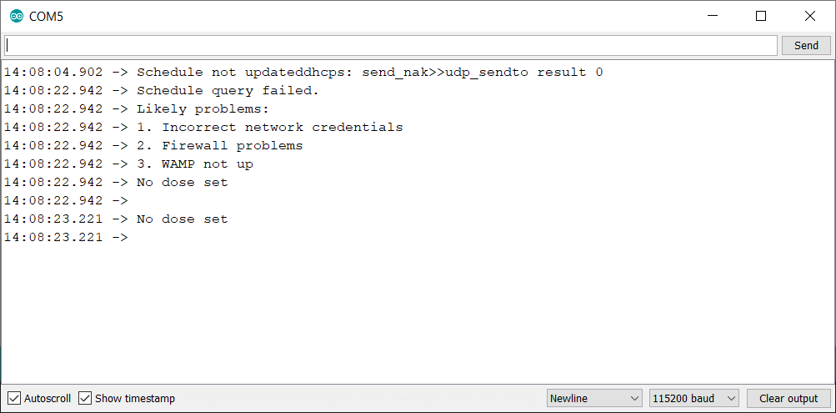
Figure A-5-3 Serial output showing troubleshooting

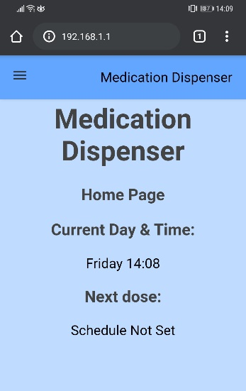
Figure A-5-4 Screenshot of home page showing it works

Appendix A.6 Dispenser Test Cases
This is the test case for the Dispenser object to make sure that the day and time comparison works, and that it executes the “Dispense()” method.

Test Case ID |  | PB_Dispense_1a
Test Title |  | Check dispensing
Description |  | Ensure the time comparison works and it dispenses
Pre-conditions |  | 1. MCU is connected to power source  2. Next dose is set
Step | Test Step |  | Test Data | Expected Result | Actual Result | Status (Pass/Fail)
1 | Set next dose to 15:03 |  | 15:03 | Dispense | Dispense | Pass
Screenshot(s) (if applicable)
Figure A-6-1 Serial output of dispense

Appendix A.7 Log Test Cases
These are the test cases for the Log object. It needs to be correct to log that the dose has been dispensed, that the user has taken the medication, and that it parses correctly back to the device if the user requests the log.

Test Case ID |  | PB_Log_1a
Test Title |  | Check log
Description |  | Ensure log is pushed to once dispensed
Pre-conditions |  | 1. MCU is connected to power source  2. Next dose is set to 15:03
Step | Test Step |  | Test Data | Expected Result | Actual Result | Status (Pass/Fail)
1 | Set next dose to 15:03 |  | 15:03 | Dispense | Dispense | Pass
2 | Check log |  | n/a | Log updated and next dose calculated | Log updated and next dose calculated | Pass
Screenshot(s) (if applicable)
Figure A-7-1 Serial output of log being pushed to

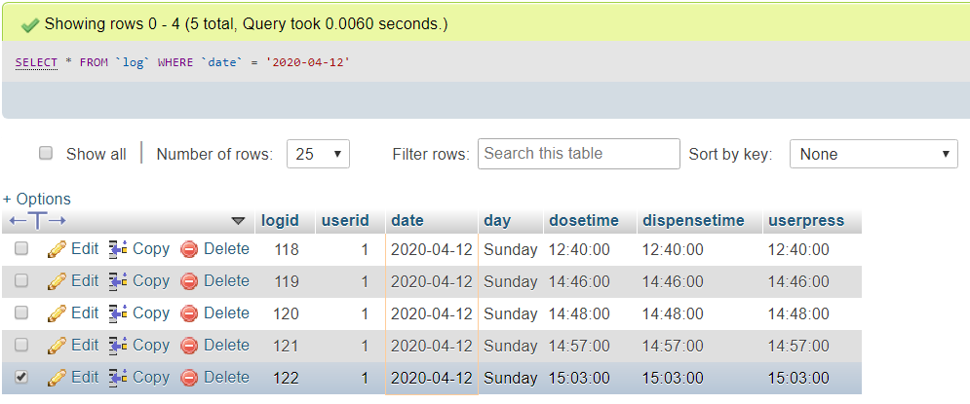
Figure A-7-2 SQL server showing update from 15:03

Test Case ID |  | PB_Log_2a
Test Title |  | Check log
Description |  | Ensure log is read and displayed
Pre-conditions |  | 1. MCU is connected to power source  2. Log has been updated on the server
Step | Test Step |  | Test Data | Expected Result | Actual Result | Status (Pass/Fail)
1 | Browse to log |  | Browse to log | Display 7-day log | Display 7-day log | Fail
Screenshot(s) (if applicable)
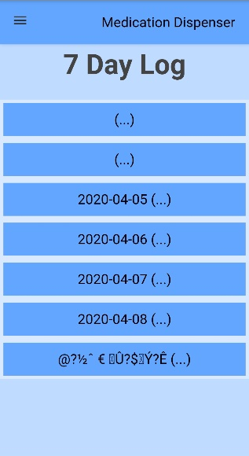
Figure A-7-3 Screenshot of invalid characters

Test Case ID |  | PB_Log_2b
Test Title |  | Check log
Description |  | Ensure log is read and displayed
Pre-conditions |  | 1. MCU is connected to power source  2. Log has been updated on the server
Step | Test Step |  | Test Data | Expected Result | Actual Result | Status (Pass/Fail)
1 | Browse to log |  | Browse to log | Display 7-day log | Display 7-day log | Pass
Screenshot(s) (if applicable)
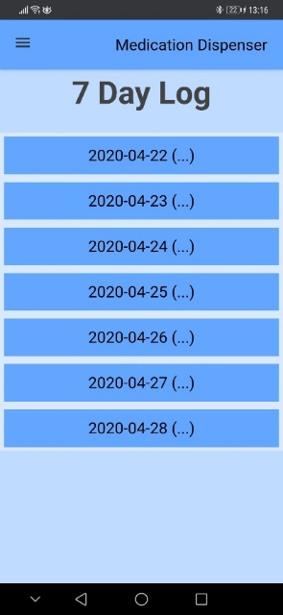
Figure A-7-4 Screenshot of valid log

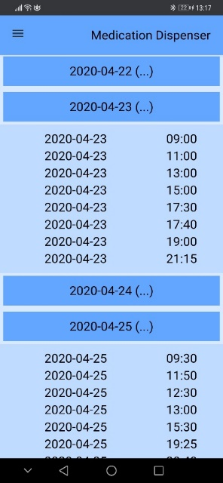
Figure A-7-5 Screenshot of drop down for log

Appendix B Web Application Screenshots
This appendix is all of the pages available on the software showing all of the accessibility the user has access to and the general layout. This was checked on Chrome and Firefox on Android.

Figure B-1 Home page

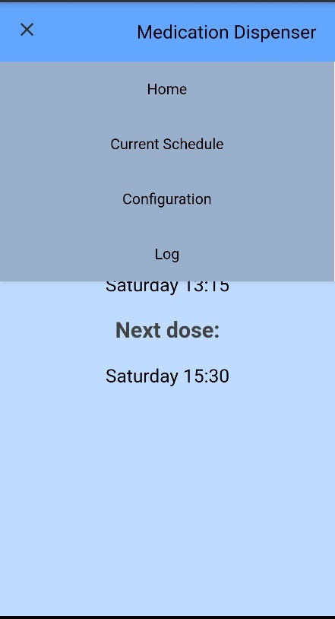
Figure B-2 Drop down menu
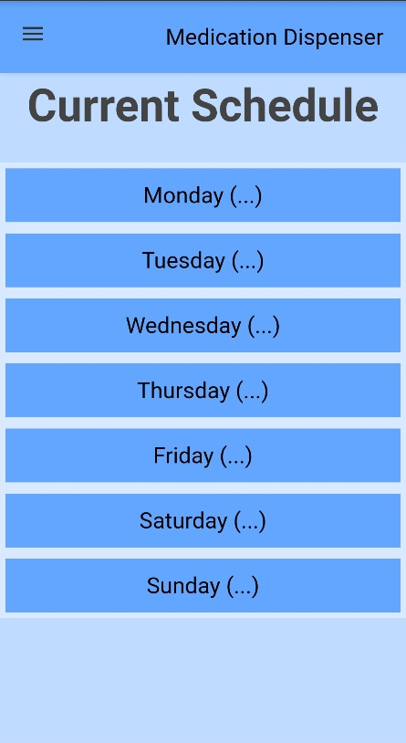
Figure B-3 Current schedule page

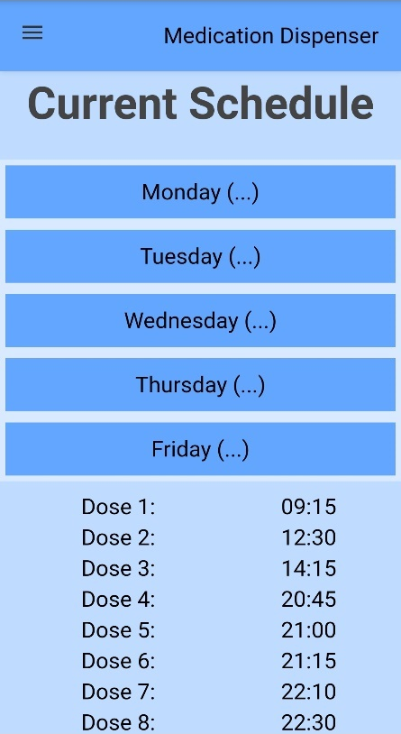
Figure B-4 Current schedule page dropdown 1
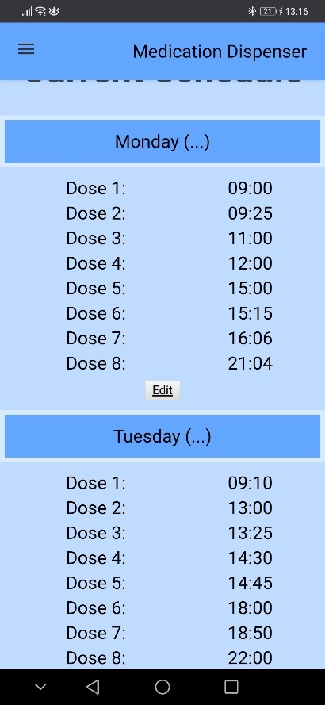
Figure B-5 Current schedule page dropdown 2

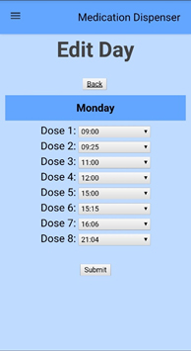
Figure B-6 Edit page 1

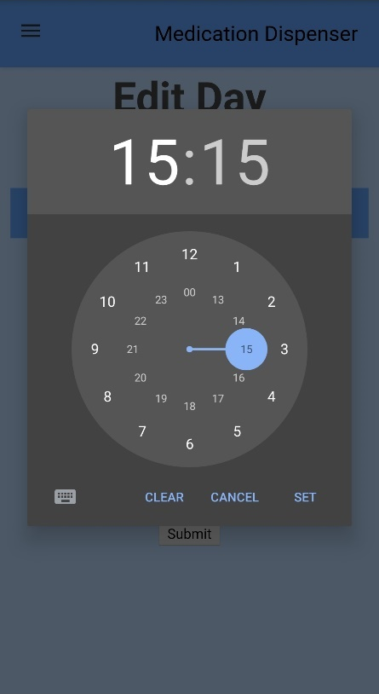
Figure B-7 Edit page 2

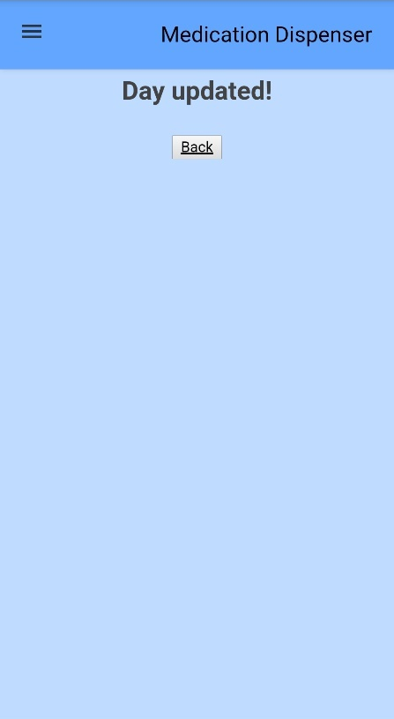
Figure B-8 Successfully updated page

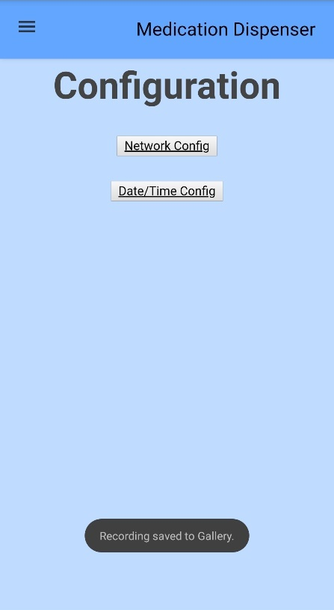
Figure B-9 Configuration page

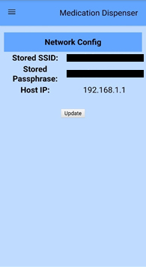
Figure B-10 Network configuration page

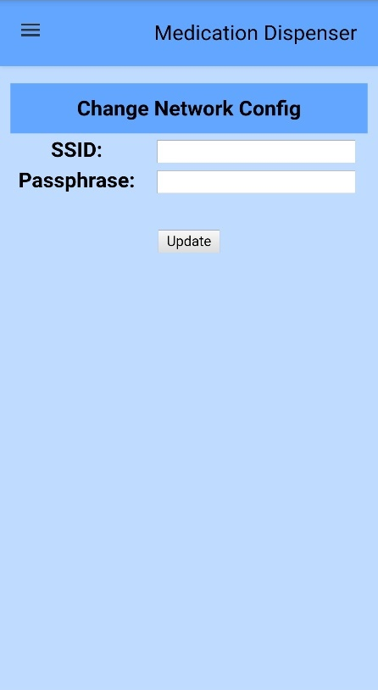
Figure B-11 Update network configuration page

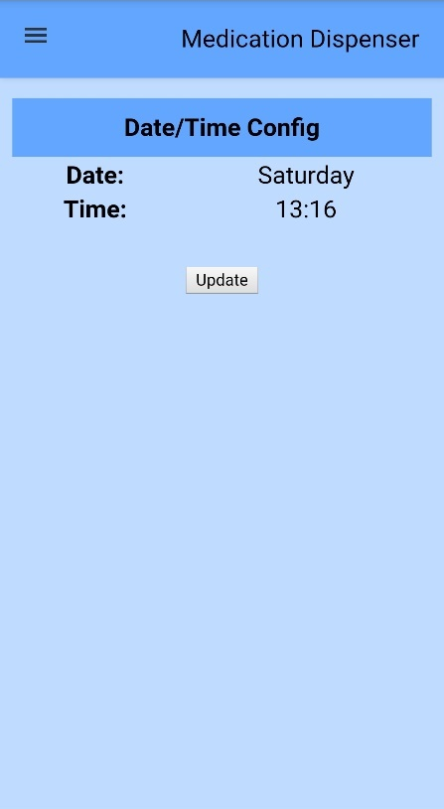
Figure B-12 Date/Time configuration page
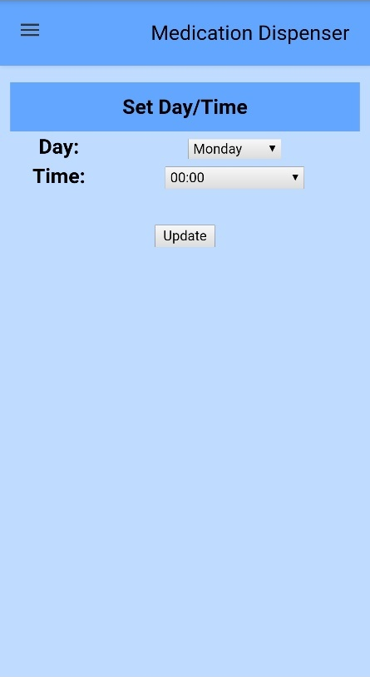
Figure B-13 Update date/time configuration page

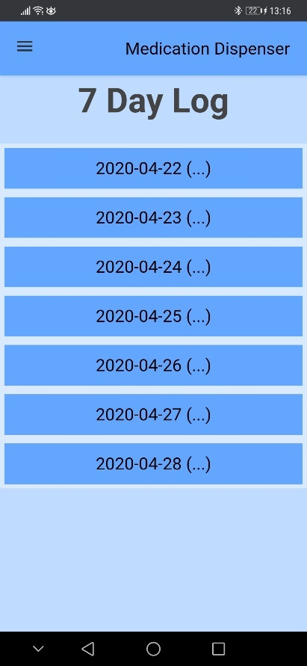
Figure B-14 Log page
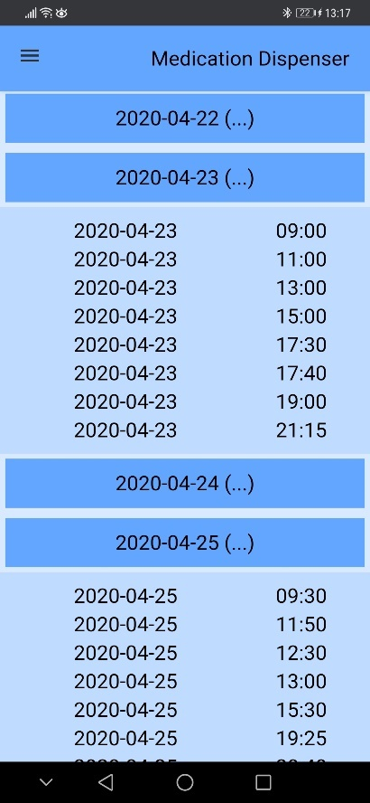
Figure B-15 Log page dropdown

Appendix C User Log
This is the log from the SQL server that shows the date, day and time that the medication was dispensed, along with the time the user pressed the button to say they have received the medication. The dispensing accuracy has been portrayed as both a table and a bar chart.

 | LogID | UserID | Date | Day | Schedule Dispense Time | Actual Dispense Time | User Push Button Time | Difference between dispense times
 | 59 | 1 | 01/04/2020 | Wednesday | 16:58:00 | 16:58:00 | 16:58:00 | 00:00
 | 60 | 1 | 01/04/2020 | Wednesday | 17:00:00 | 17:00:00 | 17:01:00 | 00:00
 | 61 | 1 | 01/04/2020 | Wednesday | 18:59:00 | 18:59:00 | 18:59:00 | 00:00
 | 62 | 1 | 01/04/2020 | Wednesday | 19:30:00 | 19:30:00 | 19:30:00 | 00:00
 | 63 | 1 | 01/04/2020 | Wednesday | 20:00:00 | 20:00:00 | 20:00:00 | 00:00
 | 64 | 1 | 01/04/2020 | Wednesday | 20:15:00 | 20:15:00 | 20:16:00 | 00:00
 | 65 | 1 | 01/04/2020 | Wednesday | 20:30:00 | 20:30:00 | 20:30:00 | 00:00
 | 66 | 1 | 01/04/2020 | Wednesday | 21:00:00 | 21:00:00 | 21:00:00 | 00:00
 | 67 | 1 | 02/04/2020 | Thursday | 09:00:00 | 09:00:00 | 09:00:00 | 00:00
 | 68 | 1 | 02/04/2020 | Thursday | 11:00:00 | 11:00:00 | 11:01:00 | 00:00
 | 69 | 1 | 02/04/2020 | Thursday | 13:00:00 | 13:00:00 | 13:00:00 | 00:00
 | 70 | 1 | 02/04/2020 | Thursday | 15:00:00 | 15:00:00 | 15:00:00 | 00:00
 | 71 | 1 | 02/04/2020 | Thursday | 17:30:00 | 17:30:00 | 17:30:00 | 00:00
 | 72 | 1 | 02/04/2020 | Thursday | 17:40:00 | 17:40:00 | 17:40:00 | 00:00
 | 73 | 1 | 02/04/2020 | Thursday | 19:00:00 | 19:00:00 | 19:01:00 | 00:00
 | 74 | 1 | 02/04/2020 | Thursday | 21:15:00 | 21:15:00 | 21:15:00 | 00:00
 | 75 | 1 | 03/04/2020 | Friday | 09:15:00 | 09:15:00 | 09:15:00 | 00:00
 | 76 | 1 | 03/04/2020 | Friday | 12:30:00 | 12:30:00 | 12:30:00 | 00:00
 | 77 | 1 | 03/04/2020 | Friday | 14:15:00 | 14:15:00 | 14:15:00 | 00:00
 | 78 | 1 | 03/04/2020 | Friday | 20:45:00 | 20:45:00 | 20:45:00 | 00:00
 | 79 | 1 | 03/04/2020 | Friday | 21:00:00 | 21:00:00 | 21:00:00 | 00:00
 | 80 | 1 | 03/04/2020 | Friday | 21:15:00 | 21:15:00 | 21:16:00 | 00:00
 | 81 | 1 | 03/04/2020 | Friday | 22:10:00 | 22:10:00 | 22:10:00 | 00:00
 | 82 | 1 | 03/04/2020 | Friday | 22:30:00 | 22:30:00 | 22:30:00 | 00:00
 | 83 | 1 | 04/04/2020 | Saturday | 09:30:00 | 09:30:00 | 09:30:00 | 00:00
 | 84 | 1 | 04/04/2020 | Saturday | 11:50:00 | 11:50:00 | 11:50:00 | 00:00
 | 85 | 1 | 04/04/2020 | Saturday | 12:30:00 | 12:30:00 | 12:30:00 | 00:00
 | 86 | 1 | 04/04/2020 | Saturday | 13:00:00 | 13:00:00 | 13:00:00 | 00:00
 | 87 | 1 | 04/04/2020 | Saturday | 15:30:00 | 15:30:00 | 15:30:00 | 00:00
 | 88 | 1 | 04/04/2020 | Saturday | 19:25:00 | 19:25:00 | 19:25:00 | 00:00
 | 89 | 1 | 04/04/2020 | Saturday | 20:40:00 | 20:40:00 | 20:40:00 | 00:00
 | 90 | 1 | 04/04/2020 | Saturday | 21:05:00 | 21:05:00 | 21:05:00 | 00:00
 | 91 | 1 | 05/04/2020 | Sunday | 09:05:00 | 09:05:00 | 09:06:00 | 00:00
 | 92 | 1 | 05/04/2020 | Sunday | 09:20:00 | 09:20:00 | 09:20:00 | 00:00
 | 93 | 1 | 05/04/2020 | Sunday | 11:35:00 | 11:35:00 | 11:35:00 | 00:00
 | 94 | 1 | 05/04/2020 | Sunday | 11:50:00 | 11:50:00 | 11:50:00 | 00:00
 | 95 | 1 | 05/04/2020 | Sunday | 14:05:00 | 14:05:00 | 14:05:00 | 00:00
 | 96 | 1 | 05/04/2020 | Sunday | 16:05:00 | 16:05:00 | 16:05:00 | 00:00
 | 97 | 1 | 05/04/2020 | Sunday | 19:40:00 | 19:40:00 | 19:40:00 | 00:00
 | 98 | 1 | 05/04/2020 | Sunday | 22:50:00 | 22:50:00 | 22:50:00 | 00:00
 | 99 | 1 | 06/04/2020 | Monday | 09:00:00 | 09:00:00 | 09:00:00 | 00:00
 | 100 | 1 | 06/04/2020 | Monday | 09:25:00 | 09:25:00 | 09:25:00 | 00:00
 | 101 | 1 | 06/04/2020 | Monday | 11:00:00 | 11:00:00 | 11:00:00 | 00:00
 | 102 | 1 | 06/04/2020 | Monday | 12:00:00 | 12:00:00 | 12:00:00 | 00:00
 | 103 | 1 | 06/04/2020 | Monday | 15:00:00 | 15:00:00 | 15:01:00 | 00:00
 | 104 | 1 | 06/04/2020 | Monday | 15:15:00 | 15:15:00 | 15:15:00 | 00:00
 | 105 | 1 | 06/04/2020 | Monday | 16:06:00 | 16:06:00 | 16:06:00 | 00:00
 | 106 | 1 | 06/04/2020 | Monday | 21:00:00 | 21:00:00 | 21:00:00 | 00:00
 | 107 | 1 | 06/04/2020 | Monday | 21:02:00 | 21:02:00 | 21:02:00 | 00:00
 | 108 | 1 | 06/04/2020 | Monday | 21:04:00 | 21:04:00 | 21:04:00 | 00:00
 | 109 | 1 | 07/04/2020 | Tuesday | 09:10:00 | 09:10:00 | 09:10:00 | 00:00
 | 110 | 1 | 07/04/2020 | Tuesday | 13:00:00 | 13:00:00 | 13:00:00 | 00:00
 | 111 | 1 | 07/04/2020 | Tuesday | 13:25:00 | 13:25:00 | 13:25:00 | 00:00
 | 112 | 1 | 07/04/2020 | Tuesday | 14:30:00 | 14:30:00 | 14:30:00 | 00:00
 | 113 | 1 | 07/04/2020 | Tuesday | 14:45:00 | 14:45:00 | 14:45:00 | 00:00
 | 114 | 1 | 07/04/2020 | Tuesday | 18:00:00 | 18:00:00 | 18:01:00 | 00:00
 | 115 | 1 | 07/04/2020 | Tuesday | 18:50:00 | 18:50:00 | 18:50:00 | 00:00
 | 116 | 1 | 07/04/2020 | Tuesday | 22:00:00 | 22:00:00 | 22:00:00 | 00:00
 |  |  |  |  |  |  | Dispense Accuracy
 |  |  |  |  |  |  | < 1 minute | 58
 |  |  |  |  |  |  | 1-5 minutes | 0
 |  |  |  |  |  |  | 5-10 minutes | 0
 |  |  |  |  |  |  | 10+ minutes | 0
 |  |  |  |  |  |  | Total Logs | 58
 |  |  |  |  |  |  | Dispense Amount | 100.00%

Appendix D Cognitive Walkthrough
This is the cognitive walkthrough for the project, linked to section 6.3.

Cognitive Walkthrough for: Smart Medication Dispenser

Task: Connecting to node device
Note: Originally this was planned for an app & a Bluetooth connection to be used, not Wi-Fi, so the connection process to the node device would be completely different.
1.
Select Wi-Fi connection | Successful? | Comments
Does the user know what needs to be done? | Y | Unable to do much about this as it’s on user device
Can the user see a control to do that? | Y | Unable to do much about this as it’s on user device
Is it clear how to operate the control? | Y | Unable to do much about this as it’s on user device
Is the immediate feedback understandable? | Y | Unable to do much about this as it’s on user device

2.
Enter passphrase | Successful? | Comments
Does the user know what needs to be done? | Y | Enter passphrase
Can the user see a control to do that? | Y | Unable to do much about this as it’s on user device
Is it clear how to operate the control? | Y | Unable to do much about this as it’s on user device
Is the immediate feedback understandable? | Y | Unable to do much about this as it’s on user device

Task: Connecting node to Wi-Fi
Note: Originally this was planned for an app & Bluetooth, not Wi-Fi. I have not found a way to edit network details on the node device THEN create the Wi-Fi object and initialise a connection, but I have coded the functionality if it were possible.
1.
Select drop-down menu | Successful? | Comments
Does the user know what needs to be done? | Y | Need to select the drop-down menu.
Can the user see a control to do that? | Y | Drop-down menu is visible at the navigation bar position.
Is it clear how to operate the control? | Y | Standard menu button
Is the immediate feedback understandable? | Y | Menu drops down.

2.
Select configuration | Successful? | Comments
Does the user know what needs to be done? | Y | Need to select configuration within drop-down menu.
Can the user see a control to do that? | Y | Options visible
Is it clear how to operate the control? | Y | Standard menu button
Is the immediate feedback understandable? | Y | Directs to relevant page

3.
Select network configuration | Successful? | Comments
Does the user know what needs to be done? | Y | Need to select network configuration on page.
Can the user see a control to do that? | Y | Button clearly visible
Is it clear how to operate the control? | Y | Standard button
Is the immediate feedback understandable? | Y | Directs to relevant page

4.
Select update | Successful? | Comments
Does the user know what needs to be done? | Y | Need to select the update button on page.
Can the user see a control to do that? | Y | Button clearly visible
Is it clear how to operate the control? | Y | Standard menu button
Is the immediate feedback understandable? | Y | Directs to relevant page

5.
Update SSID & passphrase | Successful? | Comments
Does the user know what needs to be done? | Y | Need to enter the network credentials for their Wi-Fi.
Can the user see a control to do that? | Y | Empty text boxes visible.
Is it clear how to operate the control? | Y | Press on text box and can type.
Is the immediate feedback understandable? | Y | Asks user to type in details.

6.
Press update button | Successful? | Comments
Does the user know what needs to be done? | Y | Need to press update button.
Can the user see a control to do that? | Y | Button visible.
Is it clear how to operate the control? | Y | Standard button
Is the immediate feedback understandable? | Y | Directs to relevant update page

Task: Setting the schedule up
1.
Select drop-down menu | Successful? | Comments
Does the user know what needs to be done? | Y | Need to select the drop-down menu.
Can the user see a control to do that? | Y | Drop-down menu is visible at the navigation bar position.
Is it clear how to operate the control? | Y | Standard menu button
Is the immediate feedback understandable? | Y | Menu drops down.

2.
Select schedule | Successful? | Comments
Does the user know what needs to be done? | ? | Either current schedule and within there, or set schedule?
Can the user see a control to do that? | Y | Options are visible in drop-down menu
Is it clear how to operate the control? | Y | Standard menu button
Is the immediate feedback understandable? | Y | Directs to relevant page

2.1
Select schedule | Successful? | Comments
Does the user know what needs to be done? | Y | Select current schedule – updated page to have only one link, and within there the user can edit the schedule
Can the user see a control to do that? | Y | Option is visible in drop-down menu
Is it clear how to operate the control? | Y | Standard menu button
Is the immediate feedback understandable? | Y | Directs to relevant page

3.
Drop-down on day | Successful? | Comments
Does the user know what needs to be done? | Y | Press to drop-down the required day
Can the user see a control to do that? | Y | Option is visible per day
Is it clear how to operate the control? | Y | Standard button
Is the immediate feedback understandable? | Y | Drops down the day(s) required

4.
Edit day | Successful? | Comments
Does the user know what needs to be done? | Y | Press edit on the day required
Can the user see a control to do that? | Y | Option is visible per day
Is it clear how to operate the control? | Y | Standard button
Is the immediate feedback understandable? | Y | Directs to relevant page

5.
Press on timebox | Successful? | Comments
Does the user know what needs to be done? | Y | Press on the timebox to edit or add
Can the user see a control to do that? | Y | Up to 8 per day
Is it clear how to operate the control? | ? | Standard time input box, however due to amount it may be difficult
Is the immediate feedback understandable? | Y | Opens a time input

5.1
Press on timebox | Successful? | Comments
Does the user know what needs to be done? | Y | Press on the timebox to edit or add
Can the user see a control to do that? | Y | Up to 8 per day
Is it clear how to operate the control? | Y | Added dose iterations, or add dose next to input
Is the immediate feedback understandable? | Y | Opens a time input

6.
Press submit | Successful? | Comments
Does the user know what needs to be done? | Y | Press submit
Can the user see a control to do that? | Y | Submit button below dose entry
Is it clear how to operate the control? | Y | Standard button
Is the immediate feedback understandable? | ? | Goes back to current schedule

6.1
Press submit | Successful? | Comments
Does the user know what needs to be done? | Y | Press submit
Can the user see a control to do that? | Y | Submit button below dose entry
Is it clear how to operate the control? | Y | Standard button
Is the immediate feedback understandable? | Y | Displays “day updated” message

Task: Checking the log
1.
Select drop-down menu | Successful? | Comments
Does the user know what needs to be done? | Y | Need to select the drop-down menu.
Can the user see a control to do that? | Y | Drop-down menu is visible at the navigation bar position.
Is it clear how to operate the control? | Y | Standard menu button
Is the immediate feedback understandable? | Y | Menu drops down.

2.
Select log | Successful? | Comments
Does the user know what needs to be done? | Y | Press on/select “log”
Can the user see a control to do that? | Y | Options are visible in drop-down menu
Is it clear how to operate the control? | Y | Standard menu button
Is the immediate feedback understandable? | Y | Directs to relevant page

3.
Select date | Successful? | Comments
Does the user know what needs to be done? | Y | Press on/select relevant date
Can the user see a control to do that? | Y | Dates visible on screen
Is it clear how to operate the control? | Y | Standard menu button
Is the immediate feedback understandable? | Y | Displays log for day selected

Appendix E User Manual
This is the user manual created for the dispenser as part of the project.

Smart Medication Dispenser
The smart medication dispenser is designed to assist with automatically dispensing a dose of medication when needed. It does this by the user entering their medication schedule into a user-friendly interface, then the dispenser does all of the work.

1. Connecting to the Dispenser
First the dispenser needs power. Ideally it would be run from a battery – in the terms of this project, both a laptop was used and an external power bank.
Once the dispenser is connected to power, the user will need to access their Wi-Fi settings on their device and connect to the dispenser using the information in Table 7. Alternatively, by using a camera app on their device they can scan the QR code generated by QiFi below (Figures E-1 and E-2).

Default Network Credentials
SSID: | ESP32-Test (Default project name)
Passphrase: | H2g8XXopMR
Table 7 Default network credentials


Figure E-1 Wi-Fi network QR code

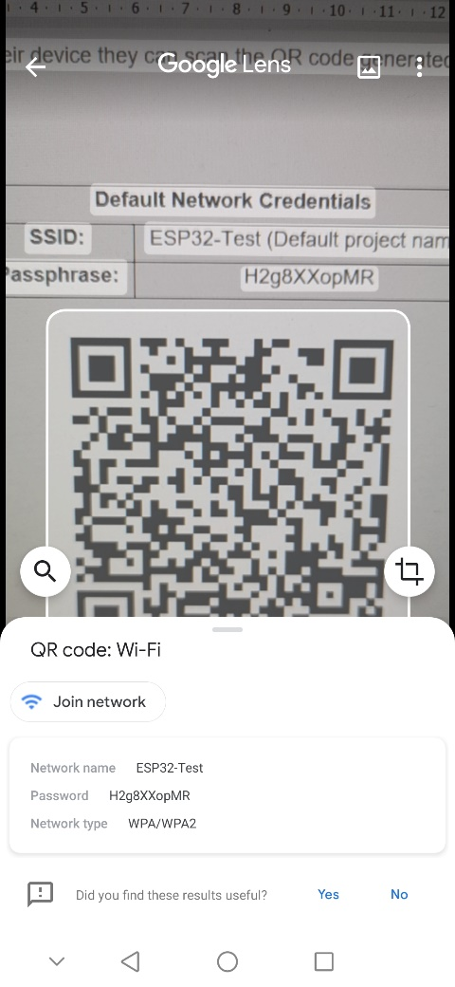
Figure E-2 Wi-Fi network QR code scanner

2. Accessing the Dispenser
Once the user has connected to the Wi-Fi connection of the ESP32, they will need to open their favourite browser on their device and navigate to http://192.168.1.1. Again, alternatively, scan the QR code below (Figures E-3 and E-4).


Figure E-3 URL QR code

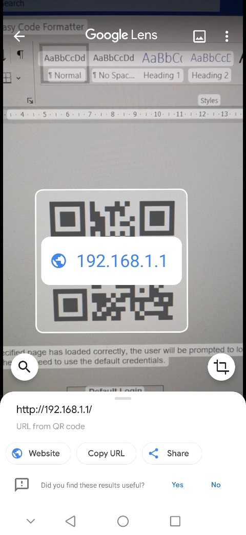
Figure E-4 URL QR code scanner

Once the specified page has loaded correctly, the user will be prompted to log in for access (Figure E-5) and they will need to use the default credentials (Table 8).

Figure E-5 Login

Default Login Credentials
Username: | admin
Password: | Pass
Table 8 Default login credentials

The user will then be greeted with a home screen (Figure E-6) showing the day, time, day/time of the next dose (if set).

Figure E-6 Home page

3. Menu Button
There is a menu button in the top left that drops down (Figure E-7) to show the user the available options.

Figure E-7 Dropdown menu

4. Setting A Schedule
If the user pressed on “Current Schedule” and browses to this page, they will be greeted with a page that shows them each day of the week (Figure E-8). The user simply presses on the day to drop it down, and then presses the “edit” (Figure E-9) button (please note the one in this manual already has been set, but the user will see no doses currently and just have the edit button).

Figure E-8 Current schedule

Figure E-9 Current schedule 2

Once the user presses edit it will take them to the edit page (Figure E-10), and they will have an option to add up to 8 doses. It doesn’t matter the order, as long as the times are correct as the dispenser will figure out the dose number for the user.

Figure E-10 Edit day

If the user selects a dose to add, they will be prompted with a time to enter (Figure E-11).

Figure E-11 Edit day 2

As long as the user is happy, they can press “submit” and it will let them know if the day updates correctly (Figure E-12) or if there are any problems. If there’s a mistake, the user just needs to press clear when on the “clock screen”, and it will reset the dose time to blank.

Figure E-12 Day updated

4. Network Configuration
The functionality has been coded to allow the user to update their SSID and network to connect to, but it does not work correctly due to problems stated in section 5.4.1.2 (HostAP Evaluation).

To get to this page, the user needs to select the “Configuration” from the menu in the top left, they are then greeted with network configuration and date/time configuration (Figure E-13).

Figure E-13 Configuration page

If the user selects network configuration, it will show them the current stored information (Figure E-14).

Figure E-14 Network configuration page (Information removed)

To update this, the user just needs to press the “Update” button, this will then take them to the page that allows them to enter the SSID and passphrase (Figure E-15).

Figure E-15 Update network configuration page

5. Day/Time Configuration
Similar to the network configuration, this has been implemented however due to problems outlined in 5.4.3.2 (DateTime Evaluation), it is not viable due to hardware constraints.

Similar to the above, if the user selects “Configuration”, then “Date/Time Config”, they will see the current day and time (Figure E-16).

Figure E-16 Date/Time configuration page

If the user selects “Update”, it will take them to a page where they can enter the relevant information (Figure E-17).

Figure E-17 Update date/time configuration page

6. View Log
If the user navigates to the menu button and selects “Log”, they will be able to see the previous 7 days of logging (Figure E-18) if there are any stored. Similar to the “Current Schedule” page, there will be dropdowns the user needs to select (Figure E-19).

Figure E-18 Log page

Figure E-19 Log page 2

