Analysis into The Problem At ASDA

March 14 2020

UNIVERSITY OF WALES TRINITY SAINT DAVID
Authored by: Ellie Draper 1905853


This Photo by Unknown Author is licensed under CC BY-SA

Executive Summary
The ongoing problem that has been identified on ASDA in this report is the amount of decrease in sales over the past few years due to the amount of competition they are facing on a daily basis by fairly new stores, like ALDI and LIDL these shops do a very similar thing to ASDA. These stores are known for the extreme bargains on products, now ALDI and LIDL are thriving as they have the most sales due to them being a smaller store and not selling bigger brands where ASDA sell named branded products.

In this report it has stated the many options ASDA can take on board to improve or even overcome the problem they are facing. For example, using social media apps to engage with customers more, using shoppable post options for customers to quickly click on the product they see and buy it straight away.

The main way to communicate, monitor and review the implementation of these new techniques put in place for ASDA would be to have the main administrators to monitor and review the new ways of marketing and seeing if they work, then they will communicate with CEO’s of the company and either carry out the new marketing strategies or change them around. It is always about changing and making things better.
Contents Page
Page No.

- Introduction 4
- Findings 5
2.1 Overview of Organization 5
2.1.1 The history of ASDA 5
2.1.2 What products and services does it offer 5
2.2 Investigating ASDA 6-7
2.2.1 Nature, Scope and Impact 7-8
2.3 SWOT Analysis 8-11
2.4 PESTLE Analysis 11
3.0 Conclusion 11
3.1 Main areas of concern 11
4.0 Options 12
4.1 New sales strategy 12-13
5.0 Action Plan 14
5.1 Communicated 14
5.2 Monitored 14
5.3 Reviewed 14
6.0 Appendices 15-18
7.0 Acknowledgements 18
8.0 References 19-20
Introduction

This report was requested by the University of Wales Trinity Saint David. The date for this report was requested on the 03/02/2020, the report was compiled by Laura James and internal verifier Maria Heffernan. The submission deadline for this report to by done by is the 20/03/2020. The purpose of this report is to provide a professional analysis of the current problem that is faced by ASDA by using analytical tools such as PESTLE and SWOT to gather information in order to suggest options for improvement at ASDA and to explain the process of communicating, monitoring and reviewing the problem the implementation of the chosen problem a hand. In this report it has used various research methods in order to find solutions to ASDA’s current and on-going problem, it uses various sources from books, newspaper articles and online articles.

2.0 Findings

2.1 Overview of the organization

ASDA is one of the most known supermarkets in Britain, it is in fact the UK’s second biggest supermarket. ASDA was founded in 1949 by two small local businesses, a greengrocer and a dairy product seller coming together to form a larger and more competitive business. its name originally was ‘Associated Dairies and Farm Group’ but shortened it to ASDA in the 1960’s. Now ASDA is a retailer that focuses on selling goods such as, food, clothing, electronics, toys, home furnishings and other day to day merchandise.

2.1.1 The History of ASDA

Like stated previously ASDA was founded in 1949, it has come a long way from being a small local run business to a huge, well know supermarket up and down the United Kingdom with ASDA stores in every city. In 1999 ASDA partnered with American well-known supermarket WALMART, which is the largest supermarket chain in the world. See appendices 1.0 there is a timeline diagram of ASDA and how far it has come over the years.

2.1.2 Services and Products
ASDA offers many products in their store such as food, clothing, home merchandise and much more. They also have various services too such as, their own Pharmacy to pick up prescription medication, a café where customers can go and eat whilst shopping, Opticians, customers can have eye tests and also get their glasses from, a travel money bureau, a scan and go shopping method where customers scan their products as they shop by using their scan and go app, Click and collect, customers can shop in the comfort of their own home and chose when to collect their shopping from the store, ASDA also do gift cards, as well as stocking their own gift cards they stock over 60 different high street retailer gift cards too. These are just a few of the many services ASDA provides for their customers.

‘Our Asda stores are jam packed full of useful services to make your trip to Asda more relaxing, fun and productive’ (ASDA Supermarket, 2019)

2.2 Investigating ASDA
There are two main problems that ASDA is facing right now. Trading/ supplier issues and employee/consumer problems are the main ones right now for ASDA, ASDA was named worst supermarket in treatment of suppliers. They dropped below fellow supermarket Morrisons which was bottom of the list already, 12% of ASDA’s suppliers said that the WALMART owned chain rarely/never complied with the grocery supply code of practice, which is

‘The Groceries Supply Code of Practice (the Code) is contained within schedule 1 of the Order. The Code provides detail on how designated retailers should manage their relationship with suppliers, to ensure compliance with both the Order and the Code’ (GOV.UK, 2020)

Secondly, the consumers/customers are fading off and there is less customer loyalty in society today. ASDA had put in place a new contract for employees to sign this involved the hourly rate to be increased from £8.21 to £9.00 but employees would not have paid breaks, ASDA is allowed to change their employees shift, change their roles on what they do in the shops and also change their hours on what they work. Obviously, employees are not happy at all about the contract and resulted in 12,000 workers refusing to sign the contract. After hearing about the new contract in place costumers were in outrage and protested against ASDA for not caring about their employees who work for the company, this also resulted in ‘37% = 7million’ (The Guardian, 2019) customers saying that they are less likely to shop at ASDA after hearing about the new contract in place. Another factor in relation to customer loyalty is dying off and the competition ASDA has, other supermarkets like Aldi and Lidl have been beating ASDA at their own game. Aldi and Lidl are known for their super low prices and comparison prices with other supermarkets, Aldi advertise themselves as the shop to go into to get the odd product when it is nearly double in price. The more the customers are going into the shop the more products they see at a super low price in comparison to ASDA. In today’s world the consumers are called ‘Promiscuous shoppers’ as they will go into different shops to find the best deals on products. ASDA are really struggling with this right now as they can’t roll back on their prices anymore as they won’t make enough profit, so they need to do something different that no other supermarket has done in order to succeed successfully and beat their competition. So, the main problem that is going to be talked about in this report will be the ongoing competition ASDA is facing right now.

2.2.1 Nature, Scope and Impact

Nature
The main problem ASDA is facing is the competition from the up and coming stores such as Aldi and Lidl, these stores are a well-known household name which nearly every family does their weekly shop at. ASDA is already known for it roll back prices and low prices on products, but as these stores don’t sell as many products as ASDA it is easier for them to really cut back on their prices and not to mention that the majority of their products are their own brand which again is easier to sell at a discounted price.

Scope
Due to the nature of the problem ASDA is facing there are some other things that contribute to the problem. For example, ASDA has always been known for their roll back deals on brands and that’s all that their known for really. Other brands such as Aldi and Lidl have super low prices on products and have a lot of organic products and products made with sustainable material, so customers are more drawn to products that are organic, independent brands rather than big brand names which are almost doubled in prices. ASDA’s marketing team play a big role in this as they are seeing that there is huge competition within the supermarket circle but are not responding by trying to do better or competing against them instead, they are doing what they think is best and relying on their roll back deals.

Impact
This problem has affected a lot of people internally and externally. Obviously, because consumers are seeing better prices else where they are less loyal to ASDA and will go to different shops to get their shopping which is resulting in a plummet in ASDA’s sales, without the customers they aren’t going to make any profit which will then effect ASDA’S finances, marketing and various others that make up ASDA. As customers are shopping else where and sales are plummeting there is a decrease in staff as they cannot afford to keep them due to the lack of finances. Also, because ASDA are partnered with well known supermarket WALMART, WALMART will also suffer financially due to ASDA’s failing.

2.3 SWOT Analysis
See appendices 2.0 for SWOT analysis of ASDA.

Strengths
ASDA partnered with WALMART in 1999 so then became part of the world’s largest retailer ever. WAMART serves their customers up to 245 million times per week and has over 11,000 stores nationwide, in result of being a part of the WALMART franchise ASDA has made a good reputation for itself and has become the second-best supermarket in the UK. ASDA made a ‘price roll back’ program which cuts the price of well-known branded products and sells them for nearly half the price, inspired by WALMARTS low priced strategies. In result of this ASDA has become a household name across the nation.

ASDA not only sells food products, they also sell electronics, house merchandise and have their own pharmacy and opticians making it a ‘one top shop’ for everyone which results in having a diverse customer audience.

Weaknesses
ASDA’s product recall may affect brands image. ASDA has been known to be in various product recalls including, plastic toasters for being at risk of electrical shock in 2014, they recalled white bread baked in Oldbury store as it faced cross contamination issues being contaminated with metal, ASDA hair straighteners for overheating and causing shock. Having frequent product recalls can affect ASDA’s image a lot causing customers not to buy from them as they are deemed as unsafe. This is also a huge issue for ASDA due to the fact that it costs a lot to keep having to recall products resulting in loss of sales because of the recall process.

The change of employee contracts took a big hit for ASDA as it saw 12,000 employees not sign the new contract. The contract consisted of reduce of paid breaks, ASDA controlling the shifts, hours and roles each employee does and changing them whenever they please. Due to this a lot of people protested ASDA saying that they do not put their employees first and don’t care for them. This effected ASDA’s image a lot and gave a bad name for the brand.

Opportunities
ASDA launched their ‘roll back’ program to bring customer sales. ASDA launched this program in 2015, they decided to invest over £300 million to reduce prices on every day household items which included huge brands. This resulted in cutting prices on branded items making ASDA the approachable shop for consumers who like discounts.

To help ASDA improve on sales and growth they should follow the trends within the home merchandise and clothing ranges. There is always a new trend in fashion to follow and being able to follow a trend at a low cost is what the customer wants. This would be extremely good especially in the children and women’s wear. Even though they do have the own brand for clothes they could try and do their ‘roll back’ program on clothing, by having branded clothing but sell them for a discounted price this will bring a lot more customers in who want affordable fashion. A major trend/movement in society today is having sustainable materials to make the clothing so maybe ASDA could try to sell more sustainable items.

To get the ultimate feedback on what to do and how to improve ASDA should carry out quarterly customer surveys in order to see what the customer want more of in store and what they don’t really like and where ASDA could improve. They could carry this out by using online surveys.

Threats
ASDA has a lot of competition and it is only increasing, Aldi and Lidl being the main ones they beat ASDA on price. These stores do not or rarely sell named branded items, so it is easier for them to sell at a discounted price, so they automatically attract more people because of their low-priced goods. They are also in competition with various other supermarkets such as Tesco and Sainsbury’s who also compete for low prices on goods. As there will always be competition ASDA needs to come up with new ways in order to beat the other shops on price, they should come up with different marketing techniques in order to be different.

2.4 PESTLE Analysis
See Appendices 3.0 for full PESTLE analysis on ASDA and the effect each factor has on ASDA, following a PESTLE analysis is extremely benefiting for businesses like ASDA so they can see if they are following what they need to in order for the to be successful in a professional way.

3.0/3.1 Conclusion
Based on the analysis undertaken in this report using the nature, scope, impact and SWOT analysis. The main problems facing ASDA is the surge of competition around them from other supermarkets and not changing their marketing strategy/ not trying different ways to reach consumers. ASDA needs to think of different ways of reaching customers, do things that haven’t already been done, maybe come up with a new slogan/action so consumers know that is ADSA’s and will be stuck in societies heads wherever they go. ASDA should also start doing their own branded food like their competitors Aldi and Lidl.

4.0 Options
There are many options to improve/resolve the problem that ASDA is going through.

ASDA needs to change its marketing strategies and advert delivery, their rival supermarket’s always do advertising on tv, social media paid adverts and through the letterbox leaflets. They even advertise through their ‘bag for life’ bags which has their logo all over. ASDA do advertise but not enough to match with their fellow competitors such as Aldi and Lidl, ASDA need to think outside of the box of different ways they can advertise their business to reach people and families of all ages. They should investigate sustainable fashion for their fashion line George as many younger people will investigate buying clothes from that range and for food too advertise more organic produce in their every day living section so it’s affordable and good for the environment. For example, if a company uses polyester it is cheaper and stays wrinkle free for longer but when they are washed microplastics are released from the clothing items and end up in our oceans. They can also ‘take up to 200 years to decompose’ (Forbes, 2019)

4.1 New Sales Strategy
There are a lot of new ways that ASDA can add in new ways to improve their sales and keep up with constant competition. For example, even though they are such a big brand they still have employees that go through a lot of administration work so by streamlining the workload they can reduce admin work and cut the amount of time employees take doing it in half. To track sales of products more efficiently they should look in to using, analytical dashboards and use individual tracking systems even though these are used more in face to face sales like car dealerships they are such a useful tool in seeing what has sold the best or most of what type of customer they’re selling the products too and also how much of a demand are they getting from one product.

Changing ASDA’s marketing strategies could really make an impact on their sales and decrease the pressure from competition. By making ‘Shoppable posts’ can really make a difference. Shoppable posts are mostly used on social media apps like Instagram or Facebook if ASDA use this useful they will see a huge rise in sales as it is a lot faster for customers to access when they see an advert and click it will take them directly to the product they want.

‘Shoppable posts also provide data that retailers can use to improve their social commerce techniques.’ (Daniel Keyes, 2017)

ASDA should also use social media apps a lot more, apps like Instagram and Facebook are ever growing and sometimes are the main source where companies get their customers. By putting out high quality content on products people will see the products and the store a lot more in their everyday life. The more posts they can create with a high quality, the more customer reach therefore, more sales. This will also bring down competition if ASDA carry out using social media a lot more and reach a lot more people rather than people using word of mouth like the other stores as that is where they are getting their customers from.

‘For years, “content is king” has been the axiom of digital marketing. As we move into 2020, it continues to be true.’ (Christian Thomson, 2019)

5.0 Action Plan

The action plan is based on the options in 4.0. ASDA should engage more with their customers through social media, in order to do that they need to hire a social media team who specialize in marketing, sales etc. ASDA’s marketing team should also put out monthly adverts on social media on a specific product they think that is going to excel sales.

Another step ASDA can take is to use Analytical dashboards stated previously in section 4.0. This strategy will make a huge difference in seeing the sales of every product.

5.1 Communicated
The action plan will be communicated between all CEO’s, Shareholders, Marketing team and the administrative team.

5.2 Monitored
The new strategies that will be taken place would be monitored by all the administrative team and marketing team as the action plan is solely based on using different marketing strategies.

5.3 Reviewed
To review the options put ahead the CEO of ASDA will have a meeting with all related colleagues to discuss if the options that have been put in place have worked, if they have worked efficiently and how they can make it better for next time.

6.0 Appendices
7.0 Acknowledgements
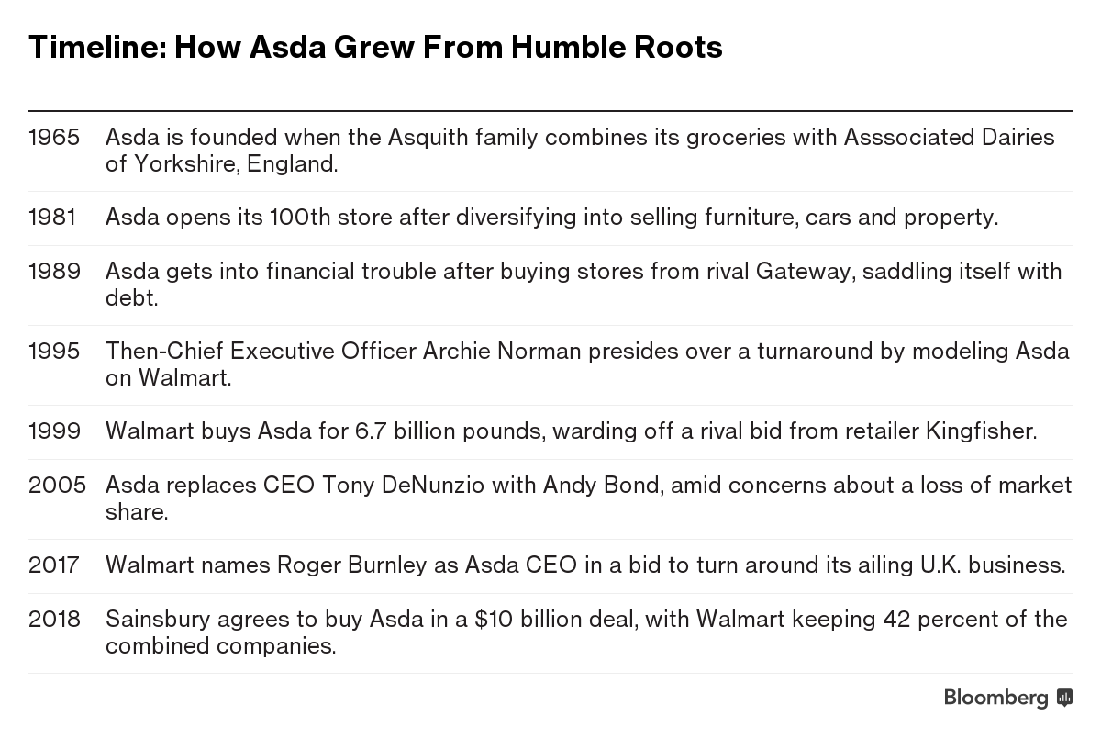
Ap 1.0 -Timeline of ASDA supporting Findings.

AP 2.0 SWOT ANALYSIS
Strengths  - ASDA has a strong presence within the UK and is recently known overseas  - Has a lot of support from American chain WALMART  - Low price deals ‘roll backs’ | Weakness  - Recalls on products affect image of brand  - The change of employee contracts  - Hardly comply with GROCERY SUPPLY CODE OF PRACTICE
Opportunities  - Launch/advertise ‘biggest ever roll back’  - Advertise comparison prices with other supermarkets in store  - Make own brand products  - Do regular survey’s for customer feed back  - Follow up to date trends with products such as clothing and home merchandise | Threats  - Competition from other stores such as Aldi/Lidl  - Shoplifting  - Customers aren’t as loyal to one shop  - Rising price in labour costs effect profit margin

Ap 3.0 PESTLE Analysis of ASDA
- Political
EU, national and international regulations will affect ASDA and any other business. Also, any war or instability will affect ASDA’s business majorly, most importantly their decisions. This means businesses like ASDA must monitor political issues all the time, but they are lucky as they are in a stable political environment which is the UK.

- Economic
Factors such as, competitive pressures, labour supply and demand, pay level and energy prices are factors ASDA needs to look at to finalize the pricing strategies the company does.

- Social
Changes in the social environment play a huge part in ASDA’s success, for example, ageing population, new trends and celebrity following will allow ASDA to keep up to date on the social side of the business and helps them to put new products on the market

- Technological
As technology is ever growing and there are new ways to connect and buy products online it is important for ASDA to keep up to date with technology, ASDA is always looking for better ways to stay close to their customers and how to use technology in their favor.

- Legal
ASDA must follow the countries rules and regulations, as if they do not, they can face serious consequences. For example, ASDA are not allowed to pay employees under the minimum wage or dismiss any employee and treat them differently to others. If any of this happens ASDA can be taken to court by the employee.

- Environmental
Various environmental factors are very important to ASDA, as society are more educated on what happens behind the scenes of companies and the impact they have on the environment. There is a huge pressure for all businesses to become environmentally friendly.

References
ASDA, 2019, In-store services, Available at: https://www.asda.com/about/instore (Accessed 11 March 2020)

GOV.UK, 2020, Grocery supply code of practice, Available at: https://www.gov.uk/government/publications/groceries-supply-code-of-practice (Accessed 11 March 2020)

The Guardian, 2019, Asda staff could end up £500 worse off under wage changes, says MP Available at: https://www.theguardian.com/business/2019/apr/16/asda-staff-could-end-up-500-worse-off-under-wage-changes-says-mp (Accessed 09 March 2020)

My5, 2019, Inside ASDA bigger, better, cheaper? Available at: https://www.my5.tv/inside-asda-bigger-better-cheaper/season-1 (Accessed 09 March 2020)

Dr. Sewel Sodry, (2018). PESTLE Analysis of ASDA [Online]. Available: https://www.google.com/search?q=how+to+reference+an+article+harvard&sxsrf=ALeKk013BRBGFux_P18Qbrd8Q6NcGwjsGQ:1583966298309&source=lnms&tbm=isch&sa=X&ved=2ahUKEwif1q-kvpPoAhUHYcAKHWdLAokQ_AUoAXoECBAQAw&biw=1366&bih=657#imgrc=Hki1MTVOZsr5_M (Accessed 08 March 2020)

Forbes, 2019, Fashion Sustainability In 2020: Trends, Achievements And The Road Ahead [Online]. Available: https://www.forbes.com/sites/theyec/2020/01/28/fashion-sustainability-in-2020-trends-achievements-and-the-road-ahead/#362f1a254b93 (Accessed 15 March 2020)

Christian Thomson, 2019, Top Marketing Trends For 2020, [Online]. Available: https://www.forbes.com/sites/forbesagencycouncil/2019/10/03/top-marketing-trends-for-2020/#4f63b9cd13d5 (Accessed 15 March 2020)

Daniel Keyes, 2017, Instagram rolls out shoppable posts for more merchants, [Online]. Available: https://www.businessinsider.com/instagram-rolls-out-shoppable-posts-for-more-merchants-2017-10?r=US&IR=T (Accessed 13 March 2020)

