Assignment learning digital era

Essential skills for study and employment
1 communication
Communication is the most important skills they look for good variable and written communication skills are often thought of as given not everyone can communicate with other people make sure the people u considers effective communication
2 decision making
Everyone should be able and decide a idea that will benefit the company regards on their role
3 commitments
Hiring candidates that show commitment to their employee are good it shows that they are engaged with work, and they can contribute
4 leadership
Leadership is not plainly important for seniors it's for all role so you can help each other and make progress this will be linked to communication, and it will inspire and motivate others
5 teamwork
Teamwork is important every employee u hire should be able to work confidentially and effectively with group work or teamwork it is good to work with other employees will learn something
6 Negotiation
Good negotiation skills are not just needed on your sales team candidate with skill can discuss and have an argument and agreement with other
7 flexibilities
Some jobs have lots of verities while other are more predictable even employees with routine jobs are flexible to be able to adjust sometime quickly when something is not right e.g. When someone cannot come work or emergency happen, they can cover up the person
8paitence

When you are working you will need potence to work with other people because not everyone can understand everything in one go

SIMILARIY
After I have submitted my work, I have got a score of %0 for me to improve that I have to use good words to describe the employee and stuff and I have to write the amount of words they asked me to.

Reference
https://eskill.com/blog/essential-skills-employees/

Task 3
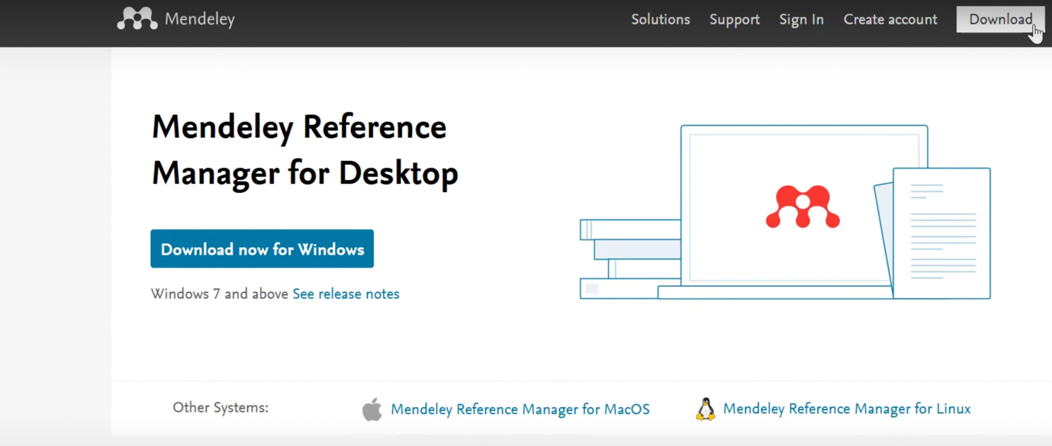
https://sway.office.com/nWrNAFlHdSbprFRT
1 click the download button and change it because it depends on what operator you are

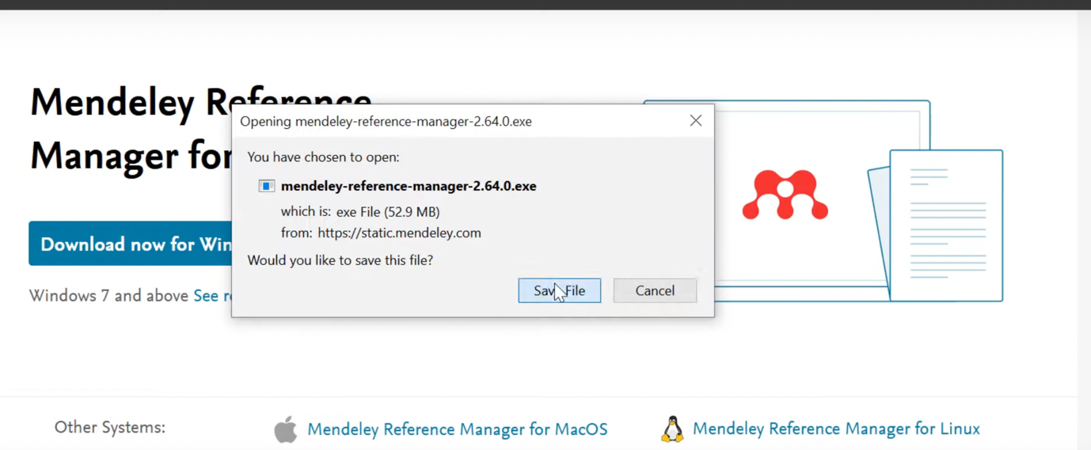
2 once downloaded you have to follow the set up wizard to install it

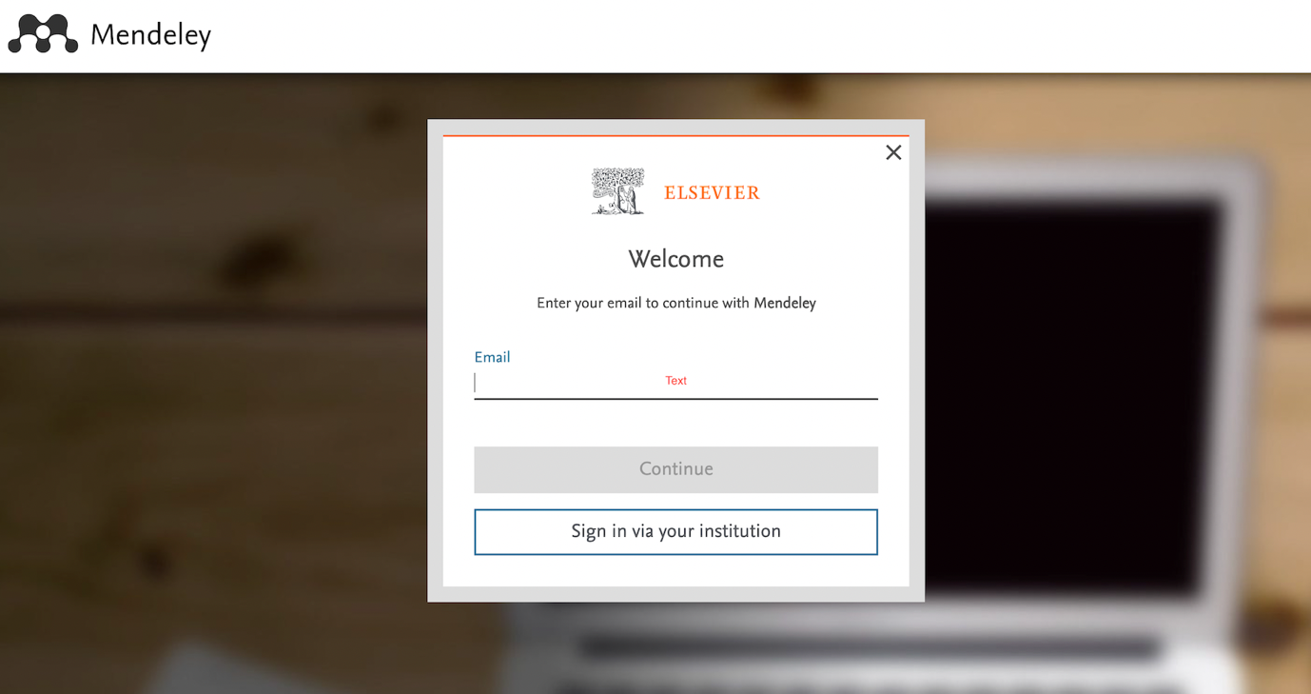

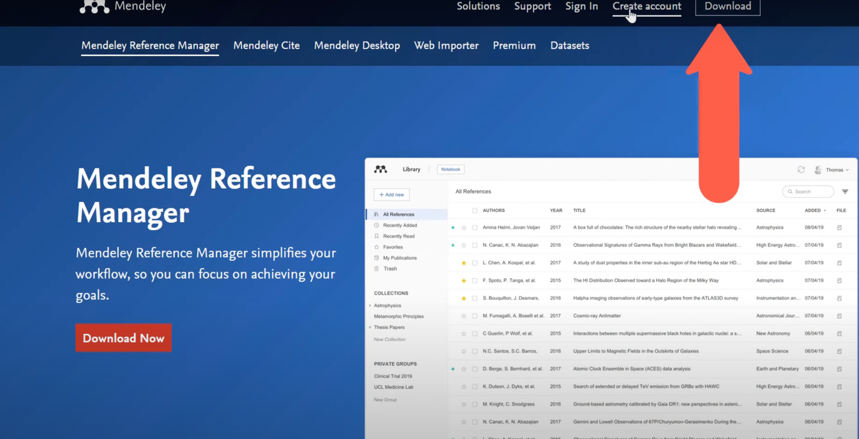

3 To use Mendeley you need to have Elsevier account good thing about it its free to create an account go back to the Mendeley website and click create account

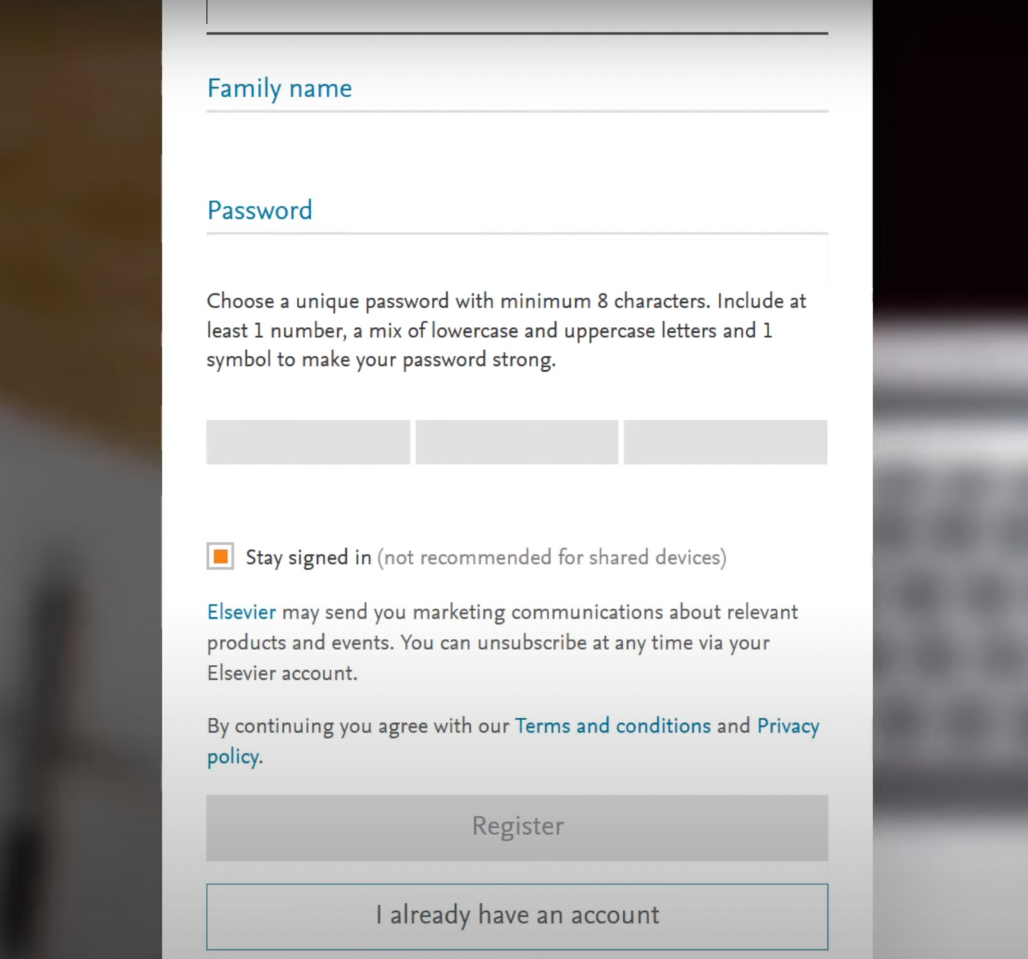
4 to make an account enter your email address and click continue and then fill out your name and any password you want then click register account now you should have an elsevera account witch u can log in to Mendeley reference account.

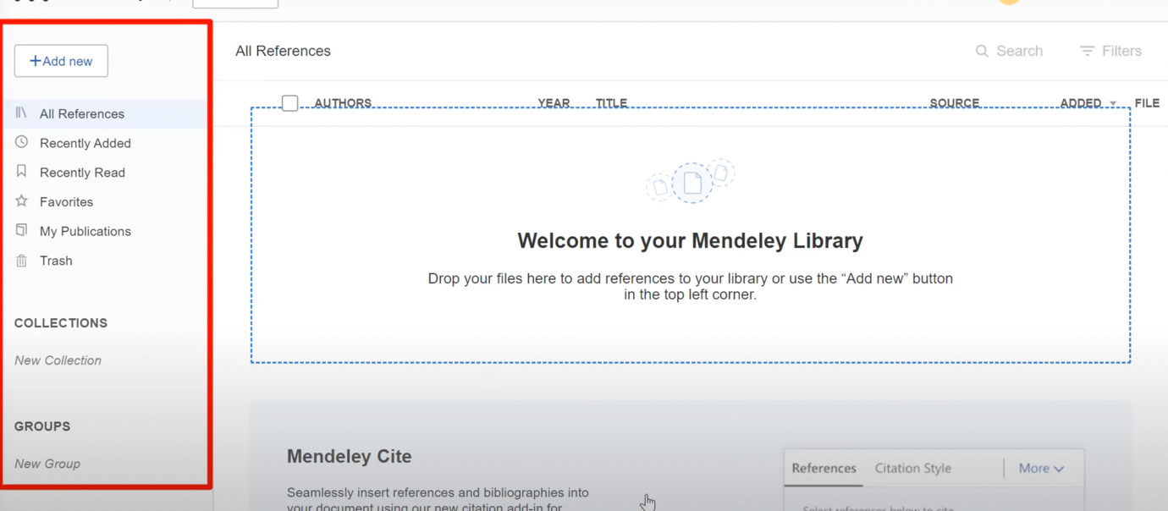
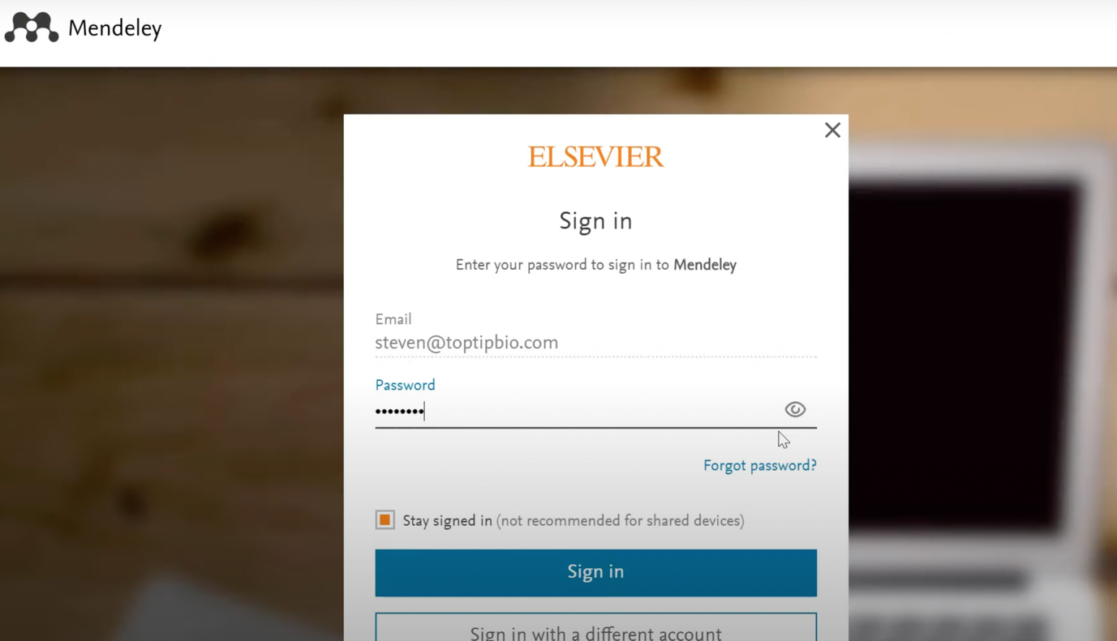
5 and now log in the Elsevier account with your detail in it when you log in inside the Mendeley manager you should see a side bar on the left click on the add new button you can see different section of the library. Recent added are red reference marked as your favourite and things you published your self
At the bottom there is trash file where all your deleted stuff from library will be

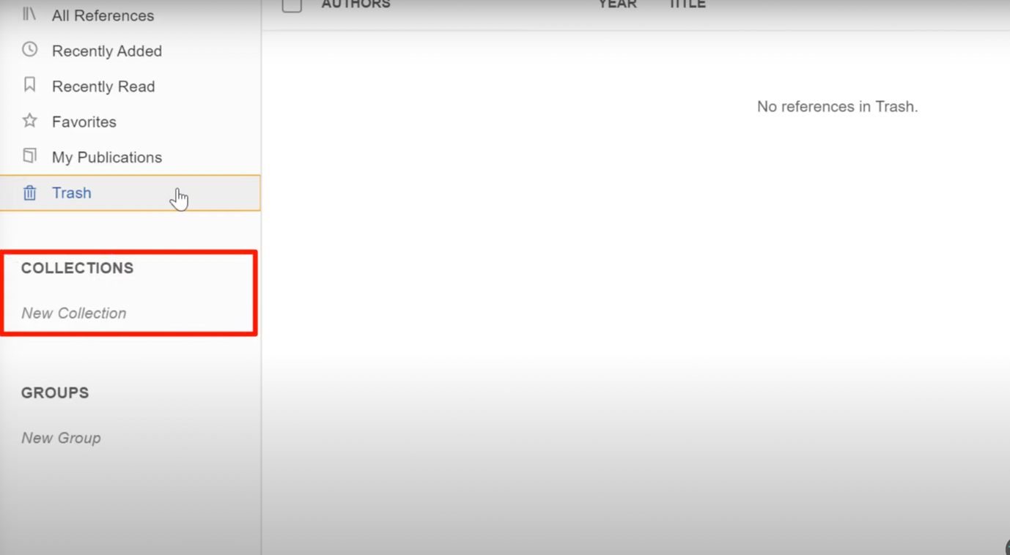
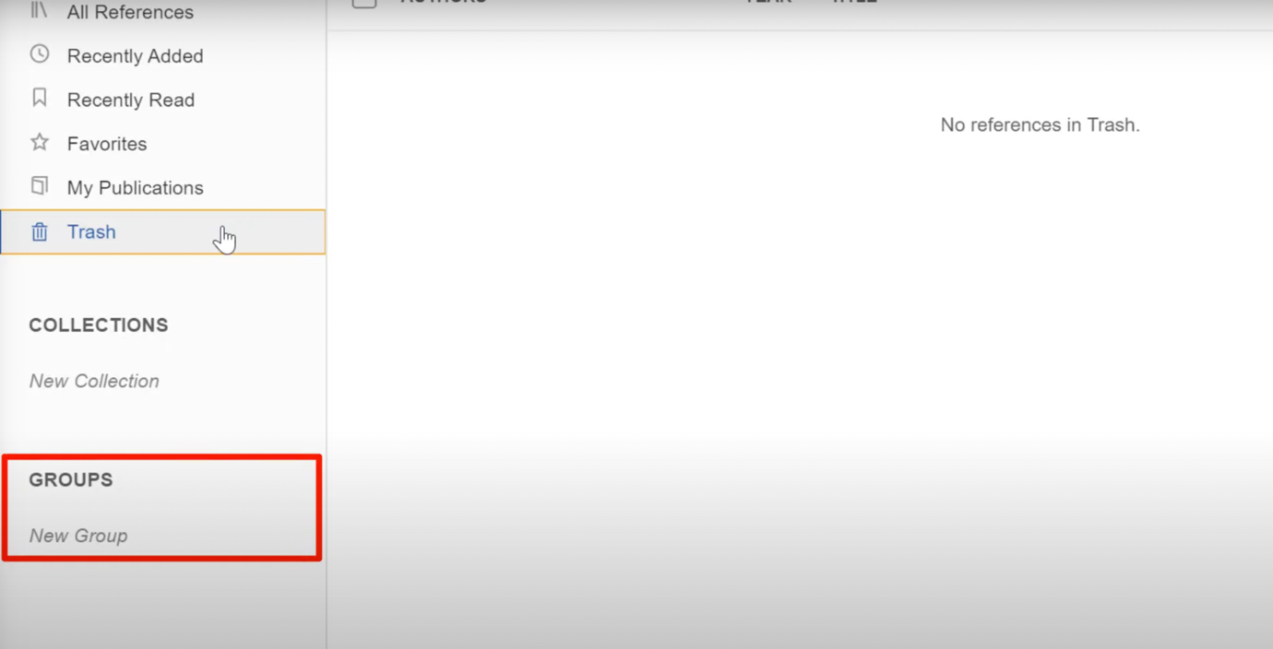
6 collections are like folders where you can manually drag and drop references into folders its perfect to keep your library organised
Under the collection you will notice a private Groupe section private Groupe are like share library and share reference and book text document to other members in your Groupe

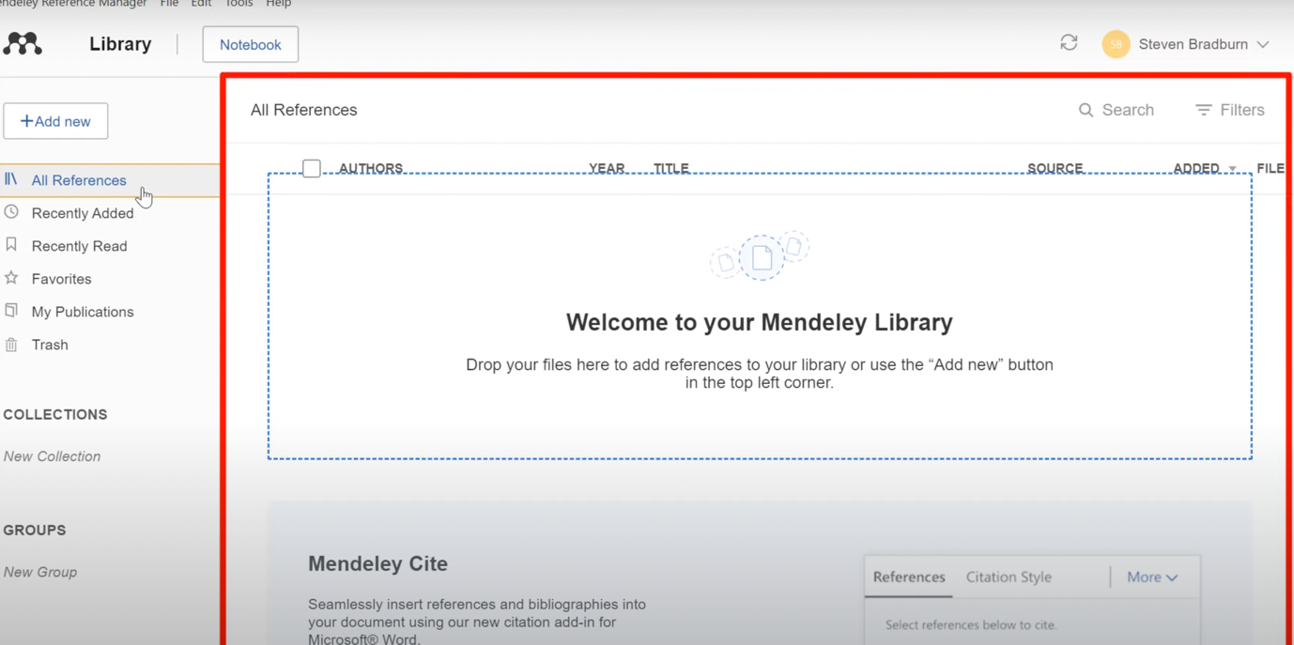
reference manager you will see all reference and panel in your libary

