

Programme: Master of Business Administration
Module: Strategic Management
Module Code: LCMB 7003
Assignment Title: Assessment: Individual Report- P&G
Lecturer’s Name: Amare Desta
Name and ID of the Student: Shitanshu Pankaj Galledar 2428869
Submission Date: 22nd December 2025

Executive Summary
This report analyses the organisational history of Procter and Gamble (P&G), the available competitive strategy choices and the rationale behind choosing Mexico as a new international market or the target market. The international market of Mexico is suggested as a high-potential country because of its high population, growing middle class, and growing demand for household and personal care products. The long-term global presence, a strong brand portfolio, and advanced R&D structure of P&G provide the opportunity to compete successfully in the fast-moving consumer goods market. Mexico offers a chance of local production, localisation of products and good penetration of the markets both offline and online. The relevance of the market to the strengths of P&G is supported by cultural alignment and value-oriented, innovative product creation, as well as the favourable market conditions in Mexico. These provide high growth opportunities and stress the global competitiveness of P&G. P&G’s global strategy is to enter the new countries first, especially into the new markets like Mexico and then proceed with its strong brand and innovation. After concentrating on the American market, P&G started to gain some seriousness when it came to international expansion after World War II. In 1948, P&G set up its first company in South America in Mexico. The company also built factories along with a distribution network in Mexico in the following 20 years. It is an indication of a global standardisation strategy with presence in many local markets. P&G has confidence in its brand, massive research and development, and production.
Table of Contents
Introduction 4
Section 1: Selection of Organisation and Target Market 5
1.1 Organisational background of P&G 5
1.2 Target market 5
1.3 Rational for the Decision 6
Section 2: Comprehensive Strategic Analysis 8
2.1 Macro-Environmental Analysis using PESTLE analysis 8
2.2. Industry/ Competitive Analysis 10
2.3. Performance Analysis using SWOT 13
2.4 Insights and Strategic Implications 14
Section 3: Strategy Development and Formulation 17
3.1 Strategic Direction and Rationale 17
3.2 Ansoff Matrix 18
3.3 Market entry mode 21
3.4. Competitive positioning using Porter’s generic strategies 21
3.5. Strategic Fit and Capability Assessment using VRIO framework 22
3.6. Strategy Implementation Components 24
3.7. Risk analysis and mitigation 25
Section 4: Performance Evaluation Framework 27
4.1 The Balanced Scorecard Framework 27
4.2 Triple Bottom Line (TBL) Integration 30
4.3. Monitoring and Mechanisms of Governance 33
Conclusion 35
References 36
Appendix 43

Introduction
P&G, the brand is chosen and the Mexican market is chosen as a target market. The report published by P&G (2025) showed that in fiscal 2025, the company paid out 9.9 billion in dividends and repurchased 6.5 billion shares, giving owners more than 16 billion in value. It marks that P&G's 69th consecutive dividend increases and its 135th year of dividend payments since the company's inception in 1890. The consumer goods company operates around 70 countries such as Europe, Latin America, Asia Pacific, Brazil, Germany, and others.
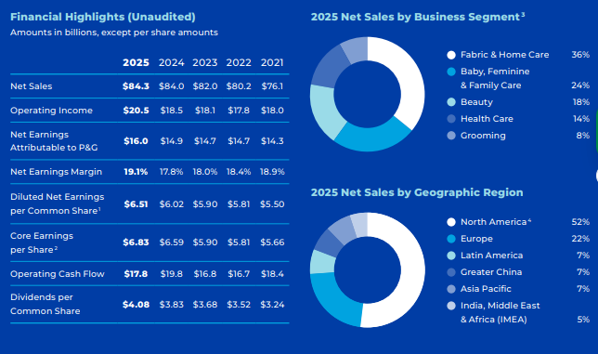
Figure 1: Financial statement of P&G
(Source: P&G-Financial Statement, 2025)
P&G is organised into long-standing global brand business divisions like Fabric and Home Care, Baby, Feminine and Family Care, Grooming, Personal Health, and Beauty (P&G, 2025). These divisions carry out centralised R&D, mass production, and local sales teams that support a wide range of well-known brands. The business type of P&G highlights that the brand sells most of the consumer goods to retain brand position in the market. The report published by P&G-Financial Statement (2025) highlighted that P&G is one of the largest consumer goods companies in the world, who have market share of 52% in North America, 22% in Europe and 7% in Asia Pacific.
Smithson (2018) stated that in the context of enhancing competitive advantage in the global market, P&G applies generic competitive strategy that includes maintaining differentiation in product portfolio and revising the product base based on the customer choices. This is relevant because customer choices are changing rapidly, and through this, P&G can retain their potential customer base.

Section 1: Selection of Organisation and Target Market

1.1 Organisational background of P&G
P&G is one of the American multinational organisations mainly involved in consumer goods. The company was incorporated in the year 1905 in Ohio with its headquarters in Cincinnati. The company sell its products in more than 180 countries. P&G is divided into age-old worldwide brand business units such as Fabric and Home Care, Baby, Feminine and Family Care, Grooming, Personal Health, and Beauty. This executes on centralised research and development, mass production and regional sales teams that sustain a diverse array of household-name brands (P&G, 2025). I evaluated that the company is a publicly traded, multinational, diversified consumer packaged goods (CPG) corporation that competes on brand equity, scale, innovation, and distribution through a post-pandemic sales boom, and increasing expenses and clingy inflation. Over the four years in P&G, the shares have appreciated by approximately 13%, which is the case with the S&P 500 index (Mishra and DiNapoli, 2025). In April, the company increased its input costs because of the trade war threatened to increase the price of its products, such as Pampers diapers and Head & Shoulders shampoo, when consumer spending was declining. It has fallen by approximately 6% this year.

1.2 Target market
Mexico offers a strategic and high-potential foreign market that Procter and Gamble (P&G) can develop to increase its world presence. Mexico is among the largest and fastest-growing economies in Latin America, which has a good consumer base of over 126 million individuals. This growing middle-class population is demanding high-quality household and personal care products. The Company distributed more than 16 billion of value to shareholders in fiscal 2025 through 9.9 billion of dividend payments and 6.5 billion of share repurchases. It is the 69th dividend increase in a row of P&G, and the 135th year of paying a dividend since the time of its incorporation in 1890 (P&G, 2025). Mexico has very good entry points with the presence of major platforms like Mercado Libre, Amazon Mexico, and Walmart de Mexico, with a favourable trade environment under the United States-Mexico-Canada Agreement (USMCA) that reduces trade barriers and gives an upper hand in cross-border logistics (Lucas, 2025). Moreover, the strong retail network of Mexico, which encompasses supermarkets, hypermarkets, convenience-store chains, and an e-commerce market that is expanding fast, gives P&G several points of distribution where it can grow effectively.
The company indicated that non-core restructuring would cost the Company between USD 1 billion and USD 1.6 billion before-tax in a period of two years. These restructuring measures are to include a reduction in the non-manufacturing overhead staff of up to 7,000 at the end of fiscal 2027 (P&G, 2025). In this plan, the company anticipates half the costs by the end of fiscal 2026, with the rest of the costs being incurred in fiscal 2027. P&G needs to implement a localisation approach to the Mexican consumers to achieve effective expansion. This involves the provision of value-based product sizing and culturally appropriate branding, product innovations that are responsive to local demands, such as water-saving detergents in those parts of the world experiencing water shortages or products that are responsive to a warmer climate (Lucas, 2025). The marketing efforts may address family-oriented messages, sustainability, and health-oriented benefits area, which are highly reflected in the Mexican purchasing behaviour.

1.3 Rational for the Decision
Strategic considerations, operational considerations, and market-driven considerations can be used to explain the decision to emphasise the organisational background of P&G and Mexico as a proposed international market to venture. It is important to sketch the organisational background of P&G since it defines the capacity, resources, and competitive advantages that the company possesses to underpin further growth (McDade, 2025). The long history and presence in the global arena, highly developed brand base, and innovative research and development show that P&G has the size, experience to venture, and operate in difficult global markets. This is because of the centralised but category-based structure that allows it to be efficient in its innovation, brand management, and flexibility to respond to varying market conditions. This organisational advantage is the reason why P&G is expected to grow even more, and it can adopt measures that will help it to be more competitive against international competitors like Unilever, Reckitt, and Colgate-Palmolive (McDade, 2025). The background analysis confirms that P&G has the capabilities internally to implement the aforementioned strategies by pointing out the options, such as e-commerce expansion, specific innovation, and supply-chain optimisation.
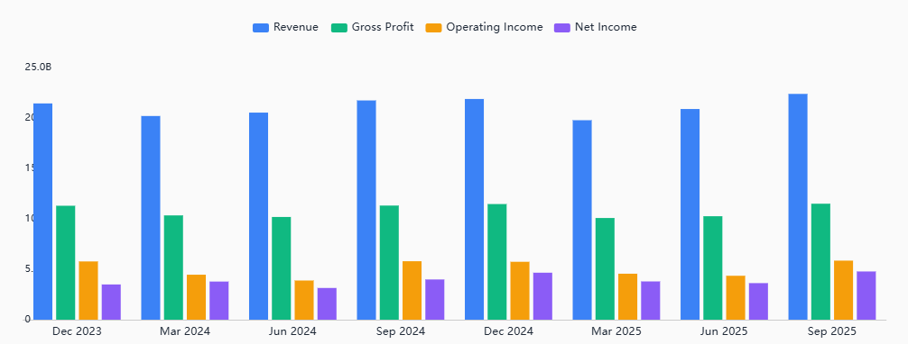
Figure 2: Revenue statement
(Source: Devyara, 2025)
Mexico is a strategically appropriate decision to be taken in terms of international expansion because of its demographic, economic, and geographic benefits. Mexico represents a large market with more than 126 million people and a growing middle-income population, which means that the demand of FMCG products in Mexico is huge in the core categories that P&G deals with (Devyara, 2025). The fast urbanisation of the country, high-level retail, and a thriving e-commerce market provide good opportunities to enter the market with the brand and develop it distribution.

Section 2: Comprehensive Strategic Analysis

2.1 Macro-Environmental Analysis using PESTLE analysis
Political: The country of Mexico has a relatively stable and business-friendly environment of manufacturing because of its substantial integration with the North American supply chains. This includes the legal predictability associated with “The United States-Mexico-Canada Agreement (USMCA)”, which supersedes NAFTA (Office of the United States Trade Representative, 2025). The federal government proactively encourages investment in industries. However, it is also aware of domestic political interests that could influence their incentives and procurement by the government. The United States Trade Representative office reported a fall in exports, although significant shifts in the export volume occurred during the last three years. The United States Trade Representative office reported a decline in exports, yet there were major changes for exports in the past three years.
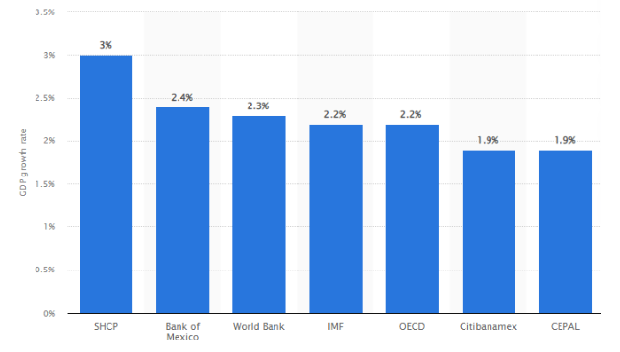
Figure 3: GDP growth of Mexico
(Source: Sanchez, 2024)
Economic: The macro environment is both good and bad. Growth rates have been moderate in the past few years, where inflation has been fluctuating around the mid-single-digit range. Sanchez (2024) stated that GDP growth of Mexico is 2.4% in 2025. However, this is slowing down and the policies by the central bank have an impact on the cost of borrowing money to invest in the capital market. According to the report published by World Bank (2024), economic growth of Mexico is projected to be 0.5% in 2025 and it is expected to increase by 1.9% in 2027. In the context of planning, the manufacturers should emphasise stress testing of lower growth, moderate inflation, and increased interest rates.
Social: It has been evaluated from the report of World Bank (2024) that nearly 130 million people are stated in Mexico. Labour supply is in industrial hubs such as Border States, Bajio, Jalisco, Nuevo Leon, but the issue of informality is still observed in certain regions and increases in minimum wages over the past years have increased labour costs of operating at entry-level jobs. However, I evaluated that social license and community relations such as demands in local hiring and supplier development have increased importance in the current day in terms of plant location and brand image.
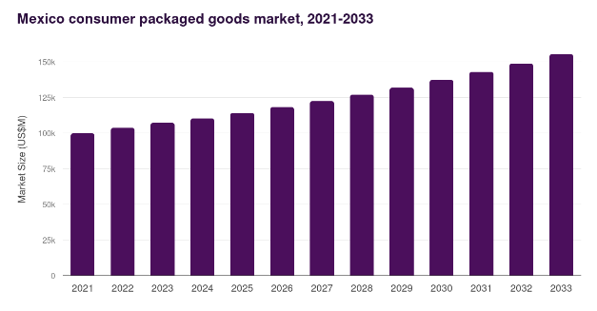
Figure 4: Consumer goods market growth of Mexico
(Source: Grand View Research, 2025)
Technological: The supply diversification by U.S. manufacturers are growing faster towards investing in Mexican plants and reorganising logistics to better access to technical labour skills, and cluster suppliers. It has been evaluated from the report of Grand View Research (2025) that trends influence Mexico’s consumer goods market to reach the revenue of USD 155,364 million in 2033. In the case of consumer-goods companies, it implies a simpler process of sourcing packaging, components and contract manufacturing firms and a chance to test automation at competitive pay.
Legal: The legal and compliance planning must be done carefully when it comes to product, packaging standards, “Official Mexican Norms (NOMs)”, customs procedures, and the recent labour reforms increased union, worker protection in certain industries (Economía, 2019). I think that exported under FTAs tariff exposure is low on many of the inputs, and so changes in tariffs or industry measures may arise to continue the discipline of custom and trade counsel and certificate-of-origin.
Environmental: Environmental regulation is becoming stricter. Wastewater, emissions and hazardous waste regulations (NOMs) are observed in the industrial areas. As suggested by Gómez (2023), Mexico City generated around 53.1 million tons of waste. A circular economy can be integrated in the organisational systems to influence the waste management approach of a brand. Water stress is a tangible operational risk in a number of manufacturing areas. Retailer and international purchaser demands regarding sustainability are increasing such as reducing packaging, waste disposal, and reporting carbon.

2.2. Industry/ Competitive Analysis
This can be analysed using Porter’s five forces model, which is analysed below.
Five forces | Strengths | Implication on business
Bargaining power of customers | High | The power of retailers in Mexico is owed to the consolidation in modern trade. In the view of Sánchez Toledano et al. (2023), Mexican consumers prefer to consume chilli peppers. I evaluated that Walmart Mexico is the solo company that holds a considerable portion of the FMCG retail, which allows bargaining hard in terms of the price, placement costs, promotion, and deliveries. Sánchez Toledano et al. (2023), stated that “Sheep meat” is an essential product for a consumer goods brand and this attracts the consumers. The end consumer is very price sensitive, and they have many brand options, hence their tendency to switch brands and demand discounts is very high. Buyer power is enhanced further by e-commerce platforms, price comparison tools and social media, which facilitate transparency and quick feedback.
Bargaining power of suppliers | Moderate | Medium power suppliers are suppliers of raw materials such as plastics, paper, agricultural commodities, and chemicals. As stated by Mora-Quiñones et al. (2024), there has been a dedicated loading-unloading zone in emerging markets that has an impact on suppliers. However, the availability of numerous local and foreign suppliers will decrease the reliance on one supplier. In the aspect of packaging, competition among the suppliers maintains a balanced bargaining power. García Alcaraz et al. (2022) stated that green supply chain has an impact on the manufacturing industry. Supplier power is more in segments where inputs are specialised fragrances, patented formula, and specialty ingredients.
Competitive rivalry | High | The consumer goods industry in Mexico is a competitive market with international players such as Procter and Gamble, Unilever, Nestle, Colgate-Palmolive and Kimberly-Clark. In the view of Atayde et al. (2021), market competition influenced the business in enhancing innovation and improving productivity. The brands entered into the market together with strong domestic ones who include Grupo Bimbo, La Costeña and Jumex. The sensitivity of Mexican consumers on prices, particularly in terms of lower and middle-income earners, makes competition among the companies very intense in terms of price competition, promotions and value packaging (Atayde et al., 2021). The competition is further brought by the retail forms, which include the conventional corner stores up to the modern supermarkets, wholesalers and online stores where users can easily compare prices. There is brand loyalty, and when prices are increased, the switching is common. Other significant roles in offering differentiation include product innovation, sustainability, and localisation.
Threat of new entrants | Moderate | In the view of Zapata-Cantu (2021), the capital requirements in certain segments such as food, beverages, and personal care are moderate, the new players have encountered problems. This includes attaining economies of scale, strict NOMs regulatory issues, distribution. This is competing with the established brands. The entry into the modern trade is complicated by the presence of strong retailers such as Walmart Mexico, Soriana, Chedraui and Oxxo in the market, rendering getting to the shelf a difficult and expensive endeavour. However, e-commerce and specialty stores provide an opportunity to enter the segment with niche and premium brands, particularly organic, natural, and artisanal (Zapata-Cantu, 2021). Contract manufacturing is also a way of reducing entry barriers to small brands.
Threat of substitutes | Moderate to High | Categories have a high presence of substitutes. Alternatives are available in informal markets and local brands in food and beverages, which are cheaper. Escobar‐López et al. (2022) stated that consumers have a perception about the products of manufacturing brands and this aids them to buy. This can also be indirectly accomplished by digital services, which can take the form of a reusable product in place of a disposable, or a homemade product in place of a packaged consumer product (Diaz and Montalvo, 2022). Sustainability trends include refill stations, biodegradable, and other local artisanal products, which pressures more on substitution.
Table 1: Porter’s five forces analysis of P&G

2.3. Performance Analysis using SWOT
The SWOT analysis will help in linking the overall performance that P&G achieved with the particular environment in Mexican market. It demonstrates the interaction of internal strengths and weaknesses of the firm with external opportunities and threats and explains how P&G can expand in Mexico in a realistic manner.
The strengths of P&G include strong label brands, large-scale production, and advanced R&D. Besides, in FY’25, P&G registered net sales of approximately $84.3 billion, organic sales increased by 2%, and the Latin America region contributed to 4% organic growth, which shows region’s strong performance (P&G Annual Report, 2025). In addition, the firm has a high cash flow and constant dividends, which supports in long-term investments in Mexican plants, marketing, and innovations. Further, weaknesses are related to increasing input prices and currency pressures. However, according to P&G Investor (2025) report, the higher pricing and mix have been applied to protect margins, which may cause strain upon price-sensitive Mexican consumers. Externally, there are certain opportunities. Like, Mexican consumer packaged goods market produced $110.2 billion in 2024, which is projected to reach around $155.4 billion over the next 10 years with 3.9% growth (Grand View Research, 2025). Besides, the Mexico market, which is directly related to P&G baby and feminine care line, is estimated at $10.7 billion today and projected to grow to $14.2 billion in next 10 years with a growth rate of 3.9% per year (Grand View Research, 2024). These statistics suggest that demand of the core categories of P&G will continue to increase. In terms of threats, it seems that there is low national GDP growth that is anticipated to increase at a slow pace of 0.5% in 2025 and then gradually to 1.9% by 2027 (World Bank, 2020). Further, this can limit consumer expenditure generally in short-term. Moreover, this level of competition with other international FMCG companies and local brands with stringent rules of environmental and packaging control can affect market share unless P&G keeps innovating and localising. However, since P&G advantages and size of Mexican FMCG and hygiene market outweigh these threats, the overall performance in Mexican strategic environment is favourable and appealing.

2.4 Insights and Strategic Implications
PESTLE analysis
Effectiveness: The key effectiveness of the PESTLE framework lies in the fact that it provides a structured and comprehensive layout to the organisation that facilitates the business to shape the processes. Dalirazar and Sabzi (2023) suggested that the macro environment of an industry guides an organisation to form reliable strategies and set goals with a timeline that need to be achieved. It helps the brand to anticipate the external opportunities that benefit the business in investing human capital into the systems to influence the functions. It assists the companies to foresee the external opportunities and the threats caused by the political, economic, social, technological, legal, and even the environmental forces. This justifies strategic planning over the long term, risk analysis, and effective decision-making. PESTLE is particularly useful to multinational businesses since it singles out cross-country differences that could affect the investment, operations or entry mode planning (Dalirazar and Sabzi, 2023). It is also user friendly, familiar, and flexible to industries hence the framework is an effective tool that can be used by executives, consultants, and researchers.
Limitation: PESTLE has its limitations even though it has its strengths. It has the tendency of simplifying complex environments since it considers external factors to the conditions can vary very fast. Hayden (2025) argued that the analysis is also subjective, as the quality greatly depends on the expertise of the analyst and the data. PESTLE has been found to identify the external factors but does not access their impact nor give solutions to them. Hence, there is the need to integrate with tools such as SWOT, scenario planning or financial modelling. However, too much breadth can create a long list of irrelevant factors, which will deform attention and utilitarianism.
Porter’s five forces analysis
Effectiveness: Porters Five Forces is useful in that it offers a logical, systematic model of analysing the competitive environment of an industry. According to the report published by The Strategy Institute (2024), it assists organisations to realise external strains that characterise profitability, such as rivalry, supplier and buyer influence, substitutes and entry obstacles. This renders it useful in the process of strategic planning, market entry as well as the evaluation of the industry viability over the long run. The model compels managers to take into account several competitive factors not only direct competitors, but also where strategic strengths or weaknesses will be found. It is universal in industries and assists companies in basing their position against those of their competitors.
Limitation: The model has a number of limitations although it is useful. It takes into consideration quite stable market structures and this assumption cannot be made in rapidly advancing industries that are shaped by technology, globalisation, and digital disruption. The model pays more attention to the outside competitive forces and fails to consider the internal forces, dynamic innovations, and ecosystems such as strategic alliances and platform economies (The Strategy Institute, 2024). It considers industry boundaries as rigid, although contemporary industries are becoming more and more overlapping. However, the model is static and it takes a snapshot as opposed to a representation of change that is in progress. Marketing may also fail to see possibilities of cooperation or differentiation due to overemphasis on competition.
SWOT Analysis
Effectiveness: SWOT framework is effective, as it provides a balanced view to understand perception of performance of P&G. It creates a link between internal financial and capability data with the external market and economic data in a single clear picture. Further, it helps managers in Mexico to observe the location of strengths, including powerful brands and cash flow, which can be aligned with the growing categories, such as disposable hygiene, and broader demand of FMCG to determine sensible strategic decisions (Grand View Research, 2025).
Limitation: SWOT analysis however has certain limitations, as it remains unchanged whereas in Mexico, markets and macro-conditions like GDP trends and regulation evolve with time. It is also subjective because the managers are able to over emphasise the strengths or underemphasise threats. Thus, SWOT should be applied with specific tools like financial ratio analysis, PESTEL, and Balanced Scorecard to provide a comprehensive and information-based performance view.

Section 3: Strategy Development and Formulation

3.1 Strategic Direction and Rationale
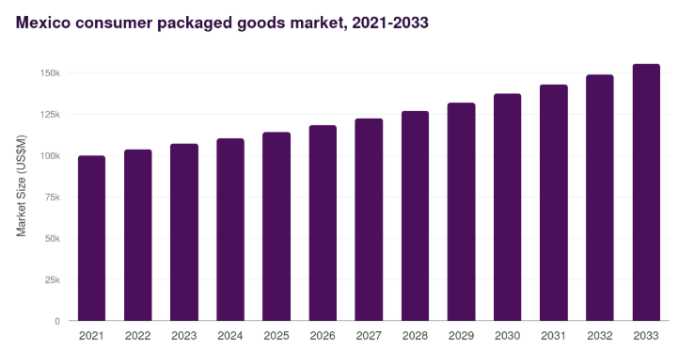
Figure 5: Consumer-packed goods market in Mexico
(Source: Grand View Research, 2025)
The global strategy of P&G is first to expand into the new countries, particularly to the emerging markets such as Mexico and then grow with its robust brand and innovation. P&G began to take international expansion seriously after World War II, after focusing on the U.S. market. P&G established the first Latin American company in Mexico in 1948. The market of consumer-packed goods in Mexico was gaining approximately US$110,190 million in the year 2024 (Grand View Research, 2025). The market is increasing, which provides P&G with a large opportunity to develop its core product lines of homecare, personal care, hygiene and health/personal hygiene. P&G has good demand in Mexico since it is a strong company in hygiene, baby care, and home care around the globe. It intends to leverage its global brands and research in Mexico, but produce products locally and customise them to the market.
The Mexican affiliation of P&G began in 1948 with the acquisition of an oil refinery plant. It erected its first large plant in Vallejo in 1951. The plant is still P&G's oldest and largest in Latin America, turning 70 in 2021 (P&G Annual Report, 2025). P&G also deploys its worldwide innovation to address the needs of the location. Company individuals declare that their system and speedy market release enabled them to rush with a new product in the market. It deals with ideas, formulas in packaging, in marketing, and distribution in both the rich and poor countries within a short span. The inflow of money is projected to increase to approximately USD$155,365 million by the year 2033, and an average rate of growth is about 3.9% annually.
The hygiene and disposable hygiene segment of the market, including baby diapers, sanitary goods, wipes, is valued at approximately US$10,686.6 million in 2023 (Fortune Business Insights, 2023). Moreover, it is expected to increase to approximately US$14,208.2 million by 2030 and grow by an average of approximately 4.2 per annum. This enables P&G in Mexico to provide good products at low prices, which are affordable to the local consumers without compromising the brand. The other key aspect of the global strategy of P&G is its establishment of local factories and distribution. Instead of just transferring goods to the U.S., P&G established factories in Mexico in the cities of Vallejo, Naucalpan and Alce Blanco to produce detergents, personal care and hygiene products in the country. This assisted in reducing expenses, accelerating the supply chain, and aligning with the local regulations and low price requirements.

3.2 Ansoff Matrix
The application of the Ansoff matrix shows the right choice of strategy in terms of determining the balance between product and market situation (Wei and Lin, 2024).
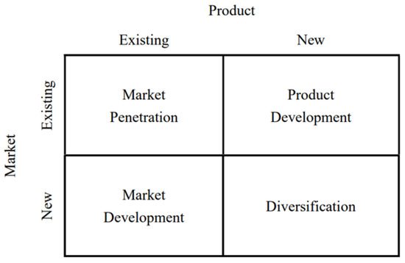
Figure 6: Ansoff Matrix
(Source: Wei and Lin, 2024)
Market Penetration: P&G has been continuously increasing its market share of core product lines in Mexico by providing fair prices, widening distribution channels using modern retail outlets, and doing intensive marketing. The Mexican grocery market is large and expanding in 2024, and P&G has opportunities to make additional sales (Fortune Business Insights, 2025). P&G sells low-cost products through its international distribution, good brand identity, and domestic manufacturing plants in too many Mexican households. The number of additional factories and warehouses assists in serving the population of cities and towns around. It is easier to distribute and reach more people by shifting the small stores to the big retail chains.
Product Development: P&G creates new or modified products in Mexico. As an example, they put out a brand of single rinse called Downy in Mexico, considering that the locals use less water. P&G will be able to localise its existing brands to suit less expensive or local markets, and this demonstrates its responsiveness to the local needs. P&G also produced health products in Mexico through the incorporation of tablets and hygiene products at its Naucalpan plant. In addition, P&G will be able to sell products manufactured in Mexico promptly in other countries, and the work will be justified on a global scale.
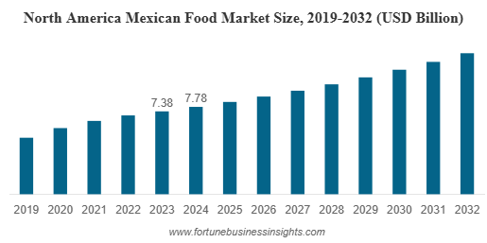
Figure 7: Food market size of North Mexico
(Source: Fortune Business Insights, 2025)
Market Development: P&G utilised the variety of its detergents, soaps, hygiene and personal care products to access additional regions and clients in Mexico. Considering the example, it currently sells such products to urban residents as well as low-income and semi-urban consumers. Reports indicate that P&G targets emerging markets when the markets in the developed countries have already been saturated (Procter and Gamble, 2024). P&G is targeting the low and middle-income groups in Mexico. P&G produces their products in Mexico, and different packaging and price alternatives allow the products to be affordable to major customers. The Mexican market expands because new retail locations and better distribution enable the company to serve locations previously underserved. I also believe through Mexico, P&G is able to produce goods that are shipped to other countries within the Latin American region and other countries as well. This reveals how Mexico assists them in the regional expansion.
Diversification: In Mexico, P&G does not experiment with a lot of unrelated products, but it has introduced a lot of types of products other than detergents and soaps, including personal care, feminine hygiene, and home care products. This provides P&G with additional sources of revenue and reduced dependence on a single product. It also enhances efficiency in production, sales penetration, and brand image. P&G markets its product lines everywhere, develops new products that meet local demands, and finds new customers and, perhaps, exports to local markets (Han, 2023). It concentrates on related products and adjusts to growth. This approach contributes to the expansion of P&G, its international brand, and the adaptation of the Mexican market.

3.3 Market entry mode
P&G's approach in emerging markets, such as Mexico, is aware of the evolving global consumer goods market. The developed markets are slowing down in growth, hence the majority of the growth is being achieved by beginner countries, where population is increasing, cities and middle- or working-class citizens are increasing. P&G targets low- and middle-income segments in Mexico, with prices, product sizes and marketing that are applicable to these segments. In my opinion, the Mexican market strategy of P&G combines good worldwide brands, centralised innovation, local plants and distribution, and local adaptation. This localised global strategy allows P&G to cater to the high demand in Mexico of consumer goods, at low costs and scale.
P&G did not just export or license into Mexico, but invested directly in new factories and established a local subsidiary that distributed its products instead of exporting them. In Mexico, P&G was initially established in 1948 through the acquisition of an oil factory, and it started operations there. It was through that initial step that it became possible to expand factories and create locally. In the year 1951, P&G constructed its first factory in Vallejo, which produced detergents such as Ariel, Ace and Downy (P&G Careers, 2025). These brands are still produced there and are popular in Mexico. Directly constructing our factories and distribution proves that P&G is in Mexico here to stay. It also enables P&G to do the production, packaging and delivery ourselves rather than through third parties. There are numerous advantages of being in total control. Local production reduces import expenses, tariffs and freight expenses. It also accelerates product delivery to market, enables us to make them local and suit the tastes of each location, maintain quality and maintain a constant supply.

3.4. Competitive positioning using Porter’s generic strategies
The competitive positioning of P&G in Mexico is analysed in terms of Porter’s generic strategies, where differentiation is reinforced by selective cost leadership. Xu (2024) stated that P&G is competing in varied categories where consumers want high performing, safe, and reliable products, which makes differentiation crucial. P&G has made significant investment in R&D in packaging technology and product quality, which increases brand excellence in all detergents, baby care, feminine hygiene, grooming and personal care. In FY’25, the business registered improved organic sales by indicating that differentiation is contributing towards performance in emerging markets like Mexico, where the business focuses on product mix and innovation upgrades. Besides, the strong brand identity in key brands like Ariel, Downy, Pampers, and Head and Shoulders are supporting the business as a preferred brand in most households in Mexico (P&G, 2024).
The Mexican market is however price-sensitive. Thus, P&G applies aspects of cost leadership, mainly in the form of local production, economies of scale, and cost-effective supply chain. The manufacturing in factories like Vallejo and Naucalpan lowers the cost of logistics and tariffs on imports, which does not lower competitive prices without lowering quality. In addition, the hybrid pricing positioning supports the company to compete against cheaper local brands and huge competitors like Unilever and Colgate Palmolive (Gadhwal et al., 2025). P&G’s competitiveness in Mexico is between differentiation and cost leadership, which helps the brand to sustain premium differentiation for being affordable in range of middle and lower-middle income consumers. Moreover, the long-term market share is strengthened by moderate approach, which supports P&G’s sustainable growth.

3.5. Strategic Fit and Capability Assessment using VRIO framework
Resources and Capabilities | Valuable | Rare | Costly to Imitate | Organised to Capture Value | Competitive Implication
Strong global brands | Yes | Yes | Yes | Yes | Sustained competitive advantage
Advanced R&D and innovation | Yes | Yes | Yes | Yes | Sustained competitive advantage
Large-scale manufacturing and distribution | Yes | No | No | Yes | Temporary competitive advantage
Long-term retailer partnerships | Yes | No | No | Yes | Competitive parity / short term advantage
Strong financial capacity and steady cash flow | Yes | Yes | No | Yes | Long term advantage
Digital supply chain and automation | Yes | No | No | Yes | Temporary advantage
Sustainability and environmental compliance | Yes | No | No | Yes | Competitive parity

Table 2: VRIO Analysis
(Source: Self-Created)
From the VRIO assessment, the internal capabilities of P&G are align with Mexican FMCG market needs. Its global brands and innovative systems are the most powerful resources, because it is difficult to find and imitate by competitors. Besides, P&G’s capabilities are completely governed by organisational structure of P&G through the centralised R&D, global learning systems, and regional adaptation teams. However, such elements create a competitive advantage in long-term, mainly within central categories like detergents, baby care and home care. The long-term production presence that P&G had in Mexico with its Vallejo and Naucalpan plants offers the firm with intense localisation in production and quality (Mexico Now, 2020). In addition, local production also reduces transportation expenses and limits exposure to currency volatility, which is important in a price-sensitive market. This is a strong ability, which is organised and valuable, as competitors as Unilever and Kimberly Clark operate local facilities, which offers a temporary advantage.
Moreover, the fast distribution and shelf visibility is supported by retail partnerships, frequently with Walmart Mexico, which has high retail presence (Kvartalnyi, 2024). The value of these relationships is not rare, as the FMCG companies tend to seek similar kind of partnerships. In case, it also helps them to sustain stable revenue streams and better market penetration. The other capability is the financial strength of P&G. The company created strong cash flows and offered high value to its shareholders in FY’25, which indicates that it can easily invest in automation, supply chain resilience, and local innovation (P&G Results, 2025). Moreover, this financial ability increases long-term development in Mexico. Finally, the robust sustainability programmes adopted by P&G, such as recyclable packaging development and reduced emission attains competitive parity (P&G Blogs, 2025). In quest, P&G also reduces regulatory risk to constrict environmental regulations in Mexico. Generally, the VRIO analysis proves that P&G is strategically fit in Mexican market.

3.6. Strategy Implementation Components
The strategy of P&G in Mexico needs to be carried out in a series of coordinated actions that would assure strong performance in the market. The company already has local factories and extensive distribution network, but there are still a number of improvements to be made to increase long-term competitiveness. First, P&G will need to increase the local production volume to reduce the reliance on imports and ensure low cost operations (Pham et al., 2022). In 2025, the firm was further protecting margins internationally by ensuring cost efficacies and mix improvements, which indicates that regional scale is crucial in maintaining profitability. Besides, FMCG market in Mexico is expected to reach $155.4 billion in 2033, which means higher demand will need adaptable and flexible production systems (Grand View Research, 2025). Besides, the company needs to implement digital technologies across supply chain. The real-time inventory tools, automation and predictive analytics will increase quality of forecasting and minimise stock outs. In addition, the tools can also be used to speed up product innovation and reduce time to deliver the product, which is crucial in a competitive environment.
Third, P&G is required to work as a strong retailer using E-commerce partnerships. As Mexican consumers are increasingly adopting platforms like Mercado Libre and Amazon Mexico, the omnichannel approach would increase visibility and penetration into homes (Broadbent, 2025). Moreover, increasing relationship with Walmart Mexico and Oxxo will facilitate more penetration in the market. Fourth, local marketing and product customisation is still required, as Mexicans like smaller pack sizes, low-cost prices, and warm climatic. Hence, brand loyalty will be achieved by personalised campaigns that are family-focused, hygienic and value-oriented. Finally, P&G needs to integrate sustainability activities in their operations. These will be recyclable packs, less water consumption in plants and less emission. I feel that as P&G aims for net-zero by 2040 globally, integrating the operations in Mexico will increase brand trust and compliance.

3.7. Risk analysis and mitigation
Key Risk | Description | Mitigation Strategy
Economic slowdown | Mexico’s GDP forecast for 2025 is low at 0.5% affects consumer spending | Offer value pack sizes, and maintain local production to reduce prices
Strong competition | Rival brands like Unilever targets same categories | Increase product innovation and differentiation through R&D
Regulatory and environmental pressures | Tight NOM standards, packaging rules, and water scarcity | Strengthen compliance systems
Supply chain disruptions | Local transport congestion and loading zone delays | Develop digital logistics planning and multi supplier sourcing

Table 3: Risk Analysis and Mitigation
(Source: Self-Created)
P&G faces certain risks in Mexico, but most of them can be managed by applying strategic planning. The economic slowdown can reduce the frequency of purchase of products that are not essential, as offering small affordable pack sizes becomes imperative. Wilkins and Ireland (2020) acclaimed that competitive pressure is also extreme, as there are global and local FMCG brands that are changing the prices and product mix on a regular basis. However, P&G’s innovation potential allows it to remain ahead by launching better formulations and more sustainable products (Jain et al., 2021). Even, there is also rising regulatory pressure, mainly on waste, emissions and packaging. In addition, water stress in some areas might also affect the manufacturing processes, which implies that P&G needs to invest in effective water systems and increase non-compliance. Moreover, the risk associated with supply chain as loading zone delays has been rising in Mexican cities, which can delay the product delivery (ILS Company, 2025). Thus, these risks can be reduced by improved digital route planning, optimised warehouse and supplier diversification.

Section 4: Performance Evaluation Framework

4.1 The Balanced Scorecard Framework
The Balanced Scorecard (BSC) is a strategic management framework that aids the business in forming a balanced approach with highlighting the key perspectives that the business should consider. In the view of Cote (2023), a balanced scorecard combines four perspectives such as financial, customer, internal process and learning and growth. This framework is used to provide a balanced approach to measure the performance. It helps the brand to communicate with their customers regarding the strategic goals and forms strategies to influence business performance.
Perspectives | Strategic objectives | Goals | KPIs | Targets
Financial | The objectives lie to maintain a cost-effective approach even in the adverse situation.  This includes high tariffs and currency volatility. | Goals are to minimise the expenses on import and exports. This creates credibility to the manufacturing industry. | Cost savings percentage, cost per unit, operating expense and procurement & supplier are the reliable KPIs that brands can use to measure the cost effectiveness approach. | 40% cost reduction in 1 year.  30% local sourcing by 2 years
Customer | The objectives are to increase brand capability to enhance brand loyalty.  Enhance customer base with increasing satisfaction.  The brand should increase market share in a reliable product category. | Increase business earnings and minimise the expenses.  Increase a minimum 20% customer base in the next 1 year.  Take feedback from the customers about the products and services that the business offers to them. | Brand equity index  Customer satisfaction  NPS  Market share (%) | Increase household penetration by 20% in next 2 years.  Increase growth market share by 20%.
Internal processes | The business can form objectives to accelerate product innovation.  P&G can sustain supply chain resilience.  Improve sustainability performance of brand. | The goals are to increase the success rate of new products.  Increase manufacturing cycle time.  The business can shape sustainability initiatives to reduce carbon footprint and waste reduction. | High innovation success rate  Product success rate  Manufacturing cycle time index  Waste reduction footprint. | The targets are to reduce cycle time by 15%.  Achieve net zero carbon emission by 2040.
Learning and Growth | The business needs to enrich employee skills in digital and innovation.  P&G should shape corporate culture and leadership.  P&G can improve talent retention in development. | The business needs to evaluate employee-training programs for better performance evaluation.  Employee goals need to be known by the leaders to influence business performance. | Employee engagement score.  Training hours (per employee)  Retention rate (%) | 20+ hours of training  20% of employees must be retained in the next 2 years.
Table 4: Balanced Scorecard approach for P&G
(Source: Self-Created)
P&G emphasises on steady value creation by expanding the margin, productivity and expanding its flagship brands. It focuses its strategy on simplification and premiumisation of its portfolio and disciplined capital allocation in order to deliver long-run shareholder returns. As suggested by Mio, Costantini and Panfilo (2022), a balanced scorecard is an appropriate approach to measure business growth and efficiency. Its constructive disruption philosophy facilitates advancement in product performance, package, and go-to-market models to enhance competitive advantage. P&G keeps on enhancing the manufacturing, supply chain, and digital integration. The investments into automation, data analytics, and sustainability projects enhance the consistency of operations and minimise costs and environmental footprint. The innovation is directed by speed-to-market and design thinking, which allow the highest quality delivery of the product. P&G develops organisational capability by means of leadership, strengthening information technology, diversity and inclusion, and digital upskilling (P&G-Innovation, 2023). The company fosters ownership culture and spirit of teamwork that facilitates constant innovation and performance excellence.

4.2 Triple Bottom Line (TBL) Integration
A system is required that verifies the amount of money that is made, to check the benefits received by a company for its people. In terms of the sustainability requirements, the TBL framework would check the influences on the planet to strategise on the development of P&G in Mexico. The Triple Bottom Line (TBL) model includes three main components of people, planet, and profit (Lee et al., 2022). P&G has always focused on operating sustainably, maintaining ethical supply chains and assisting communities. P&G already releases information about the environment and people, so TBL can suit Mexico and may assist us in seeing improvement. There are revenue growth, efficiency, and long-term value that should be looked at on the financial level. P&G generates an annual revenue of approximately USD$85 billion globally as per the net sales of 2025 (P&G, 2025). The reason behind the increasing prominence of Latin America is that the middle class is increasing, and individuals desire hygiene and domestic provisions.
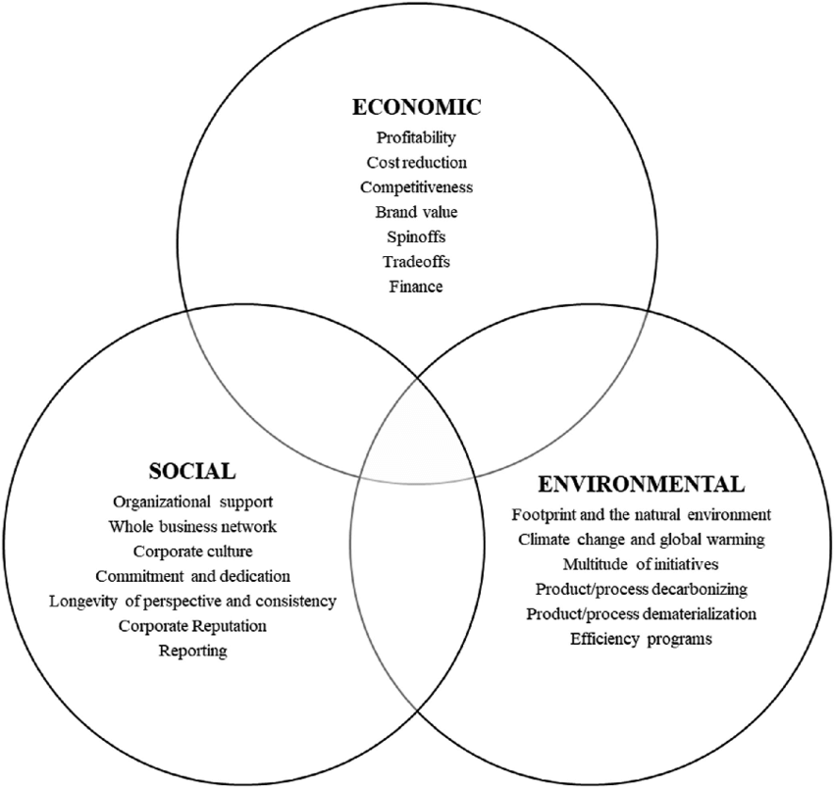
Figure 8: Triple Bottom Line model
(Source: Lee et al., 2022)
The observation on sales expansion for each key product in Mexico is required annually. That will demonstrate the level of penetration of P&G into the market. Another source of money is the ROI used in Mexican factories, logistics, and marketing. This is a “profit” recidivism of the investment in case P&G upgrades the capacity of the current plants. This includes facilities in Irapuato and Naucalpan, to monitor the ratio of the utilised capacity to the total capacity and the cost of producing a unit. These demonstrate efficiency in operations. Cost benefits are learnt by comparing savings made on local sourcing and old import models (Schütz et al., 2020). Moreover, it is required to view the extent to which P&G Mexico will be selling to other Latin American nations. That indicates the addition of power outside Mexico.
The “planet” component of the triple bottom line is the environmental performance, which is the main factor in determining whether the development of P&G is beneficial or detrimental to the environment. P&G has already achieved a lot in the global arena by reducing its Scope 1 and 2 greenhouse gas emissions by 57% since 2010, and it aims to go to net-zero by 2040. In order to implement these objectives in Mexico, we must track local environmental statistics. The total carbon emissions of Mexican factories should be measured, and emissions per tonne of product evaluated to determine whether additional production could be accommodated by the climate goals of the company. Water use and water intensity metrics per unit are also to be monitored in certain parts of Mexico, such as the Bajio experiences water shortage.
P&G already monitors water efficiency globally, and the same is expected in Mexico to ensure that the expansion will not strain the domestic water resources. Waste management is important, as P&G has not disposed of any manufacturing waste in a landfill of any type since 2020 (P&G-Investor, 2025). Continuous monitoring of the level of recycling waste would direct the recovery of materials in Mexico and the operation of the circular packaging. Another important environmental measure is sustainable packaging. As per the reports of Procter and Gamble (2025), by 2030, all of the P&G packaging is to be recyclable or reusable. The answer to the question of the responsibility of the expansion can be determined by looking at how many Mexican product lines can achieve this goal.
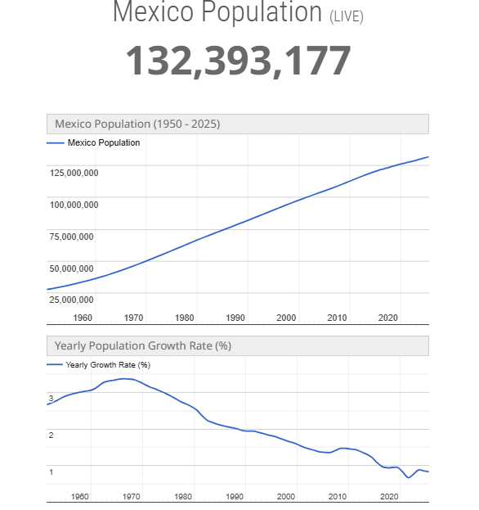
Figure 9: Growth in the Mexican population
(Source: WorldOMeter, 2025)
The “people” component of the triple bottom line examines the social consequences of the P&G growth, such as workers, communities, customers and the entire society. Over 132 million people in Mexico are young, and this provides many opportunities to enhance hygiene, health, and household products accessibility (WorldOMeter, 2025). P&G organisations worldwide, including but not limited to the Children's Safe Drinking Water programme, have supplied over 23 billion litres of clean water to developing communities since 2004 (P&G, 2019). However, conducting and overseeing comparable community initiatives in Mexican communities without a water supply would result in evident social advantages and improve the reputation of P&G in these locations. Finally, verifying the availability of products and feasible prices to low-income individuals can enable us to see whether the expansion serves just purposes. This implies examining the distance that products move to the rural areas and comparing the price for affordability.
P&G may embed them into a country-based system, such as the Balanced Scorecard, to ensure that economic, environmental, and social data are all utilised in strategy development. The system would transform the strategic aims of Mexico into tangible outcomes supported by the data collection, internal audit, and annual reports. As an example, environmental data may be provided through factory energy metres, waste records, and water systems. Furthermore, the social data may be provided through HR, safety checks, community programme records, and market research. The financial information would be provided through the revenue reports, cost research, and area performance dashboard. Combining all these data allows the managers to compare the results with the targets, identify the gaps and act. According to my understanding, the expansion will remain aligned with the worldwide sustainability objectives of P&G and the opportunities of the Mexican market.

4.3. Monitoring and Mechanisms of Governance
Monitoring and governance are also critical for ensuring that P&G’s strategy in Mexico is executed well to deliver long-term outcomes. In addition, such mechanisms help the firm to uphold transparency, regulatory adherence and performance discipline across all areas of operation. P&G already implements strong global governance systems, but the growth in Mexico needs more localised control to match Mexico’s regulatory and market situations. At first, P&G should use integrated performance dashboards tracking financial KPIs, customer satisfaction, the speed of innovation, and indicators of sustainability. These dashboards enable managers to know problems fast and increase decision-making. In quest, the Balanced Scorecard already favours four major perspectives and applying it in Mexico aligns the teams with strategic targets.
Second, internal audits should assure adherence to NOM standards, labour regulations, and environmental rules. These audits also ensure accuracy of financial reporting and offering internal controls. Nonetheless, the governance is also required to integrate external audits to maintain credibility with the regulators and partners. Moreover, P&G also needs to support stakeholder governance that includes interaction with the retailers, suppliers, local community, and environmental regulators. Thus, open communication offers trust, and feedback systems that are used to develop their plan.

Conclusion
Mexico is a good manufacturing and logistics location due to its location near the US and the advantages of the USMCA trade agreement. This not only minimises the cost of production but also helps in lessening the risks faced by the supply-chain, as well as, opening up the wider markets in Latin America. Lastly, the compatibility of culture, prospects of product localisation, and the increasing consumer interest in hygiene, beauty and home-care products are also a great match with what P&G proposes. All together, these aspects legitimise Mexico as a high-value and strategically aligned market to the long-term growth aspirations of P&G.

References
Atayde, R. et al. (2021) ‘Market competition and firm productivity and innovation: Responses in Mexican manufacturing industries’, Regional Science Policy & Practice, 13(4), pp. 1185–1215. Available at: https://doi.org/10.1111/rsp3.12417.
Broadbent, M. (2025) Insights into the Mexican E-Commerce Competition Landscape, Csis.org. Available at: https://www.csis.org/analysis/insights-mexican-e-commerce-competition-landscape (Accessed: 8 December 2025).
Cote, C. (2023) What Is a Balanced Scorecard?, Harvard Business School Online. Available at: https://online.hbs.edu/blog/post/balanced-scorecard (Accessed: 27 November 2025).
Dalirazar, S. and Sabzi, Z. (2023) ‘Strategic analysis of barriers and solutions to development of sustainable buildings using PESTLE technique’, International Journal of Construction Management, 23(1), pp. 1–30. Available at: https://doi.org/10.1080/15623599.2020.1854931.
Devyara (2025) Procter & Gamble Co. (PG) | Financial Analysis & Statements, Devyara.com. Available at: https://devyara.com/en-us/nyse/pg/financial-analysis/?utm_source (Accessed: 27 November 2025).
Diaz, R. and Montalvo, R. (2022) ‘Digital Transformation as an Enabler to Become More Efficient in Sustainability: Evidence from Five Leading Companies in the Mexican Market’, Sustainability, 14(22), p. 15436. Available at: https://doi.org/10.3390/su142215436.
Economía, S. de (2019) Standards, gob.mx. Available at: https://www.gob.mx/se/acciones-y-programas/standards (Accessed: 27 November 2025).
Escobar‐López, S.Y. et al. (2022) ‘Consumers’ perception of different types of food markets in Mexico’, International Journal of Consumer Studies, 46(1), pp. 147–160. Available at: https://doi.org/10.1111/ijcs.12650.
Fortune Business Insights (2023) Disposable Hygiene Products Market Growth & Trends [2030], Fortunebusinessinsights.com. Available at: https://www.fortunebusinessinsights.com/disposable-hygiene-products-market-104639 (Accessed: 27 November 2025).
Fortune Business Insights (2025) Mexican Food Market Size, Share | Growth Report [2032], Fortunebusinessinsights.com. Available at: https://www.fortunebusinessinsights.com/mexican-food-market-113821 (Accessed: 27 November 2025).
Gadhwal, A., Ab, A., Aggarwal, A. and Poddar, P. (2025) ‘An Analysis of Procter & Gamble’s Market and Price Discrimination Strategies in Relation to Whisper’, ResearchGate [Preprint]. Available at: https://doi.org/10.13140/RG.2.2.17260.07049.
García Alcaraz, J.L. et al. (2022) ‘Effect of Green Supply Chain Management Practices on Environmental Performance: Case of Mexican Manufacturing Companies’, Mathematics, 10(11), p. 1877. Available at: https://doi.org/10.3390/math10111877.
Gómez, C. (2023) Turning the Tide on Waste: Mexico’s Journey towards a Circular Economy, CIL. Available at: https://www.circularinnovationlab.com/post/turning-the-tide-on-waste-mexico-s-journey-towards-a-circular-economy (Accessed: 27 November 2025).
Grand View Research (2024) Mexico Disposable Hygiene Products Market Size & Outlook, Grand View Research. Available at: https://www.grandviewresearch.com/horizon/outlook/disposable-hygiene-products-market/mexico? (Accessed: 8 December 2025).
Grand View Research (2025) Mexico Consumer Packaged Goods Market Size & Outlook, www.grandviewresearch.com. Available at: https://www.grandviewresearch.com/horizon/outlook/consumer-packaged-goods-market/mexico (Accessed: 27 November 2025).
Grand View Research (2025) Mexico Consumer Packaged Goods Market Size & Outlook, Grand View Research. Available at: https://www.grandviewresearch.com/horizon/outlook/consumer-packaged-goods-market/mexico? (Accessed: 8 December 2025).
Han, X. (2023) ‘Research Report on Product Marketing of Procter & Gamble’, aemps.ewapublishing.org, AEMPS Vol.7, pp. 414–419. Available at: https://doi.org/10.54254/2754-1169/7/20230263.
Hayden, D. (2025) PESTLE analysis, CIPD. Available at: https://www.cipd.org/en/knowledge/factsheets/pestle-analysis-factsheet/ (Accessed: 27 November 2025).
ILS Company (2025) How New Automotive Tariffs Are Reshaping U.S. – Mexico Supply Chains in 2025 - The ILS Company, www.ilscompany.com. Available at: https://www.ilscompany.com/automotive-tariffs-mexico-us/ (Accessed: 8 December 2025).
Jain, P., Chou, M.C., Fan, F. and Santoso, M.P. (2021) ‘Embedding Sustainability in the Consumer Goods Innovation Cycle and Enabling Tools to Measure Progress and Capabilities’, Sustainability, 13(12), p. 6662. Available at: https://doi.org/10.3390/su13126662.
Kvartalnyi, N. (2024) How Tech Solutions Improve Supply Chain Visibility, Inoxoft |. Available at: https://inoxoft.com/blog/improving-supply-chain-visibility-with-technology/ (Accessed: 8 December 2025).
Lee, T.-R. (Jiun-Shen) et al. (2022) ‘TBL dominant logic for sustainability in oriental businesses’, Marketing Intelligence & Planning, 40(7), pp. 837–853. Available at: https://doi.org/10.1108/mip-03-2022-0093.
Lucas, A. (2025) Procter & Gamble CEO says price hikes are ‘likely,’ as Tide owner cuts outlook due to tariffs, uncertainty, CNBC. Available at: https://www.cnbc.com/2025/04/24/procter-gamble-pg-q3-2025-earnings.html (Accessed: 27 November 2025).
McDade, A. (2025) Procter & Gamble Tops Sales, Profit Estimates, Names New CEO, Investopedia. Available at: https://www.investopedia.com/procter-and-gamble-q4-fy2025-earnings-11779946 (Accessed: 27 November 2025).
Mexico Now (2020) P&G carries out expansion at its production plant in the State of Mexico, MEXICONOW. Available at: https://mexico-now.com/pg-carries-out-expansion-at-its-production-plant-in-the-state-of-mexico/ (Accessed: 8 December 2025).
Mio, C., Costantini, A. and Panfilo, S. (2022) ‘Performance measurement tools for sustainable business: A systematic literature review on the sustainability balanced scorecard use’, Corporate Social Responsibility and Environmental Management, 29(2), pp. 367–384. Available at: https://doi.org/10.1002/csr.2206.
Mishra, S. and DiNapoli, J. (2025) ‘Procter & Gamble replaces CEO Moeller with COO and long-time executive Jejurikar’, Reuters, 28 July. Available at: https://www.reuters.com/sustainability/boards-policy-regulation/procter-gamble-replaces-ceo-moeller-with-coo-long-time-executive-jejurikar-2025-07-28/ (Accessed: 27 November 2025).
Mora-Quiñones, C.A. et al. (2024) ‘Assessing the impact of loading-unloading zones in emerging markets: Evidence from Mexico’, Transportation Research Part D: Transport and Environment, 137, p. 104486. Available at: https://doi.org/10.1016/j.trd.2024.104486.
Office of the United States Trade Representative (2025) United States-Mexico-Canada Agreement, Office of the United States Trade Representative. Available at: https://ustr.gov/trade-agreements/free-trade-agreements/united-states-mexico-canada-agreement (Accessed: 27 November 2025).
P&G (2019) Children’s Safe Drinking Water, Csdw.org. Available at: https://csdw.org/ (Accessed: 27 November 2025).
P&G (2024) Celebrating the Leaders of Brand Success: The 2024 P&G Best of Brand Awards and Brand Mastery Society Induction, Pg.com. Procter and Gamble. Available at: https://us.pg.com/blogs/best-of-brand-awards/ (Accessed: 8 December 2025).
P&G (2025) P&G Announces Fourth Quarter and Fiscal Year 2025 Results, Pg.com. Available at: https://us.pg.com/newsroom/news-releases/PG-Announces-Fourth-Quarter-and-Fiscal-Year-2025-Results/?utm_source= (Accessed: 27 November 2025).
P&G Annual Report (2025) Annual Report, pp. 1–92. Available at: https://s204.q4cdn.com/332108499/files/doc_financials/2025/ar/2025_annual_report.pdf (Accessed: 27 November 2025).
P&G Annual Report (2025) Fiscal Year 2025 Results | P&G 2025 Annual Report, Pg.com. Available at: https://us.pg.com/annualreport2025/introduction-and-fy-results/? (Accessed: 8 December 2025).
P&G Blogs (2025) Waste Reduction, Plastics and Recycling: Learn About P&G’s Actions | P&G, Pg.com. Procter and Gamble. Available at: https://us.pg.com/blogs/reducing-waste-and-recycling/ (Accessed: 8 December 2025).
P&G Careers (2025) Mexico, Procter & Gamble. Available at: https://www.pgcareers.com/global/en/locations/mexico/?from=10&s=1&rk=l-mexico (Accessed: 27 November 2025).
P&G Investor (2025) P&G Announces Fourth Quarter and Fiscal Year 2025 Results, Pginvestor.com. Available at: https://www.pginvestor.com/news/news-details/2025/PG-Announces-Fourth-Quarter-and-Fiscal-Year-2025-Results/default.aspx? (Accessed: 8 December 2025).
P&G Results (2025) P&G Announces Results for the Fourth Quarter and Fiscal Year 2025 | P&G, Pg.com. Procter and Gamble. Available at: https://us.pg.com/blogs/pg-earnings-fourth-quarter-2025/ (Accessed: 8 December 2025).
P&G-Financial Statement (2025) Annual Report. Available at: https://s204.q4cdn.com/332108499/files/doc_financials/2025/ar/2025_annual_report.pdf (Accessed: 29 November 2025).
P&G-Innovation (2023) Innovation | Procter and Gamble, in.pg.com. Available at: https://in.pg.com/innovation/ (Accessed: 27 November 2025).
P&G-Investor (2025) ESG - Environmental - Waste | Procter & Gamble Investor Relations, Pginvestor.com. Available at: https://www.pginvestor.com/esg/environmental/waste/default.aspx (Accessed: 27 November 2025).
Pham, P., Bich, H., Nguyen, T., Le, H., Ho, N., Nguyen, H. and Briffett, M. (2022) Study of MNC Enterprises’s Strategy, Structure and Issues within Their Markets: Procter & Gamble (P&G) BUS302: International Business. Available at: https://ikeepmydream2302.wordpress.com/wp-content/uploads/2023/03/ib-t222pwb-1_group-2_group-report.pdf (Accessed: 8 December 2025).
Procter and Gamble (2024) Superiority to Win with Consumers and Grow Markets, Pg.com. Procter and Gamble. Available at: https://us.pg.com/annualreport2024/superiority-to-win-with-consumers-and-grow-markets/ (Accessed: 27 November 2025).
Procter and Gamble (2025) Waste Reduction, Plastics and Recycling: Learn About P&G’s Actions | P&G, Pg.com. Procter and Gamble. Available at: https://us.pg.com/blogs/reducing-waste-and-recycling/ (Accessed: 27 November 2025).
Sanchez , J. (2024) Mexico’s GDP growth rate forecasts 2025| Statista, Statista. Available at: https://www.statista.com/statistics/1060707/gross-domestic-product-growth-rate-mexico-agency/?srsltid=AfmBOordILjePijDP6zGOTWRhupOCUatFhW7h90MSEWFStvexAXZ2a_E (Accessed: 27 November 2025).
Sánchez Toledano, B.I. et al. (2023) ‘Consumer Preferences of Jalapeño Pepper in the Mexican Market’, Horticulturae, 9(6), p. 684. Available at: https://doi.org/10.3390/horticulturae9060684.
Schütz, K. et al. (2020) ‘How to achieve cost savings and strategic performance in purchasing simultaneously: A knowledge-based view’, Journal of Purchasing and Supply Management, 26(2), p. 100534. Available at: https://doi.org/10.1016/j.pursup.2019.04.002.
Smithson, N. (2018) Procter & Gamble’s Generic Strategy & Intensive Growth Strategies, Panmore Institute. Available at: https://panmore.com/procter-gamble-generic-strategy-intensive-growth-strategies (Accessed: 29 November 2025).
The Strategy Institute (2024) Porter’s five forces: The ultimate competitive strategy blueprint, www.thestrategyinstitute.org. Available at: https://www.thestrategyinstitute.org/insights/porters-five-forces-the-ultimate-competitive-strategy-blueprint (Accessed: 27 November 2025).
Wei, Y.-M. and Lin, H.-M. (2024) ‘Scrutinizing Business Development Research: Dynamic Retrospective Analysis and Conceptual Evolution’, Administrative sciences, 14(4), pp. 81–81. Available at: https://doi.org/10.3390/admsci14040081.
Wilkins, S. and Ireland, J.J. (2020) ‘FMCG firms’ margin management: consumer trade-offs among product price, quantity and quality’, Journal of Strategic Marketing, 30(8), pp. 1–18. Available at: https://doi.org/10.1080/0965254x.2020.1849362.
World Bank (2020) Mexico | World Bank, Worldbank.org. Available at: https://www.worldbank.org/ext/en/country/mexico? (Accessed: 8 December 2025).
World Bank (2024) Mexico Overview, World Bank. Available at: https://www.worldbank.org/en/country/mexico/overview (Accessed: 27 November 2025).
WorldOMeter (2025) Mexico Population (2025) - Worldometer, Worldometers.info. Available at: https://srv1.worldometers.info/world-population/mexico-population/ (Accessed: 27 November 2025).
Xu, L. (2024) ‘Research on the Referential Significance of Procter & Gamble’s Diversified Brand Strategy to Chinese Local Enterprises’, Asia Pacific Economic and Management Review, 1(6), pp. 107–115. Available at: https://doi.org/10.62177/apemr.v1i6.112.
Zapata-Cantu, L. (2021) ‘Boosting innovation in emerging markets: the moderating role of human capital’, International Journal of Emerging Markets, 16(3), pp. 604–624. Available at: https://doi.org/10.1108/ijoem-01-2019-0015.

Appendix
PESTLE Analysis
Factors | Alignment | Details
Political | Positive | - United States-Mexico-Canada Agreement  - North American supply chains
Economic | Positive | - GDP growth  - Inflation  - Increases minimum wages
Social | Negative | - Community development  - The Mexican population was nearly 130 million people in 2025
Technological | Positive | - Development in supply diversification  - Investment in Mexican plants  - Have a strength of sourcing, packaging and others
Legal | Negative | - Official Mexican Norms (NOMs)  - Packaging standards
Environmental | Positive | - Wastewater, emissions and hazardous waste regulations  - Sustainability is increasing in reducing plastic packaging
Table 5: PESTLE analysis
(Source: Self-Created)

