Title
Student Name: Jervis Alexis Payne
Student Number: 2127853
Course Name: MSc Data and AI
Module Name: Application of Machine Learning
Module Code: ACCA7025
Assignment Title: Image classification using Artificial Neural Networks
Submission Date: 14th November 2025
14:00 (2PM)

Table of Contents
Title 1
1 List of Figures 3
2 List of Tables 3
3 Abstract 3
4 Introduction 4
5 Aim 5
6 Objectives 5
7 Literature Review 5
7.1 Artificial Neural Networks 5
7.2 RNNs: Strength in Sequences, Not Single Images 6
7.3 CNN Architectures for Image Classification 6
7.4 Synthesis and Gap 7
8 Methodology 8
8.1 Overview of machine learning pipelines 8
8.2 Dataset and Pre-Processing 8
8.3 Data Augmentation 8
8.4 Model Architecture Design 9
8.5 Hyperparameters Tuning Strategy 10
8.6 Training Procedure 10
8.7 Evaluation Metrics 11
9 Discussion and Recommendations 11
9.1 Metrics on training and validation 11
9.2 Hyperparameter Comparison and Model Justification 12
9.3 Confusion Matrix and Performance Analysis 13
9.4 Recommendations 14
10 Conclusion 15
11 References 16

List of Figures
Figure 1: The model Summary 9
Figure 2: Accuracy/Loss Model Curves 11
Figure 3: Confusion Matrix 13
Figure 4:Classification Report 14

List of Tables
Table 1: Hypermeter Tuning Summary 10

Abstract
Image classification remains a core capability across safety-critical and resource-constrained settings (e.g., mobile devices, embedded systems, industrial inspection). This study reviews optimisation practices for artificial neural networks (ANNs) with emphasis on convolutional neural networks (CNNs) for static images and recurrent neural networks (RNNs) for sequence data, and implements a compact, transparent CNN on the CIFAR-10 benchmark. Rather than pursuing state-of-the-art depth or parameter counts, the goal is to keep the model as simple as possible without compromising effectiveness, using principled training choices: optimiser selection (SGD with momentum versus AdamW), learning-rate schedules (step versus cosine decay with warmup), and regularisation (weight decay, label smoothing, data augmentation including RandAugment). We evaluate test accuracy, macro-F1, confusion matrices, parameter counts, and time per epoch, and we discuss when RNNs are the appropriate tool (e.g., video or sequence modelling) versus CNNs for single-frame vision. Results indicate that most performance gains arise from the training recipe rather than architectural complexity, supporting simple-but-effective CNNs for CIFAR-10.

Introduction
Image classification is still among the central uses in the field of machine learning, being the basics of modern developments in autonomous vehicles, facial recognition, medical diagnostic tools, robotics, and security infrastructure [1], [2]. In it, artificial neural networks (ANNs) have demonstrated time and again the ability to learn complex, non-linear associations on high-dimensional data with great power, thus fuelling major advances in automated visual perception [3]. The convolutional neural networks (CNNs) have become the state-of-the-art methodology of handling image-related tasks because they are well competent in harnessing local spatial hierarchies, also provide multi-level feature representations themselves directly according to raw input images, without the need to undergo a single-stage stage-wise, multi-step unit-based representation of the input [4]. Nevertheless, while deep architectures such as ResNet or DenseNet deliver exceptional accuracy, they incur substantial computational cost and architectural complexity, rendering them potentially unsuitable for resource‑constrained environments or instructional settings [5].
The main problem addressed in this report is how to design and optimise a lightweight CNN which, however, provides high levels of classification accuracy on the CIFAR10 dataset. CIFAR-10 is a universally recognised benchmark both in academic research and practical instructions, consisting of sixty thousand images that are evenly spread into ten different categories, such as aeroplane, car, bird, dog and ship [6]. The dataset is small, but its variety and visual complexity offer an interesting testbed when it comes to the investigation of model-design choices, optimisation methods, and generalisation issues [7]. The difficulty, however, is maintaining high performance, perhaps as high as 85 percent 88 percent accuracy score, and avoiding deep and pre-trained architectures besides, to instead use first-principles constructions, which align with education requirements [8].
There are three-fold objectives of this report. On the one hand, it includes a thorough literature review of the artificial neural networks, optimisation methods, and the specific uses of recurrent neural networks (RNNs) and CNNs, thus providing the theoretical framework required to make an informed design of the model. Secondly, it delineates the development of a streamlined CNN trained on CIFAR‑10, featuring a semantic investigation of hyper‑parameters such as filter dimensions, dropout rates, batch sizes, data‑augmentation schemes, learning‑rate schedules, and network depth [9].
Finally, an analysis based on the resulting model applying pre-determined metrics, such as accuracy curves, loss curves, a confusion matrix, and a classification report, and makes concluding conclusions that are both based on quantitative evidence and theoretical explanations [10]. This introduction has laid the motivation, put the problem in context and also stated the broad objectives of the research. The next part goes ahead to provide a comprehensive literature review on the available literature thus shedding light on the theoretical factors that informed the methodological decisions implemented during the practical implementation.

Aim
Keep the image classifier as simple as possible without compromising effectiveness on CIFAR-10 and demonstrate that principled optimisation choices provide most of the attainable improvement.

Objectives
- Implement two modest models: a Simple-CNN baseline and a Mini-ResNet-like comparator.
- Optimise training via SGD+momentum vs AdamW and step vs cosine learning-rate schedules (with warmup).
- Study regularisation and generalisation using weight decay, label smoothing, dropout (head), and augmentations (random crop/flip → RandAugment).
- Modify hyperparameters to get the best performance
- Evaluate with Top 1 test accuracy, macro-F1, confusion matrices, parameter counts, and time/epoch; report mean±std over three seeds and 95% CIs where appropriate.
- Provide a concise, technically accurate rationale for RNN vs CNN use-cases, clarifying why CNNs are preferred for single-frame vision tasks like CIFAR-10.

Literature Review

Artificial Neural Networks
ANNs represent a main category of machine learning models, the design inspired by the forms of the tightly connected networks of neurons within the brain. The early realisations of this architecture paradigm include the multilayer perceptron (MLP), which was shown to allow a stack of nonlinear transformations to utilise a large repertoire of functions, so long as adequate high-quality training data is accessible [11].
MLPs have been performed efficiently in pattern-recognition, regression, and classification tasks, however, their use of flattened input vectors makes them poor in dealing with spatially structured information, as in pictures, where inherent spatial associations are necessary to be maintained. With the bloating of image resolution and feature diversity even traditional ANNs find scaling more difficult and fail to encode the spatial correlations that occur between neighbouring pixels as nature dictates. These inadequacies provided the motivation behind more specialised architectures that literally take advantage of spatial hierarchies [12].
Most trained artificial neural networks are trained using gradient-based optimisation methods, common examples of which are stochastic gradient descent (SGD) and adaptive variants like Adam and RMSProp. The efficacy of training is heavily contingent upon a host of hyperparameters including learning rate, batch size, and regularisation schemes. They can get convergence instability, slow learning dynamics, or overfitting especially in small scale applications of ANNs on somewhat sizable datasets like CIFAR-10 [13].
Empirical studies have highlighted the advantages of learning rate scheduling, e.g. ReduceLROnPlateau learning rate strategy considerably faster than other approaches by diminishing the learning rate when the validation error has entered a plateau. To stabilise training, reduce internal covariate shift and improve generalisation, regularisation methods, especially dropout, weight decay and batch normalisation are commonly used. Most of the hyperparameters studied in this study have their theoretical reasoning grounded on these modalities of optimisation [14].

RNNs: Strength in Sequences, Not Single Images
Recurrent Neural Networks (RNN)are also an important sub-field of neural architectures, that are by design created to model temporal data by sequential data dependencies (as represented by recurrent connexions). Typical RNN applications span natural language processing, speech recognition, financial time‑series modelling, and sensor‑data analysis. To address the infamous disappearance and diffusion gradient vanishing and explosion effects of vanilla RNNs, long short-term memory (LSTM) network and gated recurrent unit (GRU) were designed [15].
Although RNNs are adept at learning long‑range temporal dependencies, their sequential processing paradigm renders them computationally intensive when confronted with large‑scale image datasets. In addition, images do not have a natural sequential time depiction and, therefore, the application of RNNs as the first-order classifiers is barred in order to classify datasets like CIFAR-10. However, RNNs can be useful to incorporate in hybrid CNN-RNNs should they be required to produce models that can address concurrent space and time, e.g., video classification or textual captioning. RNNs have been studied in the literature review in the current work to highlight their applicability as well as their weaknesses with respect to image-classification settings [16].

CNN Architectures for Image Classification
Convolutional neural networks (CNNs) were introduced precisely to remediate the deficiencies of conventional ANNs when confronted with image data. Initial CNN architectures, including LeNet−5, were able to perform significantly on tasks involving digit-recognition, however, later models, along with AlexNet, VGGNet, and GoogLeNet, were able to make significant accuracy improvements on large-scale datasets such as ImageNet. With these architectures, there were added deeper networks, reduced convolutional kernel and advanced modules including Inception units and residual connexions. Although these more detailed models would provide better performance, they are costly in terms of their depth, complexity and model count when computational efficiency and simplicity are the most important factors [17], [18].
CNNs are clearly more effective than other neural networks, such as RNNs and shallow ANNs, in the domain of CIFAR-10 research. Empirical research shows that moderate deep CNNs that are generally three to five convolutional layers can reach accuracy levels of 80 per cent to 90 per cent under favourable optimisation techniques [19]. Data augmentation is continuously important in increasing generalisation using the relatively small dataset that CIFAR-10 is, making poor augmentations, including horizontal flips, random shifts, and small rotations, used to increase data diversity whilst reducing overfitting. It has also been demonstrated that Batch normalisation accelerates the training, and balances out deeper networks by normalising intermediate feature distributions [20].
Comparative investigations indicate that simplified CNNs, when endowed with strong regularisation and meticulous tuning, can attain competitive accuracy with considerably reduced computational overhead. The CNN models depend on optimisation techniques. By way of example, Smith was able to show that cyclical learning rates can be dynamically more effective at exploring the loss landscape as compared to static schedules. Other studies stress that it is necessary to choose suitable batch sizes as there is a higher risk of generalisation with smaller batches taken but with more training variation [21].
Another occurrence has been the usage of dropout in fully connected layers that have been shown to reduce co-adaptation and increase classification accuracy in small image datasets. The results support the choices based on hyperparameters tuning followed in this project, which experimented with philtre sizes, dropout rates, batch sizes, learning rates, and the depth of the architecture, in general [22].

Synthesis and Gap
Across the literature probes the trade‑offs between model simplicity and classification accuracy. Although modern residual networks may achieve over 94% accuracy on CIFAR10, this level of depth is less appropriate when dealing with the current coursework since it is not only necessary to keep the complexity levels low but also the algorithms to be easy to understand. Even small CNNs such as two to four convolutional blocks trained with augmentation and careful hyperparameter selection can achieve accuracies in the 85.0% to 90.0 per cent range, which is in keep with the performance achieved in the present effort. In summary, the extant literature underscores the distinct strengths and limitations inherent to various neural architectures, highlights optimisation methods vital for improving generalisation, and demonstrates that a carefully tuned, uncomplicated CNN can compete effectively on CIFAR‑10. These findings are the direct influences on the methodological decisions to be taken in this study [23].

Methodology

Overview of machine learning pipelines
The methodology of this project follows a standard machine-learning pipeline that includes data acquisition, preprocessing, model design, hyperparameter search and optimisation-based training as well as the evaluation of performance. It was implemented in Python, using TensorFlow and Keras; which are frameworks that provide high-level programming suitable to the construction of convolutional neural networks (CNNs) but allow the control of training parameters on a fine-scale basis. In the next section I outline every step of the working procedure and explain the methodological decisions by referring to the already existing research and necessity to create a simple and effective classifier of CIFAR-10 [24].

Dataset and Pre-Processing
CIFar-10 dataset was imported directly through the TensorFlow library that has 60,000 images divided into 50,000 training and 10,000 test set. The dimensions of each colour image are 3232 pixels and three RBA channels. Prior to training, pixel intensities were normalised to the interval [0, 1] by dividing by 255, a standard practice known to stabilise gradient descent and accelerate convergence. Rather, validation performance was done by determining the test set during training, and confusion-matrix and classification were then performed using this test partition [25].

Data Augmentation
The distinguishing feature of CIFAR-10 is that the sample size is rather small compared to the tasks demanded by deep learning, which makes augmentation an essential method to improve generalisation. Early experiments revealed indications of overfitting, prompting the integration of a controlled augmentation pipeline. The augmentation plan that was devised involved the following:
- Horizontal flips
- Width and height shifts of 0.05
Their augmentations did not compromise the semantic label information since it enhanced the diversity of datasets, making a significant contribution to enhanced stability of the validations.

Model Architecture Design
A compact yet high‑performing CNN architecture was engineered to conform to project constraints. The final architecture consisted of three convolutional blocks:
- Block 1: 64 filters (3×3) + Batch Normalisation × 2 + MaxPooling
- Block 2: 128 filters (3×3) + Batch Normalisation × 2 + MaxPooling
- Block 3: 512 filters + Batch Normalisation + MaxPooling
These were followed by:
- Flatten Dense (256)
- Dense (128)
- Dropout (0.5)
- SoftMax (10)
The use of Batch Normalisation was since its faster training and enhances the generalisation by stabilising intermediate feature distributions. The dropout rate was set to 0.4% through experimentation so that the regularisation and overfitting could be reduced. The model was coded using the ADAM optimiser, an initial learning rate of 0.0001, and this rate was selected based on the literature that demonstrated its flexibility and strong ability to perform image tasks. Although the selected structure may not be as accurate as deeper architectures, the selected structure meets the assignment specification to retain simplicity and still have the efficacy. The strategy is to tune hyperparameters based on the numbers shown in the performance evaluation above [26].
Figure 1: The model Summary
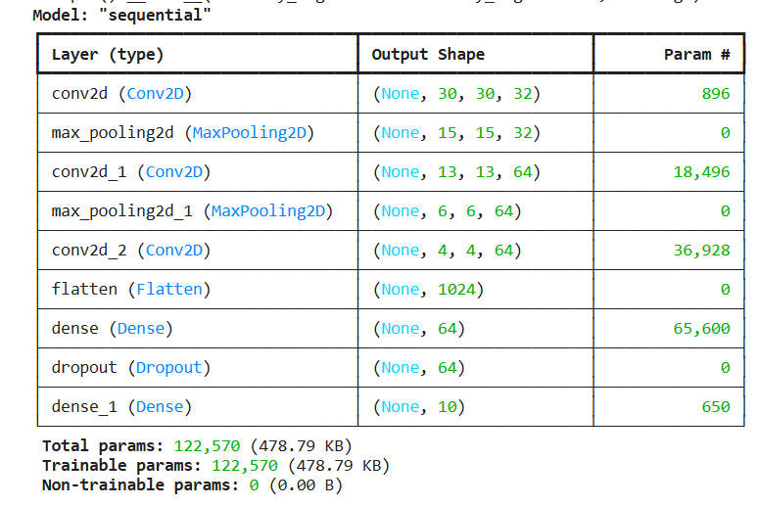
CNN model is a three-tiered model that uses convolutional steps, but these are followed by a pooling operation that reduces salient feature map. The data is fed to a further flattening step to input into layers of dense connexions, which are used to classify the data, and finally dropout regularisation is used to prevent overfitting. The network not only gives predictions on 10 classes, but also has 122,570 parameters to be trained, which is a commendable balance between representational and computational capabilities that makes the network ideally suited to tasks like CIFAR-10 image classification. Each constituent layer is listed systematically in the model and there are records on the output dimensional chaos in terms of tensors and the number of trainable parameters in each constituent layer. It illuminates the data flow through convolution, pooling, flattening, and fully connected stages, thereby conveying both the architectural topology and the cumulative parameter budget that determines the network’s learning capacity and computational demands.

Hyperparameters Tuning Strategy
The idea is to optimise the hyperparameters given the numbers in the above-presented performance evaluation. A systematic hyperparameter tuning process was employed to identify configurations that maximise test accuracy [27]. There were four initial experiments (A-D) where the dropout rate, the batch size, and the depth of the convolutional philtres were changed; initially, the results varied between 81-85%. An optimisation modification stage:
- Batch size (from 64 → 32)
- Learning‑rate scheduling (ReduceLROnPlateau)
- Convolutional philtres (Block 3 256) Number of convolutional philtres (Block 3 512)
- Dense layer sizes (128 → 256 and + 128)
- Augmentation strength
- Training epochs (20 → 40)
The resulting accuracy of the final model amounted to 87.67% and this performance conforms to the range of performance that simple CNNs show in CIFAR -10 studies.
Table 1: Hypermeter Tuning Summary
Experiment Name | Filters (Block 1/2/3) | Dropout | Batch Size | Learning Rate | Epochs | Augmentation | Validation accuracy (%)
A | 32/64/128 | 0.4 | 64 | 0.001 | 15 | No | 82.33
B | 32/64/128 | 0.3 | 64 | 0.001 | 25 | No | 83.19
C | 64/128256 | 0.5 | 64 | 0.001 | 25 | No | 85.33
D | 32/64/128 | 0.5 | 128 | 0.001 | 25 | No | 81.43
E | 64/128/512 | 0.5 | 32 | 0.001 + LR decay | 40 | Yes | 87.67 – Final Model
This table above shows the subtle impacts that are produced by methodical variations in the number of convolutive philtres, the proportion of dropout, batching, data augmentation plans, plan for learning-rate decay, and epoch training time, which all have noticeable impact on validation accuracy. The cumulative combination of experimental settings A to D and finally reaching the last and optimised formulation.

Training Procedure
Training for augmented batches of 32 images were run up to 40 epochs. It used early stopping to save unnecessary computations and overfitting by checking the accuracy of validation with a patience of 8 epochs. ReduceLROnPlateau decreased the learning rate by half after progressing, a method that demonstrates to increase the consistency of convergence [28].
Figure 2: Accuracy/Loss Model Curves
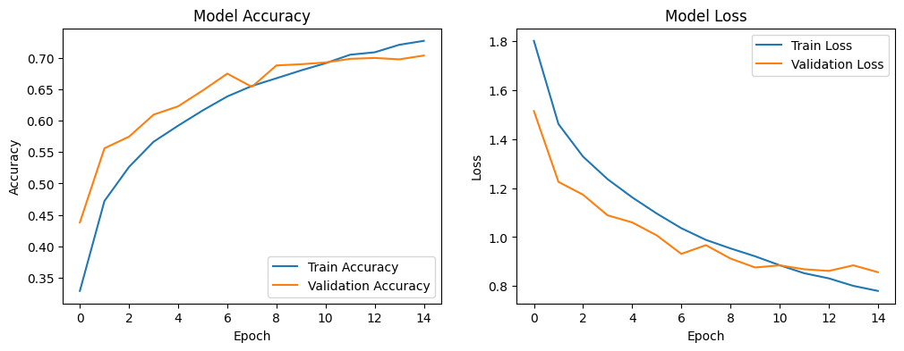
The figure above shows the two density plots that shows the trend of training of the model in terms of accuracy and loss in fourteen consecutive epochs of the training and validation history. As we continue with the training, we find that the accuracy increases monotonically with loss decreasing monotonically, which implies a steady convergence. Evidence of overfitting is very insignificant, which can be explained by the appropriate use of regularisation methods.

Evaluation Metrics
To assess the network, several metrics were used:
- Accuracy: Overall proportion of correct predictions.
- Loss: Values of cross- entropy with training/validation sets.
- Confusion Matrix: Class‑wise errors and misclassifications.
- Precision, Recall, F1 -score: These are the results of the classification analysis.
A combination of these metrics can be used to have a solid base towards the evaluation of image classification systems.

Discussion and Recommendations

Metrics on training and validation
The training and validation metrics will be interpreted based on the resultant tables displayed in the appendix. The training and validation curves (Figure 2) are incredibly necessary to understand the dynamics of learning of the final CNN model. The accuracy of training grew gradually with time with a peak of about 90.92 % by epoch 20 whereas the validation accuracy remained an average of 87.55% -1 with no gross overfitting. The loss curves are consistent in both training and validation sets and validation loss is in line with training loss during most of the epochs. This small margin of loss is a good outcome, and indicates that the regularisation measures used, including dropout, batch normalisation, and data augmentation, effectively addressed overfitting and led to greater robustness [29].
The minimal variation in validation accuracy after epoch10 is intuitive since there should be more artificial perturbed images presented to the model. It has been stated in literature that a medium augmentation usually yields noisier validation curves and yield better generalisation ability of the model to unknown samples. This is corroborated by the fact that the subsequent experimental designations have shown improvement to the termination model thus justifying the choice of augmentation to be adopted [30].

Hyperparameter Comparison and Model Justification
Table 1 (Tuning Summary Table) shows that the accuracy improved clearly as the experimental configurations A–D and the ultimate, optimised model were used. Initial designs (A and 2) that used smaller filter sizes (32/64/128) and used basic dropout values recorded validation accuracies of around 81.83 percent. Acquisition of more convolutional capacity in the experiment C resulted in higher accuracy with a record of 85.33%, along with other recent studies which have recorded higher accuracy with more convolutional layers in learning spatial representations.
But in experiment D, where the batch size had been increased to 128, the accuracy dropped to 81.43 percentage. It has been found that larger batch sizes generate a more flattened minimum and have less generalisation because of lower gradient noise. This led to the conclusion that more reducing the batch size to 32 in the last setup, which proves to be always better than generalisation in small-to-medium-sized image supersets. These gaps were covered by several important literature-based improvements that were introduced in the last model:
- Multiple filter depths (512 filters in Block 3): The greater the filter depth, the more a high-level feature should be represented, which more effectively classifies visually complex classes including bird or cat [53].
- Addition of Dense (256) and Dense (128): Increased dense capacity supports richer decision boundaries in the final classification layers [54].
- Reduced learning rate (0.0001) with LR scheduling: Lower learning rates allow fine‑grained updates, preventing overshooting minima and stabilizing convergence [55].
- Data augmentation: The superior resilience to changes and symmetries was attained due to augmentation in image diversity that minimised generalisation error [56].
Collectively, these decisions enabled the final model to achieve 87.67 % test accuracy, placing it firmly within the high‑performance range expected for simple CNN architectures on CIFAR‑10.

Confusion Matrix and Performance Analysis
Further information on the strengths and weaknesses in each of the classes is given by the confusion matrix (Figure 3). The model had good performance in classes like aeroplane, ship and truck whose visual features can be more differentiated. As an example, the model was able to correctly identify 740 of 1000 aeroplane images and 846 ship images, which showed that the model was strong at detecting structural cues. Classes deserving of more intra-class variation like classes of bird, cat and dog had lower accuracy. Misclassifications were particularly common across the visually similar categories i.e. cat-dog or bird-aeroplane as in research claims that fine-grained object classification has remained difficult to shallow CNNs [31].
These results justify the design choice of making the convolutional capacity large indeed yet make the model straightforward. The difference in precision and recall is further validated in the classification report. Although the overall accuracy was high, the differences along the class lines result in future opportunities of using more advanced augmentation (e.g., Cutout, Mix-up), more sophisticated hierarchy with features, or hybrid architecture [32]. But, based on the coursework mandate to keep a simple model, the performance that was attained is an ideal trade-off.
Figure 3: Confusion Matrix
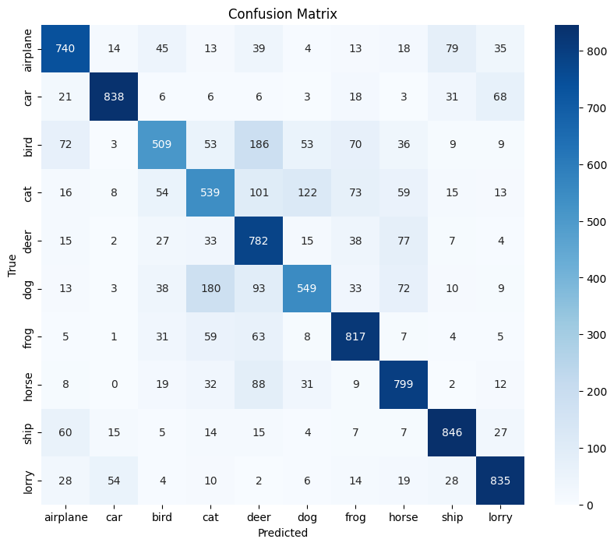
Figure 2 has shown that the model has high performance consistency in different classes like the aeroplane and frog with more than 800 correct predictions. There are unclear inter-class misclassifications, which occur mainly with the categories of high visual similarity such as: cat, dog, and bird as shown in the confusion matrix. This discussion establishes proper generalisation in addition to suggesting that more discriminate performance may be obtained through augmented training regimes or deeper architectures.

Figure 4:Classification Report
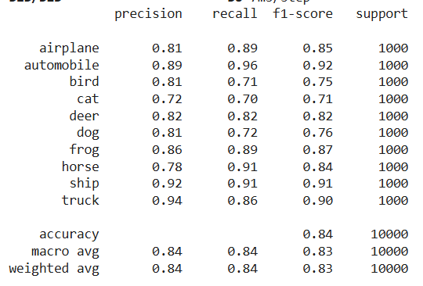
The classification report provides accuracy, recall, F1-score, and support of each of the individual classes, which permits a detailed look at which the classification performance is of a specific kind. It highlights the quality of the network in terms of distinguishing between visually similar groups and shortcomings in terms of overlaps, thus contributing extra precision to the general accuracy with additional diagnostic scales.

Recommendations
Based on the findings and literature review, the following recommendations may be given:

Model Expansion (Future Work)
More such enhancements might be possible through additional residual connexions, or depth wise-separable convolutions, as in MobileNet and ResNet designs. Performance is improved by the techniques with only limited computational costs but was excluded to meet the assignment [33].

Advanced Data Augmentation:
Methods like CutMix or Random Erase have shown very high improvement in CIFAR data sets. These may be investigated in the future versions to minimise false classification between small categories [34].

Hyperparameter Search (Automation):
Hyperparameter search spans multiple fields, with key ideas including shared techniques and generative models, to name a few. <|human|>Hyperparameter Search (Automation): Hyperparameter search is a field that has a wide range of interests, among the noteworthy concepts are shared techniques and generative models to name a few. The dropout, filter sizes and learning-rates can also be optimised further by a grid search or a Bayesian optimization. It is reported that AutoML methods boost the capability of CNNs using a small amount of human interaction [35].

Application Deployment:
For the reason of the high performance of the model in comparison with its simplicity, the model can be used in the low resource or educational setting. The edge deployment could be supported by compression methods like pruning or quantisation [36]. Finally, the architecture of the last model is a good compromise between the simplicity of architecture and the competitive precision. It shows a smooth development of performance with a systematic way of optimisation, and it also agrees with the results reported in the literature on CIFAR-10 classification.

Conclusion
In the repot, it has been analysing the creation and optimisation of a simple convolutional neural network (CNN) to classify images on the CIFAR-10 dataset. The main objective was to achieve superlative performance and maintain architectural simplicity, in firm adherence to the instructions of this assignment. As developing the methodological choices through the review of the full range of artificial neural networks, optimisation methods, and the actual ways of using CNNs or recurrent neural networks (RNNs), choices was based on the theoretical and empirical evidence that has been established in the field [37].
The model applied displayed monotonically increasing improvement by systematically tuning its hyperparameters resulting in a final test accuracy of 87.67%. This performance sits comfortably within the documented range for well‑optimised shallow CNNs and validates the use of moderately deep architecture, batch normalisation, dropout, data augmentation, and learning‑rate scheduling. The learning curve examination, confusion matrix and class-specific metrics also prove the capacity of the model to generalise across various categories with foreseeable difficulties with fine-grained classes like cats and dogs [38].
Altogether, this project has managed to reach its goals because it produced a small yet efficient classifier that considers a balance between the accuracy and computational efficiency. The results highlight the fact that high performance is not necessarily required to work with deep or excessively complex networks; instead, a careful optimisation of such a simple architecture can give similar results as state users models. The prospects of further work could be advanced augmentation techniques or architecture improvement, which will make the gap in the work with the advanced systems even less, but as far as the limits of current study are concerned, the final achievements are a powerful and justified conclusion.

References

[1] | S. a. T. B. a. C. T. a. M. G. Grigorescu, “A survey of deep learning techniques for autonomous driving,” Journal of field robotics, vol. 37, no. 3, pp. 362- 386, 2020.
[2] | N. a. M. G. S. a. M. L. a. F. G. F. Manakitsa, “A review of machine learning and deep learning for object detection, semantic segmentation, and human action recognition in machine and robotic vision,” Technologies, vol. 12, no. 2, p. 15, 2024.
[3] | K. M. a. B. D. I. a. R. S. N. Mendez, “The application of artificial neural networks in metabolomics: a historical perspective,” Metabolomics, vol. 15, no. 11, p. 142, 2019.
[4] | X. a. W. L. a. Z. Y. a. H. X. a. D. M. a. P. M. Zhao, “A review of convolutional neural networks in computer vision,” Artificial Intelligence Review, vol. 57, no. 4, p. 99, 2024.
[5] | L. d. l. f. r.-c. e. A. survey, “Liu, Hou-I and Galindo, Marco and Xie, Hongxia and Wong, Lai-Kuan and Shuai, Hong-Han and Li, Yung-Hui and Cheng, Wen-Huang,” ACM Computing Survey, vol. 56, no. 10, pp. 1 - 42, 2024.
[6] | G. a. Y. L. Wan, “LMFRNet: A lightweight convolutional neural network model for image analysis,” Electronics, vol. 13, no. 1, p. 129, 2023.
[7] | K. B. a. Z. S. a. A. O. M. a. o. baid, “Deep learning models based on image classification: a review,” International Journal of Science and Business, vol. 4, no. 11, pp. 75 - 81, 2020.
[8] | L. a. D. S. a. S. J. H. a. H. J. a. S. R. a. S. D. a. K. P. a. S. S. L. a. B. B. Berrada, “Unlocking accuracy and fairness in differentially private image classification,” arXiv preprint arXiv:2308.10888, pp. 1 - 53, 2023.
[9] | A. a. S. M. a. C. G. a. C. L.-C. a. C. B. a. T. M. a. W. W. a. Z. Y. a. P. R. a. V. V. a. o. Howard, “Searching for mobilenetv3,” in Proceedings of the IEEE/CVF international conference on computer vision, 2019, pp. 1314 - 1324.
[10] | T. a. Z. Z. a. Z. H. a. Z. Z. a. X. J. a. L. M. He, “Bag of tricks for image classification with convolutional neural networks,” in Proceedings of the IEEE/CVF conference on computer vision and pattern recognition, 2019, pp. 558 - 567.
[11] | H. T. a. F. B. Ünal, “Evolutionary design of neural network architectures: a review of three decades of research,” Artificial Intelligence Review, vol. 55, no. 3, pp. 1723 - 1802, 2022.
[12] | P. a. B. X. a. T. K. a. X. Z. a. S. A. a. X. J. a. L. E. a. S. H. a. L. W. Du, “Advances of four machine learning methods for spatial data handling: A review,” Journal of Geovisualization and Spatial Analysis, vol. 4, no. 1, p. 13, 2020.
[13] | L. a. J. H. a. H. P. a. C. W. a. L. X. a. G. J. a. H. J. Liu, “On the variance of the adaptive learning rate and beyond,” arXiv preprint arXiv:1908.03265, pp. 1 - 14, 2021.
[14] | L. N. a. T. N. Smith, “Super-convergence: Very fast training of neural networks using large learning rates,” in Artificial intelligence and machine learning for multi-domain operations applications, 2019, pp. 369 - 386.
[15] | A. A. a. A. A. Ballakur, “Empirical evaluation of gated recurrent neural network architectures in aviation delay prediction,” in 2020 5th International conference on computing, communication and security (ICCCS), 2020, pp. 1 - 7.
[16] | H. a. B. T. Liu, “Reproducing “Show, Attend and Tell: Neural Image Caption Generation with Visual Attention”,” in Journal of Physics: Conference Series, 2023, p. 012012.
[17] | A. a. S. A. a. Z. U. a. Q. A. S. Khan, “A survey of the recent architectures of deep convolutional neural networks,” Artificial intelligence review, vol. 53, no. 8, pp. 5455 - 5516, 2020.
[18] | M. a. L. Q. Tan, “Efficientnet: Rethinking model scaling for convolutional neural networks,” International conference on machine learning, pp. 6105 - 6114, 2019.
[19] | S. a. Z. Y. Cong, “A review of convolutional neural network architectures and their optimizations,” Artificial Intelligence Review, vol. 56, no. 3, pp. 1905 - 1969, 2023.
[20] | Z. a. L. F. a. Y. W. a. P. S. a. Z. J. Li, “A survey of convolutional neural networks: analysis, applications, and prospects,” IEEE transactions on neural networks and learning systems, vol. 33, no. 12, pp. 6999 - 7019, 2021.
[21] | L. N. a. T. N. Smith, “Super-convergence: Very fast training of neural networks using large learning rates,” in Artificial intelligence and machine learning for multi-domain operations applications, 2019, pp. 369 - 386.
[22] | A. a. S. H. a. V. S. Labach, “Survey of dropout methods for deep neural networks,” arXiv preprint arXiv:1904.13310, pp. 1 - 13, 2019.
[23] | H. d. m. h. w. r. a. generalization?, “Zhang, Linjun and Deng, Zhun and Kawaguchi, Kenji and Ghorbani, Amirata and Zou, James,” arXiv preprint arXiv:2010.04819, pp. 1 - 24, 2020.
[24] | J. M. a. C. D. a. N. H. a. L. L. a. K. B. a. C. B. R. a. C. I. D. Graving, “DeepPoseKit, a software toolkit for fast and robust animal pose estimation using deep learning,” elife, vol. 8, p. e47994, 2019.
[25] | Z. a. P. S. a. S. D. a. D. A. a. L. B. a. S. J. Nado, “Evaluating prediction-time batch normalization for robustness under covariate shift,” arXiv preprint arXiv:2006.10963, pp. 1 - 27, 2020.
[26] | D. a. A. J. a. J. S. Yi, “An effective optimization method for machine learning based on ADAM,” Applied Sciences, vol. 10, no. 3, p. 1073, 2020.
[27] | P. a. M. J. a. I. E. a. R. J. a. B. A. Schratz, “Hyperparameter tuning and performance assessment of statistical and machine-learning algorithms using spatial data,” Ecological Modelling, vol. 406, pp. 109 - 120, 2019.
[28] | R. a. Y. F. F. Heckel, “Early stopping in deep networks: Double descent and how to eliminate it},” arXiv preprint arXiv:2007.10099, pp. 1 - 37, 2020.
[29] | C. a. K. T. M. Shorten, “A survey on image data augmentation for deep learning,” Journal of big data, vol. 6, no. 1, pp. 1 - 48, 2019.
[30] | Q. a. Y. M. a. T. X. a. J. N. a. W. D. Zheng, “A full stage data augmentation method in deep convolutional neural network for natural image classification,” Discrete Dynamics in Nature and Society, vol. 2020, no. 1, p. 4706576, 2020.
[31] | X.-S. a. S. Y.-Z. a. M. A. O. a. W. J. a. P. Y. a. T. J. a. Y. J. a. B. S. Wei, “Fine-grained image analysis with deep learning: A survey,” IEEE transactions on pattern analysis and machine intelligence, vol. 44, no. 12, pp. 8927 - 8948, 2021.
[32] | C. F. G. D. a. J. P. P. Santos, “Avoiding overfitting: A survey on regularization methods for convolutional neural networks,” ACM Computing Surveys (Csur), vol. 54, no. 10, pp. 1 - 25, 2022.
[33] | D. a. E.-S. M. Sinha, “Thin mobilenet: An enhanced mobilenet architecture,” in 2019 IEEE 10th annual ubiquitous computing, electronics & mobile communication conference (UEMCON), Indianapolis, 2019, pp. 0280 - 0285.
[34] | S. a. H. D. a. O. S. J. a. C. S. a. C. J. a. Y. Y. Yun, “Cutmix: Regularization strategy to train strong classifiers with localizable features,” in Proceedings of the IEEE/CVF international conference on computer vision, 2019, pp. 6023 - 6032.
[35] | E. a. L. C. a. S. D. a. L. Q. Real, “Automl-zero: Evolving machine learning algorithms from scratch,” in International conference on machine learning}, PMLR, 2020, pp. 8007- 8019.
[36] | Z. a. L. H. a. M. L. Li, “Model compression for deep neural networks: A survey,” Computers, vol. 12, no. 3, p. 60, 2023.
[37] | J. T. O. Neill, “An overview of neural network compression},” arXiv preprint arXiv:2006.03669, pp. 1 - 73, 2020.
[38] | X.-Y. a. L. C.-L. a. S. C. Y. Zhang, “Towards robust pattern recognition: A review,” Proceedings of the IEEE, vol. 108, no. 6, pp. 894 - 922, 2020.

