Report December 1887
Since our founding by Bishop Burgess in 1828, we have enjoyed many visits from prestigious persons and built meaningful and beneficial connections, both ecclesiastic and secular, most notably the thousand-pound donation from King George IV and the patronage of the Bishop of Saint David’s (The Visitor). The university has been regarded as a respected house of learning by many donors such as Thomas Phillips, who generously expanded our library, enabling the College to maintain the same standards as the two universities. We have also been subject to many controversies and unfounded rumours. This year has been no exception. It is testament to the College’s robust and essential place in the local community and wider academic landscape that we have been able to meet these head on, whilst continuing to consolidate our rich associations.
I was pleased to learn that at least a small yet important part of this consolidation was student driven, with the first attempt to strengthen our ties with Oxford via mail appearing in the school Gazette this May. With subsequent appearances it may be concluded that the attempt was a resounding success. This communication will aid our fixed purpose to prepare students for further education through affiliation with Oxford and Cambridge.
However, this connection is eclipsed by our cemented relationship with the Visitor. He favoured us with his presence this June, at the opening ceremony of the Canterbury Buildings and congratulated us on “so valuable and useful an addition” to the College. We felt it prudent to hold Degree Day the same day as the ceremony this year, 24th June, when all the graduates could be honoured by the presence of the Bishop of St David’s and so that he might speak a few words of encouragement and inspiration to them, including in his address those students who will remain with us into the next year. During the occasion I commented that the opening of the buildings has “marked an epoch in the history of the College” not only because of his presence, but also as a reminder of the vitality our college possesses and the astounding progress we have made, more especially as we and our friends have attended to the new block of buildings with all the vigour of our hearts.
I stand by those remarks and am grateful for the later addition in October of the plaque dedicated to my predecessor Francis John Jayne. The inscription reads “In grateful record of the energy, devotion and public spirit of the Reverend Francis John Jayne, MA (principle of the College 1879-89) to whose exertions the erection of the Canterbury Buildings is mainly due, this tablet is put up by his many friends on his appointment to the vicarage of Lords”. The remarks follow my own sentiments and those of the Visitor. The Canterbury buildings will remain a stalwart reminder to many generations to come of both a noble founding principle of the College, namely preparing willing minds to wend along both scholarly and vocational paths by providing a full and varied education, and the vast potential to shape the world around us even from what is considered by some our “remote and inconvenient” location.
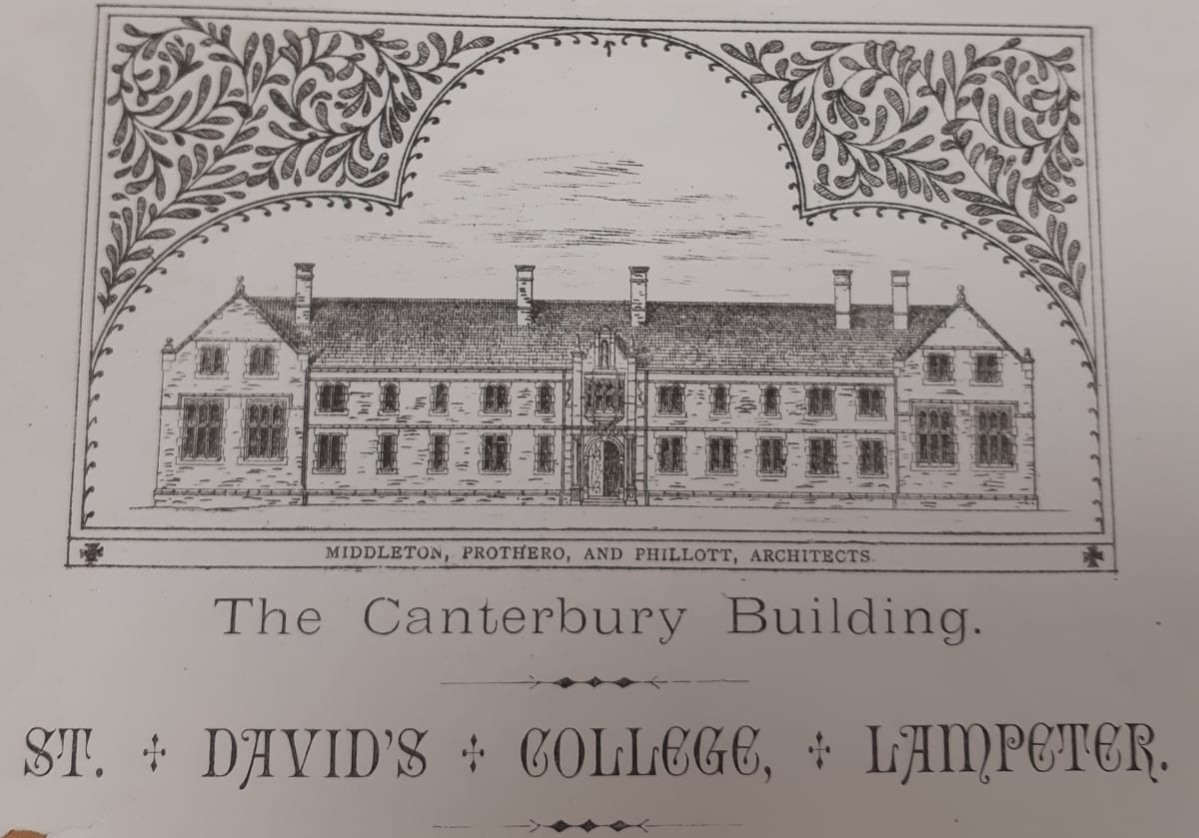
(Roderic Bowen Library and Archive, UA/X/327 Order of service for the opening of the Canterbury Buildings, 24th June, 1887)

Though the building itself has less artistry than might be preferred, we boast a blessing on its very stones with the cornerstone laid two years ago by the Archbishop of Canterbury. It contains two spacious lecture halls, a much-needed practical laboratory and equally sought after accommodation are now fully functional and are, I hope, a much-appreciated addition for our new students now living and learning in the buildings.
Said new students are, I am pleased to report, more numerous than our previous years, at forty-five. This number is close to 1885’s forty-seven but a noticeable improvement on last year’s less impressive intake of thirty-six. I note that twelve of our new students have previously attended St David’s College School, a significant increase from the average seven, demonstrating for the naysayers that, contrary to multiple rumours, the school is far from closing down. As may be expected for an auxiliary institution established only three years ago, there must be adaptations to circumstances not foreseen before its opening. This is, contrary to the prevailing belief, a sign of a modern, thriving school striving to best fulfil its mission; to provide a solid foundation education for boys and young men, most especially in our county. “Cheap and advantageous access to Oxford and Cambridge” has always been our aim.
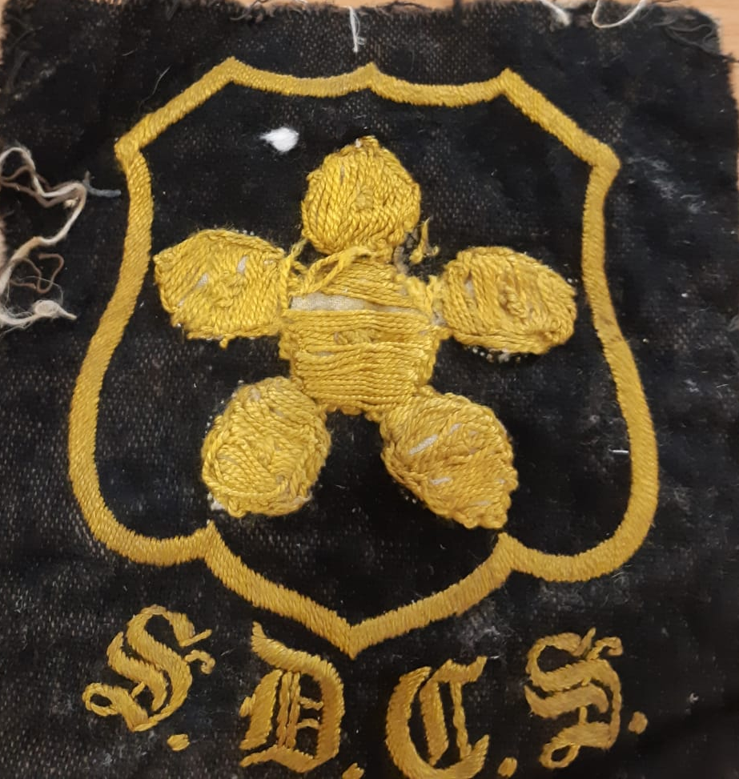
(Roderic Bowen Library and Archive, UA/S/6 St David’s College School Badge, black velvet and gold thread)

Two events which bear significance for us, but little to the wider world should be noted. First, the erection and unveiling of the statue of Gladstone must be mentioned. Lord Selebourne’s visit shall not be omitted, neither shall his comments about the local piety. He stated how it was a “special glory and honour [to be] able to speak of a church not merely thirteen, but of eighteen centuries of existence”, and he considered it to be the “purest Christianity in these islands”.
Of course, this year has not only been momentous for our college, but for the nation. Mere days prior to the opening of the Canterbury buildings, on the 20th June, Britain celebrated the Golden Jubilee of our excellent monarch, Her Most Gracious Majesty, Queen Victoria. I was proud to represent our institution at Westminster on this day, and the moving show of loyalty there displayed would have stirred any heart with a desire to burst. As a College, we thought it appropriate to combine personal and national pride, celebrating the momentous Jubilee on the 24th June, following the ceremony for the Canterbury buildings.
I feel it necessary to move my comments away from the monumental towards the more personal. The achievements of students and staff alike are no less important to us than external events. It is with deepest regret and gratitude that we said farewell this year to Mr Eliezar James, who was for thirty years the Manciple of the College. We also give our condolences to our venerable Professor of Latin on the sad loss of his wife.
Turning to more cheerful topics of success, to Mr Edward Owen, a congratulations for earning a much-deserved scholarship of eighty pounds as well as to J. Jones, who earned a scholarship of twenty-four pounds. Those who won exhibitions have earned similar appreciation; Mr H. O. Davies, Mr W. A. Morris and Mr F.D. Pierce. Also, to Mr Stephen Evans who, for his excellent performance in all sports events, was awarded the Victor Ludorum. Scholarly awards should be given their place in this report. First, the winners of the Bates prize, Mr E. Jenkins and Mr W. Williams. We are especially pleased with Mr Joseph Davies, Mr William Lewis, Mr Alfred Thomas and Mr Evan Davies, who won awards in Theology, Mathematics, Science and History.
I would like to conclude this report with a mention of recreation and some advice for new students. To begin, I would remind students about the array of societies old and new, which they may attend to improve themselves outside study hours. There is both an English and Welsh debating society. For those wishing to exercise as well as socialise, our football, cricket, rugby, athletic and lawn teams are recommended, more especially as we aim for a less tepid performance this coming year. For boys musically and dramatically inclined there is the Social Entertainment society. They put on a commendable performance of Advice Gratis and other engaging entertainments this last year.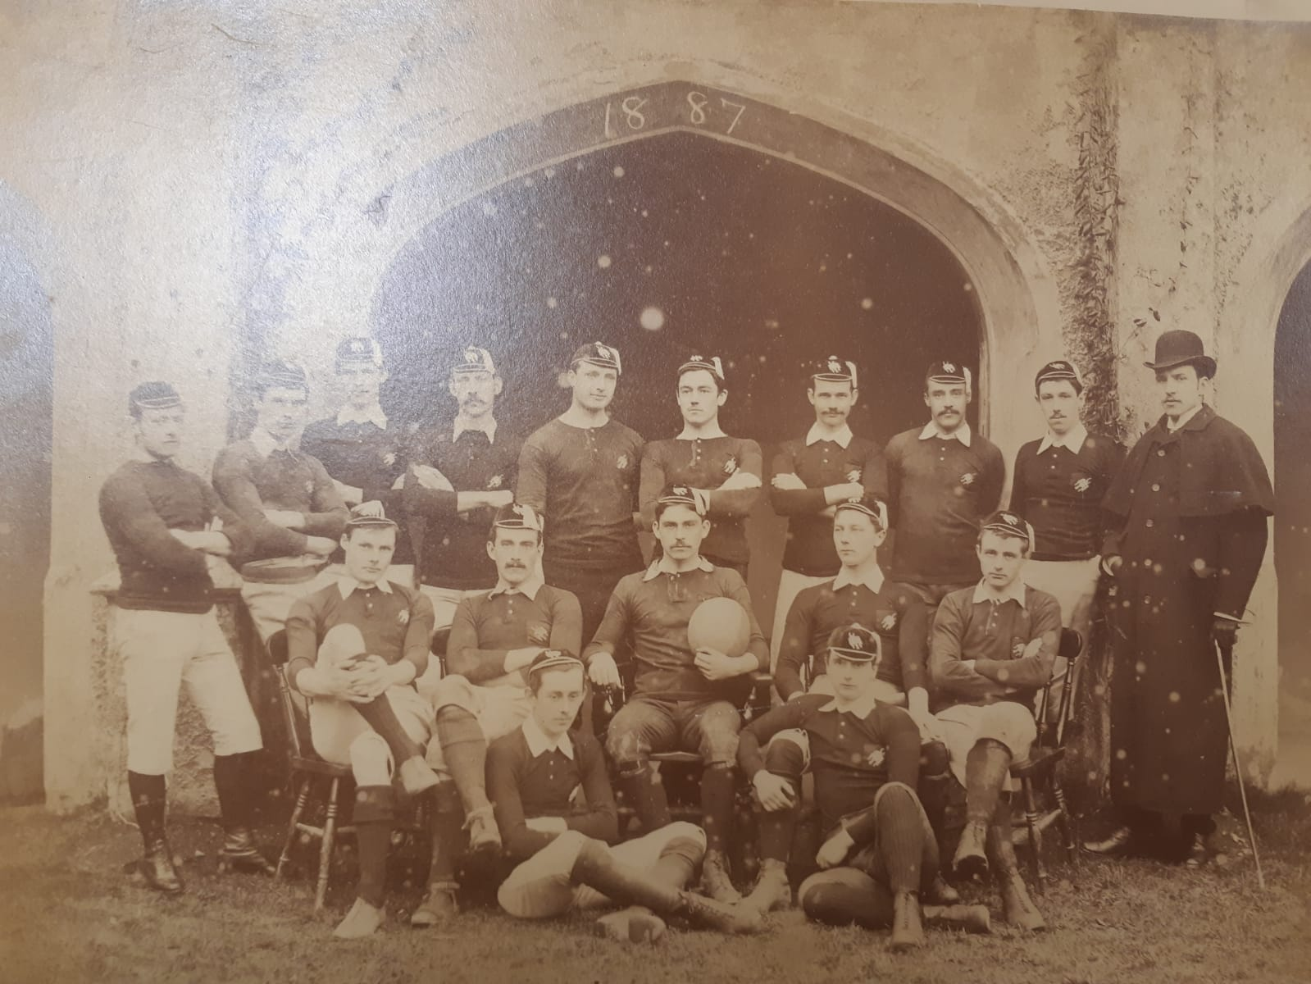
(Roderic Bowen Library and Archive, P/83 - St. David's College. First Fifteen. 1886-7. Group photograph of St. David's College Lampeter first fifteen Rugby Team 1886-7.)

I must admit my final advice for you is not my own. It instead is taken from the remarks of our esteemed new Examiner of Mathematics, Mr A. J. Wallis, chosen by the Vice Chancellor of Cambridge himself. The examiners could not have been more satisfied with the many who passed this year, and their comments reflected this satisfaction. Mr Wallis though, had valuable words of wisdom. He said, “If once habits of carefulness and accuracy are acquired, further progress will be certain... If however, habits of carelessness are acquired, they are extremely hard to put off.” I would end this report exhorting all students, old, new and those who are leaving us to attend universities to heed this warning and retain the good habits we have instilled or will instil in you during you studies at St David’s College.

Bibliography
Roderic Bowen Library and Archive, UA/C/1/5 Minutes of the College Board, 1875-86
Roderic Bowen Library and Archive, UA/X/136/6 Scrapbook of Newspaper Cuttings 1834-1893 p. 162-167
Roderic Bowen Library and Archive, UA/X/60 Statement and list of subscriptions to St. David's College Building and General Extension Fund, 1888
Roderic Bowen Library and Archive, UA/D/49 Papers, correspondence, plans and sketches concerning possible new buildings and extensions to the college, including two sketches of the proposed Canterbury Building,1884 -88.
Roderic Bowen Library and Archive, UA/A/17 Tutors' Register, 1850-98 (with index and list of college rules)
Roderic Bowen Library and Archive, UA/X/327 Order of service for the opening of the Canterbury Buildings, 24th June, 1887
Roderic Bowen Library and Archive, UA/Z/52/2 Photocopy of prayers used at the laying of the foundation stone of St David's College
Roderic Bowen Library and Archive, UA/Z/52/3 Photocopy of the memorial of the mayor, aldermen and burgess of Carmarthen re proposed removal of college from Lampeter to Brecon, 1853.
Roderic Bowen Library and Archive, UA/Z/52/6 Photocopy of reference from Professor Scott for a former student, Evan Maddock Jones, 1887
Roderic Bowen Library and Archive, P/83 - St. David's College. First Fifteen. 1886-7. Group photograph of St. David's College Lampeter first fifteen Rugby Team 1886-7.
Roderic Bowen Library and Archive, UA/CP/18 Calendar, 1885 (3 copies)
Roderic Bowen Library and Archive, UA/SP/1 St. David's College Magazine (bound vol.), 1880-1941
Roderic Bowen Library and Archive, UA/S/6 St David’s College School Badge, black velvet and gold thread
Roderic Bowen Library and Archive, UA/X/2/6 Leaflets re College and College school
Roderic Bowen Library and Archive, UA/S/5 Petition to the visitor and council of St. David's college and related correspondence, 1897

Roderic Bowen Library and Archives: University Archive UA/CP/18 Calendar, 1885
RBLA UA/CP/18 Calendar, 1885
Roderic Bowen Library and Archives UA/X/136/6 Scrapbook of Newspaper Cuttings 1834-1893 p. 162-167
Roderic Bowen Library and Archive: University Archive UA/SP/1 St. David's College Magazine (bound vol.), 1880-1941
RBLA UA/X/136/6 Scrapbook of Newspaper Cuttings 1834-1893 p. 162-167
Roderic Bowen Library and Archives UA/C/1/5 Minutes of the College Board, 1875-86
Roderic Bowen Archives: University ArchiveUA/Z/52/3 Photocopy of the memorial of the mayor, aldermen and burgess of Carmarthen re proposed removal of college from Lampeter to Brecon, 1853; RBLA UA/C/1/5 Minutes of the College Board, 1875-86 and RBLA UA/CP/18 Calendar, 1885
RBLA UA/X/136/6 Scrapbook of Newspaper Cuttings 1834-1893 p. 162-167
Roderic Bowen Library and Archives UA/A/17 Tutors' Register, 1850-98 (with index and list of college rules)
Roderic Bowen Library and Archives UA/A/17 Tutors' Register, 1850-98 (with index and list of college rules) and RBLA UA/X/136/6 Scrapbook of Newspaper Cuttings 1834-1893 p. 162-167
RBLA UA/CP/18 Calendar, 1885
RBLA UA/SP/1 St. David's College Magazine (bound vol.), 1880-1941, October 1887 and January 1887
RBLA UA/SP/1 St. David's College Magazine (bound vol.), 1880-1941, May 1887 and RBLA UA/X/136/6 Scrapbook of Newspaper Cuttings 1834-1893 p. 162-167
RBLA UA/C/1/5 Minutes of the College Board, 1875-86 and RBLA UA/SP/1 St. David's College Magazine (bound vol.), 1880-1941
RBLA UA/SP/1 St. David's College Magazine (bound vol.), 1880-1941 and RBLA UA/X/136/6 Scrapbook of Newspaper Cuttings 1834-1893 p. 162-167
RBLA UA/CP/18 Calendar, 1885 and RBLA UA/SP/1 St. David's College Magazine (bound vol.), 1880-1941
RBLA UA/X/136/6 Scrapbook of Newspaper Cuttings 1834-1893 p. 162-167

