Feasibility Plan for an International Hotel Meeting
Module Name: International Meetings Management
Student Name: Simona Macaran
Lecturer Name: Phillipa Fitzgerald

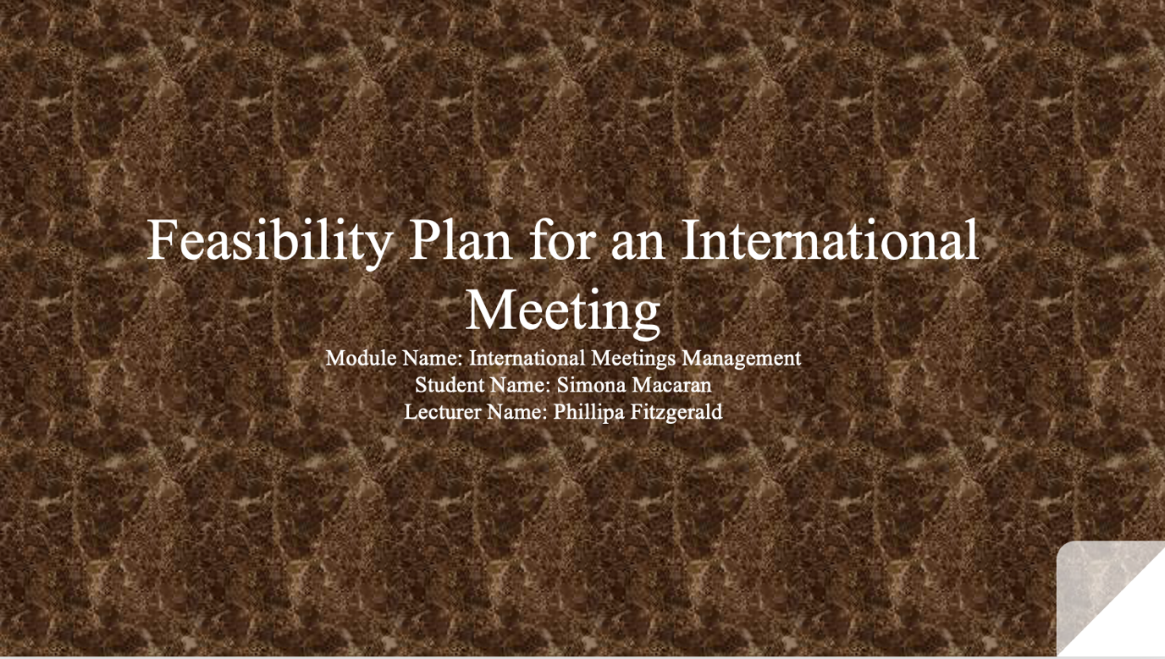

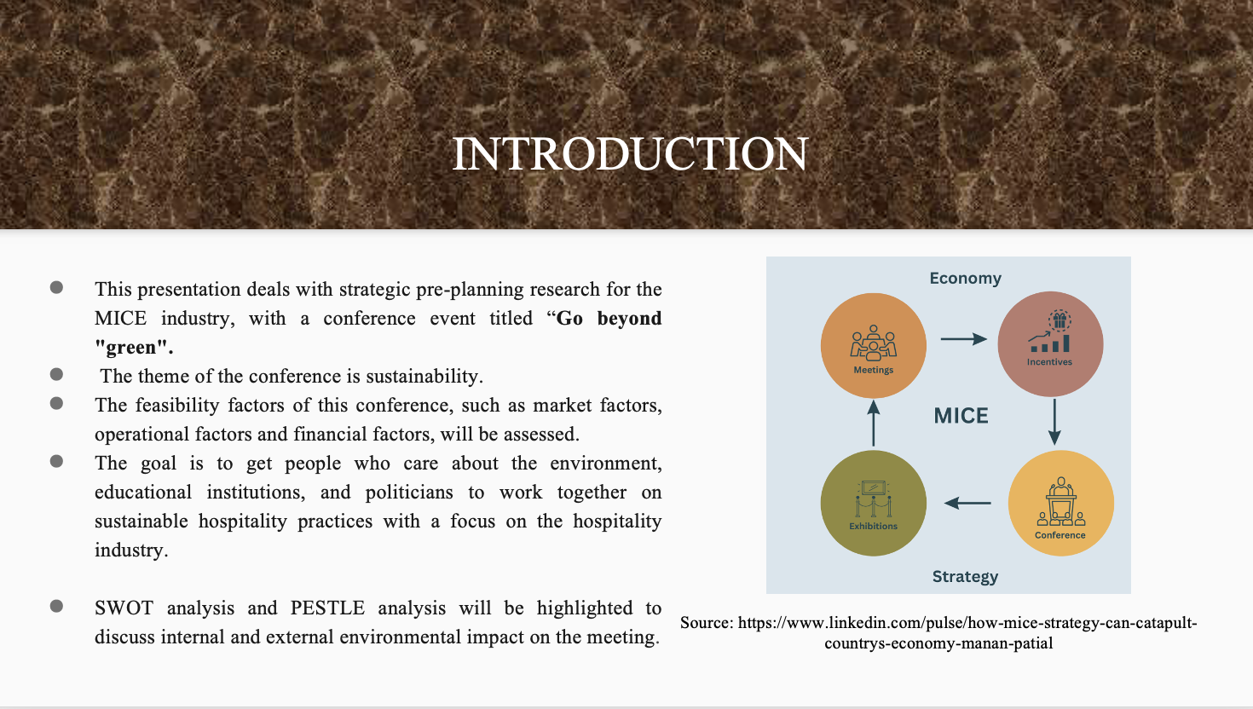
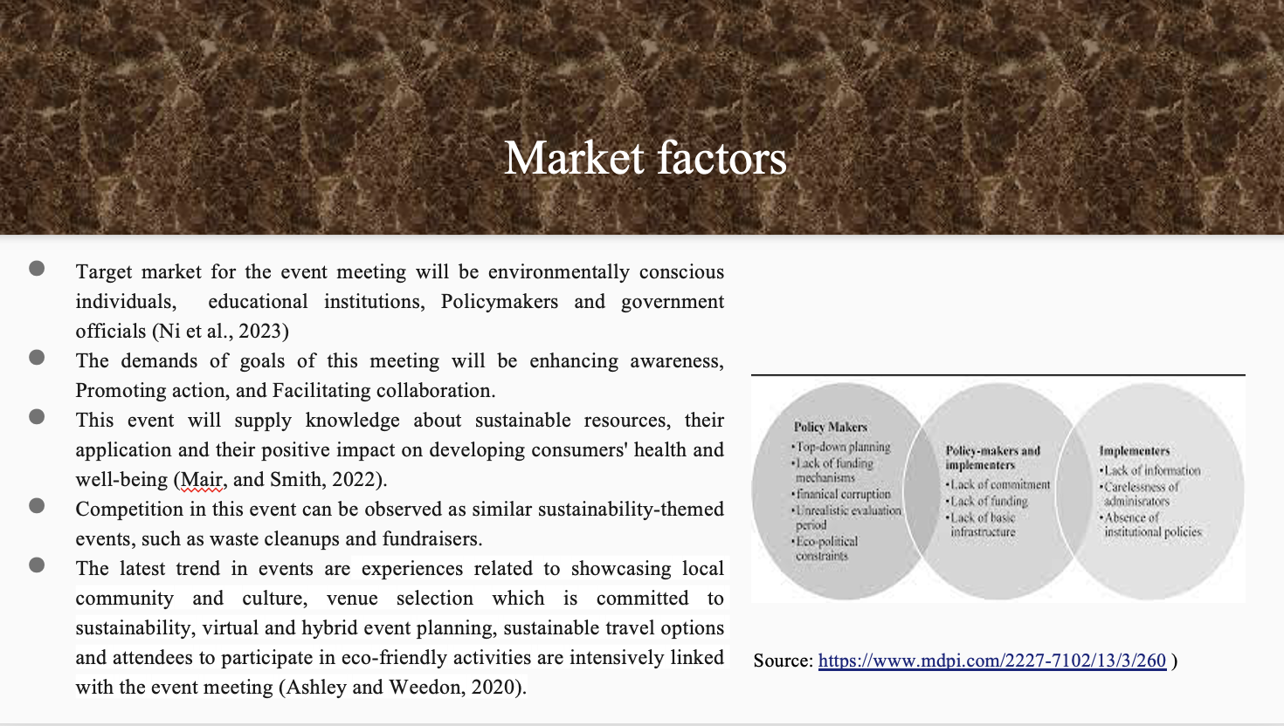
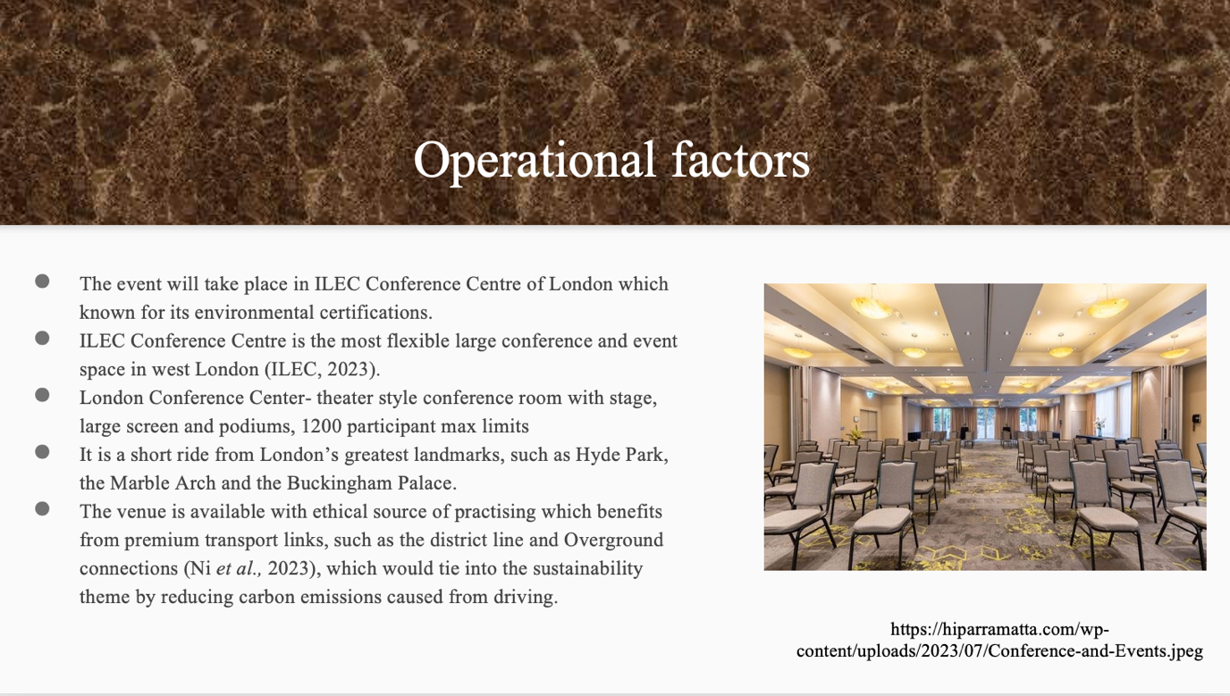
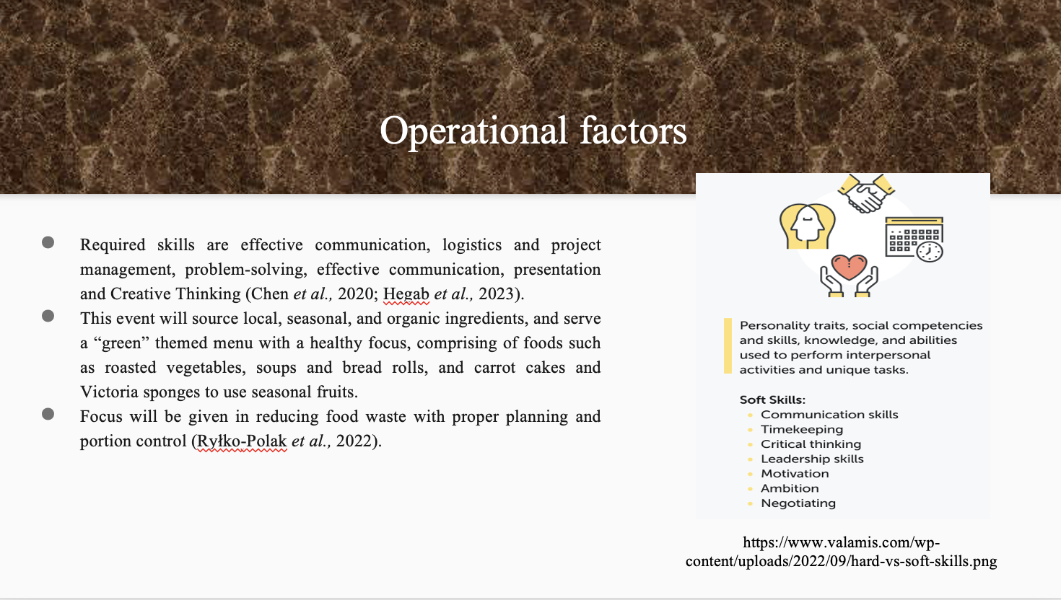
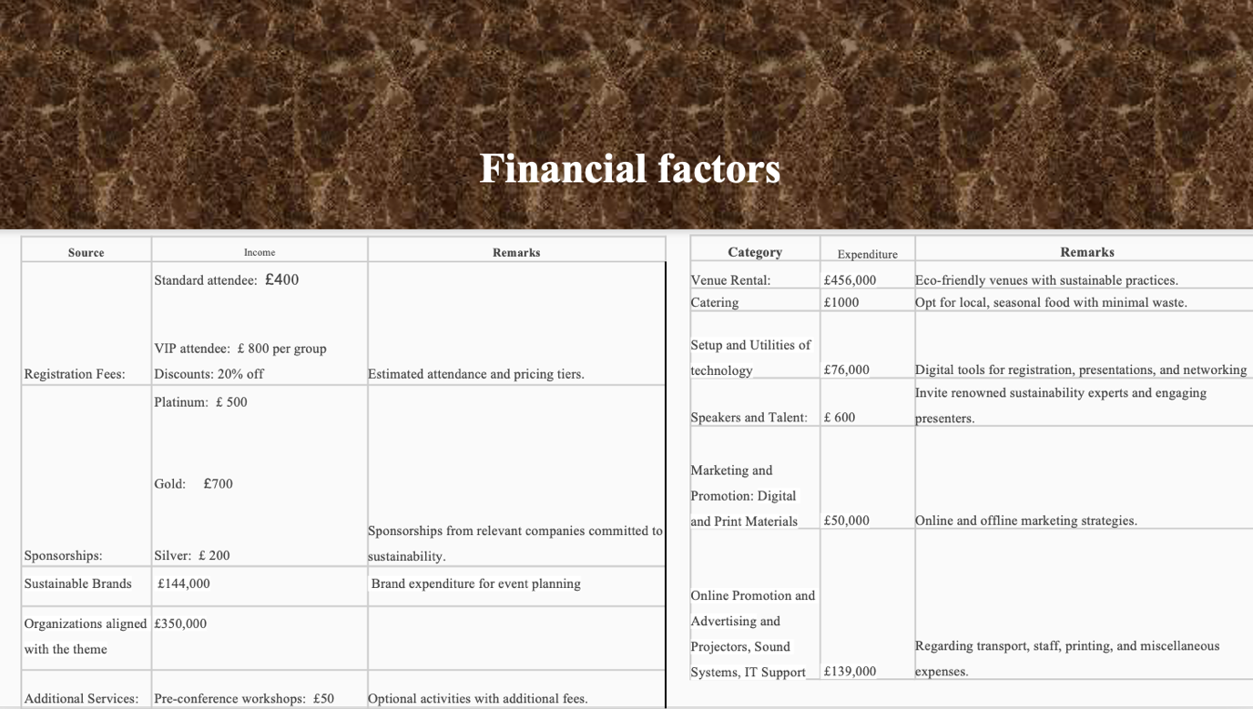
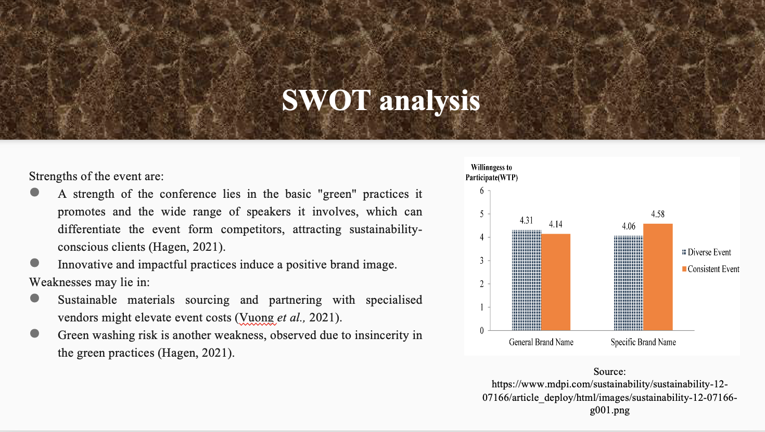
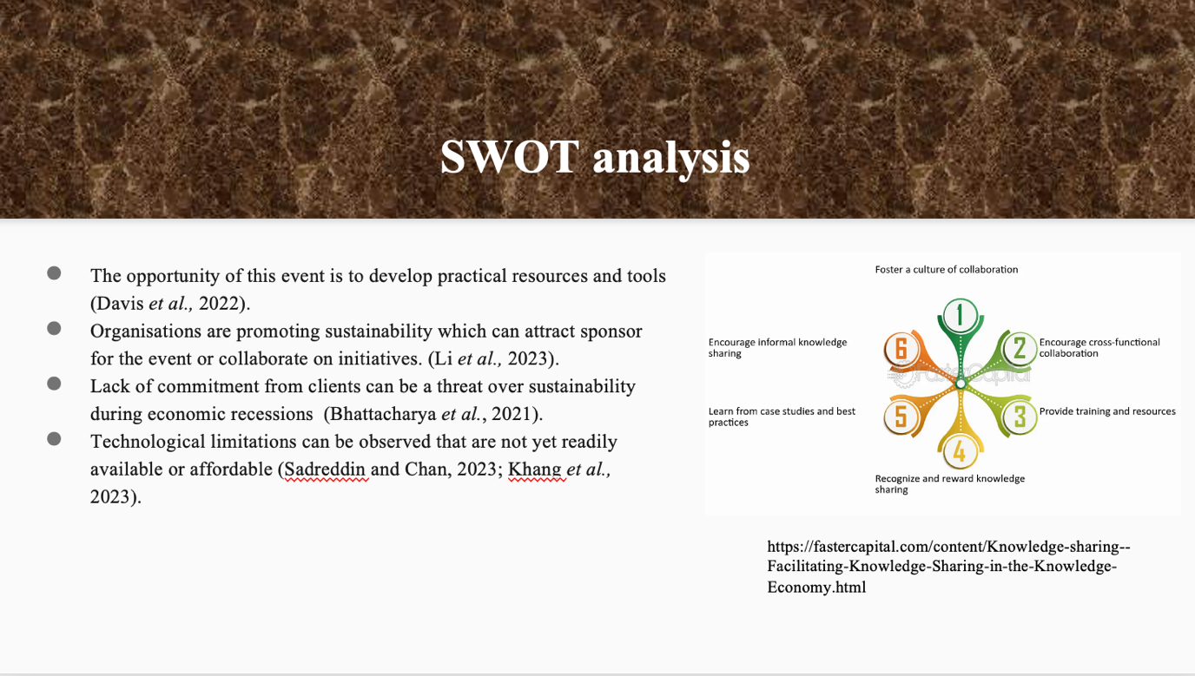
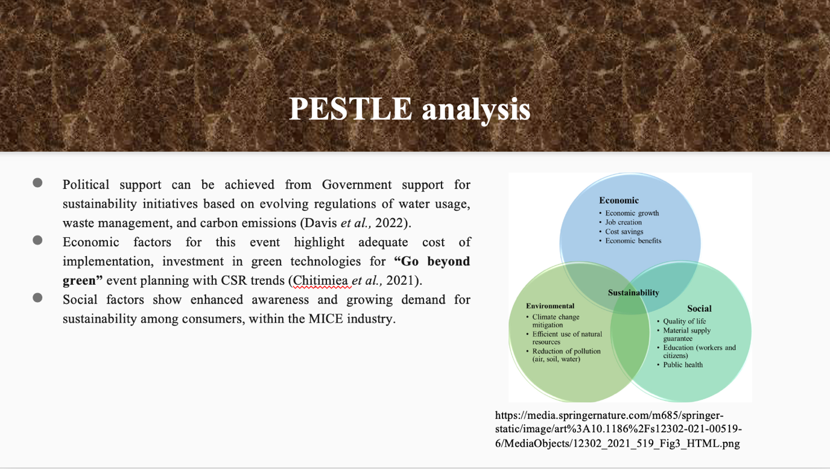
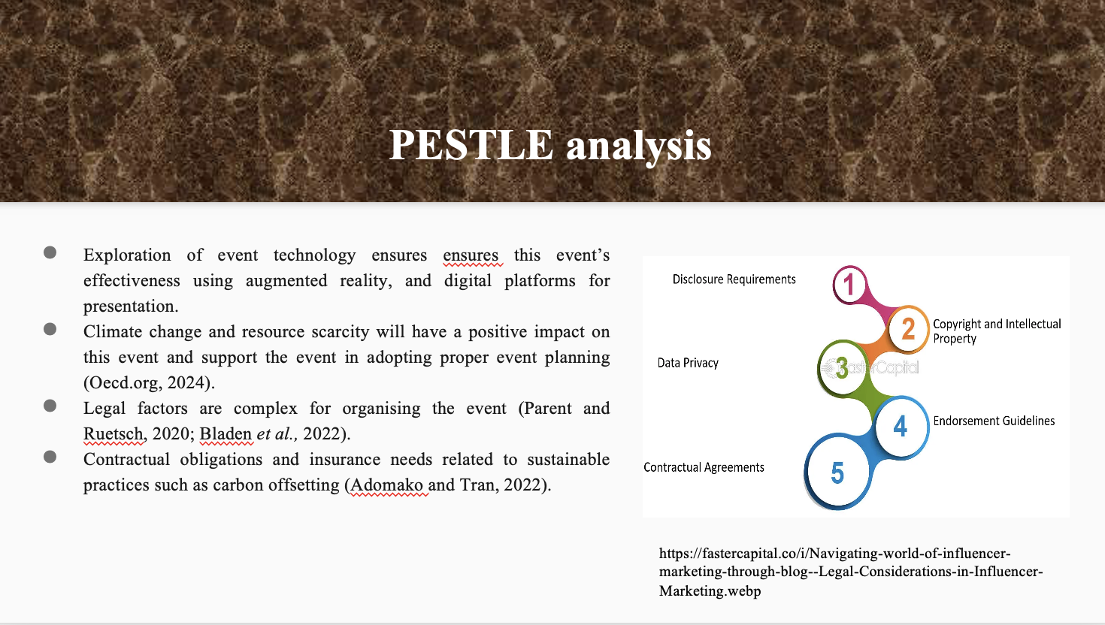
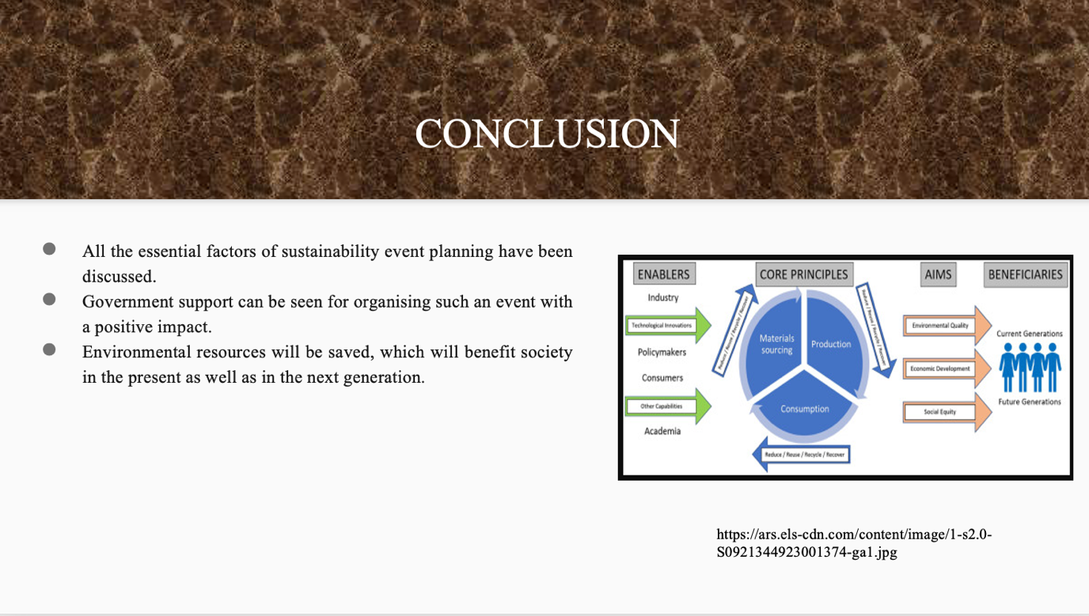

Meeting Link:
https://uowtsd-my.sharepoint.com/:v:/g/personal/2008326_student_uwtsd_ac_uk/EfmGRT4eub9At7Xjdr2mH5MBYyTJbiP3bT8k66fKIsvtlw?referrer=Teams.TEAMS-ELECTRON&referrerScenario=MeetingChicletGetLink.view.view

References:
Allen, J., Harris, R., Jago, L., Tantrai, A., Jonson, P. and D'Arcy, E., 2022. Festival and special event management. John Wiley & Sons.

Atazhanova, D., 2020. Guideline: sustainable event management in Haaga-Helia Porvoo campus.

Bhattacharya, A., Good, V., Sardashti, H. and Peloza, J., 2021. Beyond warm glow: The risk-mitigating effect of corporate social responsibility (CSR). Journal of Business Ethics, 171, pp.317-336.

Bladen, C., Kennell, J., Abson, E. and Wilde, N., 2022. Events management: An introduction. Taylor & Francis.

Chen, W.Q., Ciacci, L., Sun, N.N. and Yoshioka, T., 2020. Sustainable cycles and management of plastics: A brief review of RCR publications in 2019 and early 2020.

Resources, Conservation and Recycling, 159, p.104822.

Chițimiea, A., Minciu, M., Manta, A.M., Ciocoiu, C.N. and Veith, C., 2021. The Drivers of green investment: a bibliometric and systematic review. Sustainability, 13(6), p.3507.

Davis, K.D., Aghaeepour, N., Ahn, A.H., Angst, M.S., Borsook, D., Brenton, A., Burczy
nski, M.E., Crean, C., Edwards, R., Gaudilliere, B. and Hergenroeder, G.W., 2020. Discovery and validation of biomarkers to aid the development of safe and effective pain therapeutics: challenges and opportunities. Nature Reviews Neurology, 16(7), pp.381-400.

Hagen, D., 2021. Sustainable event management: new perspectives for the meeting industry through innovation and digitalisation?. Innovations and Traditions for Sustainable Development, pp.259-275.

Hegab, H., Khanna, N., Monib, N. and Salem, A., 2023. Design for sustainable additive manufacturing: A review. Sustainable Materials and Technologies, p.e00576.

Iatsyshyn, A.V., Kovach, V.O., Lyubchak, V.O., Zuban, Y.O., Piven, A.G., Sokolyuk, O.M., Iatsyshyn, A.V., Popov, O.O., Artemchuk, V.O. and Shyshkina, M.P., 2020. Application of augmented reality technologies for education projects preparation.

Khang, A., Misra, A., Gupta, S.K. and Shah, V. eds., 2023. AI-Aided IoT Technologies and Applications for Smart Business and Production. CRC Press.

Li, H., Yang, Z., Jin, C. and Wang, J., 2023. How an industrial internet platform empowers the digital transformation of SMEs: theoretical mechanism and business model. Journal of Knowledge Management, 27(1), pp.105-120.

Liu-Lastres, B. and Cahyanto, I.P., 2023. Are we always ready? Examining event professionals approaches to risk and crisis management and resilience. Tourism Management Perspectives, 46, p.101073.
Mair, J. and Smith, A., 2022. Events and sustainability: Why making events more sustainable is not enough. In Events and sustainability (pp. 1-17). Routledge.

Mocanu, M., Constantin, L.G. and Cernat-Gruici, B., 2021. Sustainability bonds. an international event study. Journal of Business Economics and Management, 22(6), pp.1551-1576.

Ni, L., Ahmad, S.F., Alshammari, T.O., Liang, H., Alsanie, G., Irshad, M., Alyafi-AlZahri, R., BinSaeed, R.H., Al-Abyadh, M.H.A., Bakir, S.M.D.M.A. and Ayassrah, A.Y.B.A., 2023. The role of environmental regulation and green human capital towards sustainable development: The mediating role of green innovation and industry upgradation. Journal of Cleaner Production, 421, p.138497.

Oecd.org, (2024). Climate-resilient Infrastructure. Available at: https://www.oecd.org/environment/cc/policy-perspectives-climate-resilient-infrastructure.pdf [Accessed from: 22.1.24]

Parent, M.M. and Ruetsch, A., 2020. Managing major sports events: Theory and practice. Routledge.

Ryłko-Polak, I., Komala, W. and Białowiec, A., 2022. The Reuse of Biomass and Industrial Waste in Biocomposite Construction Materials for Decreasing Natural Resource Use and Mitigating the Environmental Impact of the Construction Industry: A Review. Materials, 15(12), p.4078.

Sadreddin, A. and Chan, Y.E., 2023. Pathways to developing information technology-enabled capabilities in born-digital new ventures. International Journal of Information Management, 68, p.102572.

Vuong, Q.H., La, V.P., Nguyen, H.K.T., Ho, M.T., Vuong, T.T. and Ho, M.T., 2021. Identifying the moral–practical gaps in corporate social responsibility missions of Vietnamese firms: An event‐based analysis of sustainability feasibility. Corporate Social Responsibility and Environmental Management, 28(1), pp.30-41.

