Lecturer: Tushara Balendran
Student: 2113738 Eugenia Adriana Manda
World count: 1,279

MARKETING FUNDAMENTALS LCBB404
adriana manda
.




The IKEA vision
“To create a better everyday life for the many people.” –Ingvar Kamprad
Our vision goes beyond arranging the house. Our goal is to make a positive impact on the world - from the commodity supply communities to the way our products help our customers live a more sustainable life at home.
Sharing what we do and speaking for what we believe. We can be part of the positive change in society.

The IKEA business idea
While our vision tells us why we exist, our business idea tells us what we want to achieve. And if you’ve ever visited IKEA, you’ll have probably worked out what our business idea is – “to offer a wide range of well-designed, functional home furnishing products at prices so low that as many people as possible will be able to afford them.”
Ingvar Kamprad, IKEA Founder

.

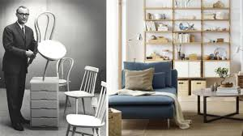 |  |  |  | Ingvar Kamprad’s empayer  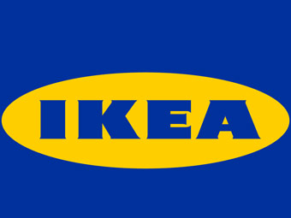  In 1943, when Ingvar was 17, his father rewarded him with a small sum of money for doing well in school, despite being dyslexic. With it, Ingvar founded a business named IKEA, an abbreviation for Ingvar Kamprad from Elmtaryd, Agunnaryd, his childhood home.(SWEDISH INSTITUTE)  Humble beginnings  Kamprad, began his career at the age of six, selling matches. When just ten, he criss-crossed the neighbourhood on his bicycle, selling Christmas decorations, fish and pencils.  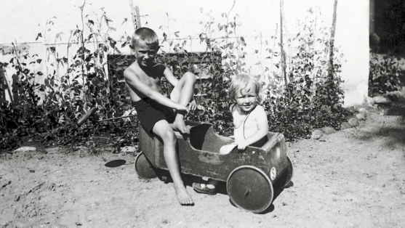  Ingvar Kamprad (left) with his sister Kerstin in the 1930s. Photo: IKEA  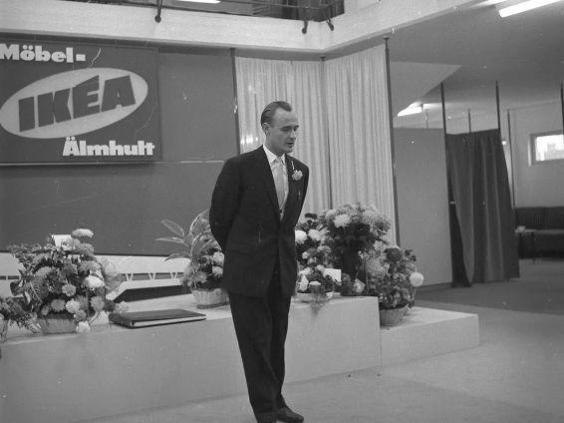Ikea founder Ingvar Kamprad at the opening of the first IKEA store on October 28, 1958, in Sweden. (Photo: IKEA)
IKEA founder Ingvar Kamprad in his younger days. He passed away at the age of 91 in Sweden
This is the sroty of IKEA founder Ingvar Kamprad, form farm life to flat pakc.
IKEA expanded throughout Sweden, to Norway and Denmark, via Germany to continental Europe, and on to the ends of the world. Today, there are nearly 450 IKEA stores spread across the globe.
Throughout his entire helm at IKEA, Kamprad never borrowed money or issued a stock.

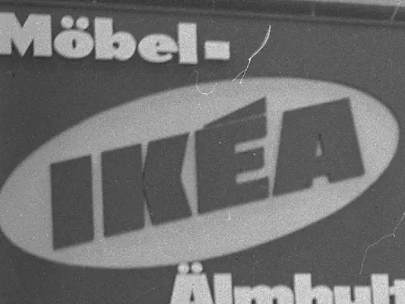

Photo: IKEA

Shaping IKEA’s flatpack concept
Aftere, two years starting IKEA Kamprad, use to deliver his goods a milk trucks. In 1947, he started selling furniture madeby local manufacturers.
Due to Kamprad’slow price, manufactures began to boycotting IKEA, in 1955. This force him to design items in-house.
Kamprad is the innovator and creator of the flat package concept..
He began selling IKEA products in flat pack form, his own warehouses. Thus the basic IKEA concept – simple, affordable flatpack furniture, designed, distributed and sold in-house – was complete.
The idea behind IKEA was, and is, that anyone can afford stylish, modern furniture.Kamprad'sbusines shas grown.

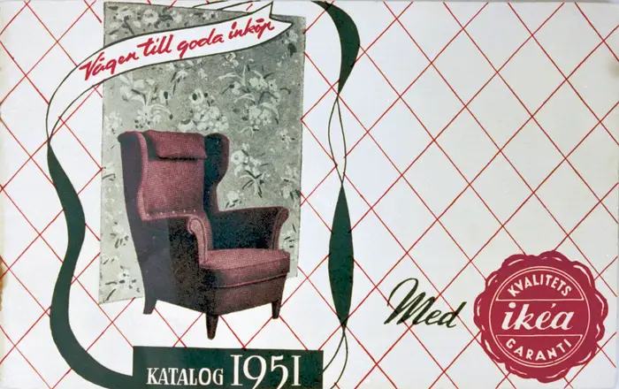  First catalog published in 1951  The first catalog featured a wingback chair on the cover, considered to have been Kamprad’s favorite piece.  (Ikea catalog) |  | 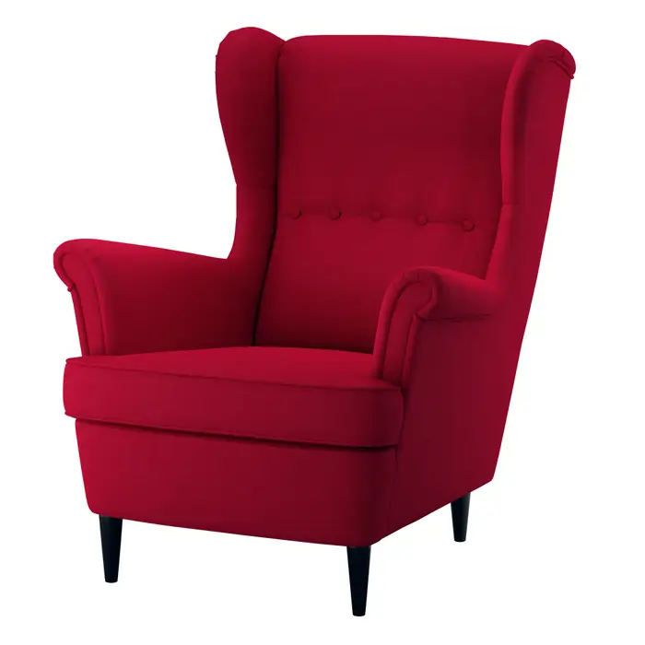 Ikea Strandmon chair  The Ikea Strandmon chair is considered the modern version of the wingback chair that was seen in previous catalog in 1951. |  | 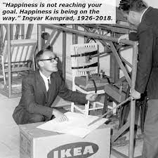

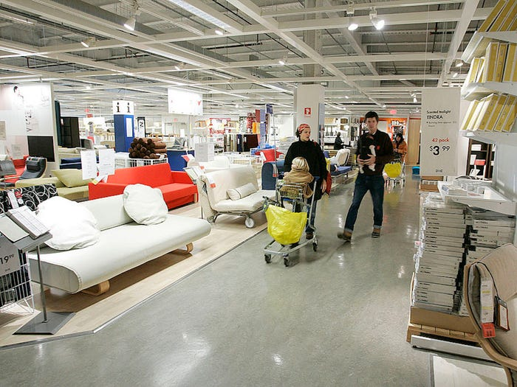

Ikea opened its first showroom in 1953, which gave customers an opportunity Oto come and experience the furniture before buying it. The showroom was located in Älmhult, Sweden.



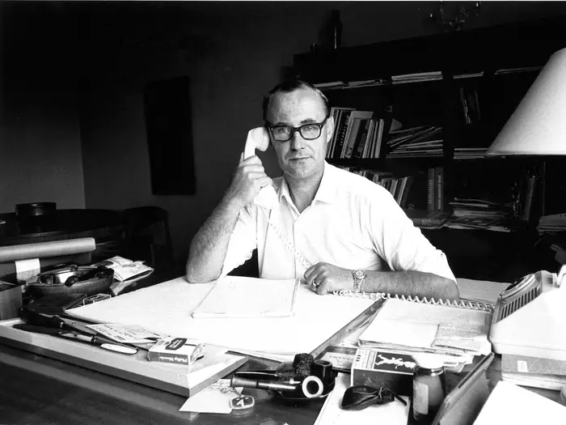 |  |  |  | “IKEA is not the work of one person alone. It is the result of many minds and many souls working together through many years of joy and hard work.”  Ingvar Kamprad  IKEA Founder  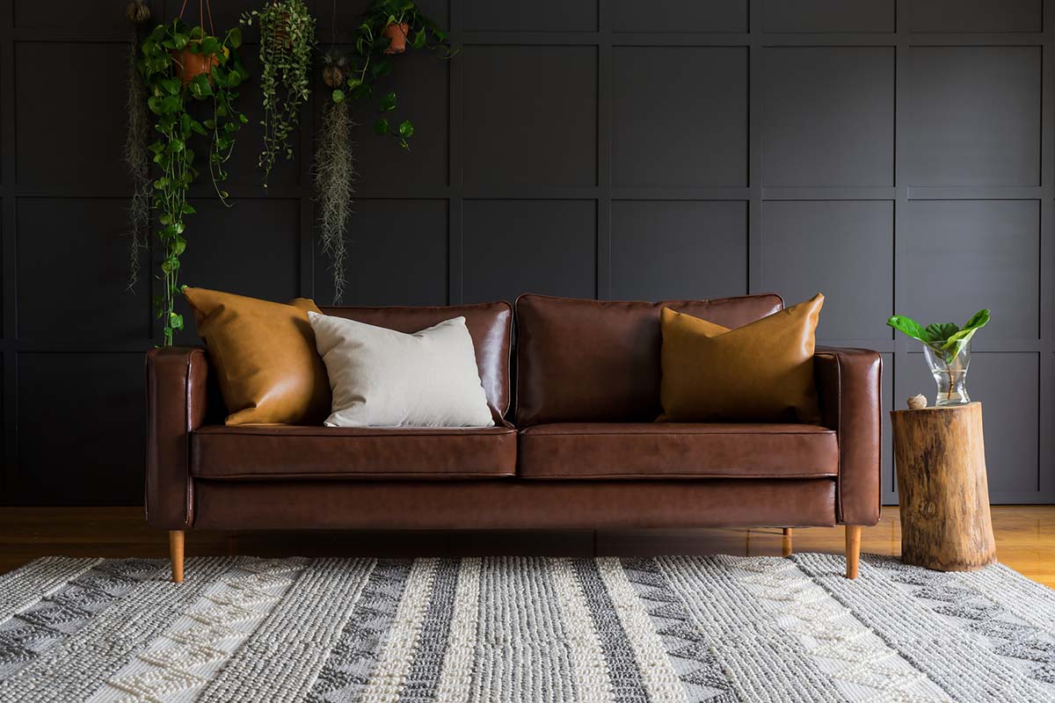  Image credit: Samson Katt/Pexels  A leather sofa is a leather sofa – right?  Today, we’ll be taking a deep dive into one option for this timeless sofa material: bycast leather.  Combining faux leather, bycast leather is an affordable, attractive leather option for sofas. (Ikea.com/leather coated fabric sofa)
Source:Ikea
Our product our image
An product can be undestanded as something that is created to satisfy a specific needs.
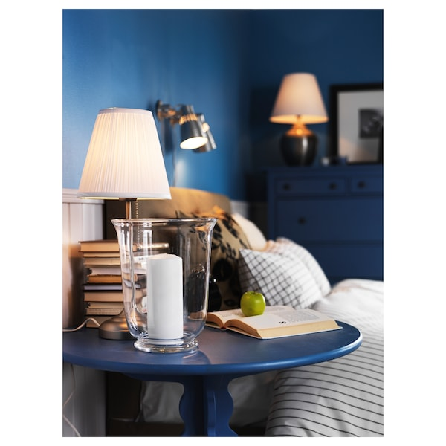 |  | Table lamps  Our table lamps are exactly what a room needs for a personal note.  Our table lamps can make the living room more ambient, comfortable to create a romantic atmosphere for the movie night or  simply for lighting like a bedside lamp.  So turn off the light above the ceiling and give the table lamps a chance to shine.
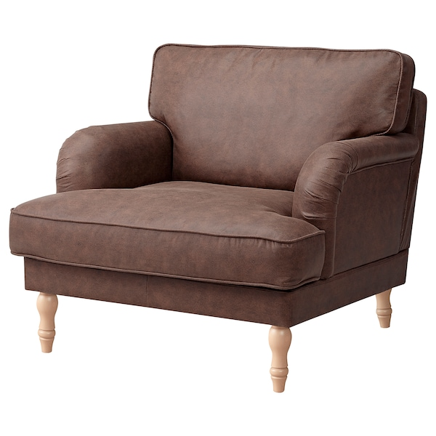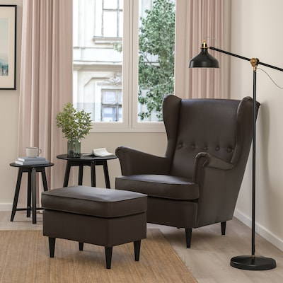
STOCKSUND –Armchair, STRANDMON – Wing chair,
Järstad antique effect/light brow Grann/Bomstad dark brown
£350 £379

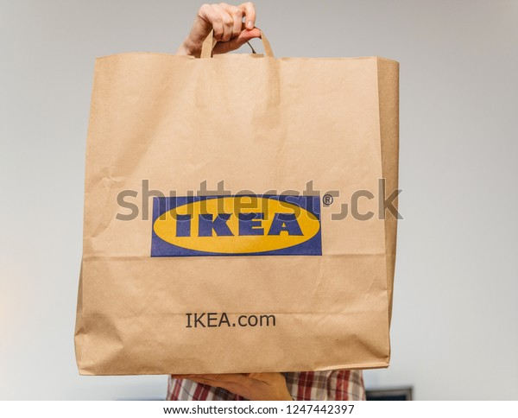 |  | 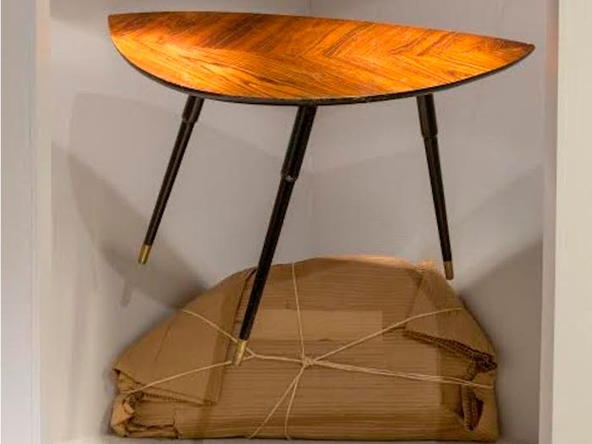  Beginning in 1956, Ikea began designing furniture that could be packaged and self-assembled.  Lövet table was the first Ikea item to be packaged - this modern Lovbaken table below is a newer interpretation of the original design. |  |  | 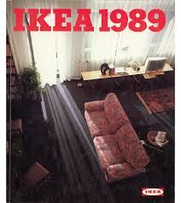  Furniture names  Our IKEA's furniture names are based on an elaborate system.  Beds have Norwegian place names.  Sofas are named after Swedish towns. Kitchen tables have Finnish geographic name. Chairs mostly have male names, and rugs mostly have Danish names.(IKEA CATALOG)
The IKEA values
Our values reflect what we consider to be important. So important in fact that we refer to them as one of our “forever parts”. They guide us in our everyday lives at work in everything from how we treat people and the planet to how we make decisions - large or small.(about Ikea)

Ikea around the world
IKEA is a multinational group of companies that designs and sells ready-to-assemble furniture (such as beds, chairs and desks), appliances and home accessories.(About Ikea/ about us, 2022)

There are 464 IKEA stores operating in 63 countries.

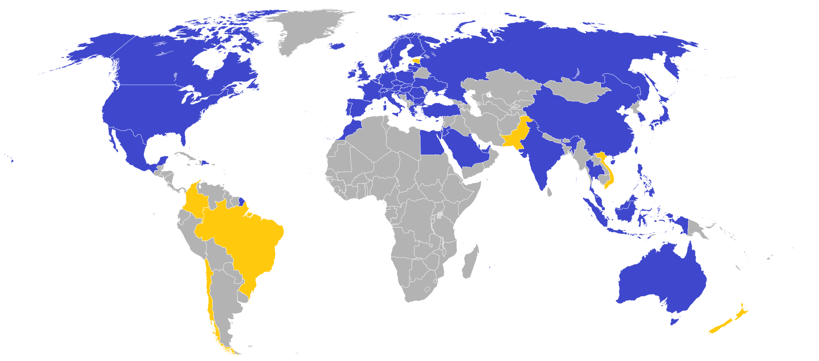
Map of countries with IKEA stores
Legend:
- Current market locations
- Future market locations
- No current or planned market locations

Throughout the UK , Ikea has 22 branches

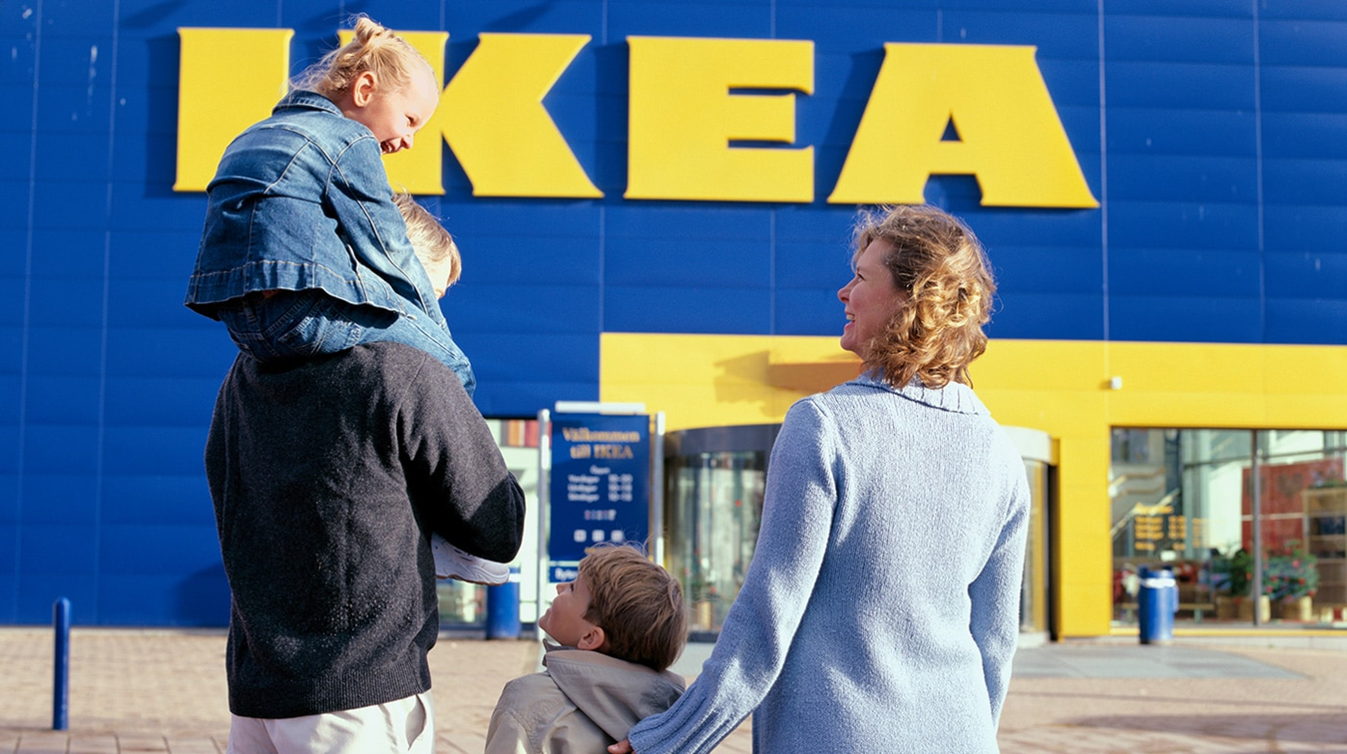

Our Marketing Strategy in Distribution and Logistics
Our goal is to achieve maximum sales, customer satisfaction and value for money to be understood by customers at its fair value.
The place is very important to find out the best channels about efficient transport of goods to the customer. The place does not only refer to the location, but also includes the distribution and logistics channels. IKEA can provide an efficient logistics procedure, as stores are also warehouses. Customers can pick up the products they want to buy from the warehouse area..

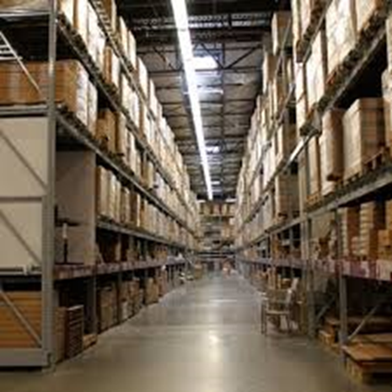
Ikea warehouse

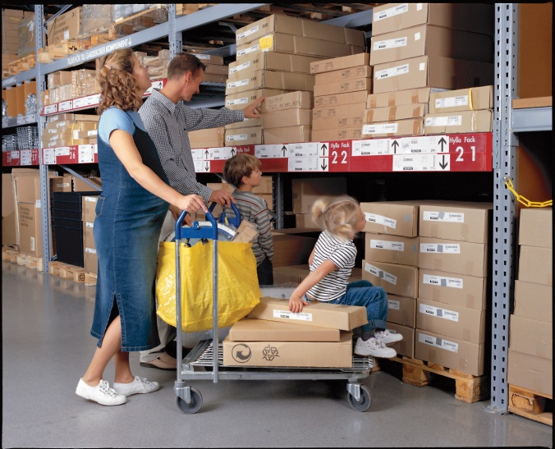
Ikea warehouse

Our goal is to serve and develop more markets. At the same time, direct transport is preferred to reduce transport costs. In the
current context, due to the pandemic created by the coronavirus - the challenge was distance shopping on the phone and on the internet. IKEA hopes sales can grow for this reason. At the same time, we need to consider new, fast and flexible distribution solutions that meet customer expectations (Distribution / Storage, IKEA). Therefore, technology-facilitated delivery innovations, such as the development of in-app voice recognition technology, store detailed customer information in the company's database.
Ikea offers a number of extra services that its competitors do not. Ikea in-store environment and purchasing processes promote greater consumer interest and facilitate the buying behavior of customers. Ikea displays every product and sells in room-like settings that help customers to imagine how to put the pieces together.



IKEA's secrets to keeping its prices so low

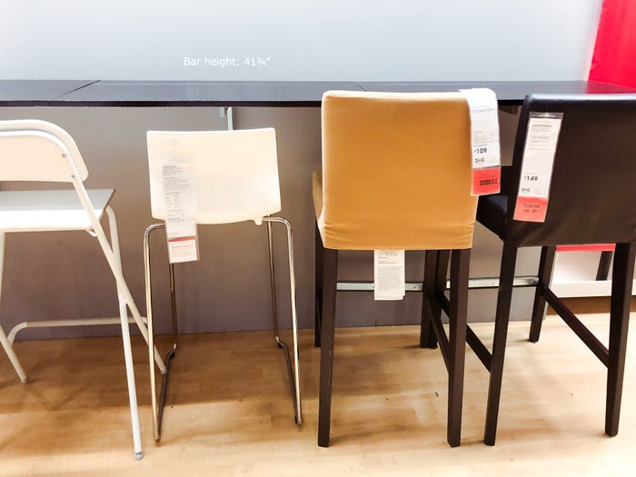

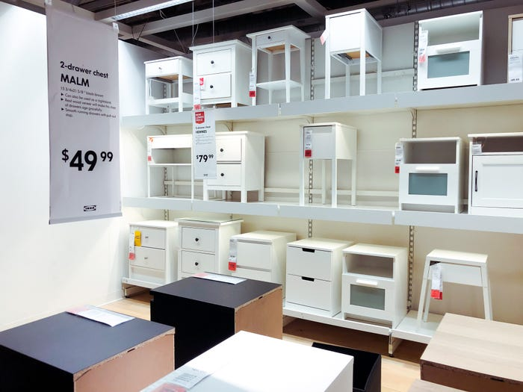
MALM
Chest of 2 drawers, white40x55 cm
$49.99

- Shoppers love IKEA because of its affordable furniture.
- Many IKEA products cost half the price of competitors.
- IKEA prices are so low because they pack everything to save on storage and shipping costs.
- "Flat packing", the method now synonymous with IKEA, reduces costs, allowing consumers to buy their furniture in pieces and assemble it themselves.

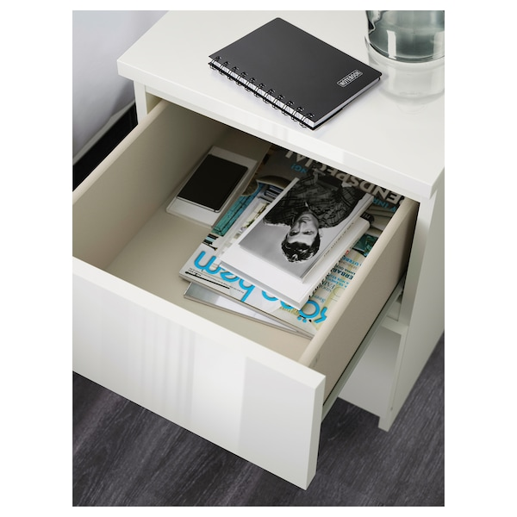
MALM
Chest of 2 drawers, white40x55 cm
£40

REFERENCES

https://sweden.se/life/people/kamprad-king-of-ikea Last updated on 1 June 2021.(Accessed 06 Jan 2022)
https://www.businessinsider.com/ikea-first-store-history-in-sweden-in-1958-2019-9?r=US&IR=T#ikea-opened-its-first-showroom-in-1953-which-gave-customers-a-chance-to-come-and-experience-the-furniture-before-buying-it-the-showroom-was-located-in-aelmhult-sweden-today-most-ikea-stores-have-large-showroom-areas-to-test-and-feel-the-furniture-6 (Accessed 06 Jan 2022)
https://archinect.com/news/article/150047314/founder-of-ikea-ingvar-kamprad-passes-away-age-91 (Accessed 06 Jan 2022)
https://blog.comfort-works.com/top-10-favourite-ikea-sofas/(Accessed 06 Jan 2022)
https://autographman.co.uk/product/ingvar-kamprad/ (Accessed 06 Jan 2022)
https://www.bbc.co.uk/news/business (Accessed 06 Jan 2022)
https://www.ikea.com/gb/en/p/strandmon-wing-chair-grann-bomstad-dark-brown-40494641/ http://www.cbpp.uaa.alaska.edu/afef/what_is_strategy.htm (Accessed 06 Jan 2022)
https://about.ikea.com/en/about-us (Accessed 06 Jan 2022)
https://www.businessinsider.com/why-ikea-is-so-cheap-2018-10?r=US&IR=T#ikea-designers-work-around-the-price-of-a-product-1 ( Accessed 06 Jan 2022)

