Alternative Powertrain

Series Hybrid Buggy

Deion Atkinson
ID No: 1703067
Bsc Motorsport Engineering
University of Wales Trinity St David

Contents
1) Table of Figures 2
2) List of Tables 2
3) Introduction 3
4) The Vehicle 4
5) The Circuit 5
6) Data Analysis 6
7) Conclusion 8
7) References 9

1) Table of Figures
Figure 1 - Example of the course 6

2) List of Tables
Table 1 - Vehicle details 5
Table 2 - Vehicle characteristics after calculations 5
Table 3 - Elevation and Height of the course 6
Table 4 - All forces acting against the buggy per lap 7
Table 5 - Total forces vs Total Power 8

3) Introduction

The purpose of this report is to conduct a duty cycle for an off-road buggy around a circuit for a corporate entertainment event. The circuit and buggy need to be suitable for each other along with providing an exciting and thrilling experience, adding onto this the circuit must elevate up to 22 meters above the lowest point. The duty cycle should include the time taken to do a lap, the time taken to do each section and the velocity the buggy is travelling at each section.
The duty cycle of the buggy will be created on an excel spreadsheet to determine the resistive forces which are aero forces, rolling drag and gradient resistance. The resistive forces will then be used to calculate the power output of the buggy at each section of the track, giving an indication of when the buggy is using its maximum power and when there is more available power. Once these values are found, they can be used to produce graphical evidence of the buggy’s behaviour at each point of the track.

4) The Vehicle
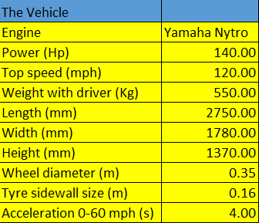
The vehicle is a Rage off-road buggy equipped with a Yamaha FX Nytro 1000cc 4 stroke engine which produces 140bhp. The details of the buggy can be seen below in Table 1 (Rage, 2015). This buggy was chosen because of its 140bhp output and its ability to do up to 120mph even though it might not be realistically possible around this circuit but its thrilling acceleration can still be experienced.

Table 1 - Vehicle details
With the vehicle data collected, calculations could then be made on the excel spreadsheet to find the characteristics of the vehicle which can be seen below;
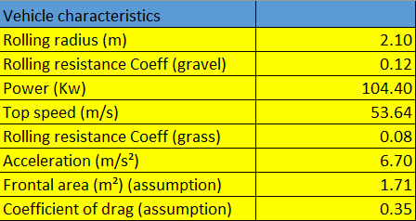

Table 2 - Vehicle characteristics after calculations

The rolling resistances were found at the buggies.builtforfun.com (2006) website, whereas the coefficient of drag was found at engineeringtoolbox.com (2004) as an assumption, comparing it to a sports car which is 0.3 while presuming that it may have a little more drag because of its hollow cab.

5) The Circuit
The buggy is required to do a 530 meter lap of the gravel circuit with four uphill sections and two downhill sections combined with a grassy corner and a tricky hairpin right after the last downhill section. The maximum height that the track elevates to is 25 meters above the starting point level, this is a combination of many different elevations and gradients, as can be seen in the table below.
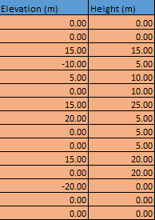
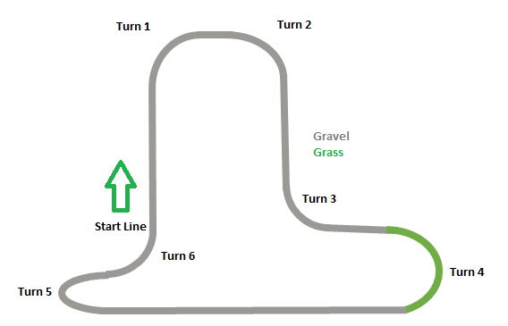
Table 3 - Elevation and Height of the course
Figure 1 - Example of the course

These elevation differences were chosen to analyse the different power outputs required at different gradients along with the difference in forces when the buggy is climbing or descending. Along with elevation changes, the grassy corner was put into place to see the effect of different rolling resistances on different surfaces. The differences can then be put into perspective when looking at the forces the buggy is experiencing due to the different rolling resistance coefficients.

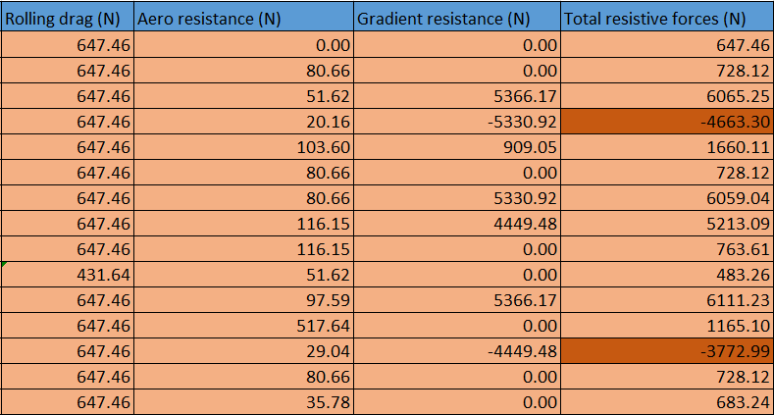
6) Data Analysis
Table 4 - All forces acting against the buggy per lap
The table above clearly identifies the resistive forces acting against the buggy as it completes a full lap. The dark highlighted sections are negative numbers meaning that the vehicle is travelling downhill where the forces acting against it are negative. The rolling drag values are the same except for one instance where the buggy travels through the grassy corner experiencing less resistance due to the grass coefficient of drag being less than the gravel. The aerodynamic resistance increases to 517.64 N at one point in the table, this is because the velocity is 38 m/s and, as stated by Özel, M (2015), the aerodynamic drag force increases proportional to the square of the speed (Ozel, 2015).
Figure 2 - Total forces vs Time graph

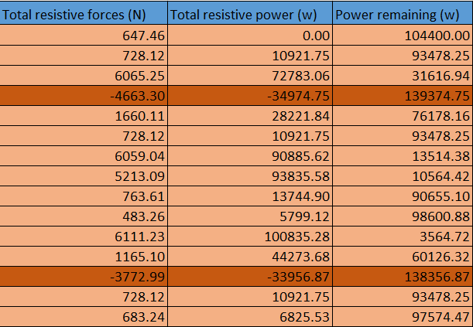

Table 5 - Total forces vs Total Power
When looking at the power output of the vehicle, it can be determined that the highest power output is occurring when the total resistive forces are experienced. Similar to table 4, the dark highlighted sections are all negative numbers meaning that the vehicle is not using any power because of it descending. The power remaining section indicates the amount of power that the engine has left, this can be determined by the max power of the vehicle minus the power used. In combination with the total forces section, it clearly shows that when the vehicle is nearly at full potential that the total forces are higher, indicating that the higher the forces – the more power needed to overcome those forces (Gao, 2010).
Figure 3 - Total power required vs Total resistive forces graph

7) Conclusion
It clearly indicates that the buggy has plenty of potential to be fast and exiting for the corporate event by looking at the power and top speed values in the report. The circuit designed for the event has different gradients and terrain to make the lap tricky and challenging for the driver and entertaining for the audience and passenger, this combined with the buggy’s ability to use almost its full power capability will make the lap entertaining.
Technically analysing the results of the lap gives shows that the buggy is using plenty of its available power along with the capability of climbing the gradients around the circuit. Looking at the velocity and resistive forces values it clearly shows that the buggy is experiencing the highest resistive forces when it’s travelling at 38 m/s, clearly proving that the aero resistance is dependent on the speed of the vehicle. When considering the downhill section where the buggy is descending at a gradient of -41 degrees, the value is -138356.87 watts which is of a higher value than the maximum power which is 104400 watts. This suggests that the car has to brake to recover the energy down the hill.

7) References

Carvill, J. (2006). Buggies.builtforfun.com/calculator. Retrieved from Buggies.builtforfun.com: http://buggies.builtforfun.co.uk/Calculator/calculator-data.html
Engineeringtoolbox. (2004). Engineeringtoolbox.com/dragcoefficient. Retrieved from Engineeringtoolbox.com: https://www.engineeringtoolbox.com/drag-coefficient-d_627.html
Gao, Y. (2010). Modern Electric, Hybrid Electric and Fuel Cell Vehicles. Boca Raton: Taylor and Francis Group.
Maxxis. (2019). Maxxis.com/catalog. Retrieved from Maxxis.com: https://www.maxxis.com/catalog/tire-16-110-bighorn-radial
Ozel, M. (2015). Flow Control around a Truck-Trailer Model. International Journal of Automotive Engineers and Technology, 195.
Rage. (2015). Rage Motorsport Slovenia. Retrieved from Ragemotorsport.eu: https://ragemotorsport.eu/

