

Police perception of the effect of cuts to youth services on the rise in youth knife crime

Sa’ipolu Tapa’atoutai Uhi

Student no. 2117847

BSc (Hons) Professional Policing

Word count: 8,060

Acknowledgements

I would like to thank my dissertation supervisor, Stephanie Brown, for her support and advice throughout the process of writing this dissertation. I would like to thank Jeff Lewis for his guidance, constant support and always making time for me when I need assistance. I would also like to thank my work colleagues and my work supervisor, Phillip Walsh, for their support and encouragement, especially when I found it difficult to balance my university work and my day job.

Lastly, I would like to give a special thanks to my family, especially to my wife for her never-ending love and support throughout the past three years. I wouldn’t have been able to get through this difficult and stressful time without your good advice and encouragement. I cannot stress enough how lucky I am to have you by my side.

I appreciate you all for your help and I am very grateful to have such a great support network.

Declaration

- Declaration - This work has not previously been accepted in substance for any degree and is not being concurrently submitted in candidature for any degree.
Signed: Sa’ipolu Tapa’atoutai Uhi Date: 8 July 2024

- Statement 1 - This dissertation is being submitted in partial fulfilment of the requirements for the degree of BSc.
Signed: Sa’ipolu Tapa’atoutai Uhi Date: 8 July 2024

- Statement 2 - This dissertation is the result of my own independent work/investigation, except where otherwise stated. Other sources are acknowledged by footnotes giving explicit references. A bibliography is appended.
Signed: Sa’ipolu Tapa’atoutai Uhi Date: 8 July 2024

- Statement 3 - I hereby give consent for my dissertation, if accepted, to be available for photocopying and for interlibrary loan, and for the title and summary to be made available to outside organisations.
Signed: Sa’ipolu Tapa’atoutai Uhi Date: 8 July 2024

- Statement 4 - I hereby give consent for my dissertation, if accepted, to be available on the university’s IT system to those who have consent to use the system.
Signed: Sa’ipolu Tapa’atoutai Uhi Date: 8 July 2024

Abstract

The aim of this dissertation was to explore and research the police perception of the effect of cuts to youth services on the rise in youth knife crime. The researcher conducted a critical analysis of current and existing academic literature on the subjects of cuts to youth services, youth crime, media coverage of youth knife crime and police perception of youth knife crime. The researcher prepared a survey for police officers and staff. The aim was to gather data and anecdotal evidence regarding police perception, and also to identify other possible factors that have contributed to the rise in youth knife crime.
The main findings are that nearly all of those surveyed believe that there has been a rise in youth knife crime, and the majority believe that cuts to youth services have contributed to the rise. Other contributing factors were identified, and many of these were also mentioned in the literature reviewed: poverty, social media, lack of trusted role models, fear or protection, status, drug use, gang exploitation, unstable home life and a lack of safe spaces. The research concludes that the police perception is that cuts to youth services has had an effect on the rise in youth knife crime.

Table of Contents

Chapter 1: Introduction…………………………………………………………… 6
1.1 Introduction……………………………………………………………………….. 6
1.2 Background and rationale……………………………………………………….. 6
1.3 Aims and objectives……………………………………………………………… 6
1.4 Research structure………………………………………………………………..7
1.5 Conclusion………………………………………………………………………… 7

Chapter 2: Literature Review……………………………………………………. 8
2.1 Introduction……………………………………………………………………….. 8
2.2 Rise in youth knife crime and possible reasons for the rise…………………. 8
2.3 Cuts to youth services and austerity…………………………………………… 9
2.4 Media coverage of youth knife crime………………………………………….. 11
2.5 Police perception and youth knife crime………………………………………. 12
2.6 Conclusion………………………………………………………………………… 13

Chapter 3: Methodology…………………………………………………………..14
3.1 Introduction……………………………………………………………………….. 14
3.2 Research Onion………………………………………………………………….. 14
3.3 Research Strategy……………………………………………………………….. 14
3.4 Data Collection…………………………………………………………………… 15
3.5 Data Analysis…………………………………………………………………….. 15
3.6 Limitation and Potential Problems……………………………………………… 16

Chapter 4: Analysis of Results………………………………………………….. 17
4.1 Introduction……………………………………………………………………….. 17
4.2 Data Analysis…………………………………………………………………….. 17
4.3 Demographic and Descriptive Statistics………………………………………. 17
4.3.1 Length of service………………………………………………………… 17
4.3.2 Current role (rank or title)................................................................... 17
4.3.3 Geographical areas within the force…………………………………… 18
4.3.4 Do participants work in a knife crime specific team?......................... 18
4.4 Questionnaire Findings………………………………………………………….. 18
4.4.1 The rise in youth knife crime……………………………………………. 19
4.4.2 The reporting of youth knife crime……………………………………… 19
4.4.3 Socio-economic factors………………………………………………….. 20
4.4.4 Demographics involved in youth knife crime………………………….. 20
4.4.5 The availability of youth services or provision………………………… 20
4.4.6 The possible effects of cuts to youth services on youth
knife crime levels…………………………………………………………. 21
4.4.7 Contributing factors in the rise of youth knife crime………………….. 21
4.4.8 The reasons young people carry knives………………………………. 21
4.4.9 Media depiction of youth knife crime…………………………………… 21
5. Conclusion………………………………………………………………………………22

Chapter 5: Conclusions and Recommendations………………………………. 23
5.1 Introduction……………………………………………………………………….. 23
5.2 Main Findings…………………………………………………………………….. 23
5.3 Recommendations……………………………………………………………….. 23
5.4 Limitations………………………………………………………………………… 24
5.5 Further Research………………………………………………………………… 24
5.6 Conclusions………………………………………………………………………. 25

Bibliography……………………………………………………………………….. 26

Appendices……………………………………………………………………….. 29
Appendix 1: Research onion………………………………………………….. 29
Appendix 2: Copy of survey…………………………………………………….30
Appendix 3: Survey responses…………………………………………………34

Chapter 1: Introduction

1.1 Introduction

The purpose of this dissertation is to research possible links between cuts to youth services and the rise in youth knife crime. The research will look at the ‘Police perception of the effect of cuts to youth services on the rise in youth knife crime’. This chapter will show the background of this topic and highlight the need for research in this area. It will also explain the reason for researching the police perception rather than researching the effect itself.

1.2 Background and rationale

It is difficult to prove a direct link between the rise in youth knife crime and cuts to youth services. Many reports exist on youth knife crime numbers and cuts to youth services. YMCA (2022) have reported that there has been a £1.1bn cut to local authority youth services spending over the last 10 years. The Youth Justice Board (2024) reported that in the year ending March 2023, just under 3,400 knife or offensive weapon offences resulting in a caution or sentence were committed by children. Although this figure is a fall of 4% from the previous year, it is still 23% higher than 10 years ago (Youth Justice Board, 2024). However, academic research is quite limited on this subject, and the researcher has decided to look at the police perception of the issue.
The researcher’s reasons for researching this topic is due to the researcher’s full-time job as a Police Constable with South Wales Police, and previously working as a Police Community Support Officer. The researcher deals with many incidents of knife crime involving youths and has personally felt that youth knife crime is on the rise. They have also seen firsthand the deprivation in communities, and the lack of services and funding that are available to support youths. They felt that these types of incidents were happening frequently, but that the media coverage does not reflect the volume of cases.

1.3 Aims and objectives

The aim of the dissertation is to contribute the police perception of the issues of youth knife crime and cuts to youth services to this area of research. It also aims to provide recommendations for further research and also actions that could be taken to support young people and reduce youth knife crime.

The objectives are:

- To research and critically evaluate existing academic literature regarding the effect of cuts to youth services on the rise in youth knife crime.
- To identify and decide on the most appropriate method of conducting the research and for collecting the perception of police officers and staff.
- To analyse the data collected to understand the perception of police officers and staff regarding whether or not cuts to youth services have had an effect on the rise in youth knife crime. Also, to see if there are other contributing factors that are perceived to have had an effect on the rise in youth knife crime.
- To provide recommendations regarding the funding of youth services and identifying ways to tackle youth knife crime.

1.4 Research structure

The dissertation is divided into five chapters. Chapter two of the dissertation will be the literature review. This chapter will critically analyse and review existing academic studies relevant to the research topic, and see if there are any gaps in existing research. It will help to provide an understanding of youth knife crime through the perception of the police.
Chapter three is the methodology, and this chapter will help to identify the most appropriate and efficient research methods to collect data on this subject matter. Chapter four will be the analysis of the results. Here, the data collected from the research method chosen in chapter three will be analysed. Statistics and charts will be included to present the results of the findings. The final chapter is chapter five, which is conclusions and recommendations. This chapter will draw conclusions from the research findings, identify limitations in the research, suggest further research and will also include recommendations.

1.5 Conclusion

Chapter one has presented the aims and objectives of the research, and has also provided the background information regarding why the researcher has chosen to research this topic, particularly police perception of the effect of cuts to youth services on the rise in youth knife crime.

Chapter 2 - Literature Review

2.1 Introduction

Although many reports exist on youth knife crime numbers and cuts to youth services, academic research is quite limited on this subject. This review of the current literature that is available is divided into different aspects of the topic the researcher is researching. The aim is to review the literature that is available on the rise in youth knife crime and the possible reasons for that rise, cuts to youth services and austerity, media coverage of youth knife crime and police perception of knife crime.

2.2 Rise in youth knife crime and possible reasons for the rise

Reilly et. al (2022) argue that knife injury to children is associated with poor socioeconomic status. Following an observational study, looking at patients admitted to a UK Major Trauma Centre, researchers found that the patients in the study were more likely to have a poor socioeconomic status compared to the rest of England in income, education, health and wellbeing. The researchers go on to suggest that trying to address socioeconomic disparities should be dealt with as a public health measure, and should be a priority. The researchers note one weakness of the research, which is that the study was done from a database of patient data, and that because of this there is a risk of selection bias and missed patients. There is also the fact that the study concentrated on patients aged ≤17 years, with a median age of 16. Knife crime affects youths of all ages, and younger youths weren’t included in this research. The study also looks at young people who have been admitted to hospital with knife trauma, but knife crime in general doesn’t always result in injury, and this is a much narrower study than this dissertation’s research topic (Reilly et. al, 2022) .
There are strengths in this paper in terms of this dissertation’s research. Reilly et. al (2022) reference a report that shows that there has been a decrease in youth funding over the last 10 years (YMCA, 2020), and that recent Home Office funding for Violent Reduction Units go a little way to redress the funding cuts (Home Office 2020), but the researcher of this dissertation’s assessment of this statement is that there is still a long way to go to ensure adequate funding for dealing with youth knife crime (Reilly et. al, 2022). The authors also found that knife violence was less common during school hours, as the young people studied would be at school (Reilly et. al, 2022). They go on to mention that other studies suggest structured after school activities could prevent violence in vulnerable groups. Any structured after-school activities would need funding, and this supports reports that the researcher of this dissertation has seen with details on the number of youth clubs that have closed since 2010 (over 700) and the number of youth work jobs that have been lost (over 4,000) (Reilly et. al, 2022).
The review by Haylock et al. (2020) of the risk factors associated with youth knife crime in the UK has found that deprivation is an important factor behind youth knife crime. Six of the studies in the review looking at the impact of deprivation all showed the strong link between deprivation and knife crime (Haylock et al., 2020). Areas of economic deprivation were found to have the highest crime rates, and this led to an increase in the chance of young people becoming involved in violent crimes. This also means that some young people carry knives to protect themselves in high crime areas (Haylock et al., 2020). The authors identified seven studies that looked at the link between young people with adverse childhood experiences and weapon-related crime, and that these studies all reported a positive link. Three studies identified poor mental health as a risk factor for becoming involved in knife crime. The authors explain that their research is limited because of the limited number of sources available, as this is a growing field of research (Haylock et al., 2020). However, a strength is that it reviews studies from a variety of possible factors that could increase knife crime (Haylock et al., 2020). They also included literature reviews, which could be influenced by the authors’ experience or personal views.
Tribe, et al., (2018) discuss the ‘fear factor’ that drives young people to carry knives for their own protection. However, the authors also mention the ‘fashion factor’ which means that carrying a knife can give young people status among others Tribe, et al., (2018). The research looked at the value of holding sessions with young people in a safe space where they can learn about and discuss knife crime and its consequences. The authors acknowledge some weaknesses in the research, such as the participants having less experience of knife crime than the researchers had expected, and the workshops were only held in the Greater London area. However, the research was conducted with 60 teenagers across the wide age range of 13-19, which could be argued is a good size sample across a range of ages.

2.3 Cuts to youth services and austerity

Thompson and Woodger (2018) write about the findings of research conducted in a London borough in 2018. It is a needs analysis of young people, and covers the topics of ‘crime and safety’ and ‘mental health and wellbeing’ as the biggest needs facing the young people who took part. In terms of services for young people, youth clubs were revealed to be the biggest need, and in second place was targeted support with crime. The stakeholders who were questioned as part of this needs analysis not only included young people in the borough, but also parents and professionals. The survey results showed a strong emphasis on youth clubs being the most important form of youth provision, and most of those surveyed believed that youth services should be primarily funded by local and national government, and that they should be free. The paper mentions the challenging financial climate and that in this context most respondents didn’t think that there was enough youth provision in the borough (Thompson and Woodger, 2018). The survey was conducted with 426 people, which is a good sample size that includes young people, parents and professionals in the field of youth services. However, the authors admit that most of the young people and parents who responded came from wards in the borough where key youth services are based. This is because the number of responses from young people was very low a few weeks after the survey was released, and therefore youth services providers used their own networks to reach young people to answer the survey. This means that the views of young people in areas where there is no youth provision weren’t fully represented (Thompson and Woodger, 2018).
Densely, et al., (2020) focuses on gangs and youth violence and looks at trends in youth violence. The paper mentions that with knife crime, particular focus is given to London, but that nearly every police force area in Britain has been affected by the rise in youth knife crime (Densely, et al., 2020). The research references a 2018 UK Government report which blames the rise in youth violence on county lines drugs gangs, and social media (HM Government, 2018). However, the authors point out that critics of this view argue that the role of county lines and social media is overstated and oversimplified. Critics point to other contributing factors, such as the toxic environments that have been created for children, caused by decades of austerity, fear of violent victimisation, cuts to police numbers and budgets, a lack of trust in government and ineffective and discriminatory policing practices (Brown, E.L., Ware, G. and Cassimally, K.A., 2019). The reference to austerity being one of the causes of the rise of youth violence ties in with the research for this dissertation, but this paper includes youth violence in general, not just knife crime. This research is also just a short introduction to a wider journal.
Even though most of the research articles the researcher has found are limited to discussing one part or one aspect of the topic, there is a book that examines nearly all aspects and themes of the research topic. Sue Roberts’s book (2021) includes chapters that look at the impact of austerity on youth knife crime, and also discusses the factors of deprivation and poverty in youth knife crime. Roberts argues that youth crime is not caused by one or two factors, but that many different factors are connected to create a situation where knife crime is on the rise. Roberts (2021) mentions the following factors that intertwine to create issues with youth and knife crime: school exclusion, mental health, poverty and deprivation, neglect, loss of police personnel, cuts to youth clubs and community centres, the rise in social media use and online gaming, social media bullying, loneliness and isolation. The research for this dissertation concentrates on the perception of a link between cuts to youth services and an increase in youth knife crime, but it is important to highlight that there are many other factors that contribute to the problem, as is seen in this book and other research reviewed here. The research mentions the cuts to public spending that were made since 2010 due to the Coalition Government’s austerity policies, and that these cuts led to a very large cut to youth services (Roberts, 2021). In a later chapter on the loss of youth services, Roberts (2021) references two reports, one by UNISON (2018) and one by YMCA (2020) that detail the cuts and their effect on youth service provision, such as the fact that 763 youth clubs closed between 2010 and 2019. It goes on to explain that these closures also mean that young people in many areas lack safe spaces, access to advice and role models, supported interaction with professionals and supervised interaction with others.
In her conclusions, Roberts (2021) emphasises that a large factor in the rise in youth knife crime is social inequality and deprivation, and that this inequality is being manifested in knife crime. The author insists that public funds to support services must be restored, alongside working in partnership, including local people in discussions around youth provision and knife crime and that the provision lost by children and young people must be reinstated. She notes that these issues must be dealt with by the Government. Roberts argues that if this isn’t done, knife crime will continue to evolve, with different weapons sourced on the dark web making their way into communities (Roberts, 2021).
Brenner (2022) discusses the results of austerity measures and the resulting closure of many youth centres and after-school provision. The author concludes that findings suggest that public health based approaches, which are preventative action based on the needs of communities, are the most effective ways of tackling knife crime (Brenner, 2022). Brenner (2022) adds that austerity measures had a negative impact on many of the factors involved in public health approaches, such as youth centres. The most dangerous times for young people in terms of knife crime, according to an Ofsted (2019) report referenced here, are outside of school hours and on the weekend, which emphasises the need for safe places where young people can go in their free time. The author also finds that mental health services, and a collaboration with social services would help to reduce the levels of youth knife crime (Brenner, 2022).
The author’s research is done from available data, not through collecting their own data, and by reviewing other available literature (Brenner, 2022). It would be interesting to see what the outcomes of engaging directly with young people in London and Croydon would be, particularly as the data would be more recent than that already available to the author.

2.4 Media coverage of youth knife crime

As this dissertation is researching the police perception of the link between the rise in youth knife crime and cuts to youth services, the researcher decided to look at research regarding whether there has been a rise in youth knife crime, or if the media reporting of knife crimes involving young people influences people’s perception of the scale of the problem. Williams (2023) compares the depiction of street muggers in the 1970s with the modern depiction of knife crime youths. The article uses the case of the stabbing of 14-year-old Luke Walmsley at school in 2003 as a case study of how the incident was reported in the media. The article mentions the type of sensational language that was used in headlines, including ‘terror, ‘panic’ and ‘horror’. Official statements weren’t released immediately, and the media reporting was based on statements by officials without any evidence or data to support their statements (Williams, 2023). This included the General Secretary of the National Association of Head Teachers claiming that incredible numbers of young people were signing up to knife culture.
In the weeks following the incident, the media concentrated on reporting stories involving children and knives, suggesting that all these cases were connected under the label of ‘knife crime’. It is suggested that the media played a large part in exaggerating the extent of youth knife crime in the UK (Williams, 2019). It shows how powerful the media can be in influencing public perception of certain crimes. Williams (2019) states that the term knife crime in the media is now associated with particular type of criminality, and it is assumed that the crime involves young people. The findings of the paper regarding the label put on young people by the media, particularly in urban areas, are extremely interesting, however the research does not look into the causes of knife crime.

2.5 Police perception and youth knife crime

As part of this research, the researcher will be surveying current police officers within South Wales Police regarding their perception of any links between an increase in youth knife crime and cuts to youth services. Bullock, et.al, (2023) surveyed police practitioners regarding the processes and challenges of applying problem-oriented and public health approaches to knife crime. The authors mention different early intervention and prevention initiatives that have been funded to try and reduce the number of young people getting involved with knife crime, but they conclude that even though there has been significant investment, not much robust evaluation of the impact of these intervention programmes exist (Bullock, et.al, 2023).
Participants in the study discussed educational programmes that were being delivered to prevent knife crime, such as sport, music and youth clubs, and the cost of delivering these services was mentioned (Bullock, et.al, 2023). The concern was raised regarding what would happen if the funding was no longer available. Concern was also raised about the reliance on police data, and that because of under reporting, the police may be missing data on knife crime from areas or people that should be benefitting from knife crime response initiatives (Bullock, et.al, 2023). The article mentions the UK Government's 2018 Violent Crime Strategy (HM Government, 2018), which mentions how important it is for law enforcement to work with partners such as education, health, social services, housing, youth services, and victim services’. These public services would all have been affected by funding cuts since 2010.
The strength of this research is that the authors interviewed both police officers with knowledge and experience of knife crime prevention, and also police analysts (Bullock, et.al, 2023). This was done to try and get a complete and accurate picture of police response to knife crime. 30 police officers were interviewed, and 14 analysts took part in focus groups. The invitation to participate in the study was sent out to all forces in England and Wales through the national policing knife crime network, and the participants represented 18 of the 30 police forces in England and Wales. A possible weakness of the research is that most officers interviewed were either knife crime leads or based in a violence reduction unit. Officers leading teams and units would be quite senior, and therefore the study would lack the views of officers on the ground who deal with incidents on a day to day basis.

2.6 Conclusion

Through their work on this chapter, the researcher has critically analysed and reviewed various research papers on a broad range of subjects. Some of these are closely linked to the research topic, such as looking at the cuts to youth services and other factors that contribute to a rise in youth knife crime, while other topics such as the media depiction of youth knife crime offers valuable insight into the public perception of the issue. Even though research has been conducted in the field of youth knife crime, and the loss of youth services, there is a gap regarding the perception of police officers when it comes to a possible link between the rise in youth knife crime and cuts to youth services. The next chapter will look at the best and most appropriate way of conducting primary research to collect data on the perception of serving police officers and staff.

Chapter 3 - Methodology

3.1 Introduction

The aim of this chapter is to identify the most appropriate method of research to collect and analyse data on the research topic of police perception of the effect of cuts to youth services on the rise in youth knife crime. Due to the nature of the topic, and the lack of academic research, a gap in data has been identified. Therefore, this research will be utilising primary data collection by using an electronic survey. The objective of this chapter is to survey police officers and staff to gather data to better understand police perception of the subject. As shown in the previous chapter, there is academic data available on cuts to youth services and also on the rise in youth crime. However, there is a gap in data on police perception of the possible effect on cuts to youth services on youth knife crime.

3.2 Research Onion

A popular framework for research design is the research onion, developed by Saunders, Lewis and Thornhill in their book Research Methods for Business Students. It is designed to help researchers form a plan for how they will answer their question (Mardiana, 2020). The layers of the onion represent different stages that researchers follow in order to identify the most appropriate method of data collection and analysis.
The research onion is made up of six layers, which represent the different stages in creating the framework. The outer layer is the research philosophy, and the philosophy most relevant to this research is interpretivism as it looks at reality subjectively through perception. The next layer is the research approaches and this includes deciding on using either inductive or deductive approaches. An inductive approach will be used here because the research is not testing an existing theory, but trying to develop a theory. The third layer is the research strategy, and this study will use simple mixed methods of data collection to include both qualitative and quantitive data. The fourth layer is where the researcher chooses the research methods, and this study will use a survey. The next layer deals with the timeframe for the research, and this study uses a cross-sectional study rather than surveying people over a longer period of time. The final layer of the model is the data collection and data analysis.

3.3 Research Strategy

The research strategy used for this study is a mixed method approach, with a questionnaire being sent out to relevant participants in the form of an electronic survey. The survey includes questions that are designed to gather statistical data and also the perceptions and opinions of participants. As the topic discusses police perception, it is important to gather qualitative evidence that highlights the perceptions of serving officers and staff. The quantitative evidence collected using closed questions will form numerical statistics for use in the findings.
The survey will be sent to a cross-section of serving police officers and staff within South Wales Police. The officers will represent different ranks and different departments, including those working specifically with knife crime. The survey will be sent out electronically using Microsoft Forms, and this method was chosen to make it as easy and simple as possible for participants to engage with the survey and submit their responses. In order for this research to be as relevant and comprehensive as possible, it is important that as many recipients as possible complete and submit the survey, therefore ease of access is vital. The aim is to receive 40 responses. The survey will be sent on email, WhatsApp groups and Facebook to some officers, staff members and teams directly, where specific names and email addresses are known. These are officers or teams that the researcher is familiar with and who work for a variety of different teams. Other recipients will be contacted through the South Wales Police HR Department to try and ensure as wide a range of roles and ranks as possible.

3.4 Data Collection

An electronic survey will be used to collect data for the research. This method was selected as it is easy to design, and also simple for recipients to complete the survey. The survey contains 13 questions, a mixture of open and closed questions. Two different electronic survey platforms were tested, SurveyMonkey and Microsoft Forms. In both of these it is possible to design a survey that contains different types of questions, e.g. multiple choice, drop down and text boxes. Both platforms also analyse the results once they have been submitted, making it easy for the researcher to collect and analyse the responses. Both platforms were tested successfully, but in the end Microsoft Forms was chosen because it appeared to be easier to analyse the results, with data available to be exported into an Excel spreadsheet. The survey itself also looked more professional.
A test version of the survey was prepared and was sent to five people who are not police employees. They were sent a link via email and asked to test access to the survey, to answer the questions and fill the text boxes, and to provide any feedback on the accessibility and practicality of completing the survey. They were also asked to submit the form in order to check that the results were recorded properly on the platform. The data was collected successfully and was accessible in the Microsoft Forms analysis section of the website, and the participants did not report any issues.

3.5 Data Analysis

The data collected in the survey will be automatically analysed in the Microsoft Forms platform as each respondent submits their survey. The full answers and charts of statistics will be included in the appendix, and a sample of these will be included in the analysis of results chapter.

3.6 Limitation and Potential Problems

Respondents will be given a deadline of three weeks from the date the survey is sent to submit their responses. Two weeks was the time limit initially, however the two weeks include the Easter break, and as most respondents will receive the survey link through their work email, many may be on leave over Easter and not see the email before the deadline. Extending the deadline by a week is to try and avoid being left with a small sample of respondents and data to analyse.
In order to avoid sending the survey to officers or staff in the same area of work, the survey will be sent to the South Wales Police HR department to send to colleagues across the force area. The limitation caused by this method of sharing the survey is that it will not be possible to know how many people exactly have received the survey from HR, therefore making it impossible to work out the percentage of recipients that responded compared to the percentage of recipients that received but did not complete the survey. There may also be technical problems that mean that recipients can’t access the survey, or that the data isn’t successfully collected, however the researcher has tested a version of the survey with five people.

Chapter 4 - Analysis of Results

4.1 Introduction

This chapter presents and analyses the findings of the survey, going through each question one by one. The online survey was sent exclusively to employees of South Wales Police, and received 50 responses. The survey collected demographic data from the respondents, and gathered police perception of the effect of cuts to youth services on the rise in youth knife crime.

4.2 Data Analysis

As participants submitted their responses, the results were immediately available on the Microsoft Forms platform. As the results were received, the data was analysed automatically by Microsoft Forms. Quantitive responses were automatically presented in the form of bar and pie charts, with qualitative responses being presented in a simple table format, making individual responses easy to understand. The results were also available to be downloaded in the form of an Excel spreadsheet.

4.3 Demographic and Descriptive Statistics

Assumed consent was used in the survey and respondents were categorised in four different ways: length of service, current role, geographical area within the force, and whether or not they work in a knife crime specific team.

4.3.1 Length of service

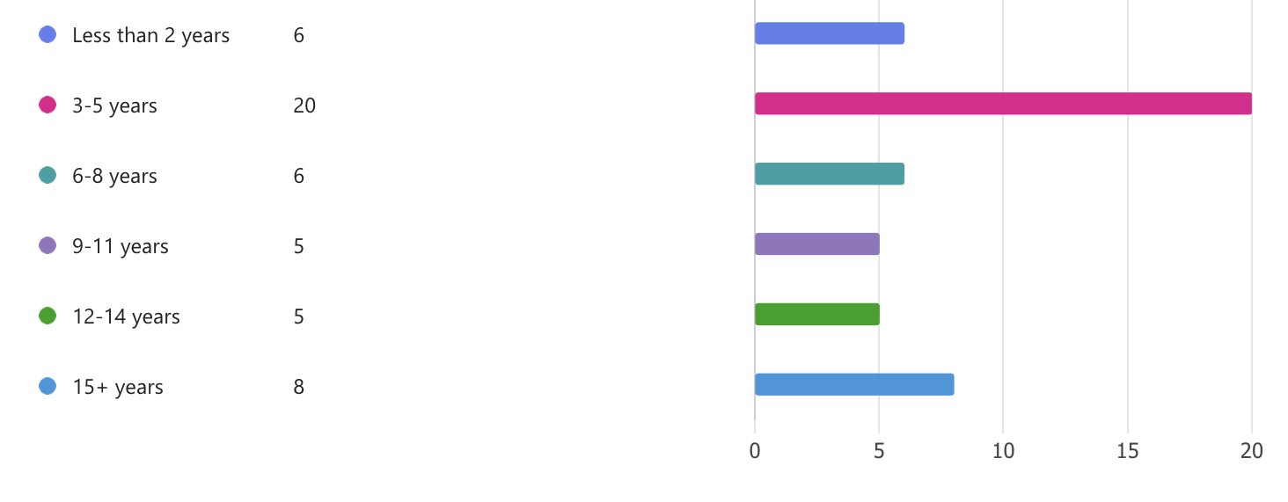

4.3.2 Current role (rank or title)

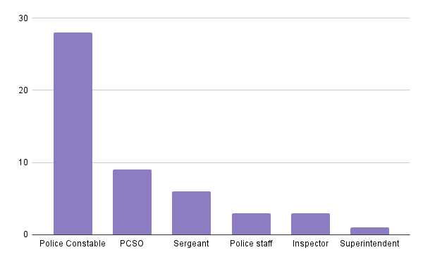

4.3.3 Geographical areas within the force

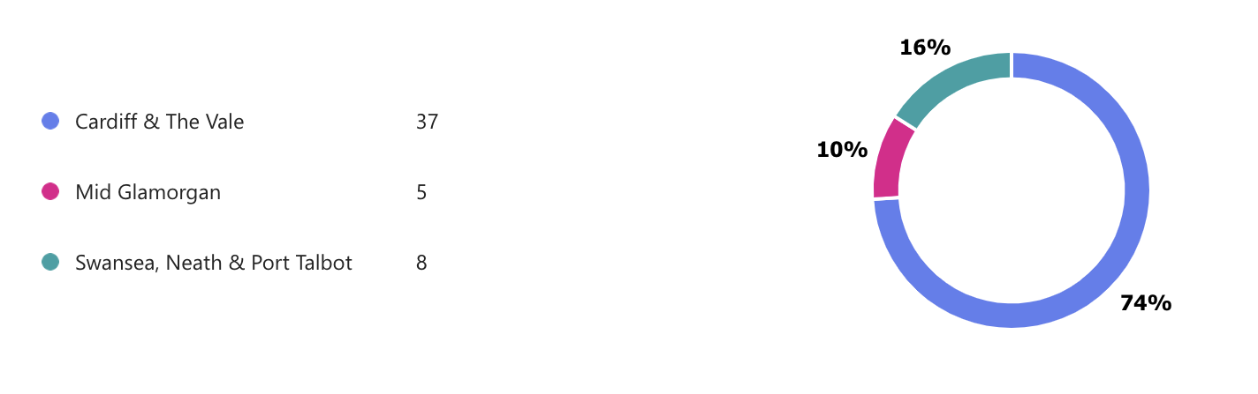

4.3.4 Do participants work in a knife crime specific team?

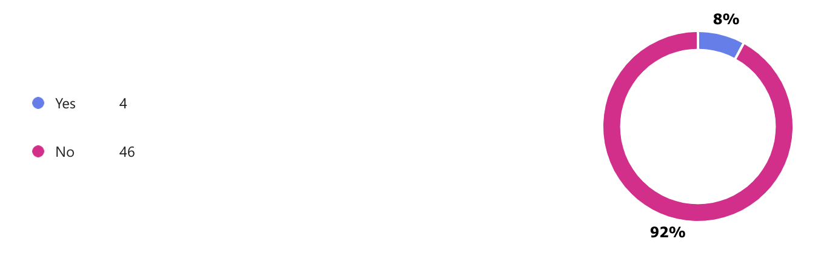
4.4 Questionnaire Findings

4.4.1 The rise in youth knife crime

From your own experience at work, do you think that there has been a rise in youth knife crime in recent years?
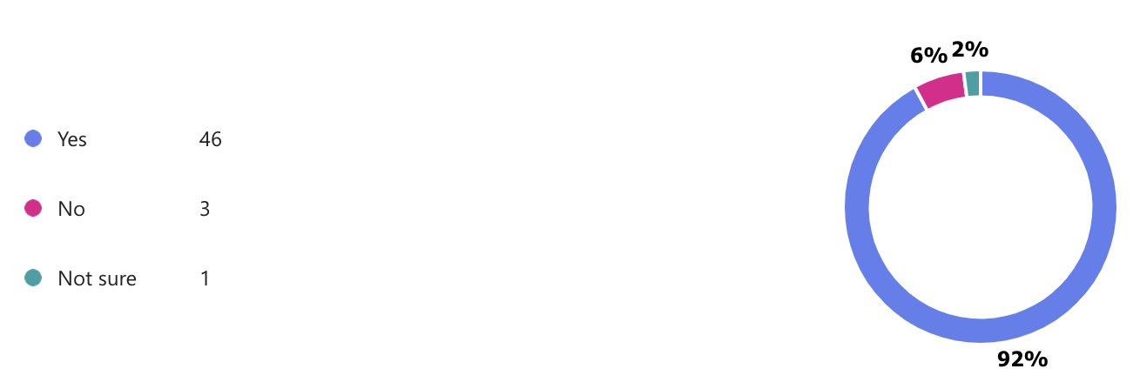

Those who answered ‘no’ included a Superintendent who works in a knife crime specific team and two Constables who don’t work with knife crime. The ‘not sure’ response was a member of police staff. The overwhelming majority of respondents do think that there has been a rise in knife crime in recent years. Most of these respondents are not senior officers, and are therefore more likely to be working on the front line of policing or within the community.

4.4.2 The reporting of youth knife crime

Do you believe that youth knife crime is underreported?

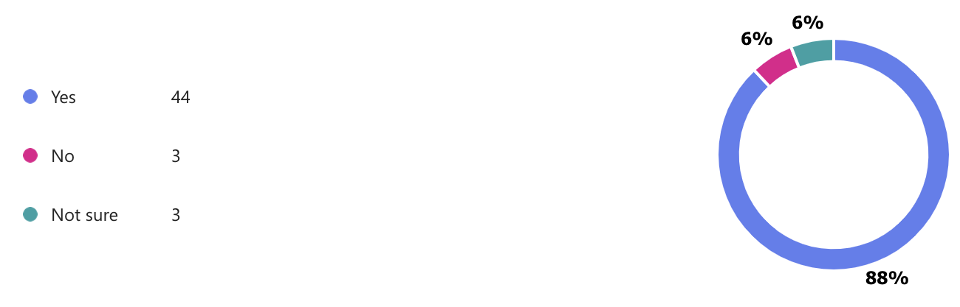

A Superintendent, a Sergeant and a Constable responded that they don’t think that knife crime is underreported, with two PCs and a PCSO answering ‘not sure’. However, 44 out of the 50 respondents do think that youth knife crime is underreported. This mirrors the finding in Bullock, et.al, (2023) that youth knife crime is underreported and that therefore data on youth knife crime could be missing.

4.4.3 Socio-economic factors

Do you believe that young people from lower socio-economic backgrounds are more likely to be involved in knife crime, either as a perpetrator or as a victim?
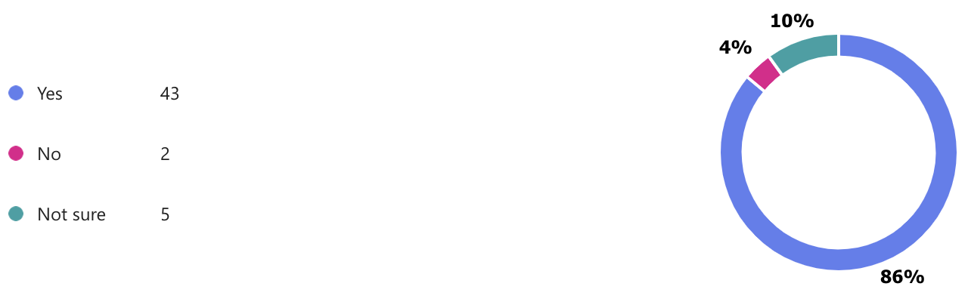

This perception of the majority of respondents that young people from lower socio-economic backgrounds are more likely to be involved in knife crime is reflected in many of the studies reviewed in the literature review chapter. Poverty and deprivation are listed as factors that contribute to the increase in youth knife crime, and this is especially seen in Sue Roberts’s book (2021).

4.4.4 Demographics involved in youth knife crime

From your own experience at work, what age range do you believe is most affected by youth knife crime (as perpetrators or as victims)?
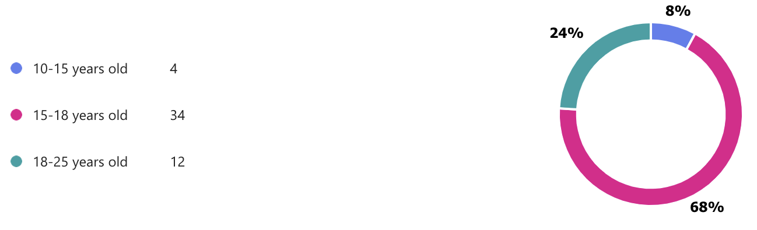

These results show that the perception is that the age range most affected are between 15-18 years old. This is also reflected later in the survey where some respondents note that they believe that there is a lack of youth provision for older teens and school leavers.

4.4.5 The availability of youth services or provision

86% of respondents believe that there is a lack of youth services or provision for young people. Many of the answers included the belief that cuts to youth services mean that there are fewer opportunities to divert young people away from crime and exploitation. There is the perception that there is a lack of free youth services, or opportunities for young people who aren’t sporty. Some commented that the lack of funding means that any existing provision is concentrated in only the most deprived communities, or that provision is aimed at younger children, leaving a gap for older teenagers. The closure of youth clubs was mentioned multiple times. 10% of respondents don’t believe that there is a lack of youth services, with one claiming that there is enough provision, but not enough take-up. 4% weren’t sure.

4.4.6 The possible effects of cuts to youth services on youth knife crime levels

66% believe that cuts to youth services over the past 10 years have contributed to a rise in youth knife crime. Different factors are mentioned, including fewer safe spaces available to young people, which leaves them open to exploitation by criminal gangs, leading to knife crime. There are fewer opportunities for young people to develop skills for future employment, and cuts have led to fewer positive role models for youths in the community.
16% believe that cuts haven’t contributed to a rise. Some responded that carrying a knife is a personal choice that can be influenced by popular culture and glorification of gangs. 18% weren’t sure, but pointed to a larger failing, e.g. education, social services, local government, social media companies and parents.

4.4.7 Contributing factors in the rise of youth knife crime

45 of the 50 participants responded to this optional question. Those who don’t believe that there has been a rise in youth knife crime were instructed to move on to the next question. Other contributing factors to the rise in youth knife crime mentioned here include the use of social media, carrying a knife to fit in, drug use, concerns for their own safety, exploitation by organised crime gangs, difficult family life and upbringing, cost of living crisis and poverty. It was also mentioned that the punishment for underage knife offenders is not strong enough to be a deterrent, as offenders are treated as children rather than as criminals.

4.4.8 The reasons young people carry knives

The overwhelming responses to this question was that young people carry knives for protection and for status and reputation. This was found in the literature review where Tribe, et al., (2018) discuss the ‘fear factor’ that drives young people to carry knives for their own protection. Also mentioned were the influence of social media and media coverage of youth knife crime. The rise in social media use is mentioned by Roberts (2021) as another factor associated with youth knife crime.

4.4.9 Media depiction of youth knife crime

66% of respondents answered that the media depiction of youth knife crime does not give an accurate reflection of the levels of youth knife crime. Some noted that youth knife crime is underreported in the media, particularly outside of London, or that the media only report when there has been a fatality. One respondent claimed that ‘the reality is well hidden, I think the public would be shocked if they knew how frequently and what type of knives were being taken off people in their communities.’
Others stated that the reason the media report on youth knife crime is because it gets more clicks online. It was noted that knife crime doesn’t just involve gangs, and that the media often stereotype child knife carriers as ‘hoody wearing hoodlums’. 10% believe that it does give an accurate reflection, with the news always covering knife crime involving those under 18 years old. 24% were unsure, gave unclear answers, or believe that it is accurate up to a point, e.g. one participant stated ‘The often described stereotype of youths involved in drugs carrying knives holds weight but you can also find others who carry knives.’

5. Conclusion

In conclusion, based on the responses in the survey, the police perception is that there is a link between the cuts to youth services and the rise in youth knife crime. It is clear that the police perception is that youth knife crime is both rising and underreported. There is also a strong perception that there is a lack of provision and safe spaces for young people, which means that they are at risk of getting involved in crime and being exploited by gangs, which leads to knife carrying.

Chapter 5 - Conclusions and Recommendations

5.1 Introduction

Following the previous chapters of this dissertation, which looked at existing research, outlined how this research would be conducted, and then presented the results, this chapter will draw conclusions and make recommendations. This chapter will also look at possible topics in this field for further research.

5.2 Main Findings

The main findings of this research is that 92% of police officers and staff responded that they believe that there has been a rise in youth knife crime, and 66% of respondents believe that cuts to youth services over the past 10 years have contributed to a rise in youth knife crime. Even though the majority of respondents believe that the cuts have contributed to the rise, other key factors were also mentioned, including the role of social media, unstable home life and lack of positive role models, and systematic failures within education, social services and local authorities. Other policing or criminal factors are also mentioned, such as weak sentencing of juveniles, the reduction in the use of stop and search and the rise of county lines activity.
The findings show that there is a clear perception among police officers and staff that there is a lack of provision and services for young people, particularly a lack of free activities. Despite the overwhelming perception that the cuts have contributed to the rise in youth knife crime, some respondents answered that they believe that there is enough youth provision, but that there isn’t enough take up, or that what is offered may not be of interest to young people. In terms of the rise in youth knife crime, social media and street cred or image seem to be big factors in why young people carry knives, but there is also a clear perception that young people carry knives because they are afraid for their own personal safety.

5.3 Recommendations

The first recommendation is the need for large-scale investment in youth services. YMCA reported that in 2022 funding cuts to youth services had reached £1.1 billion (YMCA, 2022), and that since 2010/11, youth services including youth clubs and youth workers have been cut by 69%, with more than 4,500 youth work jobs lost and 750 youth centres closed. A lack of free or affordable activities for young people can mean that young people in poorer or deprived areas cannot access youth provision.
The second recommendation, which is closely linked to the first recommendation, is that young people need safe spaces and trusted role models. The closure of so many youth clubs has taken away potential safe spaces for young people, where they could encounter service providers and role models. Young people with nowhere to go are vulnerable to exploitation by organised crime gangs, and it is becoming increasingly difficult to keep vulnerable children safe outside school due to cuts to youth support and other public services in local areas, and problems recruiting enough school support staff due to low pay (The Guardian, 2022).
The third recommendation is the need for national and local governments to look at what provision is needed for older teens and school leavers, specifically regarding future opportunities and employment. It is important to provide guidance and role models to ensure that young people at risk of falling into criminal activity are given the tools necessary to enter the workforce.
The fourth recommendation is the need for greater support and advice for parents and guardians. More education is needed for parents and guardians in order to safeguard their young people, and also advice and information regarding the threats and danger that can come through social media.

5.4 Limitations

The aim of this work was to research the police perception of the effect of cuts to youth services on the rise in youth knife crime. The main limitation of this research has been the number of officers who work in knife crime related teams who responded to the survey. Although the research benefits from the perception of a wide range of police officers and staff, only four of the 50 respondents to the survey work in a knife crime specific team. The responses of a larger sample of knife crime specific officers could have been used more effectively to compare with the responses and perceptions of officers and staff who do not work in a knife crime specific team.
Another limitation is the size and scope of the research. The fact that this is an undergraduate dissertation with a word count of 8,000 words, where the researcher also works full time alongside studying, means that the scope of the research had to be limited. The result is that only police officers and staff in one police force were surveyed. To gain a better understanding of the effect of cuts to youth services on the rise in youth knife crime, it would be better to survey officers and staff from different police forces across Wales or the UK.

5.5 Further Research

The review of the existing literature, and this research itself has highlighted that there is a gap in in-depth research into the links between cuts to youth services and youth knife crime. This research concentrates on the police perception of the issue, as it would be extremely difficult to research the links between the cuts and the rise in youth knife crime in an undergraduate dissertation of 8,000 words. Further research could look into whether or not cuts to youth services have contributed to a rise, by surveying or studying a wider range of stakeholders, such as young people, community leaders, youth workers, teachers and police officers. Such research would need much more time and resources for a comprehensive view of the subject matter.
In terms of police perception, further research could target the views and experiences of knife crime officers exclusively. It was difficult to get enough knife crime officers to complete the survey for this study, but this research was also designed to survey different police officers and staff from across South Wales Police. A few survey respondents noted in their answers that there was low uptake for existing youth provision, and that perhaps young people weren’t interested in what was being offered. Therefore, it may be valuable for this area of study to have research regarding the reasons for possible low take up of existing provision, and whether or not existing extracurricular provision is fit for purpose and is of interest to the young people it is intended to target.

5.6 Conclusions

To conclude, this dissertation has achieved the objective of researching the police perception of the link between cuts to youth services and an increase in youth knife crime. There is a strong perception within the police that there has been a rise in youth knife crime, and that this rise has been affected by the cuts to youth services. The research has also highlighted other factors that have contributed to the rise in youth knife crime. It is important to note that further research into these other factors is needed in order to gain a better understanding of the reasons for youth knife crime, but it is also essential that more money is invested in youth services to tackle youth crime, to better protect young people, and to give them hope for the future.

Bibliography

Brenner, E. (2022) ‘Youth Knife Crime in London and Croydon: A Data and Literary Analysis’, Contemporary Challenges: The Global Crime, Justice and Security Journal, vol. 3, pp. 118-136. Available at: https://doi.org/10.2218/ccj.v3.6994

Brown, E.L., Ware, G. and Cassimally, K.A. (2019) Knife crime: causes and solutions – editors’ guide to what our academic experts say. The Conversation. Available at: https://theconversation.com/knife-crime-causes-and-solutions-editors-guide-to-what-our-academic-experts-say-113318 Accessed: 31 January 2024

Booth, R. (2024) ‘Teenagers ‘crying out’ for return of youth clubs in England, study finds’, The Guardian, 30 June. Available at: https://www.theguardian.com/uk-news/2022/dec/10/county-lines-gangs-cost-of-living-crisis Accessed: 30 June 2024.

Bullock, K. et al., (2023) ‘Police practitioner views on the challenges of analysing and responding to knife crime’, Crime Science 12, article 2. Available at: https://doi.org/10.1186/s40163-022-00180-1

Densley, J., Deuchar, R., & Harding, S. (2020) ‘An Introduction to Gangs and Serious Youth Violence in the United Kingdom’. Youth Justice 20, issues 1-2, pp. 3-10. Available at:
https://doi.org/10.1177/1473225420902848

Haylock, S. et al., (2020) ‘Risk factors associated with knife-crime in United Kingdom among young people aged 10–24 years: a systematic review’, BMC Public Health 20, article 1451. Available at: https://doi.org/10.1186/s12889-020-09498-4

HM Government (2018) Serious Violence Strategy. Available at: https://assets.publishing.service.gov.uk/media/5acb21d140f0b64fed0afd55/serious-violence-strategy.pdf Accessed: 25 January 2024

Home Office (2020) Violence Reduction Unit Interim Guidance. Available at: https://assets.publishing.service.gov.uk/media/5e7de2cfe90e0706ef2db559/12VRU_Interim_Guidance_FINAL__003_2732020.pdf Accessed: 25 January 2024

Local Government Association (no date) Re-thinking local: youth services. Available at: https://www.local.gov.uk/about/campaigns/re-thinking-local/re-thinking-local-children-and-young-people/re-thinking-local Accessed: 1 February 2024

Mardiana, Siti. (2020). ‘Modifying Research Onion for Information Systems Research’, Solid State Technology, 63(4), pp. 1202-1210. Available at:
https://www.researchgate.net/publication/359542575_Modifying_Research_Onion_for_Information_Systems_Research

Melnikovas, A. (2018) ‘Towards an Explicit Research Methodology: Adapting Research Onion Model for Futures Studies’, Journal of Futures Studies, article 23 (December), pp.29-44. Available at: https://jfsdigital.org/articles-and-essays/2018-2/towards-an-explicit-research-methodology-adapting-research-onion-model-for-futures-studies/

Ofsted (2019) Ofsted Research on Knife Crime: Safeguarding Children and Young People in Education. Available at: https://assets.publishing.service.gov.uk/government/uploads/system/uploads/attachment_data/file/785055/Knife_crime_safeguarding_children_and_young_people_110319.pdf

Palinkas, L.A. et al., (2015) ‘Purposeful Sampling for Qualitative Data Collection and Analysis in Mixed Method Implementation Research’. Adm Policy Ment Health, 42(5), pp. 533-544. Available at: https://doi.org/10.1007/s10488-013-0528-y

PHD Dissertation (2023) What is Research Onion? Easy explanation for research beginners! Available at: https://www.phddissertation.co.uk/blog/what-is-research-onion-easy-explanation-for-research-beginners/#:~:text=The%2520Research%2520Onion%2520framework%2520provides%2520a%2520structured%2520and,layer%2520representing%2520a%2520different%2520aspect%2520of%2520the%2520research Accessed: 16 March 2024.

Ramsberg, N. (2018), ‘Research Methodology’, Medium, 3 April. Available at: https://medium.com/ma-leading-design/research-methodology-45871a6e4cc7 Accessed: 18 March 2024.

Reilly, JJ., Naumann, D.N., Morris, L. et al., (2023) ‘Injury by knife crime amongst children is associated with socioeconomic deprivation: an observational study’, Pediatric Surgery International 39, article 8. Available at: https://doi.org/10.1007/s00383-022-05298-6

Roberts, S. (2021) Solutions to Knife crime: A path through the red sea? Wilmington: Vernon Press.

Saunders, M.N. et al., (2019) ‘Research Methods for Business Students’ Chapter 4: Understanding research philosophy and approaches to theory development, pp.128-171. Available at: https://www.researchgate.net/publication/330760964_Research_Methods_for_Business_Students_Chapter_4_Understanding_research_philosophy_and_approaches_to_theory_development

Thompson, Naomi and Woodger, David (2020). Young people need youth clubs. A needs analysis in a London borough. Available at: https://research.gold.ac.uk/id/eprint/28431/3/Thompson%2C%20NT%20and%20Woodger%2C%20YP%20%282020%29final_AAM.pdf

Tribe, H.C., Harris, A. & Kneebone, R. (2018) ‘Life on a knife edge: using simulation to engage young people in issues surrounding knife crime’, Advances in Simulation 3, article 20. Available at: https://doi.org/10.1186/s41077-018-0079-0

UNISON (2019). Youth Services at Breaking Point. Available at https://www. unison.org.uk/content/uploads/2018/12/Youth-services-report.docx Accessed: 25 January 2024

Williams, E. (2023) ‘Policing the Crisis in the 21st Century; the making of “knife crime youths” in Britain’, Crime Law and Social Change. Available at:
https://doi.org/10.1007/s10611-023-10089-8

YMCA (no date) We believe in Youth Services. Available at: https://www.ymca.org.uk/youth-services-campaign Accessed: 26 January 2024

YMCA (2020) Almost a billion-pound decline in funding for youth services by local authorities across England and Wales. Available at: https://www.ymca.org.uk/outofservice Accessed: 26 January 2024

YMCA (2022) Devalued. Available at:
https://www.ymca.org.uk/wp-content/uploads/2022/02/ymca-devalued-2022-1.pdf Accessed: 26 January 2024

YMCA (2022) Devalued by a decade of cuts, dramatic fall in spend per head and a debilitating postcode lottery: the latest picture of youth service funding. Available at: https://www.ymca.org.uk/latest-news/devalued-by-a-decade-of-cuts-dramatic-fall-in-spend-per-head-and-a-debilitating-postcode-lottery-the-latest-picture-of-youth-service-funding Accessed: 26 January 2024

YMCA (2024) On the Ropes. Available at: https://www.ymca.org.uk/wp-content/uploads/2024/02/ymca-on-the-ropes-report-A4.pdf Accessed: 2 May 2024

Youth Justice Board for England and Wales (2024) Youth Justice Statistics: 2022 to 2023. Available at: https://www.gov.uk/government/statistics/youth-justice-statistics-2022-to-2023/youth-justice-statistics-2022-to-2023-accessible-version#main-points Accessed: 3 May 2024

Appendices

Appendix 1: Research onion

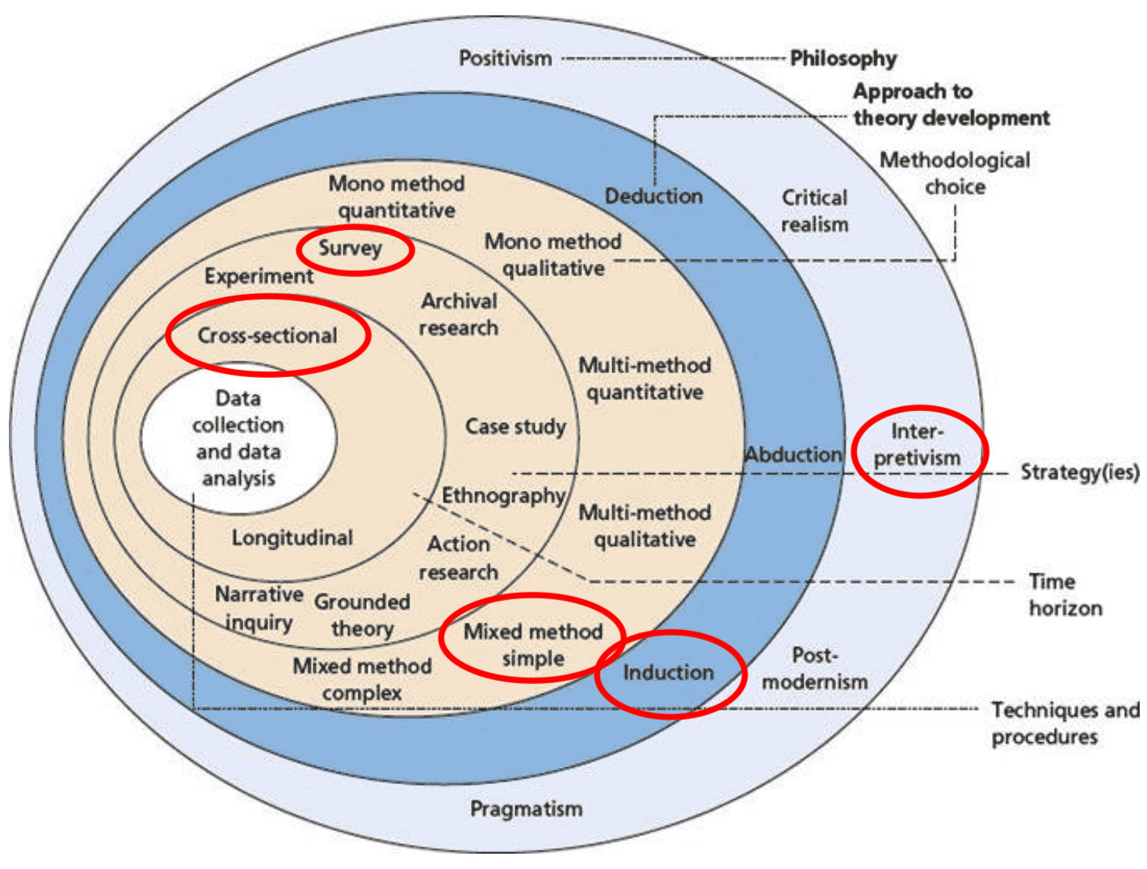
Figure 3.0.1 - Annotated diagram The Research Onion (Source: Saunders, Lewis & Thornhill, 2019)

Appendix 2: Copy of survey

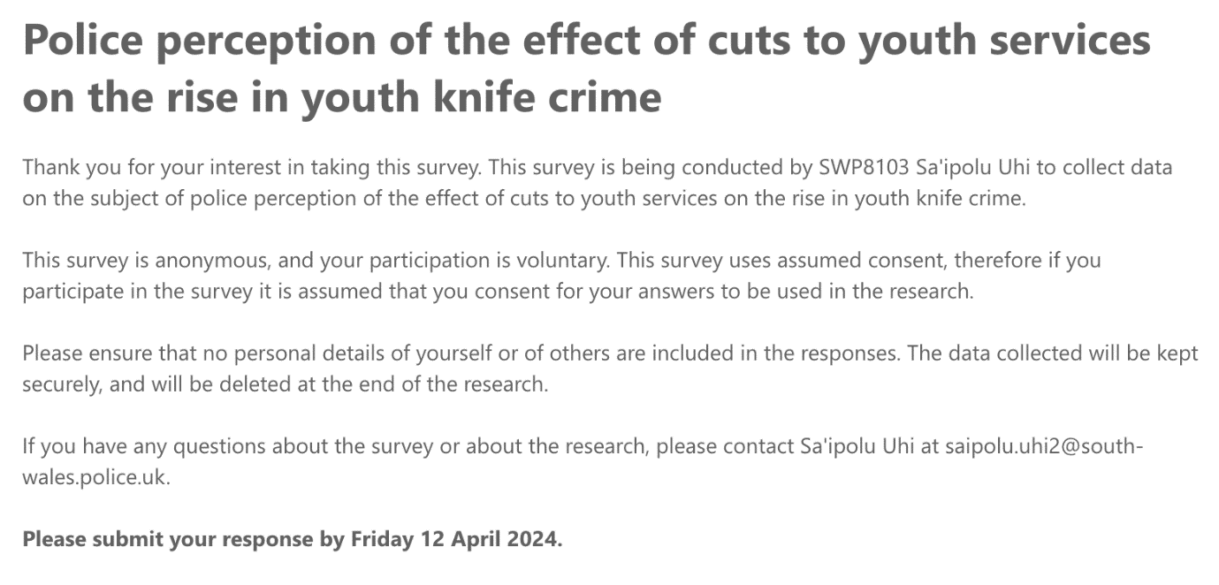

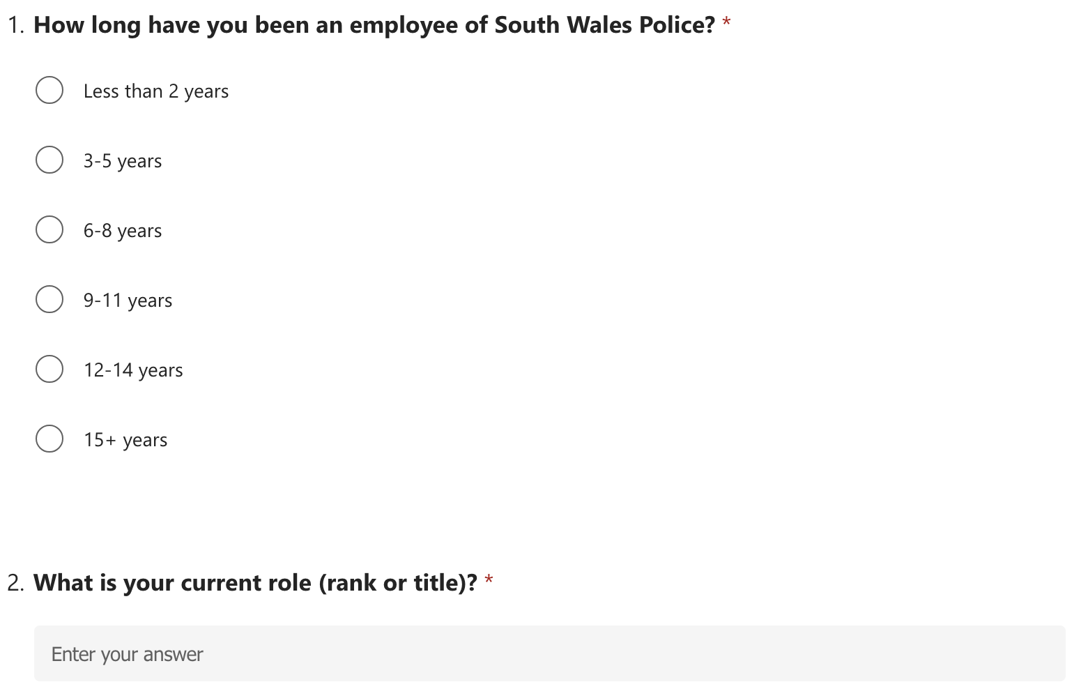

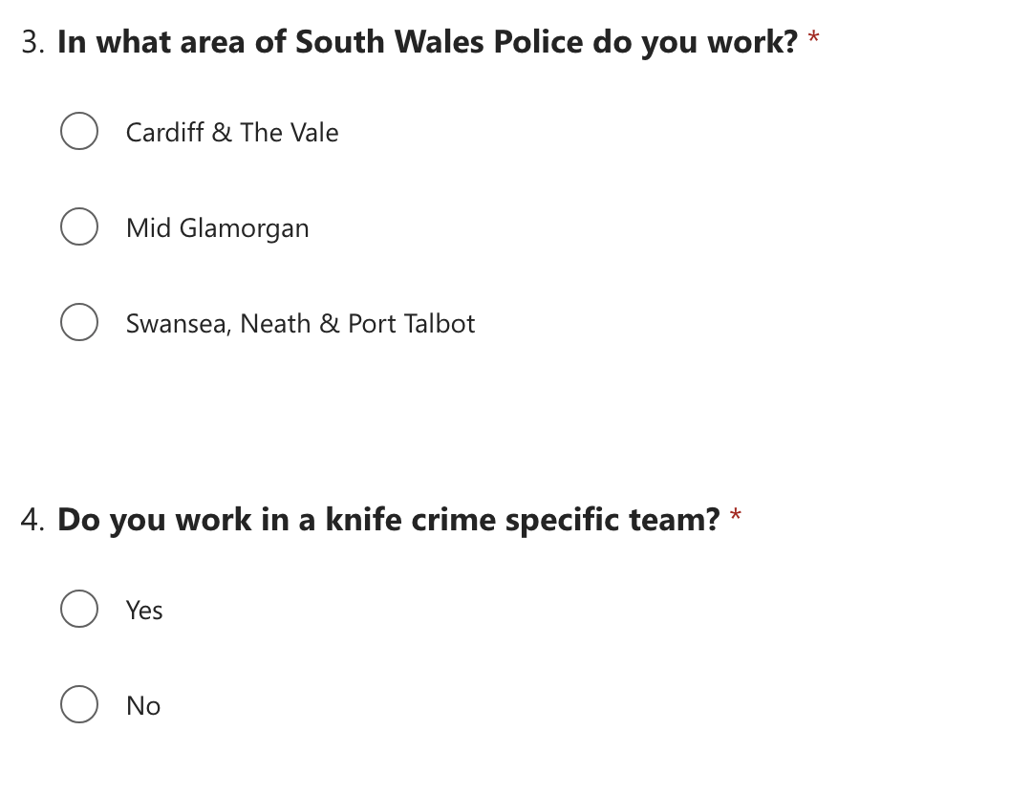

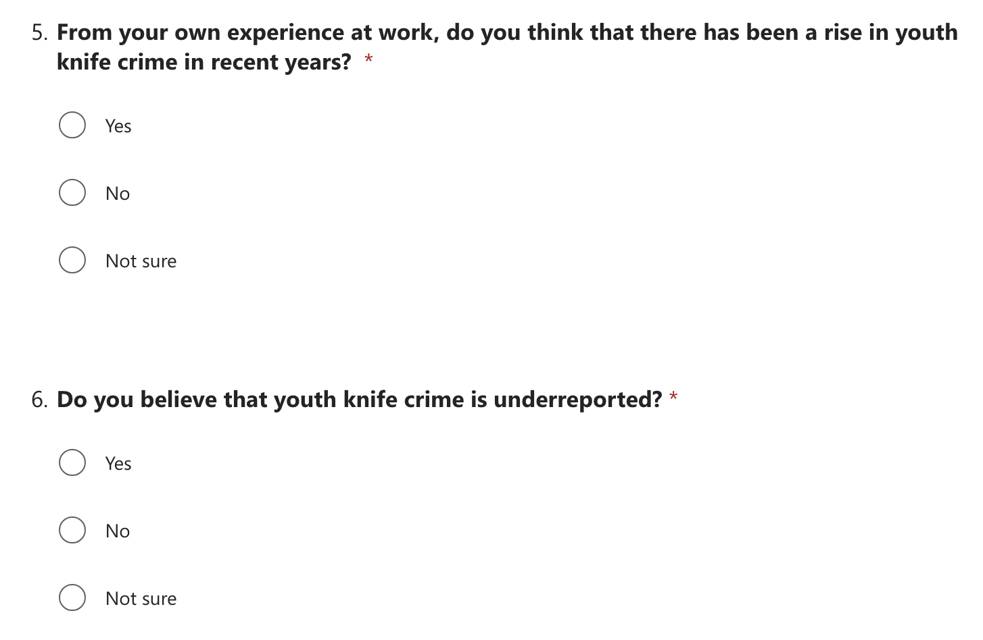

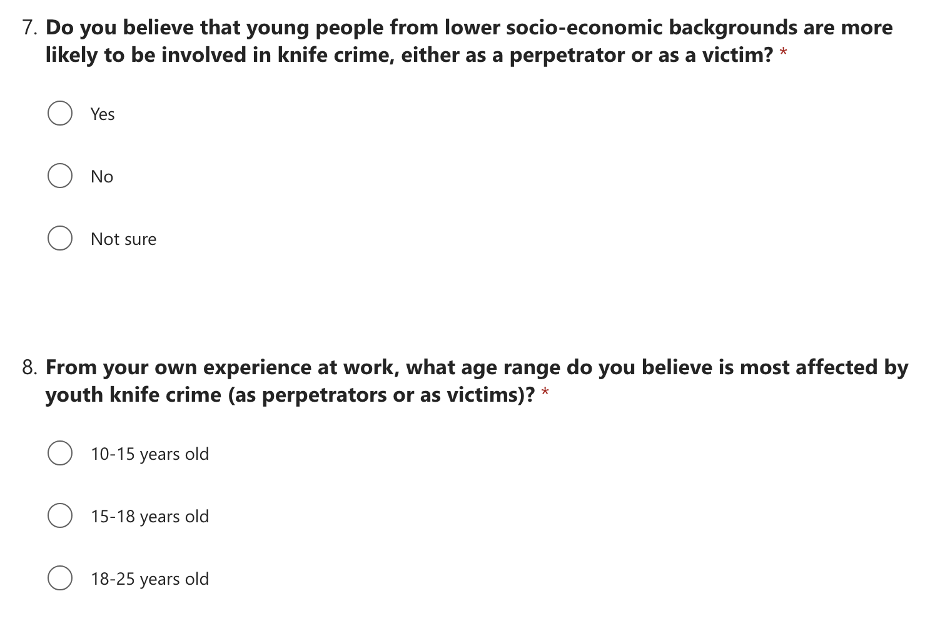

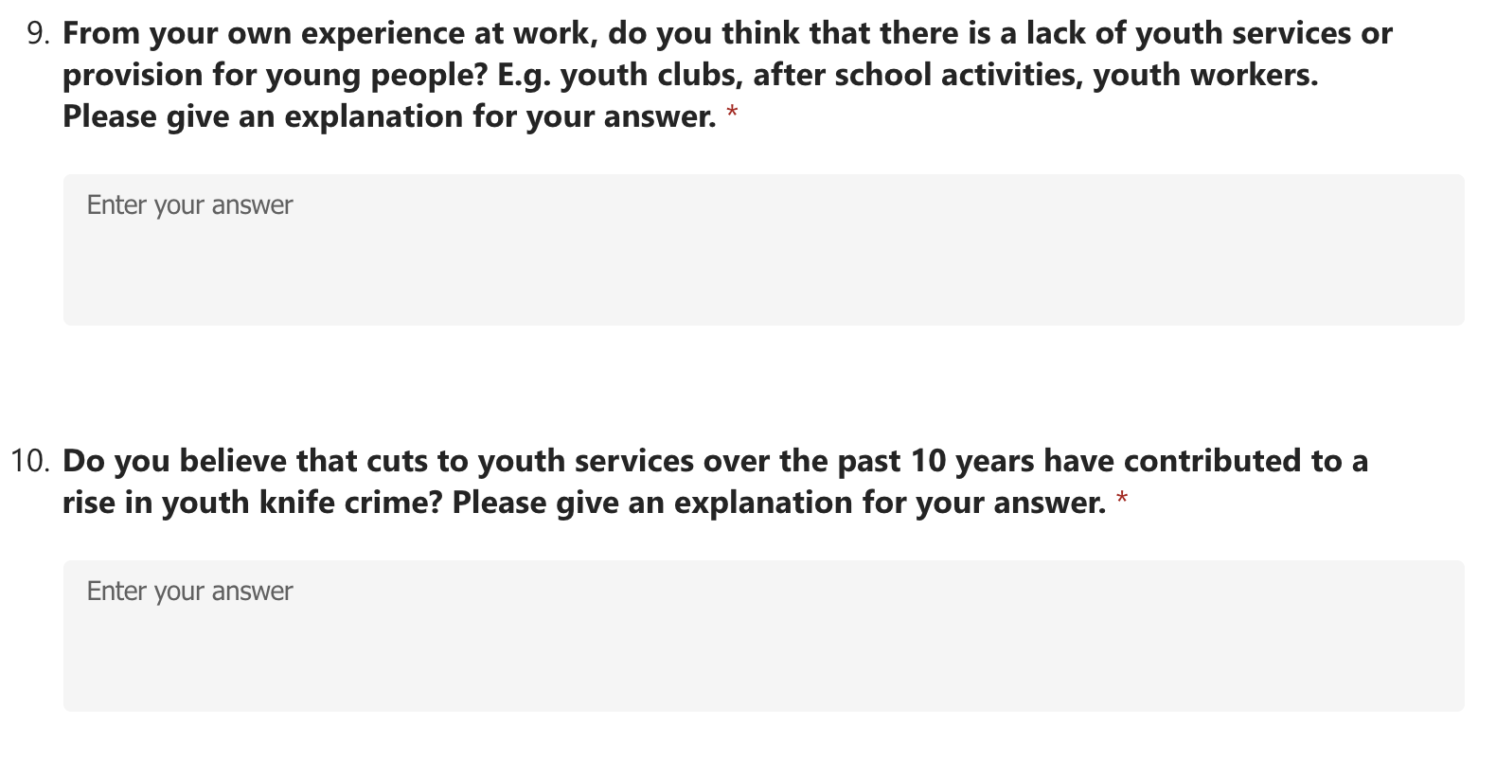

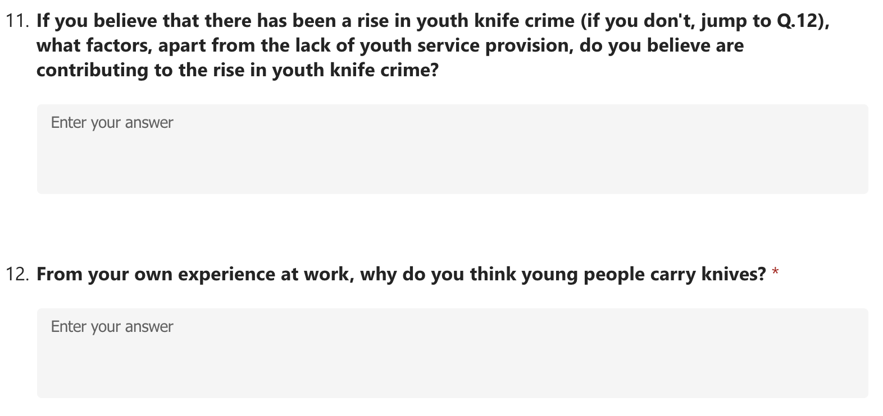

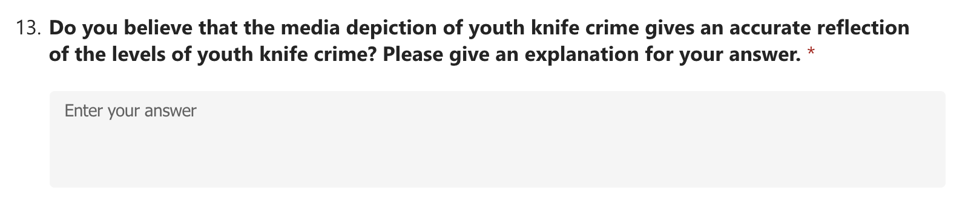

Appendix 3: Survey responses



