TASK 1
Q1: Hypervisor
Normally hypervisor divide into two kinds.

Type I: native or bare metal hypervisors
These hypervisors run directly on the host's hardware to control the hardware and manage the guest operating system.[1]

Feature:
Requires hardware support,
The virtual machine monitor serves as the primary operating system,
High operating efficiency.

Example:
VMware ESX server version, Xen 3.0 and later, Virtual PC 2005, KVM

Hardware requirement:
Server-level hardware that supports hardware-assisted virtualization technologies, such as Intel VT-x or AMD-V, is usually required.[1]

Type II: or hosted hypervisors
These hypervisors run on a traditional operating system, just like any other computer program[1]

Features:
The virtual machine monitor runs as an application within the main operating system environment,
The operating efficiency is generally lower than type I.

Example:
VMware workstation, earlier than Xen 3.0, Virtual PC 2004, Virtual Box.
Hardware requirement:
it can run on a common personal computer, but performance is limited by the hardware resources of the host operating system. [1]

Complexity for IT:
A Type 1 hypervisor is the functional OS and focal point of the system typically installed on an enterprise-class server with the intention of creating and hosting multiple VMs. This requires comprehensive knowledge of the Type 1 hypervisor and detailed server management and administration. [2]

A Type 2 hypervisor takes the form of a more traditional end-user application that can be installed and operated on simpler systems by less technical staff, though a solid knowledge of creating and managing Type 2 VMs is still highly recommended. [2]

VM security.
Type 1 hypervisors provide excellent security by invoking high levels of logical isolation between VMs -- no resources or services are shared between VMs. A security breach in one VM doesn't place other VMs at risk. [2]

Type 2 hypervisors support a good logical isolation, but the shared host OS poses a common threat. [2]

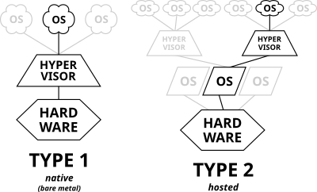
Figure 1 [1]

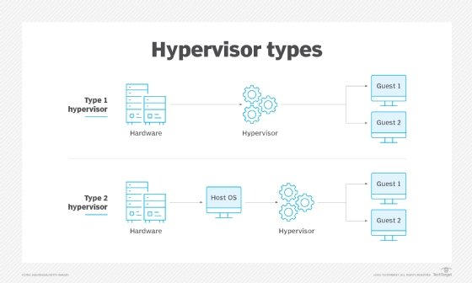
Figure 2 [2]

Q2 IP addressing

Transmitted packet

Suppose that the two computers are in different Lans, that is, the case of routing and forwarding. Data packets are encapsulated between two computers and then transmitted by the computer to the switch, and then the switch forwards it to all ports for inquiry.

If the MAC address is matched, the forwarding succeeds. If the matching fails, the receiving port discards the data frame and gives up processing. Currently, the data is passed to the router. After receiving data, the router decapsulates the destination IP address to check whether the destination IP address is in the local routing table. Router 1 queries the routing table, determines that the packet is encapsulated, and sends it from the specified serial interface.

After the packet arrives at router 2, the router unseals the packet again and queries the destination address. A switch in a Vlan queries the MAC address table based on the destination MAC address in a data frame and sends the bit stream from the corresponding port. Then the switch sends the bit stream to the target PC. [3]

In general, the act of data delivery is like the mail delivery of documents, the post office needs to know the mail address, mailing address and postcode number of the letter to send the document or package to the specified address.
Therefore, when the data is transmitted, the engineer encapsulates the information into a package to form a packet. At the same time, to ensure that each device on the network can be uniquely identified, the source MAC address and destination MAC address are separately encapsulated in the packet header.[4]
Switches and routers will decide how best to forward packets. IP addresses ensure that data can be transmitted accurately between network devices. Unlike MAC addresses, IP addresses are used for logical addressing and routing, so that data packets can be transmitted between different networks. While MAC addresses are used for physical addressing and local network communication, MAC addresses ensure that data frames can be correctly delivered within the same LAN.

IPv4 & IPv6

A: IP addresses contain two parts: a network identifier and a host identifier. The network ID specifies an area of the network where a device resides, much like an area code identifies a section of a telephone network. The host ID labels a specific device in that network section, like how a telephone number identifies a specific phone within an area code.

IPV4:
IPv4 addresses may be represented in any notation expressing a 32-bit integer value. They are most often written in dot-decimal notation, which consists of four octets of the address expressed individually in decimal numbers and separated by periods.[5]
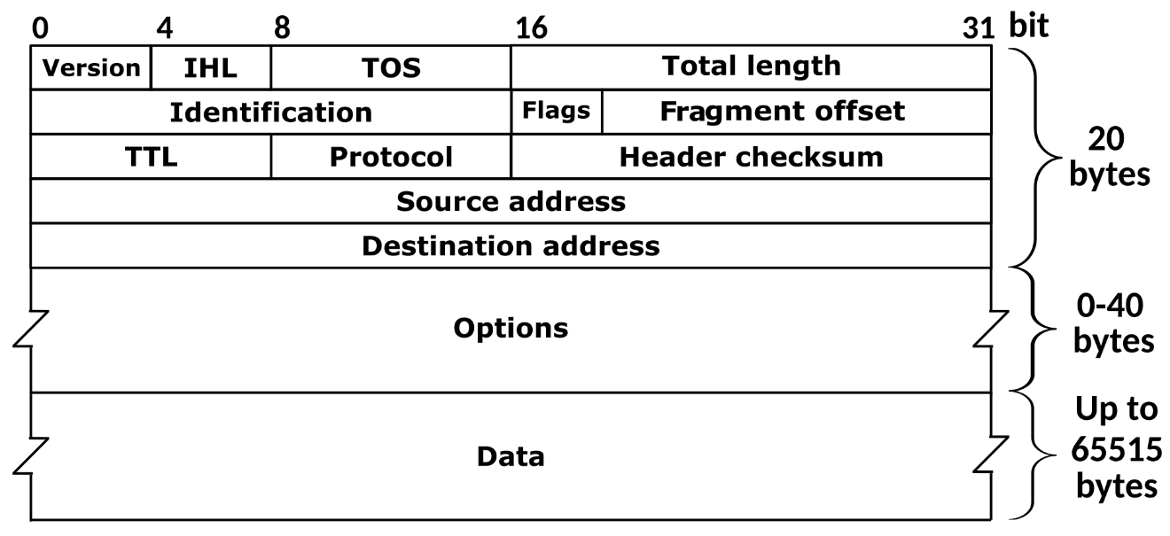
Figure 3 [5]
IPV6:
An IPv6 address is 128 bits long. These 128 bits are usually written down as eight groups of four hexadecimal digits. Hexadecimal means it be used numbers 0-9 and letters A – F to represent values [6]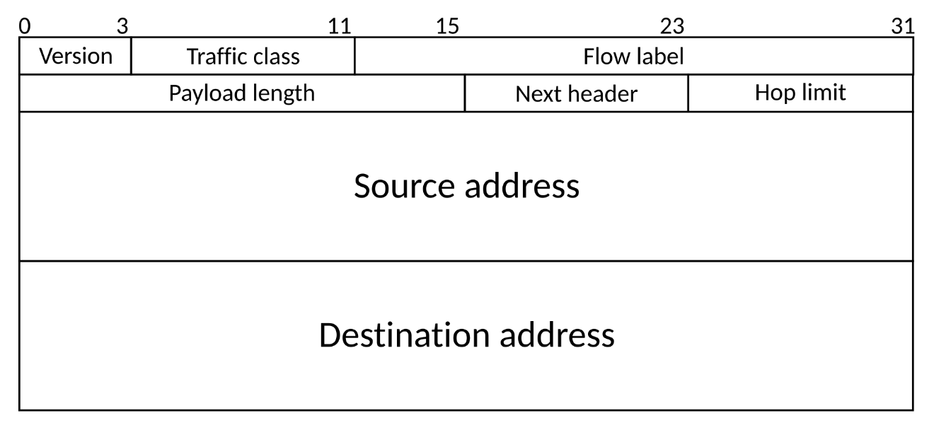
Figure 4 [6]

Routing

Concept: A routing protocol specifies how routers communicate with each other to distribute information that enables them to select paths between nodes on a computer network. [7]

How it works: Routers perform the traffic directing functions on the Internet; data packets are forwarded through the networks of the internet from router to router until they reach their destination computer. Routing algorithms determine the specific choice of route. Each router has a prior knowledge only of networks attached to it directly. A routing protocol shares this information first among immediate neighbors, and then throughout the network. This way, routers gain knowledge of the topology of the network. The ability of routing protocols to dynamically adjust to changing conditions such as disabled connections and components and route data around obstructions is what gives the Internet its fault tolerance and high availability.[7]

Static route and dynamic route
Static route: Manually configured by the network administrator. The path is fixed and does not update automatically. It has the advantages of simple configuration, low resource consumption, and high security, and is suitable for small or topologically stable networks. However, static routes lack the flexibility to automatically adapt to network changes. [8]
Dynamic routing: Automatically learns and updates the routing table through routing protocols, such as RIP, OSPF, EIGRP, and BGP. It can respond quickly to network changes and is suitable for large complex networks. The advantages of dynamic routing are strong adaptability and scalability, but the configuration is complex and requires more resources. [8]
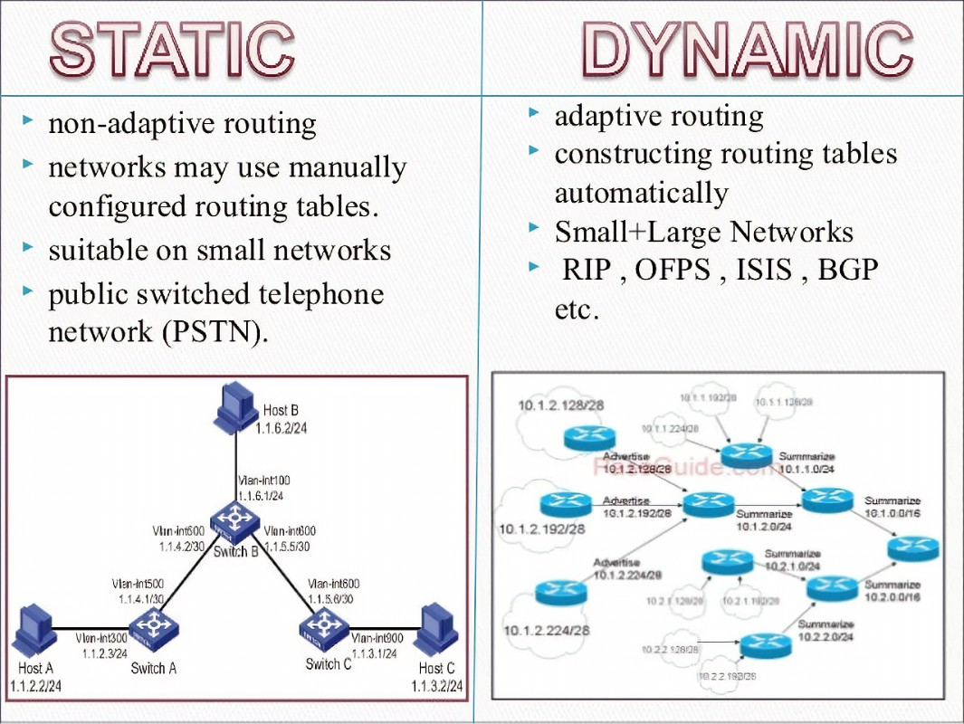
Figure 5 [9]

Application scenarios of static routes:
Small network: In a small office or home network, the network structure is simple and does not change much, and static routing is sufficient to meet the needs.

Specific path requirements: In some cases, it is necessary to ensure that packets are forwarded along a specific path, and static routing can provide this control.

Boundary routing: At the boundaries of the network, static routes can be used for connections to external networks to ensure that packets are forwarded correctly.

Application scenarios of dynamic routing:
Large enterprise networks: In large enterprise networks, the network structure is complex and often changes, and dynamic routing can automatically adapt to changes in network topology.

Internet Service Providers (ISPs): ISPs need to deal with a large amount of routing information, and the network topology changes frequently, dynamic routing is required.

Distributed network: In a distributed network environment, routing information needs to be dynamically exchanged between multiple sites to ensure that packets can be forwarded correctly.

Challenges:
By comparing the deployment scenarios of static routes and dynamic routes, we can see that although static routes and dynamic routes have their own advantages, they still face different risks in actual deployment scenarios.

Static route:
When the network changes or is faulty, a route cannot be selected automatically. As a result, the route may fail. At the same time, the network administrator in the company or organization must understand the structure and parameters of the entire network. Otherwise, the static route error may occur on the entire network due to manual configuration errors.[11]

Dynamic routing:
It is undeniable that dynamic routing will greatly reduce the consumption in labor costs, especially in maintenance, but the dynamic routing protocol will occupy the router CPU, memory, and link broadband, which will lead to a large consumption of network resources. In addition, dynamic routing will broadcast routing information, so it will also face security challenges.[10]

Network Services
VPN: A virtual private network (VPN) is a network architecture used to virtually extend a private network over one or more other networks that are either untrusted or require isolation. [12]

DHCP: DHCP is a network management protocol in an IP network that automatically assigns IP addresses and other communication parameters to devices connected to the network in a client-server architecture. This server is available for IPv4 and IPv6. [13]
AD DS: A domain controller is a server running the Active Directory Domain Services (AD DS) role. It authenticates and authorizes all users and computers in a Windows domain-type network, assigning and enforcing security policies for all computers and installing or updating software. [14]

CA: In cryptography, a certificate authority or certificate authority is an entity that stores, signs, and issues digital certificates. A digital certificate proves ownership of a public key through the specified subject of the certificate. This allows others to rely on signatures or assertions made on the private key corresponding to the authenticated public key. The CA acts as a trusted third party, trusted by both the owner of the certificate and the party that relies on the certificate in a format specified by the X.509 or EMV standard.

A particularly common use for certificate authorities is to sign certificates used in HTTPS, the secure browsing protocol for the World Wide Web. Another common use is for identity cards issued by national governments to sign documents electronically. [15]
TASK 2
Choose hypervisor

Reason: I chose to use Oracle VirtualBox as my hypervisor machine. Because it has unique advantages over other hypervisors. First, it is an open source and free virtualization software, supporting Windows, Linux, macOS and other operating systems, with a wide range of cross-platform compatibility, very in line with the equipment needs of this experiment. Second, VirtualBox's user interface is friendly and easy to use, suitable for individual users, developers, and small teams. In addition, it offers a wealth of features such as virtual hard drives, snapshots, shared folders, and USB support to cover all the requirements of this task. And in terms of performance, it is powerful enough for desktop and lightweight server virtualization scenarios. [16]

Screenshot for process

In this scenario, I have divided windows server and Windows client into Vlan1, Windows server and Debian Linux server into Vlan2, and Debian Linux server and Linux client into Vlan3. My experimental step is to make Vlan1 communicate first, and then make Vlan2 communicate with Vlan3 by configuring the Debian Linux server.
IP Addressing menu:
Windows services internal：192.168.10.1 255.255.255.192
Windows services external：200.200.2.1 255.255.255.0
Windows Client internal：192.168.10.61 255.255.255.192
Debian Linux services external：200.200.2.2 255.255.255.0
Debian Linux services internal：192.168.100.1 255.255.255.0
Debian Linux Client internal：192.168.100.2 255.255.255.0

- Install and configure the windows server 2022
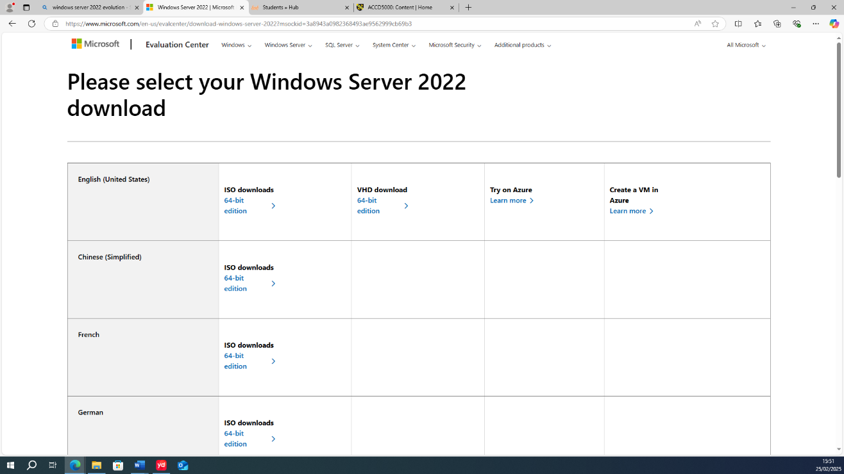
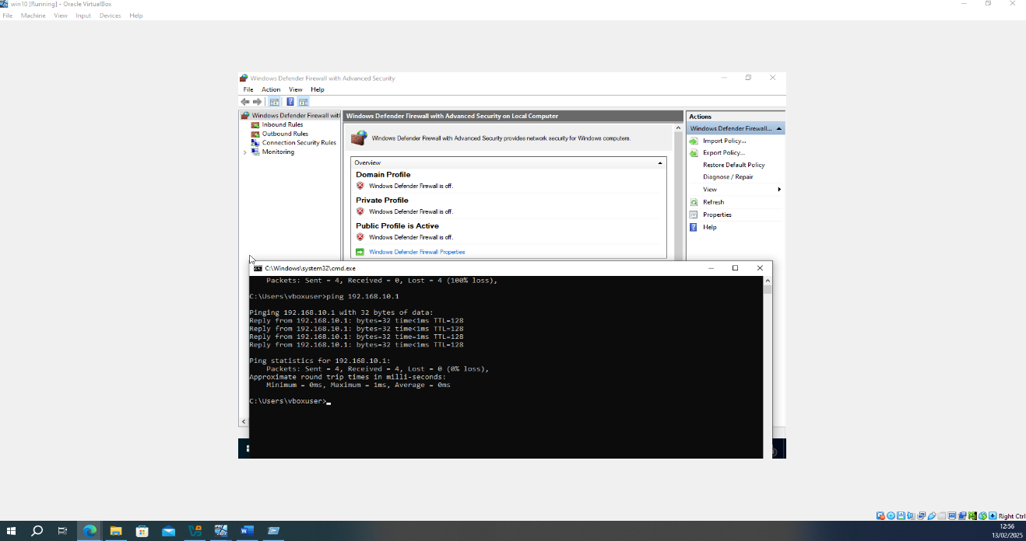
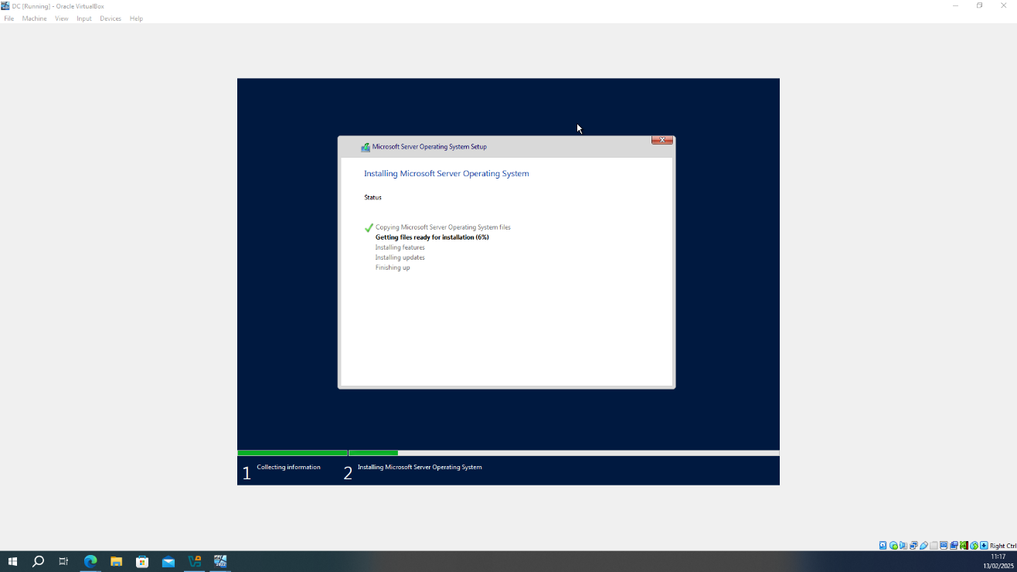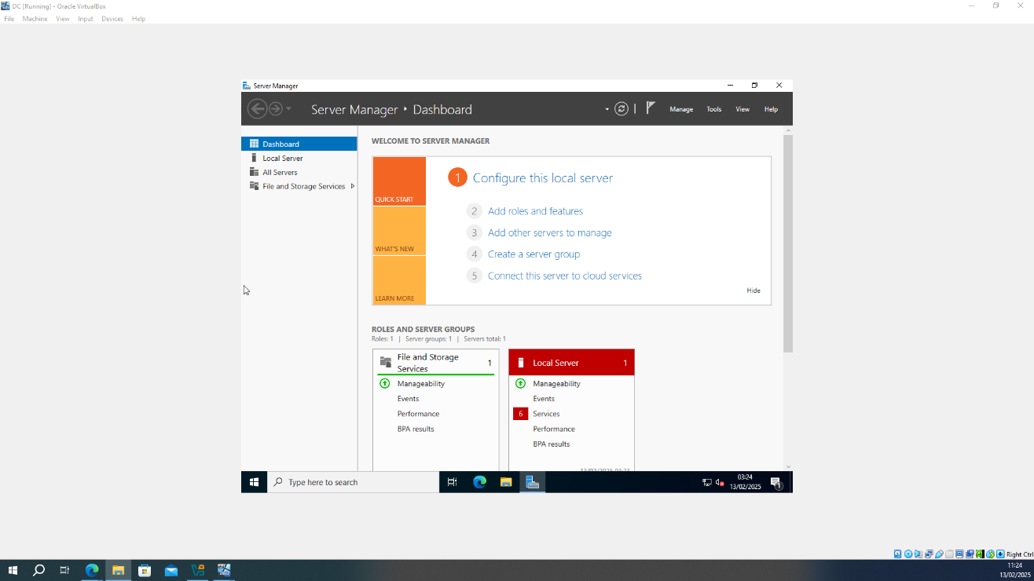

- After installing the windows server, install a Windows client and configure its IP address.
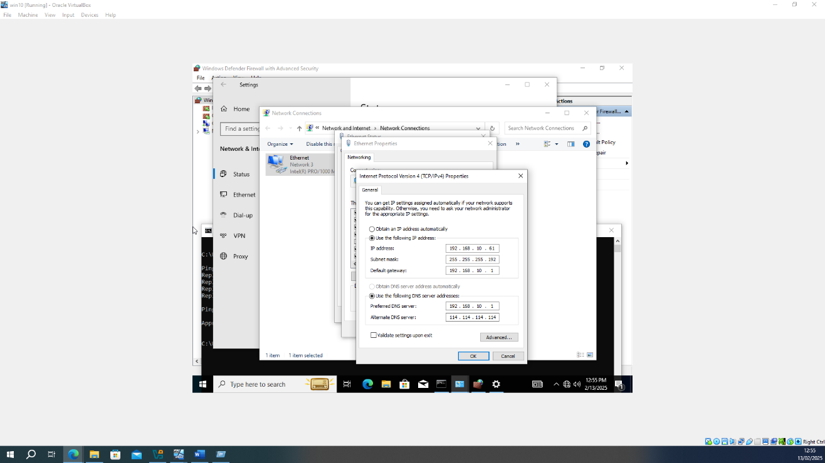
PS: After user configurate the IP address for windows client, just do same activity for user’s services.

- Don’t forget turn off the PC and service’s firewall. After try to ping between the service and client.
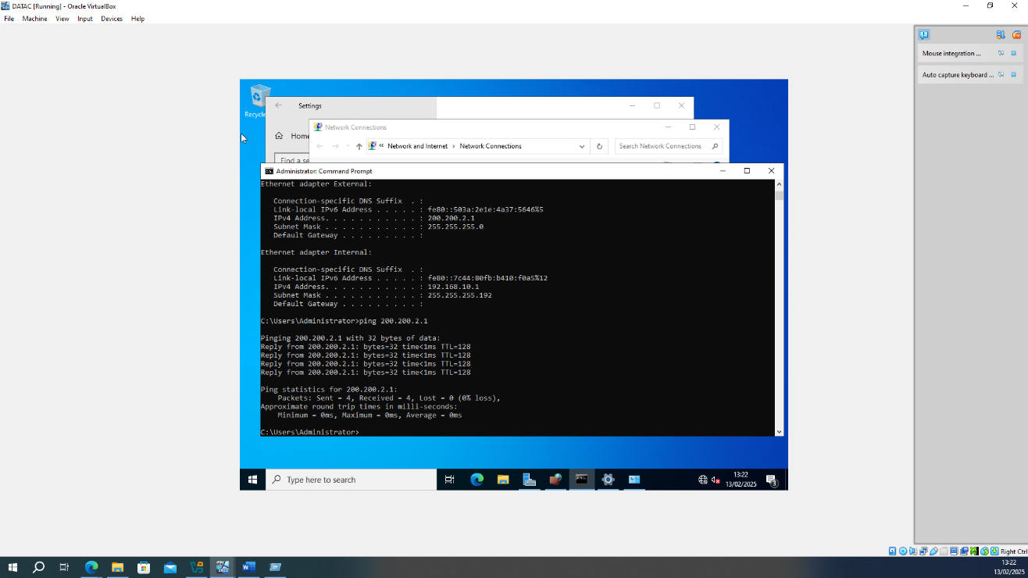
PS: successful!
Example: If user don’t turn off their firewall
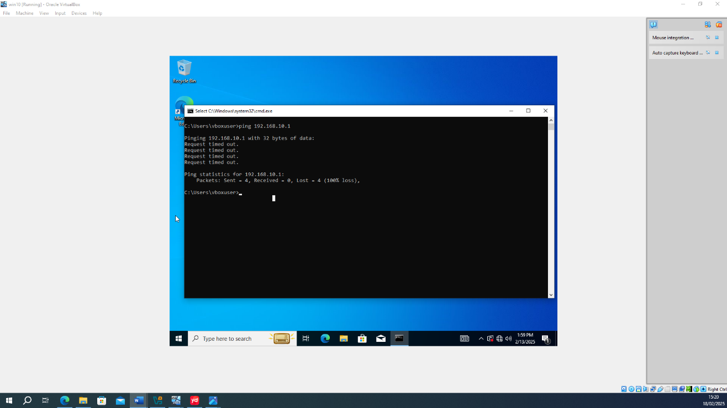
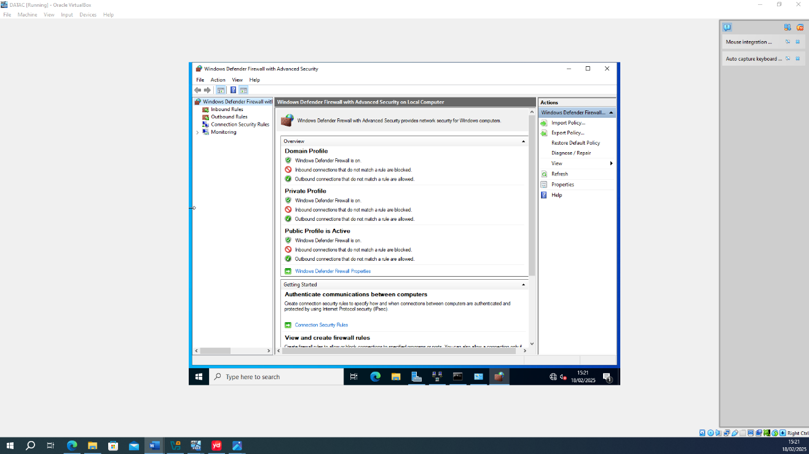

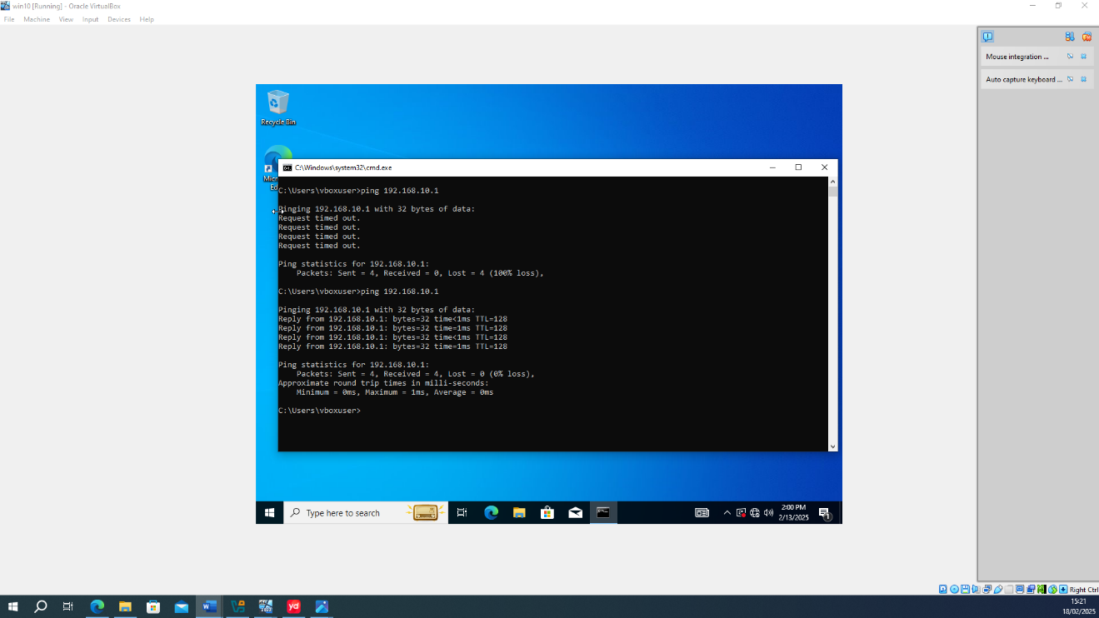

- Install and configure the Debian Linux server
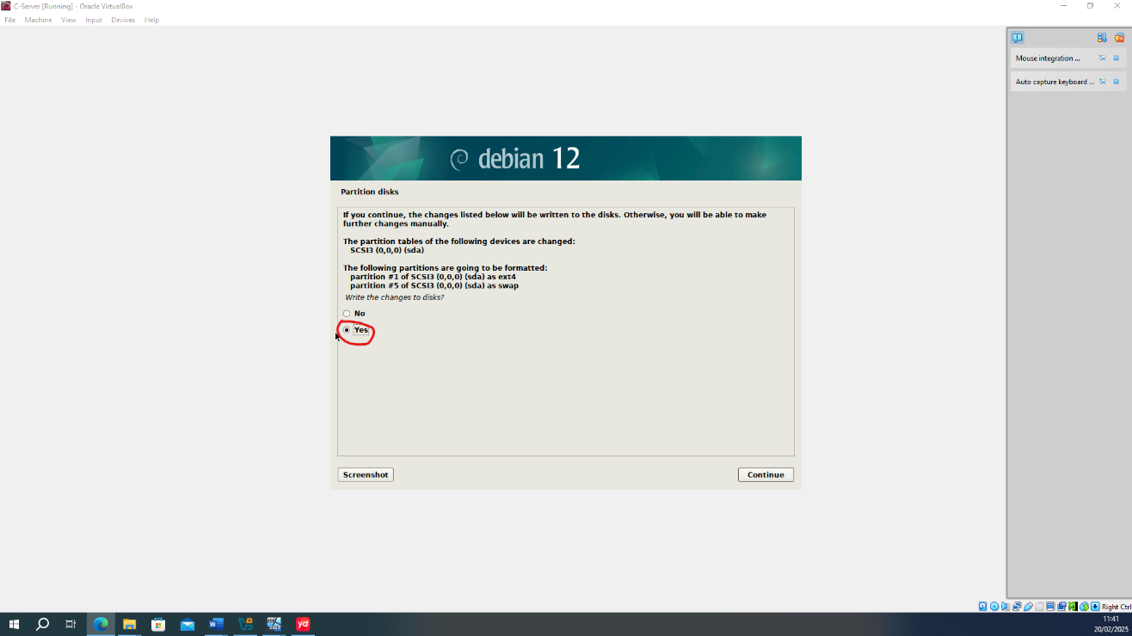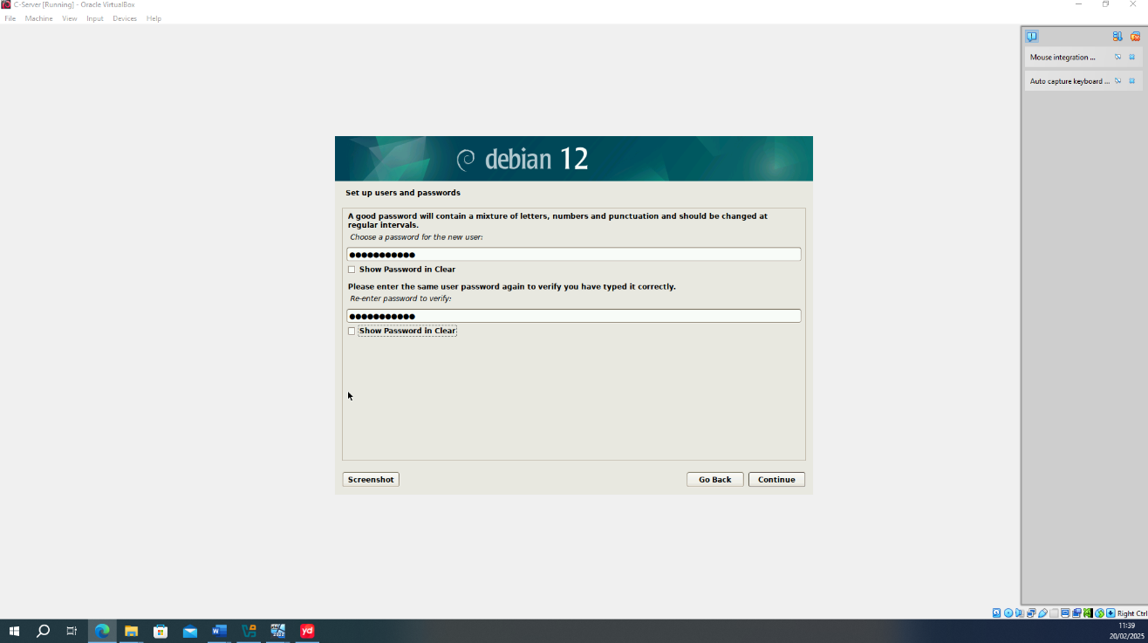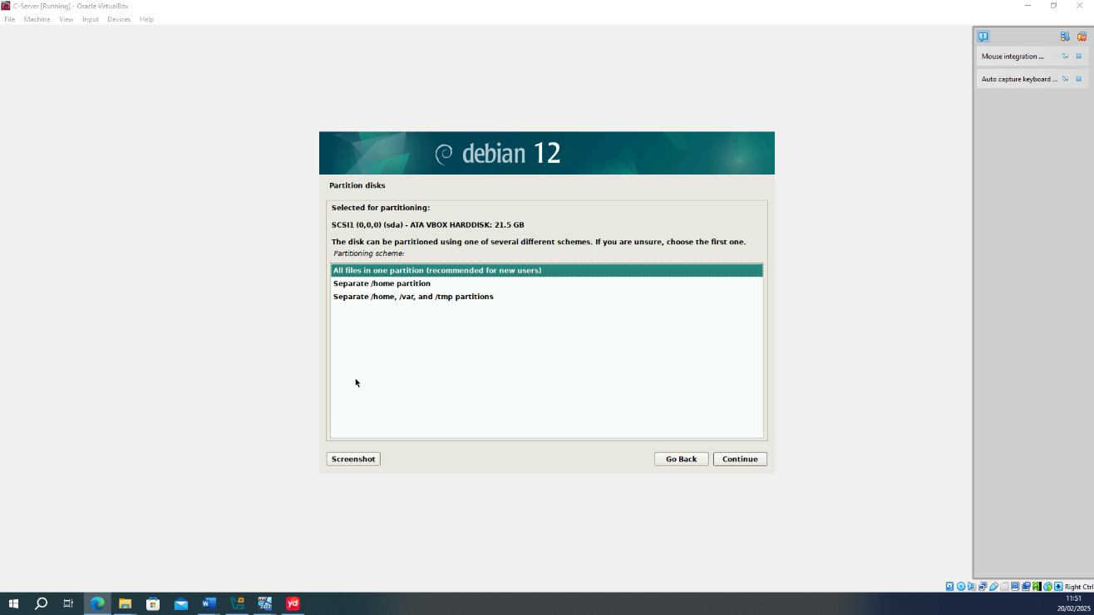
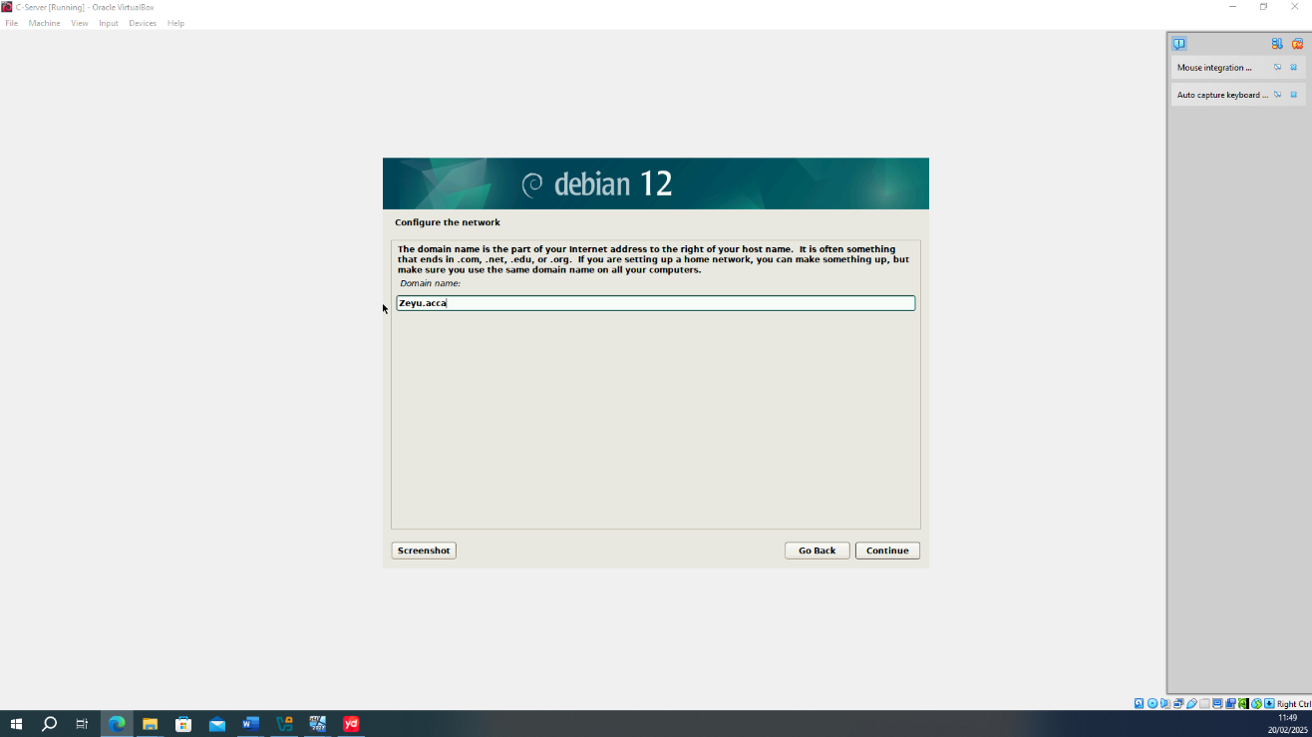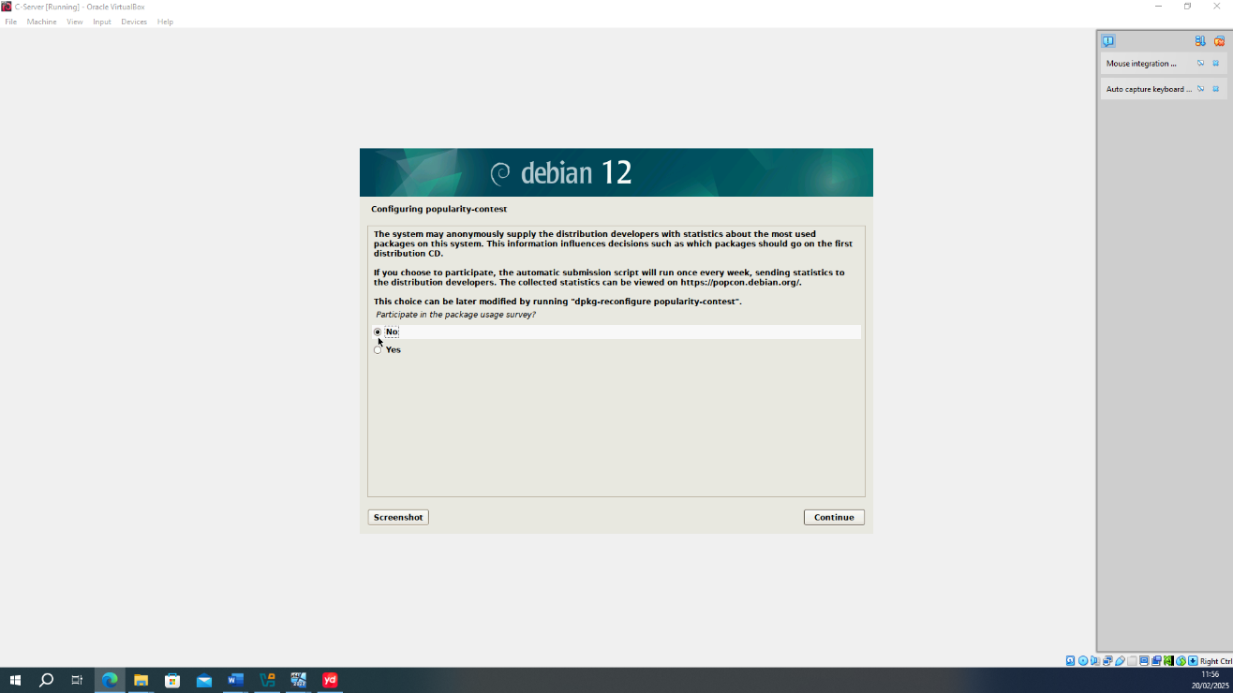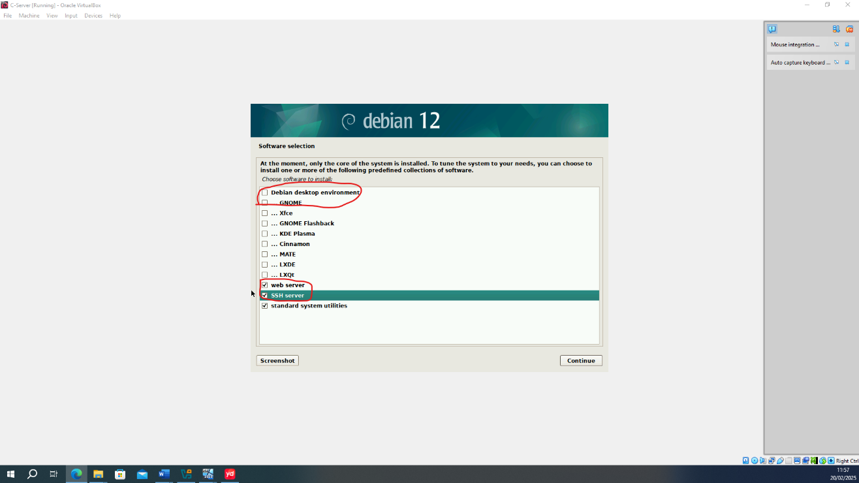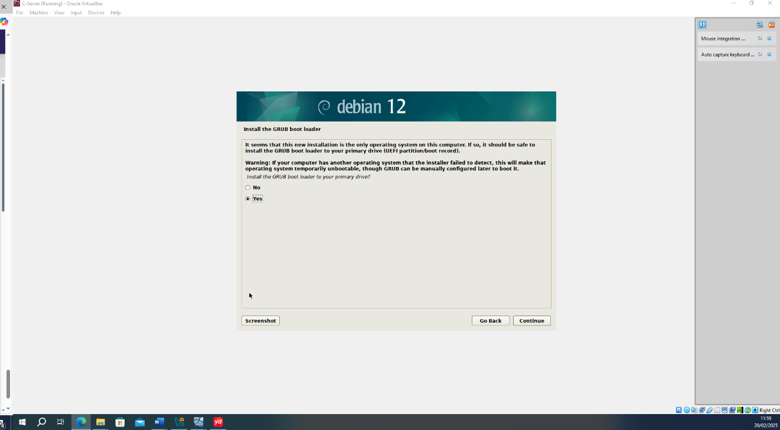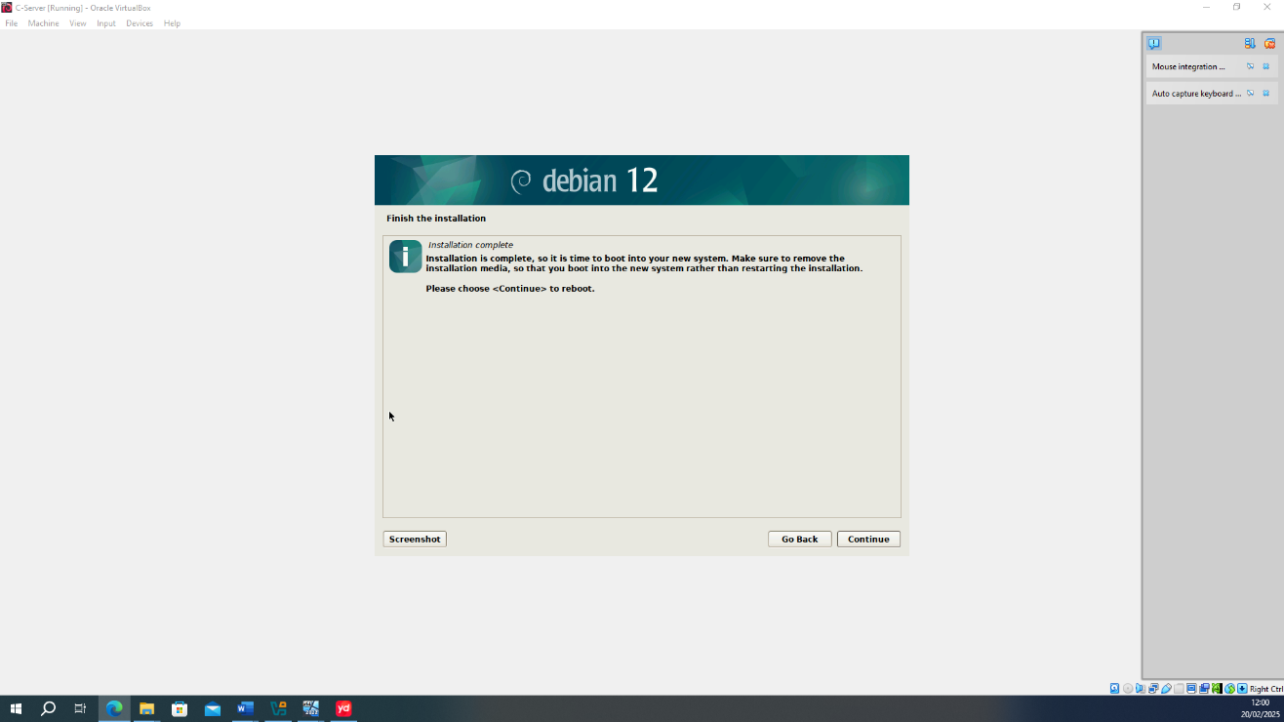

Before edit text for configuration user’s IP address. Users need to access the administration mode. After that check their network port and put user into a group.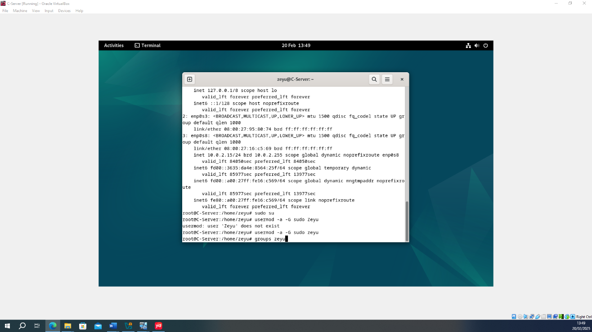

- Next, fine user’s file which call “interfaces” and edit(nano) it.
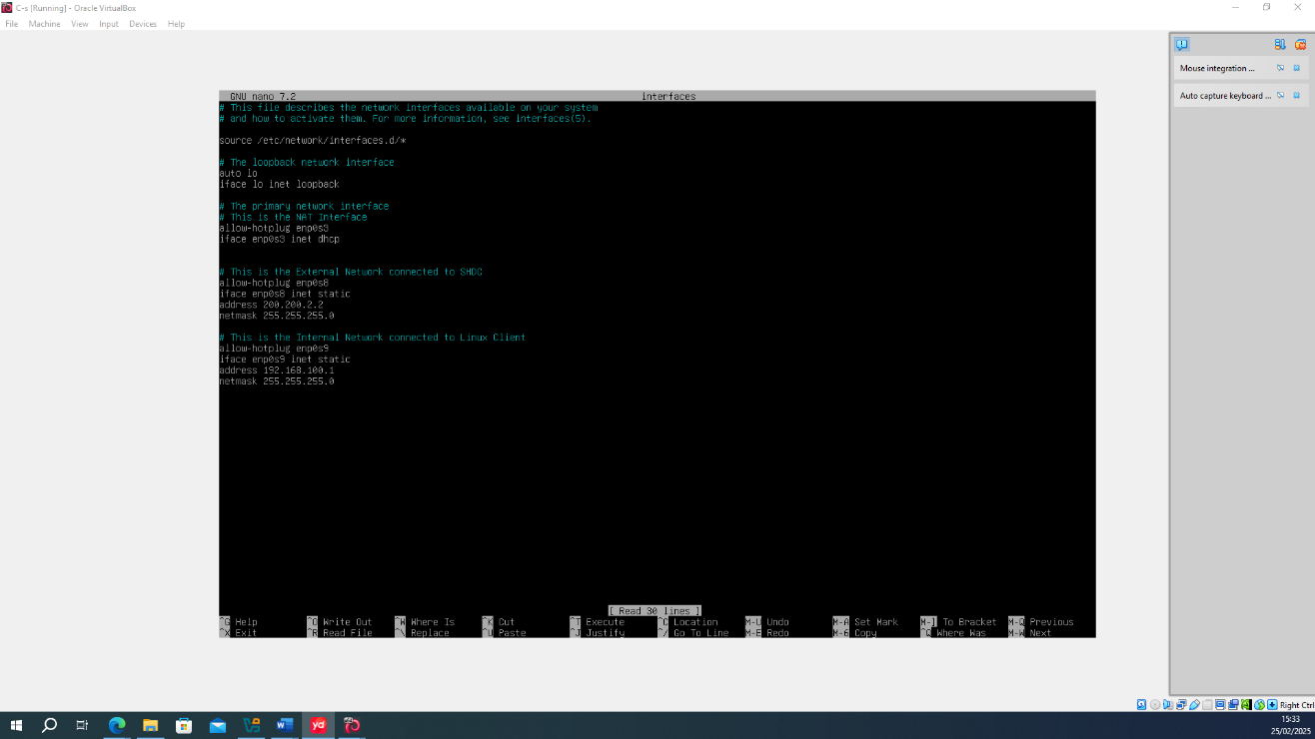

- Do not forget configuration user’s Linux client.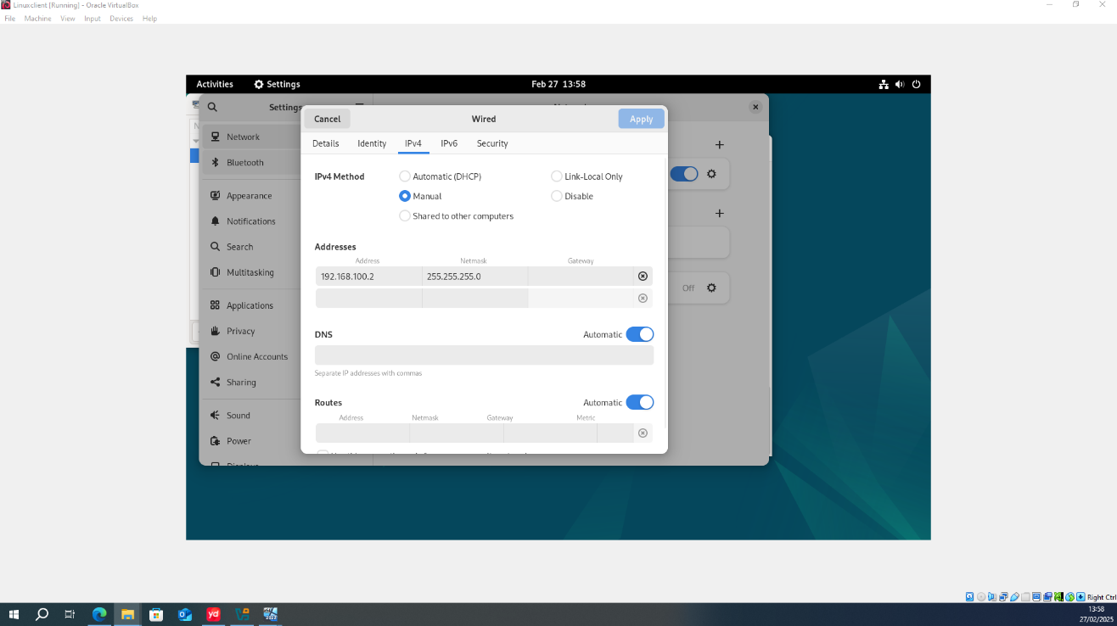

- Then try to ping each other.
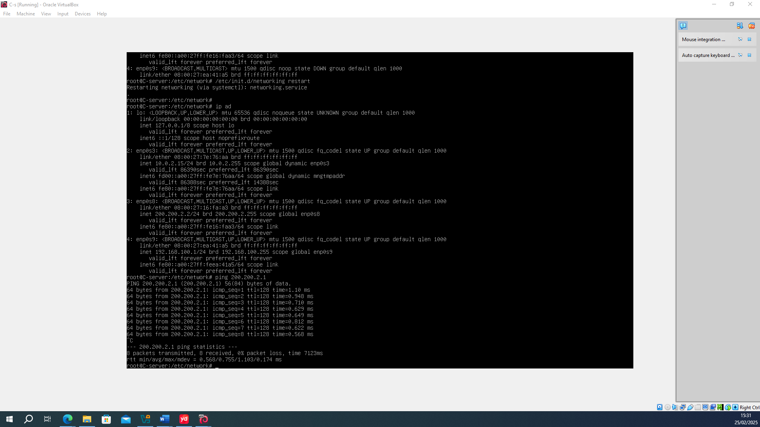
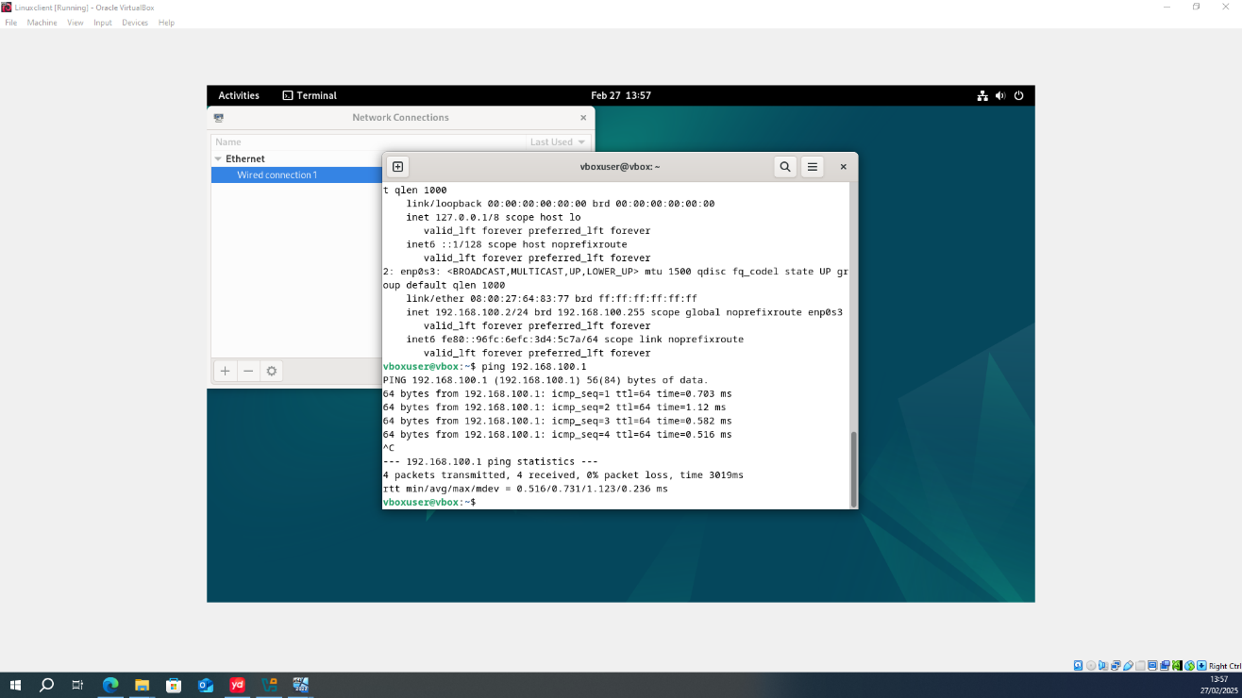

That’s it! Everything is wonderful.

TASK 3
Personal Reflection

In this network service deployment experiment, we must admit that despite the help of teachers and classmates, there will still be emergencies. Next, I'll document the issues and challenges I encountered during the deployment process.
When configuring vlan1 (windows service and client) for the first time, I tried to ping the server and client for the first time after configuring proper and correct IP addresses, but the feedback kept saying "Request time out". After a moment of confusion, I started to do a troubleshooting, the first step I chose to check my IP address Settings again, both the server IP address and the client IP address Settings are correct, and the DNS configuration is also correct.
Since this experiment is done in a virtual machine, there will be no device line connection problems. When the test server and client really can't ping each other, then the problem may be a firewall problem. So, I found the firewall advanced Settings through the "control panel". It was found that the firewalls of the "Domain profile", "Private Profile" and "Public profile when active" modules were not turned off. So, I turned off the firewall and tested whether the communication between the server and the client was successful. Two-way communication is successfully achieved at the result time.
After the experiment was completed, I helped my classmate and helped him complete the troubleshooting. The problem he encountered was that the communication between the Windows server and the Linux server could not be implemented with the firewall down. Since I joined halfway through, I didn't know all his configurations, so I started by looking at the configuration of his Linux server. After confirming that the Linux configuration was correct, I decided to start with the basics, which was to look at his IP configuration. It turned out that he had mistakenly divided the IP address between the Window server and the window client into the same network segment as the IP address between the window server and the Linux server. After I reassigned the IP address for him, I tried the ping command, and the result was successful communication.
Through these two troubleshooting, I gained a lot of valuable practical experience, but also let me realize that even if there is a detailed demonstration operation, there will be many human operation errors, and a variety of emergencies will occur in the actual deployment. When this happens, you should face it calmly. At the same time, use their knowledge to self-troubleshooting.

Reference
- Wikipedia Contributors, “Hypervisor,” Wikipedia, Feb. 08, 2019. https://en.wikipedia.org/wiki/Hypervisor

- S. Bigelow and B. Kirsch, “What’s the difference between Type 1 vs. Type 2 hypervisor?,” Techtarget, Jan. 13, 2021. https://www.techtarget.com/searchitoperations/tip/Whats-the-difference-between-Type-1-vs-Type-2-hypervisor

- D. Ahmad, “How Network Packets Work - Danyal Ahmad - Medium,” Medium, Oct. 31, 2024. https://danyalahmaad.medium.com/how-network-packets-work-c68a06826570 (accessed Mar. 05, 2025).
- “Packet switching - Networks - Eduqas - GCSE Computer Science Revision - Eduqas,” BBC Bitesize. https://www.bbc.co.uk/bitesize/guides/z7mxh39/revision/10

- Wikipedia Contributors, “IPv4,” Wikipedia, Aug. 03, 2019. https://en.wikipedia.org/wiki/IPv4

- Wikipedia Contributors, “IPv6,” Wikipedia, Jan. 10, 2019. https://en.wikipedia.org/wiki/IPv6
- Wikipedia Contributors (2019). Routing protocol. [online] Wikipedia. Available at: https://en.wikipedia.org/wiki/Routing_protocol.
- Wikipedia Contributors (2019). Routing protocol. [online] Wikipedia. Available at: https://en.wikipedia.org/wiki/Routing_protocol.
- Mehta, H. (2015). Dynamic Routing All Algorithms, Working And Basics. [online] SlideShare. Available at: https://www.slideshare.net/slideshow/dynamic-routing-all-algorithms-working-and-basics/49367846 [Accessed 5 Mar. 2025].
- Wikipedia Contributors (2022). Dynamic routing. [online] Wikipedia. Available at: https://en.wikipedia.org/wiki/Dynamic_routing.
- Wikipedia Contributors (2019b). Static routing. [online] Wikipedia. Available at: https://en.wikipedia.org/wiki/Static_routing.
- Wikipedia Contributors (2019e). Virtual private network. [online] Wikipedia. Available at: https://en.wikipedia.org/wiki/Virtual_private_network.
- Wikipedia Contributors (2019a). Dynamic Host Configuration Protocol. [online] Wikipedia. Available at: https://en.wikipedia.org/wiki/Dynamic_Host_Configuration_Protocol.
- Wikipedia Contributors (2019a). Active Directory. [online] Wikipedia. Available at: https://en.wikipedia.org/wiki/Active_Directory.
- Wikipedia Contributors (2020). Certificate authority. [online] Wikipedia. Available at: https://en.wikipedia.org/wiki/Certificate_authority.
- Raza, K. (2024). VirtualBox vs VMware: Which is Better? [online] UltaHost Blog. Available at: https://ultahost.com/blog/virtualbox-vs-vmware/ [Accessed 5 Mar. 2025].

