Impact of living space on people’s mental and emotion well-being
---- An eco-design “Revolving House”

[ Name: Hangtao Fu Number: 2307430 Major: Art & Design ]

Key words: Space, mood, lighting

Introduction:
In today’s society, the housing issue has always been an important need in people's lives that cannot be ignored. “Recent research has shown that the average person spends 90% of their time inside”(Hamilton, 2022). A warm and cosy living environment is suitable for people's survival and living space. The quality of the living environment is not only related to people's lives and physical and mental health, but also plays a crucial role in socio-economic development. In conceiving the creativity of the rotating house, the author combined own living situation and came up with the idea. Because the room interior of the author currently live in has poor lighting. In fact, we can imagine waking up in the morning and realising that our room is still dark and unable to enjoy the warmth of the light. If we stay in such a space for a long time, we may feel anxious, depressed, and may even generate a sense of loneliness, as if we are isolated from this society. In addition, being in a dim indoor environment may also affact work and study efficiency. So, in order to improve people's quality of life, the writer came up with this idea of rotating house, so that the residents can adjust the rotation of the house according to their own needs at different times and seasons to enjoy sufficient natural light, to ensure that the amount of light in each room. Plenty of natural light can bring a sense of openness to a space as well as benefit the health and mood of the occupants. Therefore, this report will focus on the impact of living space on human psychology and emotions - the eco-design concept of "rotating house" - to study and explore how to improve the quality of life of the residents by means of innovative eco-design.

1. The context and meaning of combining practices and theories:
With people's standards for quality of life being constantly raised, designers are focusing more and more on combining theories and practices to create aesthetically pleasing and comfortable living environments. “Nowadays, Design responsibility is wider as we should consider the impact on society of everything we design”(Grillo, 2021). The aim of design is no longer limited to satisfying the basic needs of people, but is committed to shaping a better future. In this background, it becomes particularly important to explore the impact of housing space on human psycho-emotional well-being. The design concept of the rotating house follows the three elements of environmental protection, greenness and ecology. It is inspired by the principles of bionics, such as the phenomenon of sunflowers chasing the sun's rays and rotating. J.J. Barrett (2021), an agent of the West Virginia University Extension Service, wrote an article regarding the "Heliotropism", it mentions that the word "Heliotropism" refers to the phenomenon of plants following the sun during the day, and sunflowers are a perfect example of this phenomenon, as they move with the sun and rotate to maximise the sunlight they absorb. Using bionics to apply this characteristic of the sunflower to my design, people adjust the direction of the house by rotating it to optimise indoor lighting and improve the quality of life and mental health of the inhabitants. Houses are more than simply living spaces; they are important places for people to rest, relax and refresh. Hence, it is very important to have a serene and cosy space. According to Archontia Manolakelli (2022) there are mentions in this article that environmental psychology can help to understand the impact of the living environment on the inhabitants and improve it through design. At the same time, myself also consider how to incorporate eco-design concepts when envisioning living spaces, “Ecological design is simply the effective adaptation to and integration with nature’s processes” (Garden, 2021). Choosing renewable, environmentally friendly materials and energy sources helps to minimise the affect on the environment. In brief, environmental psychology is the study of the impact on human psychology and behaviour, pointing out that factors such as environmental design and space design have an important role to play in psychological emotions; eco-design theory emphasizes the harmonious coexistence of man and nature. The design concept of the rotating house provides new ideas for improving the living environment and is also in line with the modern sustainable architectural design concepts of greening, energy saving and emission reduction. In the field of art and design, theories provide a scientific evidence and guiding framework for practice; while the practical work uses specific ways to verify and enrich the theoretical support, and the two complement each other in design research. Through research, we are able to identify new problems and come up with innovative solutions.

2. Assignment objectives:
The main goal of this study is to explore the impact of housing space on people's mental-emotional well-being by analysing and practising the concept of an ecological design --- the rotating house.
To be specific, it is divided into the following three points:
First of all, studying the relevant theories. To understand how indoor spatial elements affect people's psychological mood and the effect of light conditions on occupants in terms of improving their mental health. Check out the extensive literature review, analyse and summarise as an argument for this essay.

Second, demonstrating the results of practice. Through the previous research and practice cases, based on bionics and ecological design theories, the 3D model rendering of the rotating house is shown to visualise the abstract design concepts in the mind and be able to visually present them to people intuitively.

The last, outlook for the future. Standing in an objective point of view to analyse the rotating house, summarize the advantages and disadvantages of rotating house design in practical application, suggest specific improvement measures and prospects for the future, and provide reference for modern architectural design.

3. Emphasise the significance of the organic relationship between practical work and reporting:
Practical work offers an evidence base for theories. The design concept of the rotating house is based on biomimicry. Such a design concept embodies the core idea of eco-design, i.e. the harmonious coexistence of man and nature. On the Endesa website (2023) there is an article about the fact that eco-design is not only limited to everyday products, but that it is also widely used in the construction industry, many experts are committed to developing solutions to reduce the impact on the surrounding environment. J.J. Barrett mentioned "Heliotropism" phenomenon will also enlightened many architects in the future and prompt them to start thinking about how this rotationally adjusted function can be applied to human living environments in order to optimise natural light and indoor environments, and to improve the comfort and sustainability of the dwellings. As for the report, it is the summary and sublimation of practical work. In practice, designers will systematically record and analyse data on the performance of the house, which may contain information on light, temperature and air quality in different seasons and climates. The detailed report summary allows us to trace the challenges, solutions and results obtained that may be faced in the process of practice, providing a valuable reference for future projects. Thus, relating practice to reporting is essential to extending the scope of research and enhancing the quality of outcomes. The mutually supportive validation of the practical work and the theoretical report ensured the scientific quality and authenticity of the research, author hope that my idea will contribute to improving the quality of human living environment and mental health in the future, so that myself can better help this society.
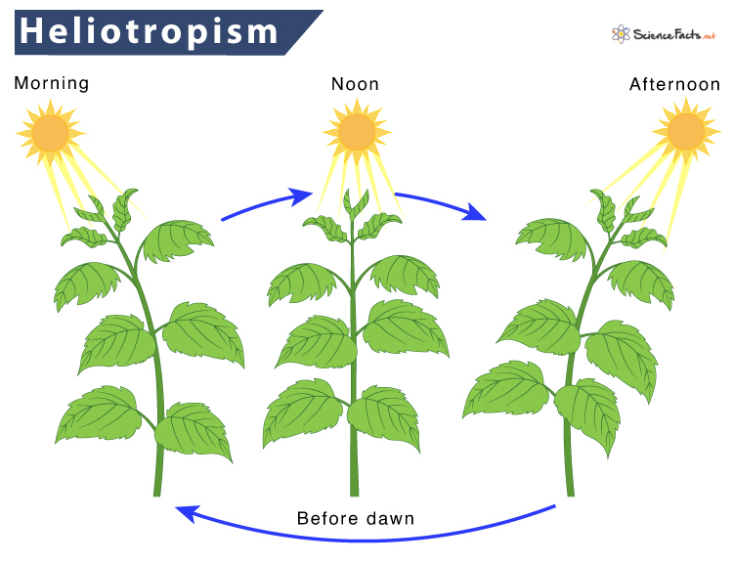

Research and Practice:
In this section the writer mainly present my practical research and results.

1. The showcase of practical and results of the main project:
Based on the design concept in my head, myself created a model of a rotating house and showed and illustrated the design process of a rotating house:
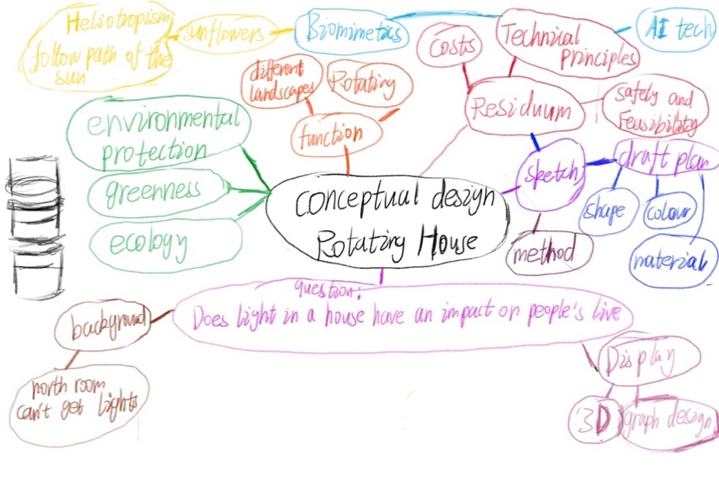
⑴. Sketch of the house design:
My initial idea was to follow the traditional construction of a house and design it in a rectangular shape, but then I designed the house in a cylindrical shape. “The circle is a divine symbol, a perfect shape” (McManus, 2024). The cylindrical shape of the house gives it a unique aesthetic from the outside, while the interior of the building is much more spacious and very evenly illuminated with natural light.
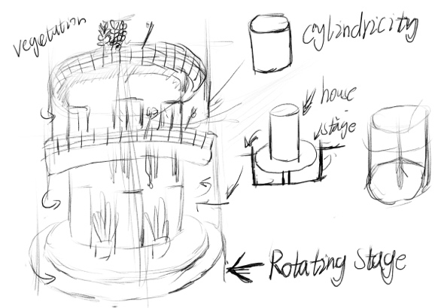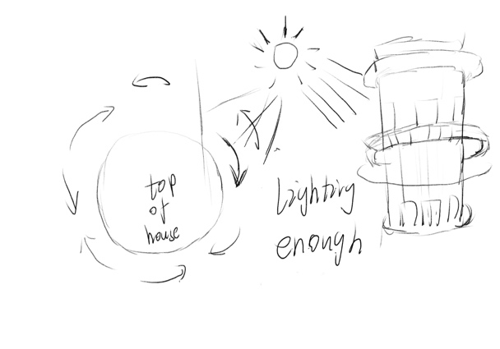
⑵. Conceptual picture of the house:
Myself used graphic designing software, Photoshop. Create a conceptual drawing according to the sketches I have made.
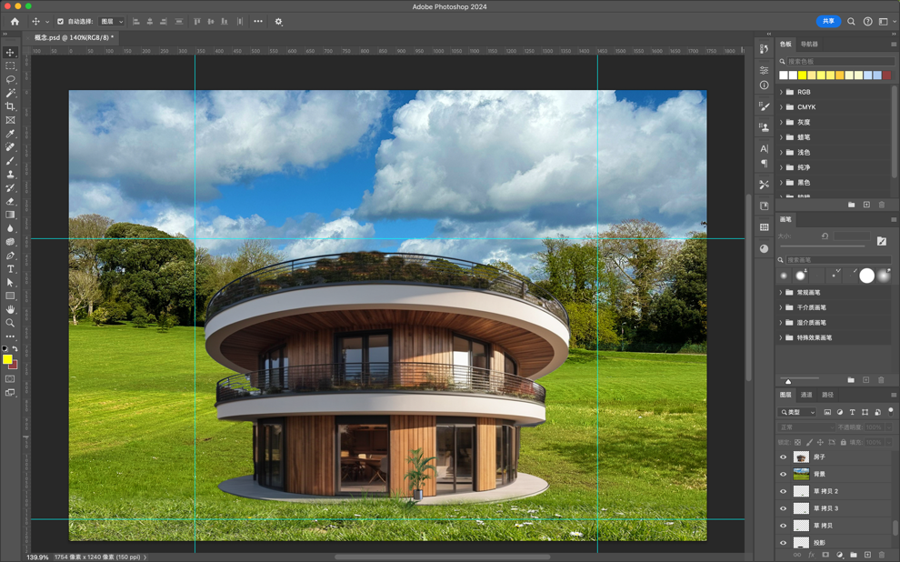
⑶. 3D model renderings:
Based on the conceptual drawing, using 3d software, Blender, to make the model. Below is a rendering of the model.
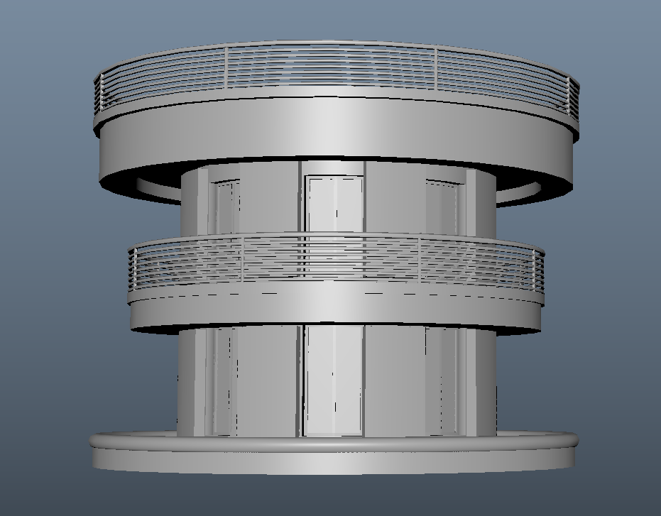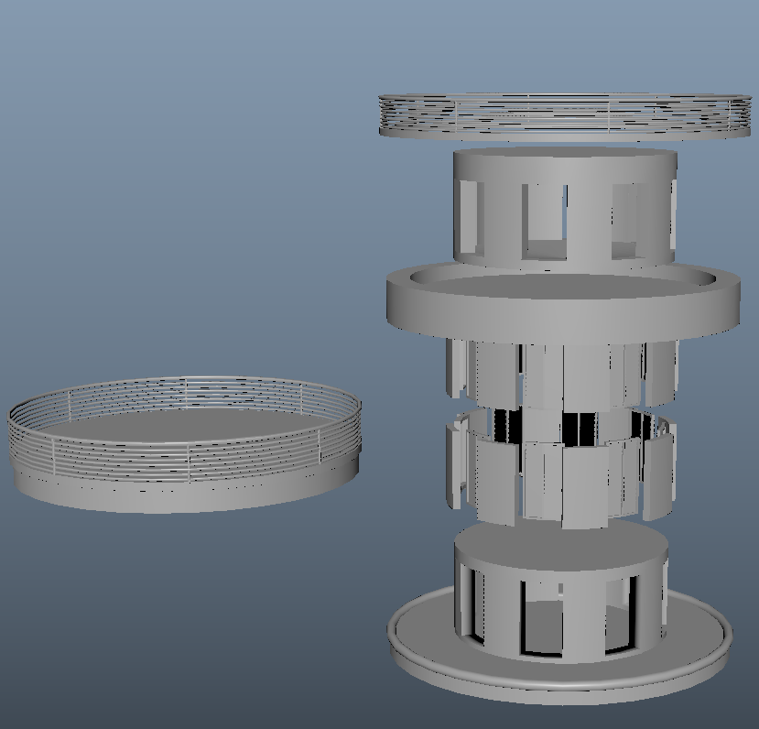
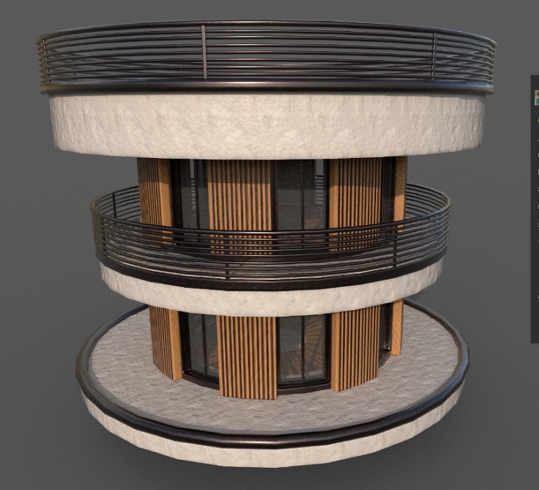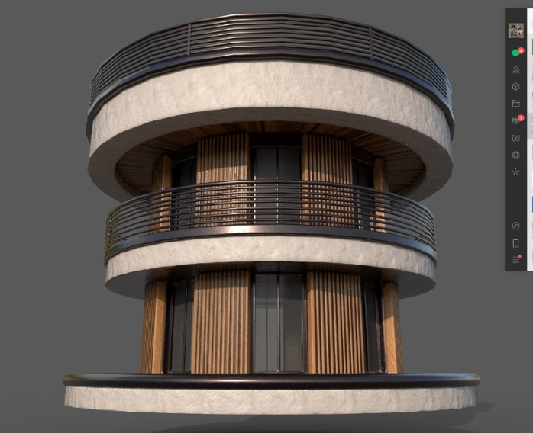
⑷. Final Showcase:
The final presentation explained the conceptual design of the rotating house in a one-minute video, a few images below are screenshots from the video.
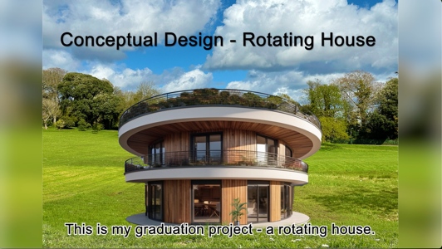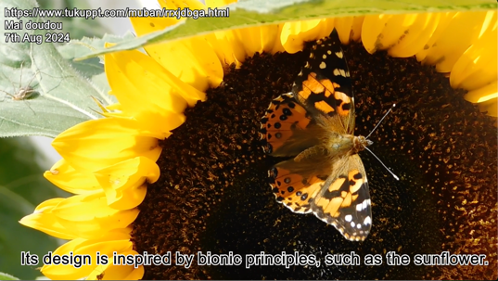
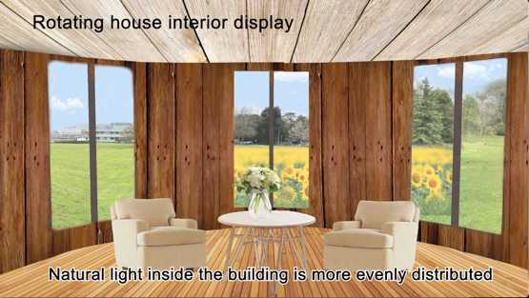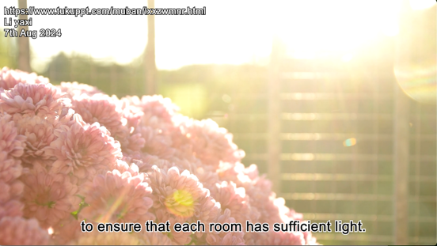
2. Creativity and illustrative of practical work:
⑴. Innovative design concepts:
The rotating house breaks away from the traditional static design concept of a house. A essay wrote by Ticleanu (2021) concerning the effects of lighting in the home on the health of people, His research into UK housing found that some homes were not particularly well illuminated by natural light, especially north-facing rooms that had difficulty in obtaining a supply of daylight. For example, as in the case of some traditional old houses, the lighting conditions may not be desirable due to the limitations of these houses in terms of building design or environmental factors. This concept also improves the flexibility and adaptability of the house, allowing the residents to choose the best view and face the house towards the most beautiful scenery.

⑵. Ecologically friendly to the environment:
In the context of global climate change and resource shortages, the construction field is gradually transforming towards sustainability and eco-friendliness. “The construction industry is a massive consumer of raw materials and natural resources, and it generates an estimated 39% of the world’s carbon emissions according to the World Green Building Council” (Lynch, 2021). This reality has prompted a greater focus on environmental and sustainable principles in building design. writer also consider the use of renewable energy in my research on rotating houses, such as installing a solar system on the roof to provide energy to the house. Synthetic wood can also be used as the main material for this building. This approach is in line with green building design, lowering the building's energy consumption and carbon emissions to the environment. This will be used to achieve energy efficiency and environmental goals.

⑶. The link between space and feeling:
All-natural light, as one of the vital consider the structure environment, has been proven to have an amazing influence on the well-being and mental health and wellness of owners. “Individuals chronically exposed to shorter hours of daylight in built environments tend to suffer more from sadness, fatigue, and clinical depression” (Bertani et al., 2021). This finding highlights the value of light on human state of minds. Rotating House is a combination of room design and psychology that deeply discovers the influence of spatial settings on feelings, a really objective analysis of people's direct sensations about their living room. This research study technique not only enhances mental research studies, yet likewise offers new viewpoints for future building layout. It helps designers to give guidance to their thoughts.

3. To analyse the objectives, methods and expected results of the practical work:
Goals:
The specific objectives are as follows:
⑴. Improve the mental mood of the inhabitants:
①. Using natural light and optimised spatial design to reduce the areas of darkness in the room and create a bright, warm and comfortable home.
②. Change in terms of the interior layout, the aim is to improve the comfort and ease of living for the occupants.

⑵. Reducing the influence on the natural environment：
①. Use renewable energy sources, such as solar technology, to make the house energy self-sufficient. Promote sustainable eco-design.

②. Achieve recycling of construction materials, such as the usage of synthetic wood, to reduce resource costs.

⑶. Search for practical application results of rotating houses:
①. Reviewing the results of previous experiments, evaluating their situations in practical applications, and analysing strengths and weaknesses.

②. Gathering information about the feelings of people living in a revolving house.

Methods:
In order to achieve the above objectives, writer intend to use the following methods:
⑴. Literature review:
Literature review method is a common research approach, through the review and analysis of existing research results, you can get a comprehensive understanding of the current status of the research field of the development trend. For this project, writer will base my work on environmental psychology and ecological design theories. A literature review is used to explore the impact of housing space design on residents' psycho-emotional well-being and quality of life, providing a strong base and reference for the argument of this article.
①. Natural Lighting:
Writer observed the houses around the accommodation and found that north-facing rooms usually have difficulty in obtaining sunlight. Therefore, the question arose in my mind: Can architecture bring positive or negative states to the people living in the space through natural light conditions? A large number of studies have shown that this phenomenon is justified. Morales-Bravo & Navarrete-Hernandez (2022) in their article about natural light helping to enhance the vitality of space and control anxiety and stress. Plenty of sunlight can regulate the biological clock, raise our mood and reduce depressive symptoms. Natural light can affect people's mental health. “There now appears to be a general consensus that regular exposure to daylight is essential to maintain human health and well-being” (Mardaljevic, 2021). Environmental psychology is the research of the interrelationships between people and environments, based on these results, it has been demonstrated that the light factor of the living environment plays a key role in the psychological well-being of the residents.
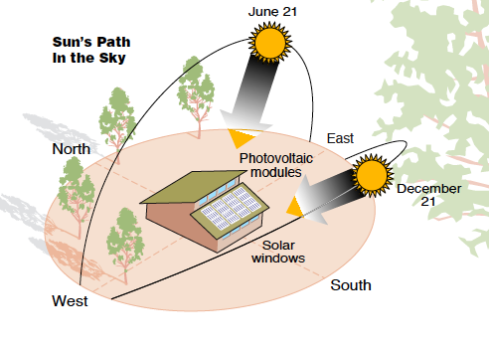
②. Space Layout:
The built environment has become a fundamental part of human life, and we spend most of our waking hours in indoor environments, whether working, studying or entertaining. An open and flexible interior design can also increase the comfort and well-being of the inhabitants. Tawil et al. (2021) explored the effects of the built indoor environment on human psychological responses, The study shows that curved designs often trigger more positive emotional responses, such as pleasure, relaxation and a sense of security, than linear designs. That's why I designed the exterior of the rotating house to be cylindrical in shape. Cylindrical interiors with no corners as in conventional houses, avoiding wasted space; the rotate function allows the user to adjust the direction of the house according to their time and needs. Meanwhile, people can also place green plants around the building. It not only can beautify the environment, but also can improve the quality of life.
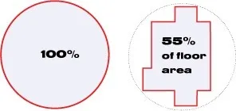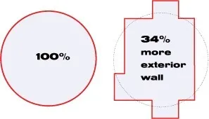
(2). Case study:
A case study is a method of analysing and exploring a particular instance in depth, Through the study of actual projects by other people, to understand their design concepts, realisation process and practical outcomes. For this project, I will select a representative revolving houses around the world for case studies to explore their practical experience in improving the spatial design of housing and the psychological and emotional well-being of the occupants, and to provide a theoretical foundation for future research progress.
①. Case Selection:
Using a case study approach, the validity of the theory and the feasibility of practical strategies are verified and an evidence base for research decisions is provided. I chose a revolving house case:
Rotating home designed by Vogin Kusic, a resident of Srbac, Bosnia
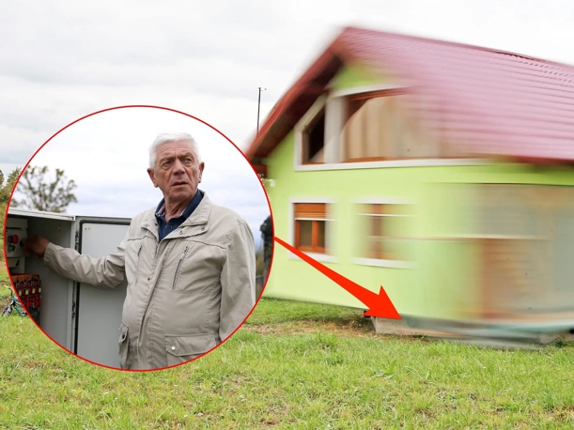
②. Case analysis:
Hadden (2021) has published an article about rotating house, According to a report by the Associated Press, Bosnian Srbac resident Vogin Kusic, who was tired of his wife's complaints, has decided to build her a revolving house to satisfy her desire to change the view from the window as she pleases. This house looks like a normal house, but it has the ability to rotate to adapt to he and his family's needs and climatic changes. Based on this case, I can confirm that the characteristics of a rotating house are the following:

a. Dynamic landscape:
The rotating house can revolve smoothly without noise. People can adjust the facing of the house to change the view from the window at any time according to their mood or season, satisfying the occupants to enjoy different scenery.
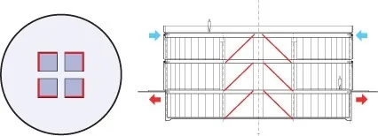
b. Optimise lighting:
By rotating and adjusting the direction of the house, it is possible to maximise the use of natural light, ensure that the interior becomes well lit, improve the comfort of the living environment and enhance the mental health of people.
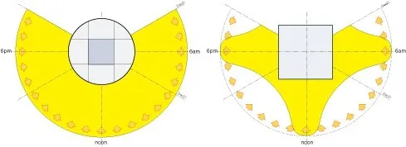
c. Increasing ventilation:
The rotating house can adjust its position according to the wind direction to optimise indoor ventilation and improve the quality of air.
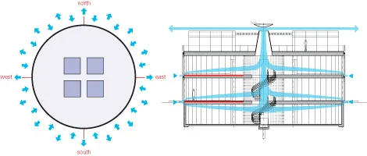
d. Flexible layout:
The house itself is fully operable independently, and the placement of furniture inside the house can be adjusted as needed to satisfy the living requirements of different family members.
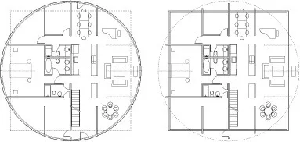
③. Case summary:
On the basis of the above case study, I can analyse and summarise the revolving house in the light of the concepts of environmental psychology and eco-design:

Benefits and limitations：
Based on the above cases, the author conducts a brief analysis and discussion
Advantages：
a. Improvement of dwelling comfort:
Living comfort and quality of life are improved by dynamically adjusting the orientation to improve light and ventilation conditions.

b. Innovative design:
The rotating house showcases the innovative nature of building design, which not only breaks through the limitations of the conventional building, but also provides new ideas and directions for future architectural design. Such design concepts can inspire more innovation and promote technological progress in the field of constructions.

c. Psychological health:
Sufficient natural light and good ventilation help to promote the mental health of the occupants and reduce depression and anxiety. At the exact same time, a heightened feeling of well-being also adds to social and financial growth.
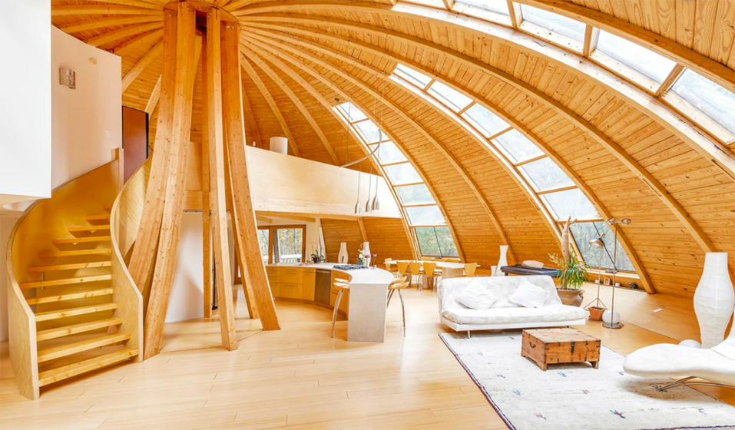
Disadvantages:
a. Complexity of technology:
The layout and construction of revolving houses entails complex mechanical and design abilities. Achieving the rotational function of your house needs exact mechanical gadgets and control systems, which may bring about troubles and raised expenses in building and upkeep..

b. Energy consumption:
Revolving tools which need electric power equipment to drive them might boost power consumption, specifically when it comes to regular rotations. Although the natural lights and air flow of the interior is optimized, careful factor to consider is still required in regards to power use.

c. Structural safety:
The structural style of a rotating residence needs to make certain that it maintains stability and safety and security during the rotation process. In case of mechanical failure or damages to your home there can be severe consequences for people. A high level of design and safety is needed in the building and construction of housing.
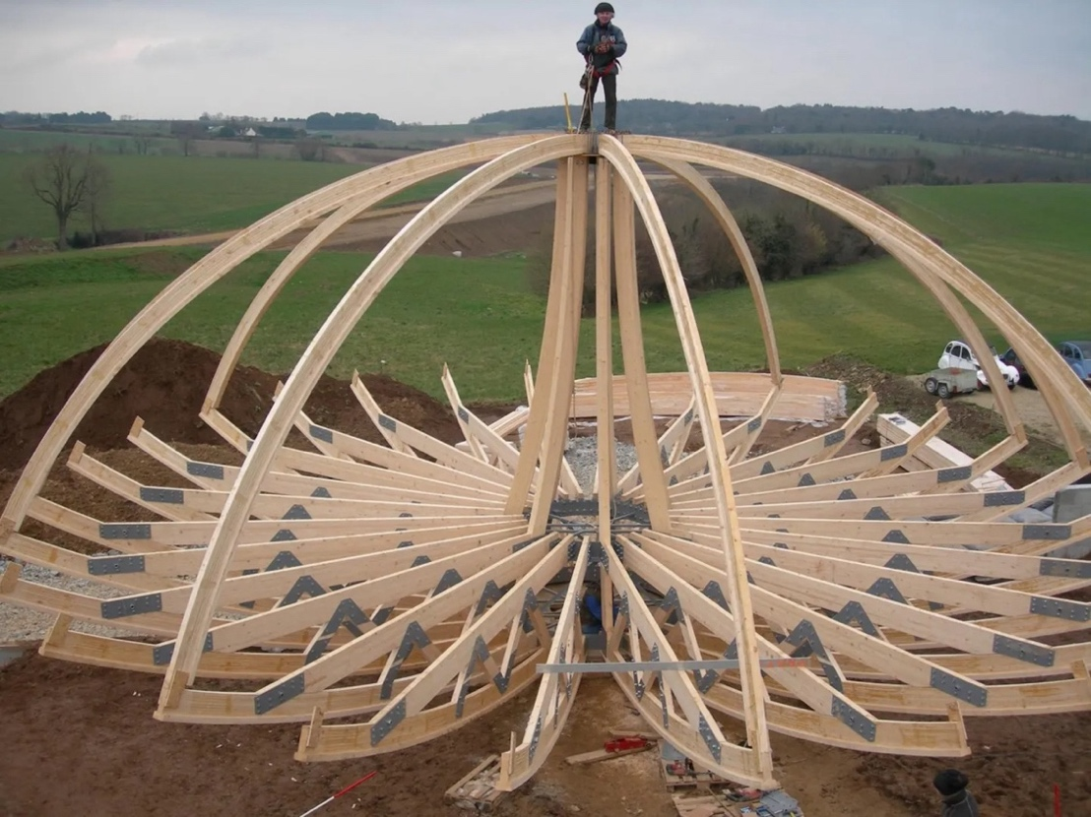
The incorporated use literary works evaluation and case study technique can confirm the usefulness of turning homes at both sensible and theoretical degrees. Via ingenious layout and application of innovation, the turning home attains a variety of benefits such as vibrant landscaping, optimised lighting and air flow, enhancing living convenience and lifestyle. The revolving house that Vogin Kusic, a resident of Srbac, Bosnia, built for his wife is one such example of blending innovation and practice. However, its disadvantages such as technical complexity, energy consumption and high cost also need to be considered and overcome in practical applications. Overall, rotating houses provide new ideas and directions for modern architectural design, but they still need further exploration and improvement in terms of promotion and popularisation.

Expected results:
author hope to achieve the following outcomes through my research practice:
①. Improved psychoemotional well-being:
By enhancing the spatial design of housing, especially the strengthening of natural light and flexible space layout, writer expect to significantly improve the psychological mood of the residents and thus enhance people's quality of life. The interior of the house should be made with attention to flexibility and comfort to provide a more pleasant and relaxing living environment.

②. Remarkable light effect:
If the project is undertaken, the rotating house can be equipped with an automated system. To be more specific, light sensors and monitoring equipment are installed to continuously collect data to assess the effect of natural light on the improvement of indoor environment and to provide data support for future building design.

③. Promotion of innovation and technology:
The rotating house is innovative in design, and the successful implementation of the rotating house may become an example in the field of architectural design, if this design concept and technology is extended to commercial or other residential projects to expand its market influence. For example, we can develop rotating houses for different types of people to meet the amount of demand at different levels of the market.

Through the realisation of these expectations, writer hope to demonstrate the potential of rotating houses to improve the psychological mood of their inhabitants, optimise light conditions and push innovation in the construction industry.

4. Practical work on answering questions or exploring research subjects:
⑴. Verified the effect of lighting on mental emotions:
The design concept of the rotating house is to examine the effect of natural lighting on human psychological emotions. Through the literature review method, writer have looked at a large number of relevant studies, all of which have indicated that adequate natural lighting can effectively improve the mood and psychological health of the occupants. Shishegar & Boubekri (2022) explored that indoor lighting can enhance the quality of life of older people and their findings confirmed this point. This is a good illustration of environmental psychology's theory about the positive effects of light on mental health, and demonstrates the feasibility of optimising the spatial design of housing to enhance the quality of life of its occupants.

⑵. Advances the development of sustainable building design:
From a design point of view, revolving houses are designed in a cylindrical shape and its graceful curves usually present a unique beauty to the people. “The curve also softens sounds inside the building, so a Round House is the perfect place to rest or for socialising and listening to music” (Cardwell, 2020). Reducing noise pollution is also an important aspect of building sustainability, lowering psychological stress and preventing disturbance to the ecosystem. This may drive the practical application of sustainable building design and provide a good example for the future of the construction industry.

5. The help of research backgrounds and methods in clarifying the practices and research relationship:
The context and methods of the study play an important role in illuminating the relationship between practice and research. This is reflected in the following aspects:
⑴. The guiding influence of the theoretical background:
Before the research started, writer read widely the literature review by scholars and collected many relevant research cases. This documentation and examples clearly demonstrate the role of spatial design, especially lighting, in affecting psychological mood. These theoretical backgrounds provide a clear guiding direction for my follow up practical work and ensure that the practical work has solid theoretical support. An indepth understanding of environmental psychology and ecological design theory enabled me to identify the design concept of the rotating house, which is to adjust the orientation of the home by rotating it to maximise the use of natural light in order to improve the mental health of the occupants. This theoretical context has guided me in helping to clarify the core questions and aims of my research, providing a scientific basis and framework for practice.

⑵. The process of testing theory in practice:
For the purpose of testing the theory, myself used phenomenology for self-reflection, supposing myself to be in a dimly lighted room, and describing how spatial properties affect emotions in terms of subjective feelings and experiences. Then, writer went out to observe the lighting of the houses near my dormitory and found that it was difficult to get sunlight from the north-facing windows. Beans (2023) also writes about the rule of windows in her blog, that south-facing windows receive the most light, compared to north-facing windows that receive the least sunlight. This information also confirms my observation. In the course of practice, author find and analyse cases of rotating house design by case study method, which not only proves the theory, but also provides reliable support for future design. In the meantime, by analysing the data, wither may have discovered details which were not considered, such as the complexity of the rotating technology, the type of people for whom it is suitable, etc. These discoveries have helped to further enrich and refine this research process.

Theoretical Perspective:
1. Exploring theoretical viewpoints:
During my research,writer explored the following theoretical perspectives to briefly summarise:
a. Environmental psychology theory:
Environmental psychology studies the correlation between human behaviour and mentalities and the environment, this theory has enabled me to gain insight into how design can optimise environmental factors and in turn improve the mental health and wellbeing of residents.

b. bionicist theory:
Bionics advocates drawing design inspiration from nature. For rotating houses, the design can mimic certain elements in nature, such as the response of plants to light. The design optimises the light conditions in the living space and improves people's quality of life.

c. Ecological design theory:
Ecological theory is concerned with resource saving, environmental protection and sustainable development, emphasising the ecological friendliness of building design, energy efficient design and minimising the impact on nature.

2. The connection between theoretical perspectives and practical work:
These theories are closely related to the actual work of this project. In designing the rotating house, bionics allowed me to be inspired by nature; environmental psychology guided me to pay attention to the impact of space on the psychological and emotional well-being of the occupants; and eco-design theory allowed me to give full consideration to sustainable development and resource usage. All in all, these theories have guided me in a clear and strong direction in completing this research, enabling me to effectively apply and verify these theories in my practical work.

3. How to turn thinking into practice:
⑴. Subject direction：Firstly, identify the theme of own practice, according to this theme to find relevant theoretical research.

⑵. Literature review: Read research articles related to the topic in detail and find theoretical support that is strong for you.

⑶. Case Study: Collect practical examples related to the research theme and analyse and explore the feasibility of the design in relation to the theories found.

⑷. Model building:
Based on the design idea, author sketched the rotating house, then created a conceptual drawing using graphic design software, and finally created a model of the house.

Evaluation:
1. The significance of combining practice and theory and its contribution to wider research:
Author verified the practical effects of the theories of environmental psychology, bionics and eco-design concepts in optimising housing space, improving psychological mood and enhancing quality of life. For broader research, this combined approach helps to promote the two-way development of theory and practice. In one hand, the effective of theory can be verified through practice, on the other hand, the scientific nature of practical work can be enhanced through the guidance of theory to practice.

2. Applying differential thinking leads to differential practice:
Writer use several different ways of thinking as follows:
⑴. Multidisciplinary thinking:
Combining theories of environmental psychology, bionics and so on. Comprehensive consideration of the impact of housing design on space, mood and light, and proposed the idea of a rotating house.

⑵. Innovative thinking:
Drawing on the sunflower's light catching properties, it breaks away from the limitations of traditional housing design.

⑶. Eco-thinking:
This study envisage a future where solar systems can be used to power rotating houses, reducing the affect on the environment.

3. Values for the future:
⑴. Creative design thinking:
The study of this project has stimulated my creative thinking and provided innovative design ideas and practical experience for future research.

⑵. Enhancing Practical Skill:
Writer use some computer software to make models of houses, according to conceptual ideas. This will help future research practice

⑶. Ecological sustainability
This project embodies the concept of ecological sustainability and points the way for future building design.

Conclusion:
1. Summarising the main findings and their impacts
The main conclusions and their implications are set out below:
⑴. Significant effects of spatial layout on mood:
Through practice and research analysis, writer found that a reasonable space layout can remarkably improve the psychological comfort and well-being of the residents. The open view and comfortable dynamic design reduce the occupants' sense of pressure and improve their psychological health. This recommends that spatial style plays a vital function in optimising the mental state of inhabitants and boosting their high quality of life.

⑵. The favorable impacts of natural light on mood:
By reviewing the literature the author understands enough natural light can substantially boost the psychological state of the residents and lower anxiety and stress and anxiety. The rotating residence maximises making use of natural light and enhances the high quality of the living environment by dynamically changing the lighting angle. This more emphasises the importance of natural light in the style of living spaces.

⑶. Sustainability and usefulness of eco-design:
The application of eco-design theory improves the high quality of life of the occupants. This offers solid support for the promotion of green structures.

2. Analysis of the achievement of the purposes of the task
The main purpose of the job is to discover just how space style can enhance the state of mind of the dwellers by optimizing area and light. The principle of a 'revolving house' demonstrates the expediency of the style by using useful instances and theoretical validations. There are challenges, such as the intricacy and high expense of the modern technology, which might limit the bigger application of this layout.
3. Point out ways for future research or improvement
⑴. Explain methods for future research or renovation:
Research could also explore how well this design can be applied in different climates and geographies, and how the design can be adapted to suit the needs of different environmental conditions.

⑵. Deeper mental and environmental research:
Future work can likewise explore in more deepness the effects of various natural light configurations on the state of mind of particular teams, such as the elderly or children, and how these arrangements match the certain health and wellness needs of the occupants.

In conclusion, through future research and improvement, the practical application of spatial design and eco-design will be optimised to enhance the quality and sustainability of the living environment, and to provide more scientific and effective solutions for the health and well-being of human habitation.

Refrence:
1. Barrett, J. (2021) What is heliotropism?, Extension.
Available at: https://extension.wvu.edu/lawn-gardening-pests/news/2021/06/01/what-is-
heliotropism (Accessed: 09 July 2024).

2. Beans, E. (2023) It’s all about the lighting, Naples Botanical Garden.
Available at: https://www.naplesgarden.org/its-all-about-the-lighting/ (Accessed: 11 July 2024).

3. Bertani, D.E. et al. (2021) ‘“shedding light on light”: A review on the effects on mental health of
exposure to optical radiation’, International Journal of Environmental Research and Public Health, 18(4),
p. 1670. doi:10.3390/ijerph18041670.

4. Cardwell, C. (2020) Why round buildings are better, Medium.
Available at: https://medium.com/the-naked-architect/why-round-buildings-are-better-
58180fc3cb38#:~:text=As%20a%20Round%20House%20has,and%20so%20admit%20fewer%20draug
hts. (Accessed: 11 July 2024).

5. Dhali, D. (2022) Heliotropism – definition, examples, & diagram, Science Facts.
Available at: https://www.sciencefacts.net/heliotropism.html (Accessed: 12 July 2024).

6. Economy, C. (2023) Ecodesign: The top ‘trend’ for the future of the planet, Endesa.
Available at: https://www.endesa.com/en/the-e-face/circular-economy/what-is-ecodesign
(Accessed: 09 July 2024).

7. Garden, T. (2021) An introduction to ecological design, Issuu.
Available at: https://issuu.com/tdgarden/docs/ecological_design/s/13435558
(Accessed: 09 July 2024).

8.Grillo, A. (2021) Why designing great experiences is no longer enough - design
responsibility evolution, Medium.
Available at: https://medium.com/tangity/why-designing-great-experiences-is-no-longer-
enough-design-responsibility-evolution-4b861133a375 (Accessed: 06 August 2024).

9. Hadden, J. (2021) A man in Bosnia built a rotating house so his wife can change the view from her
window whenever she wants, Business Insider. Available at: https://www.businessinsider.com/man-built-
rotating-house-for-wife-different-window-view-2021-10 (Accessed: 10 July 2024).

10. Hamilton, M. (2022) We spend 90% of our time inside - what does that mean for our
health?, Medium.
Available at: https://medium.com/illumination/we-spend-90-of-our-time-inside-what-
does-that-mean-for-our-health-d654193b195 (Accessed: 07 July 2024).

11. Haridy, R. (2017) Revolving Devon House concept lets you choose your own view, New Atlas.
Available at: https://newatlas.com/dhaus-devon-house-rotating-design/51321/ (Accessed: 15 July 2024).

12.Lea, K. (2013) The summer solstice!: Green Passive Solar Magazine, Green Passive Solar
Magazine | Highlighting the Sustainable, Renewable and Green Building Technologies of Passive
(and Active!) Solar Design. Available at: https://greenpassivesolar.com/2013/06/the-summer-solstice/
(Accessed: 15 July 2024).

13. Lynch, C. (2021) SAP brandvoice: The Construction Industry Is Getting Greener: Why,
how, and what’s changing?, Forbes.
Available at: https://www.forbes.com/sites/sap/2021/08/25/the-construction-industry-is-
getting-greener-why-how-and-whats-changing/ (Accessed: 10 July 2024).

14. Manolakelli, A. (2022) What is environmental psychology and how can it inform spatial
design?, ArchPsych.
Available at: https://www.archpsych.co.uk/post/what-is-environmental-psychology
(Accessed: 09 July 2024).

15. Mardaljevic, J. (2021) ‘The implementation of natural lighting for human health from a planning
perspective’, Lighting Research &amp; Technology, 53(5), pp. 489–513.
doi:10.1177/14771535211022145.

16. McManus, D. (2024) Round buildings, Circular Architecture - e-architect, e.
Available at: https://www.e-architect.com/articles/round-buildings?utm_content=cmp-true
(Accessed: 09 July 2024).

17. Morales-Bravo, J. and Navarrete-Hernandez, P. (2022) ‘Enlightening wellbeing in the home: The
impact of natural light design on perceived happiness and sadness in residential spaces’, Building and
Environment, 223, p. 109317. doi:10.1016/j.buildenv.2022.109317.

18. Shishegar, N. and Boubekri, M. (2022) ‘Lighting up living spaces to improve mood and cognitive
performance in older adults’, Journal of Environmental Psychology, 82, p. 101845.
doi:10.1016/j.jenvp.2022.101845.

19. Tablang, K. (2016) This ‘diy’ domed Eco-House will literally make your head spin, Forbes.
Available at: https://www.forbes.com/sites/kristintablang/2015/05/31/domespace-rotating-geodesic-eco-
home/ (Accessed: 15 July 2024).

20. Tawil, N. et al. (2021) ‘The living space: Psychological well-being and mental health in response to
interiors presented in virtual reality’, International Journal of Environmental Research and Public Health,
18(23), p. 12510. doi:10.3390/ijerph182312510.

21. Ticleanu, C. (2021) ‘Impacts of home lighting on human health’, Lighting Research
&amp; Technology, 53(5), pp. 453–475. doi:10.1177/14771535211021064.

