
PROGRAMME: MASTER OF BUSINESS ADMINISTRATION

MODULE: INTERNATIONAL MARKETING: PRINCIPLES AND PRACTICES
MODULE CODE: LCMB7026

STUDENT NAME: Dhruv Jaysukhbhai Pansuriya
STUDENT ID: 2529416
Lecturer Name: Tola Odugbesan
Word Count: 5439
Submission Deadline: 13th August 2026

Table of Contents
Section 1 3
Introduction 3
Overview of the company 4
a. A comparative analysis of the market in both countries: 5
PESTEL Analysis 5
Hofstede framework 11
b. A comparative analysis of STP (Segmentation, Targeting, and Positioning) and International Marketing Mix (7Ps) strategies in both countries 13
c. An analysis of the market entry strategy in one of the countries 16
d. An evaluation of whether there were ethical issues related to this brand’s marketing mix in one country 17
e. Recommendations on how this company should go forward with their international marketing strategies 18
Section 2 19
Introduction 19
Description 19
Feelings 19
Evaluation 20
Analysis 20
Action Plan 21
References 22

Section 1

Introduction
Toyota Motor Corporation is one of the leading automobile manufacturers in the world. It has already established a significant presence across the globe through operational excellence, continuous innovation, along with the customer-oriented marketing strategies (Toyota, 2026). Since the time of its foundation in 1937, Toyota has operated in more than 170 countries and regions and has also served millions of customers through the extensive portfolio of commercial vehicles, passenger vehicles, hybrid electric vehicles, battery electric vehicles, plug-in hybrid electric vehicles, along with hydrogen fuel cell vehicles (Chloe Williment, 2026). The international success of the company has been driven by its ability to maintain a balance between brand consistency globally and local market adaptation. It allows Toyota to satisfy the diverse needs of customers while also maintaining its brand reputation for reliability, quality, and technological innovation.
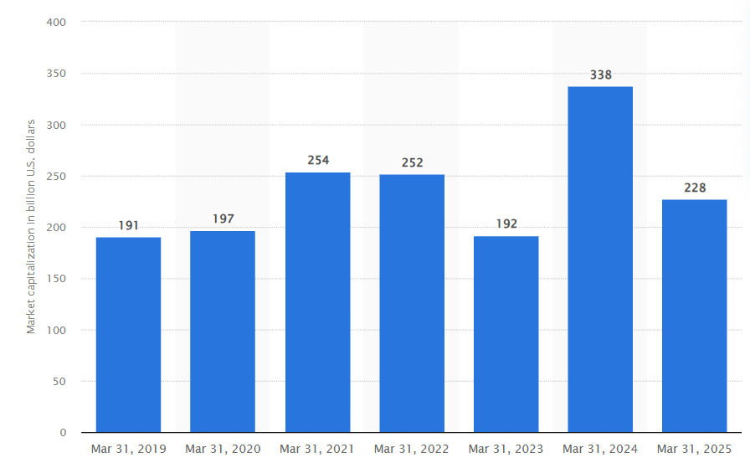
Figure 1: Toyota Motor Corporation's market capitalization between March 31, 2019 and 2025
(Source: Statista, 2020)
As of the end of March 2025, Toyota's market capitalization was recorded at 228 billion U.S. dollars. Currently, global marketing has become significant in the automobile industry. It is due to the increased global competition, environmental regulations, and rapid technological advancements, along with changing preferences of the customers towards sustainable mobility (Dakić et al. 2024). Therefore, the multinational automobile manufacturers need to adapt their marketing strategies, in accordance with the different political, economic, social, technological, environmental and legal aspects, across the global markets. In addition, cultural diversity influences the purchasing behaviours of the customers, their brand perceptions and also communication preferences. It makes the global marketing strategy a critical determinant of the competitive advantages in the long-term.
This report is going to analyse the international marketing strategy of Toyota, through the comparative analysis of Japan. It represents the domestic market of the company, along with the UK, as one of the strategically important overseas markets of Toyota. In addition, the study will also analyse the globally recognised marketing frameworks, such as the PESTEL framework, Hofstede’s Cultural Dimensions Theory, Segmentation, Targeting and Positioning (STP), 7Ps of Marketing Mix, along with the global market entry theories. These frameworks help in examining the strategic decisions of Toyota within both markets. Furthermore, the report will analyse the ethical issues involved with the international marketing activities of Toyota and also propose action-based recommendations to strengthen the future global marketing performances of the company in the increasingly competitive and sustainability-focused automobile industry.

Overview of the company
Toyota Motor Corporation was founded by Kiichiro Toyota as a spin-off from the “Toyota Automatic Loom Works” (Toyota, 2026b). It has evolved subsequently into one of the influential multinational automobile manufacturers across the globe. The organisation has headquarters in Toyota City, and it has developed its global reputation through technological innovation, high manufacturing quality, continuous innovation, such as Kaizen, along with the globally recognised “Toyota Production System” (Toyota, 2026c). These operational capabilities of the organisation have allowed Toyota to maintain a competitive advantage in the highly dynamic automobile industry across the globe.
The product portfolio of the organisation encompasses family sedans, compact vehicles, luxury vehicles under the Lexus brand, sport utility vehicles, commercial vehicles, battery electric vehicles, hybrid electric vehicles, and hydrogen-powered vehicles (Toyota, 2025). In addition, the iconic models of the organisation include Camry, Corolla, Land Cruiser, Hilux, Prius and the bZ4X have strengthened the global brand equity of Toyota, by appealing to the diverse customer segments across the developed as well as emerging markets.
In this regard, the UK represents one of the most significant international markets for Toyota (Bhattacheryay, 2023). Since the time of developing its manufacturing operations in Burniston, Derbyshire, in the early 1990s, the organisation has adequately invested in the research, local production, supply chain development and employment. In addition, the manufacturing facilities in the UK have allowed the organisation to respond effectively to the demands of the domestic customers, while also reducing the costs of transportation and improving operational flexibility. However, it is important to note that Toyota has faced challenges, which mainly arise from Brexit, supply chain disruptions, strict environmental legislation, and accelerating transformation towards electric vehicles.
Therefore, the global marketing strategy of Toyota reflects the perfect balance between standardisation and adaptation (Chloe Williment, 2026). Despite the fact that the organisation maintains consistent global values, which are centred on reliability, quality and sustainability, it also modifies its product, pricing, distribution channels and promotional campaigns to accommodate different economic conditions, cultural expectations and the regulatory environment. Thus, the strategic balance develops the foundation for the long-term global competitiveness of Toyota.

a. A comparative analysis of the market in both countries:

PESTEL Analysis
PESTEL analysis helps to analyse the macro-environmental factors that influence the strategic decisions of the organisation within the global markets (Karadzhov and Patarchanova, 2025). In the case of the multinational automobile manufacturers, such as Toyota, it is important to understand the differences in political, economic, social, technological, environmental and legal aspects, while designing the international marketing strategies. Even though Japan represents the domestic market of Toyota, the UK remains one of the significant overseas markets, due to its already established manufacturing operations, with a mature automobile sector and a commitment towards sustainable transportation.
Factors | Japan | UK | Analysis
Political | The government of Japan has actively supported the automobile industry through industrial innovation and adequate investment in advanced battery research, hydrogen fuel-cell technology, and autonomous driving systems (Dzienis and McCaleb, 2025). It is found that in 2024, Japan allocated billions of yen to accelerate investment in the next-generation mobility solutions. Therefore, Toyota has positioned the hydrogen technology, along with hybrid vehicles, as the key component of the future product strategy. | The political environment in the UK has been significantly influenced by Brexit (Dudley and Gamble, 2023). It is found that the withdrawal of the UK from the European Union caused increased customs procedures, supply chain complexities, and shortages of workforce for the autonomous manufacturers. It also creates uncertainties for the global manufacturers that operate in the UK. However, despite the challenges, the government in the UK has reinforced its commitment towards zero-emission transportation by introducing a gradual phase-out of new diesel and petrol vehicle sales by 2025, while also continuing financial support for the development of the EV infrastructure. | Therefore, it can be stated that politically, Toyota faces relatively predictable policy support in Japan. On the other hand, the strategy of the UK needs adequate flexibility to respond to the rapidly changing trade regulations as well as post-Brexit economic conditions.
Economic | Economic conditions have a direct impact on the purchasing power of the customers, financing options, and the demands for the different vehicle categories. In the case of Japan, it is the 4th largest economy in the world, with a nominal GDP exceeding US$4.2 trillion in 2024 (Straitstimes, 2024). In addition, the household purchasing behaviour of Japan is mainly characterised by careful spending decisions, which encourages Toyota to focus on reliability, long-term value, and fuel efficiency, within domestic marketing campaigns. | On the contrary, the UK recorded the GDP of around US$3.6 trillion in 2024, with the economic growth remaining constrained by the inflationary pressure, outbreak of the pandemic and Brexit-related adjustment (EBSCO, 2024). Despite the inflation in the UK in 2023, it still remained above the long-term target of the Bank of England in 2024. Therefore, the customers in the UK have become price-sensitive when purchasing the new vehicles. It encourages Toyota to expand flexible financing packages and promote hybrid vehicles. | In the case of Toyota, the economic conditions present both opportunities and challenges. Despite the fact that Japan provides a stable and relatively mature customer base, with strong brand loyalty. On the other hand, the UK provides high growth potential for electric and hybrid vehicles. However, it needs highly competitive pricing due to the increasing economic uncertainty.
Social | Japan possesses one of the oldest populations in the world, with around 30% of the citizens of the country being above 65 years, whereas the population decline continues to reduce the demand for domestic vehicles in the long-term (Sakamoto, 2025). Therefore, the customers in Japan increasingly prioritise safety, reliability, fuel efficiency and ease of maintenance of the vehicle, instead of only aesthetic characteristics. Therefore, the marketing of Toyota within Japan highlights advanced safety technologies, dependability, and long-term ownership value. | On the other hand, the UK has a young and culturally diverse population, with urbanisation. In addition, environmental awareness has increased substantially among the customers in the UK, specifically young people, who consider sustainability while making purchase decisions (Norton et al. 2023). It is also found that the environmental performance of new vehicles represents one of the influential factors that affects the selection of vehicles among customers in the UK. | The ability of Toyota to adapt its marketing communications in accordance with the demographic and lifestyle differences demonstrates the significance of responsiveness to the local markets. However, the standardised global campaigns would fail to address the unique expectations of the British and Japanese customers. It highlights the importance of maintaining a balance between brand consistency and cultural adaptation.
Technological | Technological innovation has become one of the key competitive drivers in the global automobile industry (Fan and Iqbal, 2022). In this, Japan remains among the leading countries in the world in terms of AI, robotics and advanced manufacturing technologies, with adequate investment of around 3.7% of the GDP in R&D. The innovation ecosystem has allowed Toyota to maintain leadership in hybrid technology through continuous improvements to the Corolla Hybrid, Prius and next-gen battery systems. | On a similar note, the UK has accelerated investment in the EV charging infrastructure, autonomous driving technologies and connected mobility through partnerships of government and industry (Marson and Ferris, 2025). However, compared to Japan, it can be stated that the UK heavily depends on the global manufacturing networks for advanced automotive production. | The technological leadership of Toyota provides a key competitive advantage for both markets. However, increasing competition from the leading manufacturers, such as BYD, Tesla, and Volkswagen need significant technological innovation, beyond the adoption of hybrid vehicles.
Environmental | Japan has already developed ambitious environmental policies that aim to attain Carbon Neutrality by the end of 2050, with the government promoting a diversified approach to low-carbon mobility through the hybrid electric vehicles, hydrogen fuel-cell vehicles and battery electric vehicles (Kato et al. 2023). The adequate public investment in the hydrogen infrastructure and the Green Growth strategy have created a favourable environment for Toyota. | The UK has adopted one of the most ambitious environmental regulatory frameworks in Europe to decarbonise the transportation sector. For instance, the government has already committed to attaining Net-Zero emissions by the end of 2050 and also introduced the Zero Emission Vehicle mandate, which requires manufacturers to increase the proportion of zero-emission vehicle sales every year (Sen and Miller, 2022). | Therefore, it can be stated that the domestic marketing strategy of Toyota is closely aligned with the national environmental priorities, by promoting fuel efficiency, technological innovation and low carbon emissions, instead of relying only on battery electric vehicles. However, in the case of the UK, the organisation has faced criticism from environmental organisations for adopting a slow transition towards fully battery-electric vehicles.
Legal | Japan maintains one of the most rigorous automobile regulatory systems in the world (Singh et al. 2023). For instance, it ensures a higher standard of product quality, vehicle safety and also environmental performance. In addition, under the Road Transport Vehicle Act and strict emission regulations, the automobile manufacturers must comply with the testing, continuous technological improvements and periodic inspections. | The legal environment of the UK has undergone a major change after Brexit (Fontanelli, 2023). It requires automobile manufacturers to adapt to the new trade regulations, domestic compliance requirements, and customs procedures. Therefore, Toyota must comply with the General Product Safety Regulations in the UK and the General Data Protection Regulations in the UK, including setting annual sales targets for zero-emission vehicles. | Therefore, the stable legal environment provides Toyota with a secure platform for product development and sustainable competitive advantages in the long-term. On the other hand, even though these legal requirements increase costs of operation, it also encourages innovation and support the long-term sustainability objectives of Toyota.
Overall, the PESTEL analysis demonstrates that Toyota cannot rely on a uniform international marketing strategy across Japan and the UK. On the one hand, Japan is a stable environment for the company’s hybrid and hydrogen-based strategy. On the other hand, the UK imposes stricter regulations and competitive pressure on Toyota, which makes an accelerated EV adoption inevitable. Accordingly, Toyota’s international competitiveness depends on achieving the right combination of consistent global branding and adaptation to particular markets. Compared to such rivals as Tesla and BYD, Toyota’s relatively slow pace of moving towards electric vehicles may affect its competitive position in those markets with rapidly changing environmental regulations and high customer demand.

Hofstede framework
Hofstede’s Cultural Dimensions Theory can be discussed in the context that provides a key framework to understand how the national culture influences the behaviours of the customers, their purchase decisions and also the marketing strategies (Żemojtel-Piotrowska and Piotrowski, 2023). Being a multinational company, Toyota must maintain a balance between global brand consistency and local cultural adaptation to engage customers across culturally diverse markets.
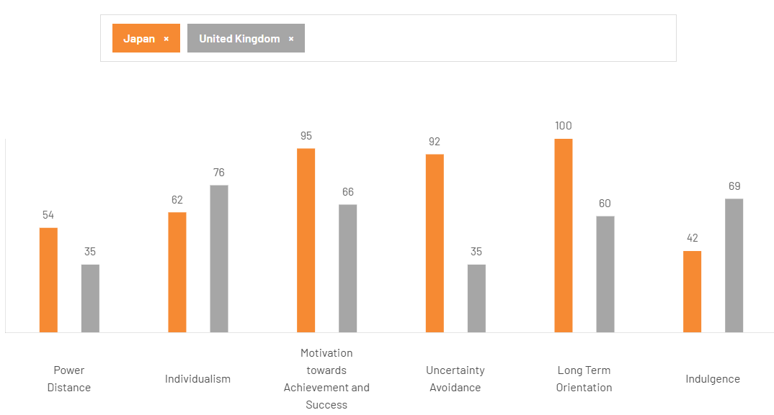
Figure 2: Cultural comparison between the UK and Japan
(Source: The cultural factor, 2026)
Applying this theory, in the context of Japan and the UK, it is found that the first dimension, such as power distance, shows the extent to which the societies accept unequal distribution of power. In this, Japan scores 54, whereas the UK scores 35 (the cultural factor, 2026). It suggests that the customers in Japan show relatively great acceptance of the hierarchical structure and authority. Therefore, the domestic marketing of Toyota focuses on engineering excellence, corporate heritage and technological expertise to reinforce credibility and trust. On the contrary, the customers in the UK prefer more egalitarian relationships with the brands and also value authenticity, transparency and customer engagement. Therefore, the marketing campaigns of Toyota in the UK frequently adopt the conversational communication style, identifying the customer experiences, instead of corporate authority.
In addition, in terms of individualism, the UK scores 76, which is higher than Japan, which scores 62. For instance, the customers in the UK are generally individualistic and seek products that reflect lifestyle, personal identity and self-expression (the cultural factor, 2026). Therefore, Toyota responds to this by promoting advanced technology, vehicle customisation, and lifestyle-oriented advertising, specifically for the models, such as the Corolla Cross and C-HR. On the contrary, although Japan shows moderate individualism, the customers place great focus on social harmony and collective well-being. Therefore, the domestic advertisement of Toyota portrays reliability, family values, and ownership in the long-term. In addition, in terms of masculinity, Japan records a high score of 95, as compared to the UK, with a score of 66. It shows that the society of Japan places a focus on competitiveness, achievement, and professional success. In the case of Toyota, the organisation capitalises on these cultural characteristics by focusing on product quality, engineering precision, and continuous innovation through the principle of Kaizen.
However, the major differences lie in uncertainty avoidance, where Japan scores 92, which is higher than the UK. For instance, the customers in Japan prefer certainty, products with proven reliability and detailed information, before making purchasing decisions. The cultural characteristics benefit Toyota, whose reputation for safety, durability, and after-sales services reduces perceived risks of purchasing. On the contrary, the customers in the UK are comfortable with uncertainty and innovation. It makes them more receptive to the emerging technologies, including digital purchasing platforms, electric vehicles, and connected mobility services (Pérez-Moure et al. 2023). Therefore, Toyota integrates digital marketing, flexible financing and online vehicle configurators within the marketing strategy of the UK. In addition, in the case of long-term orientation, Japan attains the score of 100, as compared to the UK, which scores 60. It reflects the strong focus on long-term planning, sustainable value creation and continuous improvement in Japan. Therefore, the entire corporate philosophy of Toyota, such as the Toyota Production System, along with the investment in the hybrid technology, reflects the cultural orientation. In the UK, although long-term considerations are important, customers tend to prioritise technological convenience, immediate value, and lifestyle benefits.
Furthermore, indulgence shows the key cultural aspect. For instance, the UK scores 69, whereas Japan scores 42 (the cultural factor, 2026). It indicates that the customers in the UK place great focus on leisure, enjoyment, and personal gratification. Therefore, Toyota responds by positioning its UK-based models around design, enjoyment and connectivity. On the contrary, the customers in Japan exhibit great restraint, valuing practicality and also responsible consumption. Therefore, the domestic marketing of Toyota focuses heavily on fuel efficiency, functionality, and dependable ownership, instead of emotional appeal. While Hofstede’s framework is very informative in terms of culture differences, one cannot rely solely on national culture as it may overlook many aspects of consumer behavior. Moreover, buying behavior is influenced by other factors, such as level of income, technology trends, environmental awareness, and personal lifestyle.

b. A comparative analysis of STP (Segmentation, Targeting, and Positioning) and International Marketing Mix (7Ps) strategies in both countries
Segmentation, Targeting and Positioning (STP)
Lestari (2023) has stated that STP allows multinational companies to identify the heterogeneous customer groups and also develop marketing strategies that reflect the conditions of the local markets. In the case of Toyota, despite its global brand identity, it is centred on reliability, quality and innovation. The organisation adopts the differentiated STP strategies in Japan and the UK, due to the differences in the customer lifestyles, demographic characteristics, and also purchasing behaviours of the customers.
Segmentation
It is found that Toyota applies the different segmentation variables, including demographic, geographic, psychographic and behavioural segmentation in both the markets.
In Japan, the demographic segmentation is mainly influenced by the ageing population, increasing urbanisation and declining birth rates. It is found that around 29% of the population in Japan is aged 65 years and above. It results in the increasing demand for fuel-efficient, compact and also technologically advanced vehicles, that prioritises reliability and safety.
On the other hand, segmentation within the UK reflects the young and culturally diverse population, with the great variations in lifestyle preferences. The customers in the UK increasingly value environmental sustainability, flexible ownership and vehicle connectivity. Therefore, Toyota Segments the markets based on the urban professionals, environmentally conscious families, first-time electric vehicle buyers and fleet operators. In terms of behavioural segmentation, it also differs between the two markets. The customers in Japan mainly exhibit strong brand loyalty, and also prioritise ownership value in the long-term. On the other hand, the customers in the UK are likely to compare the competing brands before purchasing and are also influenced by social media recommendations, digital reviews and sustainability credentials. These behavioural differences need Toyota to customise customer engagement across both markets.
Targeting
It is found that Toyota adopts a differentiated targeting strategy by serving different customer segments, instead of concentrating on a single niche market (Takeuchi et al. 2023). In the case of Japan, the organisation mainly targets middle-income households, business users, and elderly customers, along with the environmentally-conscious drivers, through its extensive hybrid vehicle portfolio. The domestic market also focuses on the reliability, long-term ownership and after-sales services, which allows Toyota to leverage its reputation as the most trusted automobile manufacturer in Japan.
On the contrary, the targeting strategy of the UK places greater focus on the environmentally-conscious customers, young professionals, families and fleet operators who seek affordable hybrid technology. The rapid development of environmental awareness, along with government incentives, mainly supports the low-emission vehicles. It has encouraged Toyota to strengthen its electric and hybrid vehicles in the UK.
Positioning
Toyota positions itself across the globe as the manufacturer of reliable, high-quality and technologically innovative vehicles. However, its positioning strategy demonstrates subtle adaptation across the two markets. For instance, in Japan, Toyota is positioned as the symbol of continuous innovation, national engineering excellence, and dependable long-term value.
On the other hand, in the UK, the positioning of Toyota extends beyond reliability, by focusing on hybrid leadership, sustainability, along with the environmental responsibility. In this, the promotional campaigns focus on the reduction of carbon emissions, lowering the costs of fuel and also supporting a green lifestyle. Thus, the differentiated strategy of positioning allows Toyota to compete against rivals such as Volkswagen, Tesla, Nissan, Hyundai, and others. Therefore, it is important for Toyota to maintain a balance between global brand consistency and local market adaptation.
Marketing Mix
Product
Toyota adopts the standardised product strategy partially, while also integrating the local adaptation, in accordance with the market characteristics (Lin et al. 2023). In Japan, the product portfolio of the organisation includes compact hatchbacks, kei cars, hybrid sedans, hydrogen-powered vehicles and others. These are mainly designed to accommodate dense urban environments, national sustainability priorities, and ageing customers.
On the other hand, the UK market shows strong demand for crossover vehicles, SUVs, and electrified family vehicles. Therefore, Toyota places focus on the models, such as C-HR Hybrid, Corolla Hybrid, battery-electric bZ4X and others.
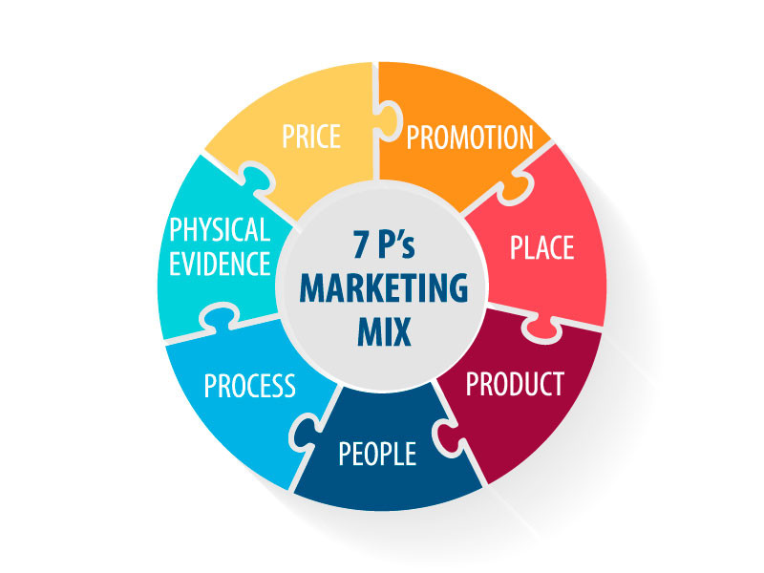
Figure 3: 7P’s Marketing Mix
(Source: Furr, 2024)
Price
Toyota focuses on the value-based pricing strategy in both countries. However, it also adapts the pricing strategies in accordance with the economic conditions of the local market (Gustiyani and Nurmahdi, 2026). In Japan, strong domestic brand loyalty and stable economic conditions allow Toyota to maintain consistent pricing while also focusing on the lifetime ownership value, with low costs of maintenance.
Place
Toyota has developed highly integrated distribution networks within both countries. For instance, in Japan, the distribution depends on the extensive dealership networks. It is supported by the effective domestic manufacturing and logistics systems. In addition, the customers also benefit from the widespread dealer accessibility, along with integrated after-sales support. It reflects the commitment of Toyota to customer relationships in the long-term.
On the other hand, in the UK, Toyota combines the traditional dealership with the digital retail channels. It allows the customers to compare the models, arrange financing and also schedule the vehicle servicing digitally. For instance, the manufacturing operations at Burniston in Derbyshire strengthen the domestic supply chain of Toyota.
Promotion
It is found that Toyota maintains brand values globally. It is centred on innovation, quality and sustainability, while also adapting the promotional strategies in accordance with the cultural preferences (Takeuchi et al. 2023). For instance, in the promotional campaigns of Japan, the focus is on the safety, technological excellence, long-term reliability and engineering quality, through corporate communication, television advertising and also community engagement strategies.
On the contrary, the promotional activities in the UK heavily rely on digital marketing, social media platforms, influencer partnerships and also sustainability-focused campaigns. It highlights the carbon reduction as well as the use of hybrid technology. In addition, Toyota also collaborates with environmental strategies and sporting events to reinforce its reputation as a responsible corporate citizen.
People, Process and Physical Evidence
Toyota identifies that the customers' needs extend beyond vehicle quality to include the brand perceptions and service interactions. In the case of Japan, the employees receive adequate training based on key principles of Kaizen, customer respect and continuous improvement (Okpala et al. 2024). It ensures high service standards consistently throughout the customer journey. In addition, the processes include maintenance scheduling, vehicle purchasing and also after-sales support. It is designed to increase efficiency and also customer satisfaction in the long-term.
On a similar note, Toyota uses the principles within the UK, while integrating the greater digitalisation through the virtual consultations, line booking systems and electronic service management. The physical evidence differs slightly between the markets. For instance, the dealership in Japan focuses on the product expertise, operational efficiency and also technological sophistication. On the other hand, the showrooms in the UK integrate modern digital displays, sustainability messaging and interactive vehicle configurations to improve customer engagement.

c. An analysis of the market entry strategy in one of the countries
The expansion of Toyota in the UK represents one of the successful global market entry decisions. It shows how the multinational companies select the best models strategically, to maximise the competitive advantages in the long-term (İşiner and Aydın, 2023). Therefore, instead of focusing on exporting, Toyota adopted the Foreign Direct Investment mode by developing manufacturing operations at Burniston, Derbyshire, along with the engine manufacturing plant at Deeside, Wales. The strategy allowed Toyota to strengthen its presence in the European market while also reducing the costs of transportation and improving the responsiveness of the supply chain.
Applying Dunning’s Eclectic Paradigm, it can be stated that the decisions of Toyota's decision to invest directly in the UK is mainly based on the three interconnected advantages. It includes ownership, location and internalisation. At first, Toyota possessed the strong advantages of its ownership. It includes its advanced manufacturing capabilities, brand reputation, hybrid technology and also Toyota Production Systems. On the other hand, the UK provided the location advantages. For instance, before Brexit, the UK had unrestricted access to the Single Market of Europe (Marson and Ferris, 2025). It allows Toyota to manufacture vehicles domestically, while also exporting them across Europe. Furthermore, the internalisation advantages allowed Toyota to maintain direct control over the manufacturing, supply chain operations and quality assurance, instead of licensing the production to external organisations. Therefore, the market entry strategy of Toyota has generated long-term benefits. For instance, the local manufacturing operations have developed relationships with the suppliers, minimised the costs of logistics and also enhanced the ability of Toyota to respond to the rapidly changing demands of the customers in the UK market.

d. An evaluation of whether there were ethical issues related to this brand’s marketing mix in one country
One of the ethical concerns related to the marketing mix of the brand is environmental marketing, aligning with the transition of Toyota towards battery electric vehicles. Historically, Toyota has promoted hybrid vehicles as a practical solution to reduce greenhouse gas emissions and improve fuel efficiency (Fan and Iqbal, 2022). Even though the hybrid technology has significantly contributed to reducing vehicle emissions, as compared to traditional diesel and petrol vehicles, the environmental organisations have criticised Toyota for not investing in fully electric vehicles, as compared to its key competitors such as Volkswagen, Tesla, BYD and others (Hong, 2024). This concern also raises the questions of accuracy as well as transparency of the environmental claims, such as risks of greenwashing.
On the other hand, the other ethical concern involves responsible sourcing within the global supply chains. The rapidly growing demands for lithium-ion batteries have intensified the scrutiny of raw materials sourcing, specifically related to lithium, cobalt and nickel extraction (Kalungi et al. 2024). The customers also expect the multinational manufacturers to ensure that the suppliers adhere to the human rights standards, ethical labour practices and also environmentally sustainable mining operations. Toyota has also responded by improving supplier monitoring and integrating sustainability audits.

e. Recommendations on how this company should go forward with their international marketing strategies
It is recommended that Toyota accelerate investment in advanced electric vehicles, while also maintaining leadership in hybrid technologies. Despite the fact that the hybrid vehicles continue to offer environmental benefits, the rapidly changing preferences of the customers and the increasing regulatory pressures show that adequate investment in fully electric mobility will improve the long-term competitiveness of Toyota and also strengthen its sustainability credentials.
On the other hand, it is also important for Toyota to expand the digital customer engagement through personalised marketing, artificial intelligence and omnichannel marketing (Battiston, 2025). The customers in the UK expect seamless online purchasing experiences and a virtual demonstration of the vehicles. Therefore, integration of the advanced digital technologies throughout the customer journey would improve customer satisfaction and also strengthen brand loyalty.

Section 2

Introduction
Reflection is considered an important aspect of both academic and professional development, as it allows individuals to analyse their learning experiences and also improve future practices (Fernandes et al. 2023). Applying Gibbs’ Reflective Cycle provides the structured framework that comprises six stages. It includes description, feelings, evaluation, analysis, conclusion and action plan (Nurlatifah et al. 2023). This reflection analyses my experiences of researching, analysing, and preparing the global marketing report on the marketing strategies of Toyota in Japan and the UK.

Figure 4: Gibb’s Reflective Cycle
(Source: McLeod, 2025)

Description
The purpose of the assessment was to analyse the international marketing strategy of Toyota by comparing its operations in both the UK and Japan, using the internationally identified marketing frameworks. The report needed me to apply the PESTEL framework, Hofstede’s cultural theory, STP and extended marketing mix. In addition, the international market entry theories and the ethical issues of the business are discussed. In order to complete the report, I collected the information from a wide range of textbooks, academic journals, government publications, along with the annual reports of Toyota, and industry reports. For this, I searched the academic databases to identify the relevant peer-reviewed articles in relation to the international marketing strategies, global marketing strategies, global automobile trends and the customer behaviour trends.

Feelings
At the start of the assignment, I felt confident about my understanding of the marketing principles. However, I am less confident in using the international marketing theories within the real-life example, such as Toyota. At first, I assumed that Toyota followed the largely standardised global marketing strategy, due to its strong brand image. However, as I have explored several academic literature and industry reports, I understand that the successful multinational companies must maintain a balance between the global consistency and the local adaptation in order to respond to the economic, cultural and regulatory differences. On the other hand, I have found the volume of available information overwhelming. However, with the progress of the research, I became confident to analyse diverse perspectives and also select evidence that supported my analysis. This experience challenged my initial assumption that successful global brands mainly rely on standardised marketing strategies.

Evaluation
Overall, I believe that the research process was successful, as it strengthened my academic knowledge, as well as my analytical capabilities. For instance, one of the positive aspects was the opportunity to implement the theoretical frameworks with real-life examples. For instance, using the PESTEL analysis allowed me to understand how the political, economic, and environmental factors influence the global marketing decisions. On the other hand, Hofstede’s Cultural Framework allowed me to modify the marketing communication of Toyota as well as product strategies across the countries. However, the challenges that I faced were maintaining the balance between the descriptive information about the company and the critical analysis. For instance, at first, I focused on analysing the marketing activities of Toyota, instead of analysing their effectiveness. Therefore, through a detailed review of the academic literature and theories, I improved my ability to analyse the strategic decisions. Thus, the experience highlighted that assignments need evaluation, interpretation, and synthesis, instead of only description.

Analysis
One of the key learning outcomes was a detailed understanding of the complexities involved in global marketing management. For instance, before undertaking the assessment, I underestimated the influence of the national culture on the marketing strategies. Therefore, using Hofstede’s Cultural Dimensions Theory, the customer behaviour is shaped by the embedded cultural values, that needs multinational companies to adapt communication, customer engagement and positioning strategy accordingly. It reinforced the theoretical analysis that the success of international marketing depends on maintaining a balance between standardisation and adaptation. On the other hand, the ethical analysis has expanded my understanding of the corporate responsibilities within international marketing. Previously, I have been involved with the analysis of marketing ethics in the advertising strategy. However, the assignment illustrated that ethical marketing extends to supply chain transparency, environmental responsibility, and customer data protection.
Conclusion
Based on the assessment, I believe that it has enhanced my understanding of multinational business management and international marketing strategy. The process illustrated that the successful international marketing extends beyond promoting products across the globe. It requires organisations to understand the economic conditions, local cultures, and political environments, along with the expectations of the customers, while also maintaining a consistent global identity. The experience reinforced the significance of using academic theories in practical business. With time, I feel confident to analyse the global marketing strategies and also make evidence-based recommendations.

Action Plan
Moving forward, I aim to improve my ability to analyse the academic literature by comparing the theoretical perspectives instead of focusing on the individual sources. It will also strengthen the quality of future assignments and improve my critical thinking skills.
In addition, I plan to develop a detailed understanding of the key international marketing-related challenges, specifically digital transformation, AI, sustainability, and customer analytics. As the global marketing environment continues to evolve, maintaining the current knowledge will enhance my ability to analyse the complex business issues.

References
Battiston, A. (2025). Redesigning the customer journey: digital technologies in the luxury automotive sector.
Bhattacheryay, S. (2023). Multinational working capital management a study on Toyota Motor Corporation. International Journal of Finance & Economics, 28(1), pp.236-256.
Chloe Williment (2026). How is Toyota Balancing EV Production and Sustainability? Available at: https://sustainabilitymag.com/news/how-is-toyota-balancing-ev-production-sustainability. (Accessed: 10th July 2026).
Dakić, P., Stupavský, I. and Todorović, V., (2024). The effects of global market changes on automotive manufacturing and embedded software. Sustainability, 16(12), p.4926.
Dudley, G. and Gamble, A. (2023). Brexit and UK policy-making: an overview. Journal of European Public Policy, 30(11), pp.2573-2597.
Dzienis, A.M. and McCaleb, A. (2025). Digital and green transitions and automotive industry reconfiguration: evidence from Japan and China. Journal of Contemporary Asia, 55(4), pp.618-644.
EBSCO (2024). United Kingdom. Available at: https://www.ebsco.com/research-starters/geography-and-cartography/united-kingdom. (Accessed: 10th July 2026).
Fan, W. and Iqbal, M., (2022). Economic, social, and environmental determinants of automotive industry competitiveness. Journal of Energy and Environmental Policy Options, 5(4), pp.36-43.
Fernandes, S., Araújo, A.M., Miguel, I. and Abelha, M. (2023). Teacher professional development in higher education: The impact of pedagogical training perceived by teachers. Education Sciences, 13(3), p.309.
Fontanelli, F. (2023). The law of UK trade with the EU and the world after Brexit. King's Law Journal, 34(1), pp.3-29.
Furr, R. (2024). The 7 Ps of Marketing. [online] Www.linkedin.com. Available at: https://www.linkedin.com/pulse/7-ps-marketing-rick-furr/ [Accessed 10 July 2026].
Gustiyani, A.R. and Nurmahdi, A. (2026). Determinants of Hybrid Car Purchasing Decisions: The Role of Price, Promotion, and People in Toyota Consumers. Journal of Sustainable Economic and Business, 3(2), pp.249-265.
Hong, J. (2024). Competitive Strategies and Market Positions of Global Automotive Giants: Toyota, Tesla, and BMW. In International Conference on Educational Information Technology (Vol. 6, No. 2).
İşiner, R.A. and Aydın, K., (2023). Strategies for Entry to International Markets: The Case of Japanese Companies. Turkish Journal of Marketing Research, 2(1), pp.40-49.
Kalungi, P., Yao, Z. and Huang, H. (2024). Aspects of nickel, cobalt and lithium, the three key elements for Li-ion batteries: an overview on resources, demands, and production. Materials, 17(17), p.4389.
Karadzhov, V. and Patarchanova, E. (2025). How to create the best PESTEL analysis. International Journal of Digital Research, 1(3), pp.8-20.
Kato, S., Lee, S., He, Y., Yoshioka, T., Morotomi, T. and Chewpreecha, U. (2023). Impact of carbon neutrality on the economy and industry, assuming Japan’s achievement of the 2030 power mix plan: a 2050 perspective based on the E3ME macro-econometric model. Energies, 16(18), p.6661.
Lestari, V. (2023). Strategic approaches to marketing management in contemporary business environments. Advances: Jurnal Ekonomi & Bisnis, 1(5), pp.255-268.
Lin, Q., Xiaoyu, L. and Jianqiang, Z. (2023). Global marketing standards and local adaptation: an analysis of the literature. International Journal of Management and Human Science (IJMHS), 7(2), pp.44-57.
Marson, J. and Ferris, K. (2025). The UK’s Intended Move to Electric, Connected, and Autonomous Vehicles: Are Infrastructural Barriers Preventing Successful Transition?. Transportation Law Journal, 50(1).
McLeod, S. (2025). Gibbs Reflective Cycle. [online] Simply Psychology. Available at: https://www.simplypsychology.org/gibbs-reflective-cycle.html [Accessed 7 July 2026].
Norton, V., Oloyede, O.O., Lignou, S., Wang, Q.J., Vásquez, G. and Alexi, N. (2023). Understanding consumers' sustainability knowledge and behaviour towards food packaging to develop tailored consumer-centric engagement campaigns: A Greece and the United Kingdom perspective. Journal of Cleaner Production, 408, p.137169.
Nurlatifah, L., Purnawarman, P. and Sukyadi, D. (2023), December. The implementation of reflective assessment using Gibbs’ reflective cycle in assessing students’ writing skills. In AIP Conference Proceedings (Vol. 2621, No. 1, p. 070006). AIP Publishing LLC.
Okpala, C., Nwamekwe, C.O. and Ezeanyim, O.C. (2024). The Implementation of Kaizen Principles in Manufacturing Processes: A Pathway to Continuous Improvement. International Journal of Engineering Inventions, 13(7), pp.116-124.
Pérez-Moure, H., Lampón, J.F., Velando-Rodríguez, M.E. and Rodríguez-Comesaña, L. (2023). Revolutionising the road: How sustainable, autonomous, and connected vehicles are changing digital mobility business models. European Research on Management and Business Economics, 29(3), p.100230.
Sakamoto, R. (2025). Ageing in Southeast Asia and Japan: challenges and opportunities. Geriatrics & Gerontology International, 25(7), pp.837-854.
Sen, A. and Miller, J. (2022). Emissions reduction benefits of a faster, global transition to zero-emission vehicles. International Council on Clean Transportation.
Singh, S., Kulshrestha, M.J., Rani, N., Kumar, K., Sharma, C. and Aswal, D.K. (2023). An overview of vehicular emission standards. Mapan, 38(1), pp.241-263.
Statista (2020). Toyota Motor Corporation: Market cap 2019-2025. [online] Statista. Available at: https://www.statista.com/statistics/279650/market-capitalization-of-toyota/?srsltid=afmboopzra4rm1qiuosnj-3riopsblcv4xmt0lhgq95gfwrah2vhn9es [Accessed 10 July 2026].
Straitstimes, (2024). Japan's GDP set to confirm slip to world’s 4th-largest economy. Available at: https://www.straitstimes.com/business/japan-gdp-set-to-confirm-slip-to-world-s-4th-largest-economy. (Accessed: 10th July 2026).
Takeuchi, I.Y., Ohmae, H.T. and Ichijo, K.K. (2023). Navigating Competition through Alliances: An Analysis of Toyota's Strategy in the Japanese Auto Industry. Journal of Strategic Management, 7(6), pp.1-12.
The cultural factor (2026). Country Comparison tool. Available at: https://www.theculturefactor.com/country-comparison-tool?countries=japan%2Cunited+kingdom. (Accessed: 10th July 2026).
Toyota (2025). INTEGRATED REPORT 2025. Available at: https://global.toyota/pages/global_toyota/ir/library/annual/2025_001_integrated_en.pdf?utm_source=openai. (Accessed: 10th July 2026).
Toyota (2026a). Toyota in the world. Available at: https://www.toyota-europe.com/about-us/toyota-in-the-world. (Accessed: 10th July 2026).
Toyota (2026b). The Beginnings. Available at: https://global.toyota/en/company/trajectory-of-toyota/history/01/. (Accessed: 10th July 2026).
Toyota (2026c). Toyota Production System. Available at: https://www.toyota-europe.com/about-us/toyota-vision-and-philosophy/toyota-production-system. (Accessed: 10th July 2026).
Żemojtel-Piotrowska, M. and Piotrowski, J. (2023). Hofstede’s cultural dimensions theory. In Encyclopedia of sexual psychology and behaviour (pp. 1-4). Cham: Springer International Publishing.

