Assessment 2: Image analysis
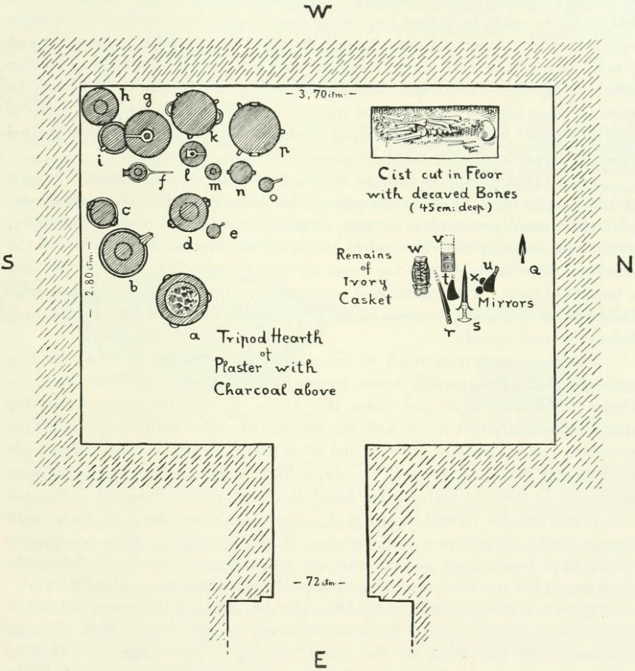

In the following paragraphs I will be analysing the above image, an archaeological drawing of Tomb 14 at Zapher Papoura, considering the grave, goods, body and other noted aspects of the tomb and how they relate to the treatment of this dead individual and any associated funerary ritual that may have taken place at this site. Specifically focusing on the position of the body within the tomb, it’s layout and the grave goods found within, and how they might help historians and anthropologists construct a vision of funerary ritual(s) that may have taken place at this site and their wider anthropological significance.
The first feature of note within Tomb 14 is the placement of the body within it. The tomb only contains the bones of one individual, buried in a cist cut into the floor, likely having been placed in a crouching position. As there are no other cists or man-made spaces cut into the ground, we can assume that this tomb was only ever intended for one inhumed occupant. The tomb and the cist itself appear to be cut very deliberately following compass directions so that the body is laid with their head facing north, with the tomb seemingly constructed to allow this when the body is placed in the upper right-hand corner, which is a common location for bodies in tombs such as this. There is no obvious explanation for this positioning found within the depiction of this tomb, but the placement and construction of the tomb is clearly deliberate, perhaps for spiritual reasons related to the transition of the body from one state of being to another. Throughout history, burial facing the East is common, so the deceased is ‘facing’ the sunrise, and many religions tell of a god or messiah figure arriving from the East. For the people at Zapher Papoura, the north may hold a similar significance, relate to belief in an afterlife or significant transition, or it may be that the body is buried purposefully facing towards or away from a particular building or settlement. In the case of the latter argument, it shows belief in the power of the body and the dead over the living world. If the body is facing towards a significant place, it may be thought of as a guardian or ancestor figure. Conversely, if facing away, this may indicate more practical concerns about the cleanliness of a dead body, furthering that association spiritually, as one who is able to cause harm or suffering, and thus may not be kept facing towards living members of the community. In either case, the positioning of the body appears deliberate, so likely has a spiritual reasoning behind it, perhaps one connected to the deceased, such as ancestor worship.
Aside from the orientation of the cist and tomb, it’s layout also holds some clues as to what funerary ritual may have looked like for the deceased individual. There appears to be enough space between the cis and the north-facing wall above the deceased’s head for an individual to stand, perhaps to say blessings or eulogies above the deceased, or to anoint them in some way. There is also some distance between the body and the grave goods laid out to the East of it, with knife handles positioned as if they were laid down by an individual facing the body. There are no grave goods pictured immediately next to or on top of the body, so their presence appears to show that their significance is more tied to ritual and the social construction present in leaving grave goods than their significance to any one individual. Their placement can read as mourners coming into the tomb, likely during the funeral, facing the body and laying down offerings or possessions of the deceased in front of them. They would be facing the body from side on, much like modern western mourners might at funerals before the body is inhumed or cremated. This is a separate area to where the hearth and jars are laid out, separating them into distinct features of the tomb and likely of the funerary ritual(s) that took place there. The grave goods themselves do not contain any jewellery or items crafted from precious metals, objects archaeologists associate with burials of high status or wealthy individuals, nor did the tomb appear to have been robbed or guarded against thieves, suggesting that no such ‘high status’ grave goods were ever deposited at tomb 14, perhaps signifying that the deceased was not an individual of high status, something unusual for a tomb such as this.
Another speculated feature of Minoan Crete funerary ritual is a feast or meal eaten ‘with’ the recently deceased as commemoration, community bonding or reinforcement of social contacts and roles. Such practice appears to have taken place in tomb 14, denoted by the presence of a tripod hearth and the size of the tomb, allowing for multiple people to come together for funerary ritual within the tomb. The many jars pictured in the top-left of the diagram may also have contained offerings of food and drink for the deceased, or for living mourners to consume as part of the funerary ritual, although funerary feasting would typically take place outside of the tomb. This indicates that no matter the status or wealth of the individual buried in tomb 14, they either had connections to their community and others who mourned for them, or that every member of the community was entitled to a ‘proper’ funeral complete with grave goods, food and drink and some form of a funeral in which community members come together to honour the deceased. While the exact reasoning for the presence of food and drink in ancient tombs is unclear, their inclusion in funerary ritual establishes an expectation for what is expected of ‘good’ or ‘proper’ funerary ritual, and the jars’ inclusion in tomb 14 implies that its occupant was treated as would be socially expected upon their death.
The above illustration of tomb 14 at Zapher Papoura, when considered in its proper historical and geographical context, reinforces contemporary ideas about Minoan funerary ritual with the presence of grave goods and its tripod hearth. This depiction of Tomb 14 also sheds light on potential beliefs around ancestors, the importance of where one is buried and in what orientation, and class relations in regard to funerary ritual, namely that being of lower status does not exclude one from being given a ‘proper’ burial and funeral.

Texts cited:
Evans, A. (2022). The Prehistoric Tombs of Knossos. Creative Media Partners, LLC. https://doi.org/10.11588/diglit.7525
Frothingham, N. L. (1876). The Custom of Burial with the Head Towards the East. Via The Atlantic. https://www.theatlantic.com/magazine/archive/1867/05/the-custom-of-burial-with-the-head-towards-the-east/628968/ accessed 15/03/2025.
Hamilakis, Y., & Sherratt, S. (2012). Feasting and the consuming body in Bronze Age Crete and Early Iron Age Cyprus. British School at Athens Studies, 20, 187–207. http://www.jstor.org/stable/23541209 accessed 15/03/2025.
Keswani, P. S. (2012). MORTUARY PRACTICES AND BURIAL CULTS IN CYPRUS FROM THE BRONZE AGE THROUGH THE EARLY IRON AGE. British School at Athens Studies, 20, 313–330. http://www.jstor.org/stable/23541216 accessed 14/03/2025.

Evans, (2022) p.36.
Frothingham (1867).
Evans, (2022) p.36.
Evans, (2022) p.37.
Hamilakis & Sherratt, (2012) p.187.
Keswani, (2012) p.316.
Keswani, (2012) p.317.

