Exploring the Relationship Between Sensation Seeking and Likelihood of Engaging in Risky Driving Behaviours

University of Wales Trinity Saint David

Abstract

Correlational study was conduct to support the hypothesis that higher sensation seeking scores will indicate greater likelihood of engaging in risky driving behavior (BRIAN A. JONAH, 1997). Twenty-six participants (5 males, 21 females) university students took part in an online study consisting of two questionnaires, one for testing sensation seeking and one for testing risky driving behavior tendencies. The results from the study were non-significant showing very week negative correlation between sensation seeking (M = 25.88, SD = 4.49) and risky driving behavior (14.57 SD = 7.88); r= -.07, n= 26, p > .05. The result are unabling the support of the hypothesis. It was concluded that due to the small sample size and poor gender distribution the results from this report were not sufficient for drawing conclusions about the relationship between the two variables. Larger sample and introduction of additional variables such as gender and age a required for better analysis in further studies.

Introduction

According to the World Health Organization (2018), each year road traffic collisions are responsible for over 1.25 fatal and between 20-50 million non-fatal injuries. Making it, the leading cause of death among people between the ages of 15 and 29. Although an argument can be made that a large portion of those injuries are the result of variables such as, poor infrastructural and vehicle maintenance, due to that 90 % of them occur in less economically developed countries (WHO, 2018). Researches conducted in developed nations such as the United States, demonstrate the overruling contribution of human factors (95%), to motor vehicle accidents (Ulleberg & Rundmo, 2003). The most notable of those being risk driving behavior (Ulleberg & Rundmo, 2003). Risk driving behavior (RDB), can be defined as a type of driving behaviors which can cause potential danger to the driver or to others, due to speeding, disregarding of traffic laws, driving under the influence of drugs and alcohol, driving anger (Dahlen et al., 2005; Jafarpour & Movaghar, 2014). Large portion of studies have been dedicated to determining the degree of influence on risk driving by variances such as sensation seeking. Sensation seeking (SS) is defined as a biologically influenced personality trait that manifest as a urge for experiencing physiological, novel, complex forms of arousal and the willingness for taking variety of physical financial, social et, risks as a mean for achieving such sensations (Johan, 1997; Stephenson, Hoyle, Palmgreen & Slater, 2003) . Whit the usage of variety of measuring scales, such as Zuckerman Sensation Seeking Scale (SSS-V), previous studies have demonstrated higher usage of alcohol and illegal drug by individuals with higher sensation seeking tendencies (Cain, Saucier & Bardo, 2005). Individuals how score higher on sensation seeking scales demonstrate higher tendency, to engage in risk driving behavior like speeding compared to lower sensation scorers. “Horvath and Zuckerman’s (1993) factor analysis of their Risk Appraisal Scale identified a Crime factor, which included driving while drunk, and a Minor Violations factor, which included involvement in collisions as a result of running red lights or speeding. High SSs scored higher than low SSs on the Crime and Minor Violation factors (r=0.53 and 0.43, respectively). Perceived personal risk of engaging in the risky activities was negatively correlated with SS such that high SSs believed their risk was lower than that of low SSs (r=−0.32 and −0.23)’’ (Johan, 1997, p. 657).
The present study uses Brief sensation seeking scale (BSSS), as a measuring tool for sensation seeking. The BSSS is a more economical version of Zuckerman Sensation Seeking Scale (SSS-V), “researchers who use the BSSS as a measure of sensationseeking should feel confident deriving predictions from published findings based on Form V of the Sensation Seeking Scale” (Hoyle, Stephenson, Palmgreen, Lorch & Donohew, 2002, p.412).
Previous studies investigating the relationship between sensation seeking and risky driving behavior using SSS-V as a measure of sensation seeking have established consistent positive relationship between SS and RDB ‘‘ r=0.43 between SS and Violations factor which includedand speeding running red lights and speeding collisions, SSS correlated −0.36 with safety motives and −0.29 with, Max. speed skill motives and acceleration SSS correlated 0.30 with max. speed and 0.27 with acceleration’’ (Johan, 1997, p. 658).
Based on this, the following study hypothesized that there will be low positive correlation between sensation seeking and risky driving behavior.

Method

Participants

Twenty-six participants (5 males, 21 females), students from an undergraduate psychology course at University of Wales Trinity Saint David (24 out of 26 self-indicated regular drivers), ranging in age from 18 to 60 (M = 27.57, SD = 11.13).

Design

Correlational analysis used for confirming the relationship between two co-accruing variables, sensation seeking and risky driving behavior.

Materials

Web-based study composed of Brief Sensation Seeking Scale and Risk driving questioner. Questioner 1: Brief Sensation Seeking Scale (Stephenson et al., 2003) containing 8 items (see appendix A), to determine the level of sensation seeking tendencies in participants. Responses are indicated on five-point scales ladled: strongly disagree = 1, Disagree = 2, neither disagree nor agree = 3, agree = 4, strongly agree = 5. Range of scores between 8 and 40. Higher scores indicated greater sensation seeking tendencies. Questioner 2: Risky driving questioner (Ivers et al., 2009) containing 14 items (see appendix B) Rating scales were used to determent the likelihood of expressing specific driving behavior. Possible responses ranged from very often = 4, often = 3, sometimes = 2, hardly ever = 1, and never = 0; the total range of scores was 0 to 56. Demographic information was gadder via form (see appendix C). Consent form (see appendix D). Debrief form (see appendix E).

Procedure

The participants received an email with a link to an online study consisting of two questioners. Before engaging whit the first questioner, they were asked to read and ''sign'' study information and consent form. After which they were required to fill demographic information sheet. On its completion the first questioner (BSSS) was displayed. The participants were asked to respond to eight statement using responses ranging from strongly disagree to strongly agree. After the completion of the first questioner the second questioner (RDB) was displayed. The participants were asked to answer as honestly as possible about how frequently they engage in risky driving behaviors such as speeding, by using rating scales ranging from ‘‘very’’ often to ‘‘never’’. After the completion of the questioner a debrief form was displayed, explaining the aim of the study and possible withdraw method. A submit button was clicked after which the study was concluded.

Results

A one-tailed correlational analysis was computed to test whether higher levels of sensation seeking would be related to greater likelihood of engagement in risky driving behaviors. The results from the study (see appendix F) were non-significant, showing week negative correlation between sensation seeking (M = 25.88, SD = 4.49) and risky driving behavior (M= 14.57 SD = 7.88); r= -.07, n= 26, p > .05. Therefore, the original hypothesis that higher sensation seeking levels will indicate greater likelihood of engaging in risky driving behavior was not supported.

Discussion

In contrast to privies literature, the results from the study indicate non-significant, weak negative correlation between the two variables unabling the support of the initial hypothesis. Possible reasons for this may be the exclusion from variables such as gender and age from the analysis. The present sample has been consisting predominantly female participants (21 females to 5 males). Men are found to score higher on Sensation seeking scales in areas such as seeding and drunk driving (Johan, 1997). Meaning that the inclusion of more male participants will increase the positive correlation between the variables. Age is also found to be a predictor of higher risky driving tendencies. According to Bjшrnskau (as cited in Ulleberg, 2003) adolescents are more frequently involved in traffic accidents as compared to other age groups (p.428). ‘‘There is some evidence that this relationship may weaken with age (e.g. Johnson and Raskin White, 1989), which may occur because of the growing importance of other influencers of risky driving (e.g. driving experidrivers ence, maturity) or it could simply be due to reduced variability in SS scores with increasing age which limits the ability to obtain statistically significant relationship’’ (Johan, 1997, p. 658). Larger sample and introduction of additional variables such as gender and age a required for better analysis in further studies

References

Cain, M. E., Saucier, D. A., & Bardo, M. T. (2005). Novelty seeking and drug use: Contribution of an animal model. Experimental and Clinical Psychopharmacology, 13(4), 367. Retrieved from http://dx.doi.org.ezproxy.uwtsd.ac.uk/10.1037/1064-1297.13.4.367

Dahlen, E. R., Martin, R. C., Ragan, K., & Kuhlman, M. M. (2005). Driving anger, sensation seeking, impulsiveness, and boredom proneness in the prediction of unsafe driving. Accident Analysis & Prevention, 37(2), 341-348. Retrieved from https://www.sciencedirect.com/science/article/pii/S0001457504000995

Hoyle, R. H., Stephenson, M. T., Palmgreen, P., Lorch, E. P., & Donohew, R. L. (2002). Reliability and validity of a brief measure of sensation seeking. Personality and individual differences, 32(3), 401-414. Retrieved from https://doi.org/10.1016/S0191-8869(01)00032-0

Ivers, R., Senserrick, T., Boufous, S., Stevenson, M., Chen, H. Y., Woodward, M., & Norton, R. (2009). Novice drivers' risky driving behavior, risk perception, and crash risk: findings from the DRIVE study. American journal of public health, 99(9), 1638-1644. Retrieved from https://www.ncbi.nlm.nih.gov/pmc/articles/PMC2724457/

Jafarpour, S., & Rahimi-Movaghar, V. (2014). Determinants of risky driving behavior: a narrative review. Medical journal of the Islamic Republic of Iran, 28, 142. Retrieved from https://www.ncbi.nlm.nih.gov/pmc/articles/PMC4322337/

Jonah, B. A. (1997). Sensation seeking and risky driving: a review and synthesis of the literature. Accident Analysis & Prevention, 29(5), 651-665. Retrieved from https://ac.elscdn.com/S0001457597000171/1-s2.0-S0001457597000171-main.pdf?_tid=da8563db-722e-491c-9f15-86e335d37659&acdnat=1525155835_b19f8ee5d470396cd366cdb21b3a4435

Stephenson, M. T., Hoyle, R. H., Palmgreen, P., & Slater, M. D. (2003). Brief measures of sensation seeking for screening and large-scale surveys. Drug & Alcohol Dependence, 72(3), 279-286. Retrieved from https://www-sciencedirect-com.ezproxy.uwtsd.ac.uk/science/article/pii/S0376871603002382
Ulleberg, P., & Rundmo, T. (2003). Personality, attitudes and risk perception as predictors of risky driving behaviour among young drivers. Safety science, 41(5), 427-443. Retrieved from https://www.sciencedirect.com/science/article/pii/S0925753501000777

World Health Organization. (2018, February 19). Road traffic injuries. Retrieved from http://www.who.int/en/news-room/fact-sheets/detail/road-traffic-injuries

Appendix A

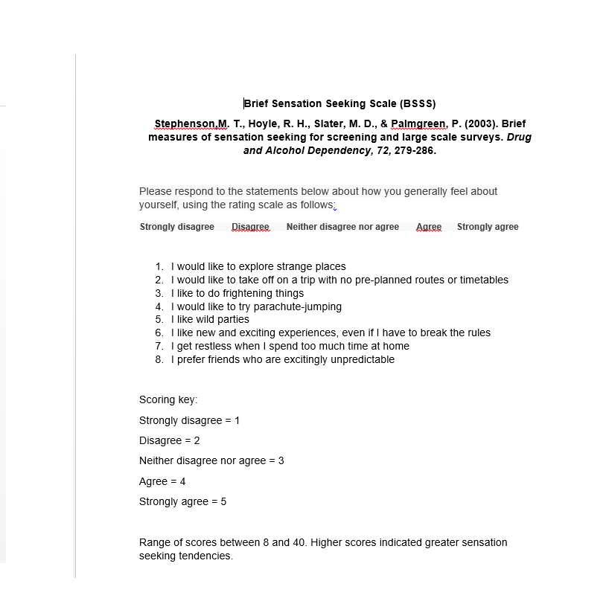

Appendix B

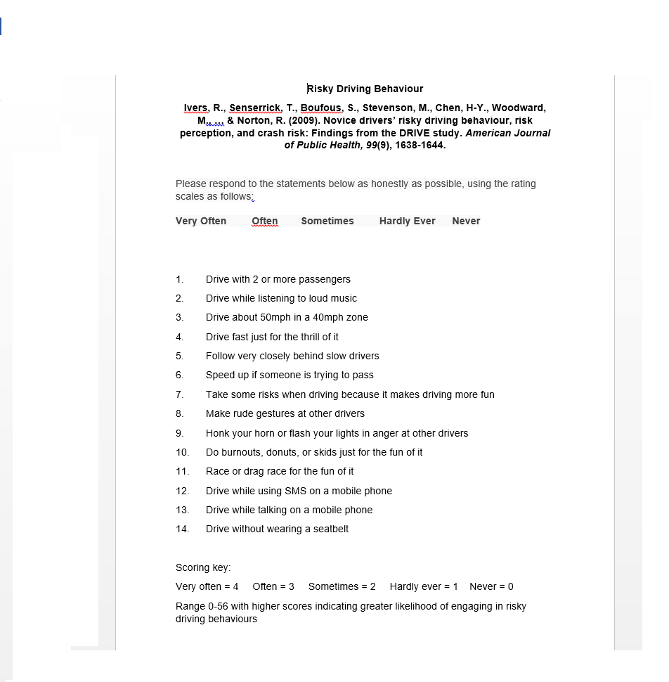

Appendix C

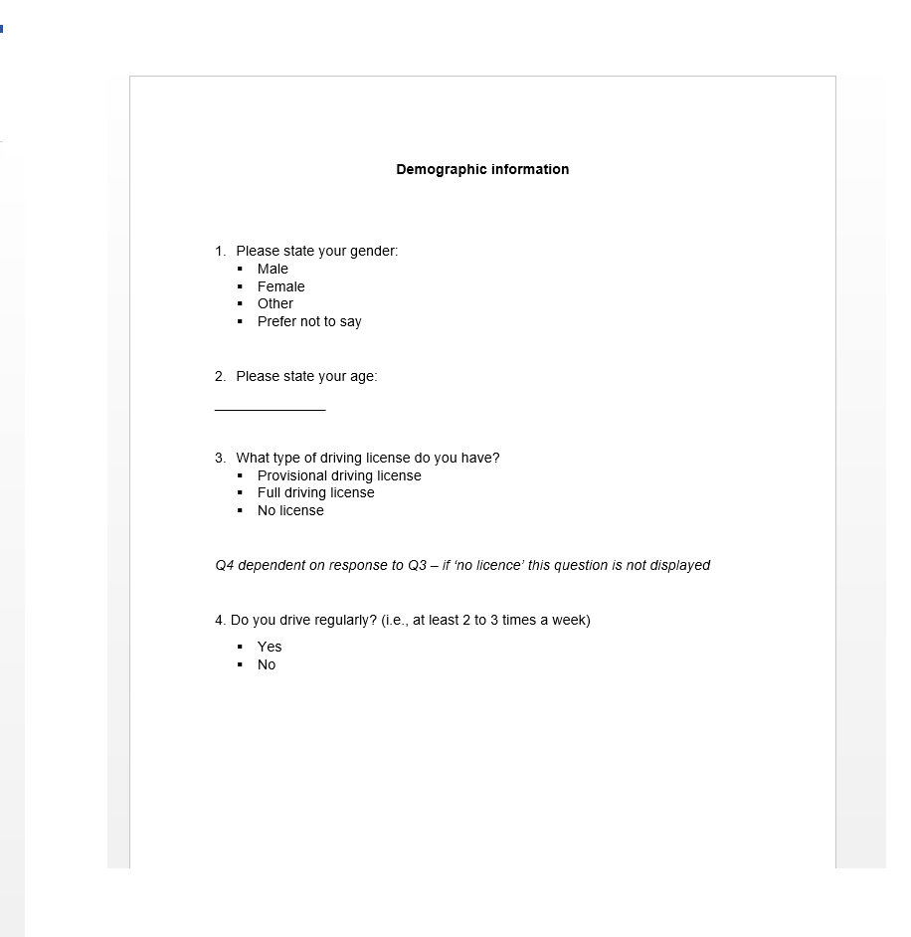

Appendix D
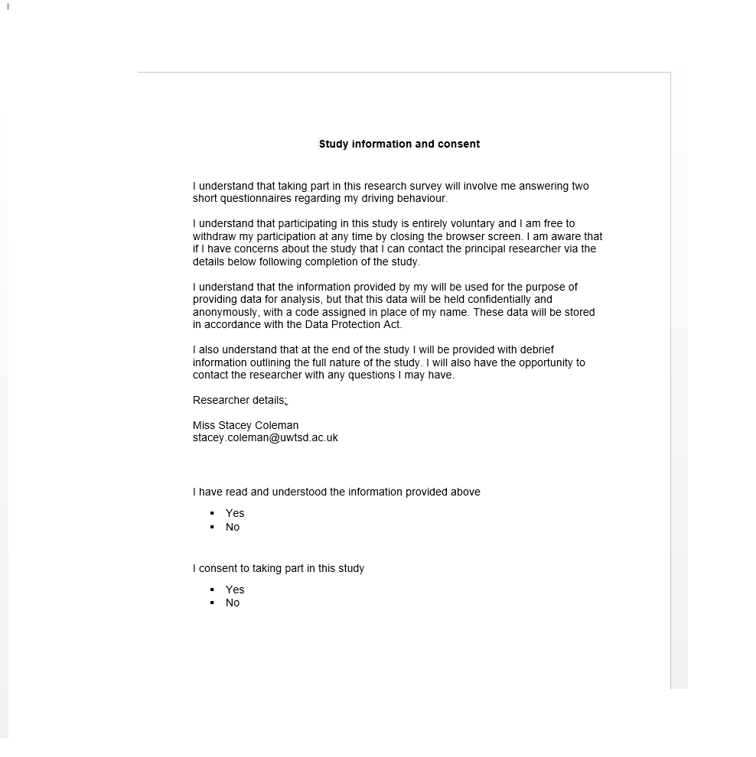

Appendix E

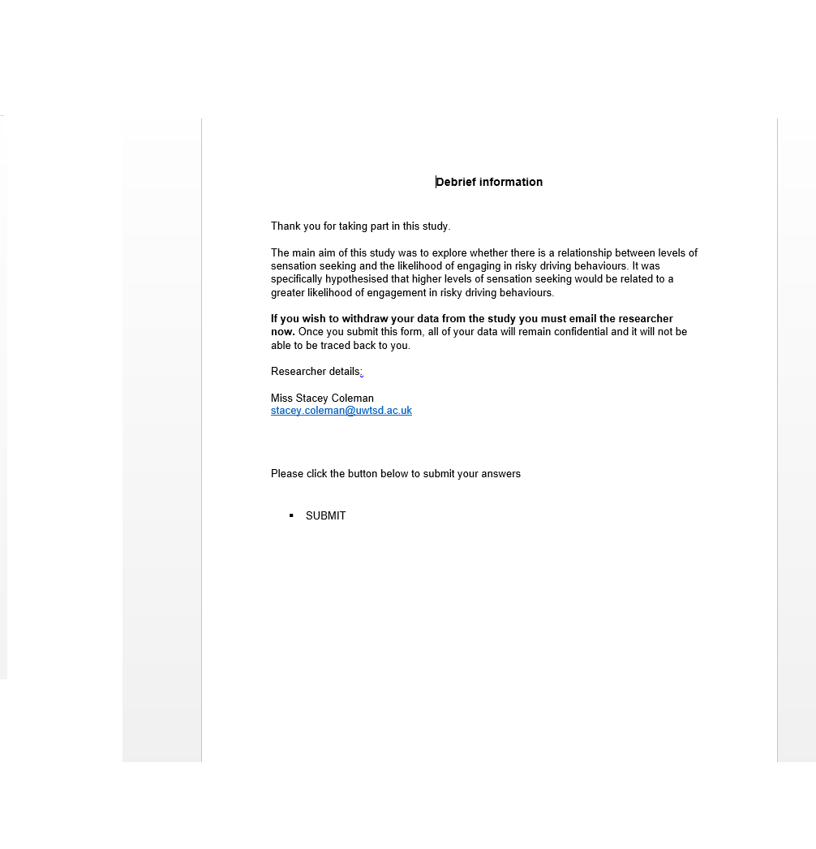

Appendix F

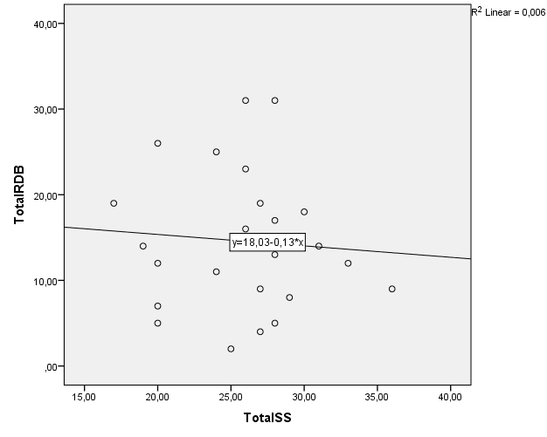

Descriptive Statistics
 | Mean | Std. Deviation | N
TotalRDB | 14,5769 | 7,88504 | 26
TotalSS | 25,8846 | 4,49290 | 26

Correlations
 |  | TotalRDB | TotalSS
TotalRDB | Pearson Correlation | 1 | -,076
TotalRDB | Sig. (2-tailed) |  | ,712
TotalRDB | N | 26 | 26
TotalSS | Pearson Correlation | -,076 | 1
TotalSS | Sig. (2-tailed) | ,712
TotalSS | N | 26 | 26

Descriptive Statistics
 | N | Mean | Std. Deviation
Age | 26 | 27,5769 | 11,13256
Valid N (listwise) | 26

RegularDrive
 |  | Frequency | Percent | Valid Percent | Cumulative Percent
Valid | ,00 | 2 | 7,7 | 7,7 | 7,7
Valid | 1,00 | 24 | 92,3 | 92,3 | 100,0
Valid | Total | 26 | 100,0 | 100,0



