Module Name: Project Management
Module code: LCLM5003
Assignment Title: A Project portfolio

Student Name: Maria Turturea
Student ID: 2410490
TABLE OF CONTENTS
PART A: PROJECT PROPOSAL POSTER 3
PART B: REFLECTIONS FROM THE FEEDBACK RECEIVED FROM TUTOR AND PEERS 4
PART C: PROJECT MANAGEMENT PLAN 5
1.Introduction 5
2.Project Description 5
3. Scope 6
4. Work breakdown structure 6
5. QUAD chart 7
6. Gantt chart 8
7. Stakeholder analysis 9
8. Allocation of resources 10
9. Risk assessment 11
10. Conclusion 12

PART A: PROJECT PROPOSAL POSTER
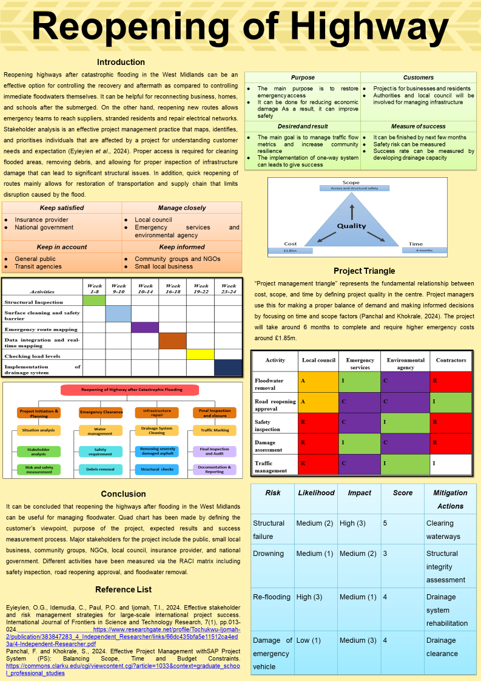

PART B: REFLECTIONS FROM THE FEEDBACK RECEIVED FROM TUTOR AND PEERS
An analysis of the feedback from my tutor and peers revealed certain good aspects as well as areas of improvement in the final project plan. The feedback being provided judged the initial project plan based on three elements, which are the methodologies used, whether the communication methods used are effective in conveying the purpose of the research, as well as efficiency of the operational framework being suggested. According to the feedback, critical areas such as coordination between different stakeholders, as well as the importance of data-driven decision making, have been elaborated extensively. In the feedback being provided, it was mentioned that the risk assessment plan being prepared was proficient for initial flood situations, but it is important to develop the plan more effectively so that for any further flood situations, this operational framework being proposed can also be used. The proposed plan should be effective in managing not only the catastrophic flood situation once but also for any further surges. Therefore, the final project plan required contingency planning. The allocation of resources has been clearly mentioned in the project plan, but the communication channels between different administrative bodies have not been mentioned in the plan. This needs to be updated in the final project report. If the communication channels are not specified, then who will be reporting to whom will not be known, and hence, the chances of the proposed plan being successful would be reduced. This will result in miscommunication between different administrative bodies, and hence, managing the situation in such scenarios would be difficult. Hence, along with the allocation of responsibilities, it is also important to mention the flow of responsibilities so that in any emergency situation, work can be managed more effectively.
The Gantt Chart suggests a 24-week plan for recovering from the situation where each of the tasks has been allocated a fixed timeline. But for catastrophic flood scenarios, it is important to execute activities simultaneously so that the risk can be mitigated more effectively. It is important to evaluate the Gantt Chart and make a more effective plan that focuses on the simultaneous execution of activities in order to manage the situation more quickly. This would prepare a plan that would be more effective, since executing a plan for 24 weeks in such a situation might not be appropriate. Apart from this, the report has been written in an appropriate manner with the use of appropriate methodologies, which makes the report detailed and easy to understand. Another important aspect of the report is that it is easy to comprehend. Hence, as mentioned previously, there are certain areas of improvement in the final project plan. Firstly, the risk assessment plan developed would be effective for initial floods, but whether it would be effective for continuous flood surges or not has not been assessed for the proposed plan. Secondly, the flow of responsibilities is required to be mentioned so that working in a collaborative environment becomes easier, and this would also enhance the efficiency of the work being done.
PART C: PROJECT MANAGEMENT PLAN
1.Introduction
The aim of this project is to manage the catastrophic flooding in the West Midlands through the reopening of highways. The catastrophic flood across the West Midlands can be managed through highways. In order to make it more convenient for the people residing in those areas, highways would be the most suitable choice. As a result of this communication would be improved, as well as emergency services would also be carried out faster. The disruptions that are caused by flooding would be effectively managed to a larger extent due to these new highways being built. It would also be possible to supply emergency aid quickly, as well as restore any damages, with the help of these new routes being developed. The residents won't be able to manage such a large scale of floods by themselves, and hence, immediate reopening of the highways is extremely essential. In these situations, managing emergency access is extremely important so that the extent of damage due to the floods can be decreased.

2.Project Description
Reopening highways after catastrophic flooding in the West Midlands can be an effective option for controlling the recovery and aftermath, as compared to controlling immediate floodwaters themselves. It can be helpful for reconnecting businesses, homes, and schools after the submerged. On the other hand, reopening new routes allows emergency teams to reach suppliers, stranded residents, and repair electrical networks. Stakeholder analysis is an effective project management practice that maps, identifies, and prioritises individuals who are affected by a project for understanding customer needs and expectations (Eyieyien et al., 2024). Proper access is required for cleaning flooded areas, removing debris, and allowing for proper inspection of infrastructure damage that can lead to significant structural issues. In addition, the quick reopening of routes mainly allows for the restoration of transportation and the supply chain, which limits the disruption caused by the flood.

3. Scope
“Project management triangle” represents the fundamental relationship between cost, scope, and time by defining project quality in the centre. The quality of the project being implemented is dependent on these three core pillars, which are scope, cost, and time. These three pillars will decide the efficiency of the project being implemented (Schneider and Domsitzova, 2024). If the deliverables have been clearly stated along with the budget and the projected timeline of completion, then it becomes easier to complete the project implementation on time and efficiently. Project managers use this to make a proper balance of demand and make informed decisions by focusing on time and scope factors (Panchal and Khokrale, 2024). This will allow the project managers to make data-driven decisions and hgence the efficiency of the decisions being taken would also be more. The project will take around 6 months to complete and require higher emergency costs of around £1.85m.
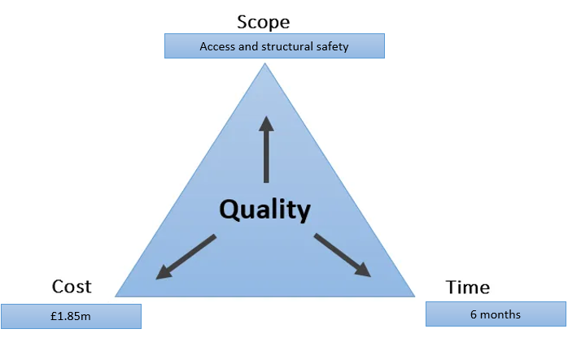
Figure 2: Project Triangle

4. Work breakdown structure
The work breakdown structure mentions the activities that would be included in the reopening of the highways. The first step involves planning and making strategies. For this it is important to perform situation analysis, stakeholder analysis as well as risk assessment (Amani and Naeij, 2026). The next step involves attaining emergency clearance. This involves water management, safety requirements, and removal of debris. Infrastructure repair is the next step and involves structural checks. The last step involves inspection being done and hence closure of the project. Through this, the work associated with the project will be understood more effectively, and hence this will ensure that the work being done is being completed in amore structure manner.
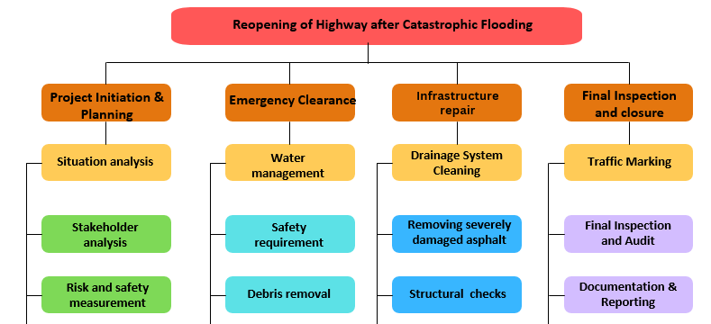
Figure 1: WBS

5. QUAD chart
The QUAD chart studies the aims, customers, KPIs as well as the deliverables that are desired (Clemente and Domingues, 2023). For the project of reopening of the highways, the main purpose of the project is to ensure that the connectivity for emergency access is being maintained through the highways during floods. The customers associated with the project are businesses and residents. The residents are heavily impacted due to the consequences of the floods and this necessitates the highways being reopened so that the situation can be managed. The deliverables associated with the project includes managing the traffic and ensuring that the connectivity is being maintained during natural disasters such as floods. The on-way system being planned would also ensure success. The KPIs of the project include completion of the project within the 6 months period and the success of the project would be measured through the drainage capacity. Drains are one of the most important components that ensure that the floods can be managed and the consequences can be minimised through it (Lai et al., 2021). Hence, the success of the project of reopening of the highways for managing floods would be measured through the drainage capability.

Purpose | Customers
- The main purpose is to restore emergency access  - It can be done for reducing economic damage As a result, it can improve safety | - Project is for businesses and residents  - Authorities and local council will be involved for managing infrastructure
Desired and result | Measure of success
- The main goal is to manage traffic flow metrics and increase community resilience  - The implementation of one-way system can leads to give success | - It can be finished by next few months  - Safety risk can be measured  - Success rate can be measured by developing drainage capacity
Table 1: QUAD Chart

6. Gantt chart
The Gantt chart shows the execution of the project over a 24-week cycle. Each of the activities has been allocated a specific timeline and they have been marked with different colours. There are six different activities that is required to be completed within the 24-week cycle and they are structural inspection, surface cleaning, safety barrier, emergency route mapping, data integration, and real-time mapping (Sunny et al., 2024). Checking load levels as well as the implementation of the drainage system. The structural inspection has been assigned for completion in weeks 1- 8. Within 9-10 weeks, the surface cleaning and safety barrier have to be accomplished. Week 10-14 is for emergency route mapping, and 16-18 weeks are for data integration an dreal time mapping. The 19-22 weeks are for checking the load levels, whereas the last two weeks have been kept for the implementation of the drainage system. This schedule has to be followed in order to complete the implementation of the project within the scheduled timeline. This will require 24 weeks in order to implement the project. Each of the timelines has been marked with a different colour and hence highlights the period of completion. This schedule is being implemented, which will allow the project manager to complete the project on time.
Activities | Week 1-8 | Week 9-10 | Week 10-14 | Week 16-18 | Week 19-22 | Week 23-24
Structural Inspection
Surface cleaning and safety barrier
Emergency route mapping
Data integration and real-time mapping
Checking load levels
Implementation of drainage system
Table 2: Gantt Chart

7. Stakeholder analysis
The stakeholder analysis evaluates the stakeholders associated with the project and the level of prioritization for each of the stakeholders. There are four levels of prioritization, and they are keep satisfied, manage closely, keep in account, and keep informed. Each of the categories has stakeholders associated with them, so that during project implementation, it becomes easier to manage the stakeholders (Rocha et al., 2026). Through these matrices, the individuals having high power can be identified, and those having low interest in the project can also be understood through it. The stakeholders are a very important part of any project, and hence understanding their importance and interest in the project is very important. In this project of reopening of the highways, the stakeholder who holds the highest power are the national government as well as the insurance provider. The local council is required to be monitored very closely, along with the emergency services, as well as the environmental agency. The emergency services will be deciding the time within which the response is being provide. The general public is also equally important and is required to be kept in account. It is important that the NGOs are informed so that recovery operations can be carried out faster. Small local business are also equally important and should be kept informed about the project as they will also play a major role in the recovery operations being carried out.
Keep satisfied | Manage closely
- Insurance provider  - National government | - Local council  - Emergency services and environmental agency
Keep in account | Keep informed
- General public  - Transit agencies | - Community groups and NGOs  - Small local business
Table 3: Stakeholder Analysis

8. Allocation of resources
The resource allocation is being studied through the RACI matrix. The RACI matrix mentions the individuals who would be responsible, accountable, informed, and consulted for each of the activities that are involved in the proposed plan of reopening of highways (Kwast-Kotlarek and Szóstak, 2026). The activities involved in the reopening of highways include floodwater removal, road reopening approval, safety inspection, damage management, and traffic management. The four administrative bodies that are in charge of the different activities involved in this project are the Local council, emergency services, the environmental agency, and contractors. In the matrix, different colours have been used in order to mark the four categories of responsibilities to each of the administrative bodies. The administrative bodies that will be accountable for each of the aspects have been marked in yellow colour, consulted is marked in purple, informed is marked in green, and responsible is marked in red. All the administrative bodies are equally responsible for the implementation of the project successfully. Hence, they should be working in a collaborative manner in order to ensure that the recovery operations are being carried out effectively. This work being distributed would ensure that there is no miscommunication and hence the work would be carried out in a more effective and smooth way.
Activity | Local council | Emergency services | Environmental agency | Contractors
Floodwater removal | A | I | C | R
Road reopening approval | A | C | C | I
Safety inspection | R | C | I | R
Damage assessment | R | I | C | R
Traffic management | R | C | I | I
Table 4: RACI matrix

9. Risk assessment
There are four risks associated with the implementation of the proposed plan for the reopening of highways. The four risks are structural failure, drowning, re-flooding, and damage to the emergency vehicle. Each of the risks has been evaluated against two parameters, which are their likelihood of occurrence as well as the impact of these risks, and based on the scores assigned to these categories, an overall score has been assigned to each of the risks (Abegaz et al., 2024). After evaluating each of the risks, structural failure emerges as the most important one with a score of 5. The mitigation action that has been proposed is clearing waterways. Structural failures would result in effective management of the floods as the connectivity would be disrupted through it (Abegaz et al., 2026). There are two risks that have been assigned equal scores due to their nature, and they are flooding and damage to the emergency vehicle. Damage to the emergency vehicle is another important risk after structural failure, which can be mitigated through drainage clearance. If the drains are not cleaned and maintained, then during floods, this will cause the water levels to increase even further due to excessive clogging. This will also make it difficult for the emergency vehicles to carry on with the recovery operations. Flooding is also equally important. The drainage system is also required to be maintained well in order to manage this risk. The recovery process gets stalled due to the presence of clogged drains. The stagnation of water causes water levels to rise again, which results in flooding (Mumtaz et al., 2026). Therefore, it is important to keep the drains clean so that the chances of recurrence of flooding can be decreased. These risks need to be mitigated to ensure a smooth recovery from the catastrophic flood situation. Evaluation of the risks and understanding their level of likelihood, as well as impact,, is important for understanding the implementation efficiency of the project. The risks, if evaluated, can be mitigated early and hence the project would not eb adversely affected due to the risks. Through this risk assessment the different risk has been studied and the measures that can be taken in order to mitigate them has also been understood.

Risk | Likelihood | Impact | Score | Mitigation Actions
Structural failure | Medium (2) | High (3) | 5 | Clearing waterways
Drowning | Medium (1) | Medium (2) | 3 | Structural integrity assessment
Re-flooding | High (3) | Medium (1) | 4 | Drainage system rehabilitation
Damage of emergency vehicle | Low (1) | Medium (3) | 4 | Drainage clearance
Table 5: Risk Assessment

10. Conclusion
It can be concluded that reopening the highways after flooding in the West Midlands can be useful for managing floodwater. This has been explained in the above sections through the use of different frameworks, such as the Quad chart, Gantt chart, and Work Breakdown Structure. All these frameworks would be making it easier to understand the objectives, stakeholders, and how the work should be progressing in a much easier manner. For the execution of a project successfully, it is important to allocate responsibilities so that the chances of miscommunication can be eliminated. This has been done through the RACI matrix that identifies the administrative bodies that would be Responsible(R), Accountable (A), Consulted(C), and Informed(I) for each of the mentioned tasks. This is important as it would ensure that the flow of work becomes easier in such a catastrophic flood situation. Different activities have been measured via the RACI matrix, including safety inspection, road reopening approval, and floodwater removal. Quad chart has been made by defining the customer’s viewpoint, the purpose of the project, the expected results, and the success measurement process. Major stakeholders for the project include the public, small local businesses, community groups, NGOs, local councils, insurance providers, and the national government. The risk assessment being performed is also equally important in order to measure the success rates of the plan being executed. The risks that could affect the efficiency of the project being executed have been mentioned along with their likelihood, impact, and the ways through which the risks can be mitigated. For each of the risks, a score has also been assigned. The risks that have been identified are drowning, flooding, structural failure, and damage to the emergency vehicle. Among these, structural failure is the one that is of the highest risk. If the infrastructure collapses, then the recovery efforts being undertaken are also affected negatively. If the highways being reopened for faster emergency access suffer structural failure, then there are no means of developing connections with the areas that were being connected through the highways. Hence, through the application of all these frameworks, the proposed plan would be effectively implemented, and the consequences associated with the catastrophic floods would also be reduced through it. All the frameworks being applied here has helped in understanding the implementation of the project in a better manner. This will also be beneficial in the effective implementation of the project. The risks being identified will enhance the accuracy of the implementation of the project.
Reference List
Abegaz, R., Wang, F. and Xu, J., 2024. History, causes, and trend of floods in the US: A review. Natural Hazards, 120(15), pp.13715-13755. https://www.proquest.com/openview/a141cb2fee21997d5e9b373d9454461b/1?pq-origsite=gscholar&cbl=18750&diss=y
Abegaz, R., Xu, J. and Wang, F., 2026. Flood impacts on civil infrastructure systems: A comprehensive review of impacts, modeling tools, emerging technologies, and mitigation strategies. Natural Hazards Review, 27(1), p.03125002.https://doi.org/10.1061/NHREFO.NHENG-2477
Amani, N. and Naeij, M., 2026. Identification and Evaluation of Sustainable Factors in Urban Construction Project Management Using SWOT Technique. Green and Low-Carbon Economy, 4(1), pp.48-61. https://doi.org/10.47852/bonviewGLCE42021909
Clemente, M. and Domingues, L., 2023. Analysis of project management tools to support knowledge management. Procedia Computer Science, 219, pp.1769-1776. https://www.sciencedirect.com/science/article/pii/S1877050923004842
Eyieyien, O.G., Idemudia, C., Paul, P.O. and Ijomah, T.I., 2024. Effective stakeholder and risk management strategies for large-scale international project success. International Journal of Frontiers in Science and Technology Research, 7(1), pp.013-024. https://www.researchgate.net/profile/Tochukwu-Ijomah-2/publication/383847283_4_Independent_Researcher/links/66dc435bfa5e11512ca4ed3a/4-Independent-Researcher.pdf
Kwast-Kotlarek, U. and Szóstak, M., 2026. RACI–AHP–BIM Methodology in Projects with High Functional Complexity and Conservation Constraints. Infrastructures, 11(3), p.105.https://doi.org/10.3390/infrastructures11030105
Lai, S.T., Susanto, H. and Leu, F.Y., 2021, October. Project management mechanism based on burndown chart to reduce the risk of software project failure. In International Conference on Broadband and Wireless Computing, Communication and Applications (pp. 197-205). Cham: Springer International Publishing.https://link.springer.com/chapter/10.1007/978-3-030-90072-4_21
Mumtaz, T., Siddique, R. and Shahid, A., 2026. Flood waters, forced migration, and humanitarian crisis: a comparative study of the 2022 and 2025 Floods in Pakistan. Policy Journal of Social Science Review, 4(2), pp.251-265. https://policyjssr.com/index.php/PJSSR/article/view/757
Panchal, F. and Khokrale, S., 2024. Effective Project Management withSAP Project System (PS): Balancing Scope, Time and Budget Constraints. https://commons.clarku.edu/cgi/viewcontent.cgi?article=1033&context=graduate_school_professional_studies
Rocha, L., Fernandes, G. and Santos, J.M., 2026. Mapping Tools for Intelligent Stakeholder Management in Project Contexts. Procedia Computer Science, 278, pp.1713-1721.https://doi.org/10.1016/j.procs.2026.03.162
Schneider, R. and Domsitzova, M., 2024. Application of project management tools in construction phases to optimize the impact on quality, cost, and time: A case study. In E3S Web of Conferences (Vol. 550, p. 01047). EDP Sciences. https://www.e3s-conferences.org/articles/e3sconf/abs/2024/80/e3sconf_ys2024_01047/e3sconf_ys2024_01047.html
Sunny, M.N.M., Sakil, M.B.H. and Al, A., 2024. Project management and visualization techniques a details study. Project Management, 13(5), pp.28-44.https://www.researchgate.net/profile/Md-Nagib-Mahfuz-Sunny/publication/384897053_Project_Management_and_Visualization_Techniques_A_Details_Study/links/670d188a77bab74415a0cc34/Project-Management-and-Visualization-Techniques-A-Details-Study.pdf

