Assignment 2: Menu Engineering
Module name & Code: Food and Beverage Operation
BMHI4002
Student name: Ana Sofia Andrade
Student number: 2026882
Lecturer name: Ryan Anthony



The Trinity

Main Course

(Breakfast 10:00 – 12:00)

- Scrambled Egg & Sauteed Vegetables – 15.99
Splendid combination of vegetables served along with scrambled egg and 2 toasted bread pieces along with an apple/peach jam.

Fresh Salad & Juice – 10.99
Indulgence of fresh vegetables with a ranch sauce dressing, served in a bowl to provide healthy and refreshing experience along with a refreshing juice.

Coffee & Croissant – 8.99
Frothy cappuccino served with a croissant with flavor of any choice between Cinnamon/butter/plain.

(Lunch 12:00 – 15:00)

Blackened Salmon – 44.99
Splendid blackened salmon with salsa verde and fresh pico de Gallo served with cilantro lime rice.

Rosemary Tenderloin Pork – 35.99
A tender pork fillet infused with buttery goodness, aromatic rosemary and mushroom sauce with a hint of honey.

Beef Wellington – 40.99
Marvelously crafted pastry along with a succulent beef chuck, hidden in the heart of the pastry to serve you exquisite blend of baking and a meaty experience.

Beef Short Rib and Onion Cottage Pie – 40.99
The earthly taste of onion cottage pie amalgamated with the mouthwatering melting beef ribs, provides aromatic experience.

Chateau La Tour De by Médoc – 60.99 (750ml)
Classic Bourdeaux having berries balanced with crisp tannins with a hint of tobacco enticing your tastebuds with their exotic taste. Perfectly suited with our special meat entrees.

Fish and Chips – 40.99
The traditional recipe, served with a spark of new blend of sauces, served with crispy French fries and ranch sauce.

Cheese Platter – 25.99
A spread of different types of cheese, with crackers and smoked protein meat, tangy fruit jams along with the fresh fruits and various dips.

(Dinner 8:00 pm – 11:00 pm)

El Hombre Bala Negre with Beef steak – 55.99
Made with carefully picked Garnacha grapes infused with dried rose petals and berries, pristine fruit on silky tannins. Enjoy this fruity exotica with our beef steak and toasted veggies

Beef Mushroom Steak – 47.99
Juicy and tender meat, intended to provide mouthwatering experience, served with a earthly mushroom sauce and a side of your own choice among Veges/Mashed Potato/Fries.

Woodlands Wilyabrup Margaret River Chardonnay – 50.99
Fermented to perfection in French oak barrels, Chardonnay shows flint, vanilla, peach and lemon, complimenting the aroma of our special pork, salmon and cheesy goodness.

Alfredo Fettuccini – 30.99
The classic Italian pasta experience of Alfredo Fettuccini, served with mesmerizing sauces and garlic bread on the side.

Vegavanza – 40.99
A new experience of eating vegetables, cooked to perfection including Cabbage, Capsicum, peas, potato, zucchini and more awesomeness, cooked in Olive Oil.

Chicken fillet with tangy sauce – 35.99
A wholesome chicken Breast or Thigh Fillet, cooked to perfection, served with the dressing of rosemary and thymes along with a tangy sauce to make the experience exciting.

Cheese & Veggies – 25.99
A rare but extravagant combination of vegetables and cheese, served in a bowl, covered with cheese and ranch sauce to give a melting yet fresh experience.

Disclaimer:
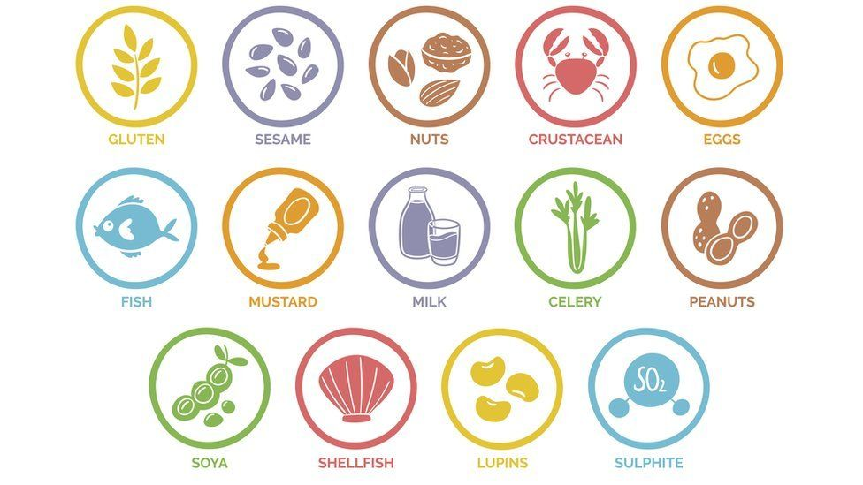
(Barnet, et.al, 2018)

Disclaimer:
Please ask the staff for help before ordering if you’re allergic to any of the shown food source above.

Contact Us:
Phone: 0207 6221199
Food can be ordered online on our website: www.Thetrinityrestaurant.com
Payment options


Food Rating

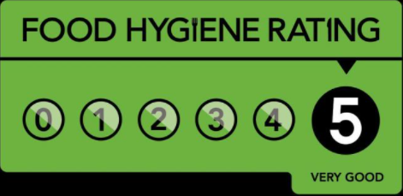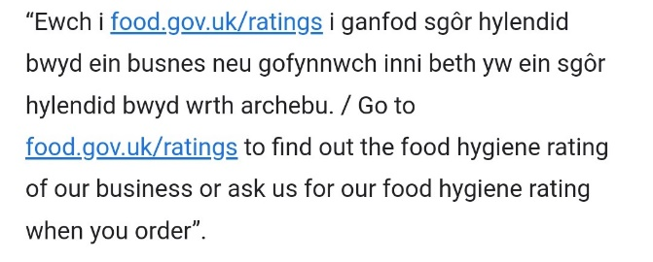

References

- An Appetite for Aesthetic, Available at:
<https://www.morganbranding.co.uk/an-appetite-for-aesthetic/>
- Restaurant Menu Design Ideas, 2021, Available at: <https://upserve.com/restaurant-insider/restaurant-menu-design-ideas/>
- Barnett, J., Begen, F.M., Gowland, M.H. and Lucas, J.S., 2018. Comparing the eating out experiences of consumers seeking to avoid different food allergens. BMC public health, 18(1), pp.1-12.
- Menu Design Aesthetics, 2021, Available at:
<https://trendland.com/material-menu-designs-culinary-aesthetic/>
- https://journals.sagepub.com/doi/10.1177/10963480211067275
- Restaurant Menu Guide, 2021, Available at: <https://aaronallen.com/blog/restaurant-menu-design#:~:text=A%20good%20restaurant%20menu%20design,fresh%20in%20your%20customer's%20mind>
- Importance of the restaurant Menu, 2019, Available at:
<http://aqua-food-mood.co.uk/the-importance-of-the-restaurant-menu/>
- EU Food Allergens, 2021, Available at: <https://sites.manchester.ac.uk/foodallergens/information-for-food-businesses/eu-legal-requirements-on-food-allergen-labelling/#:~:text=The%20EU%20Labelling%20Directive,EU%20countries%20since%20December%202014>

