Honorata Sieczych
Student No. 1708007

Submission date: 14/01/2019

Business Digital ID
Tutor: Anthony Burns
Managing Digital Identities
BMSP5004
Executive summary
This report highlights the importance of understanding essential concepts and principles by the usage of social media for enterprises and its customers. Furthermore, an author shows the strengths and weaknesses of establishment of its business on social media as well as risks for security of the business and the impact on its participants.

Content of pages

Rationale
This report will investigate the advantages and disadvantages of the creation of digital brands for business purposes and its participants. It will focus on the risks and consequences of online existence, highlighting the importance of legal protection of its users and possible implications to organisations. This report will comprise of two parts: part 1, underlines enterprise brands online and part 2 will explore and place emphasis on customers protection from a business perspective.

- Business Id on Social Media

1.1 Reasons for company to use social media
In the past, organisations had little information about its customers, however, the companies had a strong relationship with its participants, because they knew their customers behaviours, interests and needs, placing value on its customers. Nonetheless, the bookkeeper had less opportunity to advertise, gaining small audiences via newspaper, TV or radio (Eliezerov, 2018). Nowadays, businesses have endless opportunities to promote itself on social media across the globe and reaching out to customers became much easier. (fig. 1 in appendices). However, the organisations must consist of good reputation of its customer service, service itself and brand, otherwise consumers will not trust the business’s brand on social media. Therefore, the aim for businesses to create digital identity is crucial for the future existence of its company. The social marketing and activity are beneficial for both sides, business and customers alike. Moreover, social marketing is cost effective and it is good way for start-up businesses and can improve customer satisfaction. Furthermore, by using social media the business expands brand awareness for its consumers and builds a strong relationship with customers by interacting and engaging with its users on social platforms. By promoting itself on social media and gaining the attention of its users, the business encourages customers to promote their brand (Cover, 2016).
However, the personalised adverts and content leads to existing in ‘its own bubble’ therefore users must be wise and perform another search for content and products. Nonetheless, the marketing strategy must incorporate within the business and suitable social media must be chosen for its company for effective promotion and targeted audience of its digital brand (Lipschultz, 2018; Tuten & Solomon, 2017).

1.2 How company use digital brand on social media
The research shows that there are numerous tactics of promoting business online. The table below illustrates various ways of social marketing and benefits for organisation.

Types of social marketing groups and examples | Benefits for enterprises
Social networking:  Facebook, Twitter, LinkedIn | Connecting with its users and building strong relationships which will add value to its digital brand. LinkedIn- customers giving recommendation to the business which will add value.
Media sharing:  Instagram, Snapchat, You Tube, Pinterest | These companies aim to increase relationship with its participants, building brand awareness and engagement with its users. Also, it generates website traffic.
Customer review networks:  Trip Advisor | It is helpful for organisations to gain knowledge about its opinion from business perspective as well as customer. Reviews would add value to its brand.
Blogging:  WordPress | Content marketing is a helpful tactic to engage with its audience as well as building digital branding. It also generates sales and leads.
Sharing economy network:  Airbnb, Uber | Collaboration between business and its users.
Influencer marketing:  Dwyane Johnson promoting Under Armour (Fraser, 2016) | Engagement with influencers generate positive impact on its participants and digital brand.
E commerce:  Amazon | Generate sales and engagement with customers.
Reference: | (Lipschultz, 2018; Tuten & Solomon, 2017; Czaplicka, et al., 2018; Pinherio, Tiago, & Verissimo, 2014)

1.3 Risk
The research shows that there is plenty of examples of damaged reputation to digital brand. The first chosen example is fake account of Dwayne Johnson (Szathmary, 2018). Recently, a cyber-attack was performed on Twitter regarding fake accounts promoting paedophilia (Urwin, 2019).
Moreover, damaged reputation and trust can be lost in a short time, with the Adidas employee writing an inappropriate comment after Boston marathon shooting being prime example (figure 7 in appendices) (Peterson, 2017).

1.4 Precaution
The research shows that to reduce risks there are few strategies to manage treats. The principal rule for enterprises is to comply with regulations regarding protection of information’s online such as Data Protection Act 2018 which covers privacy protection (UK Government, 2018) and part of it is GDPR(General Data Protection Regulations).The GDPR specify what and how the data must be secured (UK Government Legislations, 2018; Information Commissioner's Office, 2018; Nadeau, 2018) At first, a company must avoid risks by training their employees of potential treats and spread awareness regarding professional usage of business devices of its workers, such as avoiding the use of personal social media and email accounts on companies’ devices and logging off when finishing tasks (Ryan, 2015). According to Statista (2018) 92% of UK business use emails for its personnel and customers (figure 8 in appendices) Nonetheless, Kaelin (2018) states that “more than 40% of data breaches is caused by employee’s negligence” (Kaelin, 2018). The written policies and procedures of using social media within the company must be in place such as email policies etc. Furthermore, the written guidance’s must consist of specification of entry data for each role of employees – relevant access for relevant roles. An example of this would be that surgery doctors have different levels of accessibility to the information rather than receptionists. In addition, written policies must specify what access each person is permitted to use, regarding social media and representing the company. Moreover, employees must use strong passwords to avoid potential risks of cyberattack. (Birch, 2016).
In order to secure its services, the company must compile a risk assessment, therefore calculate possible losses (figure 2 in appendices) and share the risk. Hence, ensure itself of specific treats such as phishing emails (figure 5 in appendices) or fake accounts to prevent those losses. Another way to mitigate the risks, is to accept a risk (Newberry, 2018), because for big companies which consist of large data such as Google or Amazon (Marr, World Economic Forum, 2015) if the risk loss is low, they might accept it. Companies must monitor and control social media, therefore they might employ surveillance teams for this task to be aware of any suspicious action on business accounts (Culp S, Gomes, & Narveson , 2014). Lastly, the good practice is to hire public relation employees hence, they will be responsible to maintain good relationships with its participants and represent the company in a professional manner. (Kotler & Armstrong, 2014; Stewart, 2017). However, the scrutiny shows that potential risks are existing, regardless of security in place as employees have personal accounts on social media and they can accidently break the company policies. An example would be a health care professional posting inappropriate photos on social media (figure 4 in appendices). Another example of deliberately trying to damage business reputation is a whistle blower. Chelsea Manning was a soldier and was employed as an intelligence analyst who exposed sensitive military and diplomatic data which led to a scandal. (Cadwalladr, 2018).
- Customers’ security from business perspective

2.1 Reasons for company to create digital id for its customers
The purpose of creation and collection data of digital ID for its users, is to improve and analyse services, performances, as well as relationships with its participants and personalised their profiles according to users’ needs and to market themselves. Nonetheless, another crucial aim is to prevent reputation damage of its brand and detect any prohibited activities such as theft of intellectual property, fake accounts or cybercrime such as hacking (Laurent & Bouzefrane, 2015).

2.2 How company creates digital id for its customers?
Businesses use cookies to collect, monitor and analyse customers profiles, behaviour, trends and activities’ (figure 10 in appendices). Another way to gather data is subscriptions to company’s websites, which gives an opportunity to its participants to gain incentives from it. Amazon Prime subscriptions means users gain free delivery when they subscribe (figure 6 in appendices). Another example is Disney Magic bands, customers can purchase anything cashless from band while they are in Disneyland (Disney World, 2019).
Another way of collecting data from customers is via downloading applications on mobile, laptop, tablet etc. and users are prompt to participate in surveys and reviews (figure 9 in appendices).
2.3 Risk of ramifications for business
However, the business’ profiles contain a large amount of data of its users therefore protection of customers data must be in place. The treats for its participants are everywhere. An example is the scandal with collaboration between Mark Zuckerberg and Cambridge Analytica (Verhofstadt, 2018). Another example of other data breach is the exposure of German politician’s personal data on Twitter (Magee, 2019).
Over collecting of data example is Samsung mobiles possessing the Facebook app and the user cannot delete this application from its device, but only disabled. This is not good practise and highlights an importance of “digital rights” for its users and rise a question on what extent the companies can spy on its participants without diminishing privacy policies for its users (Frier, 2019) Another example of constant invigilation is the scandal of Alexa, it was revealed that the echo assistant was listening at all times even private conversation and shared those revelations with other user of same device (Wolfson, 2018).
2.4Precautions
In order to maintain high level of security of customers’ data the company must invest in internet security such as firewalls and antiviruses software to protect its participants and update on a regular basis to prevent a cybercrime. Besides, an organisation must train their staff, monitor and control their work to prevent any major mistakes or deliberate acts. The organisation should monitor social media crisis and learn from those mistakes made by rivals and other digital brands (Information Commiser's Office, 2016; Culp S, Gomes, & Narveson , 2014). Furthermore, the enterprises must comply with Legislations such as General Data Protection Regulation and collaborate with law enforcement to detect any suspected cybercrimes which can damage business reputation and put its users at risk.

The GDPR rights for its participants are (Information Commissioner's Office, 2018):
- to be informed about consisted data
- to access its own data
- to rectification its own data
- to cancellation its own data
- to limitation processing of its own data
- “to data portability” (Burns, 2018)
- to disagree and complain of usage of its own data
- “the rights related to automated decision making and profiling its participants” (Burns, 2018)

In addition, the business should use single account for single user (Eliezerov, 2018) and store data in the Cloud as well as backing data of its participants also, sensitive data can be encrypted (Information Commiser's Office, 2016). An example of those practices is University students’ account on Moodle. As precautions, organisations must avoid a risk of data breaches and leakage as well as ensuring themselves of potential ramifications.
Moreover, the company must accept and perform a risk assessment of probability of treats to their business and will reduce their risks (Newberry, 2018) (figure 3 in appendices).
The example of usage, this risk assessment will be recommended for growing organisations such as NHS or UWTSD, as these companies generate big data of its participants.
In order to secure its customers and prevent unauthorised users gaining access to customers’ accounts, the enterprise must put in place multitude authentications, lowering the risks of potential cybercrime. There are various ways of authentications such as ID cards, passports, driving licence, National Insurance Number etc. Furthermore, the authentications of users must provide passwords and can be backed up by security questions. However, the password must be strong and should consists of numbers, letters and special characters to avoid hacking. The organisation can use biometrics such as fingerprints, eye scan or voice scan as a form of authentication (Birch, 2016). Accessing the Samsung mobile with fingerprint and pattern as password is an example of this.

3.0 Conclusion
This report shows advantages and disadvantages as well as the importance of using social media for businesses purpose. However, research indicates that business must use security precautions for appropriate usage of social media for itself as well as for customers, it can lead to potential risk of reputation losses and financial ramifications for enterprises.
References

Appendices
Figure 1 Screenshot of table
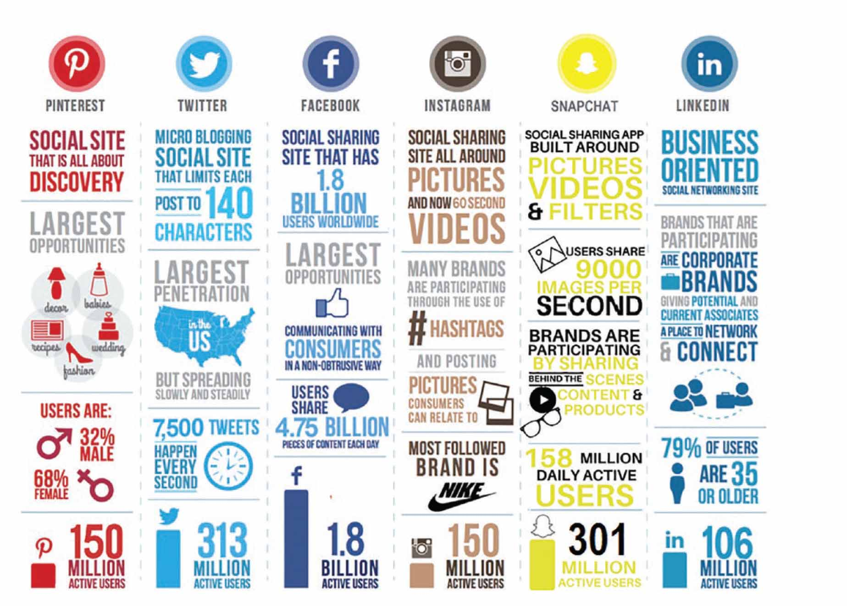
Source: Social Media Marketing by Tuten & Solomon (p.5)

Figure 2 Table of probability of social media treats.
Social media treats | Probability/like hood (%) | Cost (£) | Risk (£)
Fake accounts phishing | 0.7 | 100.000 | 70.000
Counterfeit products through fake accounts | 0.8 | 1.000.000 | 800.000
Reputation damage through fake accounts | 0.9 | 10.000 | 9.000
Source: Anthony Burns lecture week 7 UWTSD
Figure 3 Table of probability of treats to business.
Treats | Risk probability (%) | Cost (£) | Impact (£)
Ransomware | 0.75 | 1.000.000 | 750.000.00
Phishing | 0.9 | 50.000.00 | 45.000.00
Malware | 0.5 | 10.000.000 | 5.000.000
Social engineering | 0.8 | 50.000.00 | 40.000.00
Hacking | 0.9 | 1.000.000 | 900.000.00
Source: Anthony Burns lecture week 8 UWTSD
Figure 4 Inappropriate photo of nurse
Source: Nursetimes.net

Figure 5 Screenshot of an email regarding prevention of phishing
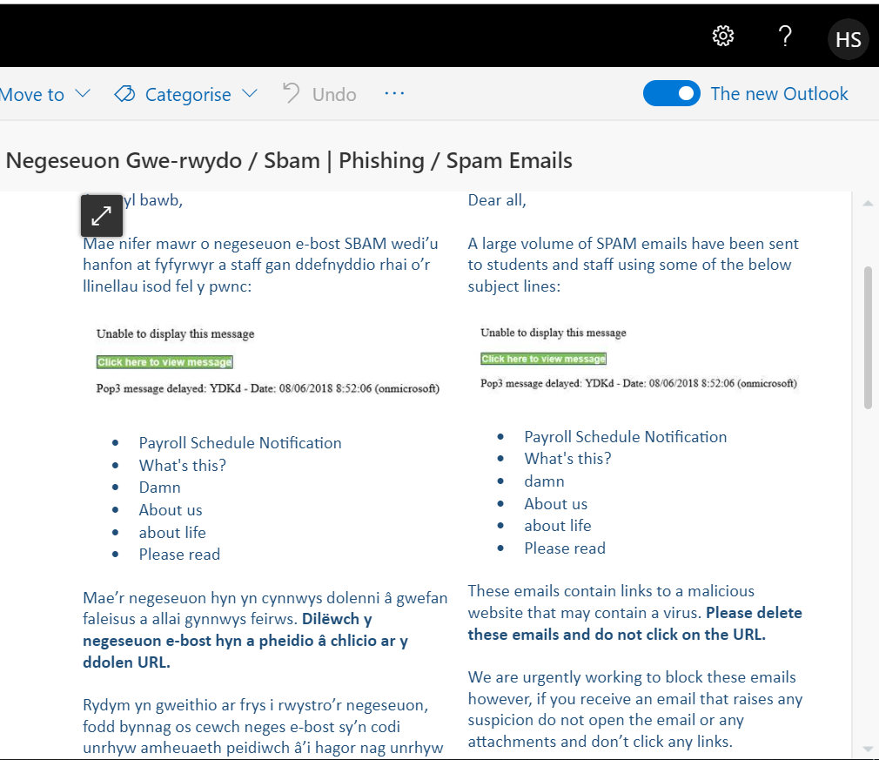
Source: UWSTD

Figure 6 Screenshot of Amazon Prime subscription
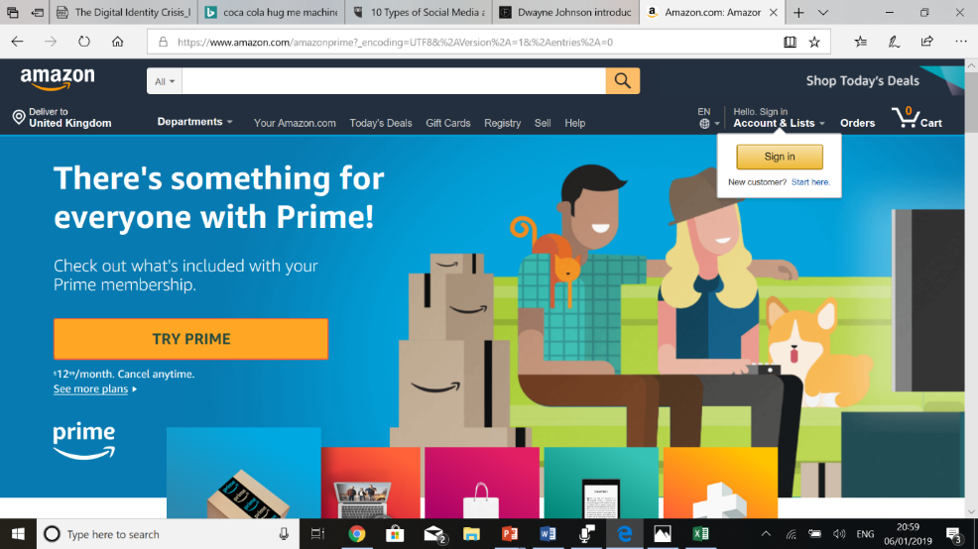
Source: Amazon website
Figure 7 Screenshot of inappropriate post on Twitter and response by Adidas company
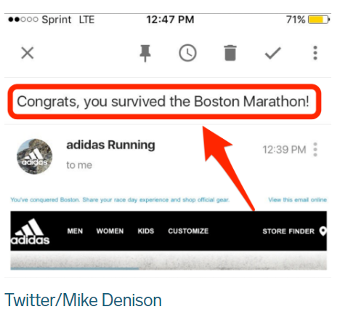
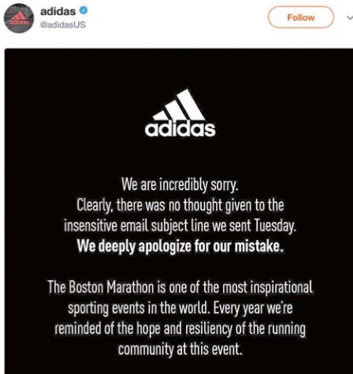
Source: Social Media Manager Magazine

Figure 8 Screenshot of graph: Share of UK business that use select online services in 2018
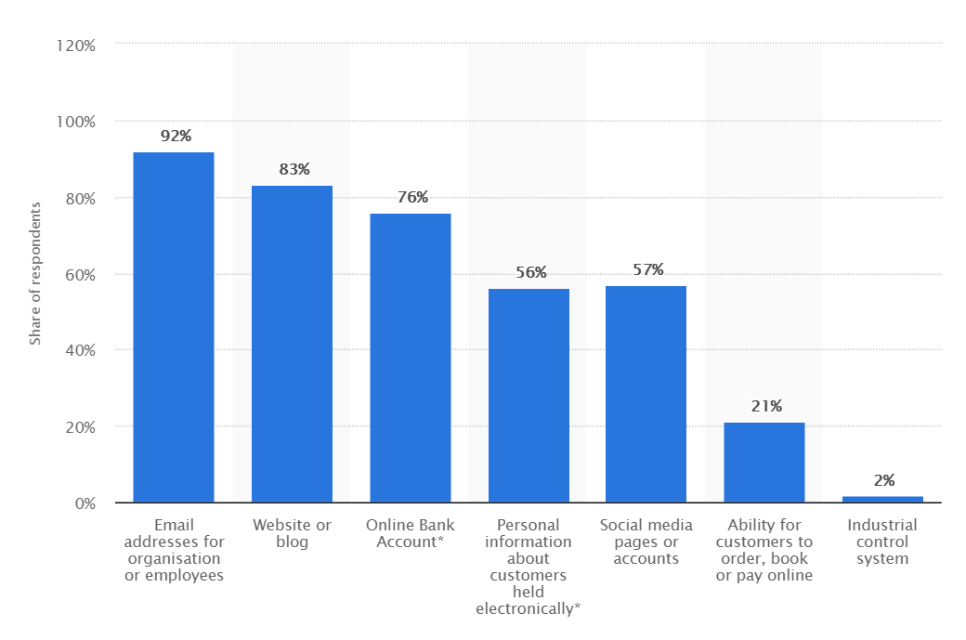
Source: Statista.com
Figure 9 Screenshot of review
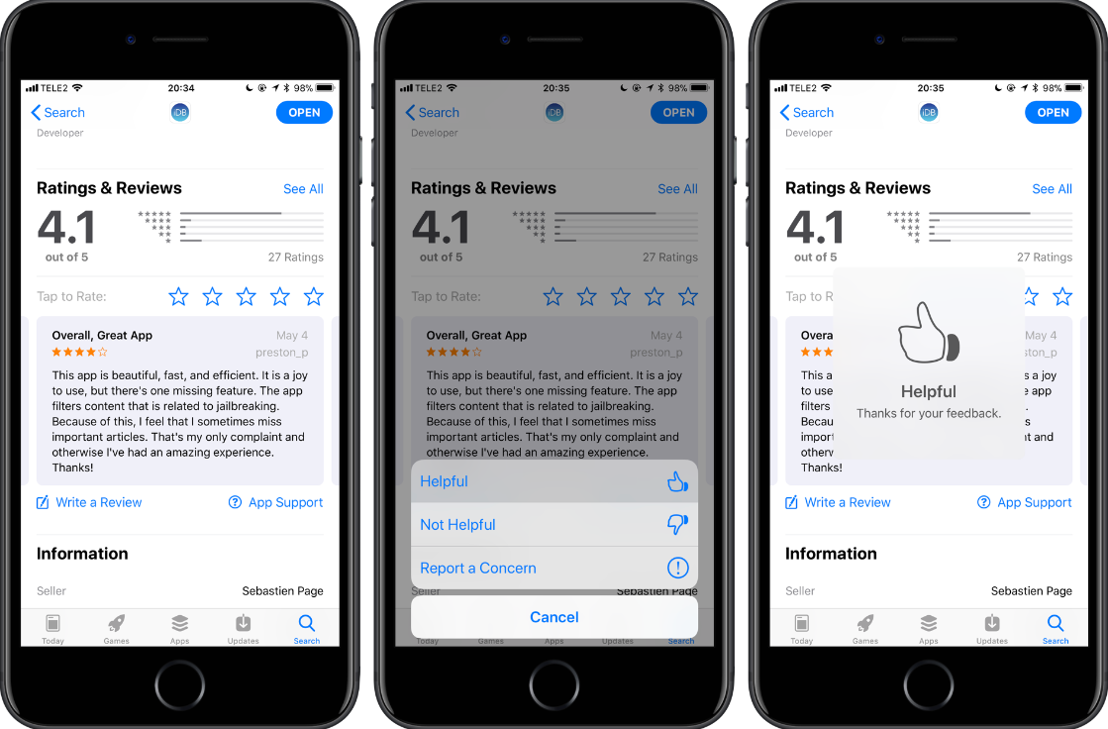
Source: www.idownloadblog.com

Figure 10 Screenshot of cookies
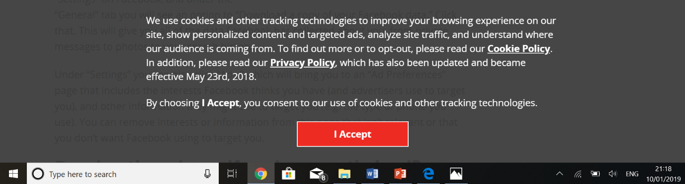
Source: www.recode.net

