

Report
Managing People In Organisations

Amazon & Walmart

2675 words
Submitted on 21/04/2024
Module BMMB7025

Executive Summary
Today, Human Resource Management (HRM) plays a pivotal role in organisational adaptation to internal and external contexts where current upheavals in geopolitical, economic and technological environments create uncertainty across different industries (CIPD, 2020a). Moreover, adaptation to the contingencies is crucial for maintaining organisational profitability and employees' resilience, ensuring a continuous and well-established innovation funnel, fostering a positive and no-blame culture, and providing agility in the face of rapid changes (Hall, 2023).
The societal shift accelerated by the COVID-19 pandemic has irrevocably changed employees' perceptions and meaning of work, attitudes, and values. (Emmett et al., 2020). The need for efficient adaptation to the ‘new work reality’ has triggered a reconsideration process of existing HRM practices, pushing businesses to use the ‘new’ agile operational model (Brassey et al., 2021). Additionally, to stay competitive, corporations must harness digitalisation where integration of artificial intelligence (AI) and machine learning (ML) in the organisational processes can save time and finances, adding value to HRM strategic forecasting and planning.
It was discovered that HRM is a complex and continuous process where people professionals act as gatekeepers and advocates in promoting organisational values, ensuring fair employee treatment and transparent practices, compliance with employment law, fostering an inclusive and diverse work environment and meeting employees’ psychological and physical needs to enhance their work experience (see Appendix H). Additionally, research has revealed that within HRM philosophy, people are considered the most valuable organisational asset, and their relationships form the cornerstone of corporate culture (Giardino, 2019).
Additionally, the report critically investigated Amazon and Walmart’s HRM approaches, similarities and differences and provided an in-depth analysis of Amazon’s CWL1 business unit people management issue where the CWL1 management team lacked compassionate and emotionally intelligent front-line managers due to insufficient knowledge acquisition process and poor support of the HR team.
The report concluded that the HRM functions at Amazon and Walmart are critical to their operations and have a similar structure. However, companies’ HR departments operate differently, reflecting distinct organisational goals. Moreover, regarding the CWL1 people management problem, it was determined that the HR team must take a proactive approach and address the knowledge acquisition gap by acting as a change agent championing a focused Kaizen event aimed at efficient problem resolution and restore healthy corporate culture with a compassionate and emotionally intelligent operational management team (Usifo, 2024).
Following the investigation results, the CWL1 HR team has been recommended to collaborate with the operational and learning and development teams, re-establish the coaching and mentoring process, and upskill CWL1 front-line managers with compassionate leadership practices.
The report was completed with support of credible information sources such as textbooks, scientific journals, articles, magazines, videos and governmental and public websites, which provided academic validity to its findings, conclusions, and recommendations.

Table of Contents

Executive Summary i
List of Appendices iii
1.0 Introduction 1
2.0 Main Discussion 2
2.1 Internal and External Influences 2
2.2 Organisational Approach to People Management 2
2.2 People Management KPIs 3
2.3 People Management Concerns 3
2.4 Role of AI in People Management 4
3.0 Conclusions 6
4.0 Recommendations 7
5.0 References 8
6.0 Appendices 15
Appendix A 15
Appendix B 16
Appendix C 17
Appendix D 18
Appendix E 19
Appendix F 20
Appendix G 21
Appendix H 22
Appendix I 24

List of Appendices

- Schein's Model of Organisational Culture…………………………………………………………………….15
- Handy’s Model of Organisational Culture…………………………………………………………………….16
- The ABCs of Motivation……………………………………………………………………………………………….17
- Amazon’s PESTLE Analysis……………………………………………………………………………………………18
- Amazon’s SWOT Analysis…………………………………………………………………………………………….19
- Walmart’s PESTLE Analysis………………………………………………………………………………………….20
- Walmart’s SWOT Analysis……………………………………………………………………………………………21
- Additional Analysis of HRM Practices and Challenges………………………………………………….22
- Overview of Amazon CWL1 HR team……………………………………………………………………………24

1.0 Introduction
Amazon is an e-commerce giant that operates in approximately 58 countries and currently has a $1.836 trillion market value (Companies Market Cap, 2023). The company is renowned for its peculiar corporate culture and leadership development practices (Meyer, 2023). Its economy of scale implies a global presence and agile business model with high adaptability when dealing with change (Grundy, 2015). Amazon uses 1,525,000 part-time and full-time employees to support its international operation, demonstrating diversity, equity and inclusion initiatives with the relevant policies, procedures and hiring practices aligned with work legislations and workplace culture (Amazon, 2022b). Amazon’s hierarchical and centralised organisational structure impacts its HRM strategies and activities, where main strategic adjustments have a top-to-bottom approach (Organimi, 2024).
Walmart is the largest multinational retail corporation with a current market capitalisation of $472.24 billion (Companies Market Cap, 2024). Unlike Amazon, the company uses an in-store business model, operating 11,443 grocery stores and hypermarkets in 26 countries and employing approximately 2.2 million people from diverse backgrounds and demographics across various business areas (Walmart, 2024a). Walmart has a matrix organisational structure supporting its stores, supply chain, and operations, using a decentralised approach that provides higher autonomy and flexibility to Walmart’s HR teams. However, Amazon’s centralised structure more effectively controls organisational culture and change initiatives across different business units. Additionally, Amazon mitigates dialectical tension by mixing and rotating employees frequently to enhance collaboration and innovation using the benefits of task culture (see Appendix B).

2.0 Main Discussion

2.1 Internal and External Influences
The SWOT and PESTLE analyses in Appendices D and E revealed that Amazon’s HRM strategies are influenced by emerging digitalisation, market expansion and economic fluctuations. These external drivers make Amazon continuously adapt its HRM strategies to keep pace with technological progress, focus on hiring and developing employees with tech-centric skills, deploy versatile approaches to accommodate different cultural norms and legal requirements in new markets, align local HR policies with global standards and corporate objectives and shift towards efficiency, often emphasising cost-effective measures through AI, automation and optimisation (Amazon, 2023). Additionally, internal influences such as organisational growth necessitate adaptive talent acquisition and internal leadership development programs to scale HR strategies in accordance with business needs, ensuring efficient performance management systems that can handle a larger, more diverse workforce and fostering the innovation culture (Harvard Business Review, 2023).
The analysis in Appendices F and G also confirmed that Walmart’s decentralised HRM approach is significantly affected by its international activities, where compliance with the local regulatory environment must be addressed in each business unit location. Moreover, socio-economic and customer behaviour trends are strong HRM external influencers, particularly in terms of wage structures, benefits packages and mental health services designed to maintain a sufficient employee retention rate while upskilling and training them to stay pertinent and motivated (Christ, 2023). Additionally, despite Walmart’s resistance, internal pressure from employees and labour unions drives changes in Walmart’s HRM strategies, focusing more on employee welfare, benefits and work-life balance to ensure high morale and productivity (Purifoy, 2024).

2.2 Organisational Approach to People Management
The research revealed that Amazon operates with a centralised HR function integrated across its various business units in different geographic locations (Functionly, 2023). This structure allows Amazon to maintain a consistent approach to HR practices and policies, aligning closely with its corporate objectives and culture of innovation (see Appendix A).
According to McKinsey (2020), Beth Galetti, an HR senior vice president of the people experience and technology team, reports directly to the CEO, underscoring the strategic importance of the HR team within the company that is tasked with a range of functions from recruitment, training, and performance management to employee relations and benefits management. The centralised HRM helps control the organisational culture and facilitates change initiatives, ensuring that HRM practices support the company’s goals of efficiency and innovation (Cardenas, 2011). In contrast, Walmart uses a more decentralised HRM approach, reflecting its vast in-store retail network and the need to address diverse local market conditions (Innvocon, 2023). Each store and regional office has its own HR team, aligning with Walmart’s focus on local community engagement (Thompson, 2023). Donna Morris, Executive Vice President and chief people officer at Walmart, also reports to the company’s CEO and supports Walmart’s operational goals and HRM strategic objectives in staffing, training, and ensuring compliance with labour laws across its business units (Walmart, 2024b).
Indeed, the differences between Amazon and Walmart's centralised and decentralised people management approaches were dictated by their business models, scale and corporate culture – in-door and e-commerce operational specifics, target auditory, used touchpoints and cross-functional employee interactions. However, both companies have similar strategic HRM frameworks with representation at the highest levels of the organisation, including direct access to the board of directors, reflecting the importance of HR function in sustaining business growth and adapting to market volatility and global changes.

2.3 People Management KPIs
People management Key Performance Indicators (KPIs) are metrics organisations use to assess and improve the performance of their HRM practices and initiatives, aligning employee performance with organisational targets (The HR Hub, 2023).
For instance, at Amazon, the commitment and skill set of the front-line area managers (AMs) significantly impact the effectiveness of the performance management system, resulting in positive or negative departmental KPIs and affecting local and regional HR performance metrics. Amazon’s CWL1 HR team KPIs trends can be observed in the employee turnover rate, employee satisfaction rate, absenteeism rate, attrition rate, employee engagement and probation period failure statistic. Moreover, on a daily basis, the CWL1 HR team monitor trends in unplanned, long-term, short-term and unauthorised absences, welcome-back conversations, outstanding disciplinary, healthcare or shift alteration meetings, shift swap and holidays approval rates, releases and staffing, conducting daily deep dives meetings, audits and Gemba Walk activities to support operational management team (OM) (see Appendix I).

2.4 People Management Concerns
The exploration of the people management concerns in Walmart and Amazon's business practices showed that both companies have demonstrated people management issues, unfair policies, unethical practices and unlawful decisions. For instance, Walmart has faced challenges in upholding an adequate program to prevent corruption, along with recent lawsuits related to gender and racial discrimination (U.S. Equal Employment Opportunity Commission, 2022). Similarly, Amazon’s recent fine of £27 million for excessive employee monitoring in one of the French business units shows the much broader issue, as knowing Amazon’s standardisation level, these dubious practices of micromanagement and excessive surveillance are used in all the fulfilment centres worldwide. These practices are not only breaching the GDPR but also are trust breakers that will imminently lead to toxicity and division, negatively impacting organisational culture and company goodwill, ultimately leading to financial losses (Mayne, 2024). However, despite the scandals related to unfair and unlawful practices, the two retail giants showed commitment to ameliorating employees’ work experiences to enhance trust, boost morale, and improve overall workplace efficiency and compliance, fostering an inclusive and diverse workplace that appeals to a broader customer base (Milanesi, 2021).
A more focused investigation into people management concerns revealed a correlation between directive leadership and Tier 1 Associates' (T1 AAs) KPIs in Amazon’s CWL1 business unit. Furthermore, an internal survey indicated that approximately 65% of day and night Area Managers (AMs) employ directive leadership to manage employee performance, demonstrating a lack of empathy and meaningful care for their team members' wellbeing. Consequently, T1 AAs show demotivation while performing their tasks, negatively impacting the department’s metrics and increasing job dissatisfaction and burnout risks. This problem indicates poor HRM practices within CWL1, where the primary concern is the mismatch between the basic psychological needs of employees, the soft skills of AMs, and the support the HR team provides in effectively aligning both parties’ personal and organisational goals.
Moreover, this issue is particularly evident in the lack of coaching and mentoring sessions provided by HR and OM teams to AMs, as these sessions were ceased during the COVID-19 pandemic and not resumed in the post-pandemic period. However, they were replaced by online video materials that most productivity-driven AMs ignore, focusing solely on their operational targets instead of simultaneously cultivate trustworthy relationships, meaningful engagement, and prioritising AAs' wellbeing. This creates a tangible discrepancy between AM role perception, especially in postgraduate AMs with no experience, Amazon’s leadership principles and compassionate leadership practices suitable for the changed working environment (Amazon, 2022a).
Therefore, to address this problem, the CWL1 HR team must act as change agents, identify knowledge acquisition gaps, and cooperate with the operational and learning and development (L&D) teams to facilitate AMs' upskilling, subsidising directives with compassionate leaders who will establish an empathetic dialogue with their T1 AAs, forge meaningful and emotionally intelligent relationships, and gain competence in new knowledge areas. Moreover, the CWL1 HR team must embrace this change and support employees and AMs in transitioning through the complexity of adaptation to ensure that people are not merely numbers but valuable assets, continuously reviewing and aligning the ABCs of motivation model with Amazon’s best practices (see Appendix C). They must ensure regular coaching, mentoring, and mental wellbeing sessions, monitor employees' satisfaction, hear their voices, and listen to their opinions. Additionally, the relevant KSA model should be used during the hiring process to define and align CWL1 AMs' competencies with current trends to ensure their organisational fit and effectiveness so they can use a compassionate leadership style, be self-aware and emotionally available, and find a balance between operational goals and AAs' job satisfaction, thereby boosting AAs' intrinsic motivation with an adequate rewarding process and establishing firm and trustworthy boundaries (Verduyn, 2023). Additionally, it is crucial to align the required competency framework with the AMs skillset to change the behaviour of AMs in CWL1. Moreover, as a role models AMs have influential power and by employing compassionate leadership techniques can alter T1 AAs' behaviour patterns when managing their performance. To achieve this, AMs must take the first step – of self-compassion and self-awareness to identify AM role challenges and choose the best course of action to develop the needed competence and culture of compassionate leadership to make employees feel valued and respected. Hence, from the strategic human resources management perspectives (SHRM) hiring and deploying motivated, self-driven, emotionally intelligent, and compassionate managers is critical, as their skills and attitudes can significantly affect overall organisational performance and potentially mitigate pitfalls while adapting to internal and external contexts pressure (Landry, 2019).

2.5 Role of AI in People Management
In addition to the e-commerce business, Amazon is a technological dreadnought, with over 31% of the worldwide cloud infrastructure market (Richter, 2023). This immense capacity allows Amazon to invest extensively in AI, ML and robotics research, enhancing its operational efficiencies and product innovations (Haranas, 2024).
Hancock, Schaninger and Yee (2023) state that the nature of work is changing, and the benefits of AI and automation have undeniable potential, as they add cost-effectiveness to businesses, increase process efficiency and accuracy, and reduce the human factor. However, the OECD (2019) suggests that AI and automation could drastically impact future employment, leading to large-scale layoffs and reshaping the job market. In contrast, Deloitte (2015) argues that while technological progress in AI and ML has contributed to the loss of circa 800,000 lower-skilled jobs, there is strong evidence that it has the potential to create 3.5 million new higher-skilled jobs in return due to the multi-industrial technological transformation.
Indeed, an agile business implies frequent change, and people professionals must be ready to support these changes (Goldberg and Kramer, 2020). Unequivocally, emerging technologies impact people management activities and will have a profound effect on the workforce, automation of complex tasks, improving recruitment decision-making process, facilitating employment forecasting and, most importantly, freeing people professionals from manual routine tasks, allowing them to do more value-added and high skilled tasks that can tangibly improve the employee experience (Gartner, 2023).
Both Amazon and Walmart incrementally integrate AI and ML in their HRM practices. For instance, Walmart uses AI tools to streamline operations and consolidate workforce software on a single interface to simplify employee access (Zielinski, 2021). Amazon, however, uses AI and ML in hiring and talent acquisition processes, personal development programs and performance management activities (Skuza, 2024).
Regarding Amazon’s CWL1 business unit, the daily HR tasks have a manual nature, with the involvement of all the HR team members in gathering shift’s metrics, monitoring and reporting observable trends and escalating problems to the central team. Additionally, the problem analysis revealed that such a manual and time-consuming approach may be because CWL1 is a legacy site with a limited capacity for implementation of the latest Amazon technologies in automation, AI, and ML.

3.0 Conclusions
To recapitulate. Amazon and Walmart face continuous changes in their external and internal environments, necessitating adaptive, responsive, and forward-thinking HR strategies. While Amazon focuses on technology and global integration, Walmart emphasises local compliance and market-specific strategy, aligning its people management tactic with business objectives and market demands. Consequently, this dynamic approach helps them remain resilient and competitive in a rapidly changing business environment.
Moreover, technological and social change drivers undoubtedly influence both companies to be at the forefront of integrating AI and ML into their HR functions, enhancing operational efficiencies and streamlining employees’ experiences. Moreover, despite evident issues in Amazon and Walmart’s past, they are continually investing in HRM best practices to create a diverse and inclusive work environment while seeking to provide fair and ethical employment opportunities.
Additionally, the research revealed a correlation between AMs’ skills, employees' job satisfaction and HR KPIs and a critical need for Amazon's CWL1 business unit to improve its HR support structure for leadership development, particularly in terms of strengthening AMs’ emotional intelligence skills, learning compassionate leadership techniques, using an empathetic approach, and aligning employee engagement strategies with Amazon best practices, social trends laws and regulations.
Therefore, people professionals must help organisational leaders and managers adapt to changing circumstances and act as change agents, supporting employees on all levels with meaningful, ethical, and lawful practices.

4.0 Recommendations
Based on the research findings and conclusions, it would be reasonable to recommend resuming and improving the discontinued coaching and mentoring programs in CWL1, as replacing these with solely online learning materials has proven ineffective for meeting AMs developmental needs, suggesting a blended approach that includes both digital and interpersonal training methods to support AMs and other managerial roles in a more relevant and sufficient way. Moreover, coaching, mentoring, and related activities must receive robust support from the most senior levels of HR and OM teams. The outcomes of these initiatives should be carefully monitored and reported to track trends in AMs' behavioural changes. Additionally, to better align managers' performance with organisational goals, a robust system of KPIs should be developed that not only tracks productivity but also employee satisfaction and engagement. This will help identify areas where leadership and management practices can be improved. To reinforce effort, the CWL1 HR team must establish robust communication with the other FCs via a focused chat group and delegate the POC responsible for collaboration and improvement actions completion, strategically aligning local HR practices with Amazon’s management development framework, ensuring that local HRM strategies comply with legal standards and meaningfully fulfil employees’ needs.
Due to the complexity, all aforementioned change implementation steps must be actioned within three weeks as part of the Kaizen event. During this event, a focused group of project champions and subject matter experts from the HR, OM, and L&D teams must design a problem-resolution roadmap and prepare the necessary procedures for approval. The approved procedures will require ongoing monitoring and updates to ensure their successful adaptation, congruence, relevancy and alignment with the evolving dynamics of the workforce.
It should be noted that the disadvantages of the recommendations stem from the significant time-consuming activities and the large scale of organisational change that will comprise the involvement of all the operational, HR and Chamge management functions and input of additional financial resources as a collateral effect of increased work hours and headcounts of the HR department. However, to mitigate this adverse effect, the HR team can use already available AI and ML solutions from the other FCs to automate their daily tasks and allocate their time to drive and implement organisational changes with no added cost.

5.0 References
ACAS (2023) Employer and Employee Duties: Employment Contracts and the Law, Acas. Available at: https://www.acas.org.uk/employment-contracts-and-the-law/employer-and-employee-duties (Accessed: 3 March 2024).
Acikgoz, Y. (2019) ‘Employee Recruitment and Job Search: Towards a multi-level Integration’, Human Resource Management Review, 29(1), pp. 1–13.
Amazon (2022a) Leadership Principles, UK about Amazon. Available at: https://www.aboutamazon.co.uk/who-we-are/leadership-principles (Accessed: 17 April 2024).
Amazon (2022b) Our Workforce Data, About Amazon. Available at: https://www.aboutamazon.com/news/workplace/our-workforce-data (Accessed: 3 March 2024).
Amazon (2023) How Amazon Leverages AI and ML to Enhance the Hiring Experience for Candidates, US about Amazon. Available at: https://www.aboutamazon.com/news/workplace/how-amazon-leverages-ai-and-ml-to-enhance-the-hiring-experience-for-candidates (Accessed: 13 April 2024).
Armstrong, M. and Taylor, S. (2023) ARMSTRONG’S HANDBOOK OF HUMAN RESOURCE MANAGEMENT PRACTICE : a Guide to the Theory and Practice of... People management. 16th edn. S.L.: Kogan Page, pp. 4–24.
Avgar, A.C. et al. (2023) ‘Changing Face of Public Agencies in Workplace Conflict resolution: a Six Country Study’, Industrial Relations Journal, 54 (4-5), pp. 281–303. Available at: https://doi.org/10.1111/irj.12406.
Baker, C. (2023) Emotional Intelligence in the Workplace: What You Should Know, Leaders.com. Available at: https://leaders.com/articles/personal-growth/emotional-intelligence-in-the-workplace/ (Accessed: 29 April 2023).
Bala, S. (2023) Geopolitical Risks Are a Top Global Threat to Businesses, Survey Finds, CNBC. Available at: https://www.cnbc.com/2023/08/03/geopolitical-risks-are-a-top-global-threat-to-businesses-survey-finds-.html.
Brassey, J. et al. (2021) Future proof: Solving the ‘Adaptability Paradox’ for the Long Term | McKinsey, www.mckinsey.com. Available at: https://www.mckinsey.com/capabilities/people-and-organizational-performance/our-insights/future-proof-solving-the-adaptability-paradox-for-the-long-term (Accessed: 19 April 2024).
Bruce, R. (2022) The Death of Business as Usual. Independently Published, pp. 34–60.
Cardenas, H. (2011) The Advantages of a Centralized Human Resources, Chron.com. Available at: https://smallbusiness.chron.com/advantages-centralized-human-resources-19397.html (Accessed: 19 April 2024).
Charan, R. (2022) What Defines a Successful Organization?, Harvard Business Review. Available at: https://hbr.org/2022/09/what-defines-a-successful-organization (Accessed: 19 April 2024).
Christ, G. (2023) Walmart Expands Mental Health Services for Employees, HR Dive. Available at: https://www.hrdive.com/news/walmart-expands-mental-health-services/651206/ (Accessed: 13 April 2024).
CIPD (2020a) CIPD | People Profession 2030 Future Trends, CIPD. Available at: https://www.cipd.org/uk/knowledge/reports/people-profession-2030-future-trends/ (Accessed: 19 April 2024).
CIPD (2020b) CIPD Coronavirus Webinar series: Managing the Psychological Impact of COVID-19, www.youtube.com. Available at: https://www.youtube.com/watch?v=dih5RwDt8hY&t=703s (Accessed: 31 May 2023).
CIPD (2022a) CIPD | Effective cross-functional Collaboration in a Changing World of Work, CIPD. Available at: https://www.cipd.org/uk/knowledge/reports/cross-functional-collaboration/ (Accessed: 3 March 2024).
CIPD (2022b) CIPD | Equality, Diversity and Inclusion in the Workplace | Factsheets, CIPD. Available at: https://www.cipd.org/uk/knowledge/factsheets/diversity-factsheet/ (Accessed: 2 May 2023).
CIPD (2024) CIPD | Neuroinclusion at Work, CIPD. Available at: https://www.cipd.org/uk/knowledge/guides/neuroinclusion-work/ (Accessed: 5 March 2024).
Companies Market Cap (2023) Amazon (AMZN) - Market Capitalization, companiesmarketcap.com. Available at: https://companiesmarketcap.com/amazon/marketcap/ (Accessed: 5 March 2024).
Companies Market Cap (2024) Walmart (WMT) - Market Capitalization, companiesmarketcap.com. Available at: https://companiesmarketcap.com/walmart/marketcap/ (Accessed: 5 March 2024).
De Loss, J. (2015) ‘How a New Lens on “HR” Can Reduce Turnover AND the Cycle of Poverty | Joe DeLoss | TEDxColumbus’, YouTube. Available at: https://www.youtube.com/watch?v=NxJZs7a3DWo.
De Smet, A. et al. (2020) Organizational Speed in the post-COVID-19 Era | McKinsey, www.mckinsey.com. Available at: https://www.mckinsey.com/capabilities/people-and-organizational-performance/our-insights/ready-set-go-reinventing-the-organization-for-speed-in-the-post-covid-19-era (Accessed: 5 March 2024).
Deloitte (2015) From Brawn to brains: the Impact of Technology on Jobs in the UK | Deloitte UK, Deloitte United Kingdom. Available at: https://www2.deloitte.com/uk/en/pages/growth/articles/from-brawn-to-brains--the-impact-of-technology-on-jobs-in-the-u.html (Accessed: 17 April 2024).
Deutsch, M., Coleman, P. and Marcus, E. (2014) The Handbook of Conflict Resolution : Theory and Practice. San Francisco, Ca: Jossey-Bass, pp. 25–67.
Eatough, E. (2022) What Is Self-Motivation? Push Yourself to Meet Your Goals, www.betterup.com. Available at: https://www.betterup.com/blog/what-is-self-motivation (Accessed: 19 April 2024).
Emmett, J. et al. (2020) COVID-19 and the Employee Experience | McKinsey, www.mckinsey.com. Available at: https://www.mckinsey.com/capabilities/people-and-organizational-performance/our-insights/covid-19-and-the-employee-experience-how-leaders-can-seize-the-moment (Accessed: 16 April 2024).
Functionly (2023) Amazon’s Corporate Structure: Exploring Hierarchy and Management Style, www.functionly.com. Available at: https://www.functionly.com/orginometry/amazon-corprate-structure (Accessed: 19 April 2024).
Gartner (2023) AI in HR: How AI Is Transforming the Future of HR, Gartner. Available at: https://www.gartner.com/en/human-resources/topics/artificial-intelligence-in-hr (Accessed: 17 April 2024).
Giardino, D.T.J. (2019) Council Post: Back to Basics: Meeting Employees’ Needs to Improve Organizational Performance, Forbes. Available at: https://www.forbes.com/sites/forbeshumanresourcescouncil/2019/06/05/back-to-basics-meeting-employees-needs-to-improve-organizational-performance/?sh=f89e7dd72c0a (Accessed: 19 April 2024).
Goldberg, Z. and Kramer, L. (2020) Agile Transformation and the Critical Role of HR in Creating Positive, Lasting Change, IBM Blog. Available at: https://www.ibm.com/blog/agile-transformation-and-the-critical-role-of-hr-in-creating-positive-lasting-change/ (Accessed: 17 April 2024).
Goleman, D. (2020) Emotional Intelligence. London: Bloomsbury Publishing.
Gouldsberry, M. (2024) 8 of the Biggest Challenges for HR in 2019, Betterworks. Available at: https://www.betterworks.com/magazine/8-of-the-biggest-challenges-for-hr/ (Accessed: 5 March 2024).
Gov.UK (2023) Employment Rights Act 1996, Legislation.gov.uk. Available at: https://www.legislation.gov.uk/ukpga/1996/18/contents (Accessed: 1 March 2024).
Grundy, T. (2015) The Source of Amazon’s Competitive Advantage | ACCA Global, www.accaglobal.com. Available at: https://www.accaglobal.com/gb/en/member/discover/cpd-articles/business-management/amazon-flow.html (Accessed: 5 March 2024).
Hall, B. (2023) Council Post: Building Strategic Agility: Navigating Challenges with Strength and Agility, Forbes. Available at: https://www.forbes.com/sites/forbesbusinesscouncil/2023/06/21/building-strategic-agility-navigating-challenges-with-strength-and-agility/?sh=d97a4252bf7d (Accessed: 19 April 2024).
Hancock, B., Schaninger, B. and Yee, L. (2023) The Impact of Generative AI on Human Resources | McKinsey, www.mckinsey.com. Available at: https://www.mckinsey.com/capabilities/people-and-organizational-performance/our-insights/generative-ai-and-the-future-of-hr (Accessed: 17 April 2024).
Haranas, M. (2024) Cloud Market Share Q4 2023 Results: AWS Falls as Microsoft Grows, www.crn.com. Available at: https://www.crn.com/news/cloud/2024/cloud-market-share-q4-2023-results-aws-falls-as-microsoft-grows (Accessed: 17 April 2024).
Harvard Business Review (2023) Inside Amazon’s Growth Strategy, Harvard Business Review. Available at: https://hbr.org/podcast/2023/07/inside-amazons-growth-strategy (Accessed: 13 April 2024).
Heffernan, M. (2015) Forget the Pecking Order at Work, www.ted.com. Available at: https://www.ted.com/talks/margaret_heffernan_forget_the_pecking_order_at_work?amp%3Butm_medium=referral&amp%3Butm_source=tedcomshare (Accessed: 1 March 2024).
Hendricks, H. et al. (2019) ‘Psychological Contracts’, Management [Preprint]. Available at: https://doi.org/10.1093/obo/9780199846740-0046.
Heskett, J. (2024) How Do You Hire for Attitude?, HBS Working Knowledge. Available at: https://hbswk.hbs.edu/item/how-do-you-hire-for-attitude (Accessed: 25 February 2024).

Hosseinzadeh, P. et al. (2022) ‘Social Consequences of the COVID-19 Pandemic. a Systematic Review’, Investigación Y Educación En Enfermería, 40(1). Available at: https://doi.org/10.17533/udea.iee.v40n1e10.
Innvocon (2023) HR: Centralized Vs Decentralized, www.linkedin.com. Available at: https://www.linkedin.com/pulse/hr-centralized-vs-decentralized-innvocon-learning-solutions (Accessed: 19 April 2024).
Jones, K.P. et al. (2017) ‘Subtle Discrimination in the Workplace: a Vicious Cycle’, Industrial and Organizational Psychology, 10(1), pp. 51–76. Available at: https://doi.org/10.1017/iop.2016.91.
Kenton, W. (2022) Understanding Succession Planning, Investopedia. Available at: https://www.investopedia.com/terms/s/succession-planning.asp (Accessed: 19 April 2024).
Landry, L. (2019) Why Emotional Intelligence Is Important in Leadership, Harvard Business School Online. Available at: https://online.hbs.edu/blog/post/emotional-intelligence-in-leadership (Accessed: 16 April 2024).
Lynch, R.L. (2021) Strategic Management. 9th edn. Los Angeles Sage, pp. 56–100.
Mayne, M. (2024) Amazon Fined €32m for ‘excessive’ Employee monitoring: What Are the Rights and Wrongs of Checking up on staff?, www.peoplemanagement.co.uk. Available at: https://www.peoplemanagement.co.uk/article/1859274/amazon-fined-%E2%82%AC32m-excessive-employee-monitoring-rights-wrongs-checking-staff (Accessed: 17 April 2024).
McKinsey (2020) How Amazon Is Built to Try and Learn | McKinsey, www.mckinsey.com. Available at: https://www.mckinsey.com/capabilities/mckinsey-digital/our-insights/fasttimes/interviews/beth-galetti (Accessed: 12 April 2024).
Meyer, P. (2023) Amazon.com Inc.’s Organizational Culture Characteristics (An Analysis), Panmore Institute. Available at: https://panmore.com/amazon-com-inc-organizational-culture-characteristics-analysis (Accessed: 5 March 2024).
Milanesi, C. (2021) The Role of Diversity Equity and Inclusion in Making Amazon the Best Employer on Earth, Forbes. Available at: https://www.forbes.com/sites/carolinamilanesi/2021/04/20/the-role-of-diversity-equity-and-inclusion-in-making-amazon-the-best-employer-on-earth/ (Accessed: 17 April 2024).
Mind Tools Content Team (2022) Improving Group Dynamics, www.mindtools.com. Available at: https://www.mindtools.com/ad3z8yv/improving-group-dynamics (Accessed: 3 March 2024).
Morrison, J. (2023) The Global Business Environment. 6th edition. Bloomsbury Publishing, pp. 34–60.
OECD (2019) OECD Employment Outlook 2019, OECD Employment Outlook. OECD. Available at: https://doi.org/10.1787/9ee00155-en.
Organimi (2024) Amazon’s Organizational Structure [Interactive Chart], Organimi. Available at: https://www.organimi.com/organizational-structures/amazon/ (Accessed: 12 April 2024).
Papworth, K. (2023) Compassionate Leadership. De Gruyter, pp. 9–58.
Purifoy, P. (2024) Walmart Charged with Threatening Workers over Union Activity, news.bloomberglaw.com. Available at: https://news.bloomberglaw.com/daily-labor-report/walmart-charged-with-threatening-workers-over-union-activity (Accessed: 13 April 2024).
Richter, F. (2023) Infographic: Amazon Dominates Public Cloud Market, Statista Infographics. Statista. Available at: https://www.statista.com/chart/18819/worldwide-market-share-of-leading-cloud-infrastructure-service-providers/ (Accessed: 17 April 2024).
Skuza, A. (2024) The Role of Machine Learning and AI in Amazon’s Data Monetization Approach, www.linkedin.com. Available at: https://www.linkedin.com/pulse/role-machine-learning-ai-amazons-data-monetization-approach-skuza-ip6pc (Accessed: 17 April 2024).
The HR Hub (2023) 10 HR KPIS You NEED to know!, www.youtube.com. Available at: https://www.youtube.com/watch?v=8XoMqQfXKUk&t=2s (Accessed: 16 April 2024).
Thompson, A. (2023) Walmart’s Human Resource Management, Panmore Institute. Available at: https://panmore.com/walmart-human-resource-management-hr-management (Accessed: 19 April 2024).
U.S. Equal Employment Opportunity Commission (2022) EEOC Sues Walmart for Gender and Race Discrimination | U.S. Equal Employment Opportunity Commission, www.eeoc.gov. Available at: https://www.eeoc.gov/newsroom/eeoc-sues-walmart-gender-and-race-discrimination (Accessed: 16 April 2024).
Usifo, D. (2024) What Is a Kaizen Event? Using It for Business Improvements, Dee Project Manager. Available at: https://deeprojectmanager.com/what-is-a-kaizen-event/ (Accessed: 19 April 2024).
Verduyn, M. (2023) 23 KSA (Knowledge, Skills & Abilities) Examples + How to Use KSAs, AIHR. Available at: https://www.aihr.com/blog/knowledge-skills-abilities-ksa-examples/ (Accessed: 17 April 2024).
Walmart (2024a) About Walmart, Walmart. corporate.walmart.com. Available at: https://corporate.walmart.com/about (Accessed: 12 April 2024).
Walmart (2024b) Donna Morris, Executive Vice President and Chief People Officer, Walmart Inc., Donna Morris, Executive Vice President and Chief People Officer, Walmart Inc. Available at: https://corporate.walmart.com/about/leadership/donna-morris (Accessed: 13 April 2024).
Zielinski, D. (2021) SHRMLabs Workplace Tech Community, workplacetechcommunity.shrm.org. Available at: https://workplacetechcommunity.shrm.org/s/articles/a2D1T000005sbkhUAA/what-walmarts-new-app-portends-for-the-future-of-hr-tech (Accessed: 17 April 2024).

6.0 Appendices

Appendix A
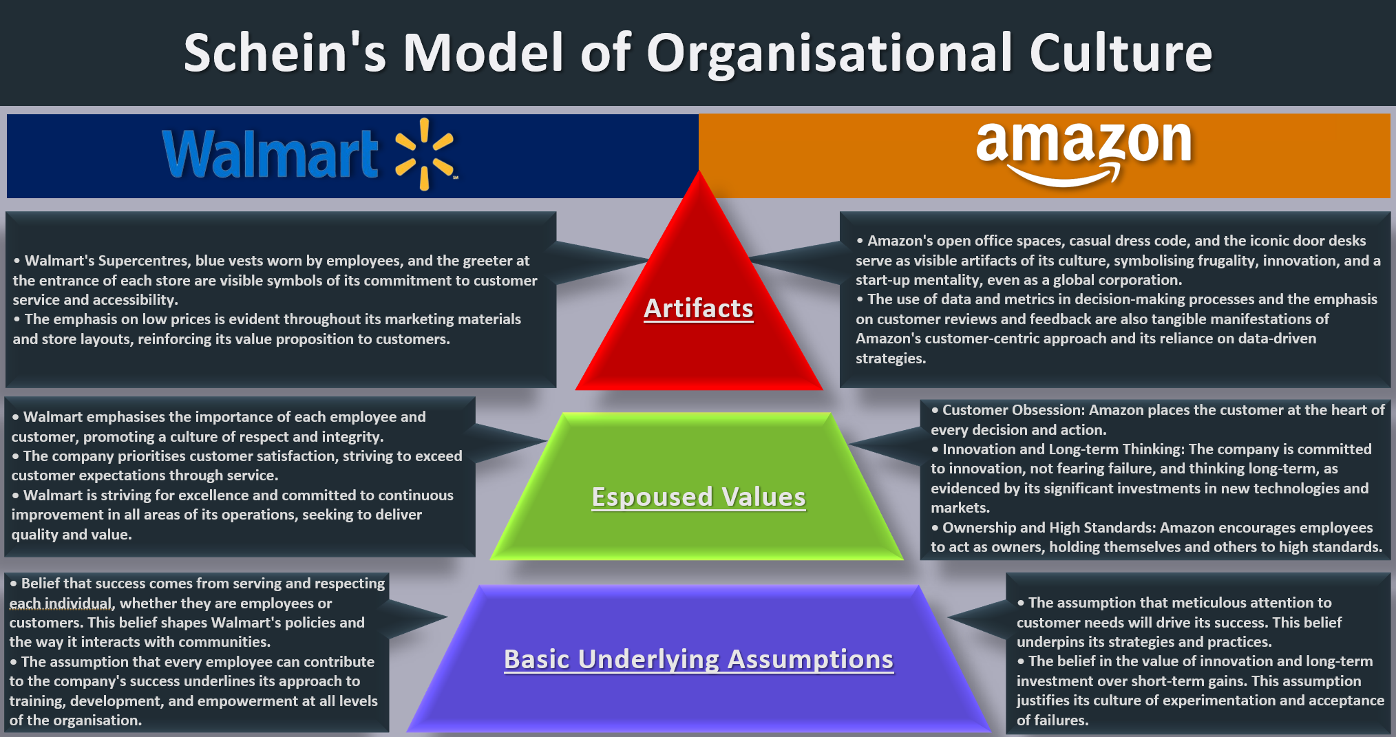

Appendix B
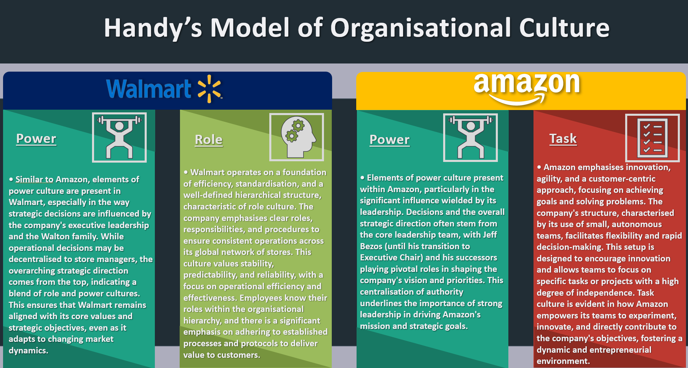

Appendix C
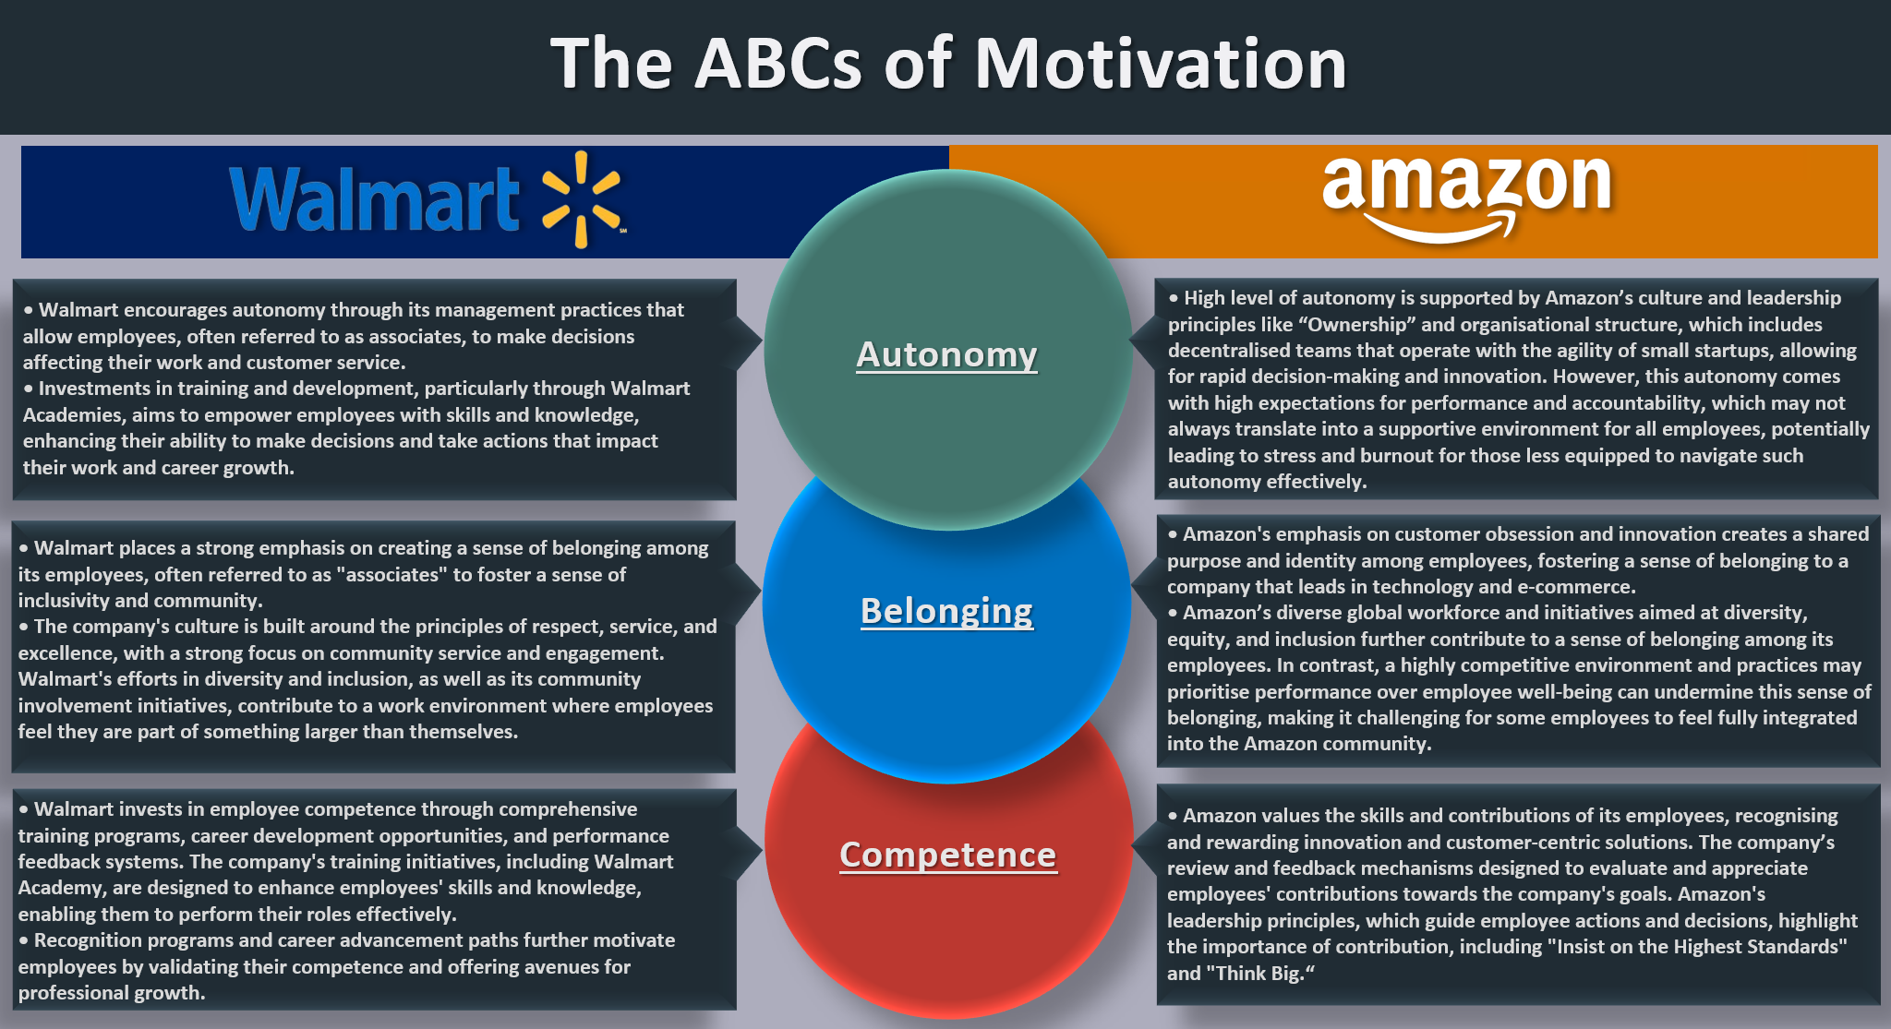

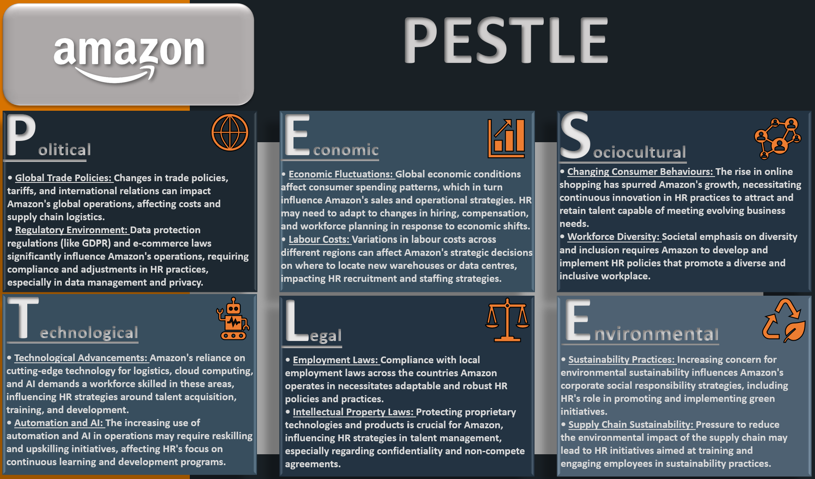
Appendix D

Appendix E
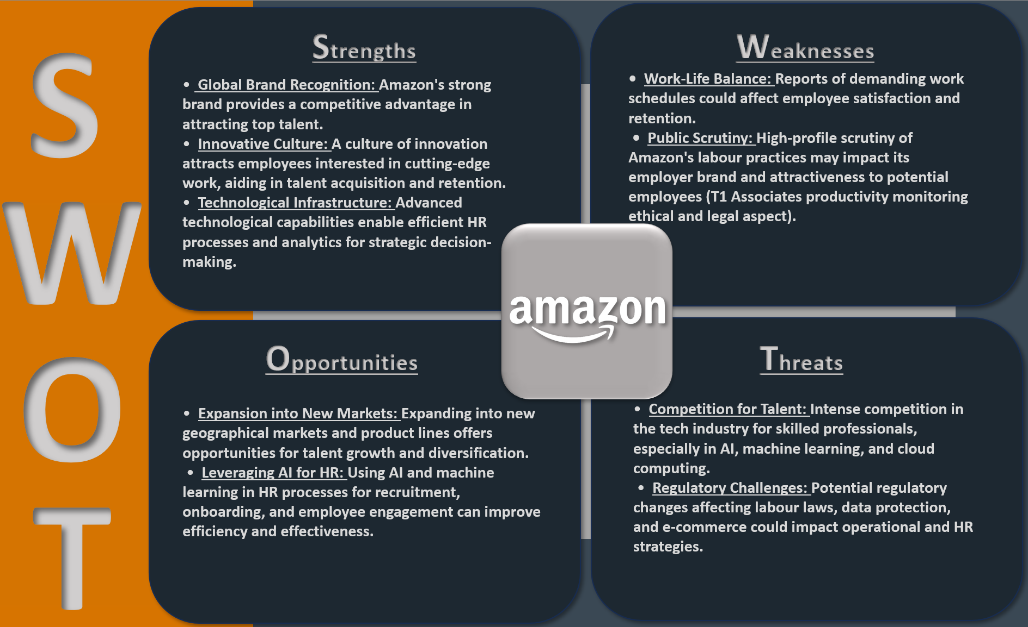

Appendix F
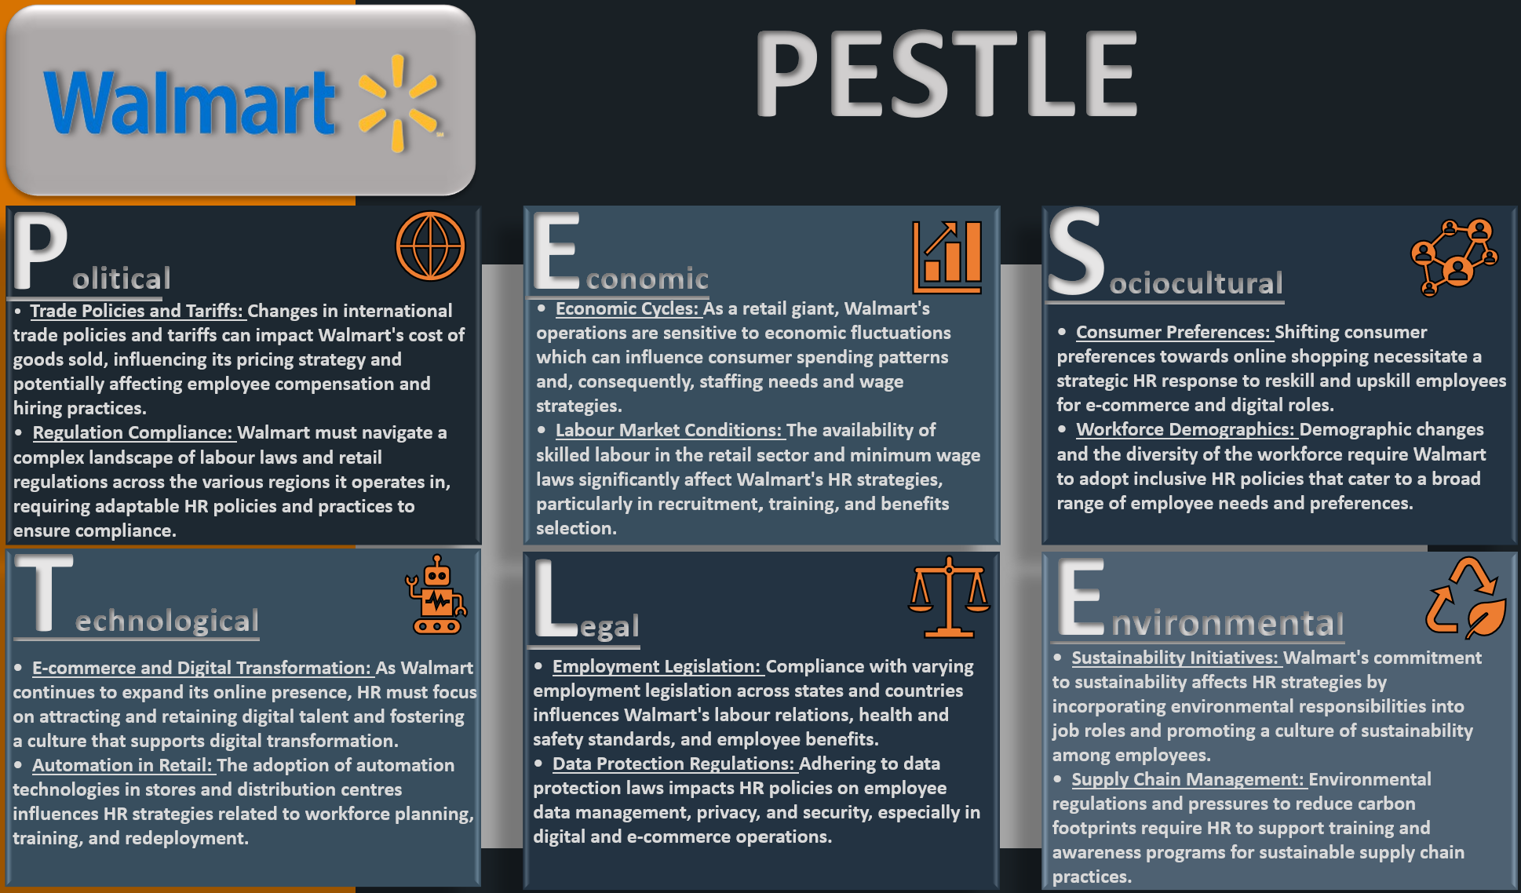

Appendix G
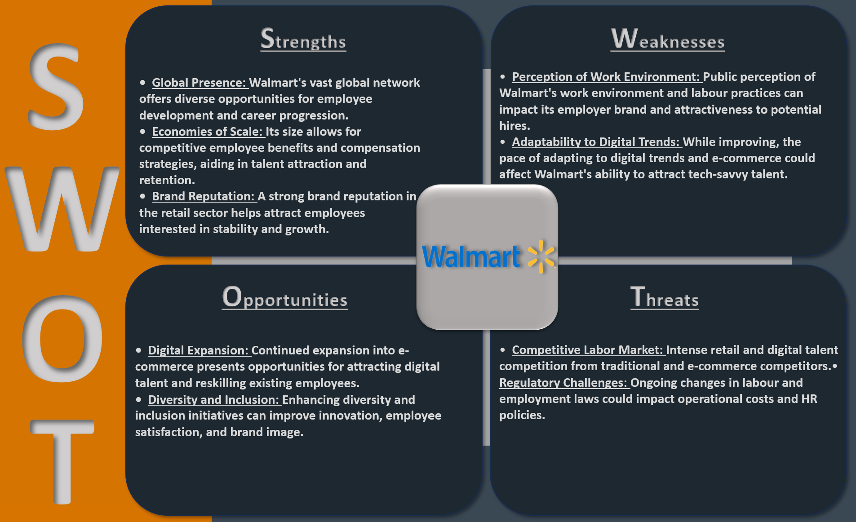

Appendix H
Additional Analysis of HRM Practices and Challenges.
According to Armstrong and Taylor (2023, pp. 4–24), HRM is a link between employer and employee, with the primary function ensuring organisational relevance, deploying a committed and capable workforce, establishing and sustaining healthy workplace relationships between two parties, aligning company policies with the employment legislations, mediating and advising the company's leadership and management with ethical and fair practices and supporting talent acquisition process, equal opportunities and employees’ wellbeing, assisting workforce on every stage of the employment lifecycle. Moreover, this functional complexity necessitates that HR professionals engage in cross-functional cooperation and partnering, seamlessly integrating these functions to foster a cohesive and productive organisational environment (CIPD, 2022a).
Organisational success depends on people's cooperation, commitment, skills, knowledge, resilience, and ability to achieve business objectives together - despite their differences, reach a consensus (Charan, 2022). To facilitate it, people professionals must understand the psychology of organisational power dynamics, as the real power within an organisation belongs to business owners where organisational governance rests on leadership and management, which must inspire people, set strategic vectors, manage performance, decide on policies, and influence corporate culture (Lynch, 2021, pp. 56–100). Additionally, the employer has moral and legal obligations towards its employees and must ensure their safety and wellbeing in the workplace to avoid legal ramifications, reputational damage and financial losses in case of negligence or employment rights violation (Gov.UK, 2023). On the other hand, employees must provide faithful service to the employer, obey lawful and reasonable orders in congruence with their employment contract, and maintain confidentiality (ACAS, 2023). However, Hendricks et al. (2019) argue that a psychological contract between employer and employee is also utterly important as it describes an informal commitment from both parties and regulates mutual understanding and expectations of their relationship.
Heffernan (2015) declares that business forecasting has faced crucial issues over the last 20 years as contingency has become a normality. Moreover, the world evolved from complicated to complex, where miscellaneous conditions created irregular patterns of ineradicable uncertainty. Additionally, organisations and individuals face the significant challenge of dealing with uncertainty, as the traditional norms of 'business as usual' and efficiency are no longer relevant; instead, agility and resilience have become critical priorities in the workplace (Bruce, 2022, pp. 34–60).
For instance, CIPD (2020b) states that the recent COVID-19 pandemic has reshaped people's work, accelerating digitalisation and automation. However, more importantly, the subsequent post-pandemic recession highlighted the significant role of emotional intelligence, equity, diversity, and inclusion in the workplace, emphasising the importance of integrating employee well-being activities into the business agenda, putting in the centre of attention people - as the most valuable organisational asset (Hosseinzadeh et al., 2022). Similarly, De Smet et al. (2020) confirm that COVID-19 showed that conventional scientific management methods could not be effective in contemporary business realities when managers, especially in manufacturing industries, use only a command and control approach to meet business targets, neglecting empathy and human-centric strategies. In contrast, emotionally intelligent managers can understand and regulate their feelings while grasping and influencing the emotions of others (Baker, 2023). Thus, their emotional awareness can bring an empathic approach to leadership, nurturing a healthy work environment and creating positive interaction that can increase employee satisfaction, retention, and overall organisational performance (Goleman, 2020).
Similarly, Papworth (2023, pp. 9–58) confirms that a shift in people's expectations toward work and organisational adaptation to the new business reality has launched a leadership and management transformation where wise, compassionate leadership supplants pure Taylorism at the workplace. Therefore, HR professionals must promote a value-driven culture amongst the functional heads, keep abreast of prevailing trends and serve as change agents, tailoring and aligning their strategies with the specific organisational context and business environment using comprehensive HR architecture (De Loss, 2015). However, today’s challenges for HRM arise not only from post-pandemic recession and evolving technological advancements but also from the complexity of human psychology and current external factors, such as global economic shifts and political and ecological concerns, which are the primary change drivers impacting all types of business (Gouldsberry, 2024).
Bala (2023) suggests that globalisation and interconnectedness have significantly impacted workplaces, increasing international job trafficking. Moreover, organisations that have achieved economies of scale influence local business subsidiaries with their corporate culture while simultaneously being influenced by the external contexts of the countries where they operate (Morrison, 2023, pp. 34–60). Hence, they must consider the ethnic and cultural backgrounds of internal and external customers when elaborating their business, customer relationship management (CRM), and HRM strategies (CIPD, 2022b).
Another significant challenge for HRM is managing a diverse working demographic and ensuring fair, inclusive practices supporting neurodiversity, people with special needs, and all-inclusive workplace cultures (CIPD, 2024). According to Deutsch, Coleman, and Marcus (2014, pp. 25–67), conflicts are inevitable during social interaction, especially in diverse environments, when challenging employee behaviour can be daunting. Moreover, conflicts should not be ignored and must be managed constructively, informally or using formal conflict-resolution procedures such as Grievance to defer discrimination, harassment or unwanted behaviour (Jones et al., 2017). However, constructive conflicts are required for effective problem-solving and creativity as long as they are controllable and in the framework of civility (Avgar et al., 2023). Therefore, the right team balance is essential for a healthy group dynamic, accumulating social capital through positive relationships, and increasing the number of actively engaged and self-motivated employees (Mind Tools Content Team, 2022).
Employee job satisfaction, motivation and active engagement are crucial for personal and organisational performance. Motivation theories such as ABC, Maslow’s Hierarchy of Needs, Herzberg’s Hygiene and Motivation Theory help HRM identify problems and fulfil employees’ psychological needs, work ambitions and expectations to provide development opportunities to keep positive morale and productivity. However, regardless of the motivation theory the organisations use, all exist to fulfil employees' basic job necessities to avoid dissatisfaction, hear their opinions and enhance employee engagement. Therefore, organisations must understand employees’ motivation factors that impact their performance and well-being. However, Eatough (2022) argues that despite organisational efforts to motivate employees, self-motivation is the most substantial factor that drives individual performance.
Succession planning is another crucial HRM function that helps the organisation stay agile and competitive (Kenton, 2022). Companies must understand the personnel capabilities and competencies needed to align recruitment with business realities and objectives and acquire the most organisational-fit talents (Acikgoz, 2019). Therefore, customising hiring practices is crucial in finding organisationally fit candidates with a well-aligned attitude and values (Heskett, 2024).

Appendix I
Overview of Amazon CWL1 HR team.
Amazon's CWL1 HR team comprises HR partners (HRP), recruiters, and senior managers. For instance, an HRP role is designed to cover a wide range of L4-L7 front-line manager people needs, as they assist as subject matter experts, increasing managers' capability, enabling their self-sufficiency, measuring and interpreting the voice of the employees and partnering with AMs on action plans from appraisals, disciplinary meetings, surveys, and exit interviews.
Additionally, the HR Business Partners (HRBP) work as an integrated part of a leadership team, using business acumen to steer strategic talent discussions and decisions. HRBPs engage with the leadership teams to design and deliver the talent roadmap, including organisation design and effectiveness, talent development and management programs, culture support initiatives, and change management activities.
Ultimately, from a strategic point of view, HRM at Amazon is not merely a support function but a critical component of the organisation, with its leadership firmly represented at the senior management and director levels. This strategic positioning underscores the significance attributed to HRM, reflecting its integral role in shaping workforce policies and driving Amazon's overarching strategic imperatives.

