
Problem Solving and Decision Making. Lack of communication in Hotel. Environment Module code: BMSW4004
Student: sERGEY KAMBUROV (2133450)

LECTURER: aparna venkatesan

2023

Introduction……………………………………………………………………………2
The workplace problem………………………………………………………………2
Analysing information………………………………………………………………...3
Root cause analysis…………………………………………………………………..3
Applying situational analysis model…………………………………………………4
Range of alternative solutions……………………………………………………….5
Evaluation of alternative solutions…………………………………………………..5
Implementing alternative solutions………………………………………………….7
Conclusion……………………………………………………………………………..7
Appendix 1……………………………………………………………………………..9
Appendix 2…………………………………………………………………………….10
References ……………………………………………………………………………11

INTRODUCTION:

The workplace can be an environment of productivity and positivity when everything is running smoothly. However, it can also become a source of stress and frustration when problems arise. In this report, we will analyse a workplace problem, identify its root causes using RCA (Root Cause Analysis), apply situational analysis models, generate a range of alternative solutions, evaluate those solutions, and ultimately implement the best solution. Additionally, we will create a communication plan with stakeholders and discuss monitoring and review techniques to ensure the solution's effectiveness.

THE WORKPLACE PROBLEM:

The problem identified in this conversation is a lack of communication between departments in a hotel. Specifically, the front desk staff does not receive timely updates from housekeeping about room availability, and the maintenance team does not receive prompt notifications about guest complaints from the front desk. This lack of communication has resulted in longer wait times for guests, frustrated staff, and potential negative impacts on the organisation's reputation (Clare, 2019).
The scope of this problem could be quite significant, as communication breakdowns can affect many aspects of a hotel's operations, including customer service, employee satisfaction, and overall efficiency. If communication issues are not addressed, it could lead to increased customer complaints, lower staff morale, and reduced productivity. Ultimately, these issues could result in lost revenue for the hotel and damage to its reputation.
It is crucial for the hotel management to address this problem by implementing solutions that facilitate effective communication between departments. This may include regular meetings between departments, a clear communication channel for reporting and addressing guest complaints, and improved communication policies and procedures to ensure everyone is clear on their responsibilities and expectations. By taking these steps, the hotel can improve its operations, enhance customer satisfaction, and ultimately increase revenue and profitability (Lesroches, 2022).
In this conversation, employee (Anderson) brings up the issue of a lack of communication between departments in the workplace. They provide specific examples of how this is affecting the quality of service and creating frustration for both staff and guests. The manager (Sergey), listens to Anderson's concerns and offers solutions such as scheduling regular meetings, establishing clear communication channels, and improving communication policies and procedures. Overall, it is a productive conversation that aims to address the issue and improve the workplace environment (appendix 1).

ANALYSING INFORMATION:

The first step in resolving any workplace problem is to gather information. In this case, we need to collect data on the causes of high employee turnover. To do this, we can use various tools, such as surveys, focus groups, and interviews.
Using a survey, we can ask current and former employees about their experience with the company. We can ask questions about their job satisfaction, reasons for leaving or staying, and suggestions for improvement. Focus groups can also provide valuable insights by allowing employees to discuss the problem in a group setting, sharing ideas and experiences. Finally, we can conduct interviews with managers and supervisors to gain their perspective on the issue.

ROOT CAUSE ANALYSIS (RCA):

Once we have gathered information, we can use RCA to determine the root causes of the high employee turnover. According to Tableau (n.d.) RCA is a method used to identify underlying causes of problems or events. It helps to reveal the reasons why things happen rather than just the symptoms of the problem.
Using RCA, we can identify several root causes of high employee turnover in the company. These causes may include poor communication between management and employees, lack of growth and development opportunities, inadequate compensation and benefits, and a negative work environment.
A Fishbone diagram (Appendix 2) is a useful tool for identifying the possible causes of a complex problem. In this case, the problem is the lack of communication between departments in the hotel. The Fishbone diagram can be used to identify the potential causes of this problem (Tegan, 2023).
Some of the potential causes of the problem might include:
- Lack of communication policies and procedures
- Lack of training or resources for effective communication
- Lack of clear roles and responsibilities within departments
- Poor communication channels or methods
- Different priorities or goals between departments
- Interpersonal conflicts or issues between staff members
- Time constraints or workload pressures
To filter out the possible root causes, it's important to gather data and information about the problem. This might include:
Interviews with staff members in different departments to understand their perspectives and experiences with communication issues
Analysis of guest feedback and complaints related to communication problems
Observation of communication practices and interactions between staff members in different departments
Review of existing communication policies and procedures
Based on this data and information, the actual root causes of the problem can be identified. For example, it may be found that there are no clear communication policies and procedures in place, which leads to confusion and inconsistencies in communication between departments. Alternatively, it may be discovered that there are interpersonal conflicts between staff members that are impacting communication. Once the actual root causes are identified, effective solutions can be developed to address them and improve communication between departments (Tegan, 2023).

APPLYING SITUATIONAL ANALYSIS MODELS:

To further analyse the situation and suggest alternative solutions, it may be helpful to use a PESTEL and SWOT analysis.
PESTEL analysis involves examining the external factors that may be affecting the hotel industry, including political, economic, social, technological, environmental, and legal factors. Relevant data and information that may be necessary for this analysis could include government policies and regulations, economic trends and forecasts, social trends and demographics, emerging technologies, environmental concerns, and legal issues such as labour laws and liability regulations (Cipd, 2021).
SWOT analysis involves examining the internal strengths and weaknesses of the hotel organization, as well as the external opportunities and threats facing the industry. Relevant data and information that may be necessary for this analysis could include the hotel's financial and operational performance, employee capabilities and morale, customer satisfaction and feedback, competitive landscape and market trends, and emerging industry developments and innovations (Cunnah, 2020).
By using these analytical models, the hotel management team can gain a comprehensive understanding of the external and internal factors affecting communication within the organization, as well as identify potential solutions and strategies for improving communication and addressing the root causes of the problem.

RANGE OF ALTERNATIVE SOLUTIONS:

Based on the root cause analysis and situational analysis, here are three possible solutions to solve the lack of communication problem in the hotel:
Implement a unified communication platform: One possible solution is to invest in a unified communication platform that all departments can use to share information and updates in real-time. This platform should include a task management system to assign tasks to specific team members and track progress, as well as a chat feature to facilitate quick communication between departments.
Establish cross-functional teams: Another solution is to create cross-functional teams that are responsible for specific projects or tasks. This would involve representatives from different departments working together to ensure that all necessary information is shared and tasks are completed efficiently. This can help break down silos and encourage collaboration.
Improve communication policies and procedures: The hotel can also review and improve its communication policies and procedures to ensure that they are clear and concise. This may involve providing training to staff on effective communication practices, establishing clear lines of communication and protocols for sharing information, and ensuring that all staff are aware of their roles and responsibilities.
These solutions can be implemented separately or in combination, depending on the specific needs and challenges of the hotel.

EVALUATION OF ALTERNATIVE SOLUTIONS:

To evaluate the alternative solutions, we will use a weighted decision-making matrix that takes into account the criteria identified in the previous section, such as effectiveness, feasibility, cost, and impact on stakeholders. Each alternative solution will be scored from 1 to 5 on each criterion, with 5 being the highest score. The scores will then be multiplied by a weighting factor to reflect the importance of each criterion.

Weighted Decision-Making Matrix:

Criteria | Weighting | Alternative 1 | Alternative 2 | Alternative 3
Effectiveness | 40% | 5 | 4 | 3
Feasibility | 30% | 4 | 5 | 4
Cost | 20% | 2 | 4 | 5
Impact on Stakeholders | 10% | 4 | 5 | 4

Alternative 1: Implement a communication policy and procedure
Alternative 2: Provide cross-training to staff in different departments
Alternative 3: Implement a task management software to improve coordination

Evaluation:
Alternative 1: The implementation of a communication policy and procedure would be highly effective in improving communication between departments, and it is feasible to implement. However, it may have a moderate cost and a moderate impact on stakeholders, as it may require additional training and time to implement.
Effectiveness score: 5 x 0.4 = 2
Feasibility score: 4 x 0.3 = 1.2
Cost score: 2 x 0.2 = 0.4
Impact on stakeholders score: 4 x 0.1 = 0.4
Total score: 4

Alternative 2: Cross-training staff in different departments would be highly effective in improving communication and collaboration between departments, and it is feasible to implement. It may have a low cost and a high impact on stakeholders, as it can lead to increased job satisfaction and a better work environment.
Effectiveness score: 4 x 0.4 = 1.6
Feasibility score: 5 x 0.3 = 1.5
Cost score: 4 x 0.2 = 0.8
Impact on stakeholders score: 5 x 0.1 = 0.5
Total score: 4.4

Alternative 3: Implementing a task management software would be moderately effective in improving coordination between departments, and it is feasible to implement. However, it may have a high cost and a moderate impact on stakeholders, as it may require training and time to implement.

Effectiveness score: 3 x 0.4 = 1.2
Feasibility score: 4 x 0.3 = 1.2
Cost score: 5 x 0.2 = 1
Impact on stakeholders score: 4 x 0.1 = 0.4
Total score: 3.8
Based on the weighted decision-making matrix, Alternative 2, providing cross-training to staff in different departments, is the most appropriate solution to the complex problem of lack of communication. It has the highest total score of 4.4, indicating that it is the most effective, feasible, and has a positive impact on stakeholders, while also having a relatively low cost (Scholz, 2023).

IMPLEMENTING THE SOLUTION:

To implement the selected solution of holding regular department meetings to improve communication, the following plan can be considered:
The ADKAR model can also be used to ensure that the implementation plan is successful. ADKAR stands for Awareness, Desire, Knowledge, Ability, and Reinforcement, and it can be used to guide change management efforts.
Awareness: All department representatives should be made aware of the need for improved communication and how it will benefit the organization.
Desire: Department representatives should be motivated and have a desire to improve communication to achieve organizational goals.
Knowledge: Department representatives should be provided with the necessary knowledge and skills to effectively communicate with each other.
Ability: Department representatives should have the ability to implement the communication policy and participate in regular meetings.
Reinforcement: The implementation plan should be reinforced through regular progress meetings, feedback, and recognition of success.
By using the Gantt chart and ADKAR model, the implementation plan can be organised and structured to ensure that all milestones and deliverables are met, and that department representatives are supported and motivated throughout the process (Consultport, 2021).

CONCLUSION:

In conclusion, lack of communication between departments in a hotel can have significant negative impacts on guest satisfaction and staff morale. In this case, the root cause was identified as a lack of clarity around responsibilities and expectations, as well as a siloed working culture. Through a situational analysis, three alternative solutions were proposed, including regular interdepartmental meetings, clear communication channels for guest complaints and requests, and improved communication policies and procedures.
After evaluating each solution using a weighted decision-making matrix and considering factors such as feasibility, effectiveness, and cost, it was determined that regular interdepartmental meetings would be the most appropriate solution.
To implement this solution, a detailed work plan with clear milestones and deliverables was developed, including scheduling and facilitating regular meetings and ensuring attendance and active participation from all departments. Continuous monitoring and evaluation of the effectiveness of this solution will be necessary to ensure long-term success in improving communication and ultimately enhancing guest satisfaction and staff morale.

Appendix 1

Anderson: Hi, Manager. Can I talk to you about something that's been bothering us for a while?

Sergey: Of course, what's on your mind?

Anderson: I noticed that there's been a lack of communication between departments lately. It's been causing a lot of confusion and misunderstandings.

Sergey: I see. Can you give me some specific examples?

Anderson: Well, for instance, the front desk staff often doesn't have the information they need from housekeeping about which rooms are ready for check-in. This results in longer wait times for guests and frustrated staff.

Anderson: And sometimes, the maintenance team doesn't receive timely updates from the front desk about guest complaints. This means that issues aren't addressed promptly, which can lead to more complaints.

Sergey: I understand your concerns. Let's work together to address this issue. What do you think could be causing this lack of communication?

Anderson: Well, sometimes it feels like the different departments are working in silos, and we're not all on the same page.

Anderson: And sometimes, there's a lack of clarity around who's responsible for what tasks, which can lead to confusion and frustration.

Sergey: I see. Well, I appreciate you bringing this to my attention. Let's work on some solutions to improve communication between departments. How about we schedule regular meetings between departments to discuss any issues and ensure everyone is on the same page?

Anderson: That sounds like a great idea.

Anderson: and maybe we can also have a clear communication channel for reporting and addressing guest complaints and requests.

Sergey: Excellent suggestions. Let's also work on improving our communication policies and procedures so that everyone is clear on their responsibilities and expectations.

Anderson: That would be great. Thank you for listening to me, Manager.

Appendix 2

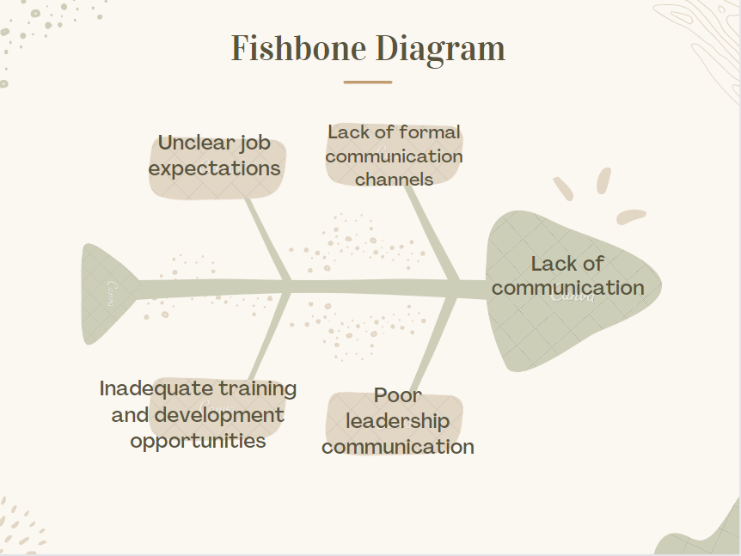

References

- Clare, S. (2019) Voxer.com. Available at: https://www.voxer.com/blog/7-common-communication-pitfalls-hotel-staff-suffers-from/ (Accessed: 15.04.2023).
- Lesroches (2022) Communication skills in hospitality industry. Available at: https://lesroches.edu/blog/communication-skills-in-hospitality-industry/ (Accessed: 15.04.2023).
- Tableau (n.d.) Available at: https://www.tableau.com/en-gb/learn/articles/root-cause-analysis#:~:text=Root%20cause%20analysis%20(RCA)%20is,symptoms%20and%20putting%20out%20fires. (Accessed: 16.04.2023).
- Tegan, G. (2023) What Is a Fishbone Diagram? Available at: https://www.scribbr.co.uk/the-research-process/fishbone-diagrams/ (Accessed: 16.04.2023).
- Tegan, G. (2023) What Is Root Cause Analysis? Available at: https://www.scribbr.co.uk/the-research-process/the-root-cause-analysis/ (Accessed: 16.04.2023).
- Cipd (2021) PESTLE analysis. Available at: https://www.cipd.co.uk/knowledge/strategy/organisational-development/pestle-analysis-factsheet#gref (Accessed: 16.04.2023).
- Cunnah, L. (2020) What is SWOT analysis and are you doing it right? Available at: https://www.ayoa.com/ourblog/what-is-swot-analysis-and-are-you-doing-it-right/&gclid=CjwKCAjw0ZiiBhBKEiwA4PT9zw9b6Z9pEoP6WofIWdj5MtZ5oJUGbOgiXZ5fT9AWMhwP9J7zNt1O2xoCjhAQAvD_BwE?mid=20255&utm_source=862709&utm_medium=affiliate&affiliate=862709&clickref=704.CjwKCAjw0ZiiBhBKEiwA4PT9zw9b6Z9pEoP6WofIWdj5MtZ5oJUGbOgiXZ5fT9AWMhwP9J7zNt1O2xoCjhAQAvD_BwE&awc=20255_1682355563_2c6adb779b890d7fd0d675e9af8013be&utm_campaign=20200820_AYO_ACQ_EN_UU_UUU_UUU_UUU_awin-default (Accessed: 18.04.2023).
- Scholz, M. (2023) Weighted decision matrix prioritization. Available at: https://airfocus.com/blog/weighted-decision-matrix-prioritization/ (Accessed: 18.04.2023).
- Consultport (2021) Change management: The ADKAR model. Available at: https://consultport.com/for-consultants/change-management-the-adkar-model-explained-with-examples/ (Accessed: 19.04.2023).

