Rhodri Owen Phillips – 1805871

Assignment 2 – Final Report

Generating Business Data and Analysis – BMSP4004

Year 1 - 2019

Introduction
In this report I will be discussing four data files that has been given to me to make changes on. In this report I will be demonstrating how to use basic Excel tools as well as more advanced Excel tools. The adding and subtracting will be demonstrated as well as other functions such as IF, Look up, Pivot tables, filtering data, Criteria and graphs. The four files I will be demonstrating this on will be a ‘Prosumer Survey’, ‘Appliance Carbon data list’. ‘Weather list file’ and ‘Electrical data file’. I will be posting photographic evidence to this report to strengthen my evidence and understanding. I have also used the web and online videos tools to better my understanding and I will be referencing from these as well as some of my lectures during this report. To start off my research I used a website called ‘Hackernoon’ that showed me the steps of processing data. I used these steps throughout my report as a guidance.

Weather List File
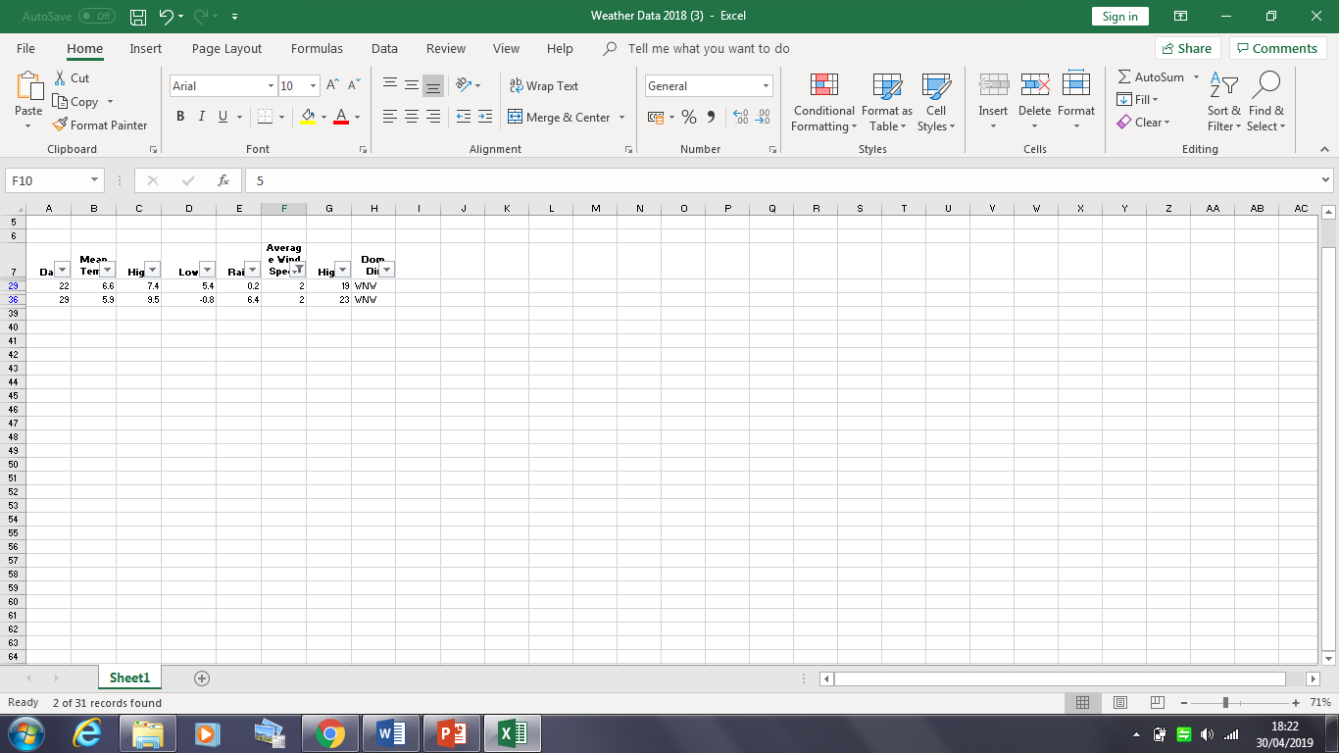
The first file I will be demonstrating is the ‘Weather list file’. In this file the data includes the monthly climatological summary for January 2018. This data file includes eight columns which show the Different days and the ‘Mean Temp’, ‘Highs’, ‘Lows’, ‘Rain’, ‘Average wind speed’, ‘Highs’ and ‘Dom Dir’. The first function I will be demonstrating using this table will be ‘Filtering Data’. The shortcut keys for filtering data is to hold ‘Ctrl’, ‘Shift’ and the number 7 while keeping your curser on the data. The longer way is to keep your curser on your data and go to the data tab then press the ‘Filter’ option. After applying this, pop down tabs should appear on every title. I chose to filter data from the ‘Average wind speed’ that occurred on different days. When clicking on the dropdown tab for ‘average wind speed’ I was given various options of filtering, for example ‘Smallest to largest’ and ‘Largest to smallest’. I also got a list of all the different wind speeds that the file held. I chose to filter the data to show on what days did the average speed of 2 occur. By using this method, it was easy for me to discover that the average wind speed of 2 occurred on days 22 and 29. I can also read any similarities that may be when looking at the other data columns. In this case there were no obvious similarities.

As we can see this from this screenshot from the excel chart, we have two results matching the criteria of our filter. Next to the ‘Average Wind speed’ tab there’s a drop down option that I could’ve clicked again and this would’ve given me the option to enhance on my filtering for example if I wanted clicked ‘smallest to largest’ it would show the days that have average wind speed of 2 from the smallest to the largest.

The next function I used was the ‘Look up’ function. To increase my understanding of the Lookup function I watched an online video that stated that ‘The ‘Look up’ function can be used for the vertical table and the horizontal table’. To use the ‘Lookup’ function I pressed ‘=’ then the word ‘Lookup’. I demonstrated this function on the ‘Weather file’. The Look up function is beneficial as you do not have to use four parameters and it’s a sharp accurate formula to seek different criteria within the data you have. On the Weather list file, I wanted to look up the average wind speed when on the days that the rain was on 2. To do this I put ‘Rain’ and ‘Average Wind Speed’ in two columns on their own on the side of the other columns as shown in the screenshot below.
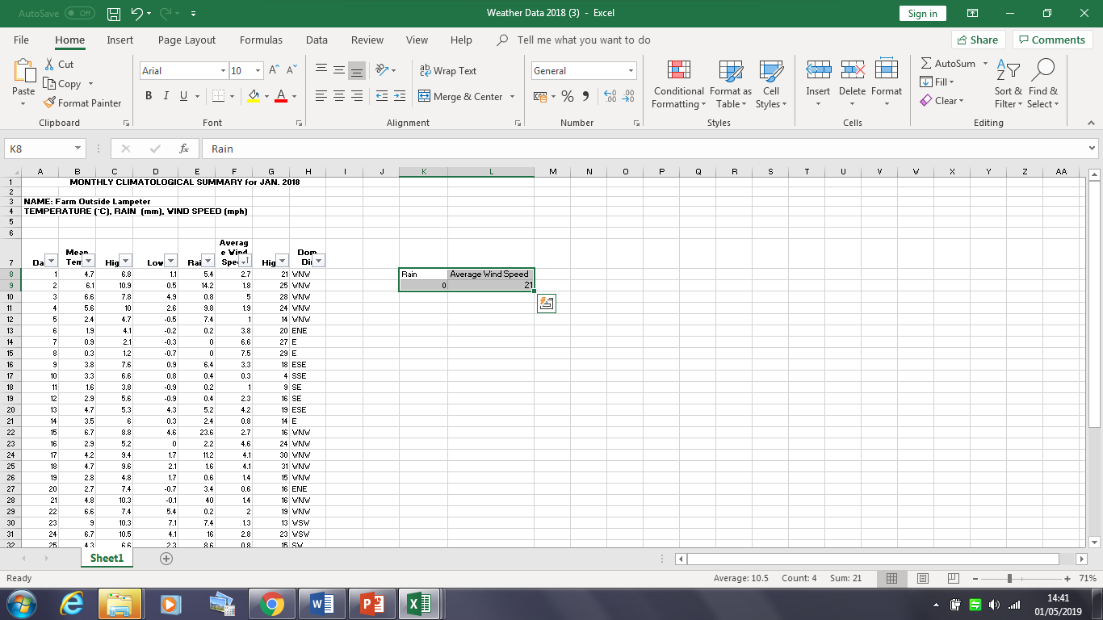

In the ‘Rain’ column I put the number 2 because that’s the number we are focusing on. In the ‘Average wind speed’ I did ‘=’ and the word ‘Lookup’ then an open bracket. I highlighted the number 2 in the rain column and after inserting a coma I highlighted the whole table with all the data in. After pressing enter Excel had examined the data and gave me the answer of 21.

Following this I wanted to discover the Total rain fall from the whole of the data recorded. To do this I used the ‘Autosum’ function which did all the calculations that I needed for me. To discover the Total rain fall I used autosum then highlighted the rain column and this gave me the answer of 198 as seen highlighted in the screenshot below.

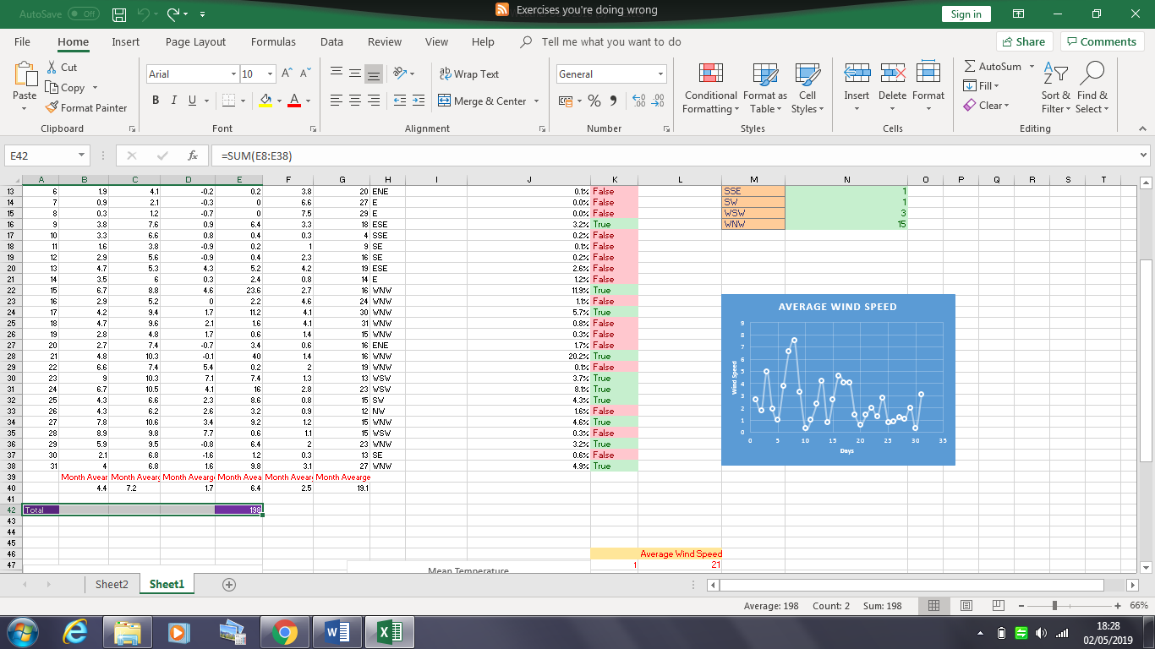

Also seen in the screenshot above is all of the averages for the different months included in the spreadsheet. I have rounded the numbers up to one disable point as the answer given to me through excel was too long. To discover the average for these months I did ‘=’ then the word ‘Average’ and I highlighted the columns I wanted to discover the average of. This was an easy and simple way that that gave me accurate results.

Next I wanted to know the daily rainfall as a percentage. To work out the percentage I used the formula shown in the screenshot below. This is an easy way to figure out percentages and once I discovered one percentage, I highlighted the whole column and excel automatically does the working out of the others for me. Also in the picture below I have put the ‘IF’ function into demonstration. I used ‘IF’ and then the >6 to ask if the data in that row was higher than 6. As you can the results are written in ‘True’ or ‘False’ for the result of that row. To demonstrate the IF function I used the formula ‘=IF(E8>6, ‘’True”,”false”) and continued doing this for the others.

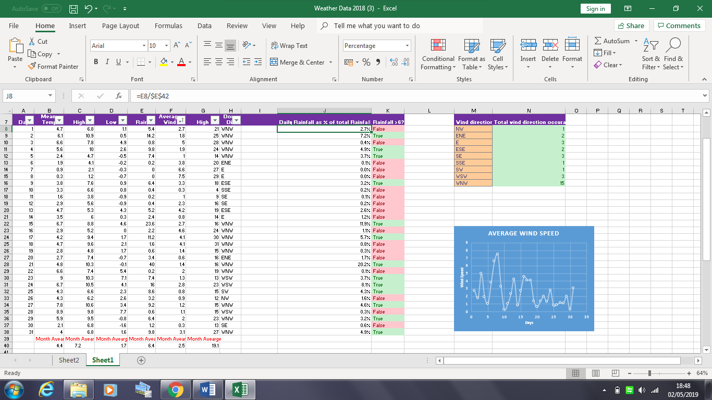

Here we can see the True/False column along with the percentages of the recorded data.

Graphs
For this spreadsheet I also produced graphs to show different findings. I did 3 graphs in total that included showed the Average wind speed, Mean Temperature and Total Wind Direction. These three graphs are of different types and I chose this accordingly.

This is the graph that shows the Average Wind Speed. On the Y axis we can see the wind speed ranging from 0 – 8. On the X axis we can see the days that this data was recorded.

This graph shows the Mean temperature.

This graph shows the Total Wind Direction

Appliance Carbon Data File

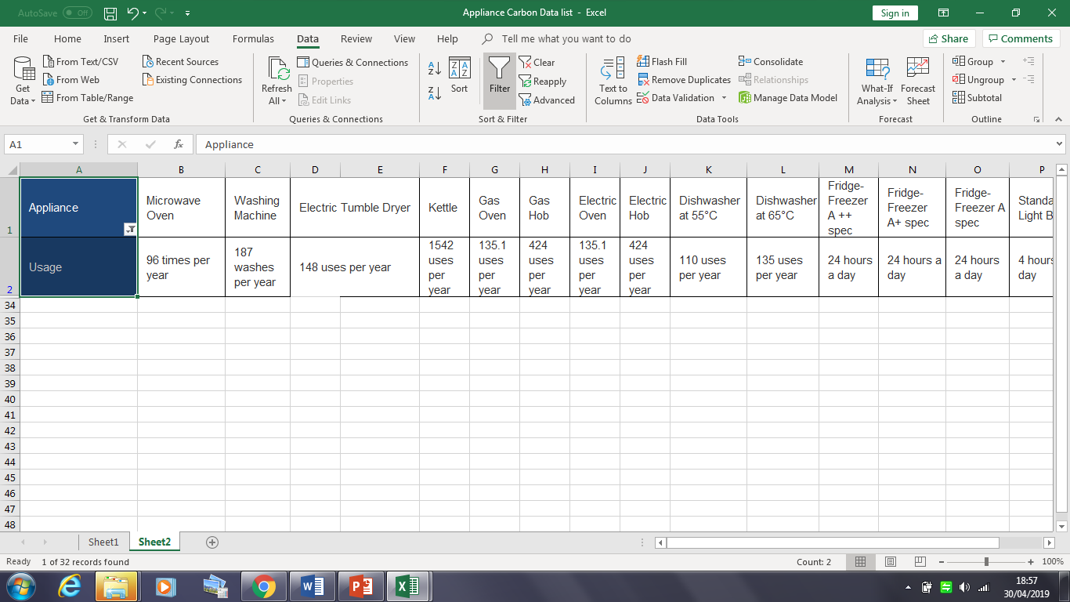
I also used the filtering function on the ‘Appliance Carbon data’ file. This file includes data showing different units of measurement for different electrical appliances. There are 16 different electrical appliances that are showed in this file, all of them showing 4 different rows of different data. This data includes the ‘Usage’ of the appliance, the ‘Assumptions’, ‘Cost per year’ and the ‘Kg of C02 per year’. For this file I decided to filter how many appliances has the usage of 24 hours a day. To do this I highlighted the ‘Appliance’ column and the ‘Usage’ column which left me with the 16 different appliances along with their usage as shown below.

By looking at this we can see that there are 3 appliances that have the usage of 24 hours per day.

I also figured out the average cost for this fie by using the =Average formula. I made all the averages into the pounds currency as that’s how they are recorded in the file. These averages are recorded next to every row in the colour yellow. In addition to this I calculated the full amount that’s given after adding all the numbers in the rows. These figures are highlighted at the end of every row in the colour green.

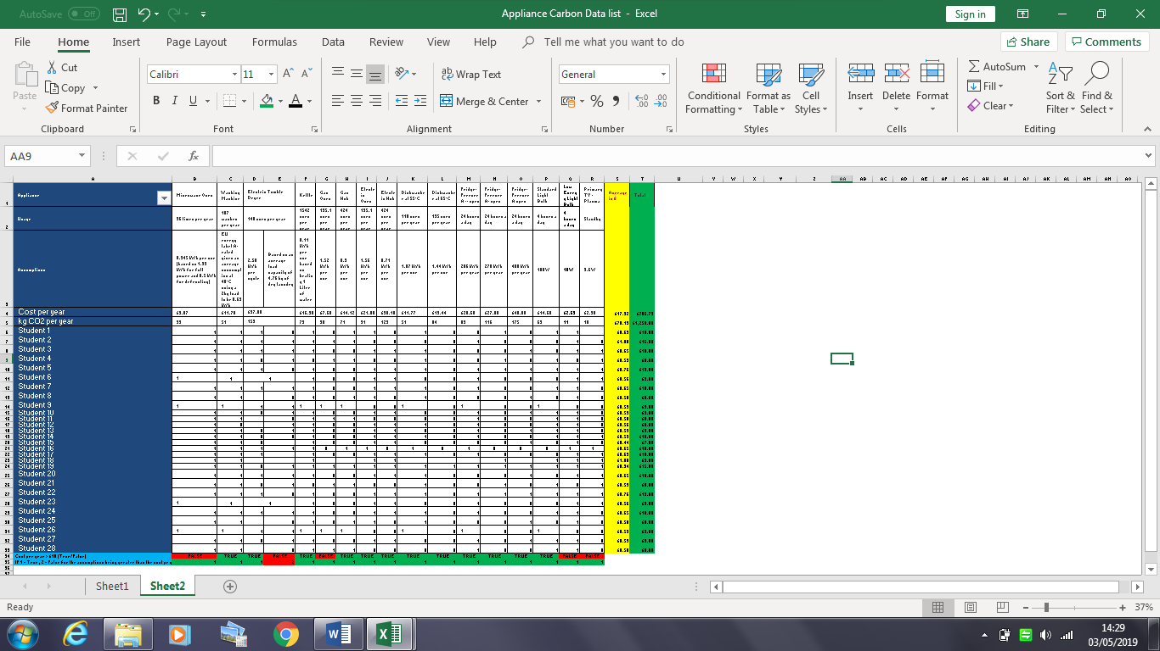

Next, I wanted to demonstrate the IF function and the formula I used to do this including the way I got the True and False answers. To discover the true and false answers I used the formula ‘=’ then the first cell following with the ‘>’ symbol and then the second cell I wanted to use. But in this case, I wanted to discover if the cost per year for each appliance was greater than £10. I chose £10 as I believed it to be a fair number. Five out of the seventeen of the figures resulted as false. These are recorded at the bottom of each row in red. I also wanted to demonstrate the IF function on this file. To do this I used the ‘Assumptions’ data and the ‘Cost Per year’ data and manually put the records for assumptions in as there are also words in the cell. I used the numbers 1 and 2, 1 being true and 2 being false. The formula I used for the first one was ‘=IF(B4>0.945,1,2)’. I then repeated this for all the others. For this data file I didn’t feel the need to demonstrate any graphs as the data is recorded quite simply and it was easy enough to interpret.

The picture below shows the IF function and the True and False function
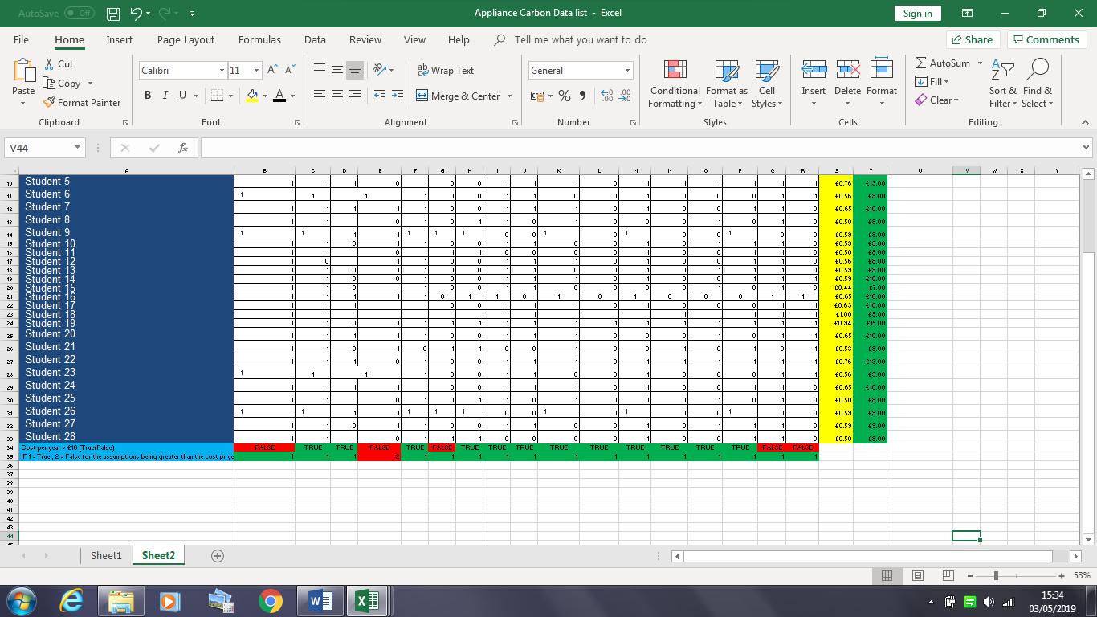

Prosumer Survey 2019 file

The Prosumer file was the largest of files given to me in this task. The prosumer file was a database and not a spreadsheet like the others. To understand my understanding of databases and spreadsheets I did some research and found a website called ‘Life Wire’ and ‘Oracle’ which showed how to manage databases. The Prosumer file included previous findings of students in my class regarding prosumer companies. The file has 944 different prosumer companies recorded and for each company the number of employees is recorded, along with their http address, the size of the company, the sector of the company in broad and more detailed. It also has the ‘evidence of sustainability’ for the company where data is recorded Yes or No. If there is evidence, there is a column where students could put the evidence they had found and the website link for that evidence. The file has 5 different tabs including Introduction to the Research, BP Model, Business Processes, Incentives and Knowledge sharing.

As this was the largest file, I thought it would be the most suitable to demonstrate the ‘Account IF’ function. The Account IF is a function used when there is a lot of data recorded and you want to find out how many of what has been recorded. In this file’s case I used the size of the company as an example. There are 4 different sizes recorded on the spreadsheet which are Small, Medium, Large and Megga. I wanted to discover how many companies were recorded that were of these sizes. As there are 944 different companies this would be a hard task if it wasn’t for the Account IF function. To put the Account IF function I made a table that I’ll provide in the picture below.
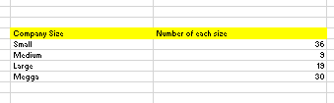
On the left side of the table are the choices of different company sizes recorded in the file. On the right side of the amount that them sizes were recorded. In this case the amount of small companies recorded was 36, the amount of medium companies recorded was 9, Large was 19 and Megga was 30. Although these numbers should add up to the total amount of records on the file which is 944 I couldn’t get them to balance. On the other hand my method was still demonstrated and my formula was shown.

Swansea Business School Half Hourly data.

The Swansea Business School Half Hourly data was the last file I did. This file was the hardest as It did not contain much information and it was very dull and bland. The data recorded in this file was from Old land registry office. This file had the most records in amounting to 1,687 records in total. There wasn’t much I could do to this file as it lacked information and useful data. The only change I did that I thought was beneficial to this file was I deleted all the dates that had no data recorded. This made the file much smaller and easier to examine if needed.

Conclusion

By completing this report and putting various functions and tools from excel into practice using the spreadsheets and database given to me I have enhanced my understanding all together. I managed to demonstrate some of the functions twice on different files which put them into practice productively. I managed to show proof of all my work via the ‘Print screen’ option and this gives extra evidence for my work. I used various different websites when researching and gathering information for this task which will be shown in the reference section below. Out of the 4 files given to me, the most enjoyable one to demonstrate on was the Weather file, the reason for this was that it was less information on the spreadsheet that gave me the chance to work more intensely on the data provided. The Prosumer database and the Swansea Half Hourly file was the hardest for me. The prosumer file included a lot information, most of it I found very hard to enhance on. With the half Hourly data file, I found that it didn’t include enough information to demonstrate any functions on. Saying this I have learned different functions and formulas that I will be able to put into practice for the future.

References
Hacker Noon. (2019). What Steps should one take while doing Data Preprocessing?. [online] Available at: https://hackernoon.com/what-steps-should-one-take-while-doing-data-preprocessing-502c993e1caa [Accessed 3 May 2019].
Lifewire. (2019). Ditch Your Spreadsheet for a Database to Access the Power of your Data. [online] Available at: https://www.lifewire.com/what-is-a-database-1019737 [Accessed 3 May 2019].
Oracle.com. (2019). Are you ready to consolidate databases into database clouds?. [online] Available at: https://www.oracle.com/database/ [Accessed 3 May 2019].
QuestionPro. (2019). Interval Data: Definition, Characteristics and Examples. [online] Available at: https://www.questionpro.com/blog/interval-data/ [Accessed 3 May 2019].
Support.office.com. (2019). Excel functions (by category). [online] Available at: https://support.office.com/en-ie/article/excel-functions-by-category-5f91f4e9-7b42-46d2-9bd1-63f26a86c0eb [Accessed 3 May 2019].
YouTube. (2019). MS Excel - Lookup Function. [online] Available at: https://www.youtube.com/watch?v=Ulm4YXfXV3o [Accessed 3 May 2019].

