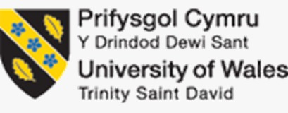

PROGRAMME: MASTER OF BUSINESS ADMINISTRATION
MODULE: HUMAN CAPITAL MANAGEMENT
MODULE
CODE: LCMB7023
Assignment
Title: Assessment component 1:
Individual report
Topic: The influence of national and international labour markets on HRM and IHRM strategies

Student Name: Takia Sultana
Student ID: 2514835
Table of Contents
Introduction 3
1.0 How are technological advancements reshaping labour markets and what implications does this have on HRM and IHRM strategies 3
2.0 What are the key demographic and geopolitical factors influencing employment markets today, and how do they create employment challenges for HR professionals 5
3.0 How can organisations address persistent skill gaps and talent shortages within critical sectors through strategic HRM 7
4.0 Reflective report on current capabilities in working in an international context 9
Conclusion 11
References 12
Appendices 17
Appendix 1: Academic qualifications 17
Appendix 2: Promotion letter 18

Introduction
The report will look to understand the above elements, including how technological involvements reshape labour markets by assessing HRM and IHRM (international human resource management) strategies, evaluating demographic and geopolitical factors affecting employment markets and how it results in employment-related issues, and how enterprises are trying to plug in skill gaps within critical sectors using strategic HRM tactics. Moreover, my own involvement in the understanding will also be examined through a short reflective report. Each development in the report will be supported by evidence-based research and scholarly citations.

1.0 How are technological advancements reshaping labour markets, and what implications does this have on HRM and IHRM strategies
As per Bailey’s Ability-Motivation-Opportunity framework, employee performance requires three essential components: skills, motivation, and opportunity to thrive (Li et al., 2021). Therefore, if technological precedence improved the propensity of the above factors, then it would be beneficial for firms to harness both human resource and international human resource management-related strategies. This is explored below.
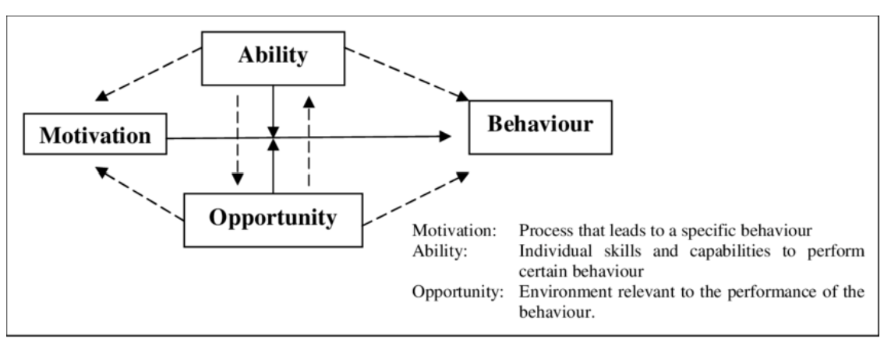
Figure 1: Ability-Motivation-Opportunity Framework principle
(Source: https://www.researchgate.net/figure/The-Motivation-Ability-Opportunity-framework_fig1_269035771)
Ability factor: Targeting reskilling and skilled intelligence
Firstly, human resource departments have started using digital data to analyse and map key employee skills, forecast potential shortcomings, and thereby personalise learning goals for training future roles and influence productivity (Aizhan Tursunbayeva, 2024). For instance, recently published reports by Harvard Business Review revealed how 24% of organisations situated in a national and international position have made connections with corporate strategy and reskilling efforts (Tamayo et al., 2023). It has allowed the likes of ICICI private banking enterprise in India to improve the skill sets of 130,000 employees, and leading tech-giant Ericsson to upskill 15000 workers with some new technology like AI or automation (Tamayo et al., 2023).
Secondly, IHRM strategies also look to standardise global competencies, including credentialing, while adapting curricula around local labour-related market conditions, educational regimes, and other regulatory considerations. This allows for mobility of internal talent marketplaces to fairly take place across borders (Li, 2022). For instance, retailer Unilever depends upon internal talent marketplaces for providing visible career pathways for over 149,000 workers (Gloat, 2024, pp. 6-11).
Motivation factor: Transparent changes with fair rewards
Firstly, automation tends to trigger displacement anxiety among the workforce, which allows HR management groups in companies to value transparent communication and recognition systems. That is largely tied to acquired skills and digital behaviour (Obaid et al., 2022). For instance, Microsoft launched their 'Global Skill Initiative' delivered through LinkedIn for assisting 25 million people to familiarise with digital skills through training, ensuring their re-deployment into demanding roles within the company (Weforum.org, 2025).
Secondly, international human resource management strategies allow organisations to balance global reward philosophies (like skill-based pay, gig-style project premium incentives, and others) with local legal norms such as maintaining equity and retention levels among teams (Li, 2022). For instance, Unilever also created its own AI-powered internal talent marketplace known as ‘FLEX Experiences’, rolling it out in over 100 countries, allowing 60000 employees (including both male and female workers) to match their talents with different project requirements (Finkelstein, 2019).
Opportunity factor: redesigning work and inclusive access
Firstly, digital platforms have enabled remote-project and gig-related arrangements: many enterprises participated with GitLab for creating a distributed workforce of 15000 individuals in 65 or more countries, by codifying nearly all processes with public handbooks and writing mandates for designated workflows, bringing asynchronous collaboration and clear accountability (Harvard Business Review, 2024).
Secondly, IHRM or international human resource management functions also create opportunities across geographies by harmonising policies for remote cross-border working (Allmann and Blank, 2021). For instance, a media service provider, Spotify, fine-tuned their 'Work from Anywhere' policy, allowing employees to choose their preferred workplace from 2021, creating an operationally consistent workforce (Mohan, 2024).

2.0 What are the key demographic and geopolitical factors influencing employment markets today, and how do they create employment challenges for HR professionals
A PESTLE analysis will identify key demographic and geopolitical factors, as shown below.
Political Factor: Geopolitical shifts characterised by events like Brexit or Covid-19 created hiring-related frictions in different sectors as they have mostly relied on foreign talent (especially in the healthcare sector, agriculture, and logistics, among others) (Shahvaroughi Farahani, 2021). Many human resource managers across companies have thus tried to redesign recruitment pipelines, depend more on domestic talents, and navigate around complex compliance or mobility rules (Shahvaroughi Farahani, 2021). For instance, a logistics company, Wincanton in the UK, cited how the shortage of HGV drivers during the Brexit and Covid regimes allowed for random losses in interim revenue. However, a reversal of 19% occurred during the same period in late 2021, after the company had acknowledged the recent spate of recruitment and retention cost requirements (Proactive Investors, 2021).
Economic Factor: Many companies faced problems due to sudden unemployment plaguing their workforce. This allowed many HR leaders in enterprises to undergo scenario planning by consulting migration policies; moreover, the companies also experience workforce supply-based disruptions and further face issues to develop an equitable global reward, compliance, and mobility frameworks that respect local labour law and pension regimes (Chen and Wang, 2024). For instance, Oil Company Shell utilised formal scenario planning for stress testing its workforce, considering both geopolitical and demographic inconsistencies, resulting in Shell reducing 20% of its oil and gas exploration team (Reuters, 2024).
Social Factor: Ageing workforces have enforced primary demographic pressure within many advanced economies. UK statistics suggest shifting economic activity involving employees aged over 50 (Gov.UK, 2024). They consider part-time working and even retaining themselves based on existing skills. For instance, Tesco plc issued a 'working policy' during July of 2023, permitting employees to request flexible working arrangements from day 1 of their joining (O’Leary, 2019). This allows for alignment with the available demographic evidence, suggesting that 30% of the UK's working-age population is over 50 years, which creates a talent cohort for employers to work with and retain at the same time (Morris, 2024).
Technological Factor: HR professionals in many organisations experienced rapid takeover by AI and automation systems, pressing the need for urgent training among the staff, aside from reshaping roles (Tomashuk and Baldynyuk, 2022). This affected their ability to impose on their available operating costs. For instance, Amazon, the tech giant, had to convert their warehouses to support large-scale reskilling among existing staff members (BeezBot, 2025).
Environmental Factor: Human resource management departments within companies started setting net-zero targets for their employees. This created backwardness in terms of skills, as many of the workforce fail to deploy green skills or adapt to low-carbon roles. For instance, it was similar to how Shell had to adjust their workforce after a 20% dip in their oil and gas exploration teams (Reuters, 2024).
Legal Factor: Data protection and cross-border employment rules have changed before the impact of events like Brexit or the pandemic (Belwalkar et al., 2018). These included newer GDPR compliance or visa-related changes after Brexit, resulting in increased compliance burdens, payroll-related complexities, and limitations on rapid international hirings (CIPD, 2021, p 4-16).

3.0 How can organisations address persistent skill gaps and talent shortages within critical sectors through strategic HRM
As persistent skill shortages become ubiquitous, it will be advisable for the majority of companies to consult David Ulrich's four core role-based framework or 'Ulrich's model'. The model outlined how HR management within organisations could drive their strategies by playing four unique roles, like strategic partner, change agent, administrative expert, and employee champion (Hermans and Ulrich, 2021). These can be broadly classified as shown below.
Strategic Partner: Company HR management must start their workforce planning by mapping future business requirements with competency taxonomies, before implementing targeted investment considerations (Georgescu et al., 2024). For instance, Amazon's initiative for 2025, where they invested $1.2 billion for retraining and upskilling over 300,000 executives into technical and logistics roles, showed how strategic HR based investments limit external hiring dependencies by also shortening the time for generating productivity around critical roles (Amazon, 2025).
Change Agent: HR departments in companies lead transformation by designing alternative entry routes and creating clear career pathways (Hermans and Ulrich, 2021). For instance, IBM has established their new 'New Collar' and skill-building initiative, which looks to train over a thousand apprentices around non-degree pathway programs (SkillReporter, 2020). Thereby, reducing reliance on the former traditional graduate pipelines for sourcing talent or from other broader labour pools (Belwalkar et al., 2018).
Administrative Expert: At other firms, HR managements use its strategies to deliver scalable systems, which makes capabilities portable. In short, they try to depend more on internal talent-based marketplaces and credentialing infrastructure (Belwalkar et al., 2018). For instance, the hospitality company of Accor's own learning infrastructure, which looks to support 19 million hours of training since 2020, have enabled 110,000 employees to match their abilities, skills, and experiences with core projects (Accor.com, 2025). This, by itself, removed much of the external recruitment costs. For this reason, the majority of enterprises look to follow in their footsteps by tracking micro-credential issuance, internal fill rates, and cost per hiring by avoiding actual marketplace advances.
Employee Champion: Certain HR managers in companies have implemented motivation strategies, even depending on retention tactics by linking learning to recognition plans (Naser et al., 2021). Healthcare company Kaiser Permanente executed tuition support and reimbursement worth $3000 per year, allowing uptake in course applications to go beyond 73224 during 2018 and beyond (Kaiserpermanente.org, 2022). This approach ensured retention surrounding target cohorts, reducing voluntary turnover among reskilled employees.
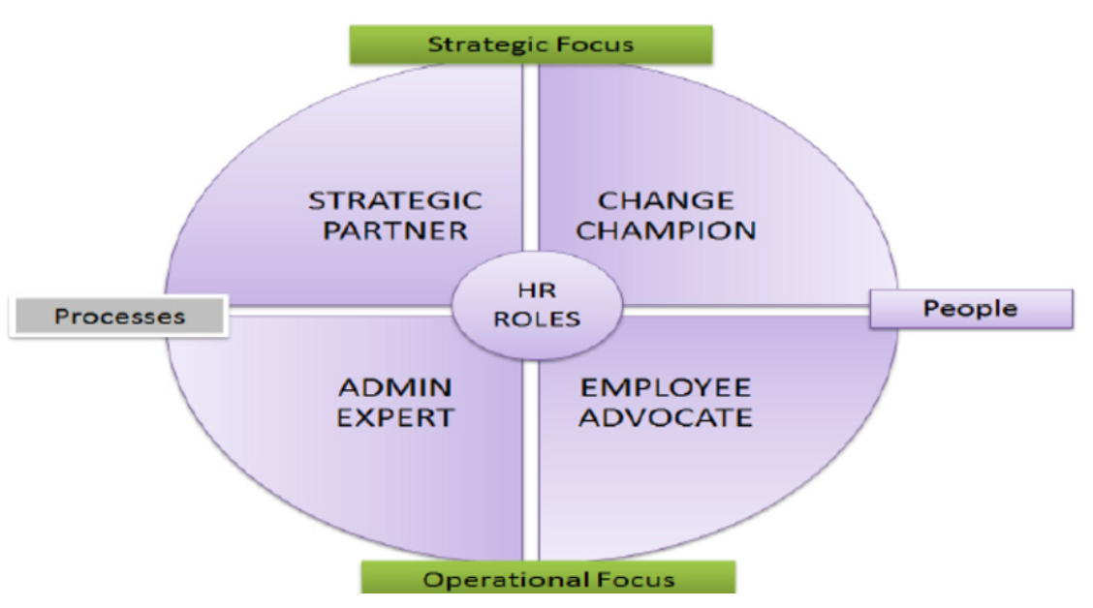
Figure 2: Ulirch’s framework logic
(Source: https://www.researchgate.net/figure/Human-resource-management-four-roles-model-Source-Conner-Ulrich-1996_fig1_287503968)

4.0 Reflective report on current capabilities in working in an international context
My experiences working in an international context can be understood from the following considerations. As I have laid out all my learnings and expressed them in terms of Graham Gibb’s reflective cycle model developed in 1988 (Sundgren et al., 2021).
Description: Initially, having completed my Bachelor's degree in Arts from Jahangirnagar University in Dhaka, Bangladesh. I strived to enhance my abilities by receiving exposure to the latest innovations (such as AI or artificial intelligence programs, cloud computing tools, data analytics, and other software systems). I also looked forward to working with teams, while expressing their concerns and ideas for getting tasks completed at the right junctures. I even thought that I could work with potential leaders by seeking their guidance and knowledge, to eventually help me in similar positions within the organisation in the future. That would advocate a self-directed form of learning. [Referred to Appendix 1]
All these aspects helped me to start my career in KSK Texstyles (a popular textile company in Bangladesh).
Feelings: I felt glad with the HR management setting training programs assigned for newcomer employees within the company. That allowed me to pick up technological dexterity, better engage with team players, raise queries when in doubt and report, as well as attend regular meetings with leaders. I felt gratified for such efforts directed by KSK Textstyles, which further allowed me to prove my mettle and grow my curiosity while undertaking critical projects. However, at times, I felt distant in terms of behaviour from select individuals within teams, while leaders, due to a busy schedule, often failed to address my project-related issues. These problems annoyed me and inconvenienced me at times during critical junctures of projects. [Referred to Appendix 1]
Evaluation: I often faced complications surrounding technologies which represented backdated versions. This failed to incorporate proper utilisation, especially in cloud systems, where backup did not occur as I was not provided with an updated version of software like SAP S/4 HANA. Also, when I tried to convey the same requirements, my queries were in a loop for a longer duration. Meanwhile, my leaders assisted me wholly in resolving the problems by escalating my requests to the proper authorities. I even learned some shorthand techniques from my leaders to execute the software during high-pressure moments, especially to aid teamworking efforts.
Analysis: As a whole, I believe that HR management of KSK Textstyles attempted to bring in talent, but in spite of driving dilettantes, amateurs, workaholics, and others, they failed to have a sound understanding of their problems. This created shortcomings in team-jelling, technological breakdown, miscommunications, and misunderstandings with leaders. Meanwhile, with the leaders standing up and taking authoritative roles, the problems were mitigated to a certain degree. I benefited when leaders themselves had undertaken innovative training classes, while allowing employees to reign in freedom after making them understand their task roles. This allowed me to professionally garner knowledge for myself during tough moments. [Referred to Appendix 2]
Conclusion: I learned how to handle and manage operations, apart from always leading from the front. I further learned that all issues and ideas must be shared during team meetings, after running them by leaders who could also provide their opinions (Sundgren et al., 2021).
Action plan: Having dealt with all the challenges and seizing opportunities, I received a promotion and became a senior assistant manager. Even though from my position, my problems are the least disregarded in the current regime, I expect that from my own position, I was able to bring clarity among my department teams, both in terms of communication and handling technologies. I have made it a culture to consult with leaders and seek their guidance, while delivering a similar attitude to other workers who require the same. This form of attitude encourages self-learning, while increasing attrition at the same time. [Referred to Appendix 2]
Strengths
Firstly, within group projects at KSK Texstyles, I demonstrated my ability to be a good team player by handling critical projects with others and being at the helm of accomplishing tasks at appropriate times. (Williams et al., 2020, p 220-235)
Secondly, learning technologies have allowed me to generate valuable input for my teams and incorporate further guidance from the leaders before approaching project tasks.
Thirdly, I have also given credence to time management considerations by making it a routine to accomplish my task roles at the right junctures.
Fourthly, I prefer to think out of the box during critical project scenarios, even in my own firm of KSK Textstyles, which helped me to suggest ways and outcomes beneficial for my team players.
Weaknesses
Firstly, I tend to become too impatient while serving around group projects, which affects others' penchant to perform in their own task roles. (Williams et al., 2020, p 220-235)
Secondly, at times while handling technologies, I can become reckless by inputting wrong data, while justifying the same until it is brought to notice by my leaders.
Thirdly, I prefer to jump around roles, as I become restless with the redundancy of duties, activities, and task requirements.
Areas for improvement
I prefer to look at other talented individuals in group roles to ensure I get less bogged down and am inspired by such players. I also want to keep on learning as I consider it mandatory, no matter the experience, position, and growth in a firm (Williams et al., 2020, pp. 220-235). As I manage timely tasks, I also want to keep taking opinions from my administrative heads, even if I continue to receive promotions. That way, I could serve my job role for a longer duration than I normally do.

Conclusion

The findings explained the current demographic and geopolitical event-based implications on current labour markets, and how they affected the human resource management of world organisations. Certain parts also highlighted how human resource strategies were adapting to the challenges, especially by addressing concerns about skill gaps and talent shortages. Finally, through my reflective report, I demonstrated how, by taking advantage of personal capabilities, any individual employee can thrive despite imposed problems from their human resource departments.

References
Accor.com (2025). Career Growth & Development. [online] Accor.com. Available at: https://group.accor.com/en/group/people-at-our-heart/career-growth-and-development [Accessed 29 Sep. 2025].
Aizhan Tursunbayeva (2024). Contemporary Human Resource Management: Evolution, Trends, and Factors of Influence. Contributions to management science, 6(3), pp.9–22. doi: https://doi.org/10.1007/978-3-031-75266-7_2.
Allmann, K. and Blank, G. (2021). Rethinking digital skills in the era of compulsory computing: methods, measurement, policy and theory. Information, Communication & Society, [online] 24(5), pp.633–648. Doi: https://doi.org/10.1080/1369118x.2021.1874475.
Amazon (2025). Upskilling 2025. [online] About Amazon. Available at: https://www.aboutamazon.com/news/workplace/upskilling-2025 [Accessed 29 Sep. 2025].
BeezBot (2025). Amazon Kiva: Industrial Robotic Explained - BeezBot. [online] BeezBot. Available at: https://www.beezbot.com/learn/amazon-kiva-industrial-robotic-explained/ [Accessed 26 Sep. 2025].
Belwalkar, S., Vohra, V. and Pandey, A. (2018). The relationship between workplace spirituality, job satisfaction and organisational citizenship behaviours – an empirical study. Social Responsibility Journal, 14(2), pp.410–430. Doi: https://doi.org/10.1108/srj-05-2016-0096.
Chen, W. and Wang, L. (2024). The Global Economic Trends and Their Impact on National Economies. International Journal of Accounting, Finance, and Economic Studies, [online] 2(1), pp.1–8. Available at: https://jurnals.net/access/IJAFES/article/view/7.
CIPD (2021). Addressing Skills And Labour Shortages Post-Brexit Report. [online] Cipd.org, London: CIPD, pp.1–41. Available at: https://www.cipd.org/globalassets/media/knowledge/knowledge-hub/reports/addressing-skills-labour-shortages-post-brexit_tcm18-102313.pdf [Accessed 29 Sep. 2025].
Finkelstein, M. (2019). Unilever, the consumer goods giant, implements AI to retain, develop, and engage talent | Gloat. [online] Gloat.com. Available at: https://gloat.com/blog/unilever-ai-retain-develop-engage-talent-innermobility-gloat/ [Accessed 29 Sep. 2025].
Georgescu, I., Bocean, C.G., Vărzaru, A.A., Rotea, C.C., Mangra, M.G. and Mangra, G.I. (2024). Enhancing Organizational Resilience: The Transformative Influence of Strategic Human Resource Management Practices and Organizational Culture. Sustainability, [online] 16(10), pp.4315–4315. Doi: https://doi.org/10.3390/su16104315.
Gloat (2024). Customer Success Story: Unilever. [online] Gloat.com, New York City: Gloat.com, pp.1–11. Available at: https://gloat.com/wp-content/uploads/How-Unilever-Uses-AI-to-Retain-Engage-and-Develop-Employees.pdf [Accessed 29 Sep. 2025].
Gov.UK (2024). Economic labour market status of individuals aged 50 and over, trends over time: September 2024. [online] GOV.UK. Available at: https://www.gov.uk/government/statistics/economic-labour-market-status-of-individuals-aged-50-and-over-trends-over-time-september-2024/economic-labour-market-status-of-individuals-aged-50-and-over-trends-over-time-september-2024 [Accessed 29 Sep. 2025].
Harvard Business Review (2024). How GitLab Leads Its Fully Remote Workforce. [online] Harvard Business Review. Available at: https://hbr.org/podcast/2024/06/how-gitlab-leads-its-fully-remote-workforce [Accessed 24 Sep. 2025].
Hermans, M. and Ulrich, M.D. (2021). How symbolic human resource function actions affect the implementation of high‐performance work practices: The mediating effect of influence on strategic decision‐making. Human Resource Management Journal, 31(4), pp.1063–1081. Doi: https://doi.org/10.1111/1748-8583.12361.
Kaiserpermanente.org (2022). Tuition Reimbursement – KP Wellness University. [online] Kaiserpermanente.org. Available at: https://kpwellnessu.kaiserpermanente.org/tuition-reimbursement/ [Accessed 29 Sep. 2025].
Li, L. (2022). Reskilling and Upskilling the future-ready Workforce for Industry 4.0 and beyond. Information Systems Frontiers, [online] 24(3), pp.1–16. Doi: https://doi.org/10.1007/s10796-022-10308-y.
Li, S., Jia, R., Seufert, J.H., Hu, W. and Luo, J. (2021). The impact of ability‐, motivation‐ and opportunity‐enhancing strategic human resource management on performance: the mediating roles of emotional capability and intellectual capital. Asia Pacific Journal of Human Resources, 60(3), pp.453–478. Doi: https://doi.org/10.1111/1744-7941.12293.
Mohan, P. (2024). What Spotify has learned from its ‘work from anywhere’ policy. [online] Fast Company. Available at: https://www.fastcompany.com/91224946/what-spotify-has-learned-from-its-work-from-anywhere-policy [Accessed 29 Sep. 2025].
Morris, A. (2024). Understanding the UK Labour Market: Opportunities Ahead | DavidsonMorris. [online] DavidsonMorris | Solicitors. Available at: https://www.davidsonmorris.com/uk-labour-market/ [Accessed 29 Sep. 2025].
Naser Alolayyan, M., Sharif Alyahya, M. and Ahmad Omari, D. (2021). Strategic human resource management practices and human capital development: The role of employee commitment. Problems and Perspectives in Management, 19(2), pp.157–169. Doi: https://doi.org/10.21511/ppm.19(2).2021.13.
O’Leary, S. (2019). Gender and management implications from clearer signposting of employability attributes developed across graduate disciplines. Studies in Higher Education, 46(3), pp.1–20. doi: https://doi.org/10.1080/03075079.2019.1640669.
Obaid, S., Ahmad, S.F. and Mumtaz, F. (2022). Ability-Motivation-Opportunity Framework: An Analysis of Interrelated Effects of HRM Practice and Leadership Style on Organisational Outcomes. International Journal of Asian Business and Information Management, 13(1), pp.1–26. Doi: https://doi.org/10.4018/ijabim.309105.
Proactive Investors (2021). Wincanton shrugs off lorry driver shortage as e-commerce demand surges. [online] Proactiveinvestors UK. Available at: https://www.proactiveinvestors.co.uk/companies/news/966783/wincanton-shrugs-off-lorry-driver-shortage-as-ecommerce-demand-surges-966783.html [Accessed 29 Sep. 2025].
Reuters (2024). Shell plans to scale back in oil, gas exploration division workforce: Report. [online] @bsindia. Available at: https://www.business-standard.com/world-news/shell-plans-scale-back-in-oil-gas-exploration-division-workforce-report-124082901412_1.html [Accessed 29 Sep. 2025].
Shahvaroughi Farahani, M. (2021). A review study of the effects of coronavirus and Brexit on the UK economy. International Journal of New Political Economy, [online] 2(2), pp.201–227. Doi: https://doi.org/10.52547/jep.2.2.201.
SkillReporter (2020). Diwali Rangoli Competition 2025. [online] Skill Reporter. Available at: https://www.skillreporter.com/csr/ibm-and-nasscom-foundation-trained-2500-youth-under-new-collar-employability-skills-program/ [Accessed 29 Sep. 2025].
Sundgren, M.K., Dawber, C., Millear, P.M. and Medoro, L. (2021). Reflective practice groups and nurse professional quality of life. Australian Journal of Advanced Nursing, [online] 38(4). Doi: https://doi.org/10.37464/2020.384.355.
Tamayo, J., Doumi, L., Goel, S., Kovács-Ondrejkovic, O. and Sadun, R. (2023). Reskilling in the Age of AI. [online] Harvard Business Review. Available at: https://hbr.org/2023/09/reskilling-in-the-age-of-ai [Accessed 29 Sep. 2025].
Tomashuk, I. and Baldynyuk, V. (2022). International Labour Migration In The Context Of Geo-Economic Transformation. Three Seas Economic Journal, 3(1), pp.203–216. Doi: https://doi.org/10.30525/2661-5150/2022-1-29.
Weforum.org (2025). Reskilling Revolution - Global Skills Initiative by Microsoft with LinkedIn and GitHub. [online] Weforum.org. Available at: https://initiatives.weforum.org/reskilling-revolution/case-study-details/global-skills-initiative-by-microsoft-with-linkedin-and-github/ [Accessed 29 Sep. 2025].
Williams, K., Spiro, J. and Woolliams, M. (2020). Reflective writing. 2nd ed. Houndmills, Basingstoke, Hampshire; New York: Palgrave Macmillan.

Appendices

Appendix 1: Academic qualifications
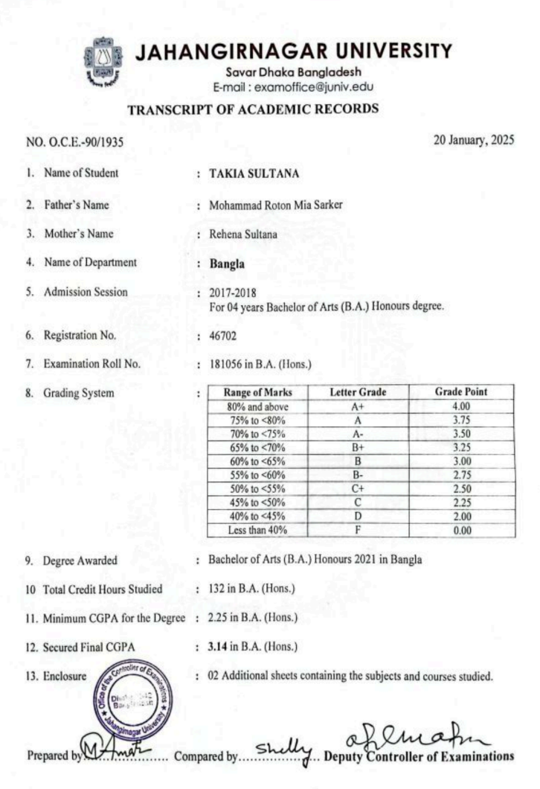
(Source: Jahangirnagar University)

Appendix 2: Promotion letter
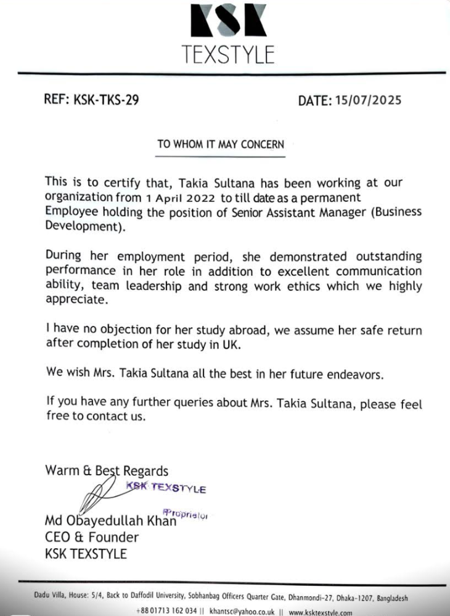
(Source: KSK Textstyles)

