Skills For the Workplace
Module assignment submission

Student Name | Seren Murphy
Student Number | 1917785
Module Number | BMSK4006
Module Title | Managing Enterprise in the 21st Century

Statement of confirmation of Authenticity
By the act of making this submission, the student declares that this is the work of the student named above. The work has not, or in part, been knowingly presented elsewhere for assessment, or where assessment has been built on a previous assessment, this has been identified. Where materials have been used from other sources it has been properly acknowledged. If this statement is untrue, the student acknowledges that an assessment offence has been committed.
Attention is drawn to the plagiarism and unfair practice policies of both the university and of ILM.

Contents
Executive Summary 3
Business Overview 3
Business Overview 3
Markets and Competition 4
Target Markets 4
Competition 4
Sales and Marketing 4
Product Positioning 4
Marketing 5
Sales 5
Management 5
Key Personnel 5
Advisors and support services 6
Operations 6
Premises and Equipment 6
Employees 6
Suppliers 6
Financial Forecast 6
Sales 6
Profitability 7
Cashflow 7
Financing 7
References 8
C.V 9

Executive Summary
My business is a family run Public house, dedicated to customer service whilst providing a relaxed and welcoming atmosphere for our customers. I will provide a bespoke coffee lounge during the daytime and a lively and entertaining pub in the evening. Our target market will differ from day to day, although all ages will be made to feel extremely welcome.
I plan to market my business using social media and a large sign on the main road to show offers and directions to our premises.
The key people in my business will be myself, partner and parents. We will not employ anyone else and will not take any wages for the first three months to enable us to put as much as the profit back into the business as possible. I will use my parents` extensive knowledge as former landlord and land lady to my advantage and consult with them on all decisions that are to be made.
The practical issues that we will face before opening will be complete re decoration of the entire premises. We would like to re paint and replace all furnishings. Once we have completed everything that we want to do we will then be ready to open.
Our financial forecast for the year is profitable. Our start-up costs have been predicted at around £13,000, as shown in my financial prediction table in my financial forecast. My parents will be investing £10,000 of personal savings, and I will be receiving a £10,000 business loan from Lloyds, (2020) This will be ample to cover all re decorating, license costs, and initial stock.

Business Overview

Business Overview
My business will be The Royal Oak Inn, an already established public house situated in the small village of Bedwas, Caerphilly. I started developing these ideas over a year ago and have put my heart and soul into ensuring that this venture will become a success. I plan to renovate and redesign this longstanding pub with new ideas and services. I plan to hold an event or entertainment five evenings a week and serve coffee during the day in a bespoke coffee lounge.
There is great opportunity for a strong and profitable business, as the village is in desperate need of local entertainment and a place for customers to meet with friends in a relaxed and social atmosphere. I plan to cater to a wide age group, from young adults in their twenties to mature people of sixty and over. I will regularly arrange entertainment evenings specifically for each age group and advertise accordingly.
As my business progresses, I have plans to expand the business by building another area in the extremely large garden, to be able to offer a large room for parties, functions and other events.
There are no particular risks that I am especially worried about to begin with. I will endeavour to use local advertisement and social media to my advantage and will offer a reduced-price open day to entice my customers and show them all about my business and what I have to offer. In this small village, word of mouth will be my most powerful ally.

Markets and Competition

Target Markets
My target customers are in a wide age range, from early twenties to the mature sixty plus. I plan to tailor entertainment around each subgroup.
For the younger customers, twenties to thirties, I plan to host live evening entertainment catered to their tastes, with a live band and barbeque in the summer months.
For the middle aged, I plan on doing the same, however with the tastes catered to them. I have a plan to adapt and amend these ideas as I get to know my customers.
I also plan on holding Bingo in the evening twice a week, and regular pool and dart tournaments for all ages.
These ideas have developed from the time I have taken to talk to potential customers of all ages around the village, from my own young and middle-aged friends and family, to friends of my parents.
A consistent finding throughout was that potential customers just wanted a relaxed atmosphere and somewhere close to home that they could go for coffee dates in the daytime and have some evening entertainment on the weekend. I feel that my plans provide this and that all my different group targets will be happy and become regular faces.

Competition
Currently, there is no competition in the local area. The closest pub is in Caerphilly 5 miles away. Their key features are their weekend entertainment, which I will match and then exceed as my business grows. There is nowhere locally that customers can obtain coffee, and the pubs in Caerphilly only put entertainment on a Saturday night. I feel that by combining the two ventures my target customers will happily come to me for the ease of no distance to travel, and the fact that I will have entertainment 5 nights of the week.

Sales and Marketing

Product Positioning
I am lucky to have no competition within the immediate vicinity. My closest competition will be in Caerphilly about 5 miles away. Because of this I have decided to use neutral pricing. My main customers will all live locally in the village so I am confident that the ease of being able to walk to my establishment will mean that customers will want to come to me instead of further afield. I will keep my sole focus on quality of products and service to keep my customers once I have got them through the door.

Marketing
I have put great thought into the best strategies to use when it comes to marketing. I have decided on a large sign on the main road (this road is directly central to customers traveling to and from Cardiff and Newport, and will greatly improve my chances of customers taking notice of my business from outside the local area. I will use social media to constantly update and advertise my upcoming entertainment and events.

Sales
In terms of actively selling, I will ensure that I am working behind the bar myself and serving customers as much as I physically can, to enable them to get to know me and become invested in my business. I will use social media to attract and advertise, along with a large sign on the main road. I do not envision it will be difficult to attract new customers. I have lived in Bedwas for 15 years and it is a very close community. I have already spoken to all friends and family who have assured me that they have spread the word and the village has responded with much positivity towards finally having somewhere local they can go for daily coffee dates and evening entertainment.

Management

Key Personnel
My business will be most definitely a family run business. Working with me will be my partner and parents. I will be the general manager of the business. I will work behind the bars serving the customers and will oversee the day to day running of the pub.
My parents, having previously been landlord and landlady of 8 previous public houses, will be invaluable for advice as I progress. My mother will work alongside me behind the bar, dealing with all the customers face to face. Having witnessed her interact with her customers in all her previous pubs, she is an extremely happy and social, easy to like and always makes every person feel welcome.
My father will be responsible for buying the stock and keeping track of it. In all his previous businesses he has done this and has the experience to know exactly what needs ordering and when. He will be vital to ensure that we do not over, or understock and that money is never wasted on products. I plan to learn everything he knows.
My partner will be responsible for the cleaning of the premises and will join me in arranging and running the entertainment.

Advisors and support services
At its current position, outsourcing is not currently required. However, in the future, if expansion is possible, I will look to source an account for payroll of staff and will need advice from a builder and planning permission if I am to expand as I desire.
I will use my parent’s vast knowledge and experience for advice and support whilst we are starting our venture, as it is free and completely reliable.

Operations

Premises and Equipment
I have already applied and been accepted for the already established royal oak inn public house. The location is fantastic for potential customers. It is situated in the small village of Bedwas. This is 4 miles from Caerphilly town, and less than 30 minutes travel from both Cardiff and Newport.
The pub is already up and running, with a bar, kitchen and seating areas. However, the décor is extremely outdated, and I plan on completely redecorating before I open.
I plan to split the premises in two, which a comfortable coffee lounge that can be then changed and adapted for evening entertainment.
I plan to rent a coffee machine and buy new tables, chairs and sofas.

Employees
I will not employ any outside help to begin with. We intend to keep all costs as low as possible and all profit back into the business for at least the first 3 months of our opening. Between myself, partner and parents we will be able to split the work needed without having to hire anyone else. However, as the business grows, we are not averse to employing help when the time comes.

Suppliers
Our key suppliers will be Brains brewery for our barrels of lager and cider, and Costco for spirits and wine, and all the products needed for our coffee. Using these suppliers gives us the reassurance for our products (as they are both very established suppliers) and bother offer credit for businesses if we ever require it. As they are so long standing, we are confident that they will keep in business for a long time in the future.

Financial Forecast

Sales
My expected sales will differ month to month, with the summer months and Christmas bring most profitable. I know this from my parent’s previous experiences in running multiple public houses. I aim to keep the rest of the year a steady income and then to take full advantage of the prosperous months. I plan to increase my marketing around these times and put on a lot of live music and incentives and deals to get the customers to thoroughly enjoy our services and return again and again.

Profitability
As you can see in my cash flow prediction below, within the first year I plan to have more than tripled our income. These predictions are using extremely low sales estimates for the months that we do not feel will be our most profitable. I expect the business to be profitable from the start and only increase more as the time goes on. If at the small chance that we do not perform as well as we initially anticipate at the start, the fact that we are not taking any wages, and have a substantial amount left from our £20,000 initial start-up amount, we ensure that we do not make a loss and can continue to put money into the business if required.

Cashflow
Below is an in-depth cash flow forecast, including my initial start-up costs and then what I expect the monthly sales to be and how all this will affect my business profit.
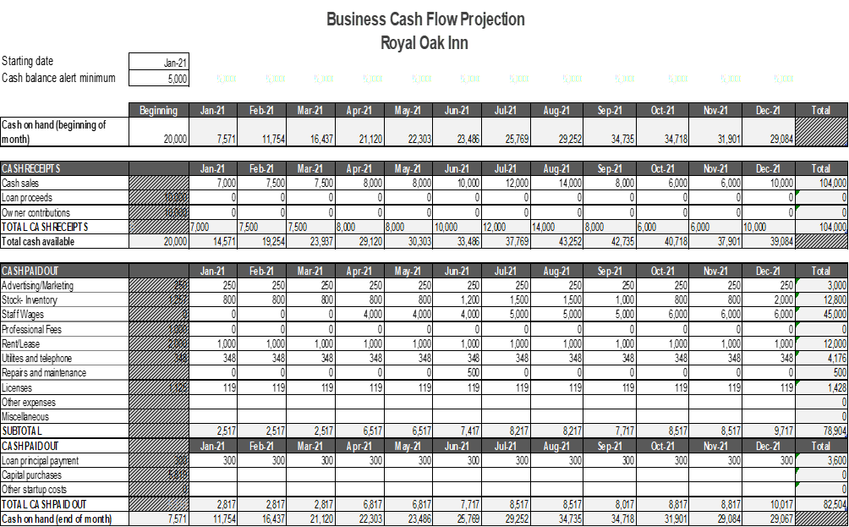

Financing
My Business will be a limited liability partnership between myself and my parents. Due to much research we have decided that this is the best possible avenue to take. My parents will be investing £10,000 of personal savings and I will take a £10,000 commercial fixed rate business loan from my personal bank. Lloyds (2020) This will enable me to be certain of my monthly repayments and know exactly how long that it will take to repay. I can also adjust the repayments to a higher amount later in the year when my business becomes more and more profitable and I can afford to pay back more.
Our start-up costs have been estimated at around £13,000, as shown above.
Broken down these include, initial marketing. Our sign has been priced at £250 a month and will be provided to us by Smart Signs (2020).
Our initial stock will cost £1,257. This includes kegs of beer and lager (124 pints in each) from Brains Brewery (2020) our spirits, wine, cordials, bottles of cider and coffee beans, milk, sugar and cream from Costco (2020)
Our Utility bills will start off at a fixed price of £348 for the year. This includes Gas (£80), Electric (£100) Eon (2020), Water (£85) Welsh water (2020) and Sky for tv and broadband (£80) Sky (2020)
Our lease is an initial £2000, however £1,000 for the rest of the year.
Our licenses are an initial cost of £1, 125, £119 a month for the rest of the year. This includes Premises license at £450 annually, Gov.uk (2020)
Personal License at £119 a month, APLH Personal License, (2020)
License to play music at £366 annually Gov.uk (2020)
Public space surveillance license at £190 annually Gov.uk (2020)
Our capital purchases will be at around £5,819, which will include new tables and chairs, a dart board, pool table and pool cues

References

Lloyds tsd, (2020), Business Loans, Lloyds, (https://www.lloydsbank.com/buisness/buisness-loans/commercial-fixed-rate-loan.html?WT.ac=lloyds-bb_and_sme-buisness_loans-hub-table-FOM-title_commercial_fixed_loan

Smartsigns, (2020), residential signs, Smartsigns, https://www.smartsigns.co.uk/

Mixed case purchase, 2020, Best of British beer, Brains Brewery, https://www.bestofbritishbeer.co.uk/buy-beer-cases/brewery-a-d/sa-brain.html

Costco, (2020) Bulk Sales, Costco, https://www.costco.co.uk/bulk-sales

Eon, (2020) Gas and Electricity Tariffs, EON https://www.eonenergy.com/for-your-home/products-and-services

Sky TV and Broadband (2020) Products and Packages, Sky, https://www.sky.com/shop/

Premises License, (2020), Premises License (England and Wales), GOV.UK, https://www.gov.uk/premises-license

APLH Personal License, (2020), APLH Personal License Training Course, Personal Licenses, https://www.get-licensed.co.uk/personal-license-training

GOV.UK, (2020) Patents, trademarks, copyright and design, License to play Music, https://www.gov.uk/license-to-play-recorded-music

GOV.UK, (2020), Public Space surveillance (CCTC) license, Licence, http://www.gov.uk/public-space-surveillance-cctv-license

C.V



