University of Wales Trinity Saint David
School of Engineering

Predictive Maintenance Strategies
Control Technology
ACMA6001
Robert Dale Gubbins
2316959
28/09/2026

Word Count: Total = 2548
Contents
1 Introduction 3
2 Maintenance Strategies in Industrial Operations 3
2.1 Reactive, Preventive and Predictive Maintenance 3
2.2 Impact on Availability, Safety and Quality 4
3 Condition Monitoring and Fault Diagnosis 4
3.1 Conventional Condition Monitoring 4
3.2 Machine Learning and AI-Based Fault Diagnosis 4
3.3 Comparison of Conventional and Contemporary Approaches 5
4 Case Study and Methodology 5
4.1 Pump P-2201A and Simulated Dataset 5
5 Comparative Analysis: Machine Learning vs Neural Network 6
5.1 Feature Based SVM Approach 6
5.2 Neural Network Approach 8
5.3 Comparative Results 9
5.4 Neural Network Tuning 11
6 Discussion 13
6.1 Fault Classification Performance 13
6.2 Detection Performance and False Alarms 14
6.3 Refinery Deployment Considerations 14
7 Conclusions and Recommendations 15
8 References 15
9 Appendices 17
9.1 Appendix A – MATLAB SVM Classification Code 17
9.1.1 Feature Extraction 17
9.1.2 Feature Selection 17
9.1.3 NCA Feature Weighting 18
9.1.4 SVM Classification 18
9.1.5 Simulation and Signal Processing Outputs 19
9.2 Appendix B – MATLAB Neural Network Code 20
9.2.1 Spectrum Preparation 20
9.2.2 Dataset Splitting and Normalisation 20
9.2.3 Neural Network Training and Testing 21
9.2.4 Five-Fold Cross Validation 23
9.3 Appendix C – Complete Neural Network Parameter Testing 23

Introduction
Maintenance strategy is an important part of industrial operations because it can directly affect equipment availability, safety, production output and product quality. Predictive maintenance aims to improve maintenance decisions by using condition-monitoring data to identify faults before they develop into failures. This report looks at applying predictive maintenance to a simulated crude charge pump drivetrain within a refinery, under three fault conditions: gear tooth damage, output shaft wear and vibration sensor drift. A feature based machine-learning method using support vector machines (SVM) is compared with a neural network approach. The main aim is to assess how well each method can identify the three failure modes and how suitable they may be for predictive-maintenance use. Performance is compared using classification accuracy and confusion matrices, before considering fault detection, false alarms, availability, safety and quality.

Maintenance Strategies in Industrial Operations

Reactive, Preventive and Predictive Maintenance
Industrial maintenance is generally approached through reactive, preventive or predictive strategies. Reactive maintenance allows equipment to run until failure, reducing routine maintenance but increasing the risk of unplanned downtime and higher long term costs (Gholipour, 2025).
Preventive maintenance reduces this risk by carrying out work at planned intervals based on time, operating hours or manufacturer guidance. Although this can improve reliability, components may be serviced or replaced while still in acceptable condition, meaning the maintenance interval may not reflect the actual equipment condition (Zhao, Gao and Tang, 2022).
Predictive maintenance instead uses condition-monitoring data to identify developing faults and plan work when deterioration is detected. This can align maintenance more closely with equipment condition, although it depends on suitable monitoring and fault-diagnosis methods (Zhao, Gao and Tang, 2022).

Impact on Availability, Safety and Quality
Maintenance strategy can directly affect availability, safety and product quality. Reactive failures can cause unexpected downtime, while preventive maintenance reduces this risk at the cost of planned intervention. Predictive maintenance can support availability by identifying deterioration early and allowing work to be scheduled around operational needs.
Orrù et al. (2020) applied SVM and neural network methods to centrifugal-pump data in the oil and gas industry to support fault prediction and maintenance decisions. This shows how condition monitoring can identify deterioration before failure. Earlier detection can also reduce the risk of operating degraded equipment and help maintain stable process conditions, while missed faults or excessive false alarms may lead to safety concerns or unnecessary maintenance.

Condition Monitoring and Fault Diagnosis

Conventional Condition Monitoring
Conventional condition monitoring uses measured equipment behaviour to identify deterioration before failure. Manual vibration analysis is widely used on rotating machinery because experienced engineers can relate vibration changes to known mechanical faults. It is physically interpretable but can be labour intensive and dependent on specialist knowledge.
Threshold and alarm-based monitoring compares measured values against predefined limits. This is simple and transparent, but poorly chosen thresholds can either miss genuine deterioration or create unnecessary alarms (Jablonski and Mendrok, 2025).
Statistical and signal-processing methods extract useful condition indicators from time- and frequency-domain vibration data. These methods are effective when fault signatures are well understood, but performance can reduce with noise, changing operating conditions or overlapping fault characteristics (Zhou et al., 2022).

Machine Learning and AI-Based Fault Diagnosis
Machine-learning methods automate fault classification by learning relationships between condition indicators and known fault states. Support vector machines (SVMs) are widely applied to rotating-machinery fault diagnosis, although performance depends strongly on the quality of the selected features and model setup (Daş, Daş and Birant, 2023).
Neural networks can reduce the need for manual feature engineering by learning more complex patterns directly from measured data (Tama et al., 2023). This can help where fault behaviour is nonlinear, but these models generally require representative training data and careful validation, while limited or imbalanced datasets and changing operating conditions can reduce performance on unseen data (Zhu et al., 2023).

Comparison of Conventional and Contemporary Approaches
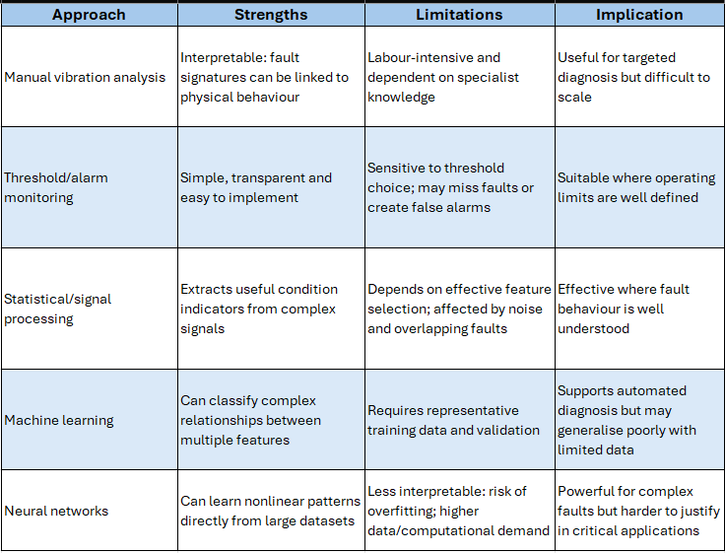
Table 1 - Comparison of conventional and contemporary fault diagnosis approaches
Table 1 shows that conventional methods generally provide greater interpretability, while contemporary methods offer more flexibility for complex faults but depend more heavily on data quality and validation. The most suitable approach therefore depends on the application and the consequences of incorrect classification.

Case Study and Methodology

Pump P-2201A and Simulated Dataset
Figure 1 shows the Pump P-2201A drivetrain arrangement on which the simulation is based, consisting of an induction motor, two-speed gearbox, output shaft and centrifugal pump. In the real system, tacho sensors monitor the drive and output shafts, while an accelerometer is mounted on the gearbox casing. These locations relate to the three simulated fault conditions: gear tooth damage within the gearbox, output shaft wear and vibration sensor drift.
Synthetic vibration and tacho signals are then generated through repeated ensemble simulations to mimic realistic condition-monitoring data across different fault conditions and severities. The first 10 seconds of each run are removed to exclude start-up transient behaviour before the data are prepared for analysis. Relevant condition indicators are extracted for the SVM, while each dataset is labelled according to the simulated fault state. This provides a controlled and repeatable dataset for comparing the feature-based SVM and neural network approaches. Example vibration, tacho and processed signal outputs are provided in Section 9.1.5.
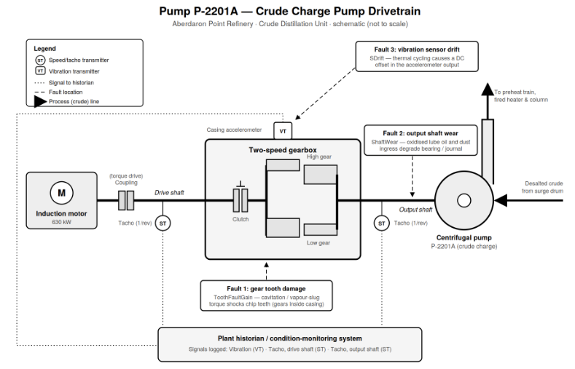
Figure 1 - Pump P-2201A transmission system model
Source: ACMA6001 Control Technology Assignment Brief (2026)

Comparative Analysis: Machine Learning vs Neural Network

Feature Based SVM Approach
The SVM approach begins by extracting 18 statistical, nonlinear and spectral condition indicators from each simulation. Neighbourhood component analysis (NCA) ranks these features for each fault, with only the highest-ranked features selected as inputs to the final SVM classifiers (MathWorks, 2026a). Supporting MATLAB code for feature extraction and selection is provided in Sections 9.1.1 and 9.1.2.
The NCA weighting showed that different features contributed to fault/non-fault classification to different degrees. Cumulative-sum range and peak spectral kurtosis provided the strongest contribution for sensor drift, while Lyapunov exponent, peak frequency and peak spectral kurtosis were the most influential features for shaft-wear classification. For visual comparison, the weights were normalised relative to the highest weight for each fault. The resulting feature-weighting plot is provided in Section 9.1.3, while the selected features are summarised in Table 2.
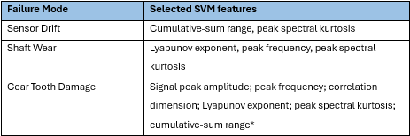
Table 2 - Selected features used for SVM fault classification
*Six features were used because classification using only the three highest-ranked indicators produced poor performance.
Feature distributions were also reviewed using grouped histograms. Figure 2 shows clear separation for sensor drift using cumulative-sum range, with values above approximately 0.5 mainly associated with a sensor drift fault condition. This suggests that cumulative-sum range is a useful indicator of likely sensor drift. In contrast, the Lyapunov exponent for shaft wear shows considerable overlap between faulty and healthy conditions, confirming that additional features are needed. Separate SVM classifiers were then assessed using five-fold cross validation and confusion matrices, with MATLAB’s fitcsvm function used for binary classification (MathWorks, 2026b). Supporting SVM classification code is provided in Section 9.1.4.
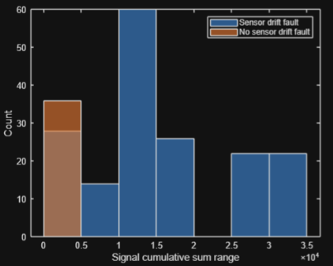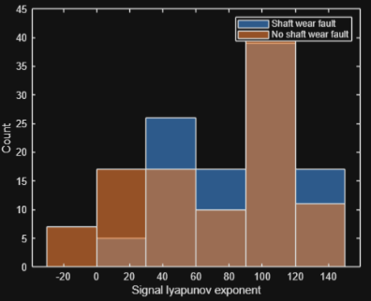
Figure 2 - Comparison of feature distributions for sensor drift and shaft wear classification

Neural Network Approach
The neural network approach uses three separate shallow networks to identify sensor drift, shaft wear and gear tooth faults. Each simulation’s raw vibration signal is converted into a frequency spectrum and fed directly into the networks, removing the need for the engineered features used by the SVM. The data-preparation process is summarised in Figure 3, with supporting MATLAB code provided in Section 9.2.
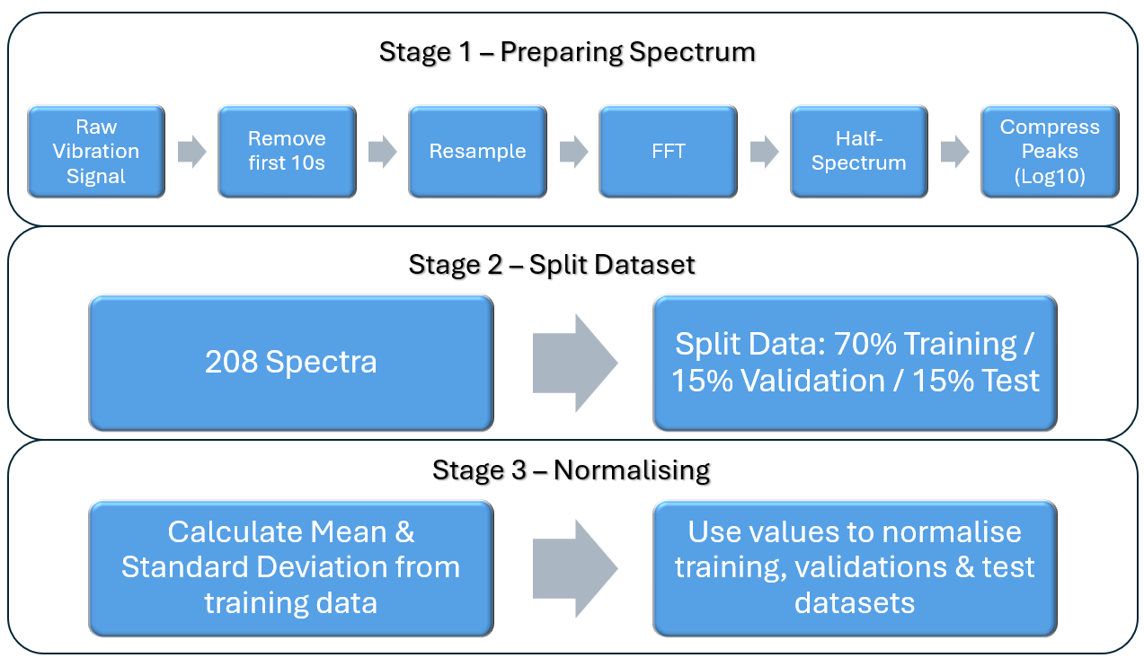
Figure 3 - Vibration data preparation and processing workflow for neural network
As shown in Figure 3, the first 10 seconds of the raw vibration signals are removed to exclude the start-up transient before the remaining data are resampled to a consistent length. A Fast Fourier Transform (FFT) converts the time-domain vibration signal into the frequency domain, allowing its frequency components to be analysed (MathWorks, 2026c). For real-valued signals the spectrum is mirrored, so only the first half is retained before a logarithmic transformation is applied, with the supporting MATLAB code provided in Section 9.2.1. The resulting spectra are divided into 70% training, 15% validation and 15% test data. Normalisation is calculated from the training data only and then applied to all three datasets, preventing information from the validation or test data influencing preprocessing (Section 9.2.2).
Separate binary networks are then trained for each fault using a baseline configuration of 20 hidden neurons, ReLU activation and a Lambda value of 1×10⁻³ (MathWorks, 2026d), with the training and testing code provided in Section 9.2.3. As the held-out test set contains only 31 of the 208 runs, five-fold cross validation is also used to give a more representative estimate of performance across the full dataset, with supporting code provided in Section 9.2.4.

Comparative Results
The initial five-fold cross validation results for the feature-based SVM and unoptimised raw-spectrum neural network are summarised in Table 3. The neural network parameters had not yet been optimised at this stage, allowing an initial comparison between the two approaches. Both achieved high accuracy for sensor drift and tooth fault, while the largest difference was seen for shaft wear, where the neural network achieved 100% compared with 61.1% for the SVM. This is consistent with the feature overlap identified in Section 5.1, which showed weaker separation between healthy and faulty shaft-wear conditions.
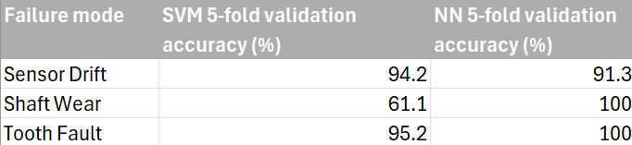
Table 3 - SVM and neural network classification accuracy
The five-fold cross validation results are further illustrated by the confusion matrices in Figures 4–6. For each failure mode, the SVM and neural network matrices are presented alongside each other to show the distribution of correct and incorrect classifications across the 208 simulation runs. In each matrix, true/true and false/false represent correctly classified fault and healthy conditions, while the off-diagonal cells represent false-positive and false-negative classifications.
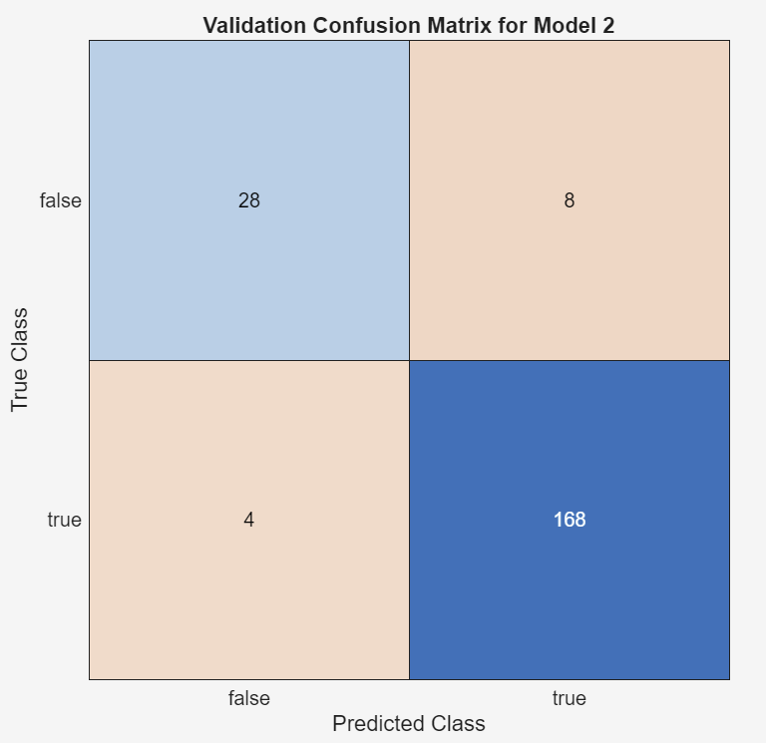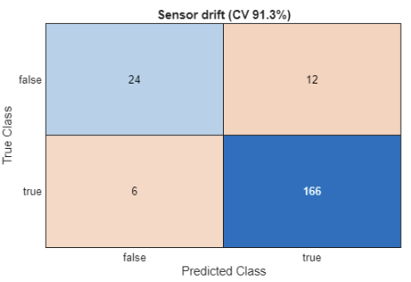
Figure 4 - Sensor Drift Confusion Matrices: SVM and Neural Network

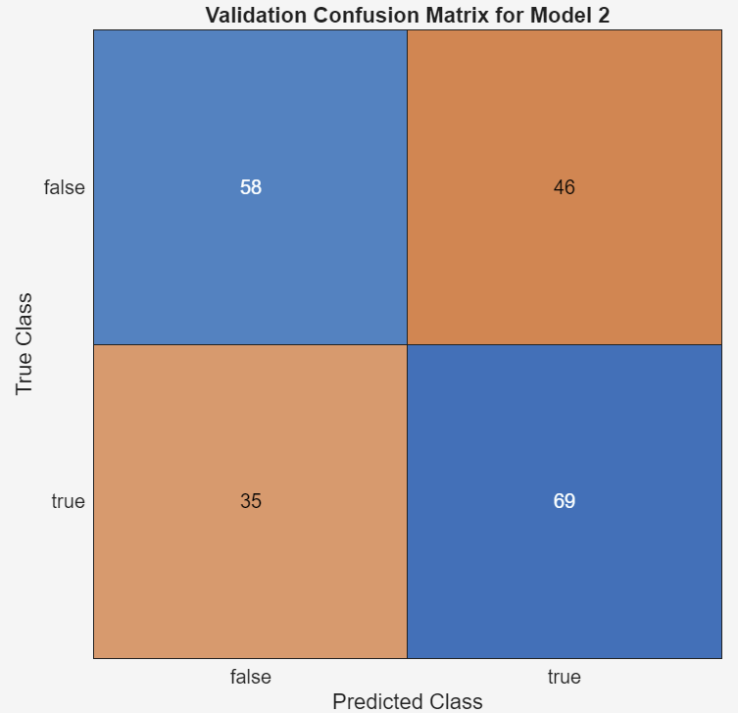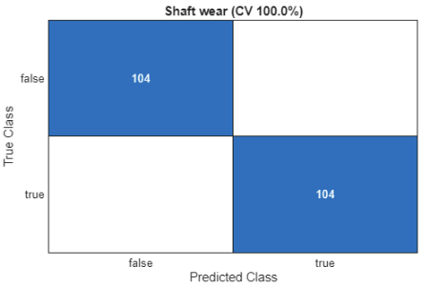
Figure 5 -Shaft Wear Confusion Matrices: SVM and Neural Network

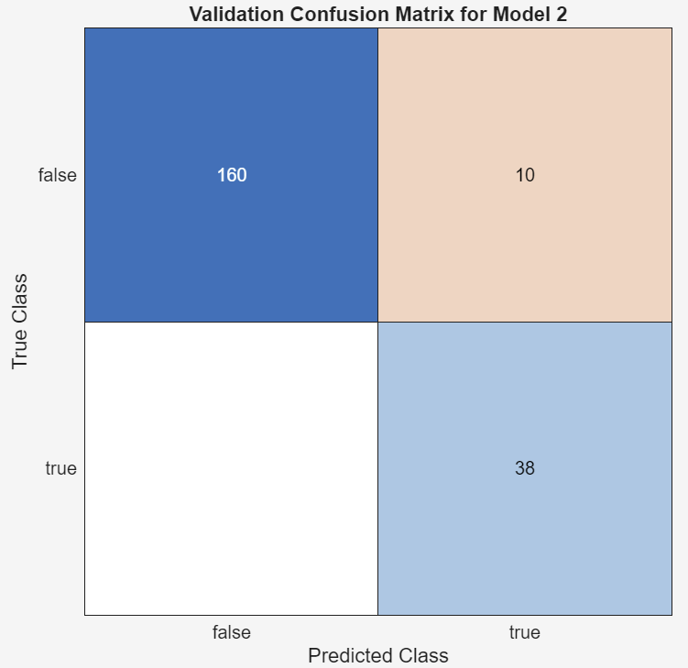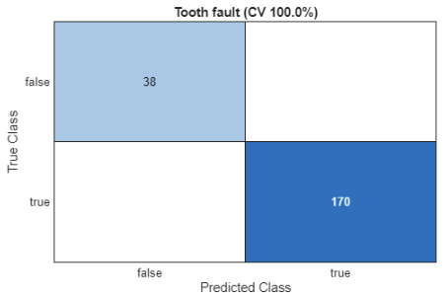
Figure 6 -Tooth Fault Confusion Matrices: SVM and Neural Network

Neural Network Tuning
Following the baseline comparison, the sensitivity of the neural network classifiers to changes in network configuration was investigated using the initial 70/15/15 data split. Layer size, activation function and Lambda parameters were varied independently while the remaining training parameters were held constant. Table 4 compares the baseline and selected optimised configurations and their associated training and test accuracies. Tooth fault required no further optimisation, having achieved 100% training and test accuracy with the baseline configuration.

The complete parameter investigation, including all tested layer sizes, activation functions and Lambda values, is provided in Section 9.3. 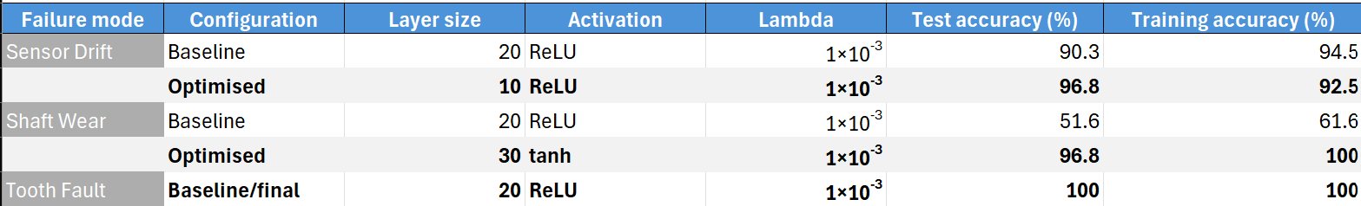
Table 4 - Baseline and optimised neural network configurations and accuracy
The effect of optimisation on classification performance is illustrated in Figures 7 and 8. Sensor drift test accuracy increased from 90.3% to 96.8% after reducing the hidden layer from 20 to 10 neurons, while shaft wear showed a substantially larger improvement from 51.6% to 96.8% after increasing the layer size to 30 neurons and changing the activation function from ReLU to tanh.
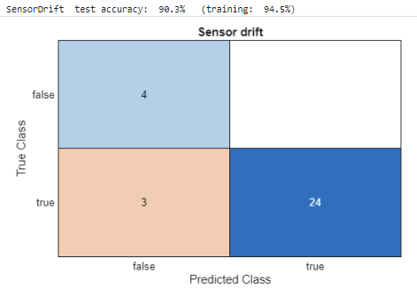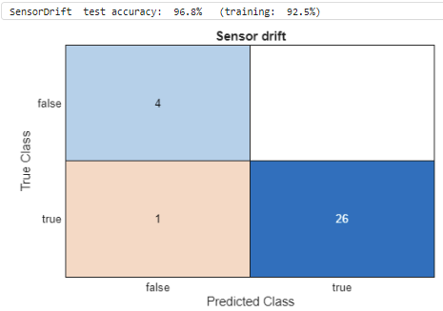
Figure 7 - Sensor Drift Confusion Matrices: Baseline and Optimised Neural Network.
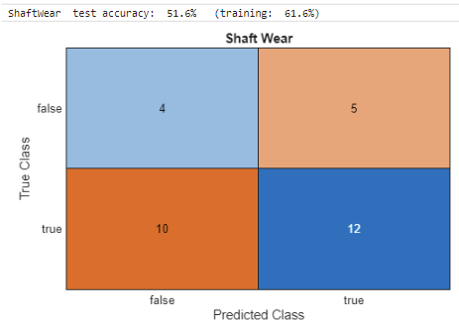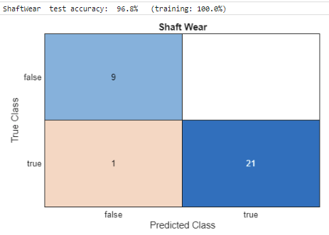
Figure 8 - Shaft Wear Confusion Matrices: Baseline and Optimised Neural Network
Following optimisation, the selected neural network configurations were reassessed using five-fold cross validation across all 208 simulation runs, shown in Figure 9 (MathWorks, 2026e).
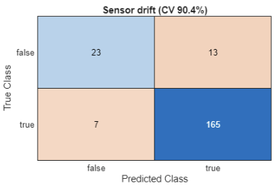
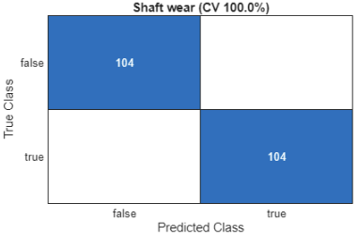
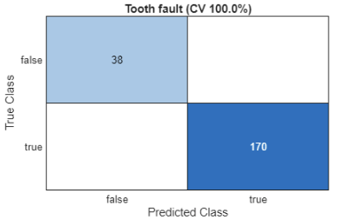
Figure 9 - Five-Fold cross validation confusion matrices: Sensor Drift, Shaft Wear and Tooth Fault
Sensor drift achieved 90.4% cross validation accuracy, while shaft wear and tooth fault both achieved 100%. The tuned sensor drift configuration achieved 90.4% five-fold cross validation accuracy, compared with 96.8% on the single test split. The higher single-split result is likely influenced by the smaller test sample, where individual classifications have a greater effect on overall accuracy. Five-fold cross validation therefore provides a more representative measure of performance across the dataset.

Discussion

Fault Classification Performance
Shaft wear presented the greatest overall classification challenge, particularly for the feature-based SVM and during neural-network tuning. The feature analysis in Figure 2 showed considerable overlap between healthy and shaft wear conditions for the Lyapunov exponent, indicating weaker separation within the condition indicators. This was reflected in the SVM results in Table 3, where shaft wear achieved 61.1% five-fold cross validation accuracy, compared with 94.2% for sensor drift and 95.2% for tooth fault.
The neural network investigation also demonstrated substantially greater sensitivity for shaft wear. As shown in Table 5, its test accuracy varied from 42.5% to 96.8% across the configurations investigated, a range of 54.3 percentage points. Sensor drift varied by only 9.7 percentage points, while tooth fault achieved 100% with the baseline configuration and required no further optimisation. Although shaft wear subsequently achieved 100% five-fold cross validation accuracy, the variation across the investigation indicates that its classification was particularly dependent on input parameters and evaluation procedure.
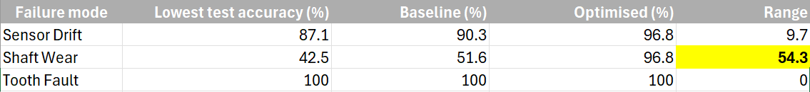
Table 5 - Variation in neural network test accuracy
The baseline shaft-wear network also showed a noticeable gap between training accuracy (61.6%) and test accuracy (51.6%). A large difference between training and unseen test performance can indicate overfitting, where a model learns the training data too closely and does not generalise as well to new data (Ying, 2019). This result therefore provided a reason to investigate the network configuration further.

Detection Performance and False Alarms
Overall classification accuracy does not distinguish between missed faults and false alarms. The five-fold cross validation confusion matrices were therefore reviewed to identify false-positive and false-negative classifications, as summarised in Table 6.
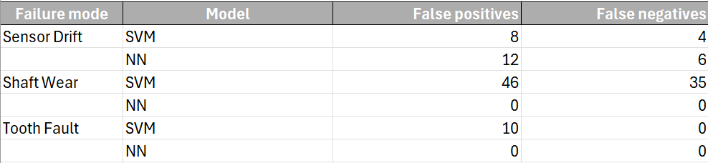
Table 6 - False-positive and false-negative classifications
The SVM produced the greatest number of errors for shaft wear, with 46 false positives and 35 false negatives, while the neural network produced no false classifications for shaft wear or tooth fault under five-fold cross validation. False negatives represent genuine faults that remain undetected and could allow equipment degradation to continue, whereas false positives may result in unnecessary inspection or maintenance. A suitable predictive-maintenance system must therefore balance fault-detection capability against the operational impact of false alarms rather than relying on overall classification accuracy alone.

Refinery Deployment Considerations
Within the refinery scenario, reliable diagnosis of the crude charge pump drivetrain could support planned maintenance before faults lead to unexpected process interruption. Earlier warning could also allow spare parts and maintenance resources to be arranged before failure, reducing the risk of extended downtime. Classification performance must therefore be considered alongside availability, safety and product quality, while false positives may lead to unnecessary inspection or component replacement.
False negatives are particularly important because an undetected mechanical fault could continue to deteriorate in service, increasing the risk of equipment damage or loss of containment. Repeated sensor-drift alarms could also reduce operator trust in instrumentation. Performance should therefore be judged on the consequences of missed faults as well as overall accuracy, while stable pump operation and consistent automated monitoring could support repeatable condition assessment and more consistent process quality. Further validation would still be required before deployment. The models were developed using simulated rather than measured vibration data, and differences between single-split and cross validation results show sensitivity to the evaluation method. Testing on real refinery equipment under varying operating conditions would therefore be needed to confirm that the results can be reproduced in practice.

Conclusions and Recommendations
This investigation showed that predictive fault classification could support maintenance decision-making within the refinery drivetrain scenario. The literature reviewed in Sections 2 and 3 suggests that predictive maintenance can support earlier intervention and improve availability by using equipment condition rather than relying only on reactive or fixed preventive maintenance.
Overall, the raw-spectrum neural network gave the strongest classification performance. Five-fold cross validation achieved 91.3% accuracy for sensor drift and 100% for shaft wear and tooth fault, compared with SVM results of 94.2%, 61.1% and 95.2%, respectively. Neural Network optimisation also increased held-out test accuracy to 96.8% for both sensor drift and shaft wear. Based on these results, the neural network approach is recommended for further development within the refinery scenario, although the SVM may benefit from improved feature selection.
The results should still be treated with caution. The models were developed using simulated rather than measured plant data, and differences between held-out and cross validation results show some sensitivity to the evaluation method. Further work should therefore test both approaches using real vibration data, larger datasets and a wider range of operating conditions. False alarms and missed detections should also be assessed before industrial deployment because of their effect on availability, safety and quality.

References
Daş, O., Daş, D.B. and Birant, D. (2023) ‘Machine learning for fault analysis in rotating machinery: A comprehensive review’, Heliyon, 9(6), e17584. doi: 10.1016/j.heliyon.2023.e17584.
Gholipour, Y. (2025) ‘A Comprehensive Review of Maintenance Strategies: From Reactive to Proactive Approaches’. SSRN Electronic Journal. doi: 10.2139/ssrn.5349871.
Jablonski, A. and Mendrok, K. (2025) ‘Automatic threshold setting for anomaly detection’, Mechanical Systems and Signal Processing, 228, 112462. doi: 10.1016/j.ymssp.2025.112462
MathWorks (2026a) fscnca – Feature selection using neighborhood component analysis for classification. MATLAB Statistics and Machine Learning Toolbox. Accessed 10 September 2026.
MathWorks (2026b) fitcsvm – Train support vector machine classifier for one-class and binary classification. MATLAB Statistics and Machine Learning Toolbox. Accessed 10 September 2026.
MathWorks (2026c) fft – Fast Fourier transform. MATLAB. Accessed 13 September 2026.
MathWorks (2026d) fitcnet – Train neural network classification model. MATLAB Statistics and Machine Learning Toolbox. Accessed 13 September 2026.
MathWorks (2026e) cvpartition – Partition data for cross-validation. MATLAB Statistics and Machine Learning Toolbox. Accessed 14 September 2026.
Orrù, P.F., Zoccheddu, A., Sassu, L., Mattia, C., Cozza, R. and Arena, S. (2020) ‘Machine Learning Approach Using MLP and SVM Algorithms for the Fault Prediction of a Centrifugal Pump in the Oil and Gas Industry’, Sustainability, 12(11), 4776. doi: 10.3390/su12114776.
Tama, B.A., Vania, M., Lee, S. and Lim, S. (2023) ‘Recent advances in the application of deep learning for fault diagnosis of rotating machinery using vibration signals’, Artificial Intelligence Review, 56, pp. 4667–4709. doi: 10.1007/s10462-022-10293-3.
Ying, X. (2019) ‘An Overview of Overfitting and its Solutions’, Journal of Physics: Conference Series, 1168(2), 022022. doi: 10.1088/1742-6596/1168/2/022022.
Zhao, J., Gao, C. and Tang, T. (2022) ‘A Review of Sustainable Maintenance Strategies for Single Component and Multicomponent Equipment’, Sustainability, 14(5), 2992. doi: 10.3390/su14052992.
Zhou, H., Huang, X., Wen, G., Lei, Z., Dong, S., Zhang, P. and Chen, X. (2022) ‘Construction of health indicators for condition monitoring of rotating machinery: A review of the research’, Expert Systems with Applications, 203, 117297.
Zhu, Z., Lei, Y., Qi, G., Chai, Y., Mazur, N., An, Y. and Huang, X. (2023) ‘A review of the application of deep learning in intelligent fault diagnosis of rotating machinery’, Measurement, 206, 112346. doi: 10.1016/j.measurement.2022.112346

Appendices

Appendix A – MATLAB SVM Classification Code

Feature Extraction
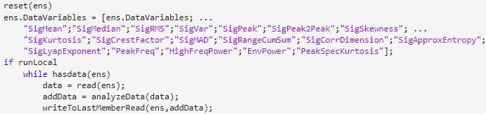

Feature Selection
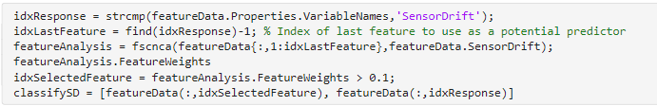
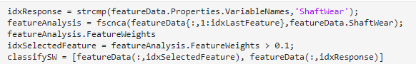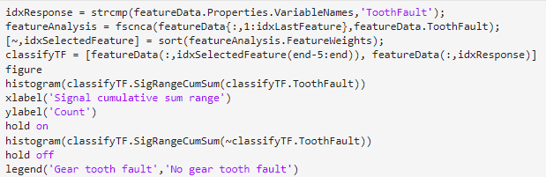

NCA Feature Weighting
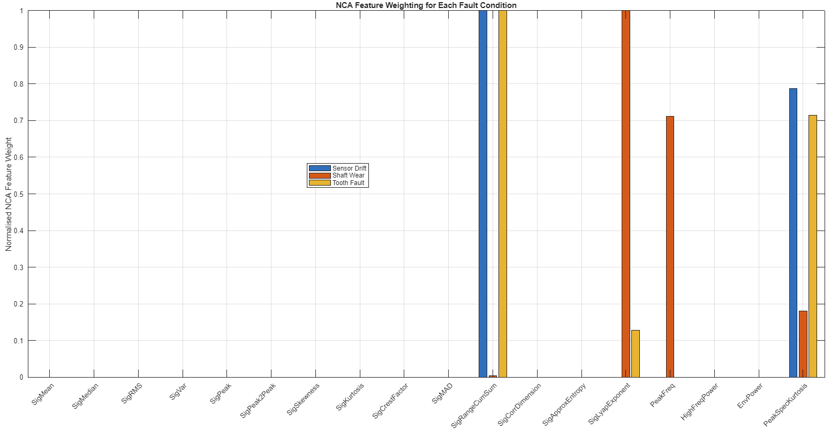

SVM Classification
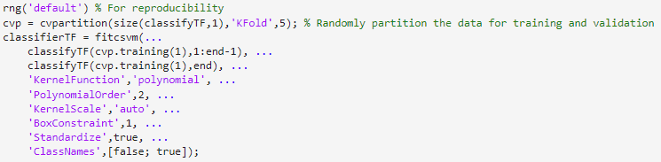
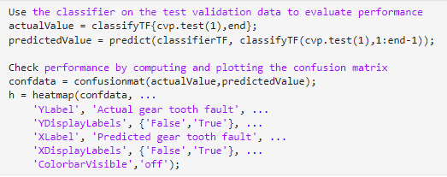

Simulation and Signal Processing Outputs

Condition Monitoring Signals
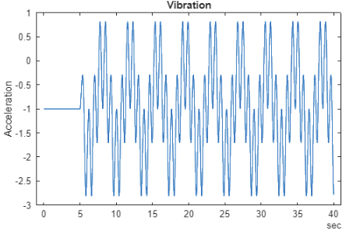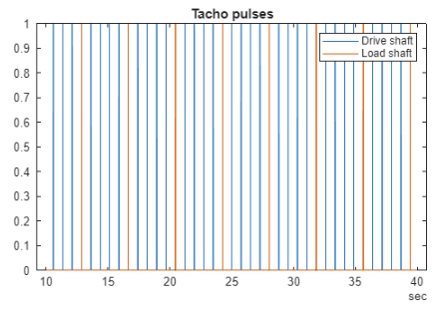

Vibration Signal Variation Across the Simulation
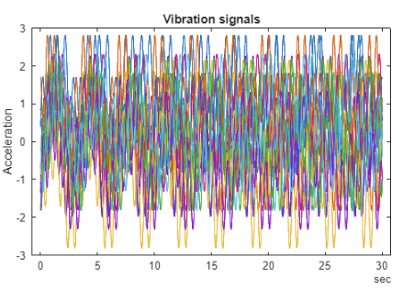

Examples of Vibration Signal Processing
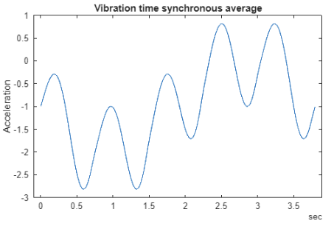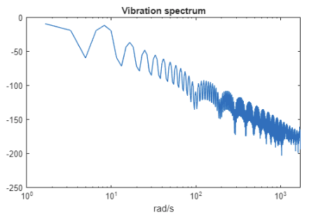

Appendix B – MATLAB Neural Network Code

Spectrum Preparation
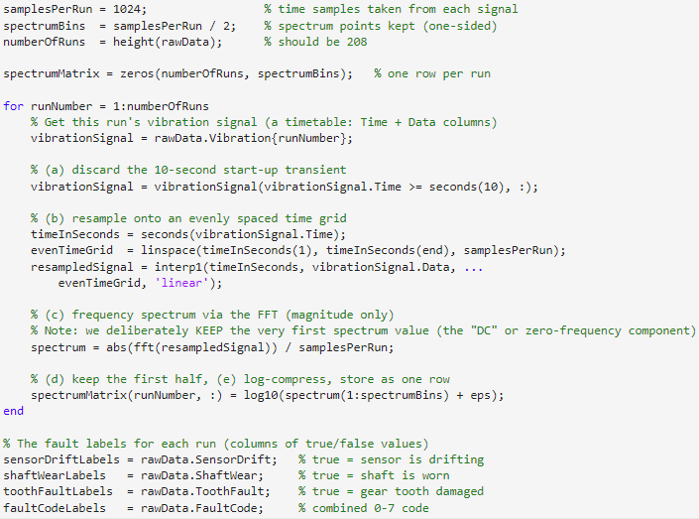

Dataset Splitting and Normalisation
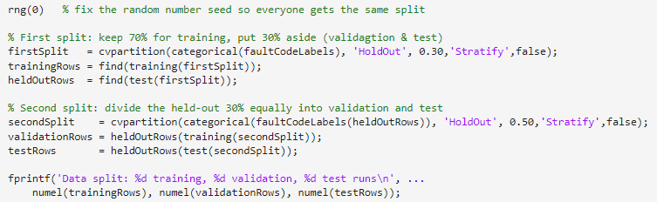
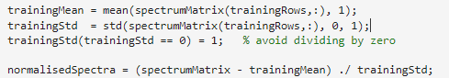

Neural Network Training and Testing

Sensor Drift
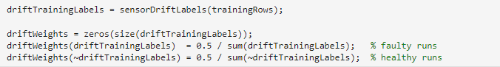
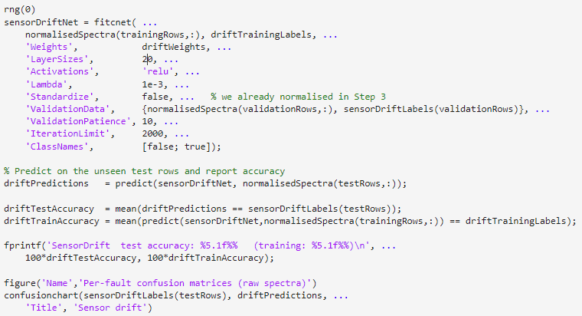

Shaft Wear
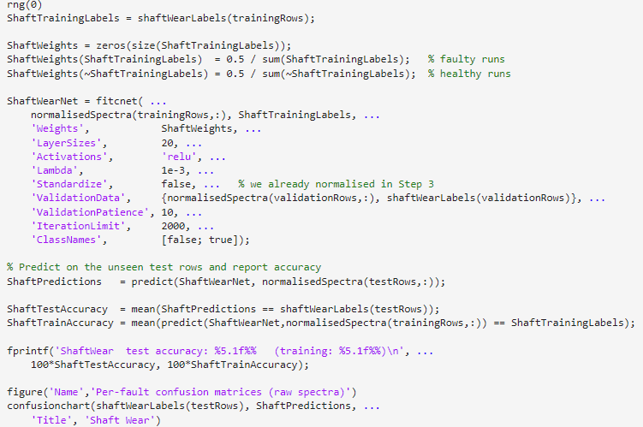

Tooth Fault
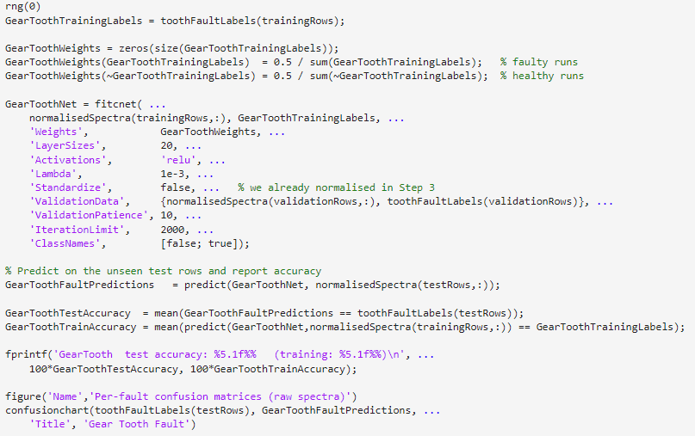

Five-Fold Cross Validation
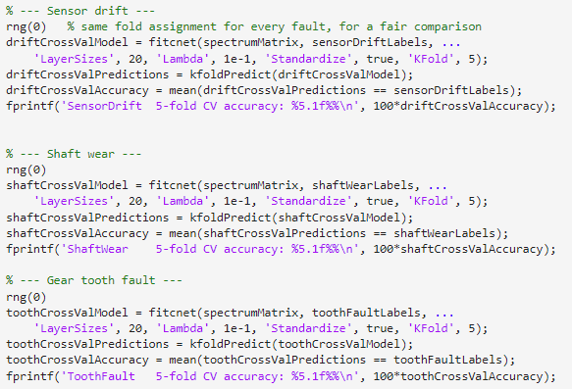

Appendix C – Complete Neural Network Parameter Testing


